SUPPLEMENTARY MATERIALS

Supplementary Table 1. Agreement among syringing, DCG, and dacryoendoscopy regarding the obstruction grade

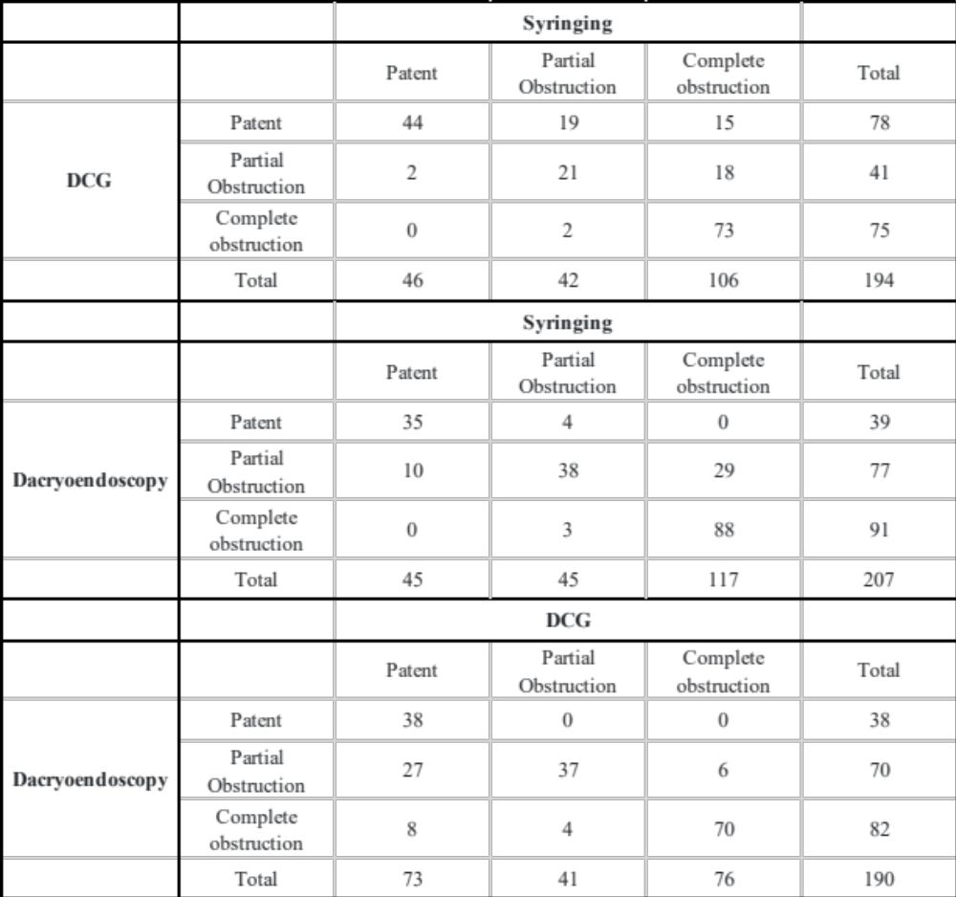
The values represent the number of LDS.
Inter-rater reliability analyses were performed between dependent samples of syringing and DCG, syringing and dacryoendoscopy, and DCG and dacryoendoscopy. For this purpose, Cohen’s kappa values were calculated, the measure of the agreement between two dependent categorical samples. The Cohen’s kappa values showed 0.55, 0.65, and 0.65, respectively.
Abbreviation: DCG, dacryocystography; LDS, lacrimal drainage system

Supplementary Table 2. Agreement between syringing, DCG, and dacryoendoscopy in diagnosing the obstruction site

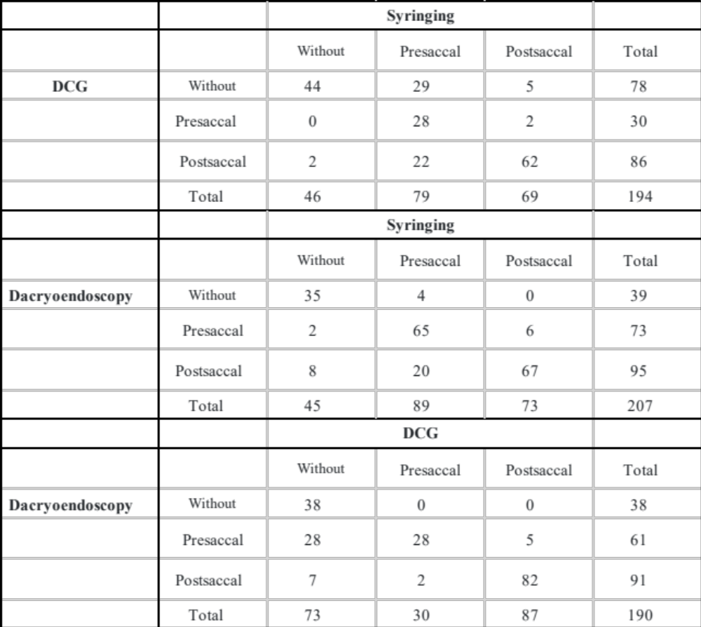
The values represent the number of LDS.
Inter-rater reliability analyses were performed between dependent samples of syringing and DCG, syringing and dacryoendoscopy, and DCG and dacryoendoscopy. For this purpose, Cohen’s kappa values were calculated, the measure of the agreement between two dependent categorical samples. Cohen’s kappa values showed 0.55, 0.7, and 0.66, respectively.
Abbreviation: DCG, dacryocystography; LDS, lacrimal drainage system

Supplementary Figure 1.
Dacryoendoscope with a bent-tip probe and a curve-tipped probe.

Left: CK10 (FiberTech Co., Ltd., Tokyo, Japan); external diameter, 0.9 mm; field of view, 60°; image quality, 10,000 pixels
Middle: CH15C (FiberTech Co., Ltd., Tokyo, Japan); external diameter, 0.82 mm; field of view, 70°; image quality, 15,000 pixels
Right: LAC-06-FY (Machida Endoscope Co., Ltd., Chiba, Japan); external diameter, 0.9 mm; field of view, 65°; image quality, 15,000 pixels

