Potential distribution of fall armyworm in Africa and beyond, considering climate change and irrigation patterns

Supplementary materials:

Bipana Paudel Tamilsena¹, Saliou Niassy², Emily Kimathi², Elfatih. M. Abdel-Rahman², Irmgard Seidl-Adams¹, Mark Wamalwa², Henri E. Z. Tonnang², Sunday Ekesi², David P. Hughes^{1,3}, Edwin G. Rajotte¹, Sevgan Subramanian²

The following supporting information is available for this article:

Supplementary Fig. S1. . The area with potential suitability for FAW population growth under historic climate using CLIMEX. FAW annual growth index (GI) under (a) natural rainfall condition, (b) irrigation scenario I, and (c) irrigation scenario II. (d) Global distribution of maize and sorghum, two major host crops of FAW.

Supplementary Fig. S2. The areas with potential suitability for FAW seasonal population growth based on current and predicted future climates (2030, 2050 and 2080) under CSIRO-Mk3.0 (top) and MIROC-H (bottom), considering irrigation scenario II.

Supplementary Fig. S3. Impact of climate change on climatic suitability area (EI) for FAW population persistence. White indicates no change, red indicates an increase, and blue indicates decrease in EI values under the future projected climate from the current climate. Depth of color indicates the degree of changes in EI value.

Supplementary Table 1. FAW occurrence records from the Americas, the native range of FAW.

Supplementary Table 2. CLIMEX parameter sensitivity values for Spodoptera frugiperda (FAW) parameters listed in Table 1, as applied to the CM10 1975H V1.2 global dataset under a natural rainfall scenario.

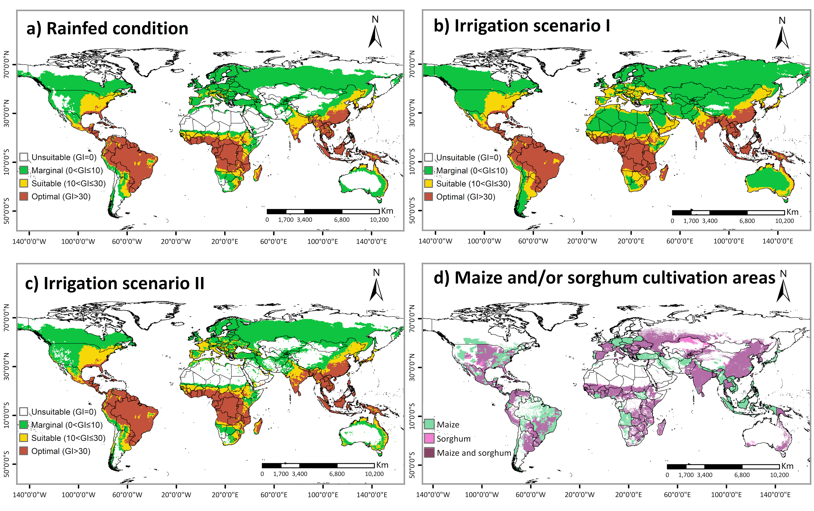
Supplementary Fig S1: The area with potential suitability for FAW population growth under historic climate using CLIMEX. FAW annual growth index (GI) under (a) natural rainfall condition, (b) irrigation scenario I, and (c) irrigation scenario II. (d) Global distribution of maize and sorghum, two major host crops of FAW.

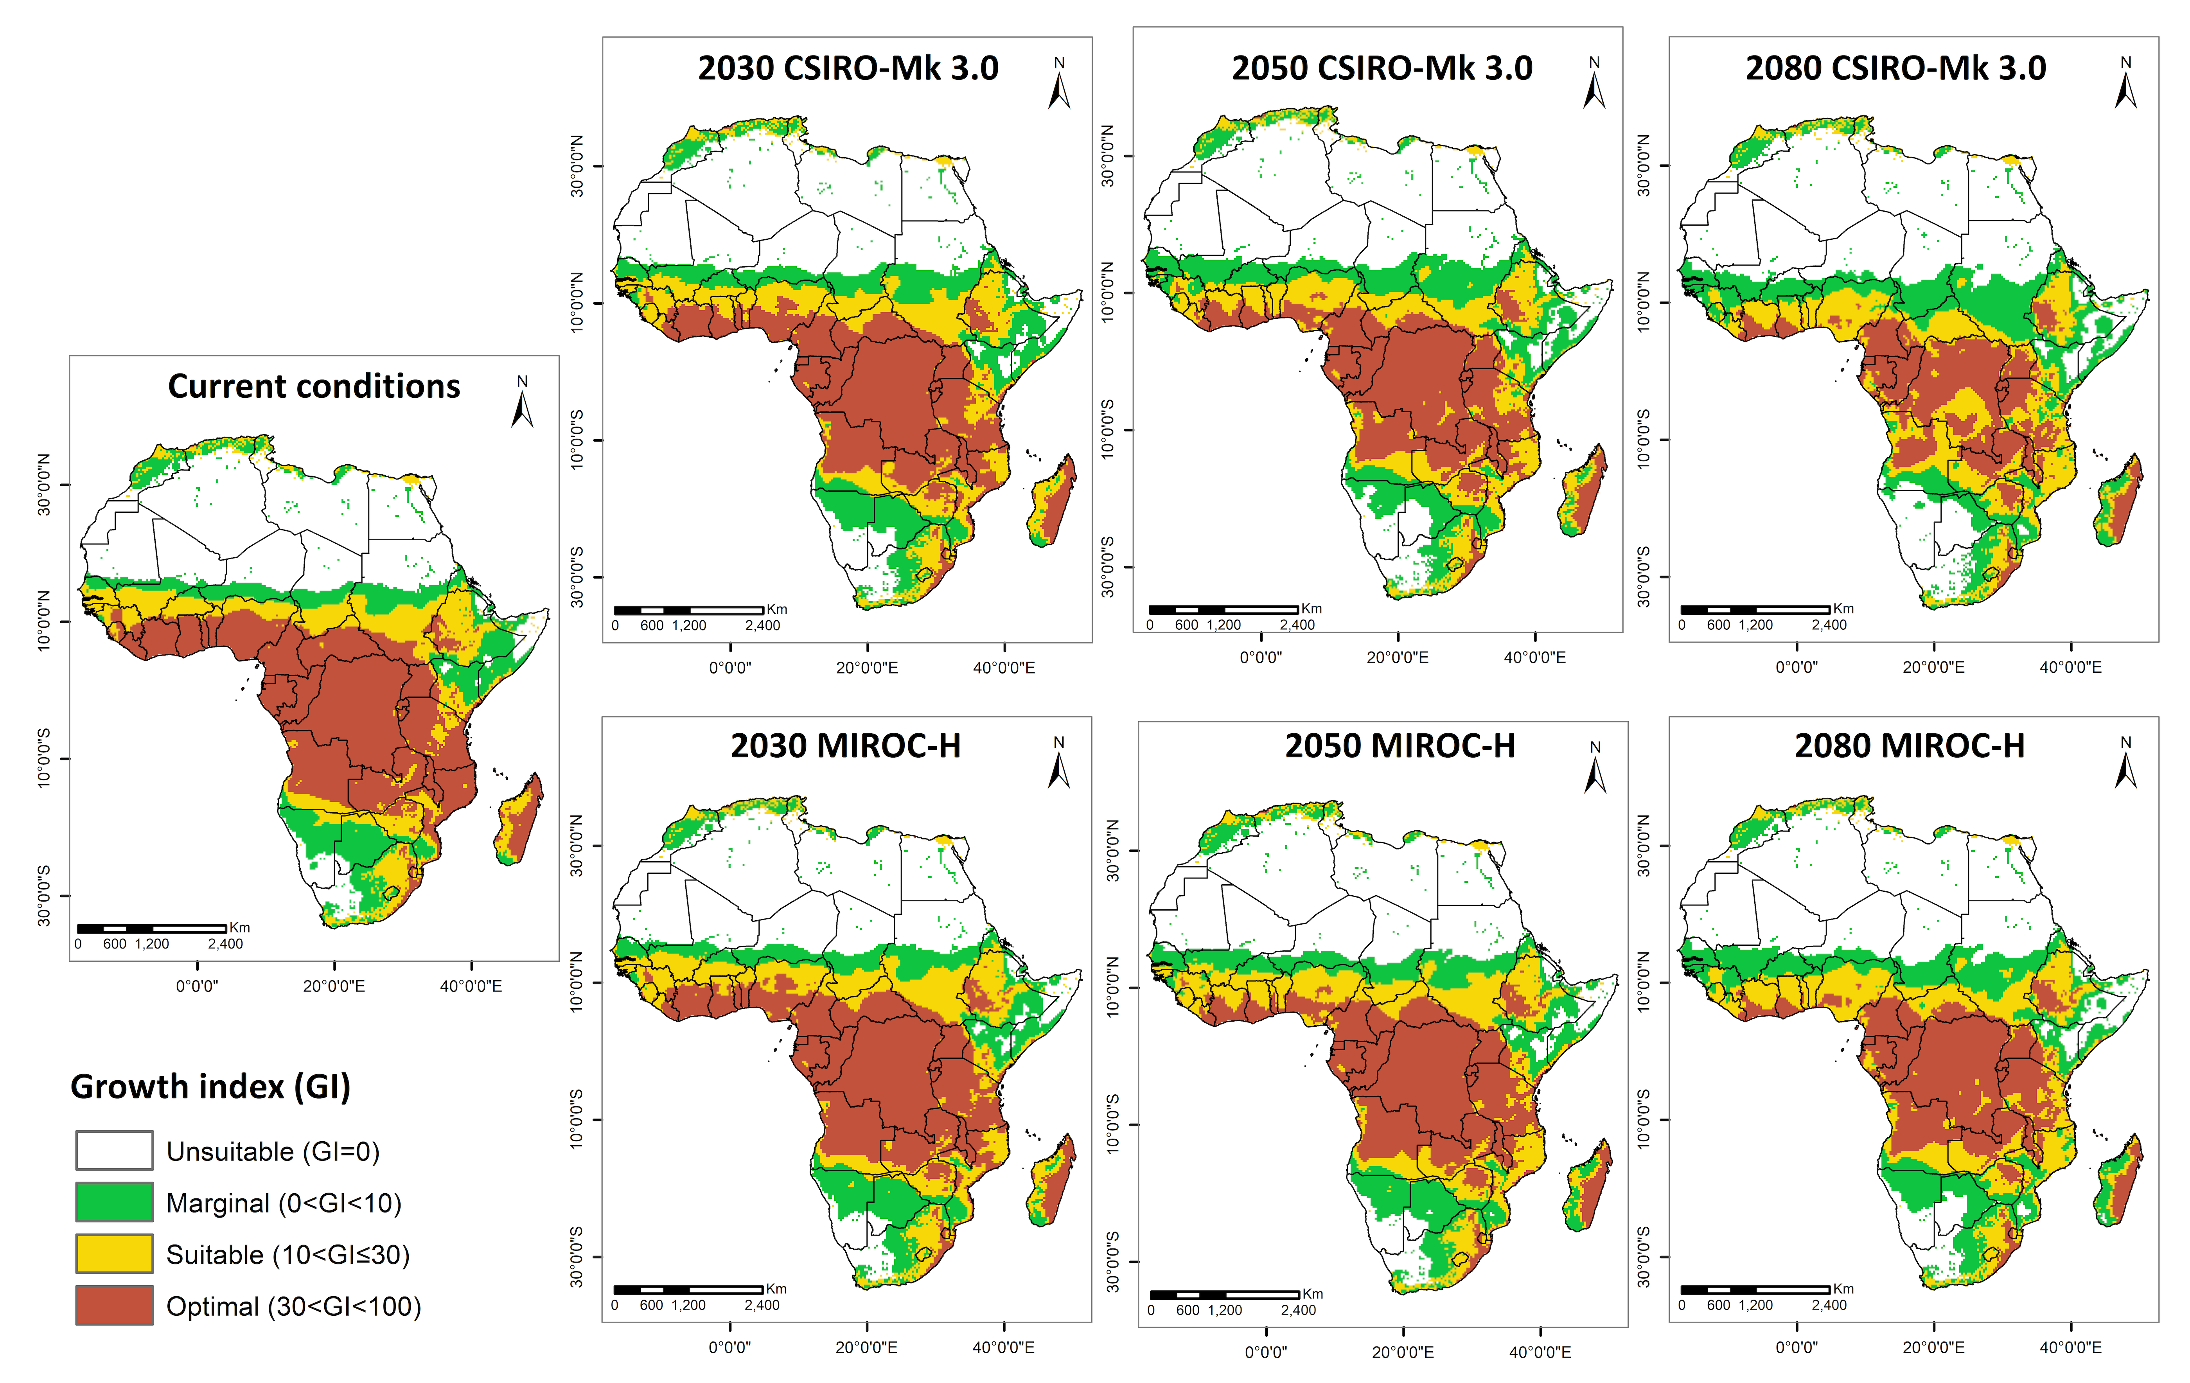
Supplementary Fig S2: The areas with potential suitability for FAW seasonal population growth based on current and predicted future climates (2030, 2050 and 2080) under CSIRO-Mk3.0 (top) and MIROC-H (bottom), considering irrigation scenario II.

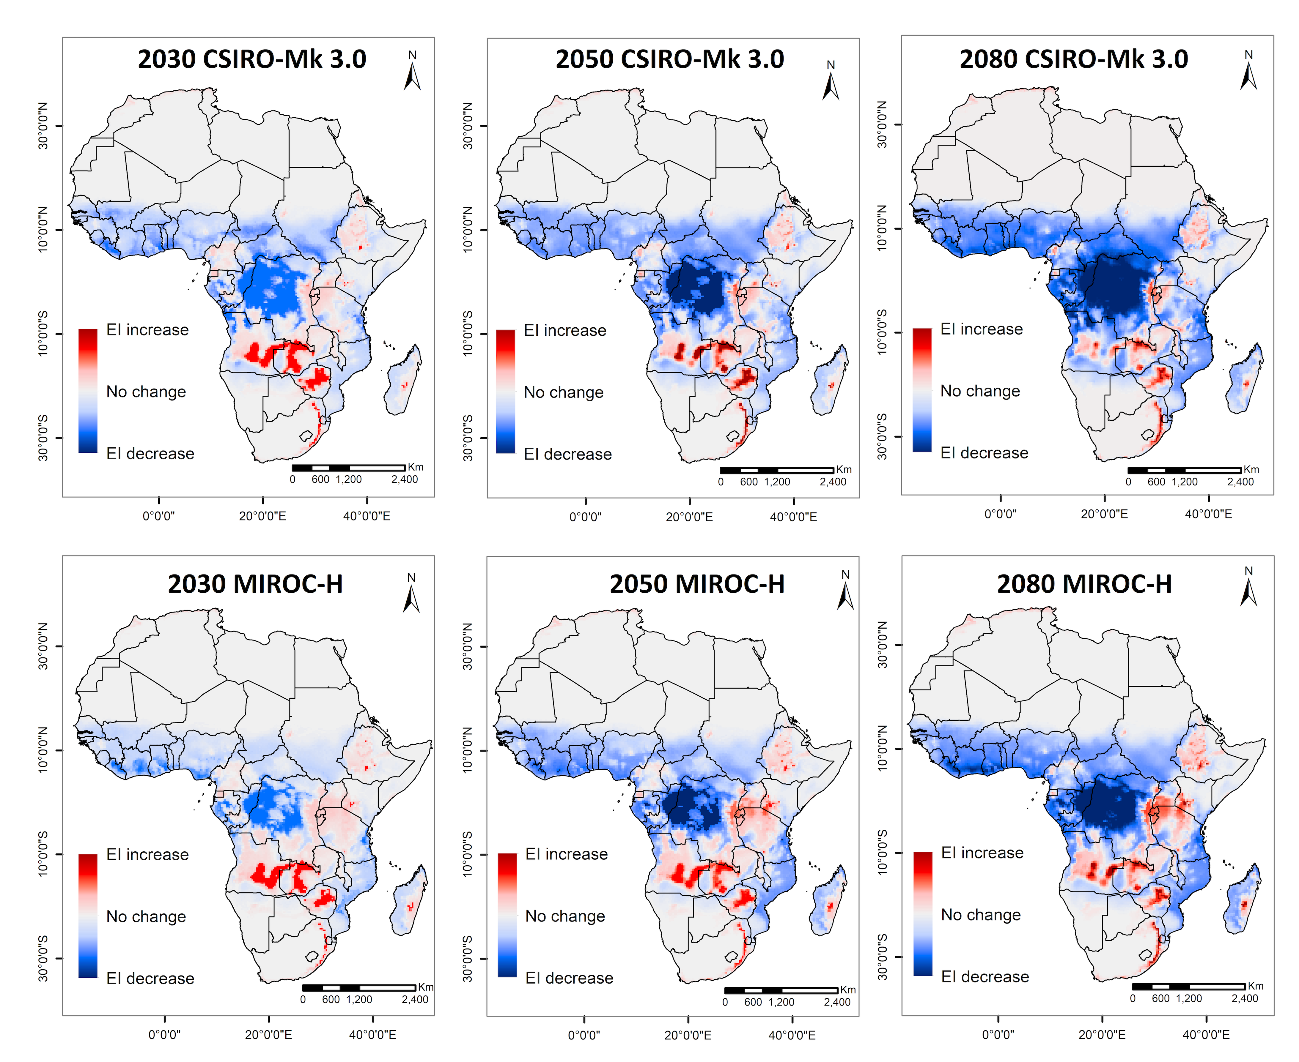
Supplementary Fig. S3. Impact of climate change on climatic suitability area (EI) for FAW population persistence. White indicates no change, red indicates an increase, and blue indicates decrease in EI values under the future projected climate from the current climate. Depth of color indicates the degree of changes in EI value.

Supplementary Table 2: CLIMEX parameter sensitivity values for Spodoptera frugiperda (FAW) parameters listed in Table 1, as applied to the CM10 1975H V1.2 global dataset under a natural rainfall scenario
Parameter | Mnemonic | Parameter range |  |  | Change in state variables
Parameter | Mnemonic | Low | Default | High | Range | Core dist’n | EI | GI | TI | MI | HS | CS | DS | WS
Cold Stress Temperature Threshold | TTCS | 7 | 8 | 9 | 1 | 0.4 | 2.9 | 0 | 0 | 0 | 0 | 17.15 | 0 | 0
Limiting low moisture | SM0 | 0.05 | 0.15 | 0.25 | 0.8 | 0 | 1.6 | 2.3 | 0 | 10.72 | 0 | 0 | 0 | 0
Limiting high temperature | DV3 | 35 | 36 | 37 | 0.3 | 0 | 1.6 | 1.7 | 4.2 | 0 | 0 | 0 | 0 | 0
Dry Stress Threshold | SMDS | 0 | 0.1 | 0.2 | 0.3 | 6.7 | 1.8 | 0 | 0 | 0 | 0 | 0 | 43.27 | 0
Cold Stress Temperature Rate | THCS | -0.006 | -0.005 | -0.004 | 0.2 | 0 | 0.7 | 0 | 0 | 0 | 0 | 4.58 | 0 | 0
Lower optimal moisture | SM1 | 0.7 | 0.8 | 0.9 | 0.1 | 0 | 1.2 | 1.6 | 0 | 6.91 | 0 | 0 | 0 | 0
Upper optimal temperature | DV2 | 29 | 30 | 31 | 0.1 | 0 | 4.3 | 4.4 | 6.7 | 0 | 0 | 0 | 0 | 0
Heat Stress Temperature Threshold | TTHS | 38 | 39 | 40 | 0.1 | 0 | 0.4 | 0 | 0 | 0 | 12.26 | 0 | 0 | 0
Upper optimal moisture | SM2 | 1.4 | 1.5 | 1.6 | 0 | 0 | 3 | 3.1 | 0 | 3.67 | 0 | 0 | 0 | 0
Limiting high moisture | SM3 | 1.9 | 2 | 2.1 | 0 | 0 | 1.7 | 1.8 | 0 | 2.07 | 0 | 0 | 0 | 0
Limiting low temperature | DV0 | 11 | 12 | 13 | 0 | 0 | 0.7 | 1.3 | 2.3 | 0 | 0 | 0 | 0 | 0
Lower optimal temperature | DV1 | 24 | 25 | 26 | 0 | 0 | 2 | 2.2 | 4 | 0 | 0 | 0 | 0 | 0
Heat Stress Temperature Rate | THHS | 0.002 | 0.0025 | 0.003 | 0 | 0 | 0.1 | 0 | 0 | 0 | 3.48 | 0 | 0 | 0
Dry Stress Rate | HDS | -0.006 | -0.005 | -0.004 | 0 | 0.3 | 0.3 | 0 | 0 | 0 | 0 | 0 | 3.68 | 0
Wet Stress Threshold | SMWS | 1.9 | 2 | 2.1 | 0 | 0.3 | 0.7 | 0 | 0 | 0 | 0 | 0 | 0 | 2.5
Wet Stress Rate | HWS | 0.008 | 0.01 | 0.012 | 0 | 0 | 0.3 | 0 | 0 | 0 | 0 | 0 | 0 | 1
Degree-days per Generation | PDD | 320 | 400 | 480 | 0 | 0 | 0 | 0 | 0 | 0 | 0 | 0 | 0 | 0

