Supporting Information

Active site recovery and N-N bond breakage during hydrazine oxidation boosting the electrochemical hydrogen production
Libo Zhu^{1,2#}, Jian Huang^{1#}, Ge Meng^{1,2}, Tiantian Wu¹, Chang Chen^{1,2}, Han Tian¹, Yafeng Chen⁴, Fantao Kong¹, Ziwei Chang⁵, Xiangzhi Cui^{1,2,3*}, Jianlin Shi^{1*}
¹ State Key Lab of High Performance Ceramics and Superfine Microstructure, Shanghai Institute of Ceramics, Chinese Academy of Sciences, Shanghai 200050, PR China.
² Center of Materials Science and Optoelectronics Engineering, University of Chinese Academy of Sciences, Beijing 100049, PR China.
³ School of Chemistry and Materials Science, Hangzhou Institute for Advanced Study, University of Chinese Academy of Sciences, Hangzhou 310024, PR China.
⁴ Collaborative Innovation Center of Steel Technology, University of Science and Technology Beijing, Beijing 100083, PR China.
⁵ School of Physical Science and Technology, Shanghai Tech University, Shanghai 201210, PR China.
*Email: jlshi@mail.sic.ac.cn (J. Shi), cuixz@mail.sic.ac.cn (X. Cui).
Fig. S1. Schematic illustration of synthesis of Ni-Co-P/NF.

Fig. S2. Typical FESEM images at different magnifications. (a) Ni-Co-Pre/NF; (b) Thickness of nanowire arrays on the surface of Ni-Co-Pre/NF.
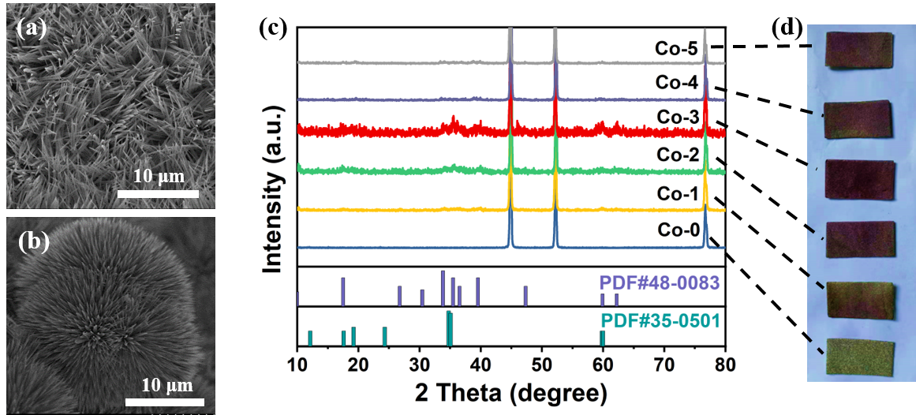
Fig. S3. Typical FESEM of Ni-Co-Pre/NF with (a) Co-3, (b) Co-5; (c) XRD patterns of precursors with different Co source addition amount (PDF#48-0083: Co(CO₃)_{0.5} (OH); PDF#35-0501: Ni(CO₃) _{0.5} (OH)), and the corresponding Digital photographs (d).

Fig. S4. Typical FESEM images of Ni-Co-P/NF (a, b) at different magnifications.
Fig. S5. The images of water contact angle measurements. (a) Ni-Co-Pre/NF; (b) Pt/C.

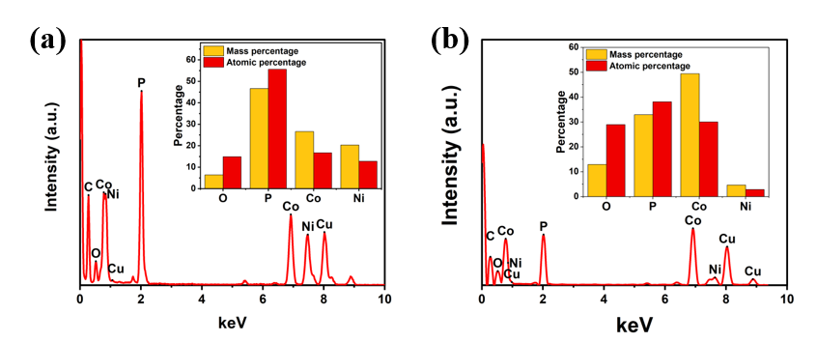
Fig. S6. TEM-EDX images of Ni-Co-P/NF of different areas in Fig. 1c. (a) Area 2; (b) Area 1, with the mass percentage and atomic percentage in the inset.
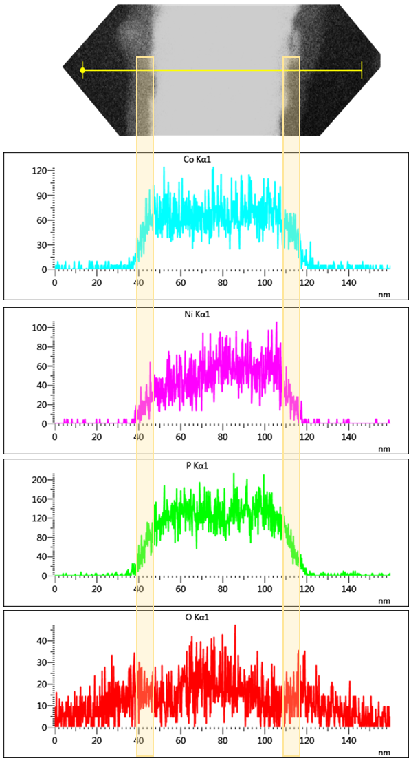
Fig. S7. TEM-EDX line scanning images of different elements in Ni-Co-P/NF.

Fig. S8. HRTEM image of Ni-Co-P/NF with interface division.

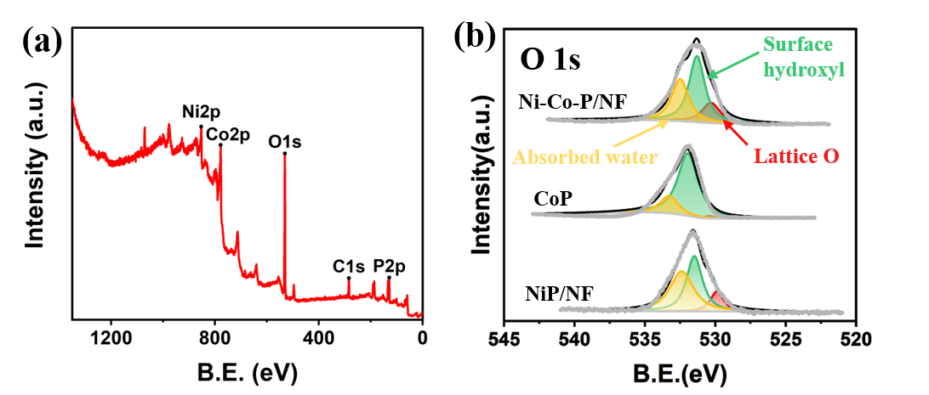
Fig. S9. (a) Survey scan of XPS spectra of the Ni-Co-P/NF; (b) O 1s of XPS spectra of the Ni-Co-P/NF, CoP, NiP/NF (530.3 eV: the lattice oxygen due to the partial oxidation of the catalyst surface; 531.3 eV: the adsorbed O from surface hydroxyl and adsorbed oxygen species due to the defect of materials; 532.5 eV: surface-absorbed H₂O¹).
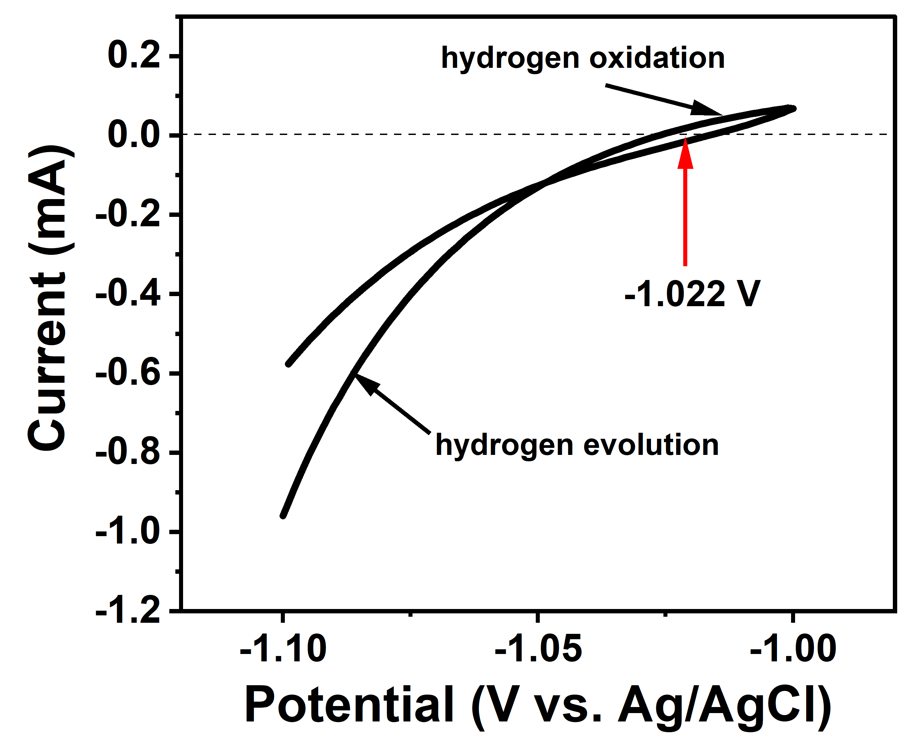
Fig. S10. Potential calibration of the Ag/AgCl reference electrode in 1 M KOH. Potential vs RHE in paper calculated as follows: E_{RHE}=E_{Ag/AgCl} +1.022V.

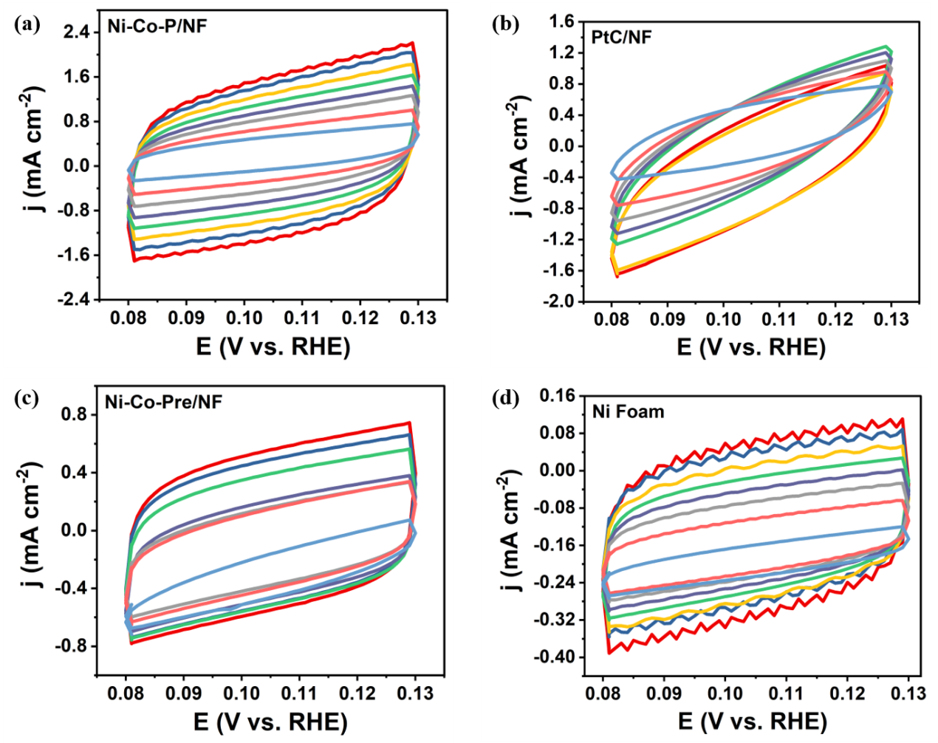
Fig. S11. The CV curves of different samples with the scan rate ranging from 10 to 80 mV s⁻¹ in 1.0 M KOH; (a) Ni-Co-P/NF; (b) Pt-C/NF; (c) Ni-Co-Pre/NF; (d) Ni foam.
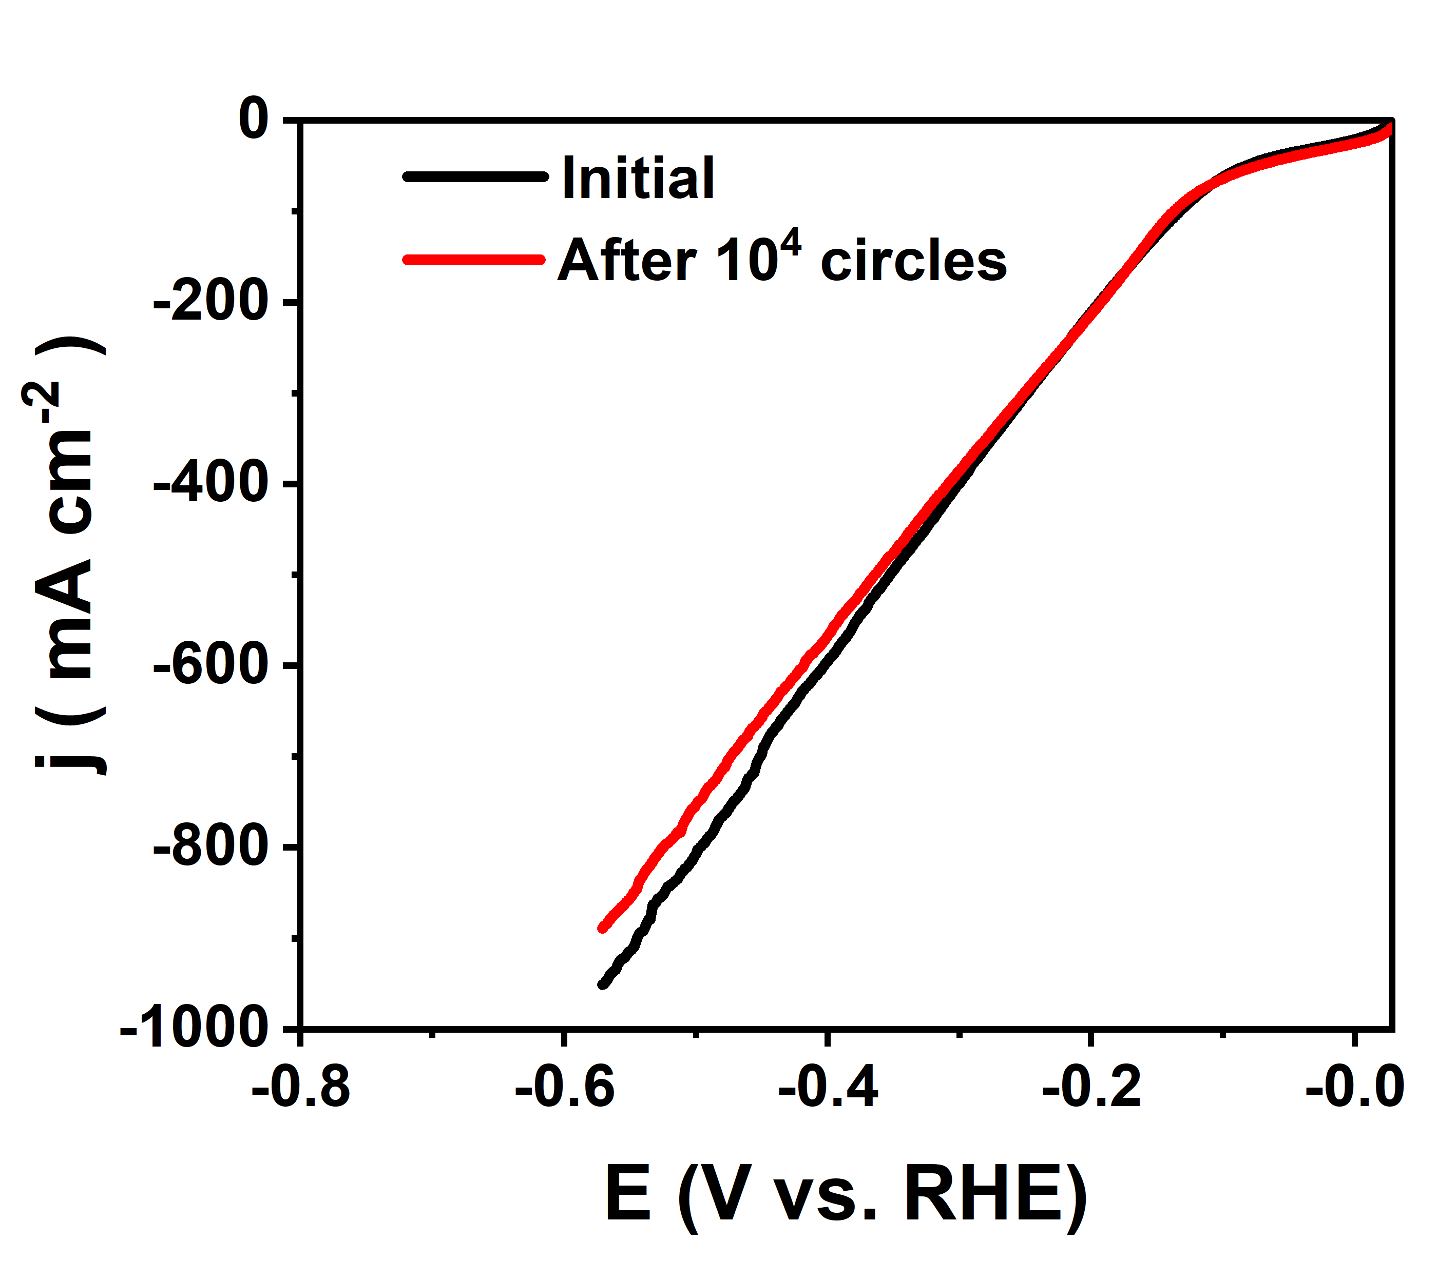
Fig. S12. LSV curves of HER of Ni-Co-P/NF initially and after 10000 cycles

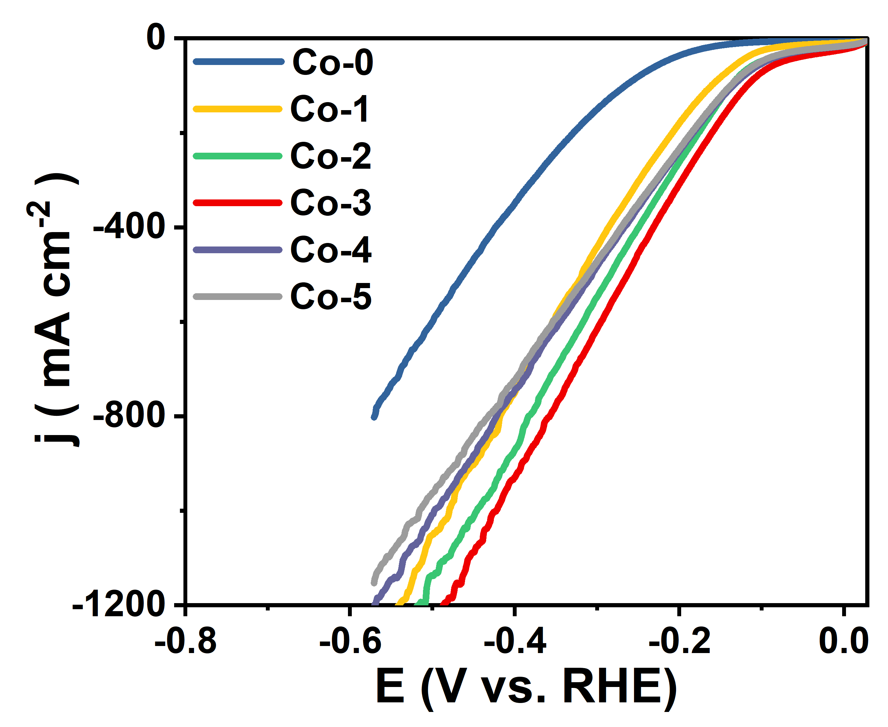
Fig. S13. LSV curves of Ni-Co-P/NF toward HER with different Co addition amounts in precursor.
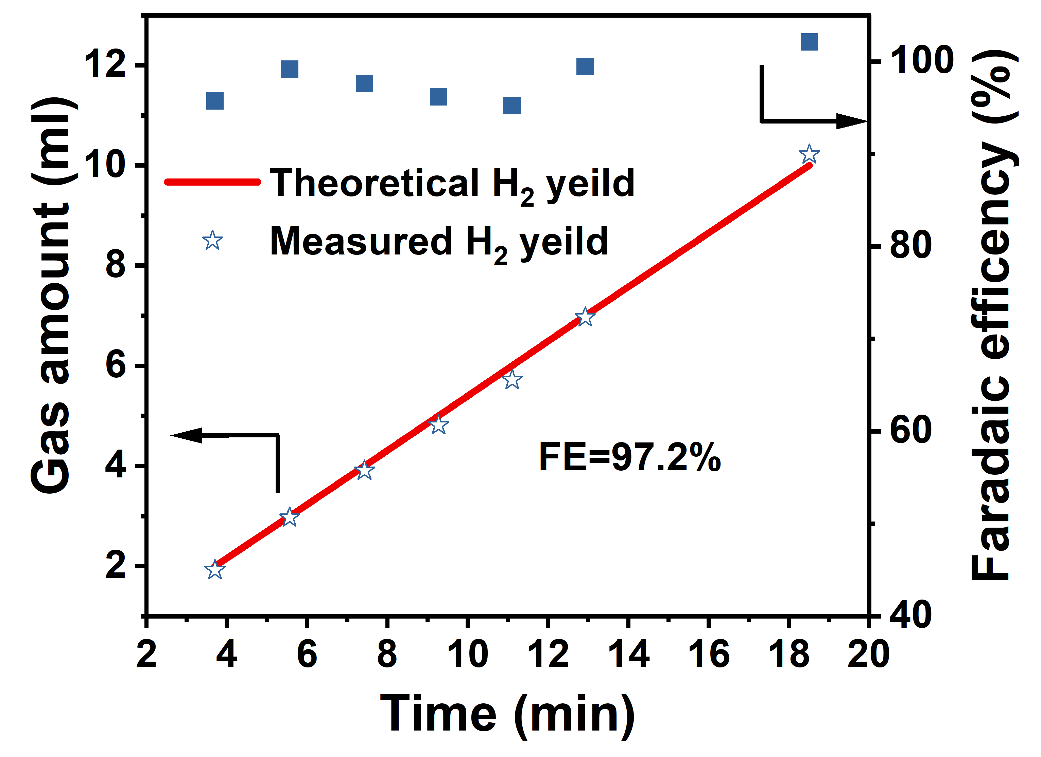
Fig. S14. The Faradaic efficiency of HER with Ni-Co-P/NF in HE unit at fixed potential of 2 V.

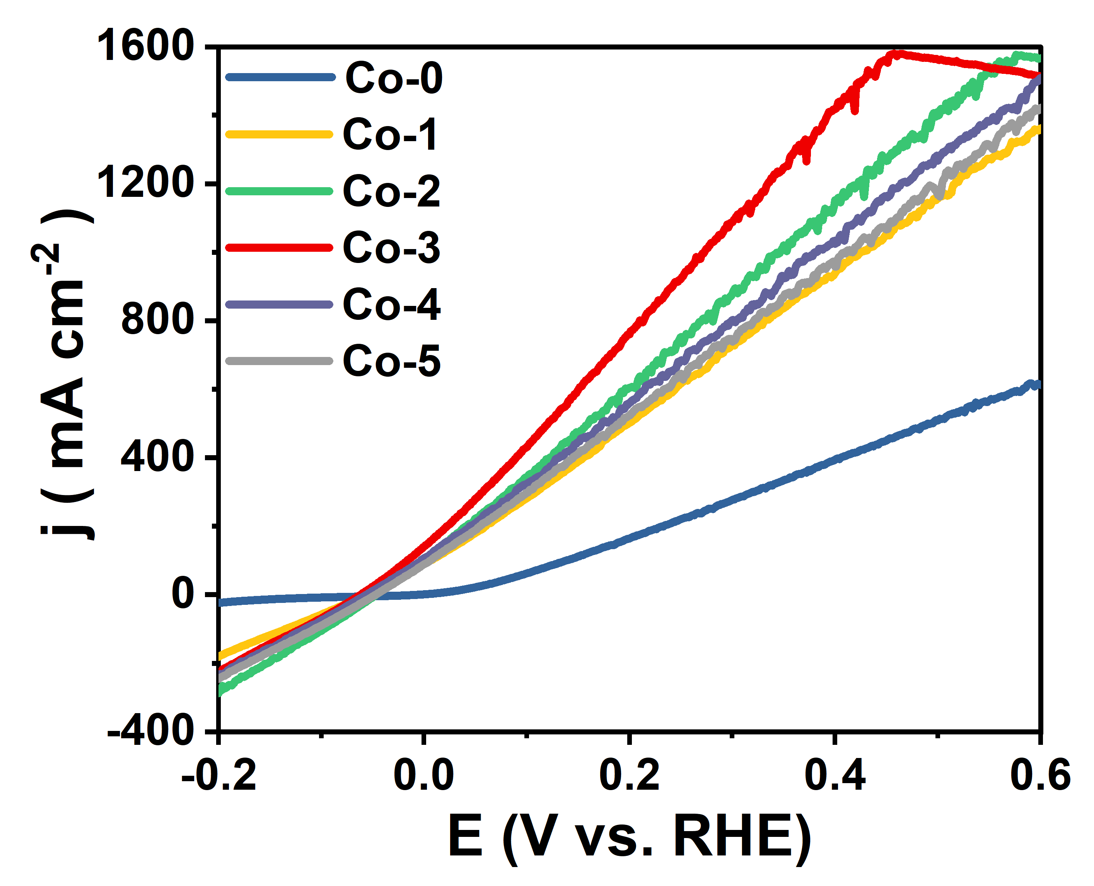
Fig. S15. LSV curves of Ni-Co-P/NF toward HzOR with different Co addition amounts in precursor.
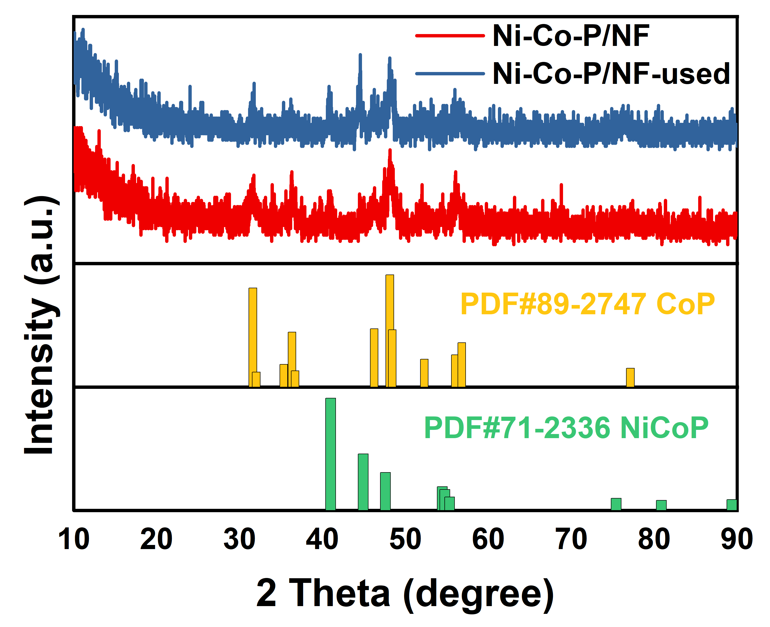
Fig. S16. XRD patterns of Ni-Co-P/NF before and after stability test (named Ni-Co-P/NF-used).

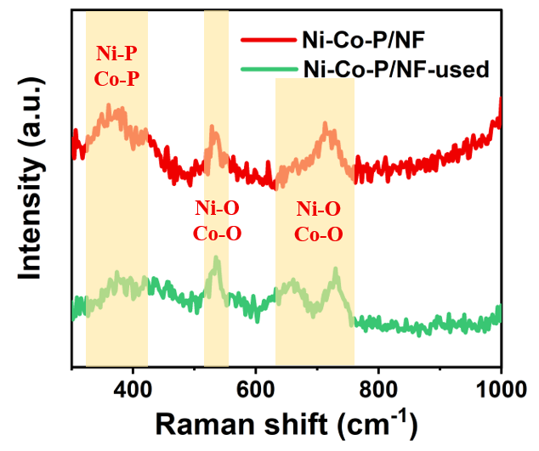
Fig. S17. Raman spectra of Ni-Co-P/NF before and after stability test.
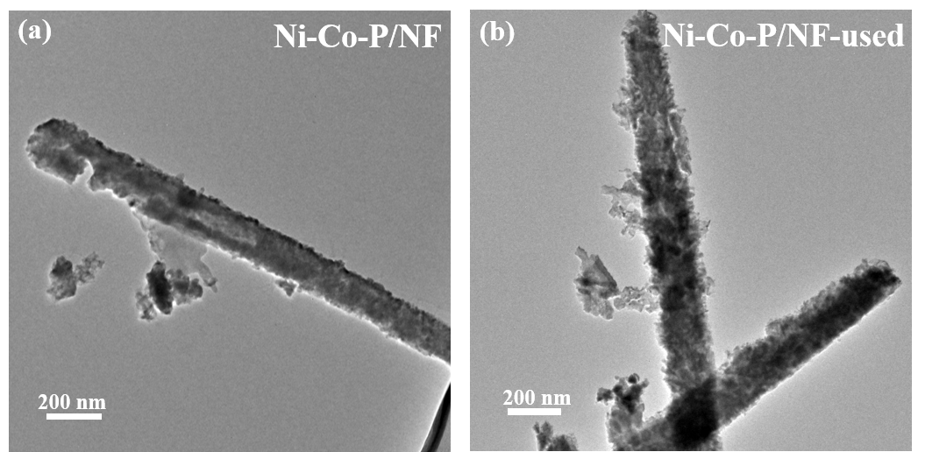
Fig. S18. TEM of Ni-Co-P/NF before and after stability test.

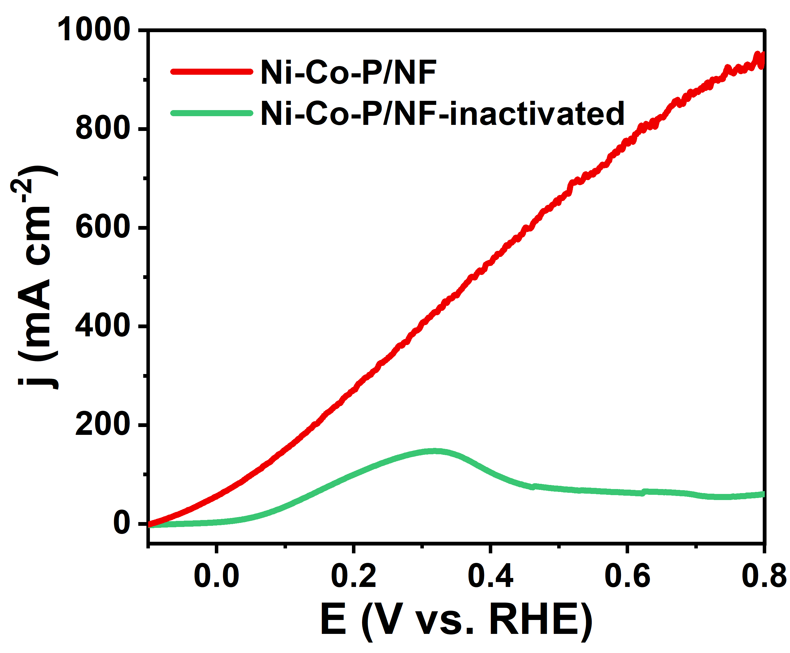
Fig. S19. LSV curves of Ni-Co-P/NF toward HzOR initially and after over-oxidation.
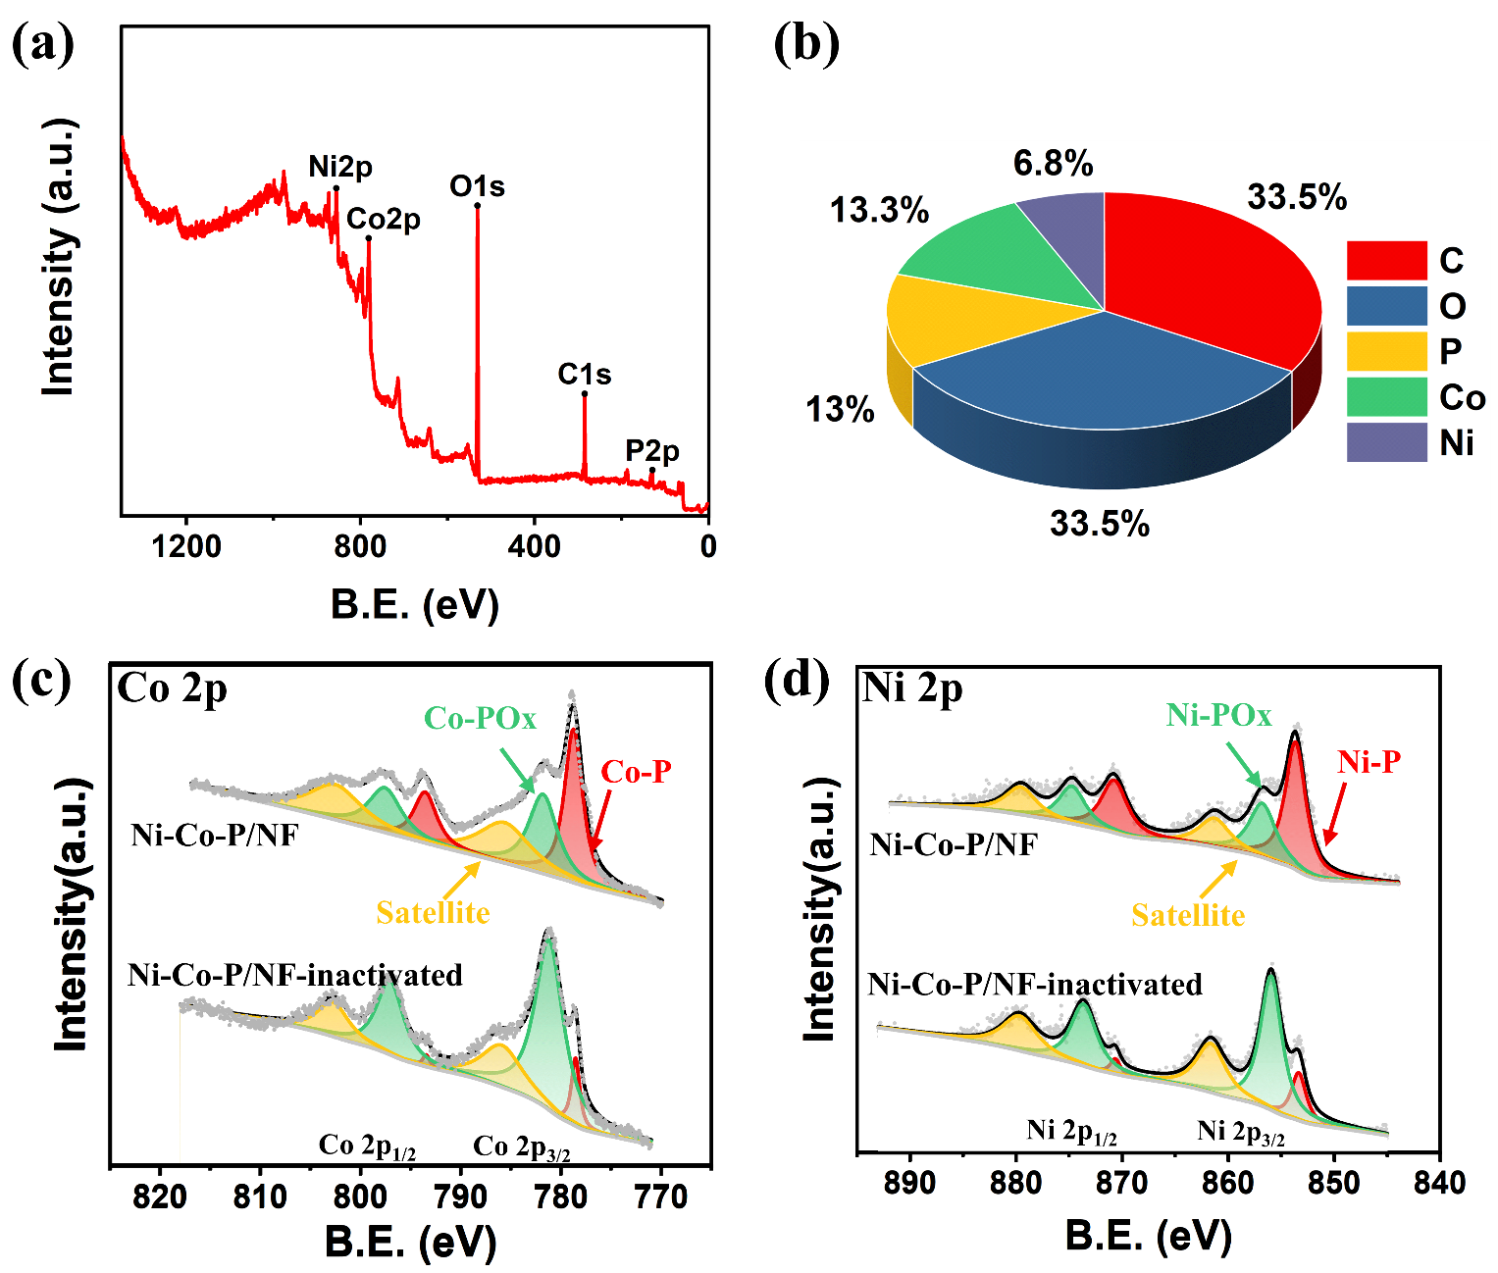
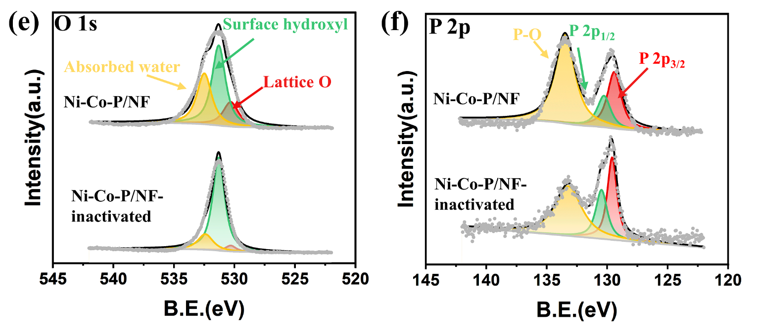
Fig. S20. XPS spectra of Ni-Co-P/NF and inactivated Ni-Co-P/NF-inactivated. (a) Survey scan; (b) Atomic percentage; (c) Co 2p; (d) Ni 2p; (e) O 1s; (f) P 2p.
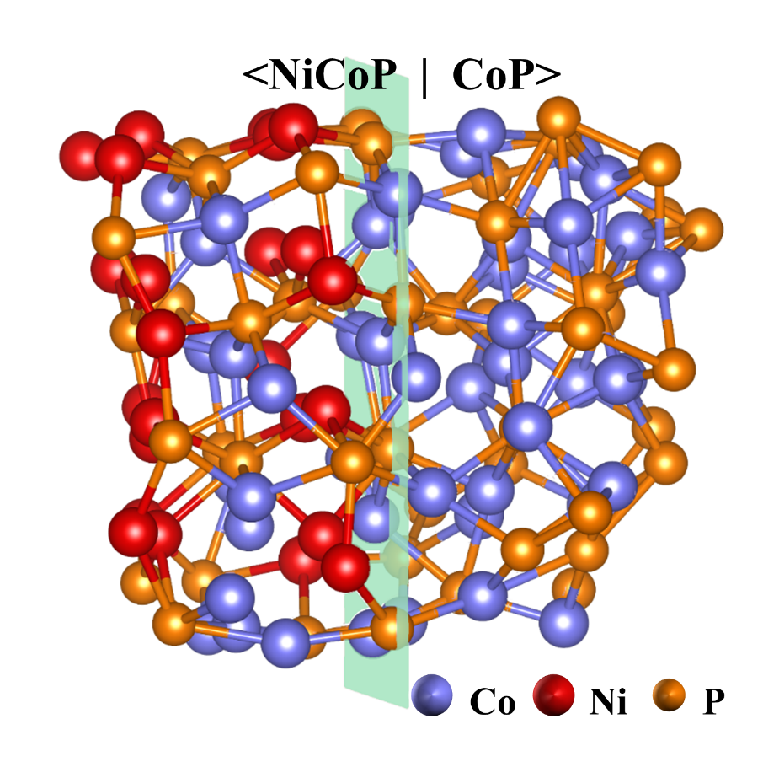
Fig. S21. The structural model to simulate the Ni-Co-P/NF.

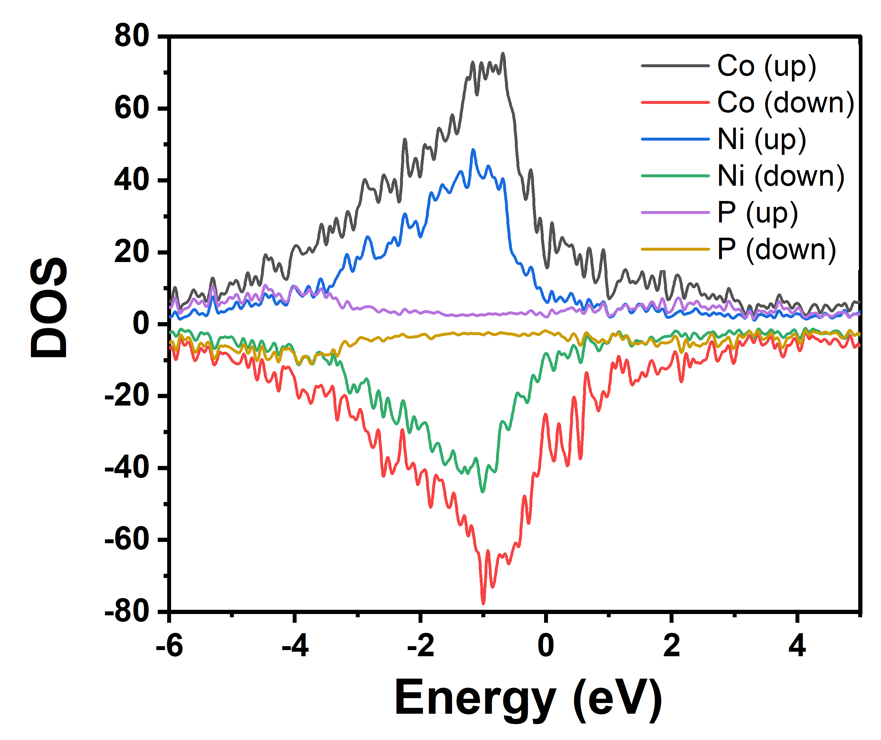
Fig. S22. The density of states (DOS) of Ni, Co, P in <NiCoP|CoP>. The Fermi level is set at 0 eV.
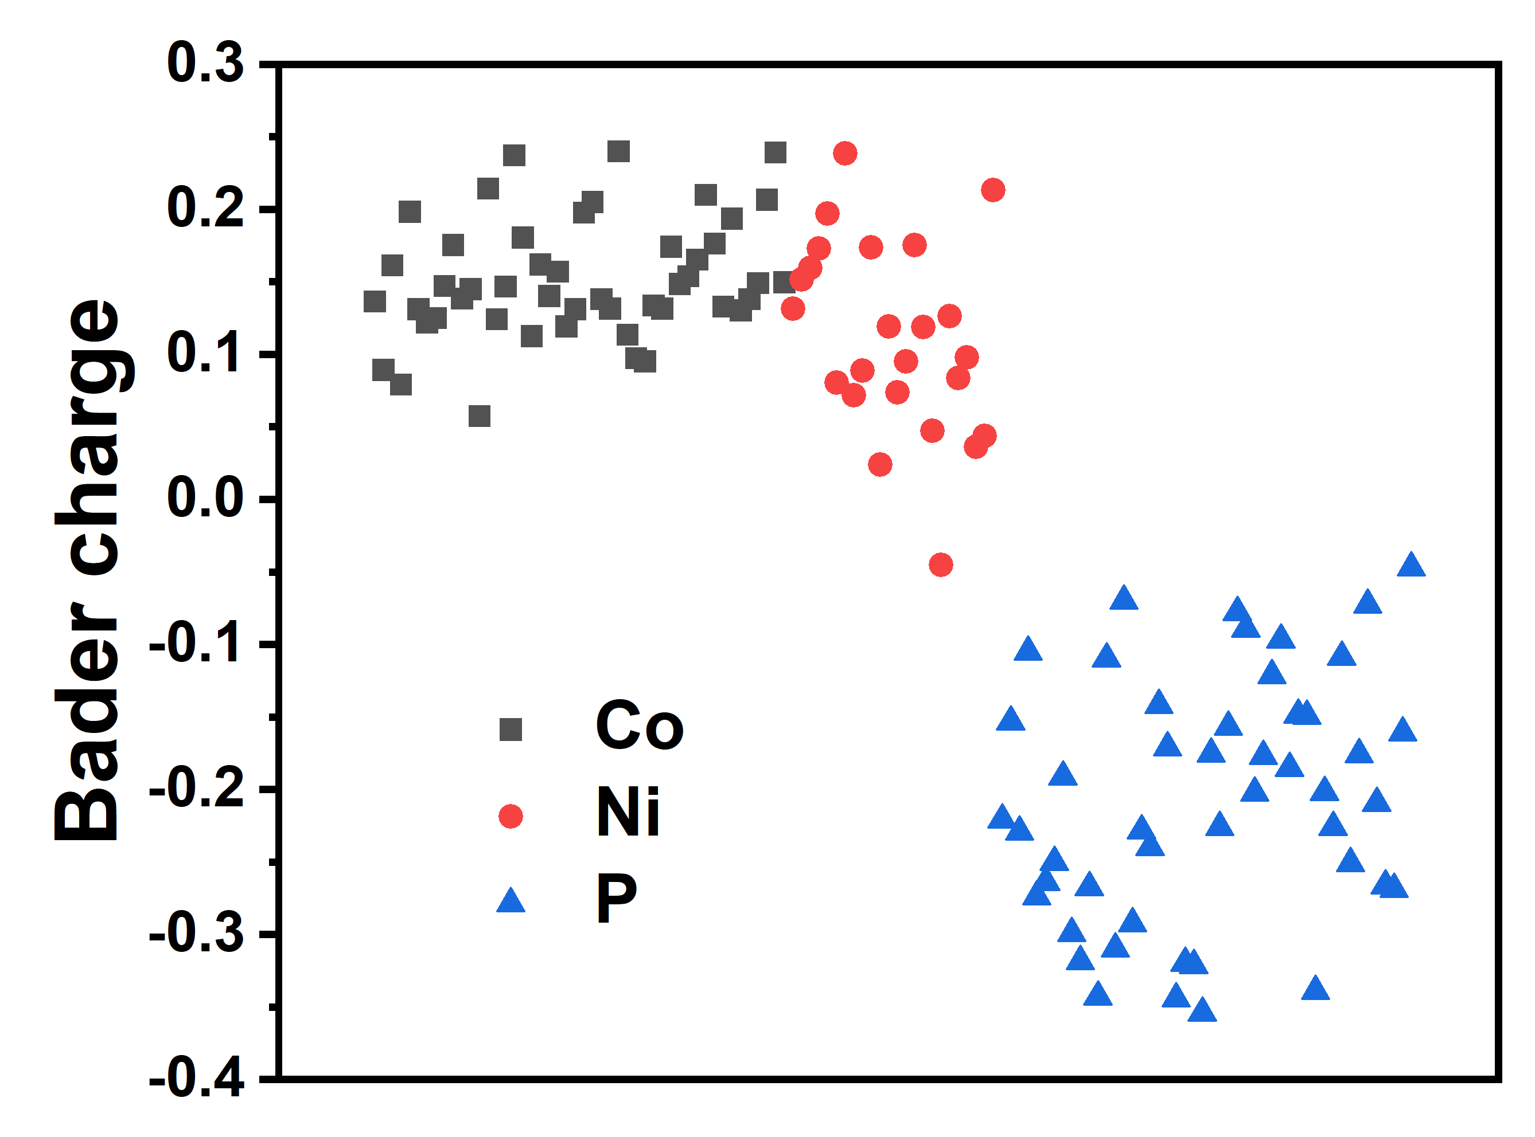
Fig. S23. The Bader charge of Co, Ni, P in <NiCoP|CoP>.

Fig. S24. N₂H₄ adsorption at different sites (set the total energy of N₂H₄ and <NiCoP|CoP> to 0 eV).
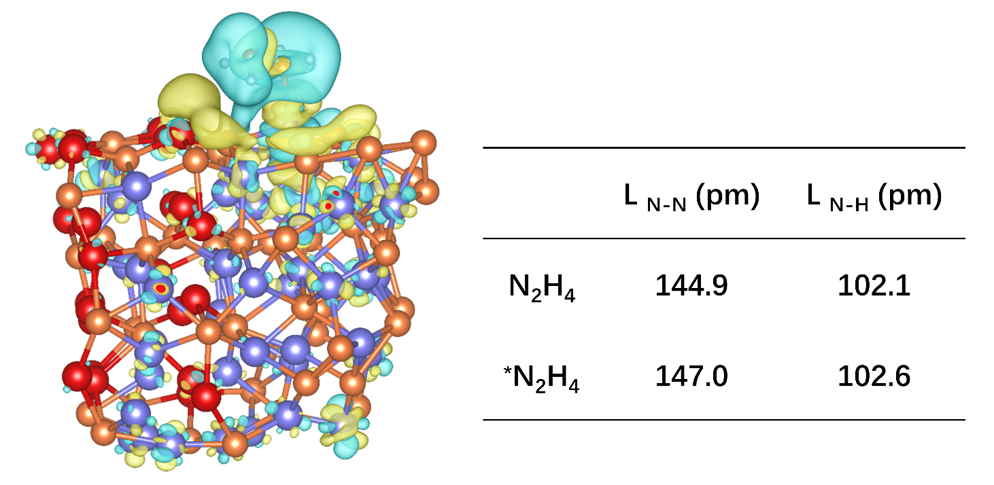
Fig. S25. The charge density difference analysis and the change of bond length of N₂H₄ before and after adsorption on <NiCoP|CoP>, where the yellow or cyan regions indicate the accumulation or depletion of the charge, respectively.

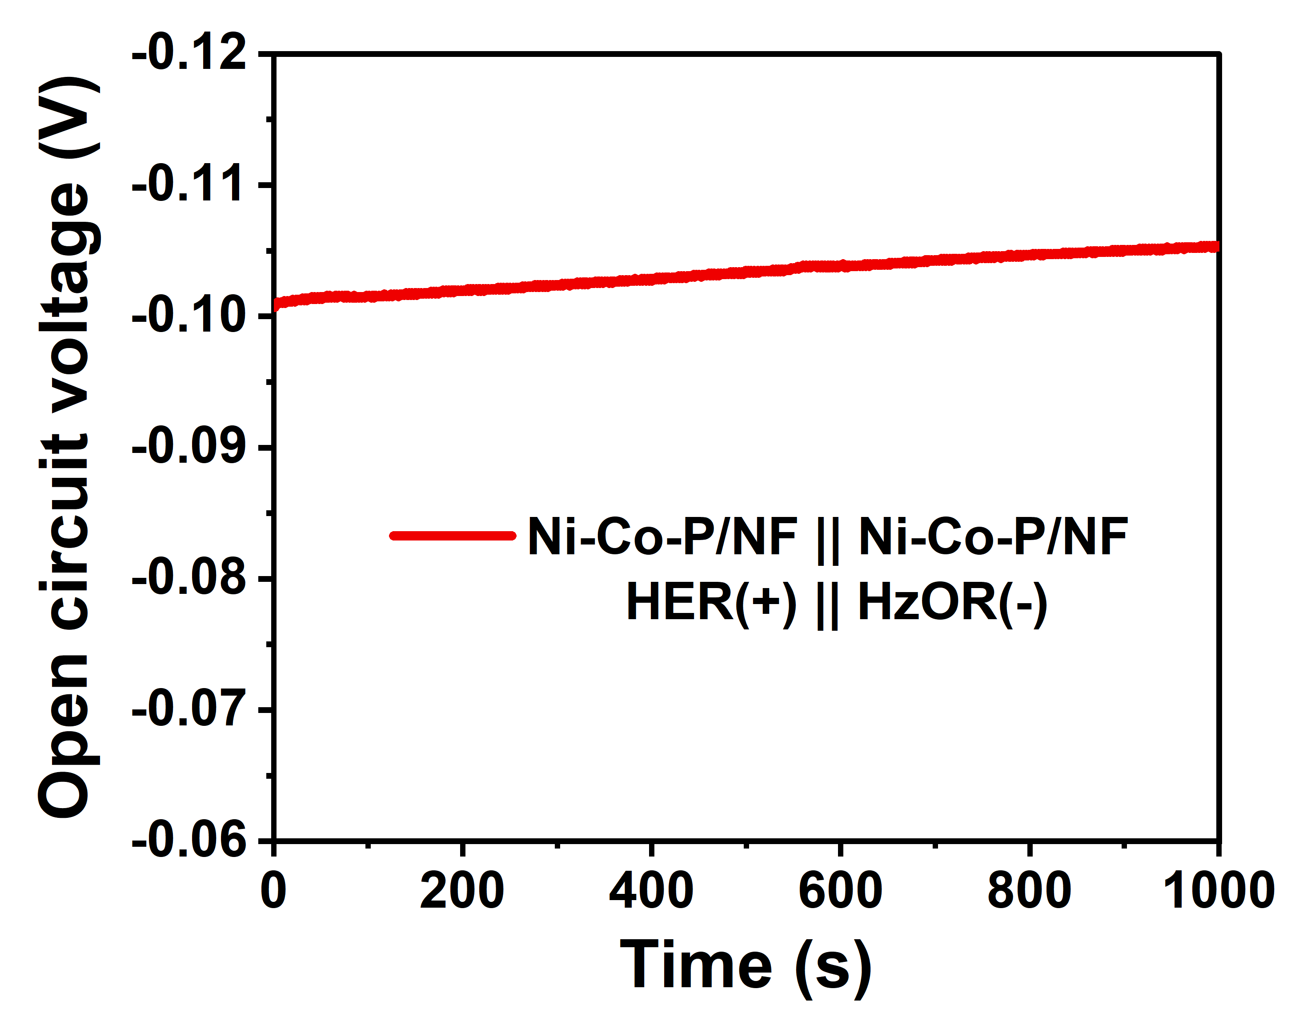
Fig. S26. Open circuit voltage trend over time of the HE unit.
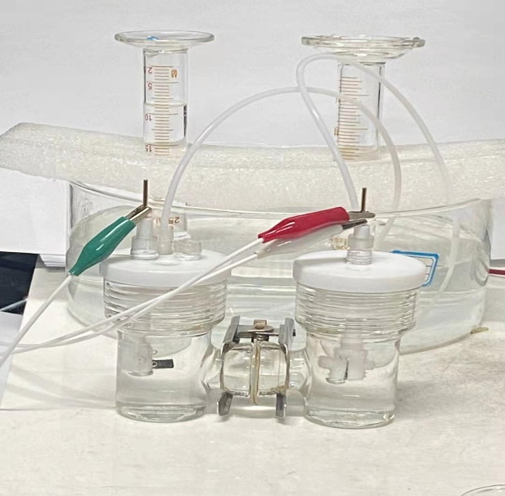
Fig. S27. Schematic diagram of gases collection device for HE unit. The utilization ratio (η) is calculated by η=3V_{C}/2(V_{A}+V_{C}); V_{A}, V_{C} are the gas volume produced in anode and cathode respectively.

Fig. S28. Digital photograph of the evolution of gas bubbles.
Fig. S29. Electrochemical properties of the HE unit with Ni-Co-P/NF as both anode and cathode catalysts. (a) 80% iR-correction LSV curve; (b) Nyquist plots with the fitting pattern in inset.

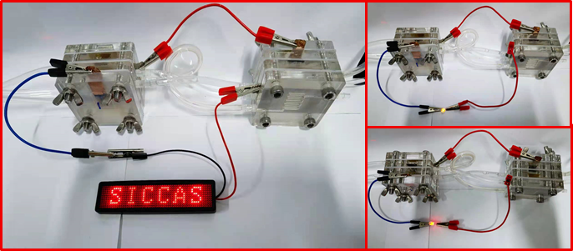
Fig. S30. Digital photograph of DHzFC driving LED.
Fig. S31. Stability measurements at different current densities of the DHzFC with Ni-Co-P/NF (+) || Pt-C/NF (-).
Table S1. Comparison of electrocatalytic activities of HER in 1.0 M KOH between Ni-Co-P/NF in this work and various transition metal based catalysts recently reported.
Materials | Current density  (mA cm^{–2}) | Potential  (mV vs. RHE) | Tafel slope  (mV dec⁻¹) | Stability  (h) | Reference
Ni-Co-P/NF | 10  100  500 | 37  115  196 | 33.3 | 90 | This work
NiCo/Mxene | 10  500 | 49  235 | 54.2 | 60 | 2
Ni₃N-Co₃N/NF | 10 | 43 | 35.1 | 40 | 3
PW-Co₃N/NF | 10 | 41 | 40 | 25 | 4
Fe-CoS₂ | 10 | 40 | 32 | 40 | 5
Ni-C HNSA | 10 | 37 | 31.9 | 50 | 6
Ni NCNAs | 10 | 47 | 89.7 | 30 | 7
CoSe₂/NF | 10 | 79 | 84 | 50 | 8
Cu₁Ni₂-N/C | 10 | 71.4 | 106.5 | 60 | 9
NiCo(OH)_{x}@  NiCoP/NF | 100 | 164 | 68.4 | 20 | 10
CC@WS2/  Ru-450* | 10 | 32 | 53.2 | 100 | 11
RP-CPM* | 10 | 24 | 47.3 | 20 | 12
*Represents containing precious metal elements
Table S2. EIS parameters of synthesized catalysts for HER in 1 M KOH.
 | R_{s} (Ω) | R_{ct} (Ω)
Pt-C/NF | 2.745 | 10.73
Ni-Co-P/NF | 2.904 | 13.09
NiP/NF | 3.178 | 45.9
Ni-Co-Pre/NF | 2.691 | 54.02
CoP | 3.178 | 57.26

Table S3. EIS parameters of synthesized catalysts for HzOR in 1 M KOH + 0.1 M N₂H₄.
 | R_{s} (Ω) | R_{f} (Ω) | R_{ct} (Ω)
Ni-Co-P/NF | 0.624 | 0.990 | 2.614
Pt-C/NF | 0.836 | 1.564 | 6.162
NiP/NF | 0.893 | 1.538 | 15.36
CoP | 2.772 |  | 42.25
Ni-Co-Pre/NF | 1.688 |  | 554.3

Table S4. Comparison of electrocatalytic activities of HzOR between Ni-Co-P/NF in this work and various transition metal based catalysts recently reported.
Materials | Electrolyte | Current density  (mA cm^{–2}) | Potential  (mV vs. RHE) | Reference
Ni-Co-P/NF | 1.0 M KOH + 0.1 M N₂H₄ | 10  100  1000 | -61  -24  176 | This work
p-Co/CF | 1.0 M KOH + 0.05 M N₂H₄ | 100 | -110 | 13
NiCo/Mxene | 1.0 M KOH + 0.5 M N₂H₄ | 100 | -25 | 2
Ni₃N-Co₃N/NF | 1.0 M KOH + 0.1 M N₂H₄ | 100 | -9 | 3
PW-Co₃N/NF | 1.0 M KOH + 0.1 M N₂H₄ | 100 | -8 | 4
Co₃Ta/C | 1.0 M KOH + 0.1 M N₂H₄ | 100 | 250 | 14
Fe-CoS₂ | 1.0 M KOH + 0.1 M N₂H₄ | 100 | 610 | 5
Ni₂P/NF | 1.0 M KOH + 0.1 M N₂H₄ | 100 | -7 | 15
Ni-C HNSA | 1.0 M KOH + 0.1 M N₂H₄ | 10 | -20 | 6
Ni NCNAs | 1.0 M KOH + 0.3 M N₂H₄ | 10 | -26 | 7
CoSe₂/NF | 1.0 M KOH + 0.5 M N₂H₄ | 100 | 170 | 8
Cu₁Ni₂-N/C | 1.0 M KOH + 0.5 M N₂H₄ | 100 | 205 | 9
NiCo(OH)_{x}@  NiCoP/NF | 1.0 M KOH + 0.1 M N₂H₄ | 100 | -40 | 10
Ni₃S₂/NF | 1.0 M KOH + 0.2 M N₂H₄ | 100 | 415 | 16
CoS₂/TiM | 1.0 M KOH + 0.1 M N₂H₄ | 100 | 110 | 17
CC@WS2/  Ru-450* | 1.0 M KOH + 0.5 M N₂H₄ | 10  100 | -74  -23 | 11
RP-CPM* | 1.0 M KOH + 0.3 M N₂H₄ | 10  200 | -70  82 | 12
*Represents containing precious metal elements.

Table S5. Comparison of hydrazine assisted hydrogen evolution performance of Ni-Co-P/NF and catalysts recently reported as the HER/HzOR electrocatalysts in alkaline condition.
Materials | Electrolyte | Current density  (mA cm^{–2}) | Cell Voltage  (mV) | Reference
Ni-Co-P/NF  (+, –) | 1.0 M KOH + 0.1 M N₂H₄  || 1.0 M KOH | 200  500 | 240*  498* | This work
NiCo@C/MXene/CF  (+, –) | 1.0 M KOH + 0.5 M  N₂H₄ (+) || 1.0 M KOH | 500 | 700* | 2
NiFe-LDH (+)  || Pt/C (–) | 0.5 M KOH (+)  || 0.5 M NaCl (–) | 200 | 1600 | 18
Ni₃N-Co₃N/NF  (+, –) | 1.0 M KOH + 0.1 M N₂H₄  (+, –) | 400 | 760* | 3
PW-Co₃N/NF  (+, –) | 1.0 M KOH + 0.1 M N₂H₄  (+, –) | 200 | 227* | 4
Fe-CoS₂  (+, –) | 1.0 M KOH + 0.1 M N₂H₄  (+, –) | 100 | 610 | 5
Ni₂P/NF  (+, –) | 1.0 M KOH + 0.5 M N₂H₄  (+, –) | 500 | 1000 | 15
*Represents the data after iR compensation.

1 Liu, H. et al. Robust NiCoP/CoP Heterostructures for Highly Efficient Hydrogen Evolution Electrocatalysis in Alkaline Solution. Acs Applied Materials & Interfaces 11, 15528-15536, doi:10.1021/acsami.9b00592 (2019).
2 Sun, F. et al. Energy-saving hydrogen production by chlorine-free hybrid seawater splitting coupling hydrazine degradation. Nature Communications 12, 4182, doi:10.1038/s41467-021-24529-3 (2021).
3 Qian, Q. et al. Artificial Heterointerfaces Achieve Delicate Reaction Kinetics towards Hydrogen Evolution and Hydrazine Oxidation Catalysis. Angewandte Chemie International Edition 60, 5984-5993, doi:10.1002/anie.202014362 (2021).
4 Liu, Y. et al. Manipulating dehydrogenation kinetics through dual-doping Co3N electrode enables highly efficient hydrazine oxidation assisting self-powered H2 production. Nature Communications 11, 1853, doi:10.1038/s41467-020-15563-8 (2020).
5 Liu, X. et al. Self-powered H-2 production with bifunctional hydrazine as sole consumable. Nature Communications 9, doi:10.1038/s41467-018-06815-9 (2018).
6 Zhu, Y. et al. Dual Nanoislands on Ni/C Hybrid Nanosheet Activate Superior Hydrazine Oxidation-Assisted High-Efficiency H2 Production. Angewandte Chemie International Edition n/a, doi:10.1002/anie.202113082 (2021).
7 Li, Y. et al. Superhydrophilic Ni-based Multicomponent Nanorod-Confined-Nanoflake Array Electrode Achieves Waste-Battery-Driven Hydrogen Evolution and Hydrazine Oxidation. Small 17, doi:10.1002/smll.202008148 (2021).
8 Zhang, J.-Y. et al. Anodic Hydrazine Oxidation Assists Energy-Efficient Hydrogen Evolution over a Bifunctional Cobalt Perselenide Nanosheet Electrode. Angew. Chem.-Int. Edit. 57, 7649-7653, doi:10.1002/anie.201803543 (2018).
9 Wang, Z. et al. Copper-Nickel Nitride Nanosheets as Efficient Bifunctional Catalysts for Hydrazine-Assisted Electrolytic Hydrogen Production. Advanced Energy Materials 9, doi:10.1002/aenm.201900390 (2019).
10 Li, M. et al. 0.03 V Electrolysis Voltage Driven Hydrazine Assisted Hydrogen Generation on NiCo phosphide Nanowires Supported NiCoHydroxide Nanosheets. Chemelectrochem 7, 3089-3097, doi:10.1002/celc.202000604 (2020).
11 Li, J. et al. Elucidating the Critical Role of Ruthenium Single Atom Sites in Water Dissociation and Dehydrogenation Behaviors for Robust Hydrazine Oxidation-Boosted Alkaline Hydrogen Evolution. Advanced Functional Materials 32, doi:10.1002/adfm.202109439 (2022).
12 Li, Y. et al. Partially exposed RuP2 surface in hybrid structure endows its bifunctionality for hydrazine oxidation and hydrogen evolution catalysis. Science Advances 6, doi:10.1126/sciadv.abb4197 (2020).
13 Liu, Q. et al. Low-coordinated cobalt arrays for efficient hydrazine electrooxidation. Energy & Environmental Science, doi:10.1039/d2ee01463g (2022).
14 Feng, G. et al. Atomically ordered non-precious Co3Ta intermetallic nanoparticles as high-performance catalysts for hydrazine electrooxidation. Nature Communications 10, doi:10.1038/s41467-019-12509-7 (2019).
15 Tang, C. et al. Energy-Saving Electrolytic Hydrogen Generation: Ni2P Nanoarray as a High-Performance Non-Noble-Metal Electrocatalyst. Angewandte Chemie International Edition 56, 842-846, doi:10.1002/anie.201608899 (2017).
16 Liu, G. et al. Vapor-phase hydrothermal transformation of a nanosheet array structure Ni(OH)(2) into ultrathin Ni3S2 nanosheets on nickel foam for high-efficiency overall water splitting. Journal of Materials Chemistry A 6, 19201-19209, doi:10.1039/c8ta07162d (2018).
17 Ma, X. et al. Hydrazine-assisted electrolytic hydrogen production: CoS2 nanoarray as a superior bifunctional electrocatalyst. New Journal of Chemistry 41, 4754-4757, doi:10.1039/c7nj00326a (2017).
18 Dresp, S. et al. Efficient direct seawater electrolysers using selective alkaline NiFe-LDH as OER catalyst in asymmetric electrolyte feeds. Energy & Environmental Science 13, 1725-1729, doi:10.1039/d0ee01125h (2020).

