Supplementary Information
High-performance photoelectrochemical hydrogen production using asymmetric quantum dots
Kanghong Wang ^{a, b}, Chao Wang ^{b}, Yi Tao ª, Zikun Tang ª, Daniele Benetti ^{b, *}, François Vidal ^{b}, Yu Liu ^{d}, Mark H. Rummeli ^{d, e, f, g}, Haiguang Zhao ^{c, *}, Federico Rosei ^{b, *}, Xuhui Sun ^{a, *}
ª Institute of Functional Nano & Soft Materials (FUNSOM), Soochow University, Suzhou, 215123, Jiangsu, PR China
^{b} Institut National de la Recherche Scientifique, Centre Énergie, Matériaux et Télécommunications, 1650 Boul. Lionel Boulet, J3X 1P7 Varennes, Québec, Canada
^{c} State Key Laboratory of Bio-Fibers and Eco-Textiles, College of Textiles & Clothing, College of Physics, Qingdao University, No. 308 Ningxia Road, Qingdao 266071, PR China
^{d} Soochow Institute for Energy and Materials Innovation, college of Physics, Optoelectronics and Energy, Collaborative Innovation Center of Suzhou Nano Science and Technology, Key Laboratory of Advanced Carbon Materials and Wearable Energy Technologies of Jiangsu Province, Soochow University, Suzhou, 215000, PR China.
^{e} Centre of Polymer and Carbon Materials, Polish Academy of Sciences, M. Curie-Sklodowskiej 34, Zabrze 41-819, Poland.
^{f} Institute for Complex Materials, IFW Dresden, 20 Helmholtz Strasse, Dresden 01069, Germany.
^{g} Institute of Environmental Technology, VSB-Technical University of Ostrava, 17. Listopadu 15, Ostrava 708 33, Czech Republic.

Methods
Materials. Zinc oxide (99 %, ZnO), cadmium oxide (99%, CdO), oleylamine (OLA, 90%), oleic acid (90%, OA), titanium tetrachloride (TiCl₄), zirconium oxide (ZrO₂), cetyltrimethyl ammonium bromide (CTAB), , sodium sulfide nonahydrate (Na₂S·9H₂O), sodium sulfite (Na₂SO₃) were purchased from Sigma-Aldrich Inc. zinc acetate dehydrate [Zn(CH₃COO)₂·2H₂O], trioctyl phosphine (90%, TOP) were obtained from Aladdin Inc. Selenium pellet (＞99.999%, Se), sulfur powder (99.5%, S), trioctylphosphine oxide (TOPO, 90%), , , alpha-terpineol octadecene (ODE) were purchased from Macklin Inc. Ethanol, isopropanol (IPA), toluene and methanol were obtained from Chinasun Specialty Products Co., Ltd. The mesoporous TiO₂ films were prepared by using paste consisted of nanoparticles of ~20 nm in diameter (18 NR-T) as transparent layer and particle of 20-450 nm in diameter as the scattering layer (18 NR-AO). All the paste were from Greatcell Solar Materials Pty Ltd. All the chemicals and solvent were used directly without any further purification.
Synthesis of CdSe QDs and core/shell QDs. For the synthesis of the CdSe core QDs, we used the hot-injection approach following previous reports. For the synthesis of CdSe/ZnSe QDs and two CdSe/Cd_{x}Zn_{1-x}Se QDs, the shell was coated on the surface of CdSe core by SILAR method. Typically, CdSe core QDs (~2×10⁻⁷ mol in toluene), 5 mL ODE and 5 mL OLA were added in the cell and degassed for 1 hour at 110 ℃. Afterwards, the temperature was increased up to 220-240 ℃. The Zn(OA)₂ [or Cd_{x}Zn_{1-x}(OA)₂] and Se-ODE were used as anion and cation precursors. With each injection, the cell was reacted for 10 min until the next injection. The injection precursor volume was calculated according to the volume of the QDs size and the concentration of the suspension. For two types of alloyed QDs, the anion precursors were used Cd_{x}Zn_{1-x}(OA)₂ with different ratio of Cd/Zn which shown in the Table S2. Finally, cold water was used to stop the growth of QDs after 6 cycles of SILAR. All reactions were conducted under N₂ atmosphere. For the synthesis of other core/shell and core/shell/shell QDs, Cd(OA)₂, Cd_{x}Zn_{1-x}(OA)₂, Zn(OA)₂ were used as the anion precursors while Se-ODE, Se_{x}S_{1-x}-ODE and S-ODE were used as cation precursors. The injection volume was calculated according to the previous method.
Anode preparation. The FTO glass was cleaned by multiple steps. First, the FTO was merged in the Triton for ultrasonic clean for 1 hour. Subsequently, the FTO was placed in IPA, ethanol and DI water separately for 30 min each under ultrasonic device and dried with N₂ flow. For the deposition of blocking layer, TiCl₄ (50 mM) solution was used as the precursor. Typically, the cleaned FTO was immerged in the aqueous TiCl₄ solution at 70-75 °C for 30 min and annealed at 500 °C for 30 min to grow a compact TiO_{x} blocking layer. To deposit mesoporous TiO₂ films, doctoral blade technique was used following the previous report. The anodes were placed under 500 °C for another annealing to obtain TiO₂ films.
EPD process and ZnS passivation layer. For the deposition of as-synthesized QDs into mesoporous TiO₂ films, EPD was applied. Generally, two anodes were placed face to face vertically immerging inside the QDs dispersion. The bias was controlled under 200 V for 2 hours. Afterwards, the toluene was used to remove the undeposited QDs on the surface and the anodes were dried under N₂ flow. Before the PEC measurement, the ligand exchange and ZnS passivation layer capping were applied. The anodes were placed in a methanolic CATB solution for 1 min and rinsed with methanol and toluene as one cycle. Two cycles were applied to complete the ligand exchange process. For the ZnS layer capping,
The as-prepared anodes with mesoporous films were immersed in QDs dispersion vertically at a distance of 0.5-1 cm. Then a direct bias (current) of 200 V was applied between two poles for 2 hours. To remove the unabsorbed QDs on the surface of anodes, toluene was used to wash the surface several times and finally the anodes were dried under N₂ flow. Before ZnS coating, ligand exchange was first conducted to replace OA/OLA long chains with CTAB. Typically, the anodes were immersed in methanolic cetyl-trimethyl ammonium bromide solution for 1 min and rinsed with methanol and toluene. Finally, the anodes were dried in N₂ flow. For the deposition of ZnS layers, 0.1 M methanolic zinc acetate dehydrate solution and 0.1 M methanol/water (1/1 v/v) Na₂S solution were prepared. With the sequence of Zn²⁺ and S²⁻ dipping, the anodes were kept in every solution for 1 min and washed with the same solvent after every dipping. In our system, two SILAR cycles were applied for the anodes to grow capping layers.
Characterization. TEM imaging was carried out in a FEI Tecnai TF20 transmission electron microscope with an acceleration voltage of 200 kV. The atomic arrangement of QDs was probed by Spherical-aberration-corrected TEM (Cs-TEM, FEI Titan Themis Cubed G2 300). X-ray diffraction (XRD) patterns were recorded using a Bruker D8 powder X-ray diffractometer (Germany) with Ni-filtered Cu K_{α} radiation (40 kV, 40 mA). UV-vis absorption spectra were acquired with a Perkin Elmer model Lambda 750. Fluorescence spectra of QD solution were obtained on Fluorescence Spectrometer (NIR-VIS, FL3) with excitation at 400 nm. The average lifetime of the QDs measurement was conducted in the time-correlated single-photon counting (TCSPC) mode with a laser of 455 nm. XPS data were collected on X-ray photoelectron spectrometer (Kratos AXIS UltraDLD) using a monochromatic Al K_{α} (1486.6 eV) X-ray source. All the XPS spectra were calibrated based on the C 1s peak at 284.8 eV of adsorbed carbon. The spectra were analyzed with the using Casa XPS software. SEM images and EDS maps were acquired using a Supera 55 Zeiss scanning electron microscope. For UPS measurements, the valence band can be measured based on high-binding-energy cutoff through UPS while Fermi level is determined by low-binding-energy cutoff and the conduction band can be calculated by adding the optical bandgap, estimated from its first-excitonic absorption peak.
PEC measurement. The PEC performance in an electrochemical workstation (CHI 760) in a three-electrode system while QDs/TiO₂ as the working electrode, Pt as counter electrode and Ag/AgCl as the reference electrode. The active area of the photoanode was about ~0.12 cm² with the other parts covered by non-conductive black tape with a circle area exposure. The electrolytes used were Na₂S (0.25 M) and Na₂SO₃ (0.35 M) (pH~13). The potential during the measurement was converted to the RHE scale from the potential based on the reference electrode according to the following equation:
V_{RHE} = V_{Ag/AgCl} + 0.197 + pH × (0.059)
A Xenon High Brightness Cold Light Source (XD300) equipped with an AM 1.5 filter was used for illumination. The photoanodes were placed from the center of the lamp at a distance of 10-20 cm. Before each test, the intensity of the light was adjusted strictly to 100 mW/cm² by using a thermopile. All the J-V measurements were carried out at a sweep rate of 20 mV/s. For calculating the electron/hole transfer rate based on average electron lifetime, the ZrO₂ was used as benchmark. Due to the band alignment between QDs and ZrO₂, the PL degradation in QDs/ZrO₂ can be attributed to carrier recombination. The average lifetime τ is calculated using the following equation:
$$<τ>=\frac{{a_{1}τ_{1}}^{2}+{a_{2}τ_{2}}^{2}+{a_{3}τ_{3}}^{2}}{a_{1}τ_{1}+a_{2}τ_{2}+a_{3}τ_{3}}$$
The PEC H₂ evolution was measured using Gas Chromatography (GC) from Agilent 8860 under the I-t mode with one sun power intensity. The faradaic efficiency can be calculated by using the following equation:
$$Faradaic efficiency (η_{FE})=\frac{V measured gas}{V calculated gas}$$
Theoretical calculation of H₂ evolution is based on J-t curves. In detail, the theoretical number of moles of evolved H₂ can be calculated from Faraday’s law using the following equation:
$$n(H_{2})=\frac{q}{zF}=\frac{\int_{t1}^{t2}{Idt}}{zF}$$
where q is the total electric charge in coulombs (C), z is the number of transferred electrons per H₂ molecular during H₂ evolution reaction (i.e., z = 2), I is the photocurrent in amperes (A), t is time in seconds (s), and F is the Faraday constant (i.e., 96485.33 C mol⁻¹).

Table S1. some typical work based on QDs for PEC H₂ evolution.
QDs | Electrolyte | Current density (mA/cm²) | Ref.
Asymmetric CdSe/Cd_{x}Zn_{1-x}Se /ZnSe | 0.35 M Na₂SO₃ and 0.25 M Na₂S | 35 | This work
CdSe | 0.35 M Na₂SO₃ and 0.25 M Na₂S | 9 | 1
Thick-shell CdSe/CdS | 0.35 M Na₂SO₃ and 0.25 M Na₂S | 10 | 2
CdSe/Pb_{x}Cd_{1-x}S/CdS | 0.35 M Na₂SO₃ and 0.25 M Na₂S | 10.2 | 3
Spherical CdSe/CdSe_{x}S_{1-x}/CdS | 0.35 M Na₂SO₃ and 0.25 M Na₂S | 7.5 | 4
Pyramidal CdSe/CdSe_{x}S_{1-x}/CdS | 0.35 M Na₂SO₃ and 0.25 M Na₂S | 12 | 5
CdSe/alloyed CdSeS/CdS | 0.35 M Na₂SO₃ and 0.25 M Na₂S | 17.5 | 6
PbS/Mn-doped CdS (SILAR) | 0.5 M Na₂SO₄ aqueous solution | 22.1 | 7
Thin-shell PbS/CdS | 0.35 M Na₂SO₃ and 0.25 M Na₂S | 11 | 8
Thick-shell PbS/CdS | 0.35 M Na₂SO₃ and 0.25 M Na₂S | 5.3 | 9
CuInSSe/ZnS | 0.35 M Na₂SO₃ and 0.25 M Na₂S | 5.3 | 10
Zn-CuInSe₂/CuInS₂ | 0.35 M Na₂SO₃ and 0.25 M Na₂S | 3 | 11
CuInSe₂/(CuInSe_{x}S_{1-x})₅/CuInS₂ | 0.35 M Na₂SO₃ and 0.25 M Na₂S | 4.5 | 12
CuInSe_{x}S_{2-x}/CdSeS/CdS | 0.35 M Na₂SO₃ and 0.25 M Na₂S | 5.5 | 13
CuGaS₂/CdS | 0.35 M Na₂SO₃ and 0.25 M Na₂S | 6.5 | 14
Carbon dots | KH₂PO₄ in water | 5.99 | 15
Table S2. Ratio of Cd/Zn in shell as function of SILAR cycles.
Sample | 1 | 2 | 3 | 4 | 5 | 6
CdSe/6ZnSe | 0/10 | 0/10 | 0/10 | 0/10 | 0/10 | 0/10
CdSe/Cd_{x}Zn_{1-x}Se#1 | 5/5 | 5/5 | 5/5 | 5/5 | 5/5 | 0/10
CdSe/ Cd_{x}Zn_{1-x}Se#2 | 9/1 | 8/2 | 7/3 | 5/5 | 3/7 | 0/10

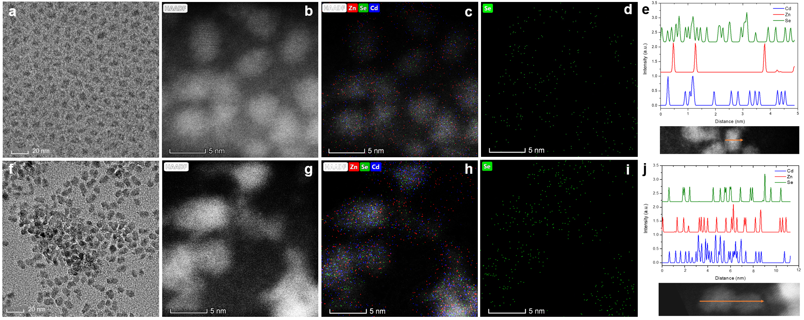
Figure S1. HADDAF-STEM images of CdSe/6ZnSe and CdSe/Cd_{x}Zn_{1-x}Se#1 QDs. a, TEM image of CdSe/6ZnSe QDs. b, HAADF-STEM image of the CdSe/6ZnSe core/shell QDs. c, Energy dispersive spectroscopy elemental maps of Cd, Zn, Se and (d) Se in the same CdSe/6ZnSe core/shell QDs shown in (b). e, Elemental profiles of Cd, Zn and Se in a typical QD from the direction of arrow below. f, TEM image of CdSe/Cd_{x}Zn_{1-x}Se#1 QDs. g, HAADF-STEM image of the CdSe/Cd_{x}Zn_{1-x}Se#1 alloyed core/shell QDs. h, Energy dispersive spectroscopy elemental maps of Cd, Zn, Se and (i) Se in the same CdSe/Cd_{x}Zn_{1-x}Se#1 alloyed core/shell QDs shown in (g). j, Elemental profiles of Cd, Zn and Se in a typical QD from the direction of the arrow below.

Table S3. Optical, dynamic parameters and PEC, stability performance for several core/shell QDs.
QDs | Abs. range  (nm) | First-exciton peak  (nm) | PL peak  (nm) | K_{et}  (10⁷ s⁻¹) | Saturated current density (mA/cm²) | Retention after 2-h continuous illumination (%)
CdSe/6ZnSe | 300-600 | 552 | 578 | 4.0 | 8.8 | 57
CdSe/Cd_{x}Zn_{1-x}Se#1 | 300-670 | 612 | 642 | 24.2 | 30 | 75
CdSe/Cd_{x}Zn_{1-x}Se#2 (CdSe/CdZnSe/ZnSe) | 300-670 | 625 | 649 | 32.7 | 35 | 96
CdSe/CdS | 300-630 | 606 | 617 | / | 17.4 | /
CdSe/CdSeS/CdS | 300-670 | 617 | 648 | 2.6 | 22 | 76
CdSe/CdS/ZnS | 300-670 | 616 | 627 | / | 14.2 | /
CdSe/CdSeS/CdS/CdZnS/ZnS | 300-650 | 618 | 632 | 3.6 | 20.5 | 83
CdSe/ZnS | 300-600 | 550 | 574 | / | 6.6 | /
CdSe/CdZnSe/CdZnS/ZnS | 300-670 | 626 | 651 | 4.5 | 16.6 | 70

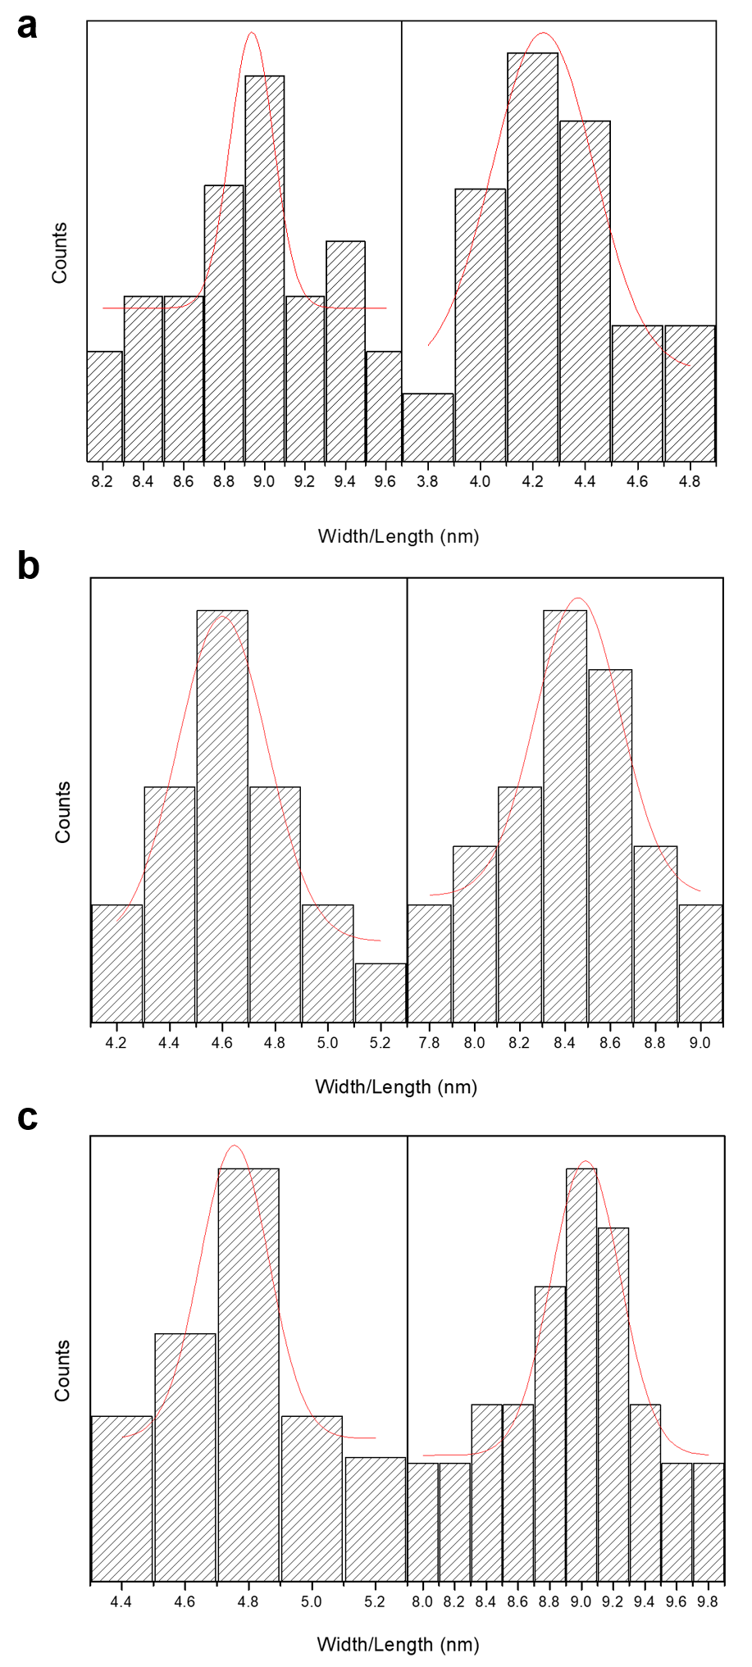
Figure S2. Size of the asymmetric QDs. The size (length and width) distribution of (a) CdSe/6ZnSe QDs (b) CdSe/Cd_{x}Zn_{1-x}Se#1 QDs (c) CdSe/Cd_{x}Zn_{1-x}Se#2 QDs.

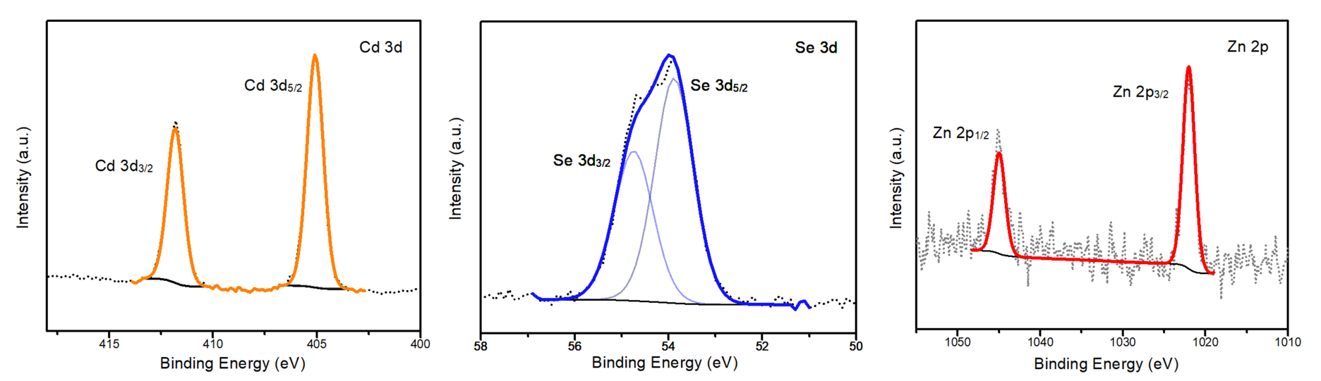
Figure S3. XPS spectra. XPS spectra of CdSe/Cd_{x}Zn_{1-x}Se#2 QDs, indicating the peaks of Cd, Se and Zn.

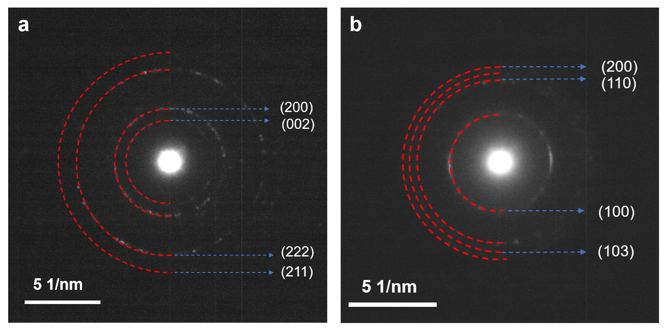
Figure S4. SAED images. SAED image of (a) CdSe/Cd_{x}Zn_{1-x}Se#1 QDs (b) CdSe/Cd_{x}Zn_{1-x}Se#2 QDs.

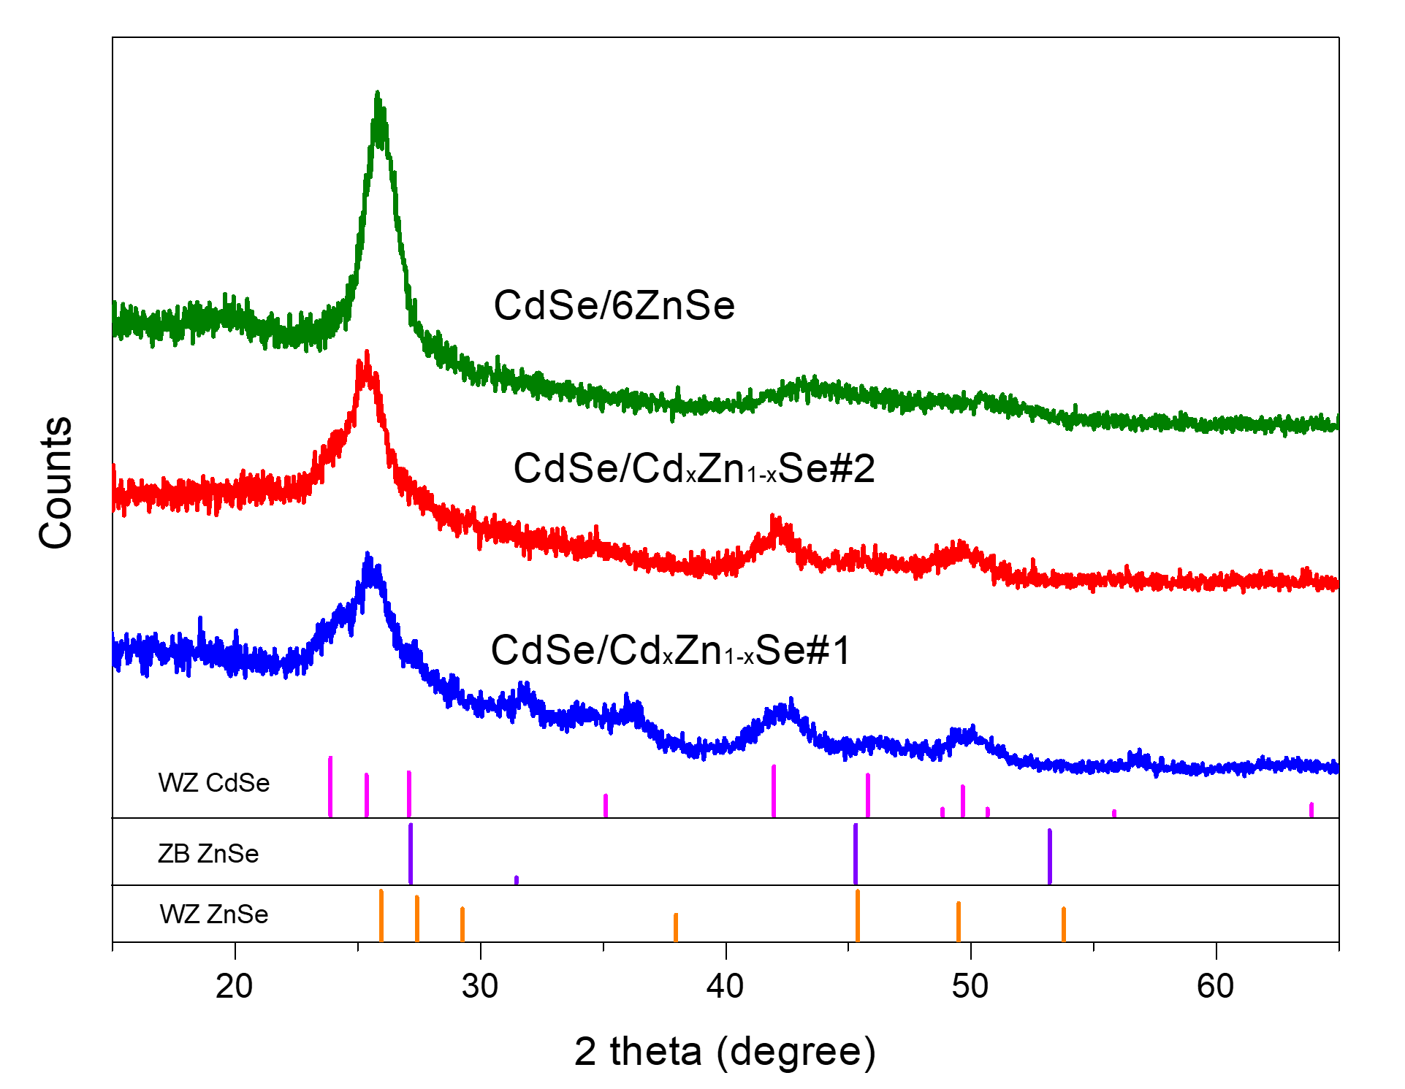
Figure S5. XRD pattern. XRD pattern of CdSe/6ZnSe, CdSe/Cd_{x}Zn_{1-x}Se#1 and CdSe/Cd_{x}Zn_{1-x}Se#2QDs.

The selected area electron diffraction (SAED) pattern also reveals that the structure of two types of alloyed QDs. In Figure S2, (200), (002), (222) and (211) planes in CdSe/Cd_{x}Zn_{1-x}Se#1 QDs are corresponding to WZ crystal structure of CdSe and ZB crystal structure of ZnSe while (200), (110), (100) and (103) planes in CdSe/Cd_{x}Zn_{1-x}Se#2 QDs correspond to the WZ crystal structure of CdSe and WZ crystal structure of ZnSe which is consistent with former results. X-ray diffraction (XRD) patterns (Figure S4) further confirmed the crystal structure of the core/shell/shell QDs.

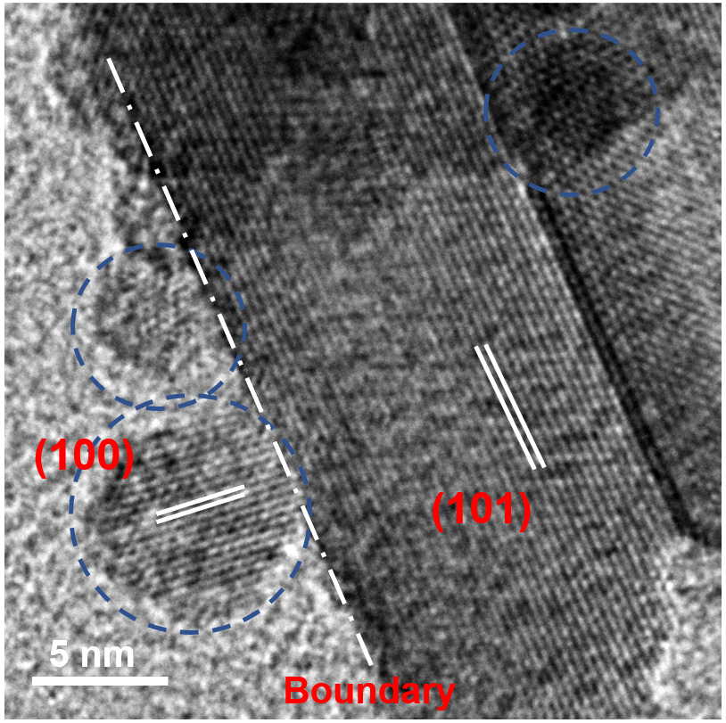
Figure S6. TEM image of QDs/TiO₂. TEM image of CdSe/Cd_{x}Zn_{1-x}Se#2 QDs deposited onto mesoporous TiO₂ via EPD.

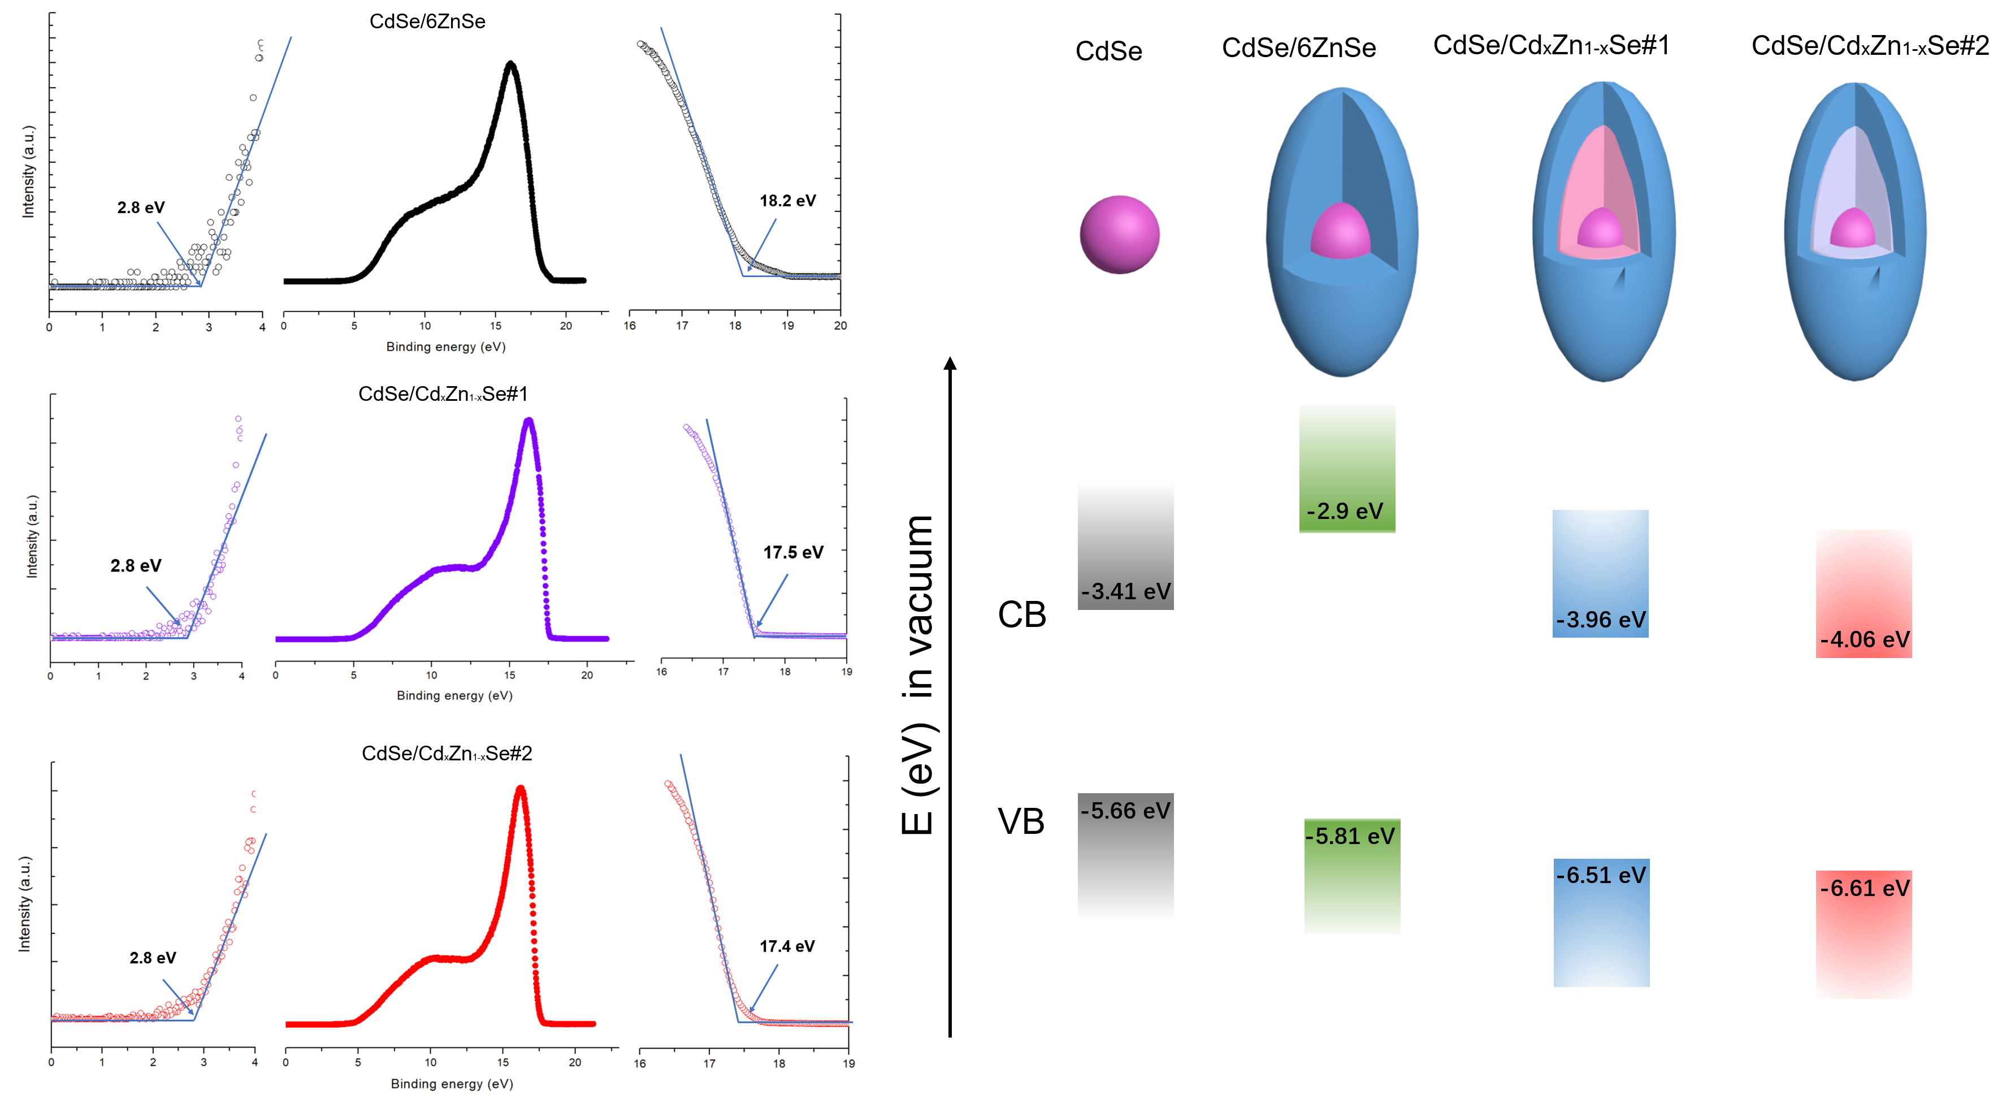
Figure S7. UPS pattern QDs. UPS pattern of three asymmetric QDs with high/low energy cut-off and the corresponding band position and band gap of QDs (the band gap was calculated based on UV-vis absorption spectra with tauc plot).

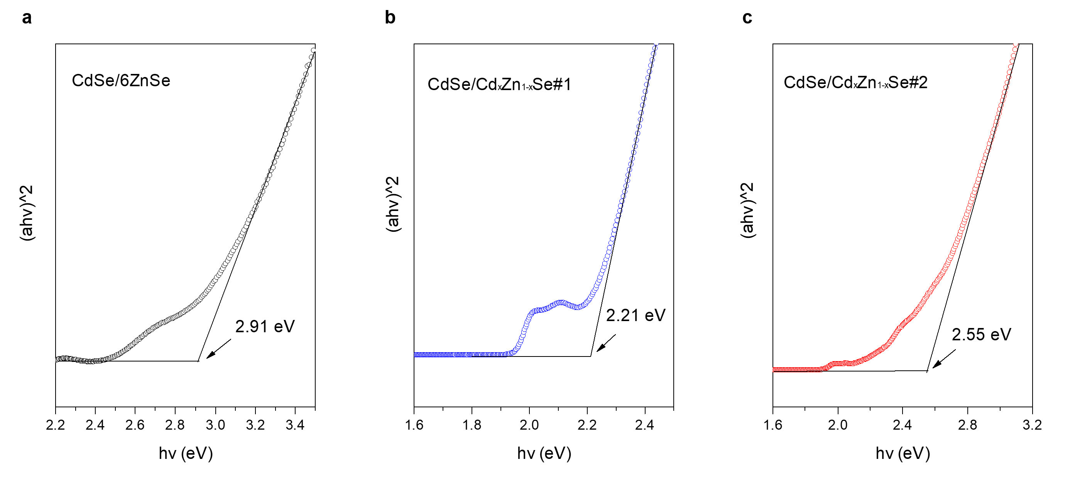
Figure S8 Tauc plot. Tauc plot of three types of QDs based UV-vis absorption spectra and the corresponding band gap of QDs.

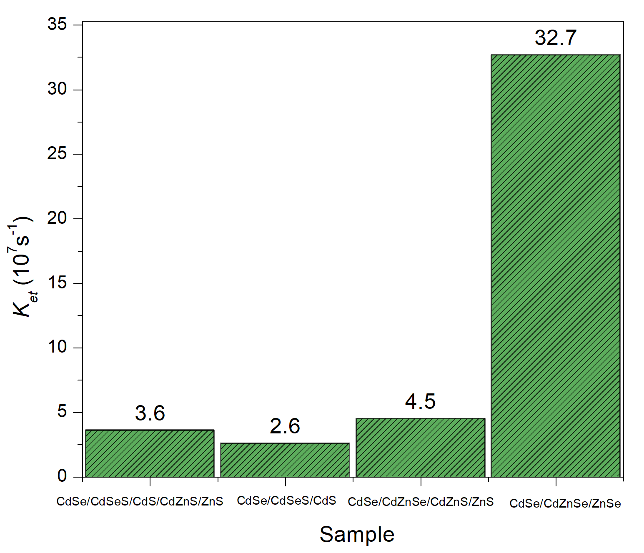
Figure S9 Comparison of electron transfer rate. Electron transfer rate of CdSe/CdSeS/CdS/CdZnS, CdSe/CdSe/CdS, CdSe/CdZnSe/CdZnS/ZnS and CdSe/CdZnSe/ZnSe QDs.

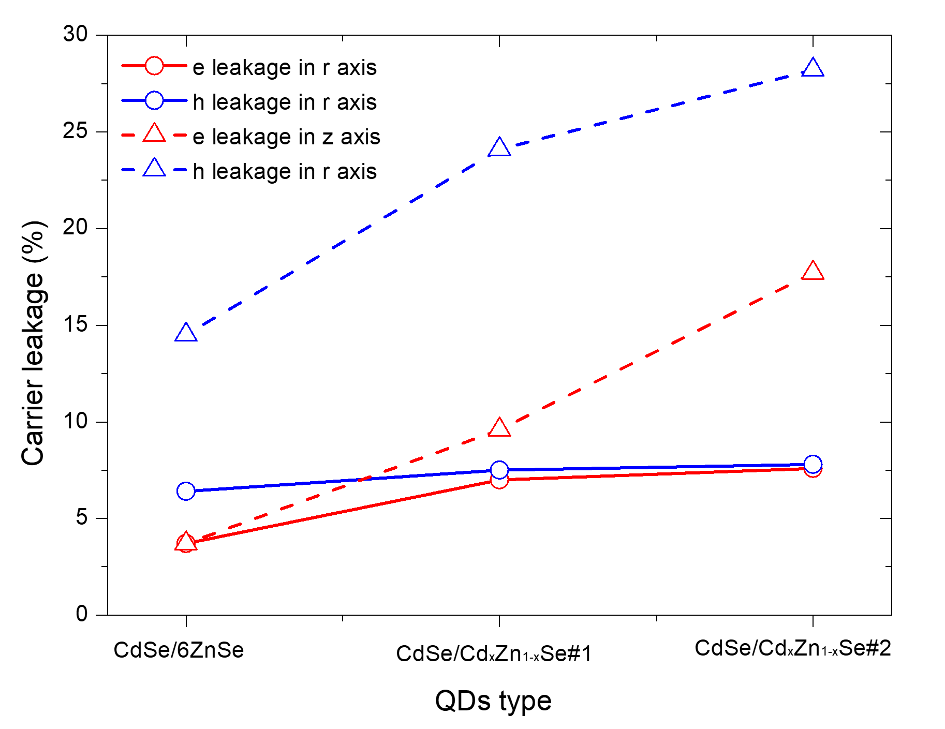
Figure S10. Carrier leakage rate. Carrier (electron/hole) leakage rate for CdSe/6ZnSe, CdSe/Cd_{x}Zn_{1-x}Se#1 and CdSe/Cd_{x}Zn_{1-x}Se#2 QDs.

Table S4. Carrier leakage rate in the direction of r/z axes.
Carrier | CdSe/6ZnSe (%)  (r/z) |  | CdSe/Cd_{x}Zn_{1-x}Se#1 (%)  (r/z) |  | CdSe/Cd_{x}Zn_{1-x}Se#2 (%)  (r/z)
Electron | 3.7 | 3.7 | 7.0 | 9.6 | 7.6 | 17.7
hole | 6.4 | 14.5 | 7.5 | 24.1 | 7.8 | 28.2

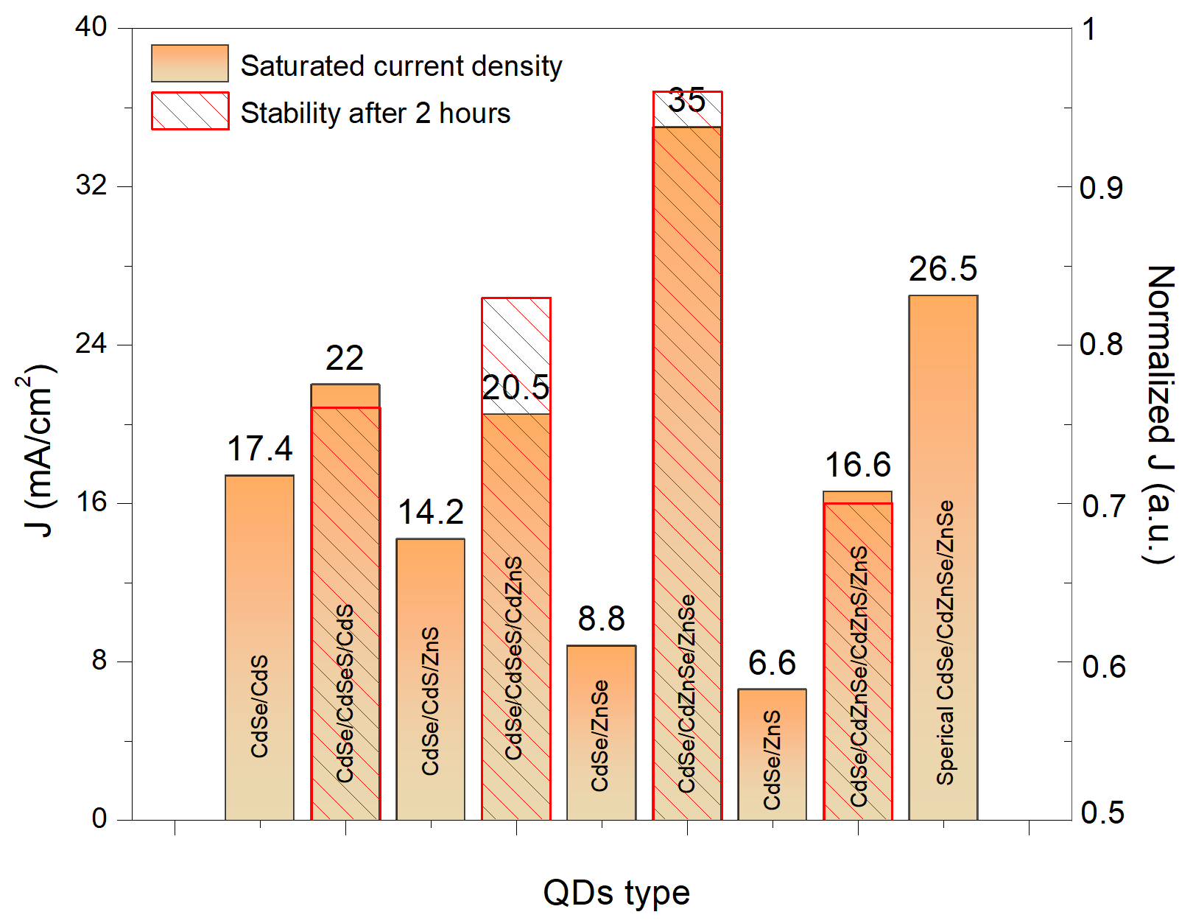
Figure S11. Saturated current density for several QDs. J_{ph} of several types of core/shell, core/shell/shell and corresponding alloyed QDs.

References:
1 Luo, J. et al. TiO₂/(CdS, CdSe, CdSeS) nanorod heterostructures and photoelectrochemical properties. J. Phys. Chem. C 116, 11956-11963 (2012).
2 Adhikari, R. et al. High efficiency, Pt-free photoelectrochemical cells for solar hydrogen generation based on “giant” quantum dots. Nano Energy 27, 265-274 (2016).
3. Adhikari, R. et al. Heterostructured quantum dot architectures for efficient and stable photoelectrochemical hydrogen production. J. Mater. Chem. A 6, 6822-6829 (2018).
4. Zhao, H., Liu, J., Vidal, F., Vomiero, A. & Rosei, F. Tailoring the interfacial structure of colloidal “giant” quantum dots for optoelectronic applications. Nanoscale 10, 17189-17197 (2018).
5. Zhao, H., Liu, G., Vidal, F., Wang, Y. & Vomiero, A. Colloidal thick-shell pyramidal quantum dots for efficient hydrogen production. Nano Energy 53, 116-124 (2018).
6. Wang, K. et al. Efficient solar-driven hydrogen generation using colloidal heterostructured quantum dots. J. Mater. Chem. A 7, 14079-14088 (2019).
7. Kim, J.-Y. et al. Highly loaded PbS/Mn-doped CdS quantum dots for dual application in solar-to-electrical and solar-to-chemical energy conversion. Appl. Catal. B 227, 409-417 (2018).
8. Jin, L. et al. Near-infrared colloidal quantum dots for efficient and durable photoelectrochemical solar-driven hydrogen production. Adv. Sci. 3, 1500345 (2016).
9. Jin, L. et al. Engineering interfacial structure in “Giant” PbS/CdS quantum dots for photoelectrochemical solar energy conversion. Nano Energy 30, 531-541 (2016).
10. Tong, X. et al. Heavy metal-free, near-infrared colloidal quantum dots for efficient photoelectrochemical hydrogen generation. Nano Energy 31, 441-449 (2017).
11. Tong, X. et al. Near-infrared, heavy metal-free colloidal “giant” core/shell quantum dots. Adv. Energy Mater. 8, 1701432 (2018).
12. Li, F. et al. “Green”, gradient multi-shell CuInSe₂/(CuInSe_{x}S_{1-x})₅/CuInS₂ quantum dots for photoelectrochemical hydrogen generation. Appl. Catal. B 280, 119402 (2021).
13. Tong, X. et al. Optoelectronic properties in near‐infrared colloidal heterostructured pyramidal “giant” core/shell quantum dots. Adv. Sci. 5, 1800656 (2018).
14. Channa, A. I. et al. Tailored near-infrared-emitting colloidal heterostructured quantum dots with enhanced visible light absorption for high performance photoelectrochemical cells. J. Mater. Chem. A 7, 10225-10230 (2019).
15. Ye, K.-H. et al. Carbon quantum dots as a visible light sensitizer to significantly increase the solar water splitting performance of bismuth vanadate photoanodes. Energy Environ. Sci. 10, 772-779 (2017).

