Supplementary Note for “Parallel interrogation of the chalcogenide-based micro-ring sensor array for photoacoustic tomography”
Jingshun Pan^{1, #}, Qiang Li^{1, #}, Yaoming Feng¹, Ruifeng Zhong¹, Zhihao Fu¹, Shuixian Yang¹, Weiyuan Sun¹, Bin Zhang¹, Qi Sui², Jun Chen¹, Yuecheng Shen^{1,} * & Zhaohui Li^{1, 2,} *
¹Guangdong Provincial Key Laboratory of Optoelectronic Information Processing Chips and Systems, School of Electrical and Information Technology, Sun Yat-sen University, Guangzhou 510275, China
²Southern Marine Science and Engineering Guangdong Laboratory (Zhuhai), Zhuhai 519000, China
#These authors contributed equally to this work
*Email: shenyuecheng@mail.sysu.edu.cn; lzhh88@mail.sysu.edu.cn

S1. The generation and demodulation processes of the digital optical frequency comb (DOFC)
In this section, we describe the details of the generation process of the DOFC, which is essential for realizing parallel interrogation to the micro-ring sensor array. Mathematically, the targeted comb structure in the frequency domain should read
$D_{input}\left(f\right)=\sum_{q={-N}/2}^{N/2}{E_{q}\exp\left(jϕ_{q}\right)⋅δ\left(f-f_{q}\right)}$ （S1）
where $E_{q}$, $ϕ_{q}$, and $f_{q}$ are the amplitude, phase, and frequency of the q-th comb line, respectively. q = ${-N}/2$, …, $N/2$ is used to denote the labeling of comb lines, where $N$ is set as an even number. Moreover, we also have $f_{q}=f_{0}+qΔf$, where $f_{0}$ is the carrier frequency of the light source and $Δf$ is the comb spacing. It is worth noting that the comb tooths are evenly distributed on both sides of $f_{0}$. In practices, $ϕ_{q}$ is set to 0 for all q, while $E_{q}$ is set to a constant $E_{0}$. By taking the Fourier transformation, the corresponding waveform in the time domain is
$E_{DOFC}\left(t\right)=\frac{1}{2π}\sum_{q={-N}/2}^{N/2}{E_{0}\cos\left(2π\left(f_{0}+qΔf\right)t\right)}$ （S2）
To generate the waveform in Eq. S2, one needs to modulate the optical field with the following form
$E_{M}\left(t\right)=\frac{1}{π}\sum_{q=0}^{N/2}{E_{0}\cos\left(2πqΔft\right)}$ （S3）
Figure S1 illustrates the experimental realization of the above mathematical descriptions. First, the computer generated a series of data as $D_{input}\left(f\right)$. Inverse fast Fourier transform (IFFT) was then conducted to generate $E_{DOFC}\left(t\right)$. After removing the carrier frequency $f_{0}$, a digital-to-analog converter (DAC) generated an electrical signal $E_{M}\left(t\right)$ and drove an intensity modulator (IM). Since the IM was set with a bias control at the node point, both the positive and negative voltages represent large modulation depths. In this way, we effectively modulated the optical field through the IM with the desired driving signal in Eq. (S3). As a result, the single-frequency light output from a tunable laser was transformed into a frequency comb.
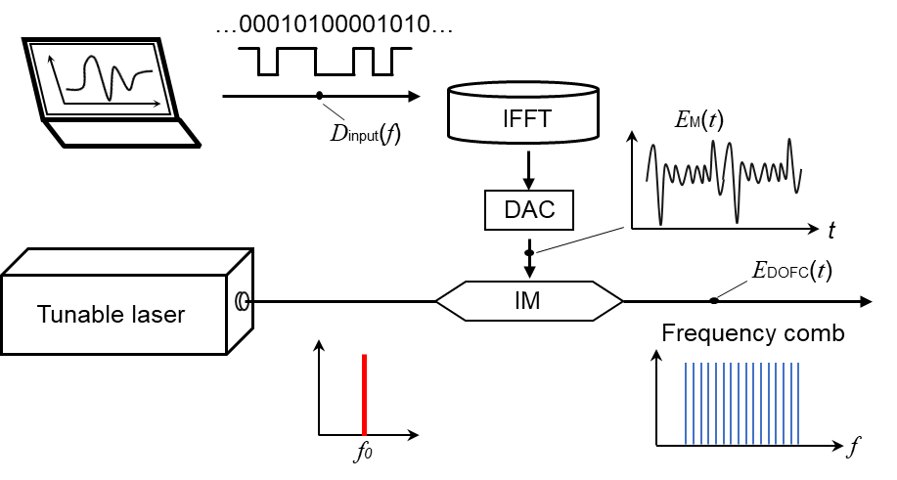
Fig. S1. The generation process of the digital optical frequency comb. IFFT: inverse fast Fourier transformation; DAC: digital-to-analog converter; IM: intensity modulator.

Then, we proceed to describe the demodulation process of the DOFC. Having interacted with the micro-ring sensor and acquired the information carried by ultrasonic wave, the optical field of the DOFC becomes
${\tilde{E}}_{DOFC}\left(t\right)=\frac{1}{2π}\sum_{q={-N}/2}^{N/2}{{\tilde{E}}_{q}\exp\left(j2π\left(f_{0}+qΔf\right)t+j{\tilde{ϕ}}_{q}\right)}$ （S4）
Here, we use the notation tilde to denote parameters of the DOFC after passing through the micro-ring sensor. During experiments, coherent detection was employed to extract the following output optical field
${\tilde{E}}_{output}\left(t\right)=\frac{1}{2π}\sum_{q={-N}/2}^{N/2}{{\tilde{E}}_{q}\exp\left(j2π\left(qΔf\right)t+j{\tilde{ϕ}}_{q}\right)}$ （S5）
where the optical frequency $f_{0}$ was filtered out. Then, we performed a fast Fourier transformation (FFT) to ${\tilde{E}}_{output}\left(t\right)$, leading to a data train as follows
${\tilde{D}}_{output}\left(f\right)=FFT\left[{\tilde{E}}_{output}\left(t\right)\right]=\frac{1}{2π}\sum_{q=1}^{N}{{\tilde{E}}_{q}\exp\left(j{\tilde{ϕ}}_{q}\right)⋅FFT\left[\exp\left(j2π\left(qΔf\right)t\right)\right]} =\sum_{q={-N}/2}^{N/2}{{\tilde{E}}_{q}\exp\left(j{\tilde{ϕ}}_{q}\right)⋅δ\left(f-{qΔf}_{q}\right)}$ （S6）
Notably, by comparing ${\tilde{E}}_{q}$ and ${\tilde{ϕ}}_{q}$ to $E_{q}$($E_{0}$) and $ϕ_{q}$(0), one can retrieve the transmission spectrum of the micro-ring sensor array, which carries the information of the ultrasonic wave.

S2. Characterization process of the sensitivity of the micro-ring sensor
In this section, we describe the characterization process of the sensitivity for the micro-ring sensor, which follows the procedure described in Ref. [1]. The ultrasound was generated by a piezo-electric transducer (Olympus, V312) with a central frequency of 10 MHz. The transducer was driven by a rectangular signal with a duration of 40 ns and a peak voltage of 5 V. We first placed a calibrated needle hydrophone (Precision Acoustics, NH0200, 20-MHz bandwidth) 2.5-mm away from the source to measure the ultrasonic wave. The measured acoustic signal $H(t)$ as a function of time is shown in Fig. S2(a), which was averaged through 200 independent time traces. Its Fourier transformation $H(f)$, which is known as the amplitude spectral density, is plotted in Fig. S2(b). Thus, the generated pressure spectral density $P(f)$ can be estimated as (Fig. S2(c))
$P\left(f\right)={H(f)}/{S_{H}(f)}$ (S7)
where$S_{H}(f)$ is the sensitivity of the calibrated Hydrophone (provided by the company). To characterize the sensitivity of the micro-ring sensor, we placed it at the same position as the calibrated hydrophone and triggered the same ultrasonic wave. Similarly, the measured acoustic signal $M(t)$ as a function of time is shown in Fig. S2(d). By performing Fourier transformation, the amplitude spectral density of the micro-ring sensor $M(f)$ is shown in Fig. S2(e). Therefore, the sensitivity of the micro-ring sensor $S_{M}(f)$ can be estimated as
$S_{M}(f)={M(f)}/{P(f)}$ (S8)
which is shown in Fig. S2(f).
Having obtained the sensitivity of the micro-ring sensor, we further characterized the noise-equivalent pressure (NEP) spectral density $N_{Pa}(f)$ (Fig. 4(g) in the main text). This quantity can be estimated as
$N_{Pa}\left(f\right)={N_{V}(f)}/{S_{M}(f)}$ (S9)
Here, ${\left|N_{V}(f)\right|}^{2}$ is the noise power spectral density, which was computed through a 10-μs long time trace without ultrasonic excitation (Fig. 4(f) in the main text). Specifically, it was estimated using the Welch method with segments of 1,400 samples, the Hanning windows, and 512 samples overlapping [2]. Moreover, the root-mean-square (RMS) pressure $P_{NEP,RMS}$ within the range from 0 to 20 MHz is computed as
$P_{NEP,RMS}=\sqrt{\int_{0}^{20 MHz}{{\left|N_{Pa}\left(f\right)\right|}^{2}df}}$ (S10)
which is about 7.1 Pa.
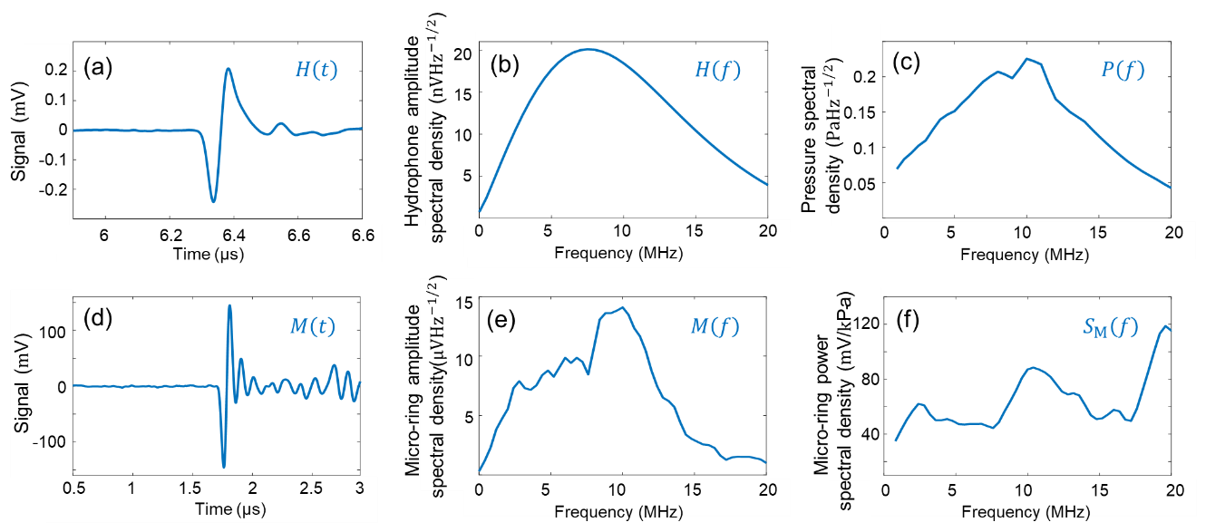
Fig. S2. Characterization process of the sensitivity of the micro-ring sensor. (a) The measured acoustic signal $H(t)$ as a function of time using a calibrated hydrophone. (b) The amplitude spectral density $H(f)$ measured by the calibrated hydrophone. (c) The generated pressure spectral density $P(f)$ by the piezo-electric ultrasonic transducer. (d) The measured acoustic signal $M(t)$ as a function of time using the micro-ring sensor. (e) The amplitude spectral density $M(f)$ measured by the micro-ring sensor. (f) The sensitivity of the micro-ring sensor $S_{M}(f)$.

S3. The process of frequency tuning for the micro-ring sensor array
The chalcogenide glass is an important class of semiconductor compounds that generally contains one or several types of chalcogenide elements, such as S, Se, or Te. In these compounds, chalcogenide elements form network structures with elements like Ge, Sb, or As through covalent bonds. Chalcogenide glasses usually exhibit a strong photosensitive effect, which is generally induced by structural rearrangement due to photon absorption [3]. Structural rearrangements, such as bending, breaking, and reforming, have been observed in many types of chalcogenide glasses, leading to a refractive index change in the macroscopic picture [4].
To exploit the photosensitive effect for frequency tuning, we built an experimental shown in Fig. S3(a), which consists of a pump laser, an optical fiber, a three-dimensional motorized translational stage, a microscope system, and a tray to hold the micro-ring sensor array. We first quantified the photosensitivity of the chalcogenide micro-ring sensor through 532-nm light illumination at 30 mW. Figure S3(b) plots the observed resonant wavelength shift as a function of illumination time, exhibiting an exponential behavior. Moreover, after being illuminated for 120 s, the resonant wavelength can be shifted by an amount up to 7.25 nm. This value is large enough to cover almost the entire free spectral range of the micro-ring resonator $λ_{\text{FSR}}\text{ = 8.5 nm}$, which can be estimated through ${λ_{0}^{2}}/{2πnR}$. Here $λ_{0}\text{ = 1}\text{,}\text{550 nm}$ is the operating wavelength, $n\text{ = 2.33}$ is the refractive index of the chalcogenide glass, and $R=20 μm$ is the radius of the micro-ring sensor.
With these preliminary results, we then proceed to tune the resonant frequencies of these micro-ring sensors made of chalcogenide glass. A typical illustrative transmission spectrum of the sensor array is depicted in Fig. S3(c). In general, their resonant frequencies are not positioned in order and may even cover a wide frequency range beyond 40 GHz (the bandwidth of the DOFC). This condition, as mentioned in the main text, is unfavorable for the DOFC-enabled parallel interrogation. To address this issue, we need to order and equally space these resonant frequencies by utilizing the photosensitive effect and the experimental setup in Fig. S3(b). The tunning process for resonant frequencies is described as follows. 1. We control the size of the illumination light so that it matches the diameter of the micro-ring sensor. 2. Under the illumination of low-intensity light, we adjust the height and position of the optical fiber so that light illumination acts on only one micro-ring sensor. This process is performed with the assistance of the microscope system. 3. While monitoring its resonant condition through a frequency-swept detection system (not shown in Figure), we increase the output power of the illuminating light to tune the resonant frequency of this micro-ring sensor. In order to efficiently utilize the bandwidth of the DOFC, the resonant frequency of the first micro-ring sensor is tuned to the far end of the operating window. 4. After tuning the resonant frequency of the targeted micro-ring sensor to the desired value, the illuminating light is turned off and the three-dimensional motorized precision translational stage transports the next micro-ring sensor to the illumination area for frequency tuning. 5. The tuning process is repeated for each micro-ring sensor in order until all resonant frequencies are placed to their designed values. An illustrative transmission spectrum of the micro-ring sensor array after the tuning process is shown in Fig. S3(d), exhibiting ordered and equally spaced resonant frequencies.

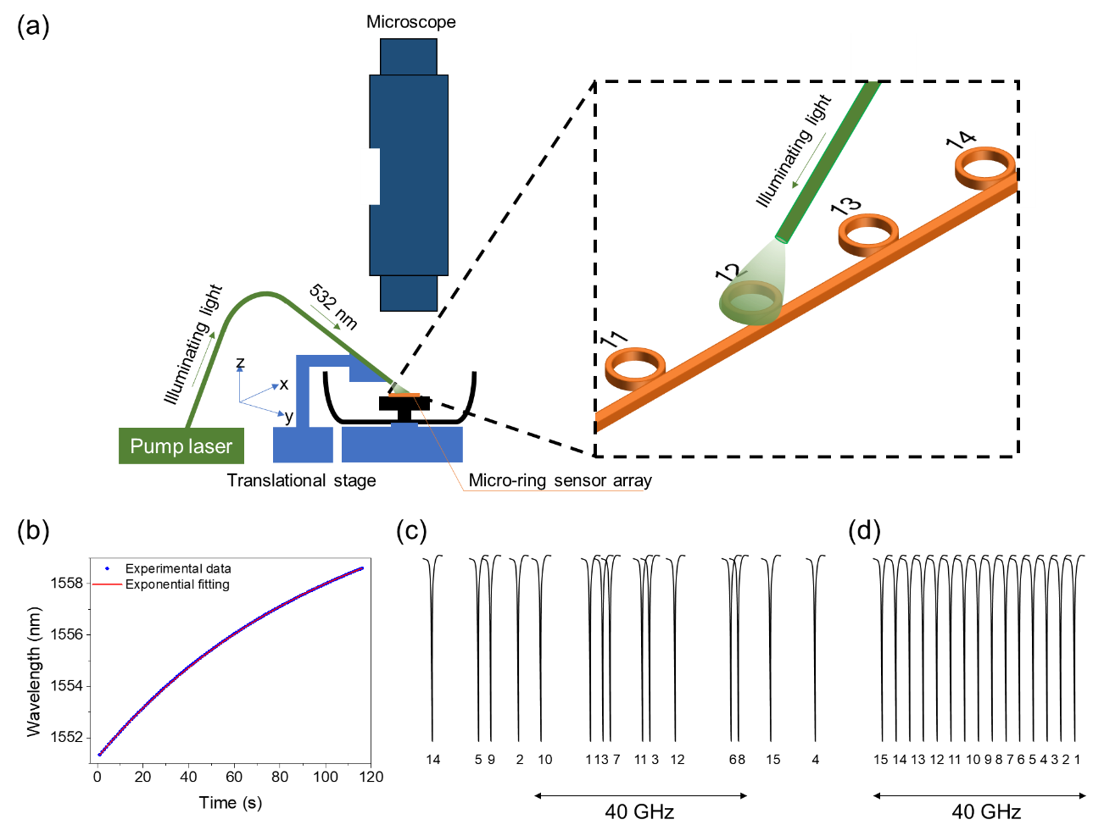
Fig. S3. Tuning the resonant frequencies for the chalcogenide-based micro-ring sensor array through the photosensitive effect. (a) Experimental setup of the tuning process. (b) The measured resonant wavelength shift as a function of illumination time for a typical micro-ring sensor. (c) An illustrative transmission spectrum of the sensor array before frequency tuning. (d) An illustrative transmission spectrum of the sensor array after frequency tuning.

S4. Detailed imaging procedures for live zebrafish
The experimental setup for imaging live zebrafish is schematically shown in Fig. S4. The light source was chosen as a 532-nm laser (Beamtech, Dawa 100) with a pulse width of 6.5 ns and a repetition rate of 10 Hz. An optical diffuser (Thorlabs, DG10-120) was used to expand and homogenize illuminating light. The light illuminated the zebrafish from the top with an area of about 8 mm in diameter. To mitigate artifacts due to limited view, the water tank was mounted on a motorized rotational stage, which rotated with a step size of 1 degree. The sensor array was hung in water at the same horizontal plane and was about 4 mm away from the zebrafish. In this condition, photoacoustic tomography (PAT) was performed by rotating the zebrafish while keeping the sensor array and excitation light fixed. When the pulsed light irradiated the zebrafish, each micro-ring sensor produced an A-line signal, which contains 4,096 data points. After rotating 360 degrees, universal back projection [5] was employed to reconstruct the image through these 360 sets of A-line signals. To acquire one image, the scanning process took about 36 seconds (360 optical pulses). A microcontroller (STMicroelectronics, STM32) was employed to synchronize the motorized rotational stage, the laser, and the data acquisition process.
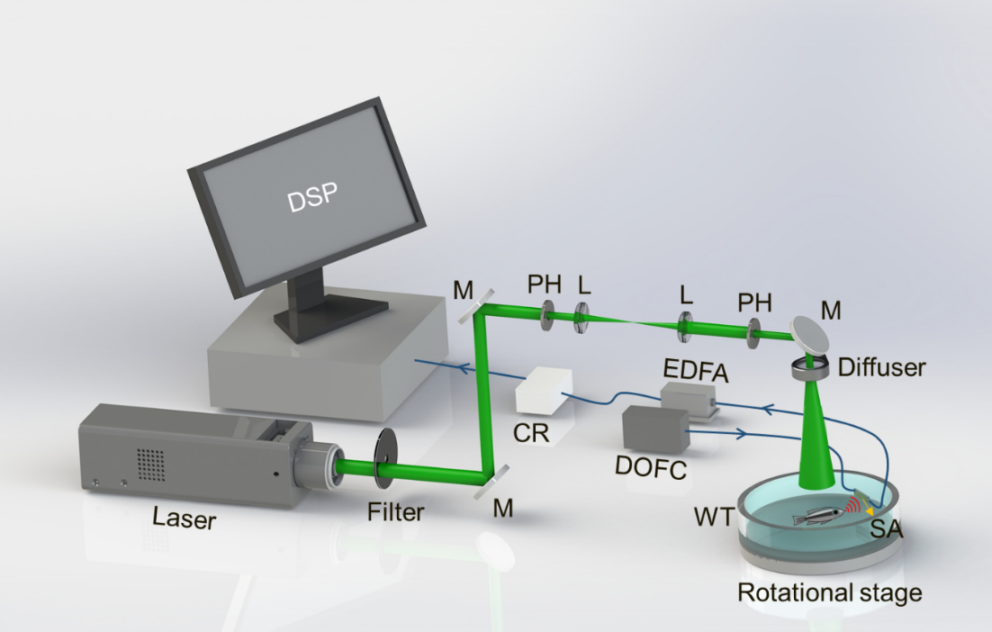
Fig. S4. Experimental setup of performing photoacoustic tomography for live zebrafish. M: mirror; PH: pinhole; L: lens; SA: sensor array; WT: water tank; DOFC: digital optical frequency comb; EDFA: erbium-doped fiber amplifier; CR: coherent receiver; DSP: digital signal processing.

Besides demonstrating a sensor array that contains 15 micro-rings in the main text, in this section, we also demonstrated PAT with another sensor array that contains 10 micro-rings. Figure S5 (a) and (b) show the whole-body image of a zebrafish 10 days post-fertilization obtained through a single micro-ring sensor and a sensor array with 10 micro-rings, respectively. Notably, the quality of the image obtained through the sensor array is much better than the other one. This result, together with the one shown in the main text, confirm the superiority of the micro-ring sensor array.
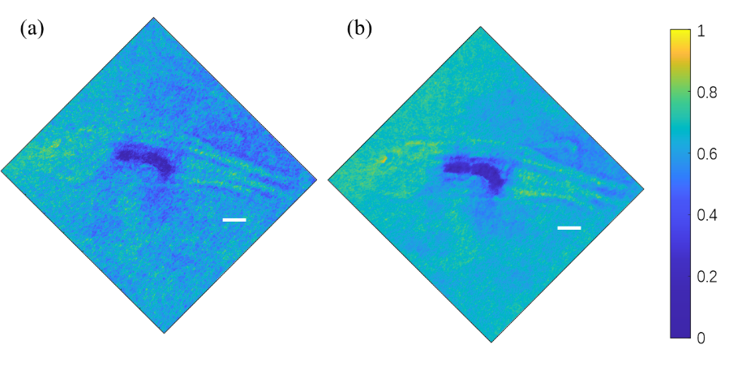
Fig. S5. Experimental results of whole-body imaging of a zebrafish 10 days post-fertilization. Scale bars: 1 mm. (a) Imaging result using a single micro-ring sensor. (b) Imaging result using a micro-ring sensor array with 10 elements.

S5. Comparison to other on-chip optical ultrasound sensors
In this section, we summarize some representative on-chip optical ultrasound sensors in Tab. 1, which represent state-of-the-art performances. π-BG resonators fabricated through silicon photonics enable optical ultrasound sensors with a small footprint while maintaining very high sensitivity per unit area [6, 7]. On the other hand, the micro-ring can be conveniently extended with arrayed structures. To date, a silicon-based micro-ring sensor array with 10 elements [1] and a polymer-based micro-ring sensor array with 4 elements [8] were reported. However, parallel interrogation with one source-detector pair has not been realized. This work reports the fabrication of a chalcogenide-based micro-ring sensor array with 15 elements and demonstrates the first parallel interrogation for PAT with only one source-detector pair. Notably, the NEP for all these optical ultrasound sensors are at roughly the same level.

Tab. 1. Comparison of the state-of-the-art on-chip optical ultrasound sensors. H × W × L: height × weight × length; NEP: noise-equivalent pressure.
Parallel interrogation | No | No | No | No | No | No | Yes
Sensor array (# of elements) | No | No | Yes (10) | Yes (4) | No | No | Yes (15)
NEP (Pa) | 45 | / | 5.5 | 105 | 0.49 | 81 | 7.9
NEP spectral density (mPa/Hz^{-1/2}) | 9 | 2.2~9.8 | 1.3~2 | 5.61 | / | / | 2.2
-6-dB Bandwidth (MHz) | 230 | 200 | 27 | 350 | 280 | 32 | 175
Dimension (H×W×L, μm) | 0.2×0.2×0.2 | 0.2×0.5×30~200 | 0.2×0.5×30~200 | 1.4×60×60 | 0.7×80×80 | 0.7×80×80 | 0.85×40×40
Structure | π-BG resonator | π-BG resonator | Micro-ring  with membrane | Micro-ring |  |  | Micro-ring
Material | Silicon | Silicon | Silicon | Polymer |  |  | Chalcogenide
 | Ref. [6] | Ref. [7] | Ref. [1] | Ref. [8] | Ref. [9] | Ref. [10] | This work

Reference
1. W. J. Westerveld, M. Mahmud-Ul-Hasan, R. Shnaiderman, V. Ntziachristos, X. Rottenberg, S. Severi, and V. Rochus, "Sensitive, small, broadband and scalable optomechanical ultrasound sensor in silicon photonics," Nature Photonics 15, 341-345 (2021).
2. P. Welch, "The use of fast Fourier transform for the estimation of power spectra: a method based on time averaging over short, modified periodograms," IEEE Transactions on audio and electroacoustics 15, 70-73 (1967).
3. A. Zakery and S. R. Elliott, "Optical properties and applications of chalcogenide glasses: a review," Journal of Non-Crystalline Solids 330, 1-12 (2003).
4. N. Singh, D. D. Hudson, R. Wang, E. C. Mägi, D.-Y. Choi, C. Grillet, B. Luther-Davies, S. Madden, and B. J. Eggleton, "Positive and negative phototunability of chalcogenide (AMTIR-1) microdisk resonator," Opt. Express 23, 8681-8686 (2015).
5. M. Xu and L. V. Wang, "Universal back-projection algorithm for photoacoustic computed tomography," Physical Review E 71, 016706 (2005).
6. R. Shnaiderman, G. Wissmeyer, O. Ülgen, Q. Mustafa, A. Chmyrov, and V. Ntziachristos, "A submicrometre silicon-on-insulator resonator for ultrasound detection," Nature 585, 372-378 (2020).
7. Y. Hazan, A. Levi, M. Nagli, and A. Rosenthal, "Silicon-photonics acoustic detector for optoacoustic micro-tomography," Nature Communications 13, 1488 (2022).
8. C. Zhang, S. L. Chen, T. Ling, and L. J. Guo, "Review of Imprinted Polymer Microrings as Ultrasound Detectors: Design, Fabrication, and Characterization," IEEE Sensors Journal 15, 3241-3248 (2015).
9. H. Li, B. Dong, X. Zhang, X. Shu, X. Chen, R. Hai, D. A. Czaplewski, H. F. Zhang, and C. Sun, "Disposable ultrasound-sensing chronic cranial window by soft nanoimprinting lithography," Nature Communications 10, 4277 (2019).
10. Q. Rong, Y. Lee, Y. Tang, T. Vu, C. Taboada, W. Zheng, J. Xia, D. A. Czaplewski, H. F. Zhang, C. Sun, and J. Yao, "High-Frequency 3D Photoacoustic Computed Tomography Using an Optical Microring Resonator," BME Frontiers 2022(2022).

