Supplementary materials

Mass-univariate feature-specific analyses
We employed mass-univariate analyses of the segmented EEG data to estimate motion-specific neural responses to the two component motion signals and their average at the level of single electrodes. As Figure S1 shows, most electrodes showed no statistically significant sensitivity to any of the analysed angles. A small number of frontal and central electrodes were sensitive to the motion signal presented in the left patch at p < .05, and none was sensitive to motion signals in the right patch (all p >> .05). One frontal electrode and a few posterior electrodes were sensitive to the average motion direction. Importantly, the temporal dynamics of feature-selective neural responses were dramatically different for mass-univariate analyses and multivariate analyses. Specifically, whereas the multivariate analyses showed a sustained feature-specific response from ~200 ms (Figure 2), individual electrodes exhibited a sharp phasic sensitivity profile restricted to a 10–20 ms time-window.
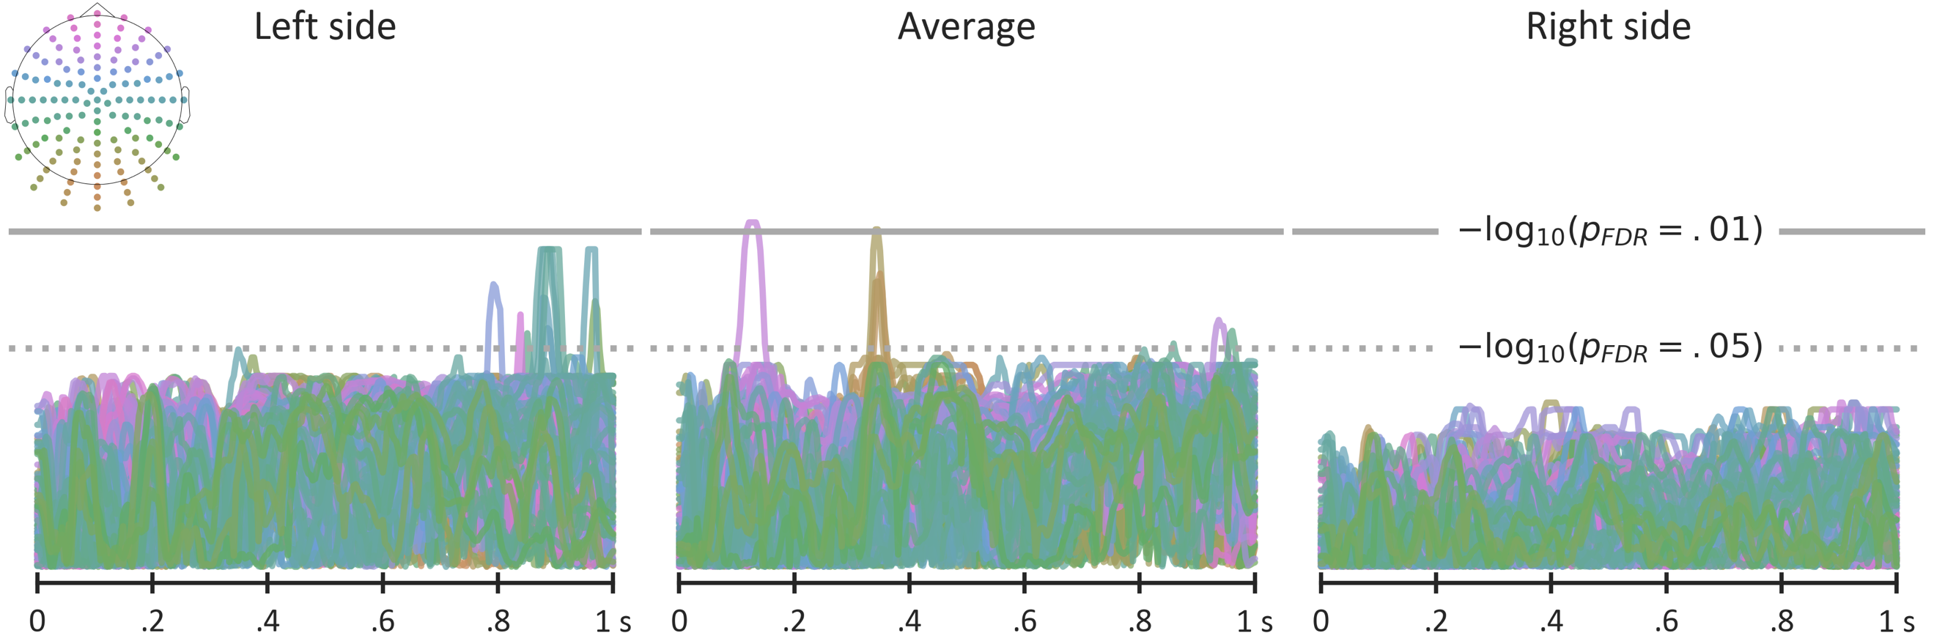
Figure S1. Feature-specific mass-univariate analyses of individual electrodes during 1 s epochs time-locked to the onset of coherent motion. Y-axis shows FDR-corrected p-values from one-sample t-test of the estimated motion-specificity against zero. Inset panel shows the electrode locations. Gray lines show FDR-corrected p-thresholds at .01 (full line) and .05 (dotted) levels.
Critically, the mass-univariate analyses demonstrate that the robust motion tuning revealed in the multivariate analyses (Figure 2) cannot be attributed to eye movements tracking the displayed motion signals. If this had occurred, we would expect strong and sustained sensitivity to the component motion signals, particularly in frontal electrodes, in the mass-univariate analyses. On the contrary, Figure S1 clearly shows this was not the case, suggesting that our feature-tuning analyses captured the time-course of neural representations of motion signals rather than motoric artefacts due to eye movements.
Methods. Similar to our previously published work³, the univariate analyses modelled (Eq. SE1) the voltage (V) for each time sample (t) and each electrode (e) as a function of the motion direction (θ) presented on the left side, the right side, and the average of the left and right sides. The cosine and sine transforms of the motion direction were used to linearise predictor variables. The average neural response to motion signals was modelled as the intercept term.
$$(SE1) V_{t,e}=Intercept+β_{cos}cos\left(θ\right)+β_{sin}sin\left(θ\right)$$
$$(SE2) s_{t,e}=\sqrt{β_{cos}^{2}+β_{sin}^{2}}$$
The univariate analyses yielded two parameters ($β_{cos}$, $β_{sin}$) per time sample per electrode. The aggregate electrode sensitivity ($s_{t,e}$) to different motion directions was computed (Eq. SE2) as the length of the $\vec{β_{cos}, β_{sin} }$ vector. To estimate the empirical null distributions of the univariate electrode sensitivity, the regression analyses were repeated 10,000 times with randomly sampled motion directions as predictors. The empirical null distribution was used to quantify the percentile of observed electrode sensitivity. That percentile was then transformed to a z-score using an inverse of cumulative normal distribution. The statistical significance of the z-scores per participant, time sample and electrode was tested using a one-sample t-test against zero, with false-discovery rate correction across time samples and electrodes.

