Supplementary material

Benthic macroinvertebrates in a protected area within the Brazilian savannah: environmental factors negatively affect diversity

¹Márcia Cristina Martins da Silva*, ²Rodrigo Roucourt Cezário, ³Vânia Regina Pivello & ¹Dalva Maria da Silva Matos

¹Laboratory of Ecology and Conservation, Department of Hydrobiology, Federal University of São Carlos, São Carlos, SP, Brazil.
²Faculty of Philosophy, Sciences and Letters at Ribeirão Preto, University of São Paulo, Ribeirão Preto, SP, Brazil.
³Laboratory of Landscape Ecology and Conservation, Department of Ecology, Institute of Biosciences, University of São Paulo, São Paulo, SP, Brazil.

MCMS Orcid ID https://orcid.org/0000-0002-4398-026X
RRC Orcid ID https://orcid.org/0000-0002-0486-5867
VRP Orcid ID https://orcid.org/0000-0001-8063-772X
DMSM Orcid ID https://orcid.org/0000-0001-9461-2179

*Author for correspondence
E-mail: mcms42@gmail.com

Number of figures: 1
Number of tables: 4

Fig S1 Environmental factors including depth, stream flow (or discharge), potential of hydrogen (i.e., pH), specific conductivity, water temperature, oxidation reduction potential, water turbidity, dissolved oxygen, and total dissolved solids for dry and wet seasons.
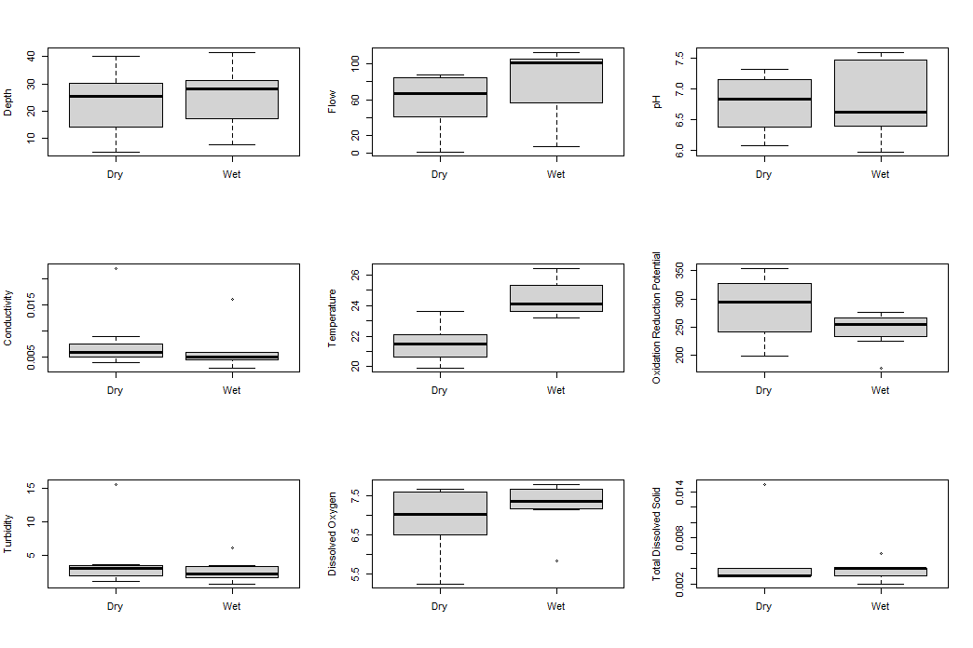

Table S1 Sampling site coordinates (i.e., PG1 to PG4, EX5, ZA6 and ZA7) as well as their integrity (i.e., HII), water quality (i.e., BMWP’) and Shannon’s diversity (H’).
 | PG1 | PG2 | PG3 | PG4 | EX5 | ZA6 | ZA7
Coordinates | 21°38'29.0'' S,  47°37'51.5'' W | 21°38'35.9'' S,  47°37'51.7'' W | 21°38'47.0'' S,  47°38'00.3'' W | 21°38'47.6'' S,  47°38'07.5'' W | 21°38'57.9'' S,  47°38'23.6'' W | 21°39'12.2'' S, 47°38'34.8'' W | 21°39'25.3'' S,  47°38'35.4'' W
HII | 0.673 | 0.769 | 0.692 | 0.755 | 0.326 | 0.674 | 0.657
BMWP’ score | 36 | 60 | 63 | 87 | 36 | 58 | 66
BMWP’ class | Bad | Satisfactory | Satisfactory | Excellent | Bad | Satisfactory | Good
H' | 1.8306 | 1.7015 | 1.8976 | 2.3437 | 1.5534 | 2.1415 | 2.2004

Table S2 Total number of benthic macroinvertebrates sampled along the Paulicéia stream, municipality of Santa Rita do Passa Quatro, state of São Paulo, Brazil. Of the seven sampling sites, four were inside the GCPG (i.e., PG1 to PG4), one where in the confluence point of the Paulicéia springs (i.e., EX5), whilst the remaining two where in the GCPG buffer zone (ZA6 and ZA7; Fig. 1).
Taxon | PG1 | PG2 | PG3 | PG4 | EX5 | ZA6 | ZA7
Annelida
Hirudinea | 2 | 5 |  |  | 1
Oligochaeta |  | 1
Coleoptera
Dytiscidae | 2 |  | 1 | 1 |  |  | 1
Elmidae |  | 1 | 2 | 10 | 4 | 19 | 11
Gyrinidae |  | 2
Noteridae |  |  |  |  | 2
Diptera
Ceratopogonidae | 14 | 37 | 26 | 20 | 13 | 12 | 15
Chironomidae | 38 | 89 | 54 | 32 | 125 | 35 | 38
Limoniidae | 17 |  |  | 5 | 44 | 13 | 4
Simuliidae | 2 | 14 | 1
Tabanidae |  |  |  |  | 1
Tipulidae | 2 |  |  |  |  |  | 14
Ephemeroptera
Baetidae |  |  | 3 | 1
Hemiptera
Belostomatidae |  |  | 1 |  |  |  | 2
Naucoridae |  |  |  |  | 13
Lepidoptera
Crambidae |  | 39 | 21 | 25 |  | 55 | 44
Megaloptera
Corydalidae |  |  |  | 1
Nematomorpha | 1 |  | 3
Odonata
Aeshnidae |  |  | 1
Calopterygidae |  |  |  | 1
Coenagrionidae |  | 5 |  | 6 |  | 8 | 4
Corduliidae |  |  | 3 |  |  | 1
Dicteriadidae |  |  |  | 2 |  |  | 1
Gomphidae | 3 | 6 | 15 | 6 | 11 | 12 | 7
Libellulidae | 8 |  |  | 2 | 11 | 2 | 4
Protoneuridae |  |  |  |  | 1
Plecoptera
Gripopterygidae |  | 1 |  |  |  | 1
Perlidae |  |  | 3 | 1 |  | 2 | 3
Trichoptera
Calamoceratidae |  |  |  | 11 |  | 9 | 4
Hydropsychidae | 7 | 9 | 4 | 8 | 8 | 13 | 4
Leptoceridae |  |  | 2 | 1 |  |  | 2
Odontoceridae |  |  |  | 3
Sericosmatidae |  |  |  | 1 |  | 3 | 1
Total | 96 | 209 | 140 | 137 | 234 | 185 | 159

Table S3 Limnological variables (i.e., depth, discharge, pH, conductivity, water temperature, oxidation reduction potential, turbidity, dissolved oxygen, and total dissolved solids) measured in the Paulicéia stream municipality of Santa Rita do Passa Quatro, state of São Paulo, Brazil. Variables were collected during dry season in seven sampling sites (i.e., PG1 to PG4, EX5, ZA6 and ZA7).
 | PG1 | PG2 | PG3 | PG4 | EX5 | ZA6 | ZA7
Depth (cm) | 5.2 | 15.5 | 30.5 | 25.6 | 13.25 | 30.1 | 40.0
Width (cm) | 49.00 | 83.25 | 194.75 | 174.25 | 250.00 | 158.25 | 149.50
pH | 6.08 | 6.24 | 6.83 | 7.09 | 6.53 | 7.2 | 7.31
Conductivity | 0.022 | 0.009 | 0.006 | 0.005 | 0.006 | 0.004 | 0.005
Water temperature (°C) | 19.92 | 22.23 | 20.45 | 21.93 | 23.62 | 21.48 | 20.75
Oxidation reduction potential (mV) | 199 | 236 | 247 | 350 | 354 | 306 | 294
Turbidity (NTU) | 15.6 | 3.1 | 3.6 | 3.4 | 1.1 | 1.8 | 2.1
Dissolved oxygen (mg/L) | 5.24 | 6.47 | 7.03 | 7.58 | 6.54 | 7.67 | 7.62
Total dissolved solids (g/L) | 0.015 | 0.004 | 0.003 | 0.004 | 0.003 | 0.003 | 0.003
Discharge (L/s) | 1.86 | 35.72 | 66.66 | 87.29 | 46.73 | 86.56 | 82.81

Table S4 Loadings of the Principal Component Analysis (PCA). Bold values indicate variables whose contribution is above the cut-off value of 0.30 and/or -0.30, the later indicating a negative correlation between the variables. NTU: water turbidity; TDS: total dissolved solids; HII: habitat integrity index; OD: dissolved oxygen; ORP: oxidation reduction potential.
Physical-chemical variables | PC1 | PC2
NTU | 0.52792248 | -0.30523065
TDS | 0.46545217 | -0.18296538
Conductivity | 0.43918055 | -0.03751428
Canopy coverage | 0.03319254 | -0.52855948
Water temperature | -0.01777005 | 0.07688541
OD | -0.08220234 | -0.07473898
ORP | -0.10268859 | 0.08636012
Width | -0.21151287 | 0.2755536
Depth | -0.25883497 | -0.44705528
pH | -0.29279154 | -0.45148957
Stream flow | -0.30918079 | -0.30657639

