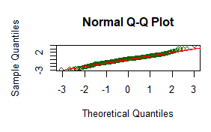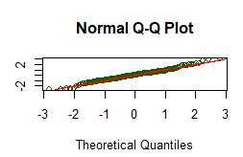
1b: FEV1 in females
1a: FEV1 in males

1d: FVC in females
1c:FVC in males

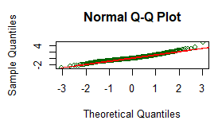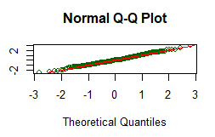

1f: FEV1/FVC in females
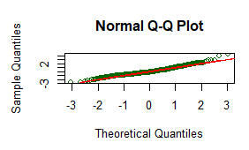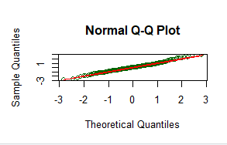
1e: FEV1/FVC in males

1g: FEF25-75% in males
1h: FEF25-75% in females
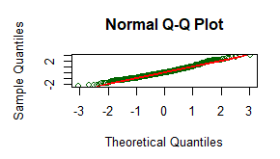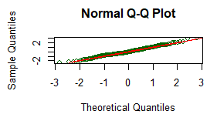

Figure 1a to 1h supplementary: Normal Q-Q plots for FEV₁, FVC, FEV₁/FVC and FEF_{25-75%} by gender

