Supplementary Data
Table S1 Summary of Illumina 16S rDNA sequencing data of Cynomys ludovicianus fecal microbiome across study sites
Sites | Sample ID | Reads | Filtered reads | Observed OTUs | Shannon | Faith’s PD
Lubbock | BH22621 | 77295 | 54964 | 1733 | 6.84 | 13.14
Lubbock | BH42621 | 91316 | 65179 | 1678 | 6.77 | 12.73
Lubbock | BH152521 | 83497 | 59364 | 1729 | 6.77 | 12.86
Lubbock | BH252521 | 74216 | 54097 | 1916 | 6.94 | 13.30
Lubbock | MP18111 | 51568 | 37568 | 647 | 5.17 | 8.96
Lubbock | MP18112 | 55870 | 42509 | 1168 | 6.25 | 10.89
Lubbock | MP18113 | 56935 | 41591 | 1094 | 6.16 | 10.16
Lubbock | MP18114 | 65203 | 50207 | 1922 | 6.93 | 14.09
Lubbock | MP18115 | 105295 | 81544 | 1773 | 6.77 | 12.51
Lubbock | MP18116 | 89500 | 69002 | 1023 | 6.02 | 9.67
Lubbock | ID352521 | 40676 | 28950 | 1482 | 6.59 | 11.28
Lubbock | ID452521 | 48011 | 32234 | 1608 | 6.71 | 11.89
Randall | BL641 | 72630 | 52130 | 1679 | 6.68 | 11.93
Randall | BL642 | 56565 | 40933 | 1528 | 6.52 | 11.39
Randall | BL643 | 73853 | 53193 | 1708 | 6.74 | 11.62
Randall | BL644 | 66696 | 46337 | 1705 | 6.68 | 11.80
Randall | BL645 | 75130 | 52812 | 1901 | 6.95 | 12.94
Randall | BL646 | 60496 | 41036 | 1771 | 6.75 | 12.31
Randall | BL647 | 92870 | 65413 | 1910 | 6.99 | 12.98
Randall | BL648 | 88695 | 63855 | 1733 | 6.77 | 11.84
Randall | BL649 | 71601 | 52182 | 1829 | 6.54 | 12.92
Randall | BL6410 | 70439 | 52676 | 1751 | 6.35 | 11.93
Randall | BL6411 | 97095 | 68788 | 1233 | 6.27 | 9.58
Randall | BL6412 | 49993 | 36002 | 1698 | 6.71 | 11.88
Randall | BL6413 | 150685 | 109441 | 1331 | 5.48 | 11.18
Randall | BL6414 | 87710 | 62767 | 1808 | 6.77 | 13.27
Randall | BL6415 | 90038 | 64745 | 1586 | 6.62 | 11.11
Hockley | LV641 | 36755 | 26828 | 1077 | 5.98 | 9.88
Hockley | LV642 | 81899 | 60198 | 1205 | 6.07 | 9.91
Hockley | LV644 | 33270 | 23824 | 1189 | 6.22 | 10.53
Hockley | LV645 | 43535 | 30595 | 1307 | 6.22 | 10.78
Hockley | SM641 | 74984 | 53411 | 1415 | 6.50 | 11.94
Hockley | SM642 | 70557 | 51159 | 1565 | 6.67 | 11.91
Hockley | SM643 | 105297 | 78120 | 1363 | 6.33 | 10.87
Hockley | SM644 | 95878 | 69991 | 1311 | 6.27 | 11.06
Hockley | SM645 | 81012 | 58160 | 1559 | 6.58 | 12.87
Hockley | SM646 | 98651 | 69497 | 972 | 6.00 | 9.29
Hockley | SM647 | 70155 | 49930 | 1602 | 6.65 | 12.96
Hockley | SM648 | 43622 | 30827 | 1129 | 6.17 | 10.04
 | SM649 | 81545 | 58333 | 1225 | 6.19 | 10.52
 | SMI641 | 92127 | 66357 | 1585 | 6.69 | 10.82
Bailey | M6121 | 77937 | 57458 | 1250 | 6.35 | 11.09
Bailey | M6122 | 50915 | 32855 | 1130 | 6.21 | 10.59
Bailey | M6123 | 109928 | 81582 | 1325 | 6.21 | 10.93
Bailey | M6124 | 28178 | 15839 | 1053 | 6.17 | 10.52
Bailey | M6125 | 66589 | 47998 | 1199 | 6.30 | 10.79
Bailey | M6126 | 58992 | 43434 | 1198 | 6.29 | 10.56
Bailey | M6127 | 357624 | 256779 | 1614 | 6.35 | 12.98
Bailey | M6128 | 127413 | 104072 | 1718 | 6.66 | 12.38
Bailey | M6129 | 30203 | 23528 | 1252 | 6.22 | 10.73
Bailey | M61210 | 78538 | 58841 | 1281 | 6.20 | 10.37
Bailey | N6121 | 124427 | 97636 | 1323 | 6.31 | 11.39
Bailey | N6122 | 70638 | 56080 | 1258 | 5.99 | 10.26
Bailey | N6123 | 72956 | 56789 | 1093 | 6.17 | 10.23
Bailey | N6124 | 74422 | 55543 | 1114 | 6.08 | 10.33
Bailey | N6125 | 69107 | 47439 | 1039 | 6.12 | 10.55
Bailey | N6126 | 75448 | 53711 | 1067 | 5.72 | 10.15
Dallam | RB681 | 67526 | 48401 | 1677 | 6.73 | 12.38
Dallam | RB682 | 62888 | 46430 | 1552 | 6.65 | 11.91
Dallam | RB683 | 106628 | 78895 | 1819 | 6.81 | 13.62
Dallam | RB684 | 64624 | 47353 | 1642 | 6.74 | 12.04
Dallam | RB685 | 54201 | 37337 | 1165 | 6.05 | 9.61
Dallam | RB686 | 79835 | 58307 | 1847 | 6.93 | 12.66
Dallam | RB687 | 71679 | 49086 | 1828 | 6.96 | 13.26
Dallam | RB688 | 73365 | 53881 | 1603 | 6.71 | 12.21
Dallam | RB689 | 88499 | 65052 | 1878 | 6.91 | 12.32
Dallam | RB6811 | 35826 | 27208 | 1790 | 6.90 | 12.69
Dallam | RB6812 | 53133 | 40000 | 1796 | 6.84 | 13.18
Dallam | RB6813 | 49734 | 37062 | 1509 | 6.17 | 12.10
Dallam | RB6814 | 73242 | 54602 | 1733 | 6.77 | 12.82
Total | 70 | 5,407,660 | 3,939,947 | 5,118

Table S2 Effect of host locations on the microbiome community composition based on the results of overall and pairwise ADONIS (Permutational multivariate analysis of variance using distance metrics) tests
Comparison | Metrics | F-statistic | R² | p-value
Overall | Bray-Curtis | 3.49 | 0.17 | <0.01
Overall | Unweighted Unifrac | 4.33 | 0.21 | <0.01
Overall | Weighted Unifrac | 3.54 | 0.18 | <0.01
Bailey/Dallam | Bray-Curtis | 3.20 | 0.14 | <0.01
Bailey/Dallam | Unweighted Unifrac | 4.53 | 0.19 | <0.01
Bailey/Dallam | Weighted Unifrac | 2.69 | 0.12 | <0.01
Bailey/Hockley | Bray-Curtis | 3.29 | 0.15 | <0.01
Bailey/Hockley | Unweighted Unifrac | 4.81 | 0.21 | <0.01
Bailey/Hockley | Weighted Unifrac | 3.32 | 0.15 | <0.01
Bailey/Lubbock | Bray-Curtis | 4.07 | 0.17 | <0.01
Bailey/Lubbock | Unweighted Unifrac | 6.04 | 0.23 | <0.01
Bailey/Lubbock | Weighted Unifrac | 3.64 | 0.16 | <0.01
Bailey/Randall | Bray-Curtis | 2.75 | 0.13 | <0.01
Bailey/Randall | Unweighted Unifrac | 3.89 | 0.17 | <0.01
Bailey/Randall | Weighted Unifrac | 2.57 | 0.12 | 0.01
Dallam/Hockley | Bray-Curtis | 3.35 | 0.14 | <0.01
Dallam/Hockley | Unweighted Unifrac | 5.42 | 0.21 | <0.01
Dallam/Hockley | Weighted Unifrac | 2.96 | 0.12 | 0.01
Dallam/Lubbock | Bray-Curtis | 3.78 | 0.15 | <0.01
Dallam/Lubbock | Unweighted Unifrac | 5.57 | 0.22 | <0.01
Dallam/Lubbock | Weighted Unifrac | 3.48 | 0.14 | <0.01
Dallam/Randall | Bray-Curtis | 2.61 | 0.11 | 0.02
Dallam/Randall | Unweighted Unifrac | 3.35 | 0.14 | <0.01
Dallam/Randall | Weighted Unifrac | 2.61 | 0.12 | <0.01
Hockley/Lubbock | Bray-Curtis | 4.50 | 0.18 | <0.01
Hockley/Lubbock | Unweighted Unifrac | 7.78 | 0.27 | <0.01
Hockley/Lubbock | Weighted Unifrac | 5.16 | 0.20 | <0.01
Hockley/Randall | Bray-Curtis | 3.35 | 0.15 | <0.01
Hockley/Randall | Unweighted Unifrac | 5.43 | 0.22 | <0.01
Hockley/Randall | Weighted Unifrac | 3.79 | 0.16 | <0.01
Lubbock/Randall | Bray-Curtis | 3.81 | 0.16 | <0.01
Lubbock/Randall | Unweighted Unifrac | 5.75 | 0.22 | <0.01
Lubbock/Randall | Weighted Unifrac | 4.11 | 0.17 | <0.01

Table S3 Comparison of sampling method and gut microbiome composition of black-tailed prairie dogs’ study in North American Great Plains
Study area | Sample size | Sample type | Variable regions amplified | Phyla identified | % of Firmicutes | % of Bacteroidetes | Source
Chihuahua, Mexico | n=10 | Fecal | V3-V4 | 12 | 83.1 | 9.9 | Pacheco-Torres et al. 2019
Kansas, USA | n=58 | Fecal and Cecal | V4 | 28 | 75.0 | 1.8 | Rooney et al. 2021
Texas, USA | n=70 | Fecal | V1-V3 | 11 | 39.6 | 57.3 | This study

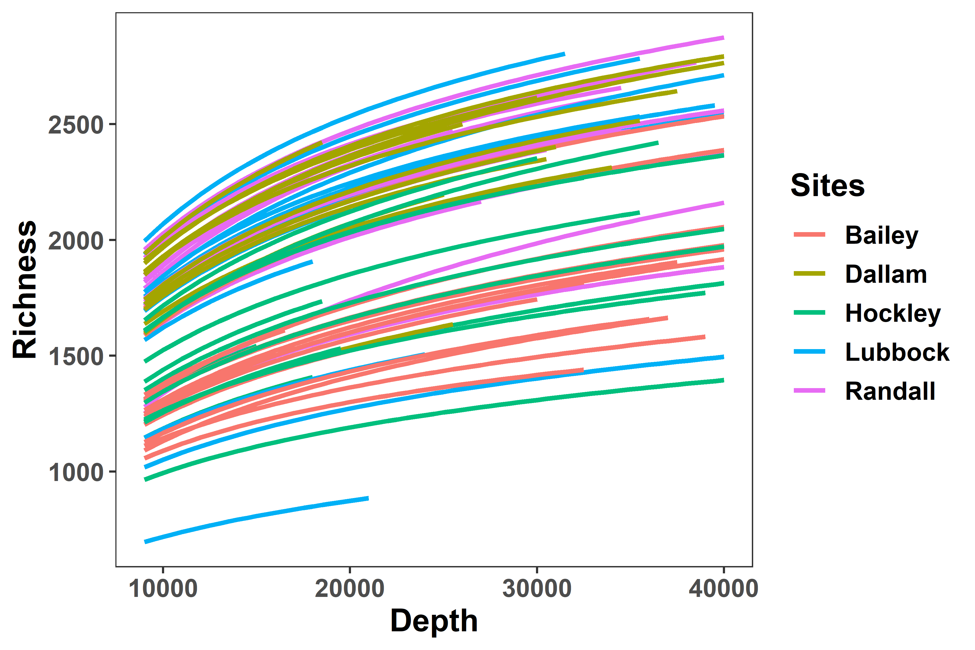
Fig. S1 Rarefaction curves showing species richness as a function of normalized sequence depth for each sample clustered by sites

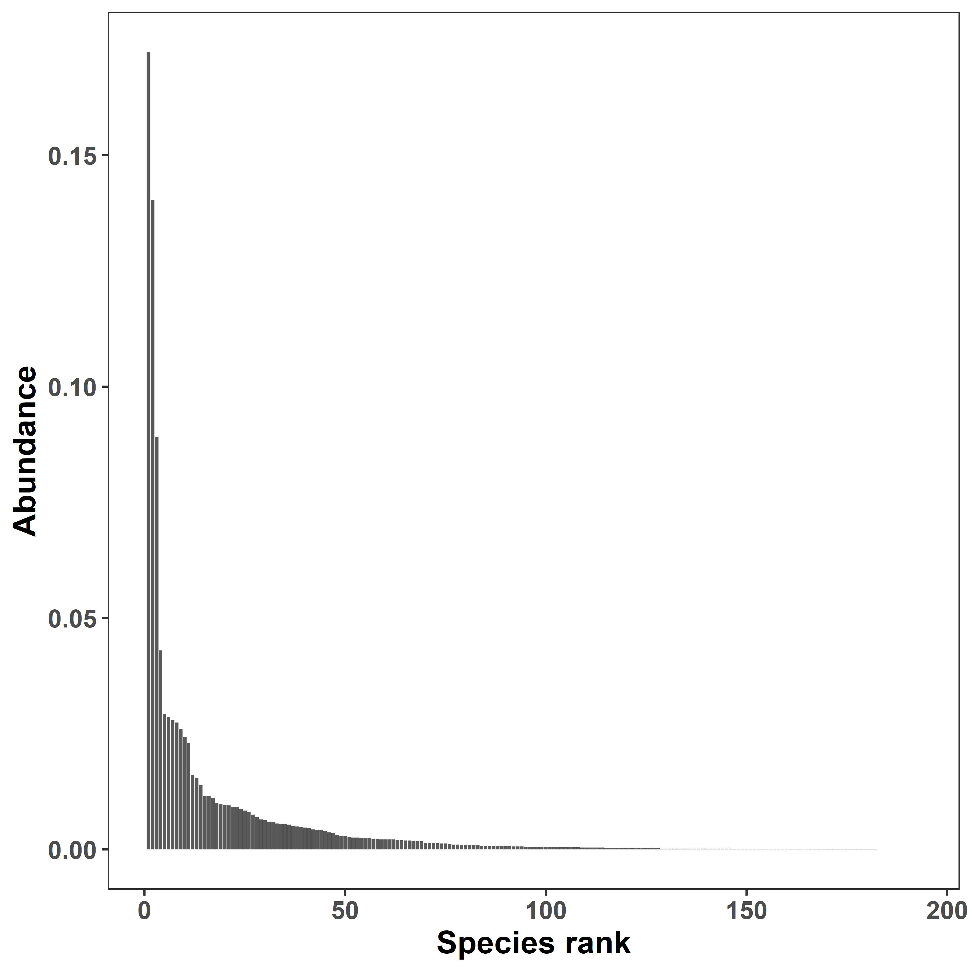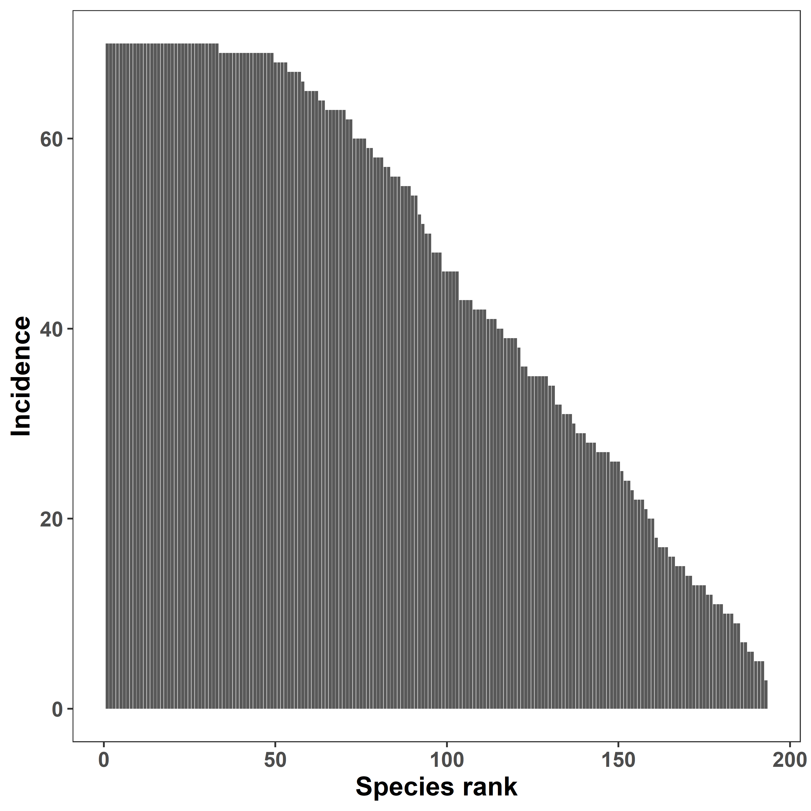
(A) (B)
Fig. S2 Species abundance distribution and detection rate across sample datasets (A) Rank abundance plot depicts high-ranking species having higher abundances compared to low-ranking species, and (B) Incidence abundance plot shows about 100 bacterial species being detected in 70% of fecal samples across the dataset

