Supplementary Materials for

“Cognitive and Psychiatric Relevance of Dynamic Functional Connectivity States in Children”

ABCD Data
The present study used the ABCD data that is shared by the National Institute of Mental Health Data Archive (NDA) (https://nda.nih.gov/). NDA provides infrastructure for sharing human subject data across many scientific domains to enable collaborative science and discovery. The ABCD data were collected from 21 sites throughout the United States, where the imaging methods and assessments were selected, optimized, and harmonized across centers ¹. The ABCD study collected T1, T2, diffusion, and multiple fMRI data (including resting-state and tasks) relevant to adolescent development and addiction. The ABCD study also provides a diverse range of measures assessing predictors and outcomes related to mental health and cognitive development across childhood and adolescence ². The release 2.0.1 of the ABCD FastTrack images with recommended active series was downloaded and used for the present investigation. The FastTrack images are unprocessed imaging data that completed and passed raw quality control (QC).

Image Acquisition
High spatial and temporal resolution multiband echo-planar imaging (EPI) resting-state fMRI data with fast integrated distortion correction are acquired using three 3T scanner platforms: Siemens Prisma, General Electric 750, and Phillips. Resting-state fMRI parameters are similar across platforms: a standard multiband EPI sequence, repetition time (TR)/echo time (TE) = 800/30 ms, voxel spacing size = 2.4 × 2.4 × 2.4 mm, slice number = 60, flip angle (FA) = 52°, field of view (FOV) = 216 × 216 mm, multiband acceleration = 6, and a total acquisition time is around 5 min. During resting-state fMRI scans, participants were instructed to keep their eyes closed and rest quietly without falling asleep. More details of the imaging parameters for each platform are provided in ¹.

fMRI Preprocessing
We preprocessed the FastTrack fMRI images via a combination of the FMRIB Software Library v6.0 (FSL) toolbox and Statistical Parametric Mapping 12 (SPM) toolbox, under the MATLAB 2019b environment. First, rigid body motion correction was performed using the mcflirt tool in FSL. Second, we ran the distortion correction using the fMRI field map data that were collected with the phase reversed blips, producing pairs of images with distortion occurring in opposite directions. Volumes acquired with phase encoding in the anterior-posterior (AP) direction and volumes with phase encoding in the posterior-anterior (PA) direction were used with the FSL tool topup ^{3,4} to estimate the susceptibility-induced off-resonance field. The output field map coefficients were used to correct the distortion in the fMRI volume using the FSL tool applytopup. Third, we discarded 10 initial scans with large signal changes to allow the tissue to reach a steady state of radiofrequency excitation. Forth, the fMRI data were warped into the standard Montreal Neurological Institute (MNI) space based on the echo-planar imaging (EPI) template, resampling to 3 × 3 ×3 mm³ isotropic voxels using the normalization tool in SPM. Finally, the resliced fMRI images were smoothed using a Gaussian kernel with a full width at half maximum (FWHM) = 6 mm.

Behavior Assessment
The cognitive scores of each child were measured via the NIH Cognition Battery Toolbox (in abcd_tbss01 file) ⁵. Higher scores indicate better cognitive performance. The NIH neurocognitive battery contains seven distributional characteristics, including the Toolbox Picture Vocabulary Task (TPVT), the Toolbox Oral Reading Recognition Task (TORRT), the Toolbox Pattern Comparison Processing Speed Test (TPCPST), the Toolbox List Sorting Working Memory Test (TLSWMT), the Toolbox Picture Sequence Memory Test (TPSMT), the Toolbox Flanker Task (TFT), and the Toolbox Dimensional Change Card Sort Task (TDCCS). It also has three composite scores, including a Crystalized Intelligence Composite, a Fluid Intelligence Composite, and a Total Score Composite. Therefore, in total ten cognitive scores were used in this study. The details of the definition and measurement of each score can be found in ⁵.
The mental problem scores of each child were measured by the Parent-Child-Behavior-Checklist-Scores (in abcd_cbcls01 file). This checklist collected eight psychiatric problem scales associated with anxious/depressed, withdrawn/depressed, somatic complaints, social problems, thought problems, attention problems, rule-breaking behavior, aggressive behavior. There are also three summary scores, a total syndrome scale, internalizing broadband score, and externalizing broadband score ⁶. In addition, the checklist includes 6 DSM-Oriented scales and 3 CBCL Scale2007 scales that were calculated based on the questionnaire. In total 20 scores from the Parent-Child-Behavior-Checklist-Scores were used for the investigation. Higher scores on these measures indicate more dimensional psychopathology. Detailed information on these mental scores can be found in ⁷.

Quality Control and Subject Selection
We performed data QC on the preprocessed fMRI images to select subject data for further analysis. Whether subjects’ data have been well normalized to the MNI space will significantly influence the ICA results as well as the DFC estimation. Therefore, we excluded those scans that did not show good normalization to the MNI standard space. To be specific, we compared individual masks with the group mask and retained those scans with high similarities between the individual masks and the group mask. First, based on the first fMRI time volume, we calculated the individual mask for each scan of each subject by setting voxels to 1 if they are greater than 90% of the whole brain mean. Next, we computed a group mask by setting voxels to 1 if they have more than 90% of the scans with 1 for individual masks. For each scan, we then calculated the spatial correlations between the group mask and the individual mask. The spatial correlations were calculated using voxels within the top 10 slices of the mask, within the bottom 10 slices of the mask, and of the whole mask, resulting in three correlations for each scan. If a scan has the top-10-slices correlation larger than 0.75, the bottom-10-slices correlation larger than 0.55, and the whole-brain correlation larger than 0.8, we include this scan for further analysis. This method can ensure we have high-quality mask and fMRI data for the retaining scans and has been shown to work well in previous work ^{8–10}.

Neuromark Framework
The Neuromark framework leverages an adaptive-ICA technique that automates the estimation of comparable brain markers across subjects, datasets, and studies. A set of component templates were used as references to guide the estimation of single-scan components for the ABCD data. These component templates were created via a unified ICA pipeline. They were constructed using the resting-state fMRI data with large samples of healthy subjects from the human connectome project (HCP) and the genomics superstruct project (GSP).
The HCP data include 823 subjects’ scans and the GSP data include 1005 subjects’ scans that passed the data QC. High model order (order = 100) group ICA was performed on each data respectively, and then the independent components (ICs) from two data were matched by examining the similarity of their spatial maps ¹¹. The IC pairs are considered consistent and reproducible across GSP and HCP data if their spatial correlation ≥ 0.4. A correlation value ≥ 0.25 has been shown to represent a significant correspondence (p < 0.005, corrected) between components, and here we used a higher threshold because we would like to capture more reliable and consistent ICs as the templates. The matched IC pairs were labeled as meaningful component templates or noise components by five experts in the ICA field based on expectations that ICNs should exhibit peak activations in grey matter, low spatial overlap with known vascular, ventricular, motion, and susceptibility artifacts, and should have TCs dominated by low-frequency fluctuations. inspecting the locations of the peak activations of their spatial maps and the low-frequency fluctuations of their TCs. The less noisy ICs from the GSP data were chosen as the component templates for the estimation of the single-scan components and TCs. More details of the Neuromark framework and its implementation can be found at ¹².

Component Templates (Peak Coordinates and Spatial Maps)
              - Peak Coordinates of Components
Selected Components as Regions of Interest | X | Y | Z
Subcortical Network (SC)
Caudate (69) | 6.5 | 10.5 | 5.5
Subthalamus/hypothalamus (53) | -2.5 | -13.5 | -1.5
Putamen (98) | -26.5 | 1.5 | -0.5
Caudate (99) | 21.5 | 10.5 | -3.5
Thalamus (45) | -12.5 | -18.5 | 11.5
Auditory Network (AUD)
Superior temporal gyrus ([STG], 21) | 62.5 | -22.5 | 7.5
Middle temporal gyrus ([MTG], 56) | -42.5 | -6.5 | 10.5
Sensorimotor Network (SM)
Postcentral gyrus ([PoCG], 3) | 56.5 | -4.5 | 28.5
Left postcentral gyrus ([L PoCG], 9) | -38.5 | -22.5 | 56.5
Paracentral lobule ([ParaCL], 2) | 0.5 | -22.5 | 65.5
Right postcentral gyrus ([R PoCG], 11) | 38.5 | -19.5 | 55.5
Superior parietal lobule ([SPL], 27) | -18.5 | -43.5 | 65.5
Paracentral lobule ([ParaCL], 54) | -18.5 | -9.5 | 56.5
Precentral gyrus ([PreCG], 66) | -42.5 | -7.5 | 46.5
Superior parietal lobule ([SPL], 80) | 20.5 | -63.5 | 58.5
Postcentral gyrus ([PoCG], 72) | -47.5 | -27.5 | 43.5
Visual Network (VS)
Calcarine gyrus ([CalcarineG], 16) | -12.5 | -66.5 | 8.5
Middle occipital gyrus ([MOG], 5) | -23.5 | -93.5 | -0.5
Middle temporal gyrus ([MTG], 62) | 48.5 | -60.5 | 10.5
Cuneus (15) | 15.5 | -91.5 | 22.5
Right middle occipital gyrus ([R MOG], 12) | 38.5 | -73.5 | 6.5
Fusiform gyrus (93) | 29.5 | -42.5 | -12.5
Inferior occipital gyrus ([IOG], 20) | -36.5 | -76.5 | -4.5
Lingual gyrus ([LingualG], 8) | -8.5 | -81.5 | -4.5
Middle temporal gyrus ([MTG], 77) | -44.5 | -57.5 | -7.5
Cognitive-control Network (CC)
Inferior parietal lobule ([IPL], 68) | 45.5 | -61.5 | 43.5
Insula (33) | -30.5 | 22.5 | -3.5
Superior medial frontal gyrus ([SMFG], 43) | -0.5 | 50.5 | 29.5
Inferior frontal gyrus ([IFG], 70) | -48.5 | 34.5 | -0.5
Right inferior frontal gyrus ([R IFG], 61) | 53.5 | 22.5 | 13.5
Middle frontal gyrus ([MiFG], 55) | -41.5 | 19.5 | 26.5
Inferior parietal lobule ([IPL], 63) | -53.5 | -49.5 | 43.5
Left inferior parietal lobue ([R IPL], 79) | 44.5 | -34.5 | 46.5
Supplementary motor area ([SMA], 84) | -6.5 | 13.5 | 64.5
Superior frontal gyrus ([SFG], 96) | -24.5 | 26.5 | 49.5
Middle frontal gyrus ([MiFG], 88) | 30.5 | 41.5 | 28.5
Hippocampus ([HiPP], 48) | 23.5 | -9.5 | -16.5
Left inferior parietal lobule ([L IPL], 81) | -47.5 | 5.5 | 22.5
Middle cingulate cortex ([MCC], 37) | -15.5 | 20.5 | 37.5
Inferior frontal gyrus ([IFG], 67) | 39.5 | 44.5 | -0.5
Middle frontal gyrus ([MiFG], 38) | -26.5 | 47.5 | 5.5
Hippocampus ([HiPP], 83) | -24.5 | -36.5 | 1.5
Default-mode Network (DM)
Precuneus (32) | -8.5 | -66.5 | 35.5
Precuneus (40) | -12.5 | -54.5 | 14.5
Anterior cingulate cortex ([ACC], 23) | -2.5 | 35.5 | 2.5
Posterior cingulate cortex ([PCC], 71) | -5.5 | -28.5 | 26.5
Anterior cingulate cortex ([ACC], 17) | -9.5 | 46.5 | -10.5
Precuneus (51) | -0.5 | -48.5 | 49.5
Posterior cingulate cortex ([PCC], 94) | -2.5 | 54.5 | 31.5
Cerebellar Network (CB)
Cerebellum ([CB], 13) | -30.5 | -54.5 | -42.5
Cerebellum ([CB], 18) | -32.5 | -79.5 | -37.5
Cerebellum ([CB], 4) | 20.5 | -48.5 | -40.5
Cerebellum ([CB], 7) | 30.5 | -63.5 | -40.5

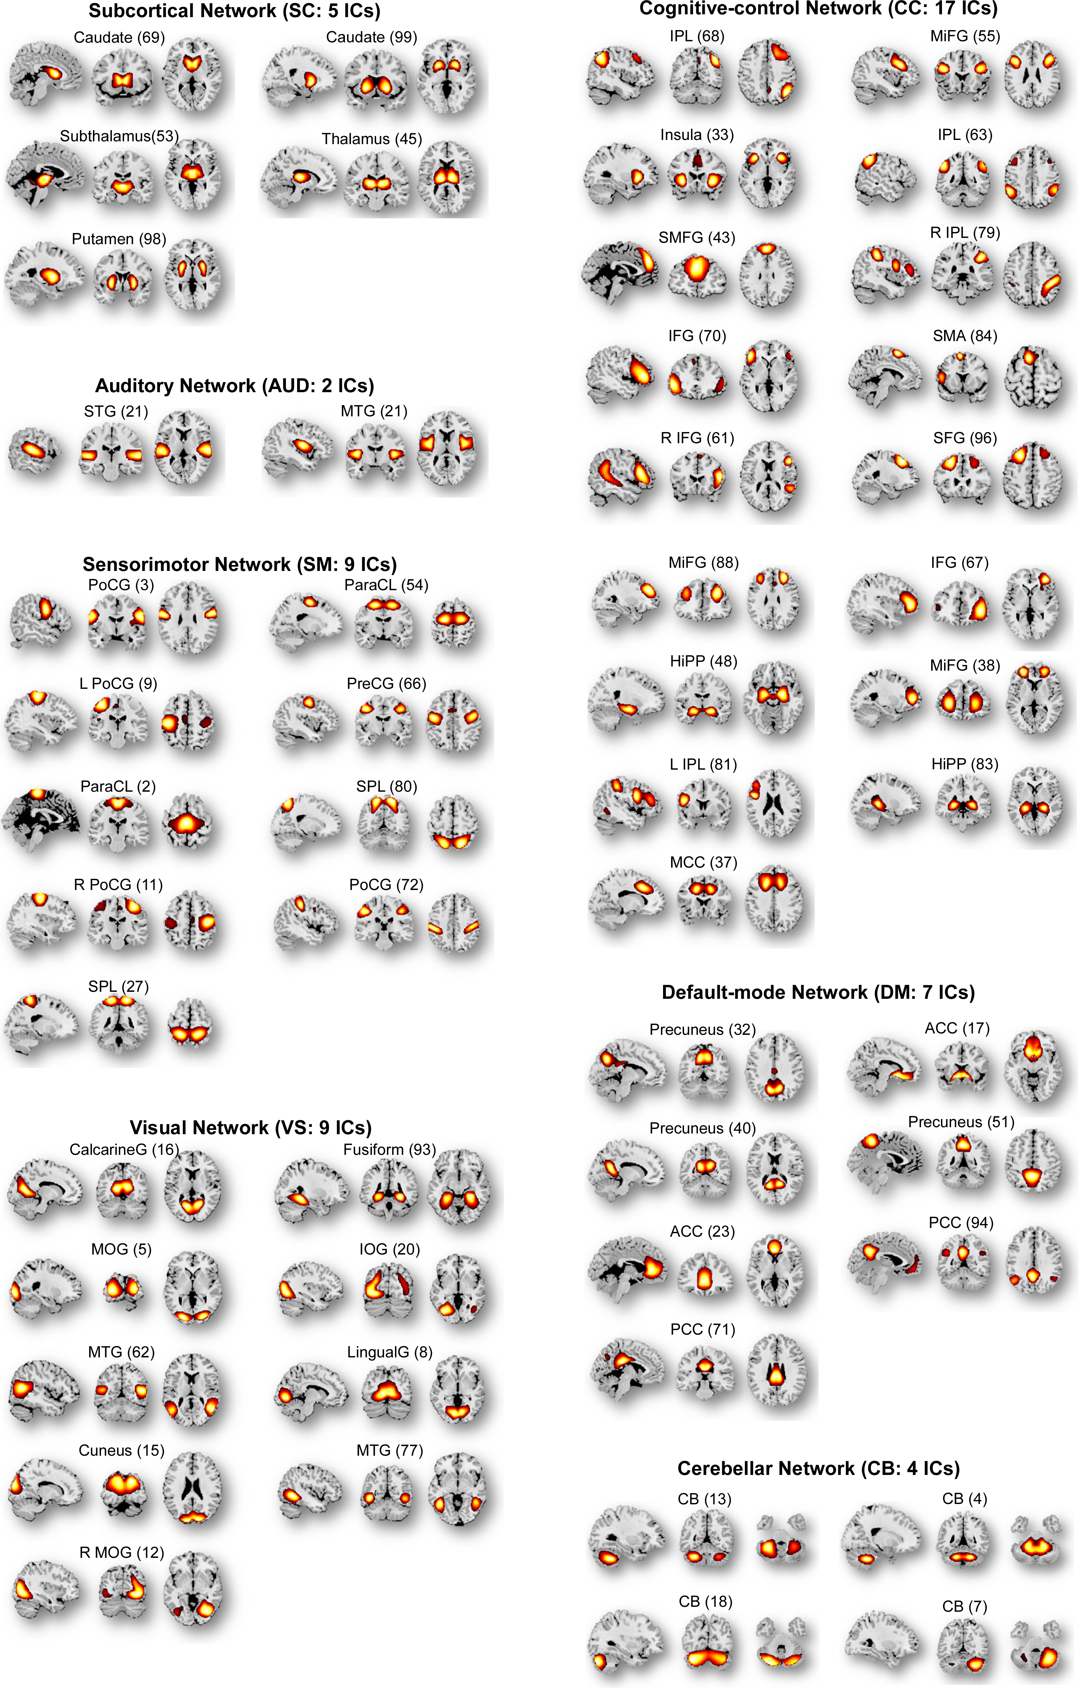
            - Component templates constructed by the Neuromark framework. Spatial maps of the 53 IC templates are arranged into 7 functional networks according to the anatomic and functional prior knowledge. Component templates are thresholded at |t|>10, where one-sample t-statistics have been computed across the single-subject spatial maps. Sagittal, coronal, and axial slices are shown at the maximal t-statistic for clusters larger than 3 cm³.

Replication of Associations by Controlling for Head Motion
We noted that head motion in children’s imaging may significantly influence the data quality and the estimation of DFC. In the main text, we have carefully performed three procedures to minimize the impacts of head motion in the images. To further show that the identified associations between DFC states and children’s cognition and mental problem scores are not introduced by the head motion, we reperformed the analysis by controlling for the head motion in the LMM.
Specifically, we calculated the framewise displacement (FD) ^{13,14} of scan for each subject and used the mean FD, which is the averaged FD across volumes to evaluate the overall head motion factor for each subject. Then we modeled the head motion factor as one of the fixed effects in the LMM analysis. The other model settings are the same as those introduced in the main text. Association results are highly replicated by controlling for mean FD and are provided in Table S2 and S3. The cardsort score, fluid composite score, and total composite score were negatively correlated with the fractional rate of state 1 and positively correlated with the fractional rate of state 5. Meanwhile, the attention score and the DSM-5 ADHD score were positively correlated with the fractional rate of state 1 and negatively correlated with the fractional rate of state 5.
              - Correlation between fractional rate of state 1 and children’s cognition and mental scores
Assessments | R value | Cohen’s d | P value
nihtbx_cardsort | -0.0328 | -0.0656 | 6.48×10⁻⁴
nihtbx_fluidcomp | -0.0455 | -0.0911 | 2.33×10⁻⁶
nihtbx_totalcomp | -0.0429 | -0.0859 | 8.43×10⁻⁶
cbcl_scr_syn_attention | 0.0319 | 0.0639 | 8.29×10⁻⁴
cbcl_scr_dsm5_adhd | 0.0298 | 0.0596 | 1.77×10⁻³
              - Correlation between fractional rate of state 5 and children’s cognition and mental scores
Assessments | R value | Cohen’s d | P value
nihtbx_cardsort | 0.0321 | 0.0643 | 8.28×10⁻⁴
nihtbx_fluidcomp | 0.0216 | 0.0431 | 0.0253
nihtbx_totalcomp | 0.0145 | 0.0289 | 0.1334
cbcl_scr_syn_attention | -0.0516 | -0.1034 | 6.31×10⁻⁸
cbcl_scr_dsm5_adhd | -0.0443 | -0.0887 | 3.43×10⁻⁶

Replication of Associations using Different Samples
Here, we randomly split the data in half, one half includes data from randomly picked 10 sites, and the other half includes data from the remaining 11 sites. For each half of the data, we re-performed the k-means clustering to identify 5 reoccurring DFC states. Then we matched the DFC states captured by each half to the state centroids obtained using data from all 21 sites. The two meaningful DFC states are consistently observed across each half of the data with r values > 0.99. After identifying the matched states, we replicated the associations between DFC states and cognitive/mental scores (Fig. S3B) using the LMM analysis.
            - Replication of associations between DFC states and children’s cognitive development/mental health by using different sub-samples. A) The main findings from the discovery data of the baseline scan 1, which includes 10988 subjects from all 21 sites. B) Replication by spliting the data in half. Two brain states with consistent associations with cognitive scores and mental problem scores are identified in both half of data. C) Replication by using balanced samples across sites. Two brain states with consistent associations with cognitive scores and mental problem scores are identified.
To further demonstrate that the imbalanced samples across sites will not influence our findings, we repeated our analysis by selecting the same number of subjects from each site. 294 subjects (the minimum number of subjects within one site that pass the QC) were selected for each site, resulting in a total of 6174 subjects for the analysis. We performed the same analysis, including k-means clustering, state matching, and LMM to explore the relationships between the DFC states and cognition/mental scores. The overall results are consistent, where the two DFC states show significantly reverse relationships with the cognitive performance and mental scores (Fig. S3C).

Replication of Associations using Different Numbers of Clusters
In this section, we will show that our findings are not due to the arbitrary selection of the number of clusters in the k-means clustering. We performed the k-means clustering with 4 or 6 centroids on the DFC estimates from the baseline scan 1. Then we matched the new captured brain states to those presented in the main text by evaluating their FC similarities via correlation. The two DFC states highlighted in the main text can be consistently observed with r values > 0.95. More importantly, these two states show similar positive and negative correlations with cognitive performance and mental scores, respectively.
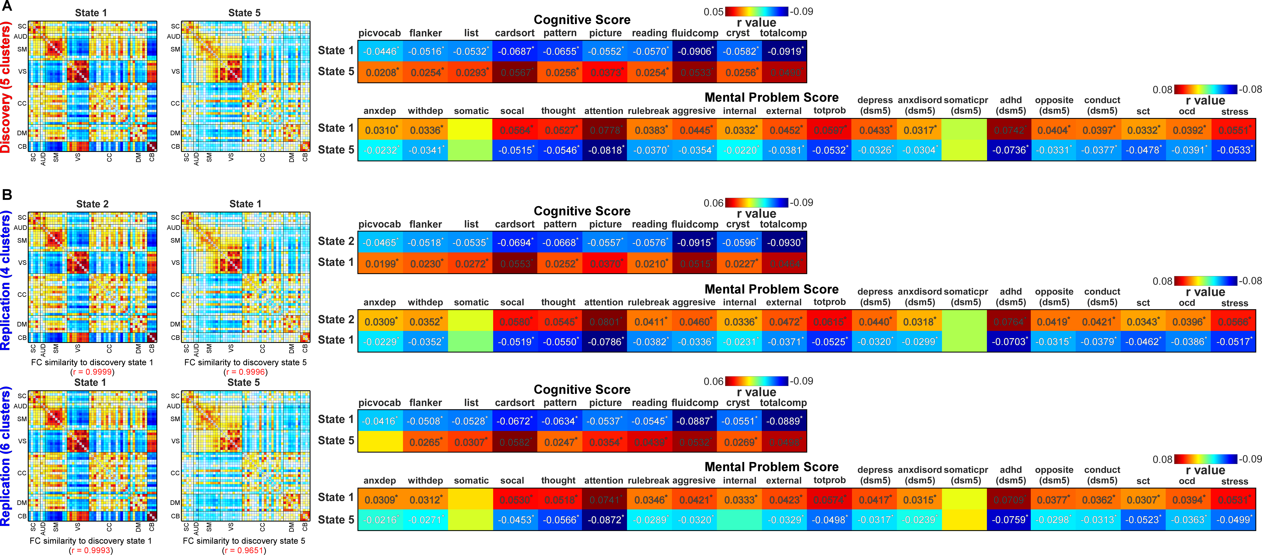
            - The associations between the fractional rate of DFC states and children’s cognitive development and mental health are replicated by using different numbers of clusters in k-means clustering. A) Two brain states identified by the k-means clustering with 5 clusters. These two states show reverse associations with cognitve scores and mental problem scores. B) The two DFC states were reproduced by using k-means clustering with four and six clusters. The associations with cognitive scores and mental problem scores are in line with the main findings.

Mental Health mediates Effects of DFC States on Total Composite Score
The fractional rate of DFC states is the independent variable, and the total composite score is the dependent variable. Similarly, we selected the attention score and DSM-5 ADHD score as the mediators. The mediation analysis shows that the attention score mediates the effect of the occurrence of state 1 on the total composite score (Fig.S5A, path AB, 14.86% of the total effect size, beta = -0.7076, p = 2.54 × 10⁻⁴; CI, -0.7775~-0.6372). The attention score also mediates the effect of the occurrence of state 5 on the total composite score (Fig.S5B, path AB, 28.18% of the total effect size, beta = 0.7769, p = 1.60 × 10⁻⁴; CI, 0.7187~0.8484).
Similar results were also found for the DSM 5 ADHD score. The ADHD score mediates the effect of the occurrence of state 1 on the total composite score (Fig.S5C, path AB, 12.80% of the total effect size, beta = -0.6101, p = 3.01 × 10⁻⁴; CI, -0.6778~-0.5533). On the other hand, the ADHD score mediates the effect of the occurrence of state 5 on the total composite score (Fig.S5D, path AB, 22.74% of the total effect size, beta = 0.6266, p = 2.08 × 10⁻⁴; CI, 0.5678~0.6865).
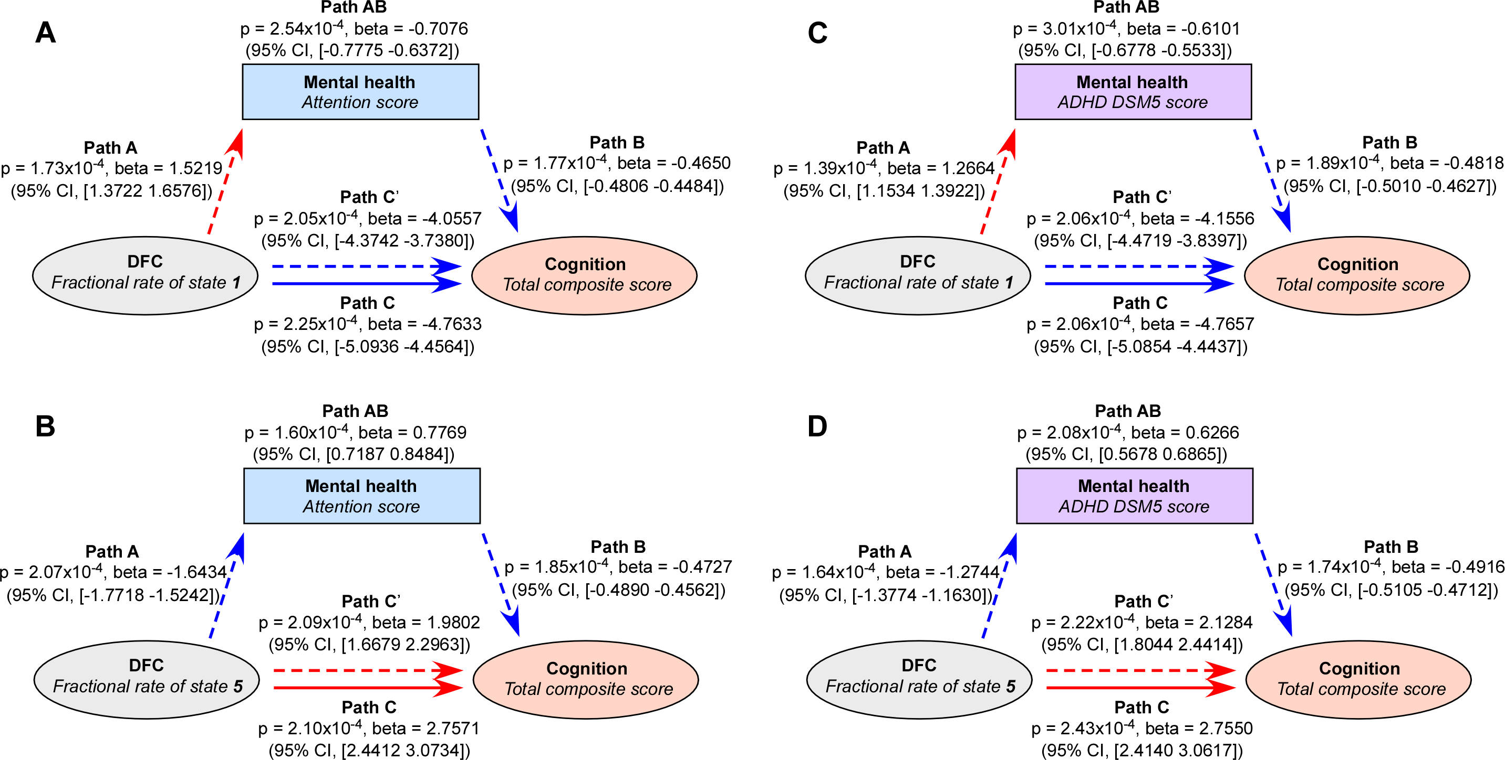
            - The mediation effects among DFC states, children’s cognition and mental health. A) The mediation implemented by attention problems from the state 1 on the total composite score is significant (beta = -0.7076, p = 2.54 × 10⁻⁴, 14.86% of the total effects). B) The mediation implemented by attention problems from the state 5 on the total composite score is significant (beta = 0.7769, p = 1.60 × 10⁻⁴, 28.18% of the total effects). C) The mediation implemented by ADHD scores from the state 1 on the total composite score is significant (beta = -0.6101, p = 3.01 × 10⁻⁴, 12.80% of the total effects). D) The mediation implemented by ADHD scores from the state 5 on the total composite score is significant (beta = 0.6266, p = 2.08 × 10⁻⁴, 22.74% of the total effects). The indirect paths A, B and AB show that the mental health meidiates part of the effect of DFC states on the total composite score. Path A: effect of the fractional rate of DFC states on the mediator, mental health scores; Path B: effect of the mediator on cognitive performance; Path C’: direct effect of the fractional rate of DFC states on cognitive performance; Path AB: Percentage of effect of DFC states on cognition is explained by the mental health problems.

Reference
1. Casey, B. J. et al. The Adolescent Brain Cognitive Development (ABCD) study: Imaging acquisition across 21 sites. Dev. Cogn. Neurosci. 32, 43–54 (2018).
2. Barch, D. M. et al. Demographic, physical and mental health assessments in the adolescent brain and cognitive development study: Rationale and description. Dev. Cogn. Neurosci. 32, 55–66 (2018).
3. Andersson, J. L. R., Skare, S. & Ashburner, J. How to correct susceptibility distortions in spin-echo echo-planar images: Application to diffusion tensor imaging. Neuroimage 20, 870–888 (2003).
4. Smith, S. M. et al. Advances in functional and structural MR image analysis and implementation as FSL. Neuroimage 23, S208–S219 (2004).
5. Luciana, M. et al. Adolescent neurocognitive development and impacts of substance use: Overview of the adolescent brain cognitive development (ABCD) baseline neurocognition battery. Dev. Cogn. Neurosci. 32, 67–79 (2018).
6. Cheng, W. et al. Sleep duration, brain structure, and psychiatric and cognitive problems in children. Mol. Psychiatry 26, 3992–4003 (2021).
7. Achenbach, T. M. & Rescorla, L. A. The achenbach system of empirically based assessment (ASEBA) for ages 1.5 to 18 years. Use Psychol. Test. Treat. Plan. Outcomes Assess. Vol. 2 Instruments Child. Adolesc. 179–213 (2014). doi:10.4324/9781410610621-7
8. Fu, Z. et al. Dynamic state with covarying brain activity-connectivity: On the pathophysiology of schizophrenia. Neuroimage 224, (2021).
9. Sendi, M. S. E. et al. Abnormal Dynamic Functional Network Connectivity Estimated from Default Mode Network Predicts Symptom Severity in Major Depressive Disorder. Brain Connect. 11, 838–849 (2021).
10. Tu, Y. et al. Distinct thalamocortical network dynamics are associated with the pathophysiology of chronic low back pain. Nat. Commun. 11, (2020).
11. Smith, S. M. et al. Correspondence of the brain’s functional architecture during activation and rest. Proc. Natl. Acad. Sci. U. S. A. 106, 13040–13045 (2009).
12. Du, Y. et al. NeuroMark: An automated and adaptive ICA based pipeline to identify reproducible fMRI markers of brain disorders. NeuroImage Clin. 28, (2020).
13. Patel, A. X. et al. A wavelet method for modeling and despiking motion artifacts from resting-state fMRI time series. Neuroimage 95, 287–304 (2014).
14. Power, J. D., Barnes, K. A., Snyder, A. Z., Schlaggar, B. L. & Petersen, S. E. Spurious but systematic correlations in functional connectivity MRI networks arise from subject motion. Neuroimage 59, 2142–2154 (2012).

