Supporting Information for the article:
Fully-Automated SPE Coupled to UPLC-MS/MS Method for Simultaneous Detection of Sulfonamides, Quinolones, and Macrolide antibiotics in Water
Ming Zheng^{a,* ,1}, Suwen Tang^{a, 1}, Yangyang Bao^{b}, Kevin D. Daniels^{c} Zuo Tong How^{d}, Mohamed Gamal El-Din^{d}, Liang Tang^{a, *}
ª Key Laboratory of Organic Compound Pollution Control Engineering, School of Environmental and Chemical Engineering, Shanghai University, Shanghai 200444, China
^{b} Pudong New Area Environmental Monitoring Station, No.51 Lingshan Road.Pudong New Area, Shanghai, China.
^{c} Hazen and Sawyer, 1400 E. Southern Ave, Tempe, Arizona, 85282, USA
^{d} Department of Civil & Environmental Engineering, University of Alberta, Edmonton, Alberta, T6G 1H9, Canada
¹ These authors contributed equally to this work.

Suwen Tang: ytdxtangsuwen@163.com
Yangyang Bao: byy_0625@yeah.net
Kevin D. Daniels: kddaniels@outlook.com
Zuo Tong How: how@ualberta.ca
Mohamed Gamal El-Din: mgamalel-din@ualberta.ca
*Corresponding authors
E-mail addresses: 1010zhengming@tongji.edu.cn (M. Zheng). Tel.: +86 21 66137508; fax: +86 21 66137787；
E-mail addresses: tang1liang@shu.edu.cn (L. Tang).

Tables
Table S1 Longitude and latitude of sampling stations and related parameters
Sampling | Description | Longitude | Latitude
WWE1 | Outlet 1 of Bailongang STP | 121°44'35’’ | 31°14'52’’
WWE2 | Outlet 2 of Bailongang STP | 121°44'35’’ | 31°14'52’’
SW1 | The water of the Yangtze River near WWTP outlet | 121°45’9.6’’E | 31°15’31’’N
SW2 | 5 km upstream of Yangtze River from SR1-section | 121°42’37’’E | 31°17’39’’N
SW3 | 4 km downstream of Yangtze River from SR1 section | 121°45’03’’E | 31°8’47’’N

Table S2 Compound-dependent parameters in MS/MS analysis
Category | Compound | Precursor Ion(m/z) | Product Ion (m/z) | Fragmentor (v) | Collision Energy (v) | Retention time (min)
Sulfonamides | SD | 251.06 | 156 | 110 | 14 | 3.436
Sulfonamides |  |  | 92 | 110 | 26
Sulfonamides | SDMD | 265.08 | 155.9 | 126 | 14 | 5.123
Sulfonamides |  |  | 92.1 | 126 | 34
Sulfonamides | SM2 | 279.09 | 186 | 138 | 18 | 7.068
Sulfonamides |  |  | 92 | 138 | 34
Sulfonamides | SMT | 271.03 | 156 | 118 | 14 | 7.414
Sulfonamides |  |  | 92 | 118 | 34
Sulfonamides | SMX | 254.06 | 155.9 | 86 | 10 | 9.624
Sulfonamides |  |  | 92.1 | 86 | 26
Sulfonamides | SDM | 311.08 | 156 | 134 | 20 | 15.719
Sulfonamides |  |  | 92.1 | 134 | 36
Quinolones | MAR | 363.37 | 320 | 122 | 14 | 7.461
Quinolones |  |  | 72.2 | 122 | 20
Quinolones | ENR | 360.41 | 342.1 | 128 | 18 | 10.672
Quinolones |  |  | 316.1 | 128 | 18
Quinolones | DAM | 358.51 | 340.1 | 132 | 22 | 10.988
Quinolones |  |  | 82.1 | 132 | 46
Quinolones | DFLX | 400.31 | 382.1 | 132 | 22 | 11.413
Quinolones |  |  | 356.1 | 132 | 18
Quinolones | OFL | 362.38 | 318.1 | 138 | 18 | 8.78
Quinolones |  |  | 261.1 | 138 | 26
Quinolones | NOR | 320.31 | 302.1 | 108 | 22 | 9.415
Quinolones |  |  | 276.1 | 108 | 14
Quinolones | LOM | 352.51 | 314 | 129 | 42 | 10.817
Quinolones |  |  | 231 | 129 | 42
Quinolones | NAL | 233.25 | 215.1 | 96 | 13 | 21.115
Quinolones |  |  | 187 | 96 | 25
Quinolones | FLU | 262.26 | 244.1 | 98 | 18 | 22.458
Quinolones |  |  | 202 | 98 | 34
Quinolones | CIP | 332.51 | 314 | 129 | 18 | 10.073
Quinolones |  |  | 231 | 129 | 42
Macrolides | LIN | 407.22 | 359.1 | 128 | 18 | 5.881
Macrolides |  |  | 126.1 | 138 | 30
Macrolides | SPM | 843.52 | 174.1 | 204 | 42 | 16.705
Macrolides |  |  | 101 | 204 | 54
Macrolides | TILM | 869.61 | 174 | 108 | 48 | 20.974
Macrolides |  |  | 88.1 | 108 | 70
Macrolides | TYL | 916.53 | 174 | 238 | 44 | 26.159
Macrolides |  |  | 101 | 238 | 50
Macrolides | LM | 772.4 | 174 | 146 | 32 | 26.162
Macrolides |  |  | 109 | 146 | 48
Macrolides | ETM-H₂O | 716.46 | 558.3 | 150 | 14 | 26.65
Macrolides |  |  | 158.1 | 132 | 30
Macrolides | CTM | 748.51 | 158.1 | 162 | 29 | 27.338
Macrolides |  |  | 83.1 | 156 | 60
Macrolides | AZM·2H₂O | 749.41 | 591.3 | 130 | 30 | 27.337
Macrolides |  |  | 83.1 | 138 | 60
Macrolides | ROM | 837.51 | 679.4 | 158 | 18 | 27.565
Macrolides |  |  | 158.1 | 158 | 38
Macrolides | CLI | 425.19 | 377.1 | 150 | 18 | 19.605
Macrolides |  |  | 126.1 | 150 | 34

Table S3 Absolute Recoveries of target antibiotics on six different SPE cartridges/disks. (Analytes of 100 ug L⁻¹)
Category | Compound | Absolute Recovery (%) and the corresponding RSD (%) (n=5)
Category | Compound | HLB disk | RSD (%) | C18 disk | RSD (%) | HLB cartridge | RSD (%) | C18 cartridge (Lab tech) | RSD (%) | C18 cartridge (IST) | RSD (%) | Florisil cartridge | RSD (%)
Sulfonamides | SD | 68.7 | 1.3 | 98.4 | 1.2 | − | − | − | − | − | − | − | −
Sulfonamides | SDMD | 71.2 | 5.2 | 97 | 4.1 | 6.8 | 20.4 | − | − | 5.85 | 17.3 | − | −
Sulfonamides | SM2 | 84.2 | 7.5 | 94.1 | 2.2 | 10.3 | 9.7 | − | − | 12.8 | 9.3 | 9.9 | 23.7
Sulfonamides | SMT | 69.5 | 11.9 | 88.8 | 7.6 | 21.7 | 6.2 | − | − | 21.8 | 3.3 | − | −
Sulfonamides | SMX | 60.2 | 7.7 | 90.3 | 8.4 | 20.5 | 2.3 | − | − | 18.8 | 8.9 | − | −
Sulfonamides | SDM | 74 | 8.6 | 102.4 | 5.2 | 82.8 | 5.2 | − | − | 192.3 | 17.6 | 18.2 | 11.2
Quinolones | MAR | 50.2 | 6.7 | 7.8 | 5.6 | 35.4 | 12.6 | 2.0 | 19.4 | 34.6 | 13.3 | − | −
Quinolones | ENR | 19.8 | 4.4 | 2.5 | 6.6 | 13.5 | 15.8 | 1.1 | 11.3 | 27.4 | 9.3 | − | −
Quinolones | DAM | 19.7 | 7.5 | − | − | - |  | - |  | 13.4 | 6.4 | − | −
Quinolones | DFLX | 37.5 | 10.4 | 21.5 | 2.4 | 50.8 | 5.1 | 8.8 | 8.4 | 60.2 | 7.4 | − | −
Quinolones | OFL | 35.4 | 14.1 | 7.7 | 4.2 | 10.0 | 10.7 | 2.5 | 19.2 | 38.5 | 8.6 | 1.5 | 7.7
Quinolones | NOR | 89.1 | 7.9 | 54.8 | 12.5 | 34.0 | 4.1 | − | − | 60.2 | 2.6 | − | −
Quinolones | LOM | 30.3 | 5.3 | 21.9 | 20.4 | 52.0 | 7.9 | − | − | 52.0 | 2.3 | − | −
Quinolones | NAL | 47.4 | 9.6 | 57 | 9.2 | 50.3 | 20.9 | − | − | − | − | − | −
Quinolones | FLU | 84.6 | 5.5 | 157.1 | 7.5 | 243.6 | 26.4 | 26.0 | 24.6 | 130.7 | 3.1 | 12.1 | 8.9
Quinolones | CIP | 39 | 6.5 | 26.5 | 8.1 | 28.2 | 10.3 | 16.0 | 17.9 | 51.5 | 8.3 | 14.2 | 9.1
Macrolides | LIN | 12 | 14.4 | 29.3 | 6.4 | 89.4 | 4.6 | 39.2 | 9.3 | 59.8 | 12.9 | 12.0 | 10.5
Macrolides | SPM | 55.5 | 7.8 | − | − | 6.9 | 2.9 | − | − | − | − | 31.5 | 12.5
Macrolides | TILM | 27.4 | 2.1 | 9.9 | 9.1 | 28.8 | 6.7 | 7.0 | 5.1 | 27.4 | 9.4 | 2.4 | 7.5
Macrolides | TYL | 106.8 | 4.7 | 96.1 | 13.5 | 153.5 | 5.4 | 112.8 | 6.5 | 153.9 | 12.2 | 2.4 | 6.2
Macrolides | LM | 90.5 | 11.6 | 60.8 | 3.6 | 20.4 | 7.6 | 31.7 | 10.4 | 44.6 | 7.5 | 37.8 | 15.7
Macrolides | ETM-H₂O | 51.8 | 16.2 | 42 | 4.2 | 28.7 | 3.3 | 41.1 | 9.4 | 35.1 | 3.2 | 31.2 | 12.2
Macrolides | CTM | 63.6 | 9.6 | 36.3 | 20.3 | 30.4 | 4.1 | 10.2 | 15.6 | 26.1 | 1.9 | 7.0 | 8.5
Macrolides | AZM·2H₂O | 75.3 | 7.4 | 119.7 | 6.1 | 93.7 | 6.6 | 37.2 | 12.8 | 93.1 | 5.1 | 37.1 | 7.6
Macrolides | ROM | 86.5 | 5.6 | 128.2 | 5.3 | 84.4 | 6.4 | 40.6 | 78.1 | 115.1 | 9.3 | 38.2 | 9.7
Macrolides | CLI | 81 | 2.4 | 119.4 | 7.2 | 87.3 | 11.2 | 69.9 | 7.3 | 109.4 | 3.7 | 43.8 | 15.6
RSD: relative standard deviation. The eluent consist of 40 mL mixed solvent of methanol and acetone.

Table S4 Optimal selection of elution solvents on the recoveries for antibiotics.
Category | Compound | Methanol | Acetone | Methanol/Methylene chloride | Methanol/Acetone | Methylene chloride
Sulfonamides | SD | - | √ | - | - | -
Sulfonamides | SDMD | - | √ | - | - | -
Sulfonamides | SM2 | - | √ | - | - | -
Sulfonamides | SMT | √ | - | - | - | -
Sulfonamides | SMX | - | - | - | - | √
Sulfonamides | SDM | - | - | √ | - | -
Quinolones | MAR | √ | - | - | - | -
Quinolones | ENR | - | - | √ | - | -
Quinolones | DAM | - | - | - | - | √
Quinolones | DFLX | √ | - | - | - | -
Quinolones | OFL | - | - | - | - | √
Quinolones | NOR | - | - | - | √ | -
Quinolones | LOM | - | √ | - | - | -
Quinolones | NAL | - | - | √ | - | -
Quinolones | FLU | √ | - | - | - | -
Quinolones | CIP | √ | - | - | - | -
Macrolides | LIN | √ | - | - | - | -
Macrolides | SPM |  | √ | - | - | -
Macrolides | TILM | √ | - | - | - | -
Macrolides | TYL | - | - | - | √ | -
Macrolides | LM | - | √ | - |  | -
Macrolides | ETM-H₂O | - |  | - | √ | -
Macrolides | CTM | - | √ | - | - | -
Macrolides | AZM.·2H₂O | - | - | - | - | √
Macrolides | ROM | √ | - | - | - | -
Macrolides | CLI | - | √ | - | - | -
The elution effect were all calculated at a time of 6 mL eluent.

Table S5 Optimal selection of elution volume on the recoveries for antibiotics using MeOH and acetone.
Category | Compound | Elution volume (mL)
Category | Compound | 3 × 6 | 4 × 6 | 5 × 6
Sulfonamides | SD |  | MeOH
Sulfonamides | SDMD |  | MeOH
Sulfonamides | SM2 |  | MeOH
Sulfonamides | SMT |  | MeOH
Sulfonamides | SMX |  | MeOH
Sulfonamides | SDM |  | MeOH
Quinolones | MAR |  | MeOH
Quinolones | ENR |  |  | MeOH
Quinolones | DAM |  | Acetone
Quinolones | DFLX |  | Acetone
Quinolones | OFL |  | Acetone
Quinolones | NOR | MeOH
Quinolones | NAL | Acetone
Quinolones | FLU |  | MeOH
Quinolones | CIP | MeOH
Macrolides | LIN |  | MeOH
Macrolides | SPM |  |  | MeOH
Macrolides | TILM |  | Acetone
Macrolides | TYL |  | MeOH
Macrolides | LM | MeOH
Macrolides | ETM-H₂O |  | MeOH
Macrolides | CTM |  | MeOH
Macrolides | AZM.·2H₂O | Acetone
Macrolides | ROM |  | MeOH
Macrolides | CLI |  | MeOH

Table S6 Matrix spike recoveries of target antibiotics in PW, SW and WWE and the corresponding matrix effects (MEs). (Target analytes and isotopically-labeled surrogates (ISs) were set at 50 μg L⁻¹)
Category | Compound | PW |  | SW (n=5) |  |  | WWE
Category | Compound | Recovery (%) | RSD (%) | Recovery (%) | RSD (%) | ME (%) | Recovery (%) | RSD (%) | ME (%)
Sulfonamides | SD | 96.3 | 2.9 | 80.0 | 2.3 | 17.0 | 96.5 | 2.4 | -0.2
Sulfonamides | SDMD | 99.2 | 1.7 | 79.3 | 4.5 | 20.0 | 88.1 | 2.6 | 11.2
Sulfonamides | SM2 | 89.8 | 7.1 | 73.4 | 4.3 | 18.3 | 80.3 | 4.7 | 10.5
Sulfonamides | SMT | 95.0 | 5.4 | 80.4 | 1.3 | 15.4 | 87.0 | 2.9 | 8.4
Sulfonamides | SMX | 95.7 | 3.2 | 82.8 | 2.2 | 13.5 | 102.8 | 5.0 | -7.4
Sulfonamides | SDM | 94.0 | 4.3 | 91.3 | 3.6 | 2.8 | 94.0 | 4.1 | 0.0
Quinolones | MAR | 76.6 | 2.5 | 71.5 | 2.4 | 6.7 | 65.3 | 6.8 | 14.8
Quinolones | ENR | 83.8 | 2.9 | 75.0 | 4.6 | 10.6 | 67.2 | 8.3 | 19.8
Quinolones | DAM | 64.6 | 4.2 | 69.8 | 2.4 | -8.0 | 65.8 | 6.8 | -1.9
Quinolones | DFLX | 87.2 | 4.1 | 76.9 | 4.6 | 11.8 | 76.2 | 8.3 | 12.6
Quinolones | OFL | 74.3 | 3.1 | 69.8 | 5.8 | 6.1 | 67.8 | 6.9 | 8.8
Quinolones | NOR | 79.9 | 2.4 | 75.6 | 3.8 | 5.3 | 77.7 | 6.0 | 2.7
Quinolones | LOM | 72.7 | 6.1 | 66.9 | 5.2 | 8.0 | 70.5 | 4.6 | 3.1
Quinolones | NAL | 97.0 | 3.4 | 72.0 | 2.0 | 25.8 | 73.7 | 6.0 | 24.0
Quinolones | FLU | 88.2 | 2.4 | 80.3 | 3.4 | 8.9 | 82.0 | 4.8 | 7.0
Quinolones | CIP | 84.4 | 11.0 | 79.1 | 4.6 | 6.3 | 74.0 | 2.4 | 12.3
Macrolides | LIN | 74.6 | 2.1 | 68.5 | 4.5 | 8.2 | 71.5 | 4.4 | 4.1
Macrolides | SPM | 76.3 | 3.4 | 63.5 | 3.5 | 16.7 | 65.1 | 2.3 | 14.6
Macrolides | TILM | 69.4 | 2.1 | 69.0 | 8.6 | 0.6 | 64.7 | 4.4 | 6.9
Macrolides | TYL | 64.4 | 4.4 | 60.8 | 4.5 | 5.5 | 59.9 | 4.4 | 7.0
Macrolides | LM | 63.3 | 2.3 | 62.7 | 4.3 | 0.9 | 61.9 | 4.4 | 2.3
Macrolides | ETM-H₂O | 70.0 | 4.6 | 69.5 | 5.6 | 0.8 | 68.4 | 4.9 | 2.3
Macrolides | CTM | 74.5 | 6.7 | 74.5 | 7.8 | 0.0 | 74.0 | 1.8 | 0.7
Macrolides | AZM.·2H₂O | 73.7 | 7.8 | 70.7 | 6.9 | 4.1 | 70.7 | 5.5 | 4.1
Macrolides | ROM | 86.0 | 5.5 | 88.9 | 5.2 | -3.3 | 75.5 | 5.7 | 12.2
Macrolides | CLI | 69.1 | 2.4 | 64.0 | 10.2 | 7.4 | 69.7 | 6.0 | -0.9
PW: pure water; SW: surface water; WWE: wastewater effluent; ME: matrix effect

Figures
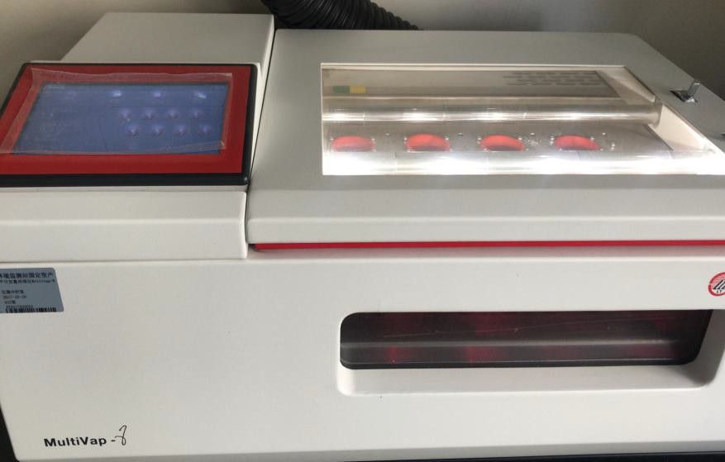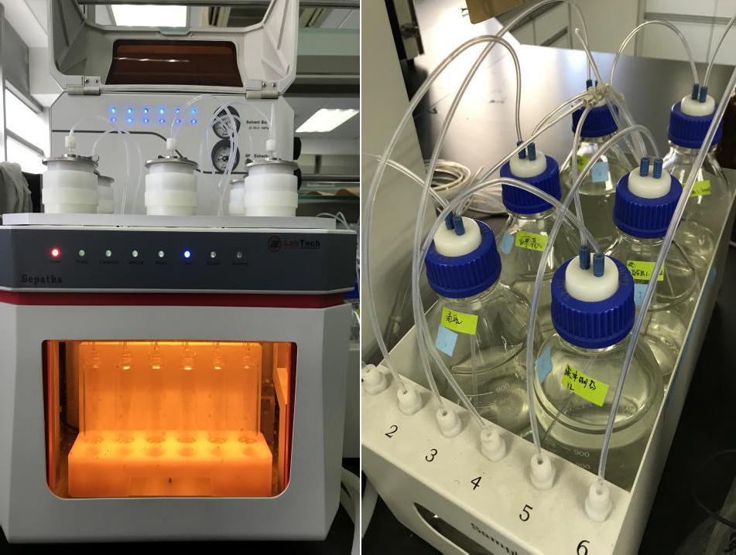
B
A2
A1

Figure S1 (A) Automatic cartridge-disk universal solid phase extraction system (LabTech, China), (B) MultiVap-8 channel parallel concentrator (LabTech, China).

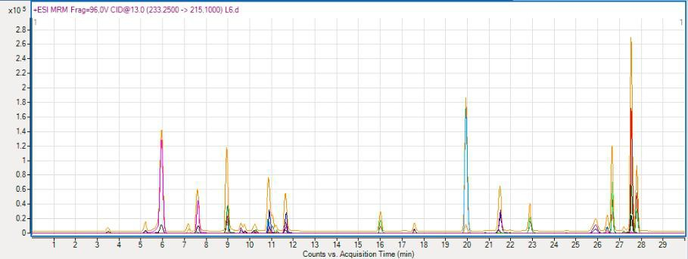
Figure S2 Total ion chromatogram of target compounds with mixing standards.
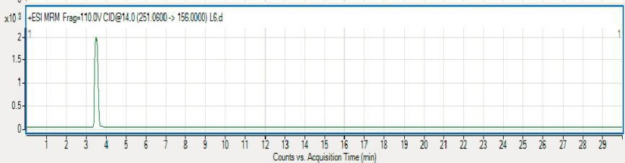
(a) Sulfadiazine

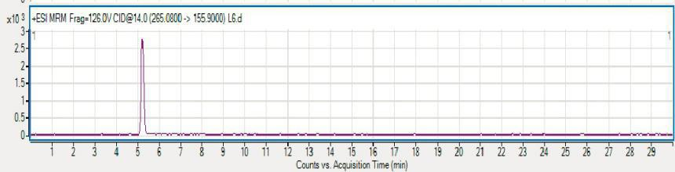
(b) Sulfamerazine

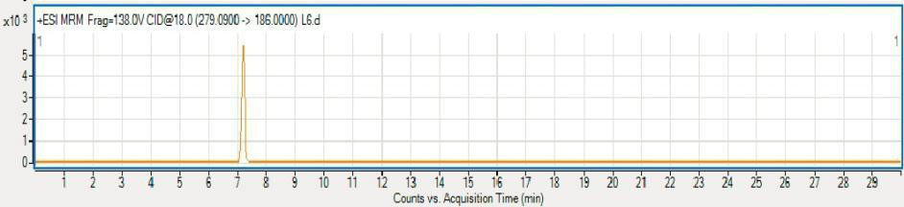
(c) Sulfamethazine
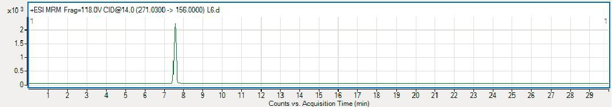
(d) Sulfamethoxadiazole

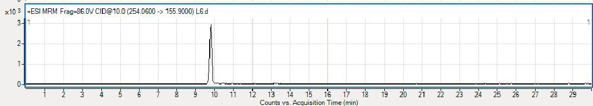
(e) Sulfamethoxazole

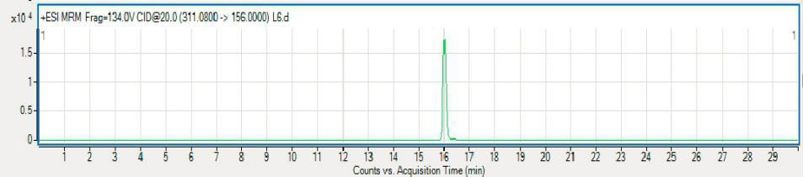
(f) Sulfamethoxine

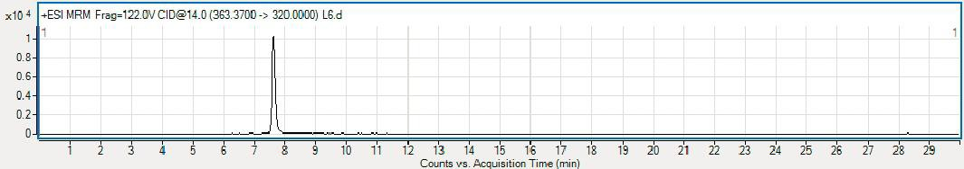
(g) Mabofloxacin

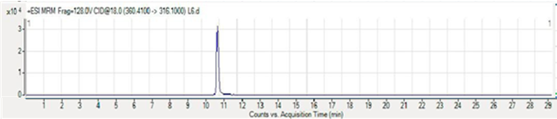
(h) Enrofloxacin

(h) Enrofloxacin

Figure S3 (a)−(z) Mass spectra of 26 antibiotics standards.
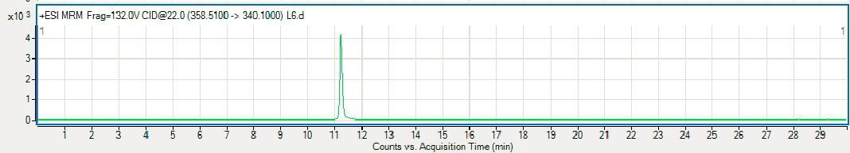
(i) Dafloxacin mesylate

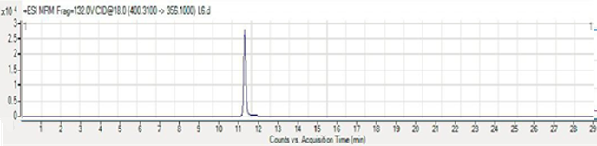
(j) Difloxacin
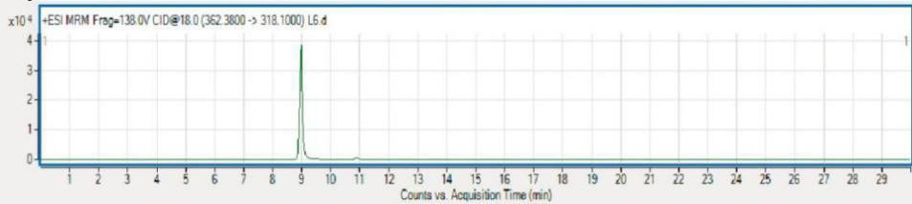
(k) Ofloxacin
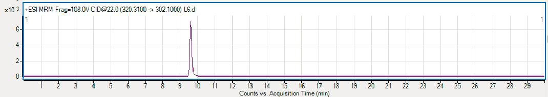
(l) Norfloxacin

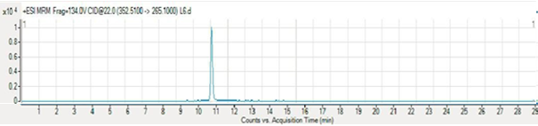
(m) Lomefloxacin hydrochloride

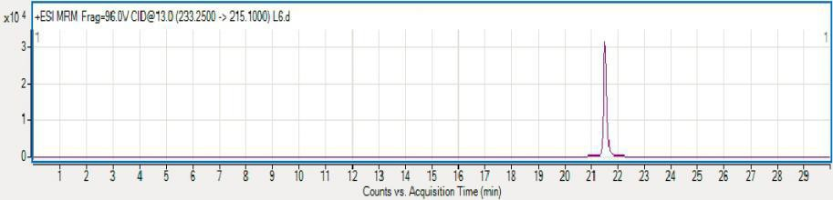
(n) Nalidixic acid

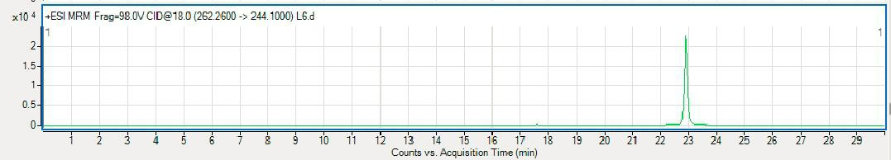
(o) Flumequine

Figure S3 (a)−(z) Mass spectra of 26 antibiotics standards (continued)..

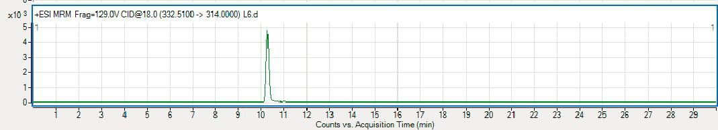
(p) Ciprofloxacin Hydrochloride

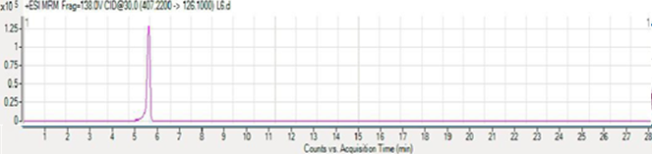
(q) (7S)-Lincomycin

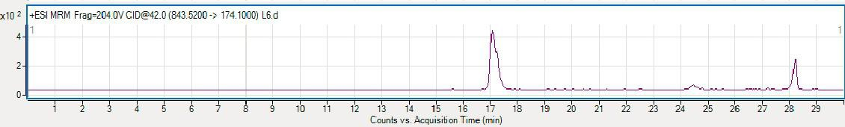
(r) Spiramycin

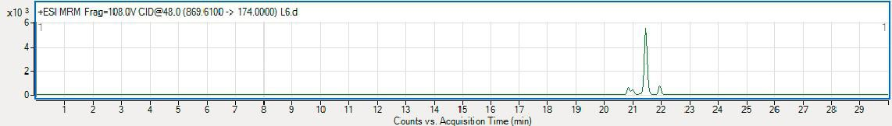
(s) Tilmicaoxin

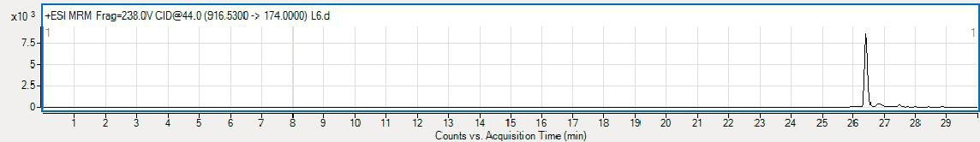
(t) Tylosin

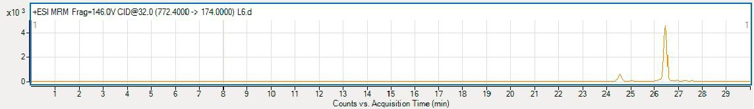
(u) Leucomycin A5

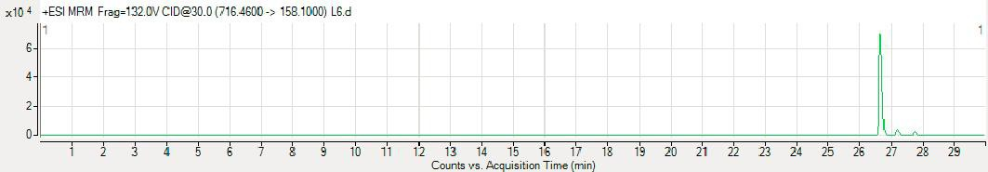
(v) Anhydroerythromycin A

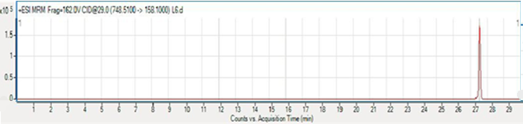
(w) Clarithromycin

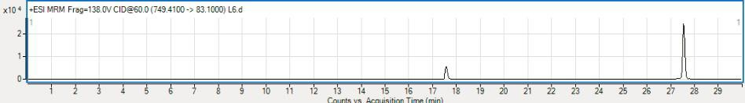
(x) Azithromycin Dihydrate

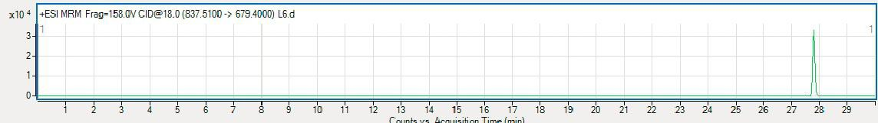
(y) Roxithromycin

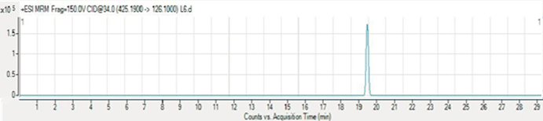
(z) Clindamycin hydrochloride

Figure S3 (a)−(z) Mass spectra of 26 antibiotics standards (continued).

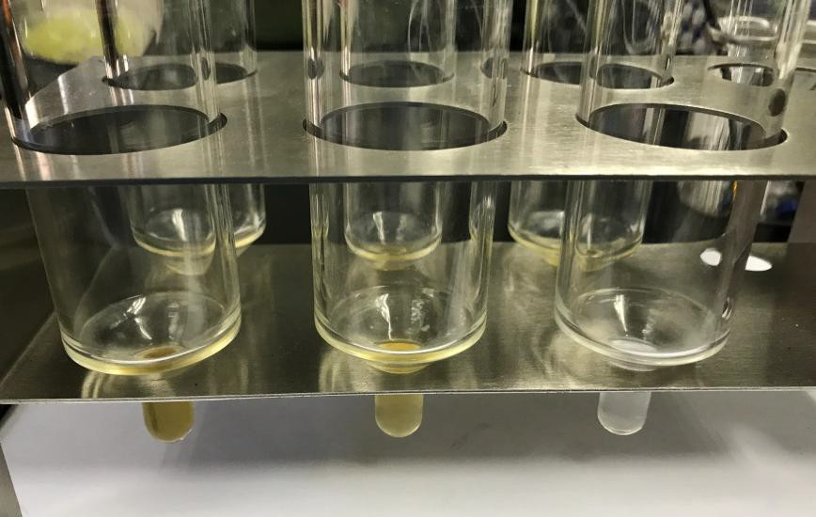
pH 5.0
pH 4.0
pH 3.0
Figure S4 The eluent of different pH.

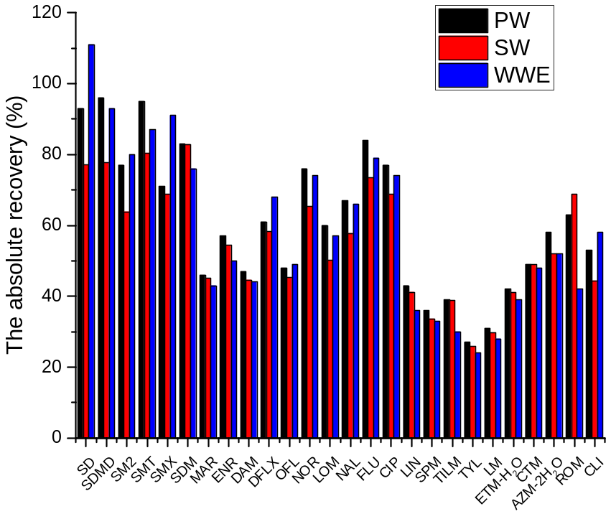
Figure S5 Absolute recoveries in pure water (PW), surface water (SW), and wastewater effluent (WWE). (Target analytes and isotopically-labeled surrogates (ISs) were set at 50 μg L⁻¹).

