Supplementary Information
A method to analyze the food-water-energy nexus for data-sparse cities: A comparison of green roofs in São José dos Campos, Brazil and Johannesburg, South Africa
Fanxin Meng^{1,8 *}, Qiuling Yuan¹, Rodrigo A. Bellezoni², Jose A. Puppim de Oliveira^{2,3,4}, Yuanchao Hu⁵, Rui Jing⁶, Gengyuan Liu¹, Zhifeng Yang^{1,7}, Karen C. Seto⁸

¹State Key Joint Laboratory of Environment Simulation and Pollution Control, School of Environment, Beijing Normal University, Beijing 100875, China
²São Paulo School of Management (FGV EAESP), Fundação Getúlio Vargas (FGV), Rua Itapeva, 474, sala 712, Bela Vista, São Paulo, 01332-000, Brazil
³Brazilian School of Public and Business Administration (FGV EBAPE), Fundação Getúlio Vargas (FGV), Rua Jornalista Orlando Dantas 30, Rio de Janeiro, Brazil
⁴Institute for Global Public Policy, Fudan University, Shanghai, China
⁵School of Resource and Environmental Sciences, Wuhan University, 129 Luoyu Road, Wuhan, 430079, China
⁶College of Energy, Xiamen University, Xiamen 361000, China
⁷Key Laboratory for City Cluster Environmental Safety and Green Development of the Ministry of Education, Institute of Environmental and Ecological Engineering, Guangdong University of Technology, Guangzhou, 510006, China
⁸Yale School of the Environment, Yale University, 380 Edwards St, New Haven, CT, ZIP 06511, USA
Supplementary Discussion: Trade-offs of green roofs
Local food production on green roofs in SJC and Johannesburg supplied 6.83 kg (Fig. 2a) and 5.68 kg (Fig. 2b) of tomato per square meter, respectively. From the energy perspective, due to the climate regulation effect, green roofs can modulate the ambient temperature and further reduce the energy consumption of buildings. In SJC, the direct energy saving from green roofs was 45.40 MJ·m⁻², and the life cycle energy consumption was 89.08 MJ·m⁻². Similar values were observed for Johannesburg with green roofs, i.e., 43.82 MJ·m⁻² and 89.85 MJ·m⁻². The green roof direct energy saving benefit in these two cities was 49%–51% of the total energy consumption in their entire life cycle, which agreed with the findings of Wang et al.¹ and indicated that green roofs are net energy consumers. From a carbon emissions perspective, the direct carbon capture potential of green roofs in SJC and Johannesburg virtually offset their life cycle carbon emissions, making them nearly carbon neutral. Specifically, the direct carbon capture potentials of green roofs in SJC and Johannesburg were exactly the same, 5.57 kg·m⁻², with life cycle carbon emissions also close at 5.58 kg·m⁻² and 5.63 kg·m⁻², respectively.
Based on the direct benefits of local food production, energy saving, and water saving by green roof implementation, urban food, energy, and water imports from outside city boundaries can be reduced. These reductions lead to the trans-boundary environmental footprint savings in the upstream production and supply chains, which can be considered as indirect benefits of green roofs. Our analysis revealed that the avoided energy footprint in SJC was 143.05 MJ·m⁻² (i.e., AE_{f}: 97.18 MJ, AE_{e}: 36.16 MJ, AE_{w}: 9.71 MJ, referring to the avoided energy footprints by local food production, energy saving and water saving respectively, from Fig. 2), which was 1.6 times the life cycle energy consumption (i.e., 89.08 MJ·m⁻²). In Johannesburg, the avoided energy footprint was 2.9 times of the life cycle energy consumption, with 257.07 MJ·m⁻² of avoided energy footprint (i.e., AE_{f}: 103.62 MJ, AE_{e}: 130.97 MJ, AE_{w}: 22.48 MJ). In addition, the avoided trans-boundary carbon footprint in SJC was 9.15 kg·m⁻² (i.e., AC_{f}: 8.66 kg, AC_{e}: 0.37 kg, AC_{w}: 0.12 kg), 1.6 times of the life cycle carbon emissions (i.e., 5.58 kg·m⁻²), and 8.05 kg·m⁻² of the avoided carbon footprint (i.e., AC_{f}: 2.71 kg, AC_{e}: 4.46 kg, AC_{w}: 0.88 kg) was 1.4 times of the life cycle carbon emissions (i.e., 5.63 kg·m⁻²) in Johannesburg.
From the water perspective, the direct water saving potentials of green roofs were similar, namely, 95.62 L·m⁻² and 101.94 L·m⁻², respectively, for SJC and Johannesburg (Fig. 2). The life cycle water consumption of green roofs in SJC was 36.5% of that in Johannesburg (288.53 L·m⁻²). The large water consumption of green roofs in Johannesburg resulted from a high irrigation demand for tomatoes, which was included in the life cycle water consumption of green roofs. Although there was disparity between life cycle water consumption of green roofs in SJC and Johannesburg, both values outweighed (1.1 and 2.8 times greater) their direct water saving, which indicated that green roofs were net water consumers within city boundaries. Whereas from a trans-boundary perspective, green roofs have considerable benefits on water footprint savings. Especially in SJC, the green roofs avoided 3,625.79 L·m⁻² (i.e., AW_{f}: 2,159.18 L, AW_{e}: 1,155.77 L, AW_{w}: 310.85 L, Fig. 2a) of water footprint beyond urban boundaries, which represented an impressive 34 times the life cycle water consumption (i.e., 105.34 L·m⁻²). More modestly but still positive, 1,446.42 L·m⁻² (i.e., AW_{f}: 1,159.97 L, AW_{e}: 250.23 L, AW_{w}: 36.22 L, Fig. 2b) of trans-boundary water footprint was reduced in Johannesburg, accounting for nearly 5 times the life cycle water consumption (i.e., 288.53 L·m⁻²).
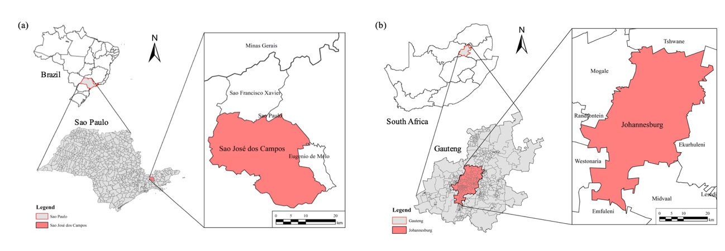
Supplementary Figure 1. Location of São José dos Campos (left) and Johannesburg (right).

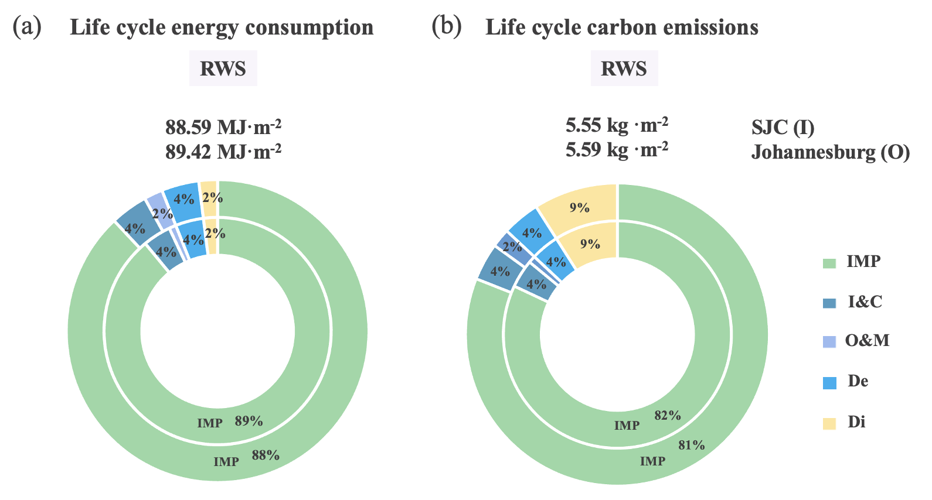
Supplementary Figure 2. In-boundary negative energy and carbon impacts of green roofs per square meter in the scheme of RWS. I: inner circle; O: outer circle; IMP: infrastructure material production; I&C: installation and construction; O&M: operation and maintenance; De: demolition; Di: disposal.

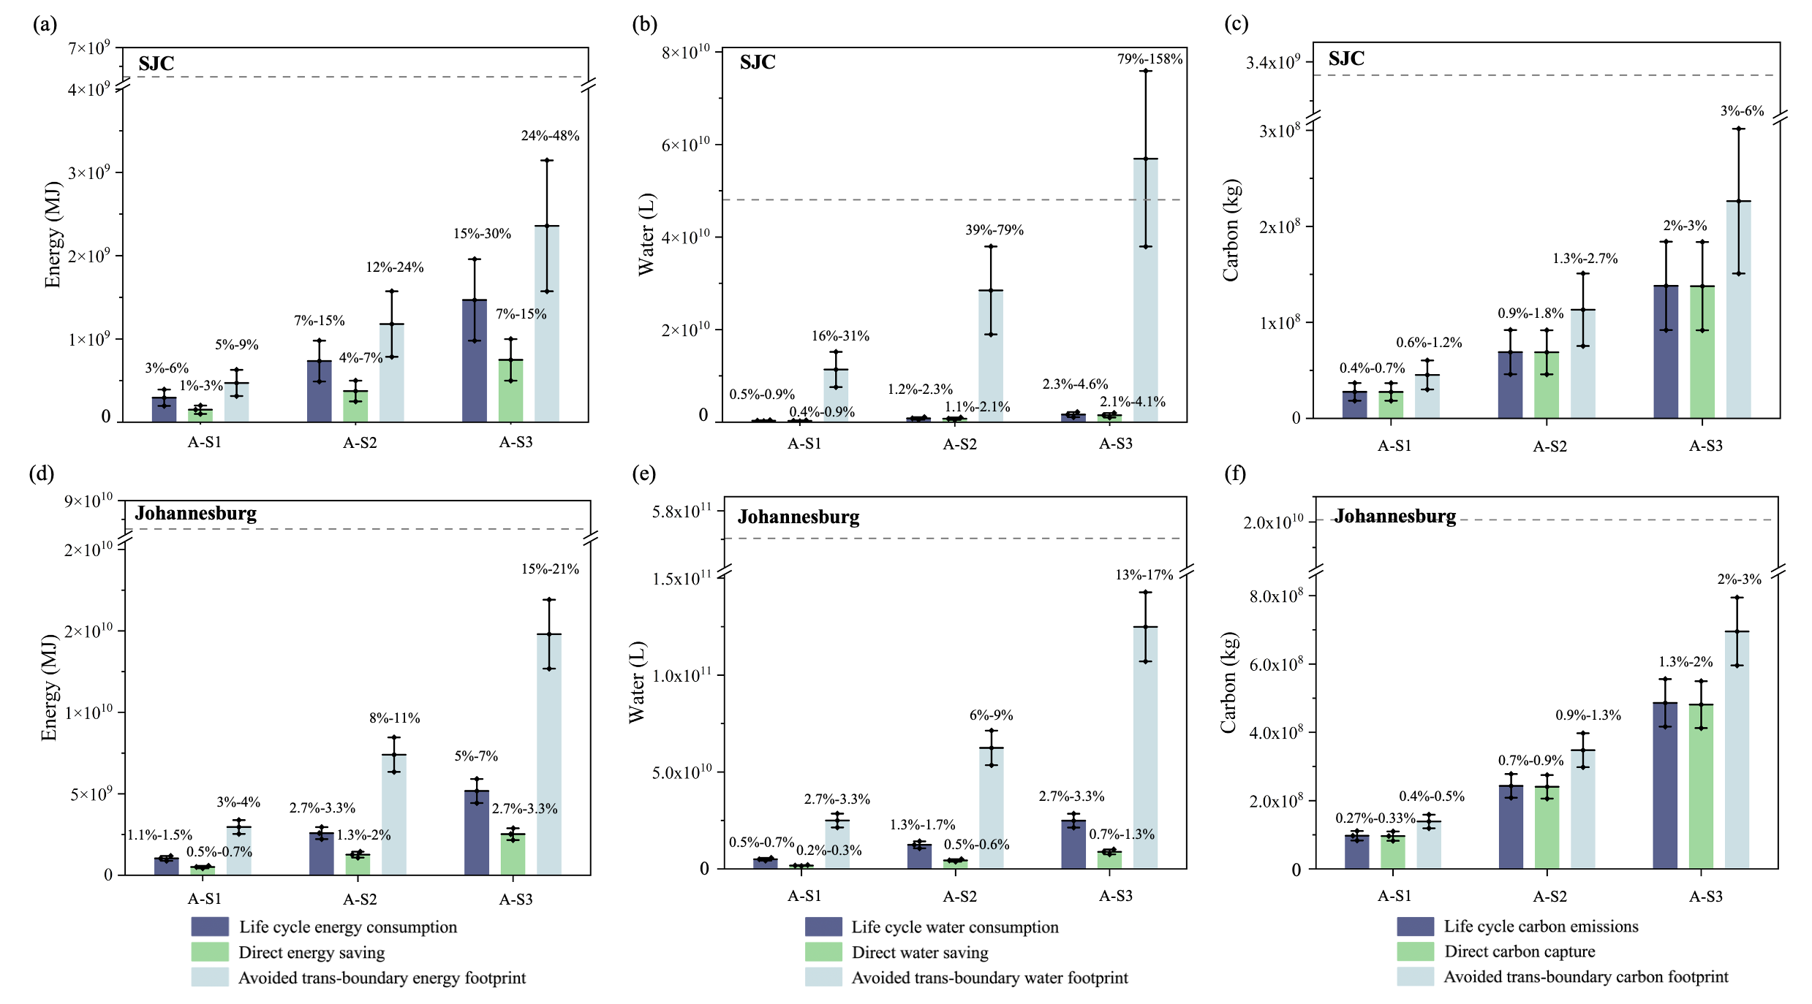
Supplementary Figure 3. Life cycle environmental impacts, FWE-related benefits, and avoided environmental footprints under different scenarios in 20% of the available urban rooftop assumption.

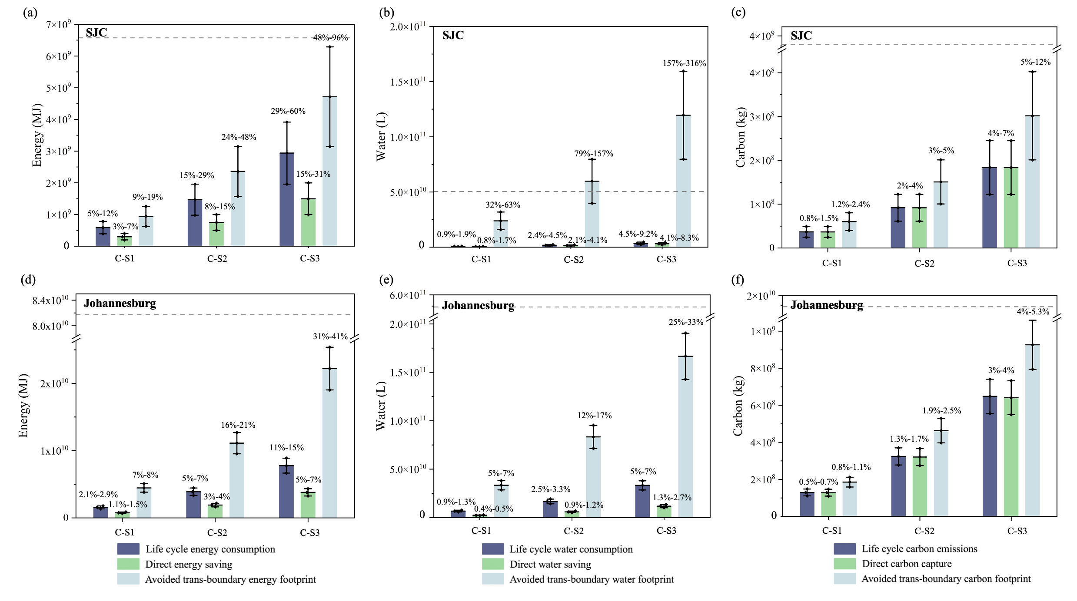
Supplementary Figure 4. Life cycle environmental impacts, FWE-related benefits, and avoided environmental footprints under different scenarios in 40% of the available urban rooftop assumption.

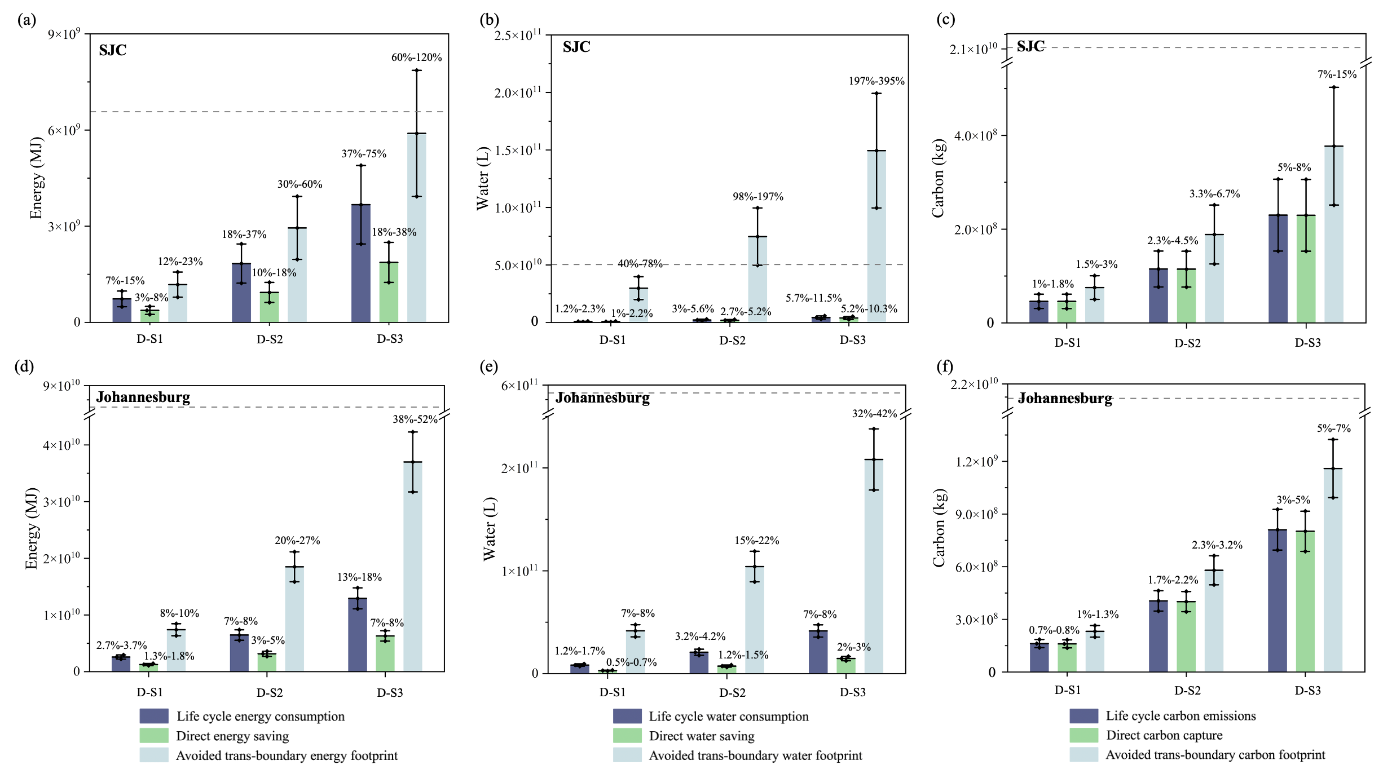
Supplementary Figure 5. Life cycle environmental impacts, FWE-related benefits, and avoided environmental footprints under different scenarios in 50% of the available urban rooftop assumption.

Supplementary Table 1. Reduction of the life cycle energy consumption, carbon emissions, and water consumption of green roofs per square meter after implementing the RWS scheme, compared with the BAU scheme.
Life cycle impacts  after rainwater substitution | SJC | Johannesburg
Life cycle energy consumption  (W-E nexus) | - 0.49 MJ | - 0.53 MJ
Life cycle carbon emissions  (W-C nexus) | - 0.03 kg | - 0.04 kg
Life cycle water consumption  (W-W nexus) | - 95.90 L | - 102.24 L

Supplementary Table 2. Contributions to the urban and national targets for different green roof development scenarios with different ratios of available urban rooftops.
 |  | 20% (A) |  |  | 30% (B) |  |  | 40% (C) |  |  | 50% (D)
 |  | A-S1 | A-S2 | A-S3 | B-S1 | B-S2 | B-S3 | C-S1 | C-S2 | C-S3 | D-S1 | D-S2 | D-S3
Urban water target | Johannesburg | 0.53%–1.07% | 1.33%–2.67% | 2.67%–5.33% | 0.80%–1.60% | 2%–4% | 4%–8% | 1.07%–2.13% | 2.67%–5.33% | 5.33%–10.67% | 1.33%–2.67% | 3.33%–6.67% | 6.67%–13.33%
National carbon target | Johannesburg | 0.005%–0.009% | 0.01%–0.02% | 0.03%–0.05% | 0.008%–0.014% | 0.02%–0.04% | 0.04%–0.07% | 0.01%–0.02% | 0.03%–0.05% | 0.05%–0.09% | 0.01%–0.02% | 0.03%–0.06% | 0.07%–0.12%
National carbon target | SJC | 0.02%–0.03% | 0.05%–0.07% | 0.09%–0.13% | 0.03%–0.04% | 0.07%–0.04% | 0.14%–0.20% | 0.04%–0.05% | 0.09%–0.13% | 0.13%–0.27% | 0.05%–0.07% | 0.12%–0.17% | 0.23%–0.33%

Supplementary Table 3. Scope and boundary of the energy and water consumption, and carbon emissions over the life cycle of green roofs.
Life cycle phase | Description
1 Infrastructure material production | This phase refers to the process of all the material production dividing into three parts:  1) the materials used for the installation and construction for the regular green roof layers.  2) and materials for the fertirrigation of the open-air farming.  3) and all the fertilizers used in the operation and maintenance phase.  And all the materials transported to the building site are considered separately for each phase.
2 Installation & Construction | This phase includes two parts: 1) the labor and equipment inputs for the installation and construction, such as lift, and labors used in the construction process. We assume the energy and CO₂ value is 5% of the materials in construction phase (Meng et al., 2017). And water consumption is ignored here.  2) and the transportation for the materials used in this phase are considered here.
3 Operation & Maintenance | This phase includes three parts:  1) irrigation water for the vegetable cultivation in this phase, including the tap water used for irrigation, and the rainwater collection in the harvesting system for irrigation.  In this study, we assume that all the tomato planted on the intensive green roofs, and the direct irrigation blue water was used for the vegetable cultivation in this phase. We accounted for the blue water demand for tomato considering the climate condition and geographical location. We evaluated the utilizable green water for irrigation from the rainwater collection on the basis of local precipitation. Then the tap water irrigation can be calculated by deducting the rainwater collection from blue water demand.  2) direct labor for weeding and irrigation activities, which is evaluated as 5% of the embodied energy and CO₂ of the materials used in this phase².  3) and the transportation for the materials used in this phase are considered here.  Ecological benefits are accounted for separately in this phase.
4 Demolition | This phase includes the equipment and labor inputs in demolition work, which is evaluated as 90% of the embodied environmental effects in material production process in the installation and construction phase.
5 Disposal | In this phase, we assume that all the building wastes from the decommissioning phase are transported to the municipal landfill, which including two processes: 1) Transportation of all the construction waste to the landfill assuming the transportation distance of 25 km.  2) The landfill process for different materials is considered.

Supplementary Table 4. Climate conditions of case cities.
Case city | SJC | Johannesburg
ASHARE Climate Zone | 2B (Hot-Dry) | 3A (Warm-Humid)
Köppen climate classification |  | Subtropical highland climate (Cwb)
Corresponding US city | Las Vegas, or Phoenix, Arizona | Memphis, Tennessee
Annual HDD Base 18 °C/65 F # | 264.4 °C/475.52 F | 924.2 °C/1695.56 F
Annual CDD Base 10 °C/50 F # | 4140.5 °C/7484.9 F | 2770.9 °C/5019.62 F

Supplementary Table 5. Nomenclature.
Abbreviation | Description
GBI | Green and blue infrastructure
FWE | Food, water, and energy
LCA | Life cycle assessment
AE_{f} | Avoided trans-boundary energy footprints by local food production
AE_{e} | Avoided trans-boundary energy footprints by direct energy saving
AE_{w} | Avoided trans-boundary energy footprints by direct water saving
AC_{f} | Avoided trans-boundary carbon footprints by local food production
AC_{e} | Avoided trans-boundary carbon footprints by direct energy saving
AC_{w} | Avoided trans-boundary carbon footprints by direct water saving
AW_{f} | Avoided trans-boundary water footprints by local food production
AW_{e} | Avoided trans-boundary water footprints by direct energy saving
AW_{w} | Avoided trans-boundary water footprints by direct water saving
BAU | Business-as-usual scheme
RWS | Rainwater substitution scheme
MGR | Materials for green roof layers
MOAF | Materials for open-air farming
IMP | Infrastructure material production phase
I&C | Installation and construction phase
O&M | Operation and maintenance phase
De | Demolition phase
Di | Disposal phase
RB | Root barrier layer
GM | Growing medium layer
W/R | Water retention layer
D/F | Drainage/filter layer
NI | Nexus Index
NEI | Nexus Energy Index
NCI | Nexus Carbon Index
NWI | Nexus Water Index

Supplementary References
- Wang, Y. et al. Environmental performances and energy efficiencies of various urban green infrastructures: A life-cycle assessment. J. Clean. Prod. 248, 119244 (2020).
- Meng, F. et al. Energy efficiency of urban transportation system in Xiamen, China. An integrated approach. Appl. Energy 186, 234–248 (2017).

