Supplementary materials
Producing of high-transparent antiscratch thin films on polycarbonate substrate by nanohybrid sols based on Si and Al alkoxides by very simple method

Narges Kiomarsipour, Akbar Eshaghi, Mazaher Ramazani

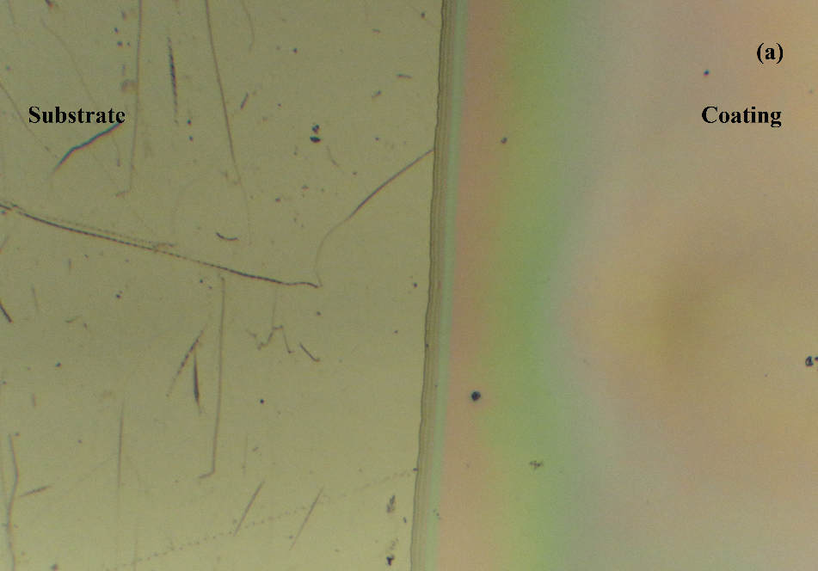
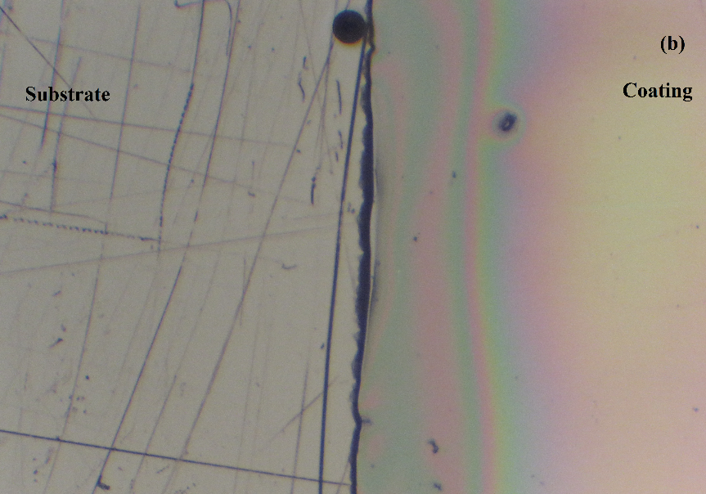

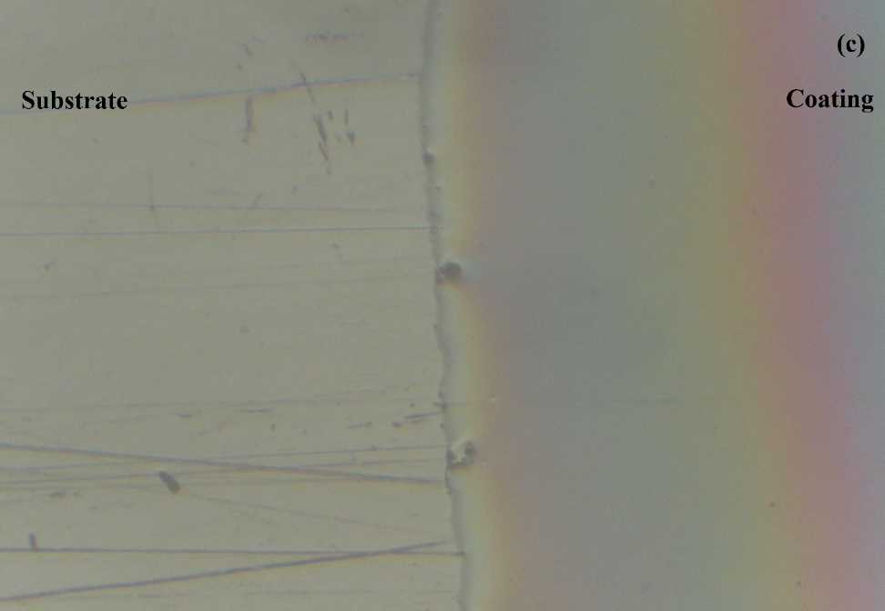

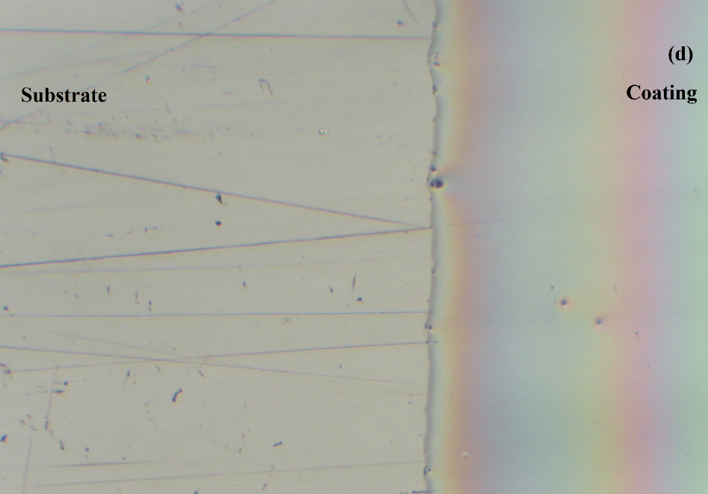

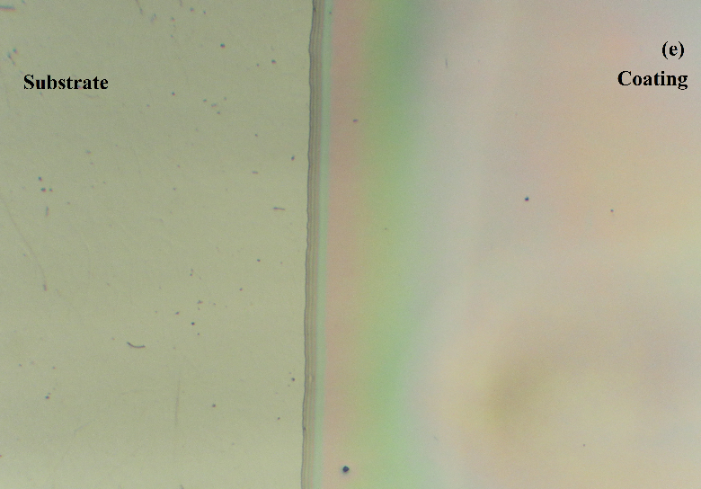
Fig. S1 The optical images of the sol-gel coatings with different ratios: (a) A31, (b) A21, (c) A52, (d) A41 and (e) A24 (The scale bars are 200 μm)

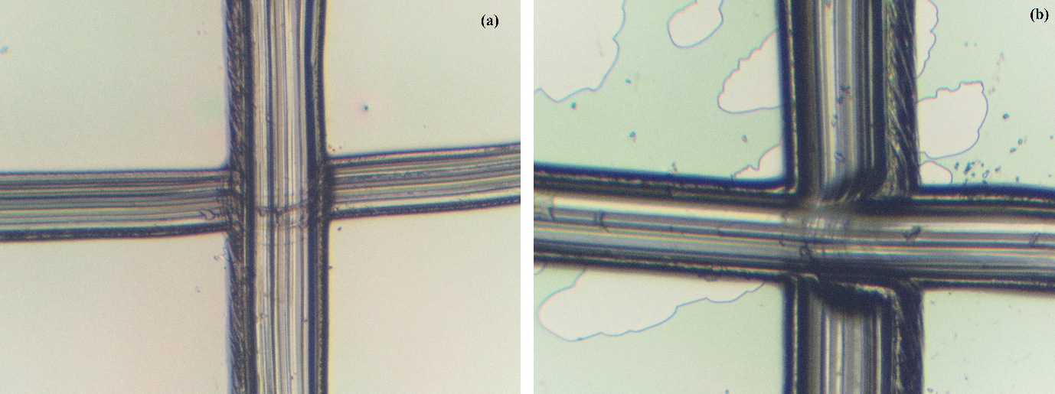

Fig. S2 The optical micrographs of cross cut adhesion test on sol-gel nanohybrid coatings on PC: (a) 4PA24 and (b) 6PA12

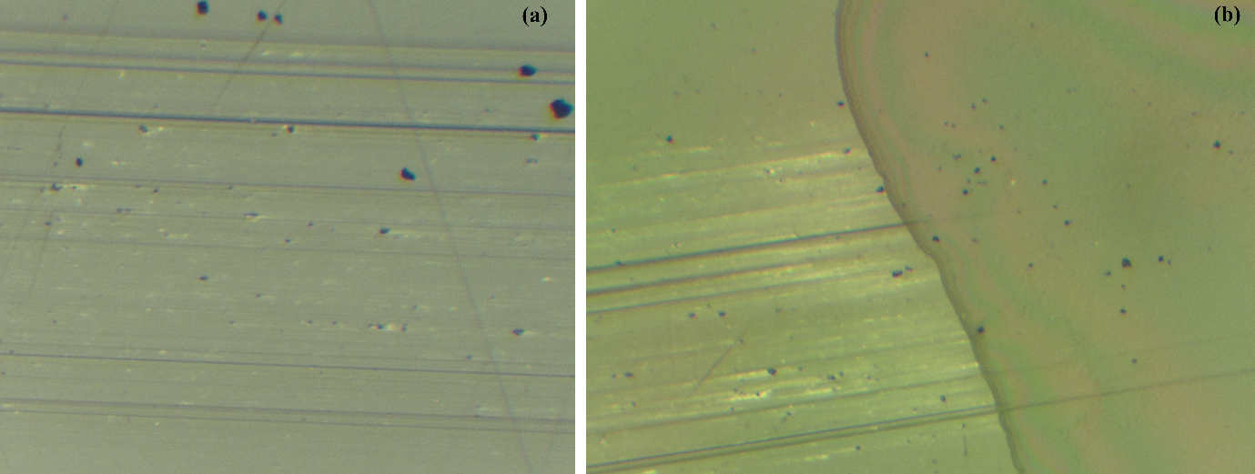
Fig. S3 The optical micrographs of pencil impressions on: (a) bare PC by 4B pencil and (b) on 4PA24 coating by 3H pencil

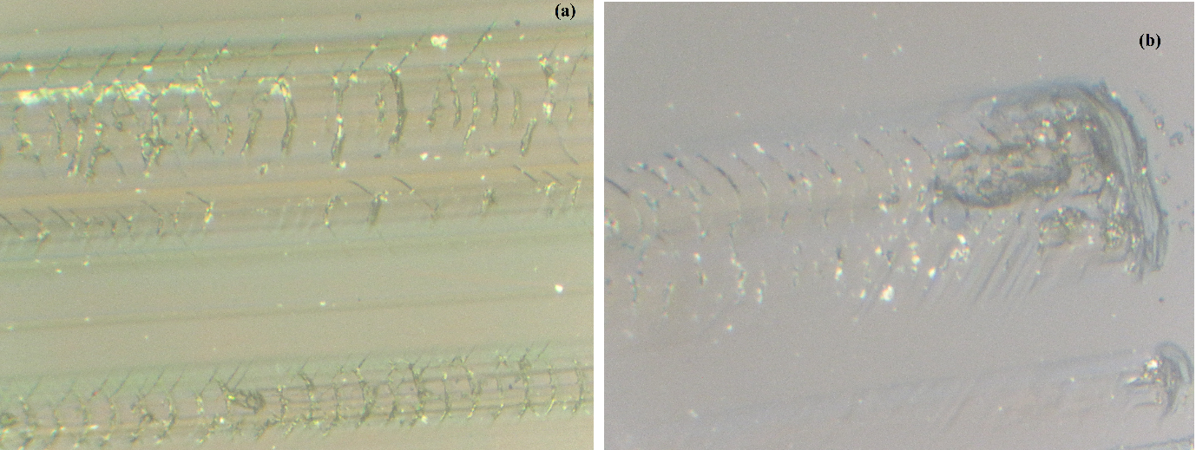
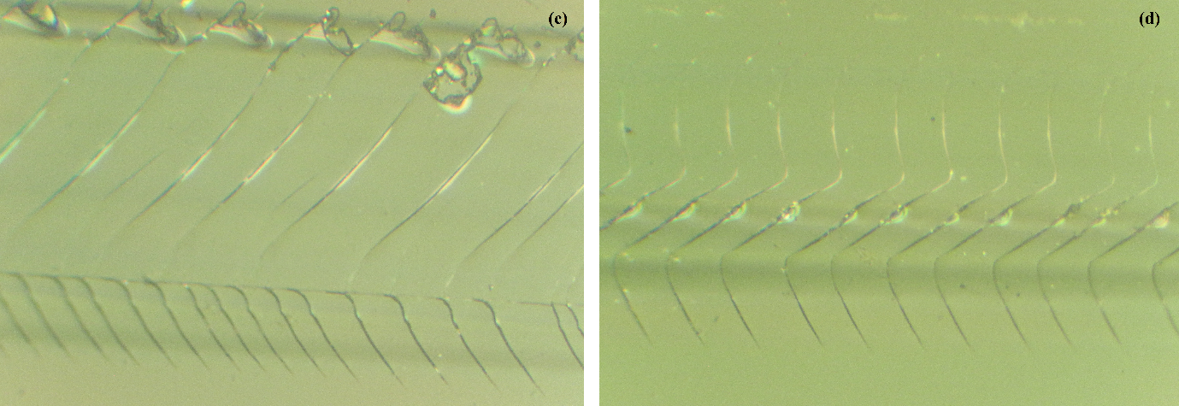
Fig. S4 The optical micrographs of pencil scratch impression with different scale bars: (a,b) 200 μm and (c,d) 100 μm

Corresponding author: Eshaghi.akbar@gmail.com, Eshaghi@mut-es.ac.ir

