Science governs the future of the mesopelagic zone
Amanda Schadeberg, Marloes Kraan, Rolf Groeneveld, Damian Trilling and Simon Bush

Supplementary Material
Contents
Figure S1. Growth in output of texts containing “mesopelagic zone” and/or “ocean twilight zone” over time 2
Figure S2. Ratio of tweets and abstracts per topic 2
Table S1. List of all policy documents 3
Text Box S1. Context for ‘ocean carbon’ quote 4
Text Box S2. Stopwords 4
Figure S3. The 25 most common words in science and Twitter database 5
Figure S4. LDA Tuning Plot 5
Figure S5. Sensitivity analysis: model default topic keywords 6
Figure S6. Sensitivity analysis: model default distribution of tweets and abstracts per topic 6
Figure S7. Sensitivity analysis: model default network of meaning 7
Figure S8. Sensitivity analysis: low symmetrical alpha topic keywords 7
Figure S9. Sensitivity analysis: low symmetrical alpha distribution of tweets and abstracts per topic 8
Figure S10. Sensitivity analysis: low symmetrical alpha network of meaning 8
Text Box S3. Outcomes of manual validation exercise 9
Text Box S4. Instructions for manual validation exercise 10

Figure S1. Growth in output of texts containing “mesopelagic zone” and/or “ocean twilight zone” over time

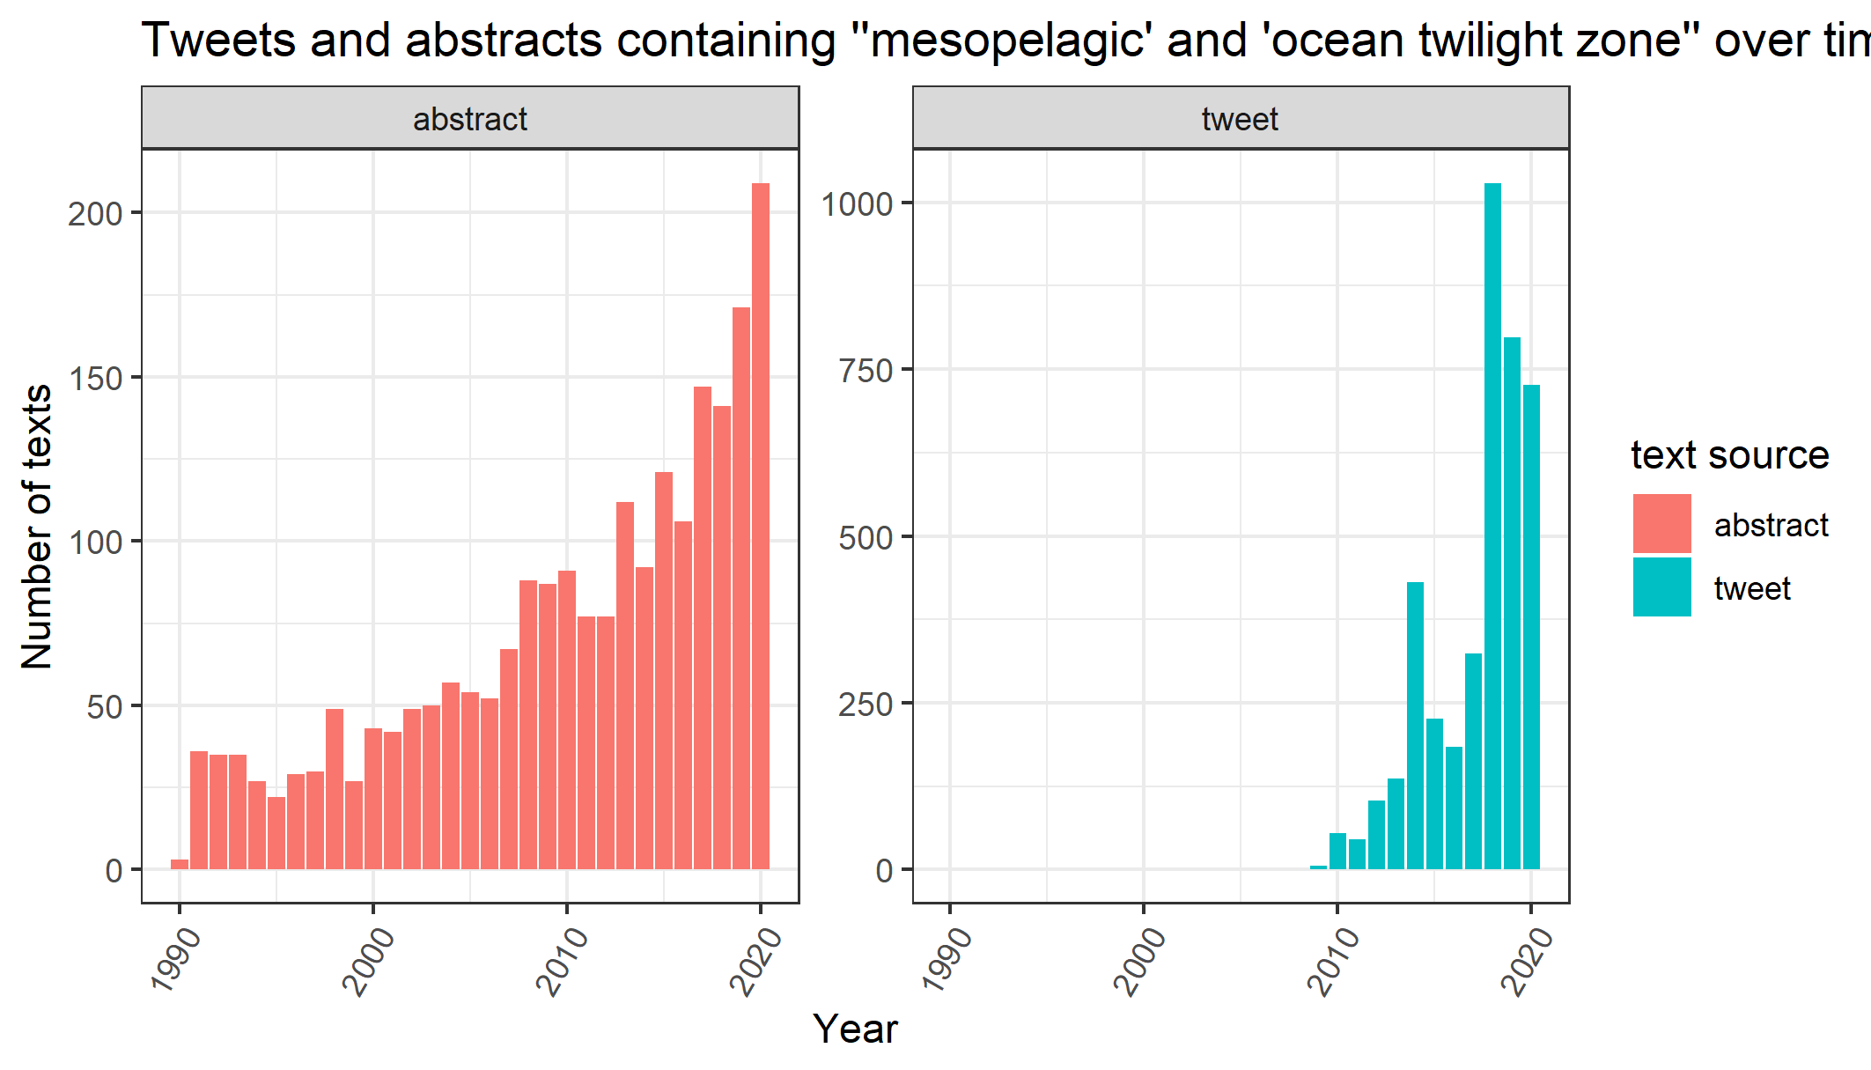

Figure S2. Ratio of tweets and abstracts per topic

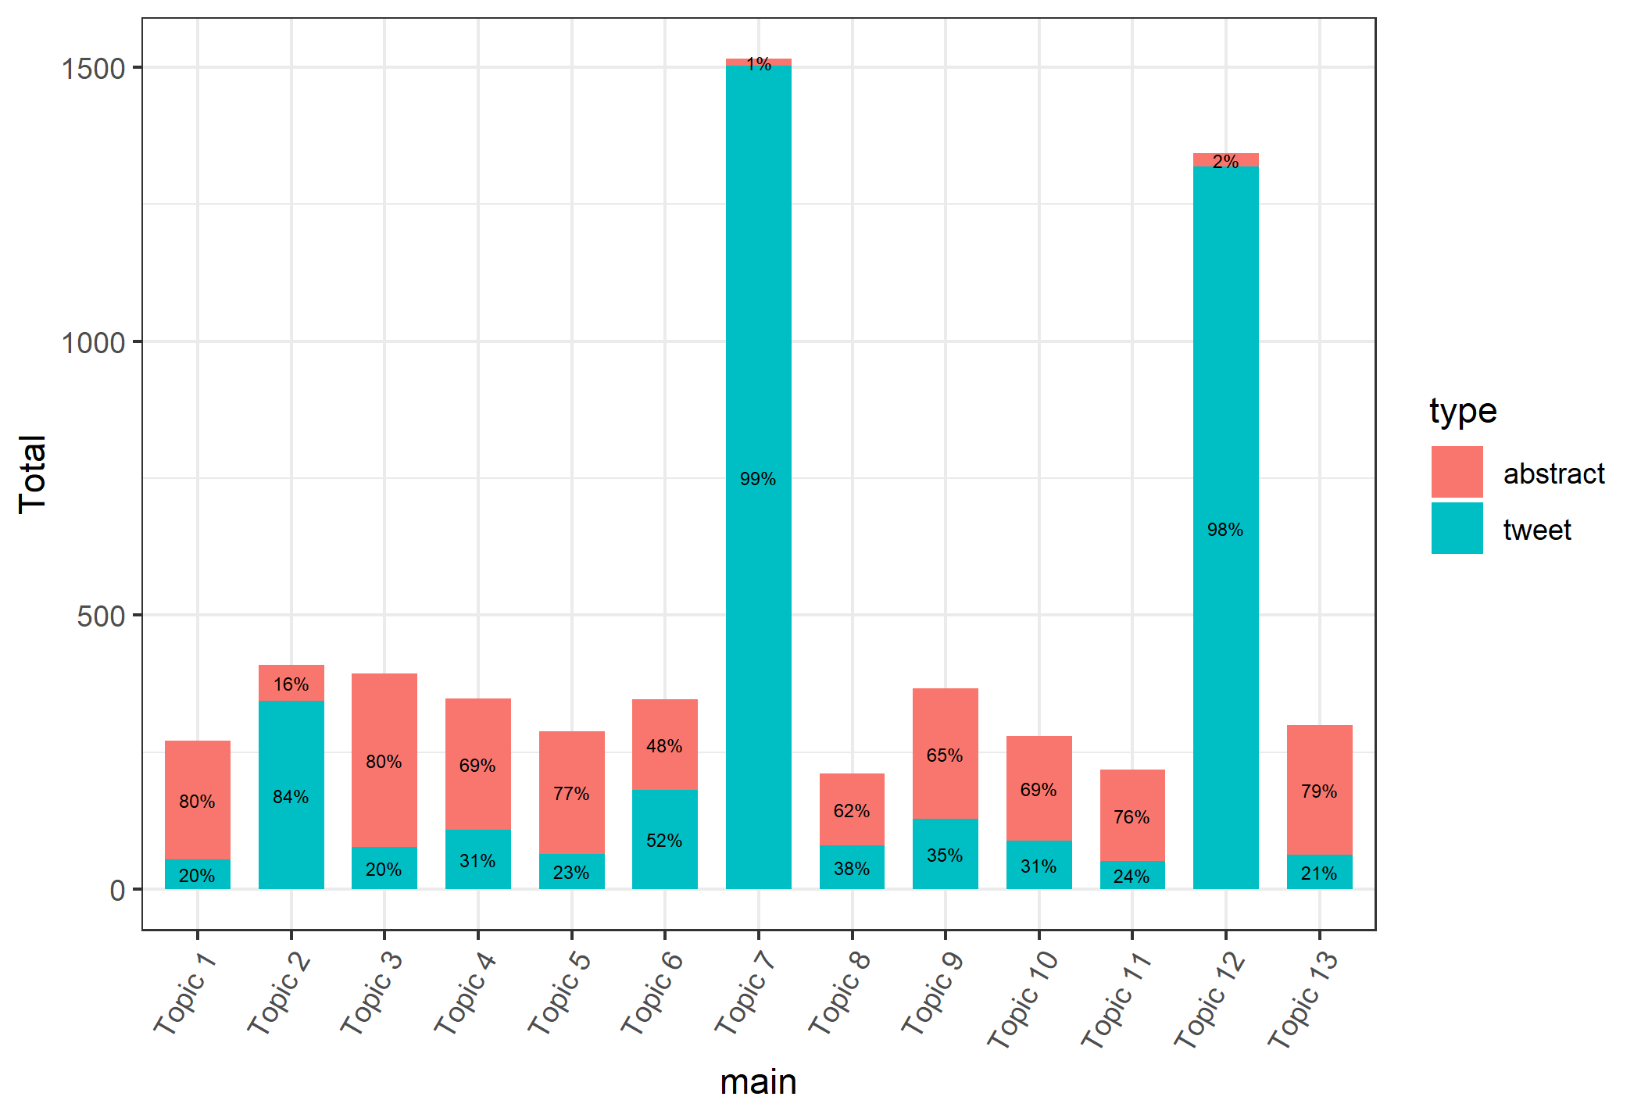

Table S1. List of all policy documents

Document Name | Year | Location | Length (words)
Convention on the High Seas | 1958 | United Nations | 3,310
Endangered Species Act | 1973 | USA | 21,686
Convention on the Conservation of Migratory Species of Wild Animals | 1979 | United Nations | 4,575
Convention on International Trade in Endangered Species of Wild Fauna and Flora | 1983 | United Nations | 6,977
Convention on Environmental Impact Assessment in a Transboundary Context | 1991 | United Nations | 6,576
Convention on Biological Diversity | 1992 | United Nations | 9,039
Convention on the Law of the Sea | 1994 | United Nations | 77,380
Code of Conduct for Responsible Fishing | 1995 | UN FAO | 13,938
Conference on Straddling Fish Stocks and Highly Migratory Fish Stocks | 1995 | United Nations | 13,108
Briefing on Developments in Ocean Affairs and the Law of the Sea 20 years after the Conclusion of the United Nations | 2002 | United Nations | 7,045
General Assembly Resolution 61-105 on Sustainable Fisheries | 2006 | United Nations | 9,768
International Guidelines for the Management of Deep-sea Fisheries in the High Seas | 2009 | UN FAO | 25,780
Common Fisheries Policy | 2013 | European Union | 21,360
Joint Communication to the European Parliament: International ocean governance - an agenda for the future of our oceans | 2016 | European Parliament | 6,822
Draft text of an agreement under the United Nations for Biodiversity Beyond National Jurisdiction | 2019 | United Nations | 17,490
Magnuson-Stevens Fishery Conservation and Management Act (update to original 1973) | 2021 | USA | 60,641

Text Box S1. Context for ‘ocean carbon’ quote
Policy document: Joint Communication To The European Parliament, The Council, The European Economic And Social Committee And The Committee Of The Regions International Ocean Governance: An Agenda For The Future Of Our Oceans
Year: 2016
Location: European Union
Excerpt (page 10):
Section 3, Action 6: Implementing the COP21 Agreement and mitigating the harmful impact of climate change on oceans, coastlines and ecosystems
The Commission will work to protect the role of marine and coastal ecosystems in reducing the impacts of climate change. In association with the High Representative, it will aim to achieve broad political consensus on the need to preserve the oceans’ natural ‘blue carbon’ function through working with EU and international political actors, in the context of climate change negotiations and relevant environmental international conventions.

Text Box S2. Stopwords
We removed all English stopwords in the R package stopwords v 2.3 (Benoit et al., 2021) as well as single-letter words (e.g. “C”, which is ambiguous as to whether it refers to temperature in degrees centigrade or the chemical symbol for carbon). We also removed the following words that were so common due to the search terms that they confounded the topic model: "species", "mesopelagic", "zone", "ocean*", "depth", "water*", "sea", "marine". Other words were remnants of the structure of the texts (e.g. publisher information or remnants of links) and were therefore removed so as not to confound the topic model: "ltd", "limited", "elsevier", "rights", "reserved", "publish*", "co", "rt", "t", "tinyurl", "amp", "com", "www", "bit", "ly", "via".

Figure S3. The 25 most common words in science and Twitter database

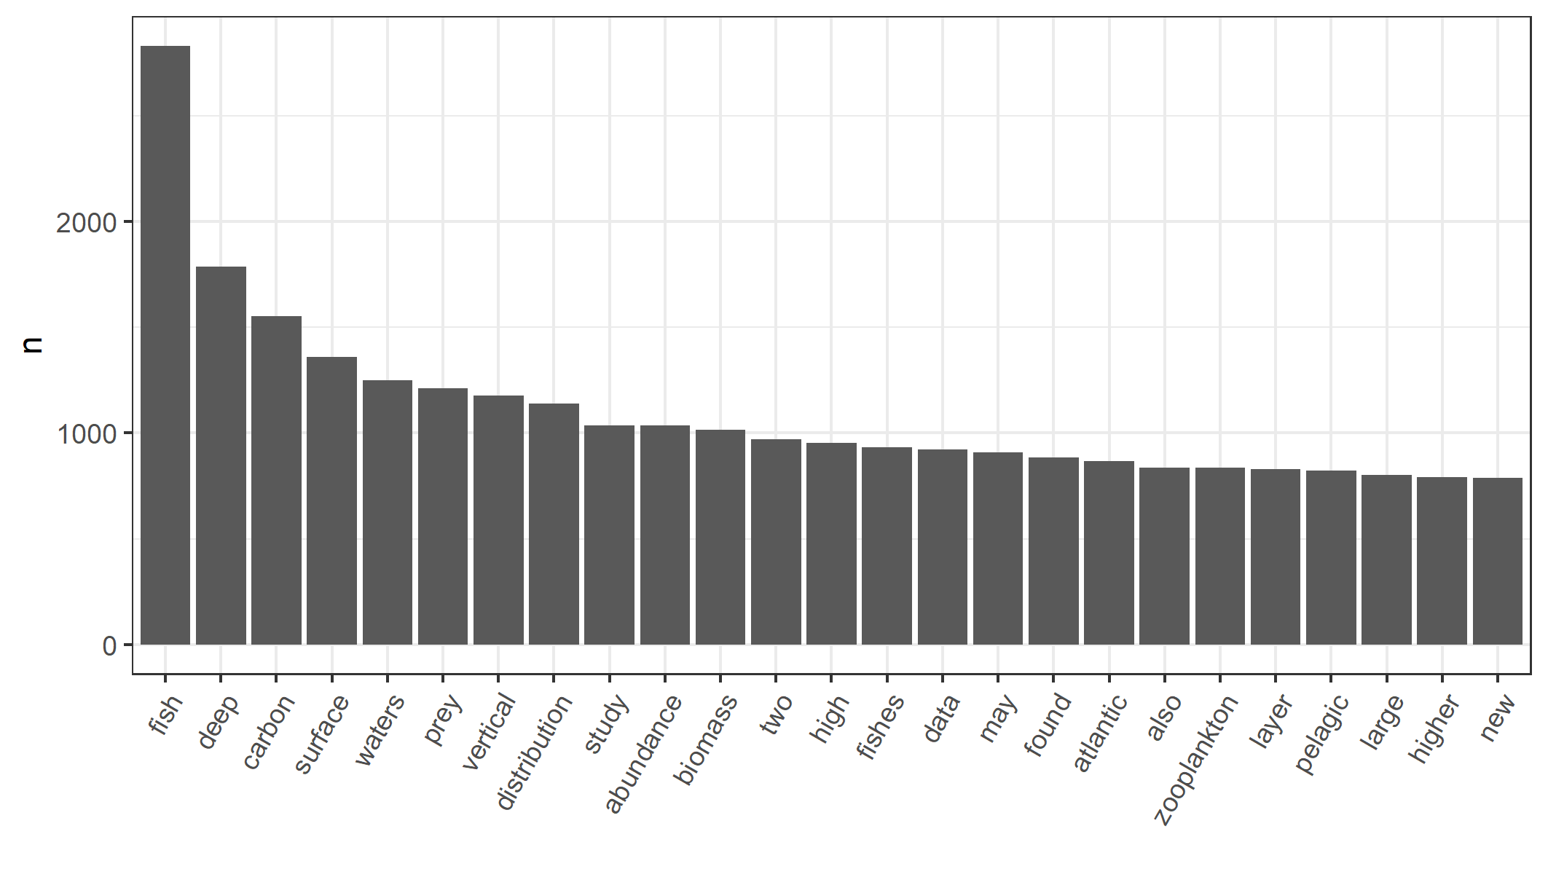

Figure S4. LDA Tuning Plot

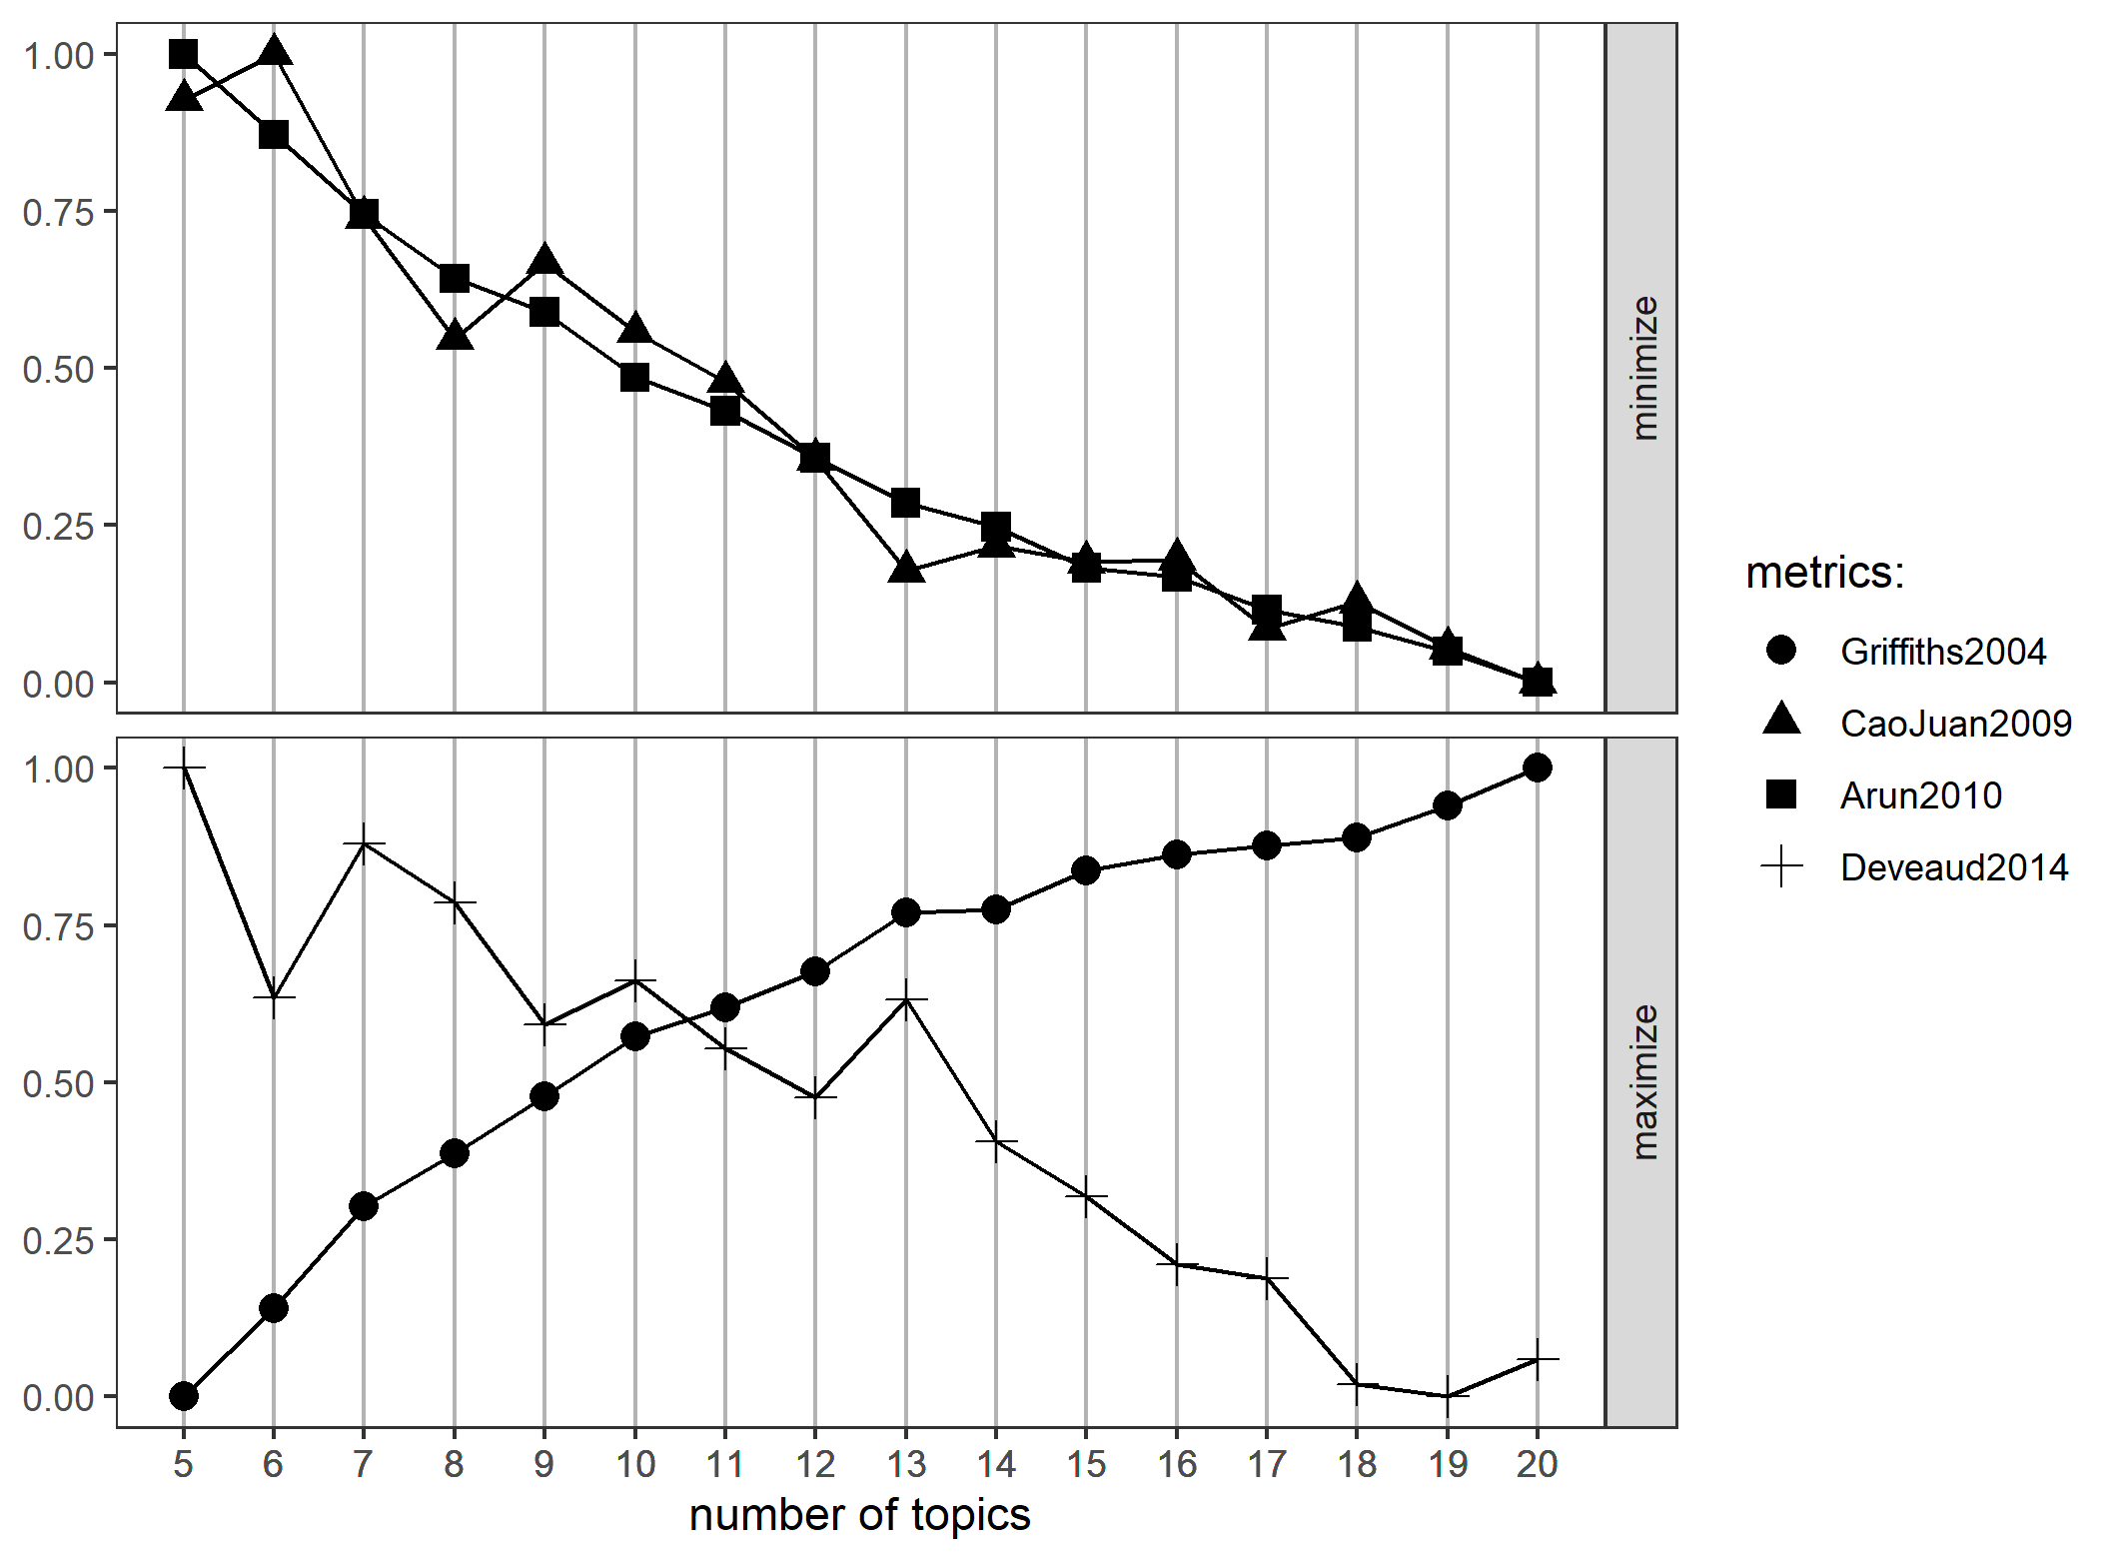
Sensitivity Analysis
We tested three model options: The default alpha of the function LDA() from the R package topicmodels, a low symmetrical alpha (5/k), and a low asymmetrical alpha (1/1:k), where k= the number of topics (in this case, 13). The model outputs with the low asymmetrical alpha are presented as results in the paper. Below are the alternative model outputs.

Figure S5. Sensitivity analysis: model default topic keywords
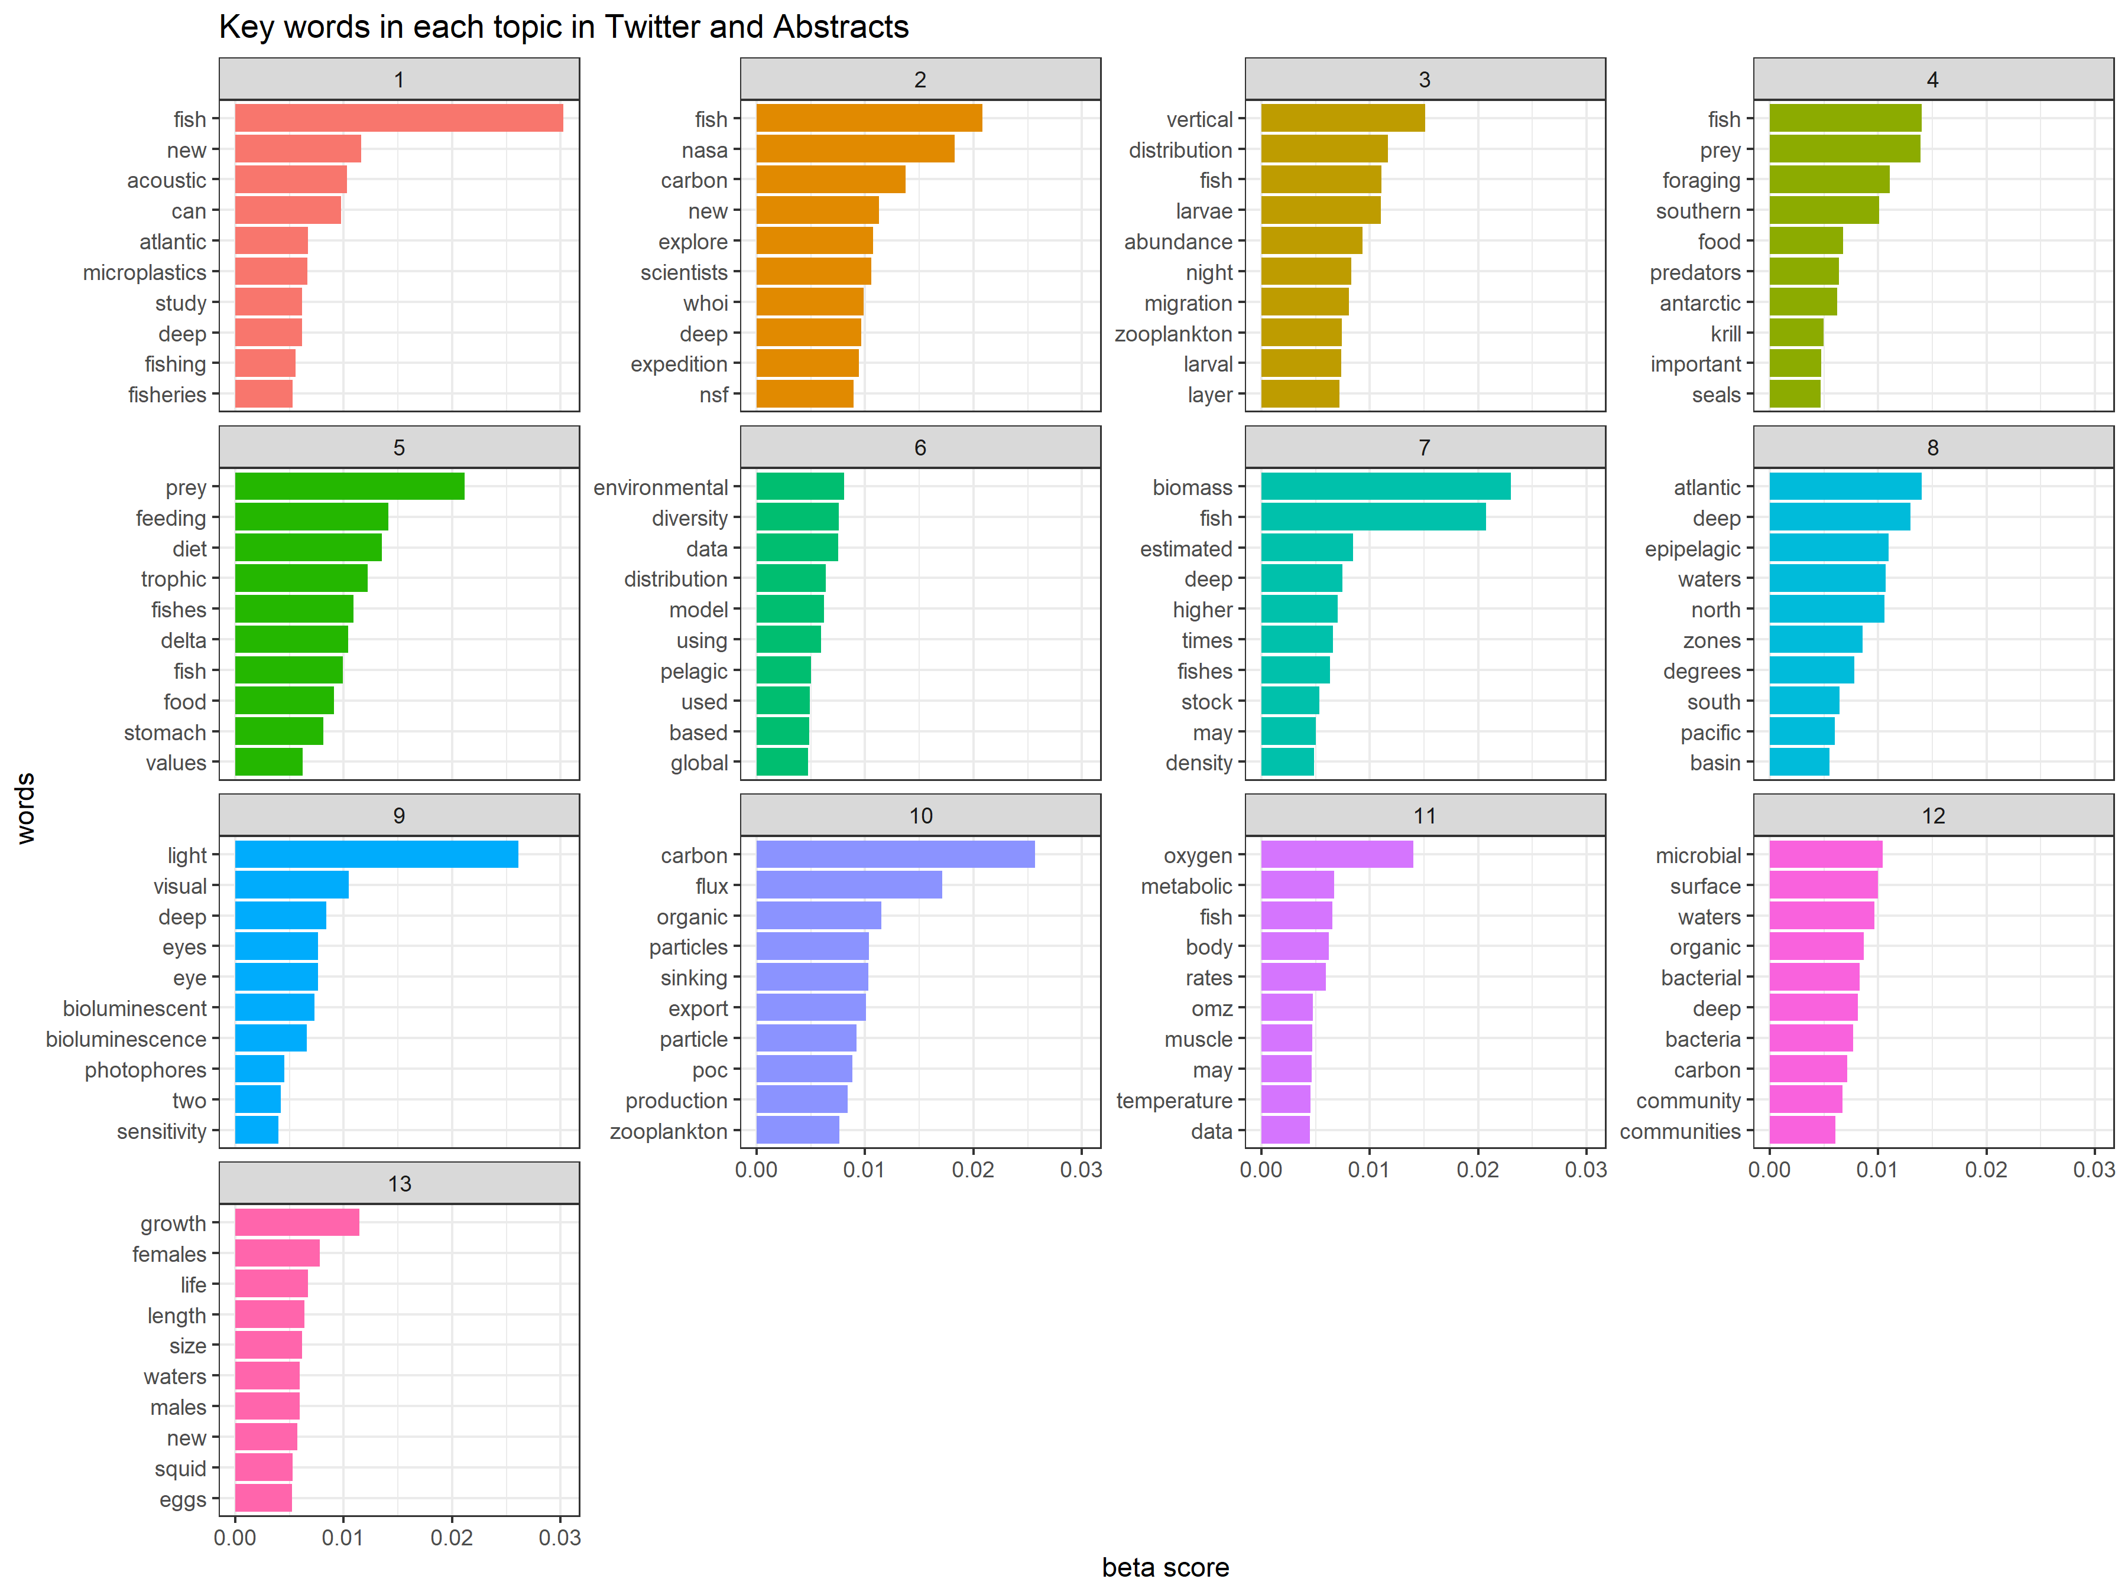

Figure S6. Sensitivity analysis: model default distribution of tweets and abstracts per topic
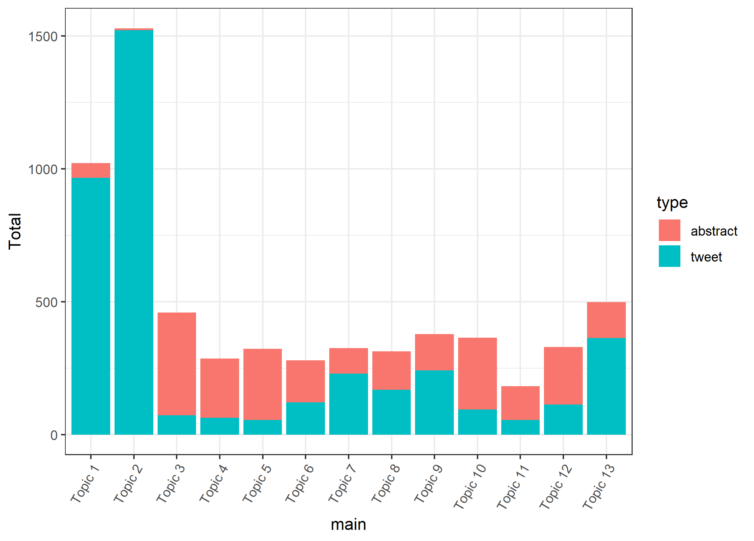

Figure S7. Sensitivity analysis: model default network of meaning
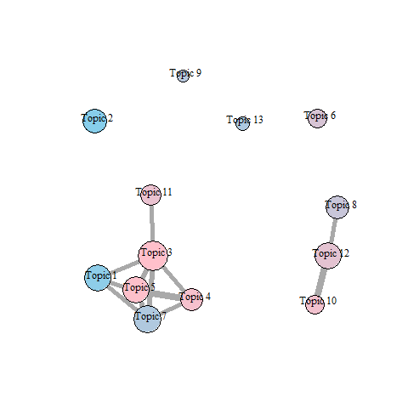

Figure S8. Sensitivity analysis: low symmetrical alpha topic keywords
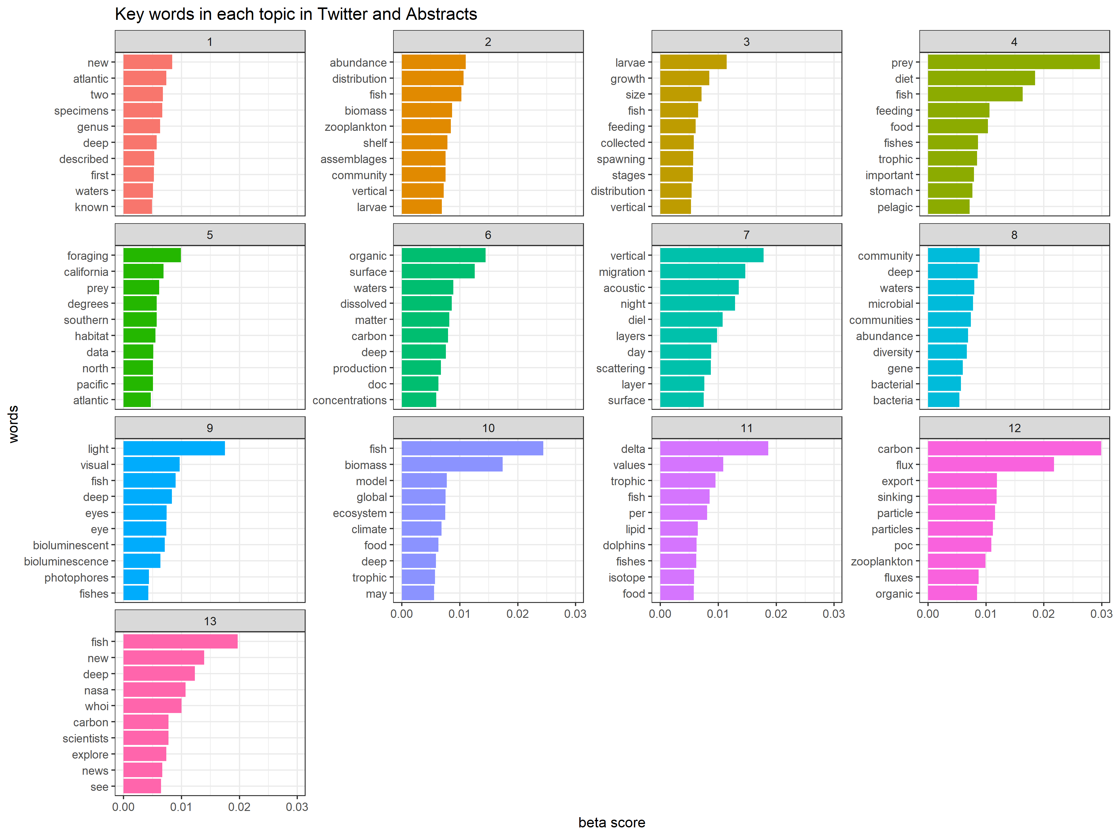

Figure S9. Sensitivity analysis: low symmetrical alpha distribution of tweets and abstracts per topic
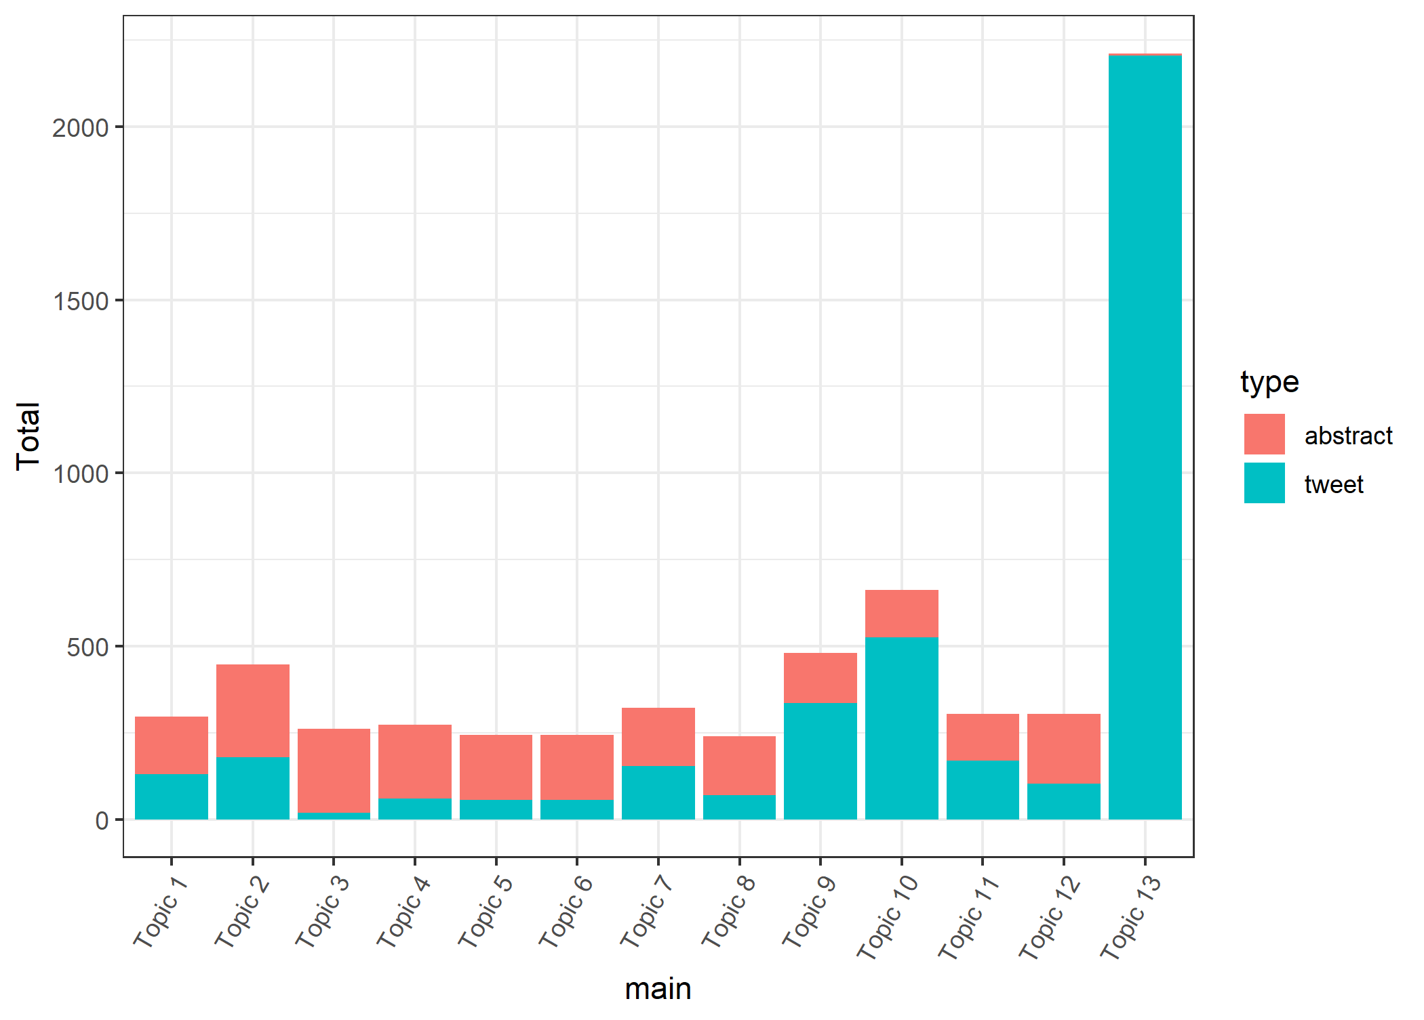

Figure S10. Sensitivity analysis: low symmetrical alpha network of meaning
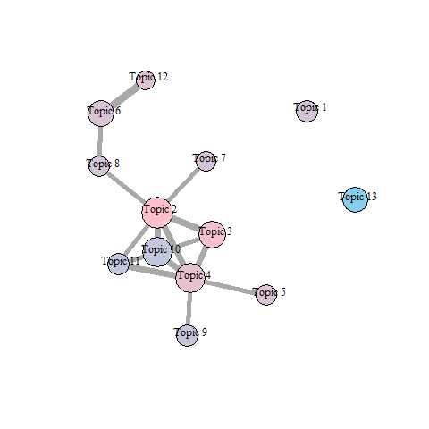

Text Box S3. Outcomes of manual validation exercise
We engaged 6 participants (two MSc students working on mesopelagic topics (social science), one mesopelagic biologist, one fisheries economist, and two people whose work is unrelated to the mesopelagic zone). All versions of the intrusion test performed extremely well. Because there was no substantial difference between the three model options, we went ahead with the model that best fits our theoretical interest (low asymmetrical alpha):
P value for default model: 3.4 × 10⁻²⁷
P value for low symmetrical model: 1.06 × 10⁻²³
P value for low asymmetrical model: 4.27 × 10⁻²²

Text Box S4. Instructions for manual validation exercise
The task is to identify which word or group of words is the intruder or ‘the odd one out’, based on the descriptions provided to you and the prompts given. This is not a test of your intelligence or logic, but rather a test of how well the model matches human understanding of the topic. Once you have read the instructions and topic descriptions, please try to complete each test in one sitting of maximum 20 minutes. The validation relies on your intuition, so do not overthink it.
Please proceed with the following steps for each test (one test at a time):
- Read the descriptions of each of the topics and the vocab words. Feel free to ask about or google any jargon you don’t recognize or understand. There is a glossary on the next page.
- Start test by opening the link (double check that the last part of the link address matches the name of the test).
- Take a look at the description of Topic 1 in this document, then answer the question by selecting the word that is the ‘intruder’ (i.e. does not fit the topic). If there is a word you do not understand in the list, you can check the glossary or google it. Once you have made a selection, hit confirm. If you skip, you can come back to it later by clicking “jump to uncoded item”, but try to avoid doing this.
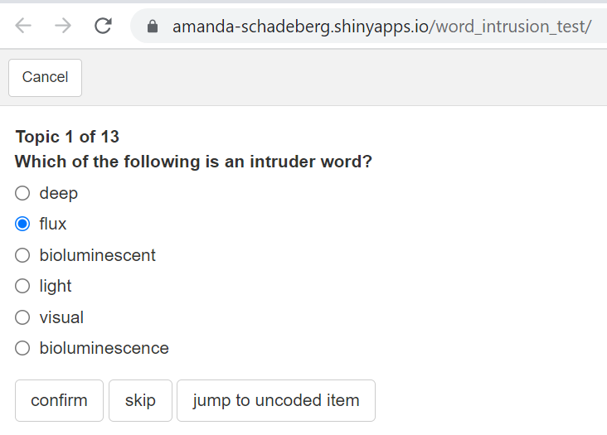
- Repeat the ‘quiz’ for all questions in the set (13 topics).
- When you have completed the test you will return to Topic 1. Add your name and download the file – write your name and the last part of the link of the test (see example below). 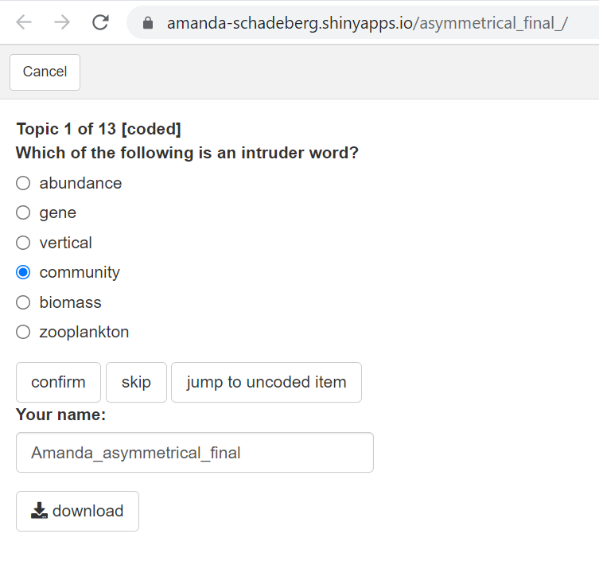
- Download the file (do not rename it).
- Once you have completed all three tests, please email me your files.
- Note: Please close these tabs as soon as you are finished with them. I only have 15 hours of ‘server time’ to complete the tests, so please be mindful of this when you complete the task.
Many thanks!
Text Box S4. Instructions for manual validation exercise (continued)
Glossary:
Pelagic: The water column (i.e. the large body of water between the surface of the sea and the seafloor). The word can also be used as an adjective for an animal that lives in open water (e.g. a tuna or a herring or plankton)
Epipelagic: The surface layer of the water column, up to 200m deep
Mesopelagic: The ‘twilight zone’ of the water column, 200m-1000m deep
Fish Stock: The total population of a species of fish
Biomass: The weight or volume of renewable organic life in a certain area (e.g. fish)
Fish vs Fishes: Fish = one fish, or the plural of fish. Fishes = specifically more than one species of fish
NSF: National Science Foundation (US science funding org.)
WHOI: Woods Hole Oceanographic Institute (US marine research org.)
NASA: National Aeronautics and Space Administration (US governmental science org.)
Photophores: Small glands or organs that create light on the bodies of animals
Flux: Rate of flow or exchange; passing through a surface to another place
OMZ: Abbreviation of oxygen minimum zone: parts of the sea where there is very little oxygen
Cephalopod: Marine animals with arms or tentacles (e.g. squid, octopus, cuttlefish, nautilus)
Continental Shelf: An edge or drop-off where the underwater part of a continent ends and the water becomes dramatically deeper. There is often a steep drop or wall on the edge of the shelf.
Trophic System: Also known as a food web or food chain, this is the scientific word for the transfer of energy as one organism eats another, and is itself in turn eaten by something else.
DOC: Abbreviation of dissolved organic carbon: very small molecules of organic carbon that is dissolved into water
POC: Abbreviation of particulate organic carbon: particles of carbon that are larger than dissolved organic carbon and which can be up to 2 millimetres in diameter
Diel: Adjective meaning “within a period of 24 hours”; daily
Scattering: Also known as ‘backscatter’. When scientists send pings of sound into the deep water, the sound can bounce back off a fish in a type of echo. This is known as scattering. Big groups of fish will give back large scattering signals.
Bioluminescence: Light produced by a living organism.
Copepod: A tiny crustacean (usually 1-2mm long) that lives in the open ocean.
Zooplankton: A collective term for tiny (can be microscopic or up to 3-4mm long) animals that live in the ocean open. They include copepods, gastropods, and the eggs and larvae of many species including fish and shrimp.
Larvae: The young form of many animals, including fish. Adjective: larval
Myctophids: A family of small mesopelagic fish known as lantern fish. They are the size of an anchovy and one of the most abundant animals on the planet.

Text Box S4. Instructions for manual validation exercise (continued)
Test 1: Low Asymmetrical [used in publication]
Link: https://amanda-schadeberg.shinyapps.io/asymmetrical_final_/
Topic Descriptions:
- Scientists are interested in where groups of tiny ocean animals live. They study their distribution in the water column, as well as where on the planet they may be located in different seasons.
- Scientists working in the US are curious about the role the mesopelagic zone and all the creatures that live within it play. They are studying how it may regulate our climate and its potential for fishing there to provide food for humans.
- Animals such as fish and cephalopods live in the mesopelagic zone. Scientists can understand who eats who by studying the contents of the digestive systems of specimens they collect from this ecosystem.
- Small pieces of carbon fall to the sea floor, or are carried there by animals who feed at the surface and transfer the carbon downwards in their own natural cycles.
- Mesopelagic animals of various sizes and life stages gather in groups in different parts of the ocean. One place where life is particularly abundant is where the underwater part of the continent ends and there is a sharp drop to deeper water. Animals like these places because it is where different streams of water often intersect.
- There are many microscopic life forms in the ocean. Scientists are studying where they live and how many (groups of) tiny single-celled life forms are there. This often involves understanding DNA as well.
- Large scientific organisations, working in waters close to their homes, share their stories about their discoveries in the mesopelagic zone and their potential contributions to humanity (in terms of food and climate services).
- Scientists can understand who eats who by studying signals in the bodies of animals, which all contain a chemical signature. Higher or lower delta values indicate whether the presence of a particular isotope is higher or lower than standard. A useful source of these signatures in fish is the lens of their eye.
- Scientists can understand where fish are in the water column using sound. They collect signals and turn them into models which can show where fish are at different times and how they group with one another.
- Scientists are constantly making new discoveries in the mesopelagic zone. When they find an example of a new animal, they describe what it looks like, where they found it, and classify it in the existing scientific system
- Microscopic life forms in the ocean may play a role in the transfer of small molecules of carbon from shallow water to the mesopelagic zone. Scientists want to know how quickly and how much this happens.
- Scientific organisations are excited to tell the public about what they find in the mesopelagic zone. They like to focus on cool and memorable features of mesopelagic fish.
- Scientists want to know about the life cycles of different lanternfish species: How big do they get? How long does that take? How do they reproduce? They do this by taking samples from the mesopelagic zone.

Text Box S4. Instructions for manual validation exercise (continued)
Test 2: Default alpha
Link: https://amanda-schadeberg.shinyapps.io/default_/
Topic Descriptions:
- Scientists explain how they can use acoustic technologies to study fish that live in the deep sea. These studies (led mostly by European and American researchers in their own waters) can identify new fisheries and study phenomenon such as microplastic ingestion.
- Scientists from different large research institutes in the US take trips down into the deep sea to understand what resources it might hold (food) or services it might provide (climate regulation).
- Mesopelagic fish migrate upwards from the deep sea to the surface each night. They are spread in various layers that have different densities of micro-organisms (e.g. plankton), fish and their young.
- In the Southern Ocean (near the Antarctic), many large mammals feed on fish and krill. These small creatures are important food for many species.
- The relationships between predators and prey (known as the trophic system) can be understood by studying the stomach contents of different species. These are measured with scientific statistical methods to understand the food web.
- The distribution of fish around the world can be understood by using large computer models. These models can estimate the biodiversity of the natural world, specifically the open ocean.
- Many scientists want to know the size of a population of a particular species of fish. In the deep sea, some studies have shown that there may be much more fish (and in much higher concentrations) than first estimated.
- Oceanographers (geographers of the sea) divide the ocean into vertical layers (i.e. of depth), geographical features (e.g., underwater mountains and valleys) and geo-politically relevant areas (e.g. by giving names of oceans and delineating where they begin and end using latitude and longitude coordinates).
- Fish that live in the deep sea need to be very sensitive to light. They have adapted to their environment in two ways: by developing better ways to see in the dark, and by evolving organs that produce light to either attract food or avoid predators.
- The many creatures that live in the mesopelagic zone play a role in the cycle of carbon. Small pieces of carbon fall to the sea floor, or are carried there by micro-organisms who feed at the surface and transfer the carbon downwards in their own natural cycles.
- Mesopelagic animals have evolved to adapt their bodies to the lack of oxygen and extreme cold of the mesopelagic zone. Scientists can study their adaptations by dissecting them.
- There are many microscopic life forms in the ocean. These groups move up and down the water column and even though they are microscopic, this may play a role in the transfer of carbon from the surface to the deep.
- Cephalopods breed in the mesopelagic zone. In their life cycle they must mate and reproduce. Scientists can study this cycle by collecting eggs as well as adult specimens of both sexes.

Text Box S4. Instructions for manual validation exercise (continued)
Test 3: Symmetrical
Link: https://amanda-schadeberg.shinyapps.io/symmetrical_/
Topic Descriptions:
- Many new species are discovered each time scientists visit the mesopelagic zone. They collect examples of animals, classify them, and share their descriptions with others. Much of this work happens in the ocean near the US and Europe.
- Mesopelagic animals of various sizes and life stages gather in groups in different parts of the ocean. One place where life is particularly abundant is where the underwater part of the continent ends and there is a sharp drop to deeper water.
- Scientists can understand the life cycles of mesopelagic animals by studying them at various points in their life. They gather samples at different depths to understand which life stages occur in which part of the ocean
- Animals in the mesopelagic zone are part of complex food webs that link to other parts of the ocean. They eat and are eaten by many different species.
- Scientists are interested in the location of different feeding behaviours of predators in the ocean. They study different zones and describe them in terms of the animals that live there, as well as the geopolitical locations of the zones in terms of latitude and longitude.
- Carbon can be captured by the ocean when it dissolves into the top layers of the water. This carbon can then move down in the water column and accumulate on the sea floor.
- Every evening, animals in the mesopelagic zone move up from the deep waters towards the surface. At dawn they move back down again. Scientists using acoustic technology to study fish biomass can detect these layers of life.
- There are many microscopic life forms in the mesopelagic zone. Scientists are studying how many (groups of) tiny single-celled life forms are there. This often involves understanding DNA as well.
- Fish species that live in the deep sea need to be very sensitive to light. They have adapted to their environment in two ways: by developing better ways to see in the dark, and by evolving organs that produce light.
- Scientists produce models of the ocean that can help them answer various questions about what could be happening there. These models can be at local or global scales, and are used to understand how many fish there are, what their food webs look like, and what roles they play in their habitats and for the global carbon system.
- Scientists can understand who eats who by studying signals in the bodies of animals. When one animal eats another, they ingest carbohydrates, lipids and proteins, which all contain a chemical signature. Higher or lower delta values indicate whether the presence of a particular isotope is higher or lower than standard. This is used to understand the diets of various fish and marine mammal species.
- Tiny creatures that live in the mesopelagic zone play a role in the cycle of carbon passing through the surface of the ocean. Small pieces of carbon fall to the sea floor via gravity, or are carried there by animals that feed at the surface and transfer the carbon downwards in their own natural cycles.
- Large scientific organisations share their stories about their groundbreaking discoveries in the mesopelagic zone and their potential contributions to humanity (in terms of food and climate services).

