Supplementary Material 1: Summary of Stomata and Trichome identification characteristics for key Reevesby Island species.
All measurements recorded as μm. A =abundant; SC = single celled; CG = capitate-glandular; PG = Pilate-glandular; MC = multicellular; UC = unicellular; SB = Salt bladder; V = vesicular. For illustration of the traits used, see the figures on the next page.
Plant species | Stomata (mature) |  |  | Trichomes
Plant species | Subsidiary cells | Guard cells | Size | Description | Base width | Head
Myoporum insulare | anisocytic | symmetrical | 30 | CG | 50 | 90
Tetragonia implexicoma | anomocytic | symmetrical | 30-40 | UC, V, SB papillate |  | 200 wide
Lycium ferocissimum | anomocytic | asymmetrical | 40 | unicseriate UC, A, cylindrical | 20 | 240 long
Atriplex paludosa | unknown | symmetrical | 30 | unicseriate PG, MC | - | 200 long
Enchylaena tomentosa | unknown | symmetrical | 20-31 | PG vesicular | 20 | 80-100
Carpobrotus rossii | paracytic | symmetrical | 50-60 | none present/preserved
Salicornia quinqueflora | paracytic | symmetrical | 20 | none present/preserved
Senecio lautus | anomocytic | symmetrical | 20-39 | none present/preserved

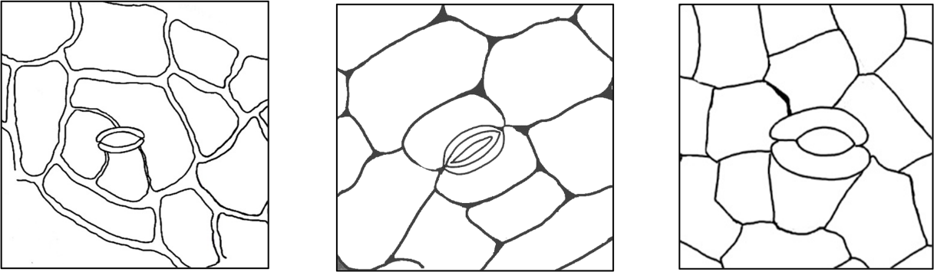
Supplementary Material Figure 1: Three types of stomatal subsidiary cells. From left to right: Anisocytic, Paracytic, and Anomocytic. Anisocytic: where the subsidiary cells (usually three) are of indeterminate size and shape and whose common walls have no fixed relation to the stoma (left). Paracytic: Two subsidiary cells similar in size and shape and whose common wall is co-linear with the guard cells (middle). Anomocytic: no subsidiary cells, i.e., guard cells are immediately surrounded by undifferentiated epidermal cells (right).
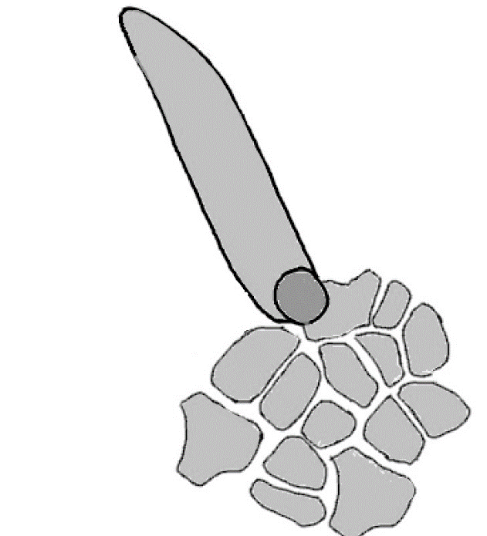
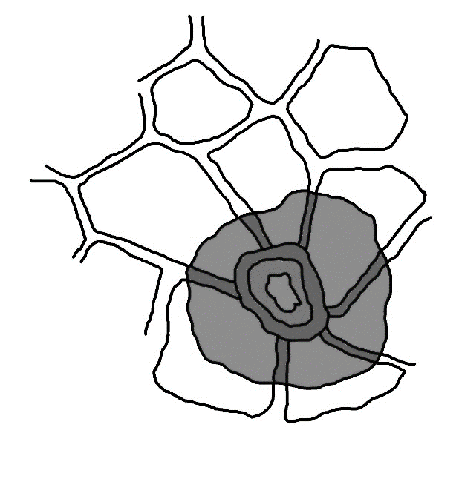
epidermal cells
trichome base
apical glandular cell
basal stalk
epidermal cell walls
trichome base
unicellular uniseriate trichome

Supplementary Material Figure 2. Trichome types relevant to this study: Glandular (left) and Uniseriate (right). Glandular trichomes can be pilate-glandular, with a glandular cell atop an elongate basal stalk, or capitate-glandular, with a glandular cell having a very short or no basal stalk. In chenopods, the glandular cell is often large and vesicular. Uniseriate trichomes consist of a single row of cells; either unicellular, bicellular or multicellular.

