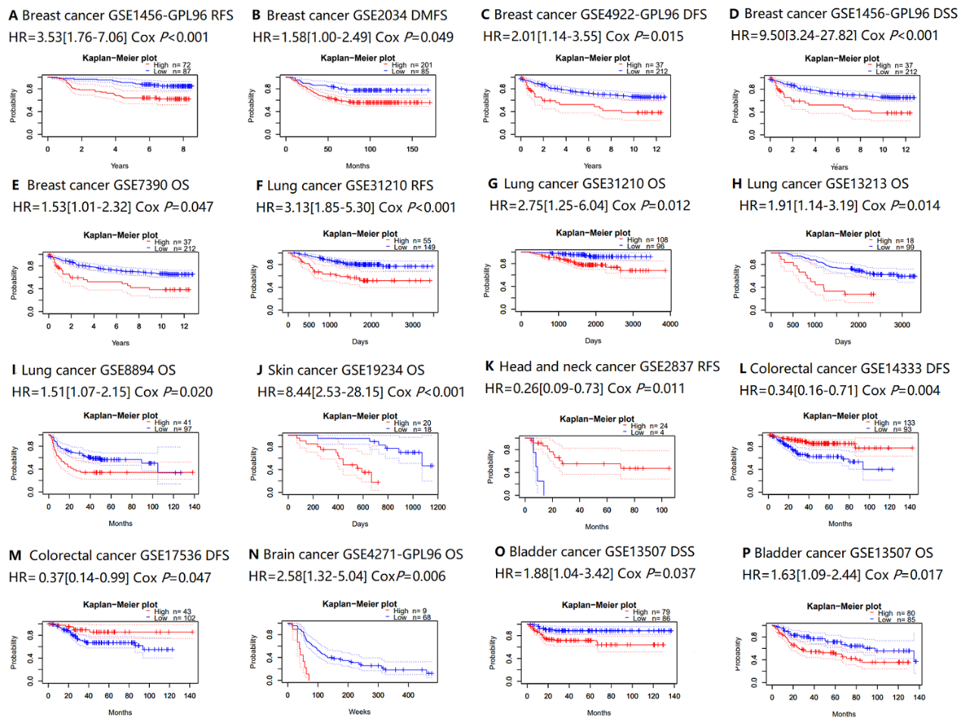
Figure S1. Survival curves based on FLAD1 expression in different endpoints and cancers in the PrognoScan database. (A)-(E) BRCA, (F)-(I) lung cancer, (J) skin cancer, (K) head and neck cancer, (L)-(M) colorectal cancer, (N) brain cancer, (O)-(P) bladder cancer. (A) RFS in the GSE1456-GPL96 cohort. (B) DMFS in the GSE2034 cohort. (C) DFS in the GSE74922-GPL96 cohort. (D) Disease-Specific Survival (DSS) in GSE1456-GPL96 cohort. (E) OS in the GSE7390 cohort. (F) RFS in the GSE31210 cohort. (G) OS in the GSE31210 cohort. (H) OS in the GSE13213 cohort. (I) OS in the GSE8894 cohort. (J) OS in the GSE19234 cohort. (K) RFS in the GSE2837 cohort. (L) DFS in the GSE14333 cohort. (M) DFS in the GSE17536 cohort. (N) OS in the GSE4271-GPL96 cohort. (O) DSS in the GSE13507 cohort. BRCA, breast cancer; FLAD1, flavin adenine dinucleotide synthetase 1. FLAD1, flavin adenine dinucleotide synthetase 1; OS, overall survival; RFS, relapse-free survival; DFS, disease-free survival; DMFS, disease metastasis-free survival.
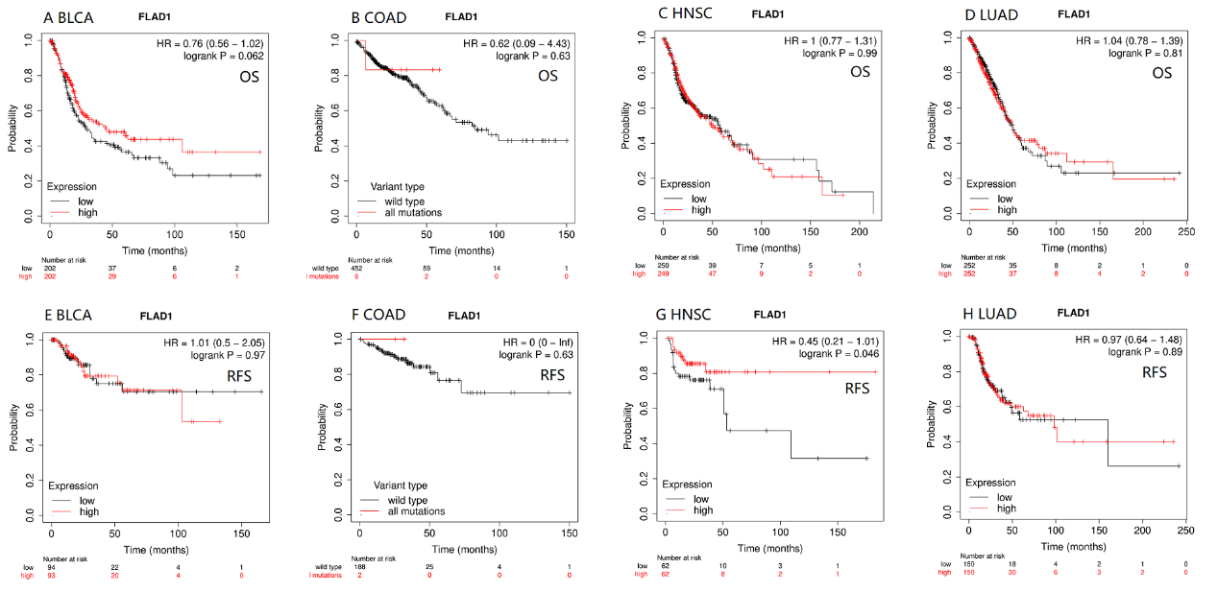
Figure S2. Survival curves based on FLAD1 expression in different endpoints and cancers in the Kaplan-Meier Plotter database. (A) OS curves of BLCA. (B) OS curves of COAD. (C) OS curves of HNSC. (D) OS curves of LUAD. (E) RFS curves of BLCA. (F) RFS curves of COAD. (G) RFS curves of HNSC. (H) RFS curves of LUAD.
FLAD1, flavin adenine dinucleotide synthetase 1; BLCA, bladder urothelial carcinoma; COAD, colon adenocarcinoma; HNSC, head, and neck squamous cell carcinoma; LUAD, lung adenocarcinoma; OS, overall survival; RFS, relapse-free survival.
Figure S3. Correlation between FLAD1 expression and immune gene markers in the PrognoScan database. (A) Correlation of FLAD1 expression adjusted by purity. (B) Immune markers of M1 macrophage. (C) Immune markers of M2 macrophage. (D) Immune markers of monocyte. (E) Immune markers of DCs. (F) Immune markers of NK cells. (G) Immune markers of exhausted T cells. (H) Immune markers of Treg cell. (I) Immune markers of Th1 cells.
NK, nature killer cell; DC, dendritic cell; Th, T helper cell; Treg, regulatory T cell.

