Supplementary Information

Conducting polymer/hydrogel hybrid free-standing electrodes for flexible supercapacitors capable of self-sensing working conditions: large-scale fabrication through facile and low-cost route

Madari Palliyalil Sidheekhaª, Aranhikkundan Shabeebaª, Lijin Rajanª, Mohamed Shahin Thayyil^{b}, Yahya A. Ismailª*

ª Advanced Materials Research Center, Department of Chemistry, University of Calicut, Thenhipalam, Kerala - 673635, India
^{b} Department of Physics, University of Calicut, Thenhipalam, Kerala - 673635, India

*Correspondence
Yahya A. Ismail
Department Of Chemistry, University of Calicut, Kerala, India- 673635
aiyahya123@gmail.com; aiyahya@uoc.ac.in

- Cs/PANI hybrid film
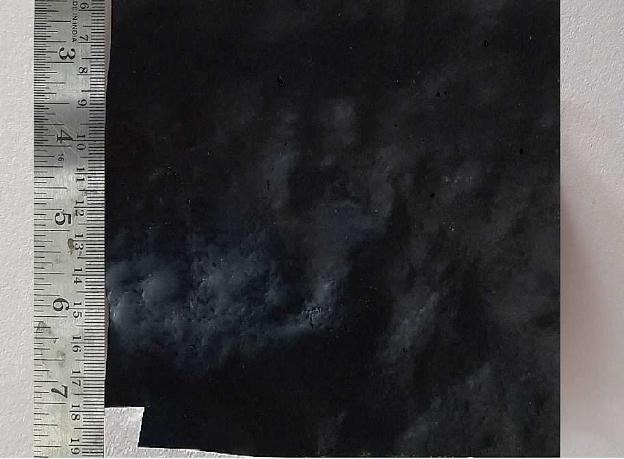
Fig. S1: photograph of fabricated CPF hybrid hygrogel film

- EDS analysis

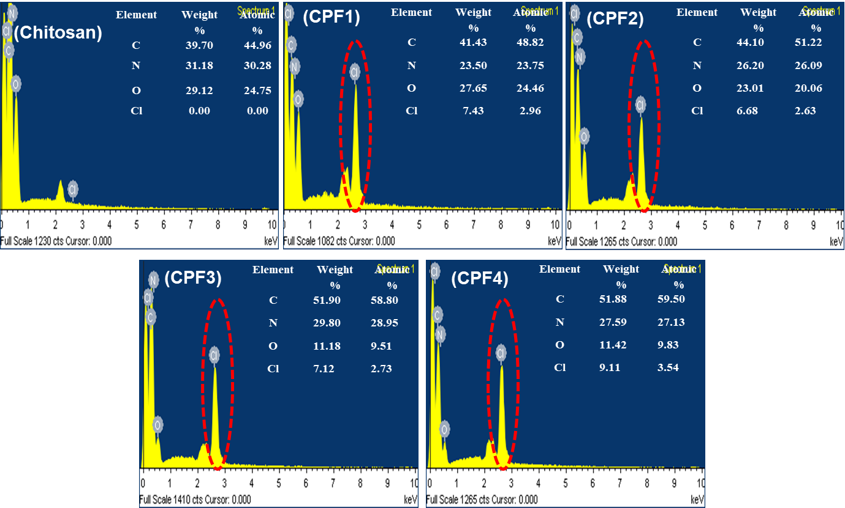
Fig. S2: SEM-EDX spectra of Chitosan and CPF films
- Cyclic voltammograms at different scan rate
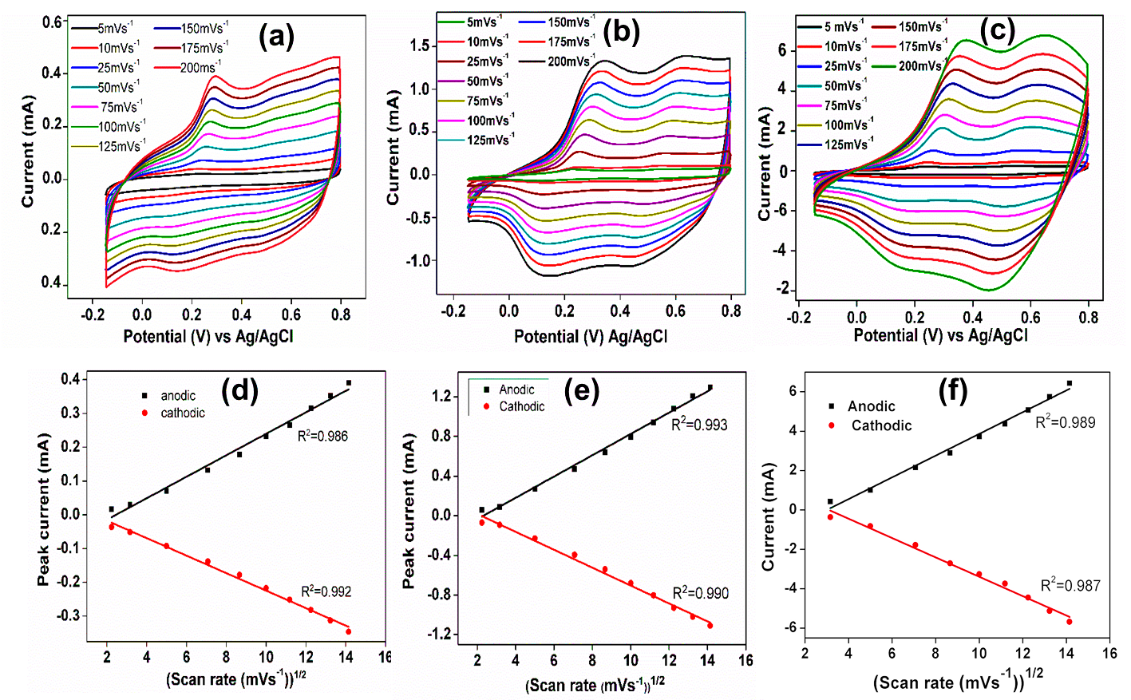
Fig. S3: (a,b and c) CVs obtained at different scan rates for CPF1, CPF2 and CPF3 films respectively and (c,d and f) variation peak current as a function of square root of scan rate for CPF1, CPF2 and CPF3 films respectively

- Chronopotentimetric responses during consecutive oxidation/reduction cycles
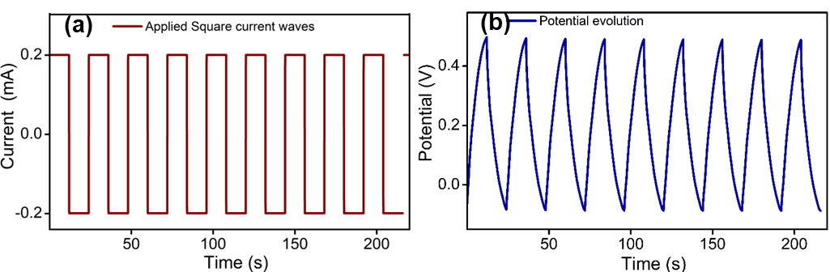
Fig. S4: (a) A representative square current waves applied to the CPF working electrode and (b) resulting chronopotentiometric responses
- CVs of CPF films at the scan rate of 5 mV s⁻¹
Fig. S5: CVs at scam rate of 5 mV s⁻¹

- Chronopotentiogram at different working current at constant charge for the device
Fig. S6: Second cycle of charge-discharge (oxidation-reduction) curve at different working (charging/discharging) currents by consuming constant charge of ±38 mC

- Mechanical properties of CPF films

Table S1: Tensile strength, Young’s Modulus and % elongation at break of CPF films
Film | Tensile strength (MPa) | Young’s Modulus (MPa) | % Elongation at break
CPF1 | 9.82 | 2.32 | 8.12
CPF2 | 8.22 | 1.99 | 7.08
CPF3 | 6.64 | 1.85 | 6.42
CPF4 | 5.84 | 1.56 | 5.86

- CV peaks of CPF film at scan rate 25 mV/s

Table S2: Anodic and cathodic peaks of CPF electrodes at the scan rate 25 mV/s
Film | Anodic peaks (V) |  | Cathodic peaks (V)
 | LE to ES | ES to PN | PN to ES | ES to LE
CPF1 | 0.27 | 0.54 | 0.43 | 0.059
CPF2 | 0.28 | 0.54 | 0.42 | 0.11
CPF3 | 0.28 | 0.59 | 0.48 | 0.19
CPF4 | 0.29 | 0.57 | 0.45 | 0.13
LE- leucoemeraldine, ES- emeraldine salt, PN- pernigraniline

- EIS Fitting data of device

Table S2: The best fitting values of the equivalent circuit elements in Figure 13e for the impedance data of CPF device
Parameters | Rs  (Ω) | Q₁ (CPE₁)  (S·s^{α1}) | α₁ | R_{ct1}  (Ω) | Q₂ (CPE₂)  (S·s^{α2}) | α₂ | R_{ct2}  (Ω) | W  (Ω. s^{-0.5})
Values | 19.6 | 0.00432 | 0.455 | 4.27 | 0.0348 | 0.784 | 46.5 | 0.0277

