Antibody and T cell responses against wild-type and Omicron SARS-CoV-2 after the third dose of BNT162b2 in healthy adolescents

Xiaofeng Mu,^{1,}* Carolyn A Cohen,^{2,3,}* Daniel Leung,^{1,}* Jaime S Rosa Duque,^{1,}* Samuel MS Cheng,²* Yuet Chung,¹ Howard HW Wong,¹ Amos MT Lee,¹ Wing Yan Li,¹ Issan YS Tam,¹ Jennifer HY Lam,¹ Derek HL Lee,¹ Sau Man Chan,¹ Leo CH Tsang,² Karl CK Chan,² John KC Li,² Leo LH Luk,² Sara Chaothai,² Kelvin KH Kwan,² Nym Coco Chu,² Masashi Mori,⁴ Trushar Jeevan,⁷ Ahmed Kandeil,⁷ Richard J Webby,⁷ Wenwei Tu,^{1,†} Sophie Valkenburg,^{2,3,5,†} Malik Peiris,^{2,3,6,†} Yu Lung Lau,^{1,8,†}

¹ Department of Paediatrics and Adolescent Medicine, The University of Hong Kong, Hong Kong, China
² School of Public Health, The University of Hong Kong, Hong Kong, China
³ HKU-Pasteur Research Pole, School of Public Health, The University of Hong Kong, Hong Kong, China
⁴ Research Institute for Bioresources and Biotechnology, Ishikawa Prefectural University, Nonoichi, Japan
⁵ Department of Microbiology and Immunology, Peter Doherty Institute for Infection and Immunity, University of Melbourne, Melbourne, Australia
⁶ Centre for Immunology & Infection C2i, Hong Kong, China
⁷ Department of Infectious Diseases, St Jude Children’s Research Hospital, Memphis, TN, USA
⁸ lead contact

EXTENDED DATA

TABLES

Table S1. Characteristics of the participants in the healthy expanded population.
Healthy adolescents
Number of participants | 28
Male sex | 15 (53.6%)
Han Chinese | 25 (89.3%)
Age (years) | 13.7 (1.44)
Healthy adults
Number of participants | 41
Male sex | 21 (51.2%)
Han Chinese | 37 (90.2%)
Age (years) | 48.4 (7.08)
Values are either count (%) or mean (standard deviations).

Table S2. Humoral immunogenicity outcomes against wild-type SARS-CoV-2 after the third dose of BNT162b2 in expanded analysis population
 | Adolescents  3 doses | Adults  3 doses
S IgG on ELISA
N | 28 | 33
GM OD450 value (95% CI) | 1.39 (1.32-1.48) | 1.44 (1.40-1.47)
% positive (>/=LOD at 0.3) | 100%, P>0.9999 | 100%
S-RBD IgG on ELISA
N | 28 | 41
GM OD450 value (95% CI) | 2.89 (2.85-2.93) | 2.90 (2.81-2.99)
% positive (>/=LOD at 0.5) | 100%, P>0.9999 | 100%
S-RBD ACE2-blocking antibody on sVNT
N | 25 | 41
GM % inhibition (95% CI) | 97.1% (97.0-97.2%) | 96.9% (96.7-97.1%)
% positive (>/=LOQ at 30%) | 100%, P>0.9999 | 100%
Neutralizing antibody on PRNT
N | 14 | 14
GM PRNT90 (95% CI) | 263 (218-317) | 215 (166-279)
% positive (>/=LOD at 10) | 100%, P>0.9999 | 100%
GM PRNT50 (95% CI) | 320 (320-320) | 320 (320-320)
% positive (>/=LOD at 10) | 100%, P>0.9999 | 100%
S IgG avidity on ELISA
N | 28 | 33
GM avidity index (95% CI) | 88.8% (85.8.8-91.9) | 79.7% (76.13-83.4)
S IgG FcγRIIIa-binding on ELISA
N | 28 | 33
GM OD450 value (95% CI) | 1.90 (1.86-1.93%) | 1.87 (1.85-1.90%)
% positive (>/=LOD at 0.28) | 100%, >0.9999 | 100%
S, spike protein; ELISA, enzyme-linked immunosorbent assay; GM, geometric mean; OD, optical density; LOD, limit of detection; LOQ, limit of quantification; CI, confidence interval; RBD, receptor-binding domain; ACE-2, angiotensin-converting enzyme-2; sVNT, surrogate virus neutralization test; PRNT, plaque reduction neutralization test; PRNT90, 90% plaque reduction neutralization titre; PRNT50, 50% plaque reduction neutralization titre; FcγRIIIa, Fc gamma receptor III-a. P-values compare the proportion of positive responses between adolescents and adults by Fisher’s exact test.

Table S3. Cellular immunogenicity outcomes against wild-type SARS-CoV-2 after the third dose of BNT162b2 in expanded analysis population
 | Adolescents  3 doses | Adults  3 doses
T cell responses
S-specific T cell responses on flow cytometry
N | 26 | 33
GM % IFN-γ⁺CD4⁺ T cells  (95% CI) | 0.058%  (0.031-0.111%) | 0.047%  (0.025-0.089%)
% positive (>/=cut-off at 0.01%) | 88.5%, P=0.72 | 81.8%
GM % IL-2⁺CD4⁺ T cells  (95% CI) | 0.046%  (0.022-0.095%) | 0.037%  (0.021-0.065%)
% positive (>/=cut-off at 0.01%) | 80.8%, P>0.9999 | 78.8%
GM % IFN-γ⁺CD8⁺ T cells  (95% CI) | 0.045%  (0.023-0.091%) | 0.017%  (0.008-0.037%)
% positive (>/=cut-off at 0.01%) | 84.6%, P=0.003 | 45.5%
GM % IL-2⁺CD8⁺ T cells  (95% CI) | 0.027%  (0.012-0.059%) | 0.008%  (0.005-0.015%)
% positive (>/=cut-off at 0.01%) | 76.9%, P=0.009 | 42.2%
S, Spike; GM, geometric mean; CI, confidence interval; IFN-γ, interferon-gamma; IL-2, interleukin-2. P-values compare the proportion of positive responses between adolescents and adults by Fisher’s exact test.

FIGURES

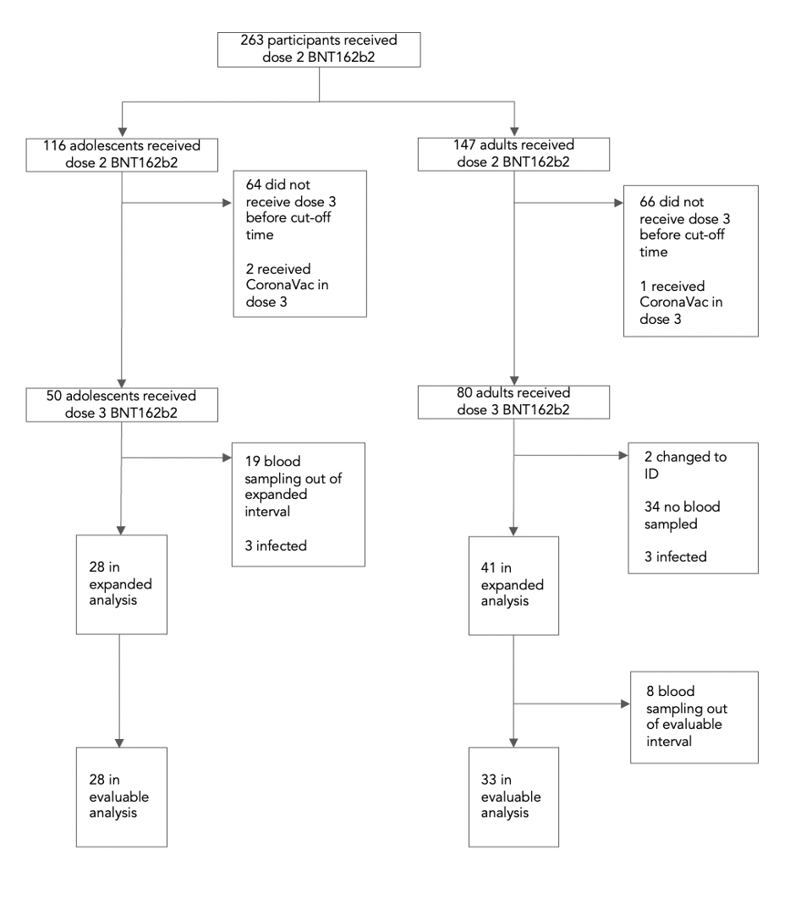

Fig. S1 Flow diagram of study participants. There were 116 adolescents aged 11-17 years and 147 adults aged 18 or above received two doses of BNT162b2. In this population, 50 adolescents and 80 adults received a third dose of BNT162b2. Uninfected participants who had no major protocol deviations and a valid result were included in the evaluable analysis population. The criteria for expanded analysis population were more relaxed, including the samples out of evaluable interval.

Fig. S2 Comparable humoral responses to WT virus after the third dose of BNT162b2 vaccine between adolescents and adults. A. Comparison of S IgG (adult N=28, adolescent N=28), S-RBD IgG (adult N=33, adolescent N=28), sVNT inhibition (adult N=33, adolescent N=25), PRNT90 (adult N=14, adolescent N=14), PRNT50 (adult N=14, adolescent N=14), S IgG avidity (adult N=28, adolescent N=28) and S IgG FcγRIIIa-binding (adult N=28, adolescent N=28) between evaluable adolescents and adults. B. Non-inferiority test of S IgG (adolescent N=28, adult N=33), S-RBD IgG (adolescent N=28, adult N=41), sVNT inhibition (adolescent N=25, adult N=41), PRNT90 (adolescent N=14, adult N=14), PRNT50 (adolescent N=14, adult N=14), S IgG avidity (adolescent N=28, adult N=33) and S IgG FcγRIIIa-binding (adolescent N=28, adult N=33) in expanded adolescents in comparison to adults. Statistical analysis was determined using unpaired t-test after natural logarithmic transformation with p-values denoted. There was no associated 95% CI for PRNT50 as all values in both groups were equal, at the upper LOD of 320. ***p<0.001. ns, not significant. LOD: Limits of detection; LOQ: limits of quantification; WT: wild-type; S-RBD: Spike-receptor binding domain; sVNT: surrogate virus neutralization test; PRNT: plaque reduction neutralization test; FcγRIIIa: Fcγ receptor IIIa.

Fig. S3 Comparable cellular responses to WT virus after the third dose of BNT162b2 vaccine between adolescents and adults. A. Longitudinal analysis of S-specific interferon-γ (IFN-γ)⁺ CD4⁺(pre-dose 1 N=0, post-dose 2 N=10, pre-dose 3 N=17, post-dose 3 N=17), interleukin-2 (IL-2)⁺ CD4⁺ (pre-dose 1 N=0, post-dose 2 N=10, pre-dose 3 N=17, post-dose 3 N=17), IFN-γ⁺ CD8⁺ (pre-dose 1 N=0, post-dose 2 N=10, pre-dose 3 N=17, post-dose 3 N=17), and IL-2⁺ CD8⁺ (pre-dose 1 N=0, post-dose 2 N=10, pre-dose 3 N=17, post-dose 3 N=17) T cells responses in evaluable adults. B. Comparison of S-specific interferon-γ (IFN-γ)⁺ CD4⁺ (adult N=28, adolescent N=26), interleukin-2 (IL-2)⁺ CD4⁺ (adult N=28, adolescent N=26), IFN-γ⁺ CD8⁺ (adult N=28, adolescent N=26), and IL-2⁺ CD8⁺ (adult N=28, adolescent N=26) T cells responses between evaluable adolescents and adults. Data labels and centre lines show geometric means (GM) estimates, with corresponding 95% confidence intervals shown by error bars. C. non-inferiority test of S-specific IFN-γ⁺ CD4⁺ (adolescent N=33, adult N=26), IL-2⁺ CD4⁺ (adolescent N=33, adult N=26), IFN-γ⁺ CD8⁺ (adolescent N=33, adult N=26), and IL-2⁺ CD8⁺ ((adolescent N=33, adult N=26) T cells responses in expanded adolescents in comparison to adults. Geometric mean ratios (GMR) and two-tailed 95% confidence intervals (CI) were plotted. Statistical analysis was determined using unpaired or paired t-test after natural logarithmic transformation with p-values denoted. *p<0.05, **p<0.01. ns, not significant. Cut-offs were drawn as grey lines. WT: wild-type.

