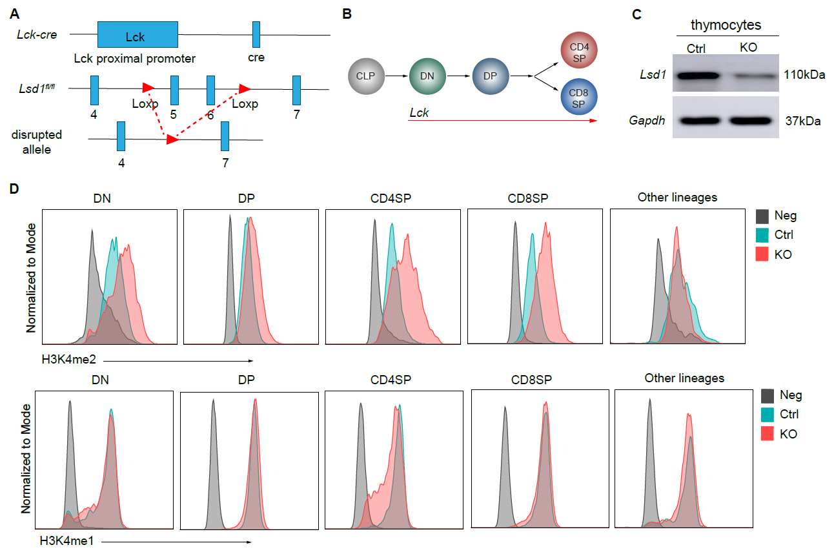
Figure S1. The deletion of Lsd1. A. Lck-Cre mice were crossed with Lsd1^{fl/fl} strain to generate conditional knockout mice. Exon 5 and 6 of the Lsd1 gene flanked by LoxP site were removed after recombination to inactivate the Lsd1. (B) The development trajectory of thymocytes was shown. The Lck activates at the DN stage. (C) The expression of Lsd1 in thymocytes from control and KO mice was analyzed by immunoblot. (D) Intracellular flow cytometry analysis of H3K4me2 and H3K4me1 in double-negative (DN, CD4⁻CD8⁻Lin⁻), double-positive (DP, CD4⁺CD8⁺Lin⁻), CD4 single-positive (CD4SP, CD4⁺CD8⁻Lin⁻), CD8 single-positive (CD8SP, CD4⁻CD8⁺Lin⁻) and other lineage cells (CD4⁻CD8⁻Lin⁺) from control and KO mice. Control: Lsd1^{wt/fl}Lck-Cre, KO: Lsd1^{fl/fl}Lck-Cre. Lin: Ly6G, TER-119, CD11b, CD11c, γδTCR，CD19, NK1.1.

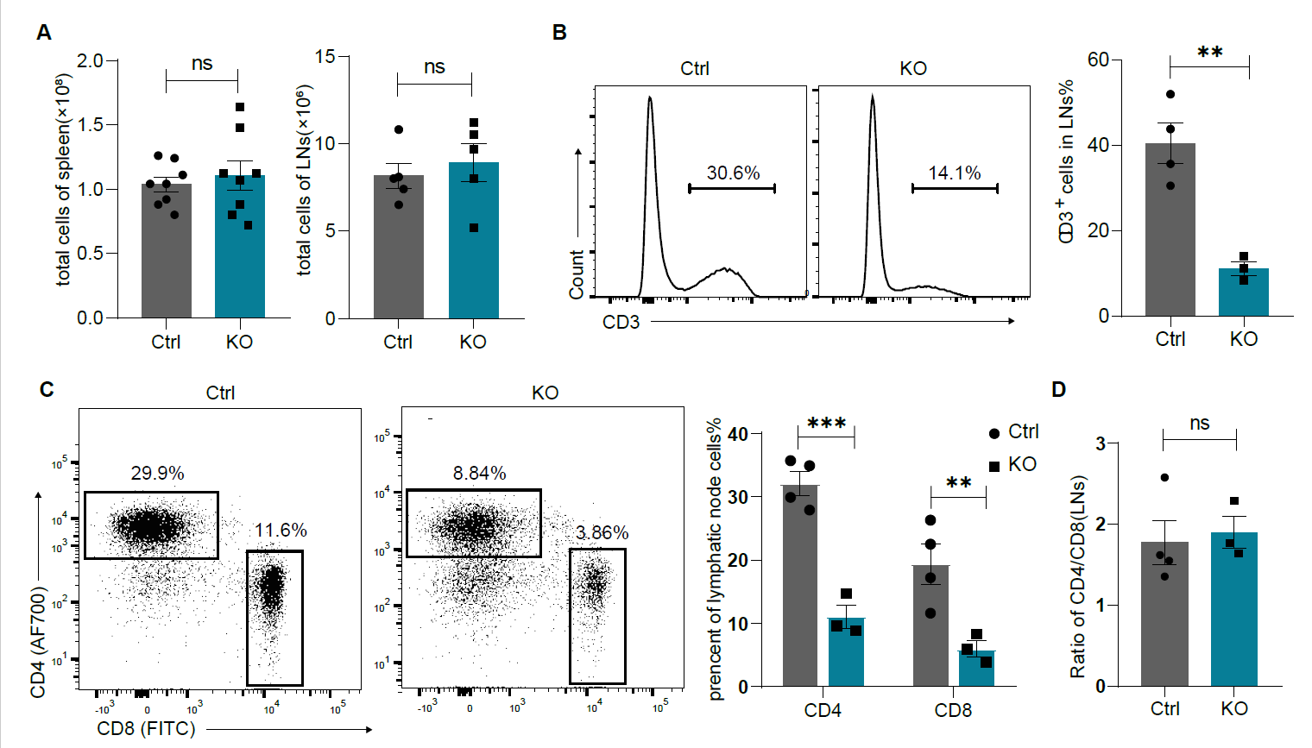
Figure S2. Decreased periphery T cells in lymph nodes from Lsd1-deleted mice. (A) Total cell numbers of spleen and lymph nodes from control and KO mice. (B) Representative histograms show the percentages of CD3⁺ cells in lymph nodes from control and KO mice. Frequencies of CD3⁺ T cells were statistically shown on the right. (C) Representative CD4 versus CD8 staining of lymph node cells from control (n=4) and KO (n=3) mice. Frequencies of CD4⁺ and CD8⁺ T cells were statistically shown on the right, respectively. (D) Ratio of CD4⁺ versus CD8⁺ subsets in the lymph nodes from control (n=4) and KO (n=3) mice. Control: Lsd1^{wt/fl}Lck-Cre, KO: Lsd1^{fl/fl}Lck-Cre. Cumulative data are means±SEM. **p<0.01, ***p<0.001, ns: not significant, as determined by unpaired Student’s t test.

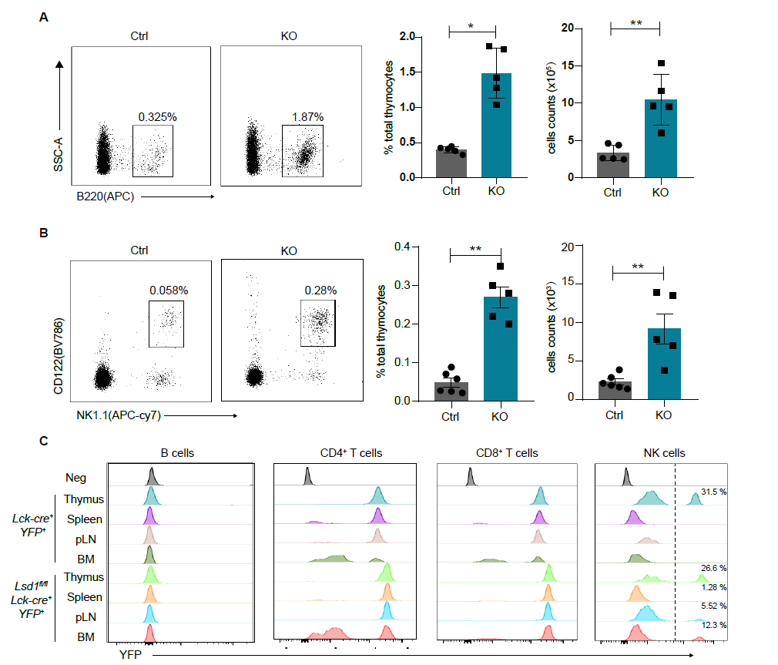
Figure S3. Increased thymic B cells and NK cells after Lsd1 deletion. (A) CD4⁻CD8⁻B220⁺ thymic B cells from control and KO mice were detected by flow cytometry. The numbers on plots indicate their frequencies in total thymocytes. Statistical analysis of frequencies and numbers of thymic B cells are shown on the right. (B) CD4⁻CD8⁻CD3⁻CD122⁺NK1.1⁺ thymic NK cells from control and KO mice were detected by flow cytometry. The numbers on plots indicate their frequencies in total thymocytes. Statistical analysis of frequencies and numbers of thymic NK cells are shown on the right. (C) YFP-positive B cells, CD4⁺ T cells, CD8⁺ T cells and NK cells in thymus, spleen, lymph nodes (LNs) and bone marrow (BM) from Lck-Cre⁺YFP⁺ and Lsd1^{fl/fl}Lck-Cre⁺YFP⁺ thymocytes were detected by flow cytometry. Control: Lsd1^{wt/fl}Lck-Cre, KO: Lsd1^{fl/fl}Lck-Cre. **p<0.01, ***p<0.001, as determined by unpaired Student’s t test.

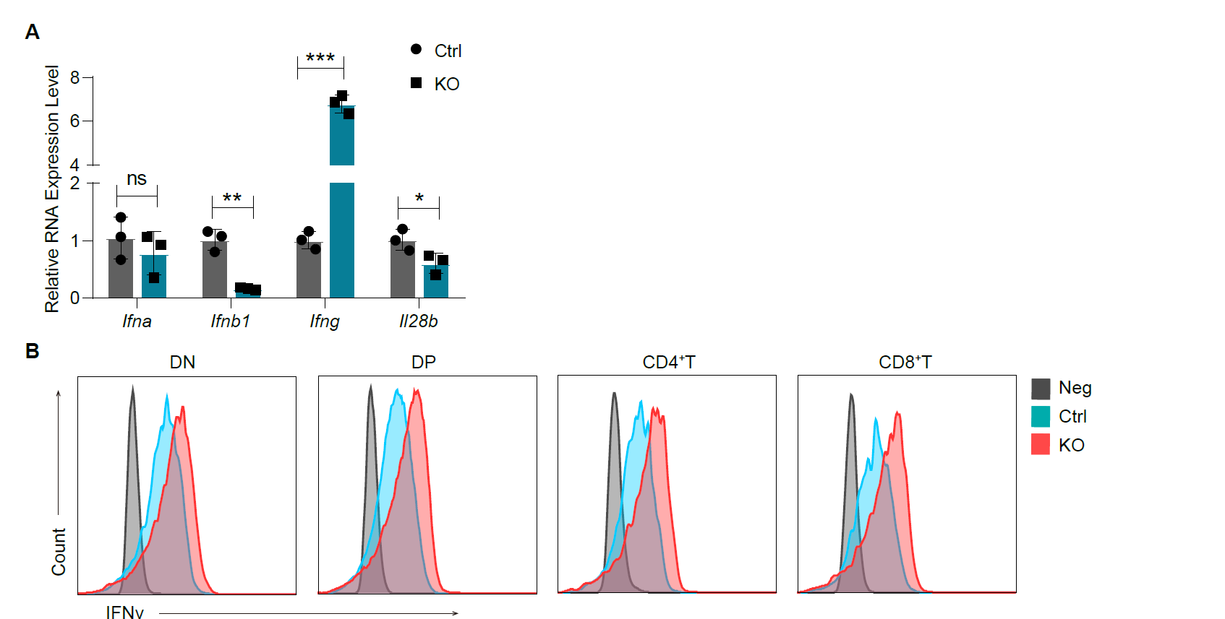
Figure S4. The expression of interferons in the thymus. (A) The expression of Ifna, Ifnb1, Ifng, and Il28b in control and KO thymocytes analyzed by qPCR. Error bars represent SD between triplicates in one of three experiments. (B) IFN-γ expression in double-negative (DN), double-positive (DP), CD4 single positive, and CD8 single positive T cells from control and KO mice. Control: Lsd1^{wt/fl}Lck-Cre, KO: Lsd1^{fl/fl}Lck-Cre. *p<0.05, **p<0.01, ***p<0.001, ns: not significant, as determined by unpaired Student’s t test.

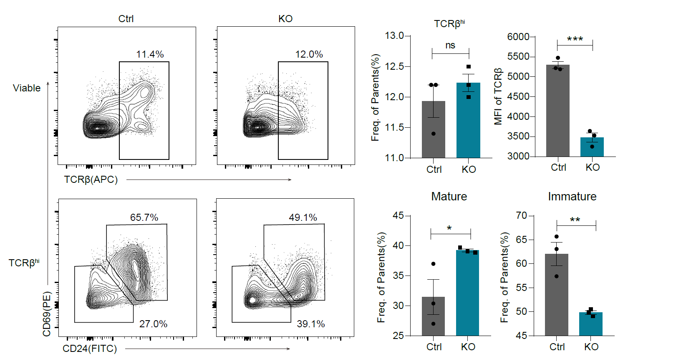
Figure S5. The maturation of post-selection thymocytes. TCRβ^{hi} thymocytes were detected by flow cytometry and further fractionated into CD69⁺CD24⁺ immature and CD69⁻CD24⁻ mature subsets. Frequencies of indicated subsets are shown on the right. Control: Lsd1^{wt/fl}Lck-Cre, KO: Lsd1^{fl/fl}Lck-Cre. *p<0.05,**p<0.01, ***p<0.001, ns: not significant, as determined by unpaired Student’s t test.

