Supplementary information for

Sara Esteghlal ª , Seyed Mohammad Hashem Hosseini ^{a,*}
ª Department of Food Science and Technology, School of Agriculture, Shiraz University, 71441-65186 Shiraz, Iran

* Corresponding author.
E-mail address: hhosseini@shirazu.ac.ir (S. M. H. Hosseini)

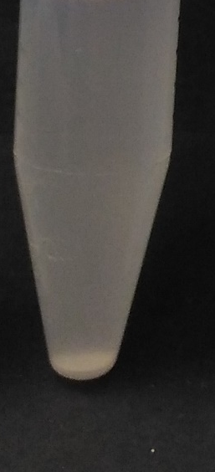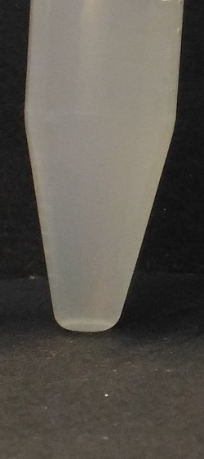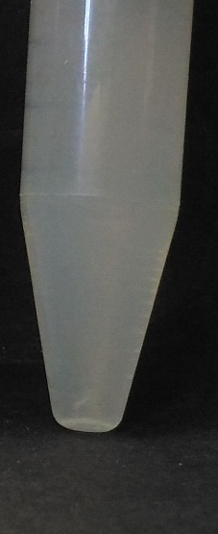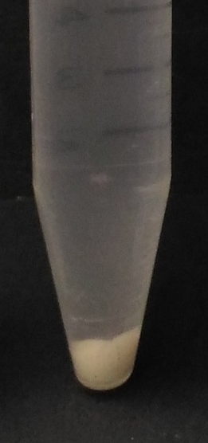
Zein pH 4
Zein:WPG (1:1) pH 4
Zein:WPG (1:1) pH 7
Zein:WPG (10:1) pH 4
da
ca
ba
aa

Fig. S1. Visual images of (a) zein particles dispersion at pH 4, (b) zein:WPG (1:1) particles dispersion at pH 4, (c) zein:WPG (1:1) particles dispersion at pH 7, and (d) zein:WPG (10:1) particles dispersion at pH 4

