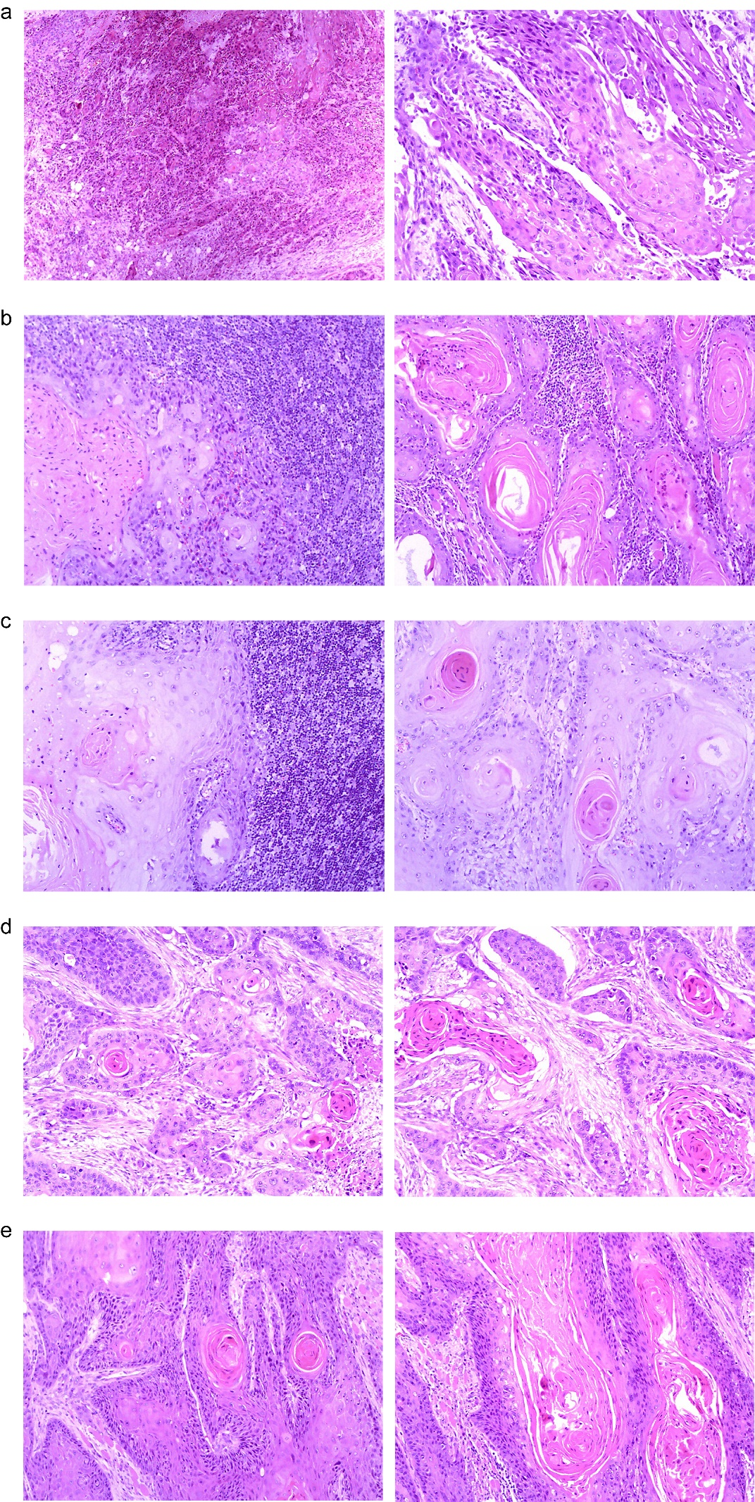
Figure S1. HE staining of cancer tissue samples from five patients. (a) 93481, squamous cell carcinoma of the floor of the mouth with squamous carcinoma metastasis detected in bilateral submandibular lymph nodes and squamous carcinoma metastasis detected in the left deep lower cervical lymph node. (b)93541, squamous cell carcinoma of the right tongue, metastasis of squamous carcinoma in the right chin lymph node and metastasis of squamous carcinoma in the right deep upper neck lymph node. (c) 93510, squamous cell carcinoma of right tongue ventral and tongue root, metastasis of squamous carcinoma in right deep upper neck lymph node, metastasis of squamous carcinoma in left deep upper neck lymph node. (d) 93488, squamous cell carcinoma of the right floor of the mouth with no metastasis in the lymph nodes. (e) 93487, squamous cell carcinoma of the right tongue and abdominal floor of the mouth with no metastasis in the lymph nodes.

