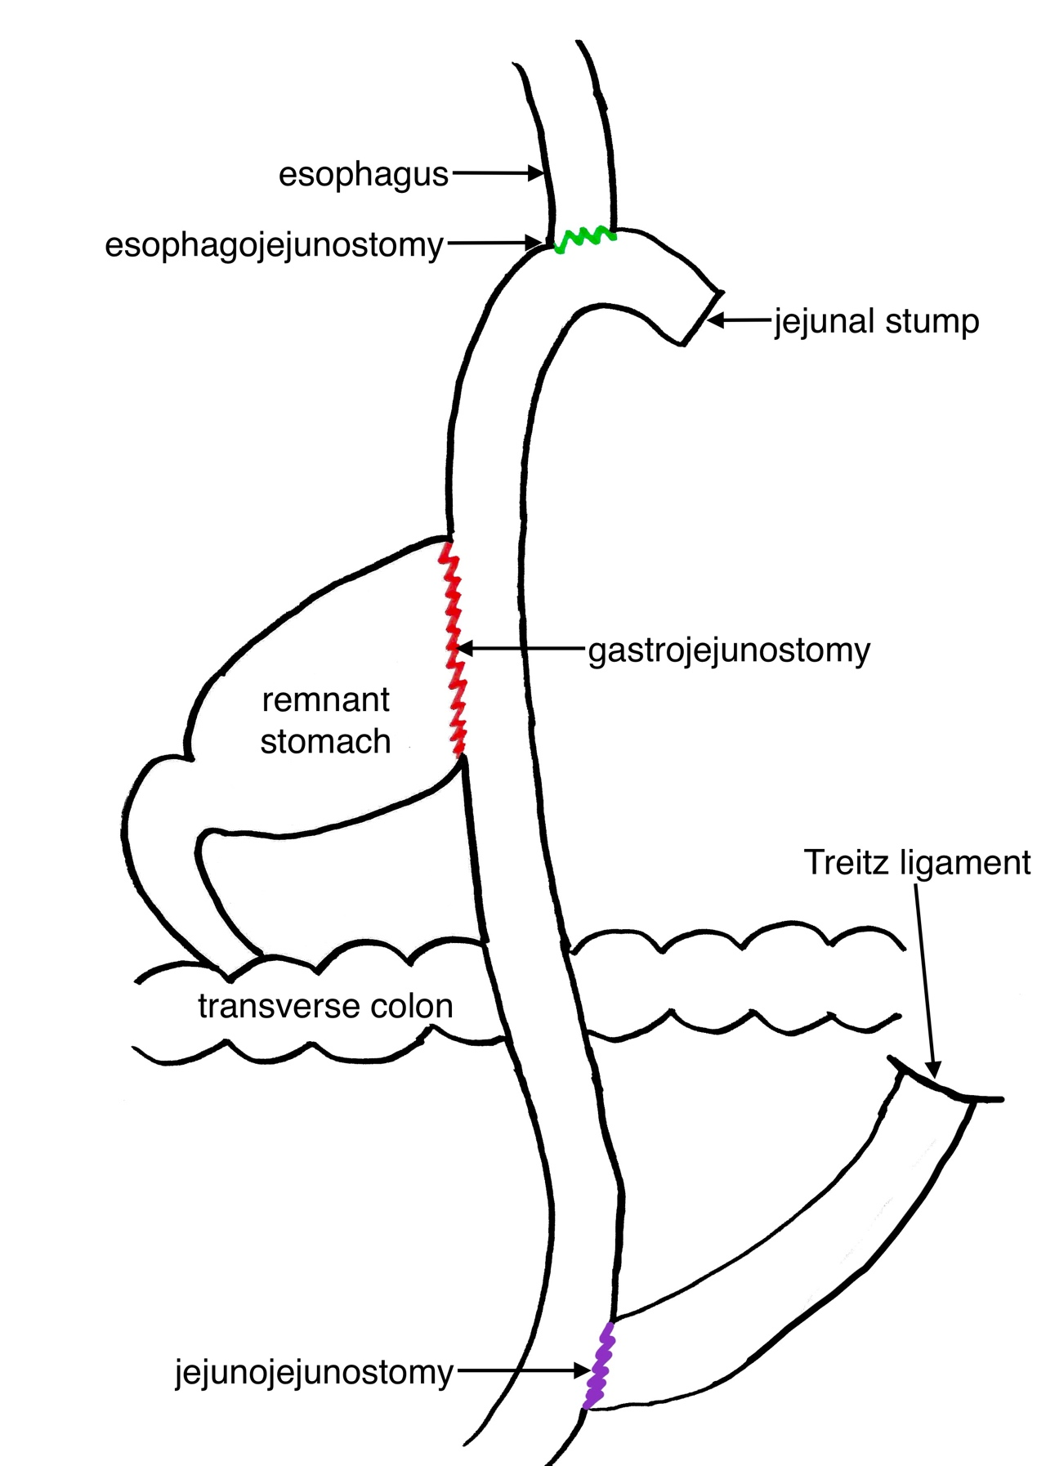

Double-tract reconstruction after radical proximal gastrectomy

