Supplementary Information
Stable, reproducible, and binder-free gold/copper core-shell nanostructures for high-sensitive non-enzymatic glucose detection
Hossein Siampour¹, Sara Abbasian², Ahmad Moshaii^{1, 2*}, Amir R. Amirsoleimani¹

¹Department of Physics, Tarbiat Modares University, Tehran, P.O Box 14115-175, Iran
²Department of Sensor and Biosensor, Faculty of Interdisciplinary Sciences and Technologies, Tarbiat Modares University, P.O. Box: 14115-336, Tehran, Iran
* E-mail: moshaii@modares.ac.ir

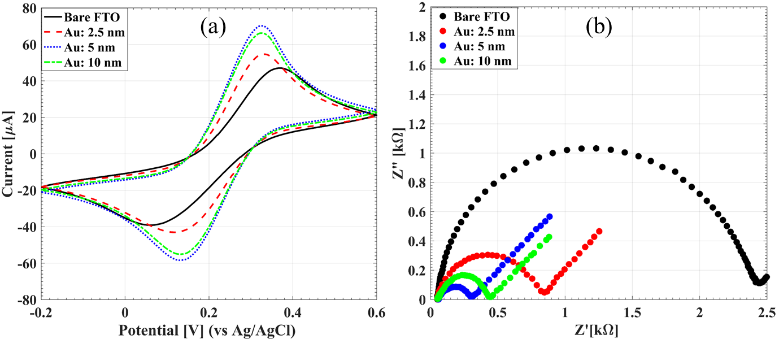
Figure S1. Cyclic voltammograms (a) and Nyquist plots (b) of the bare FTO electrode and the Au nanocores electrodes with deposition thicknesses of 2.5, 5 and 10 nm in 0.1 M KCl solution containing redox couple of [Fe (CN)₆] ^{-3/-4}.

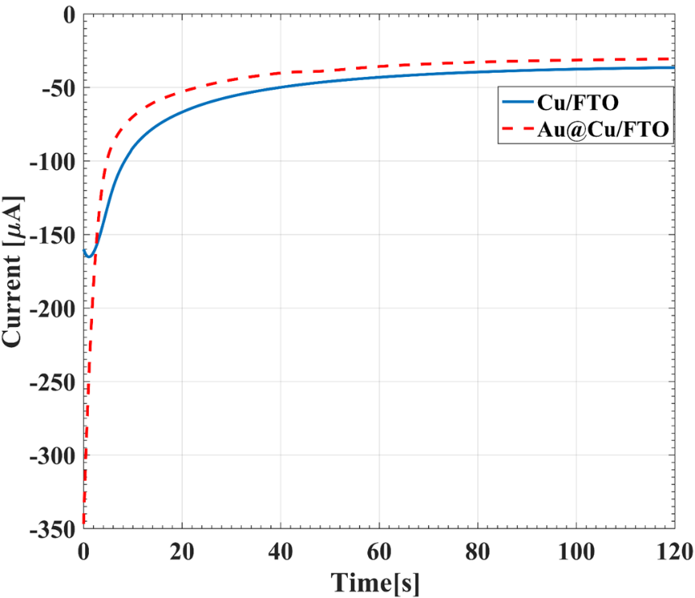
Figure S2. The current transient curves of Cu deposition on the bare and the Au core supported FTO electrodes.

Figure S 3. XRD pattern of the bare FTO electrode, Au core supported FTO electrode, Au@Cu, Au@Cu₂O and Au@CuO FTO electrodes.

Figure S4. Amperometric response of the Au@Cu₂O electrode after successive addition of 0.5 mM glucose at different applied potentials in 0.1 M NaOH solution (a), and different concentrations of NaOH solution at the applied potential of +0.55 V (b).

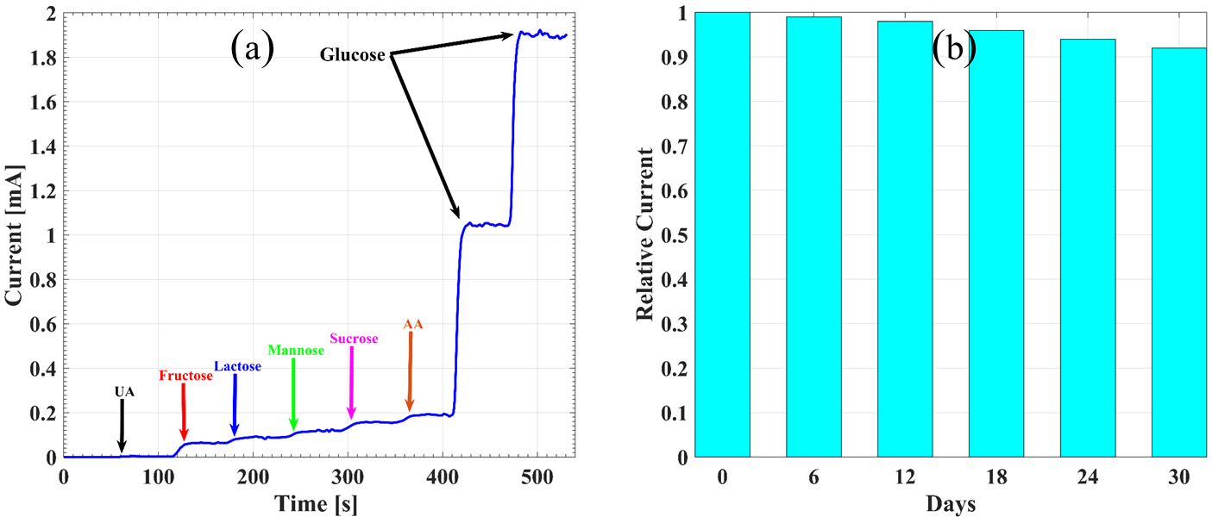
Figure S5. (a) Selectivity of Au@Cu₂O electrode in present of interference species including 0.02 mM UA, 0.1 mM fructose, 0.1 mM lactose, 0.1 mM mannose, 0.1 mM sucrose, 0.1 mM AA and addition of 0.5 mM glucose at applied potential of + 0.55 V and (b) stability Of Au@Cu₂O electrode in present of 1mM Glucose during one month.

Table S1. Detection results of glucose in human serum samples
Samples | Clinical results (mM) | This sensor  (mM) | Difference (%) | RSD (n = 3)  (%) | Glucose added  (mM) | Recovery test  (%)
Serum 1 | 4.80 | 4.65 | 3.12 | 2.84 | 0
 |  |  |  |  | 0.5 | 99
 |  |  |  |  | 1 | 104
Serum 2 | 4.26 | 4.12 | 3.28 | 3.05 | 0
 |  |  |  |  | 0.5 | 101
 |  |  |  |  | 1 | 105
Serum 3 | 5.63 | 5.44 | 3.37 | 3. 43 | 0
 |  |  |  |  | 0.5 | 101
 |  |  |  |  | 1 | 104

