Supporting information

The data for peer review were found on
hui, Fu (2021), Ecogeographic patterns of macrophyte metacommunities in the Hengduan Mountain Region, Dryad, Dataset, https://doi.org/10.5061/dryad.1jwstqjwf

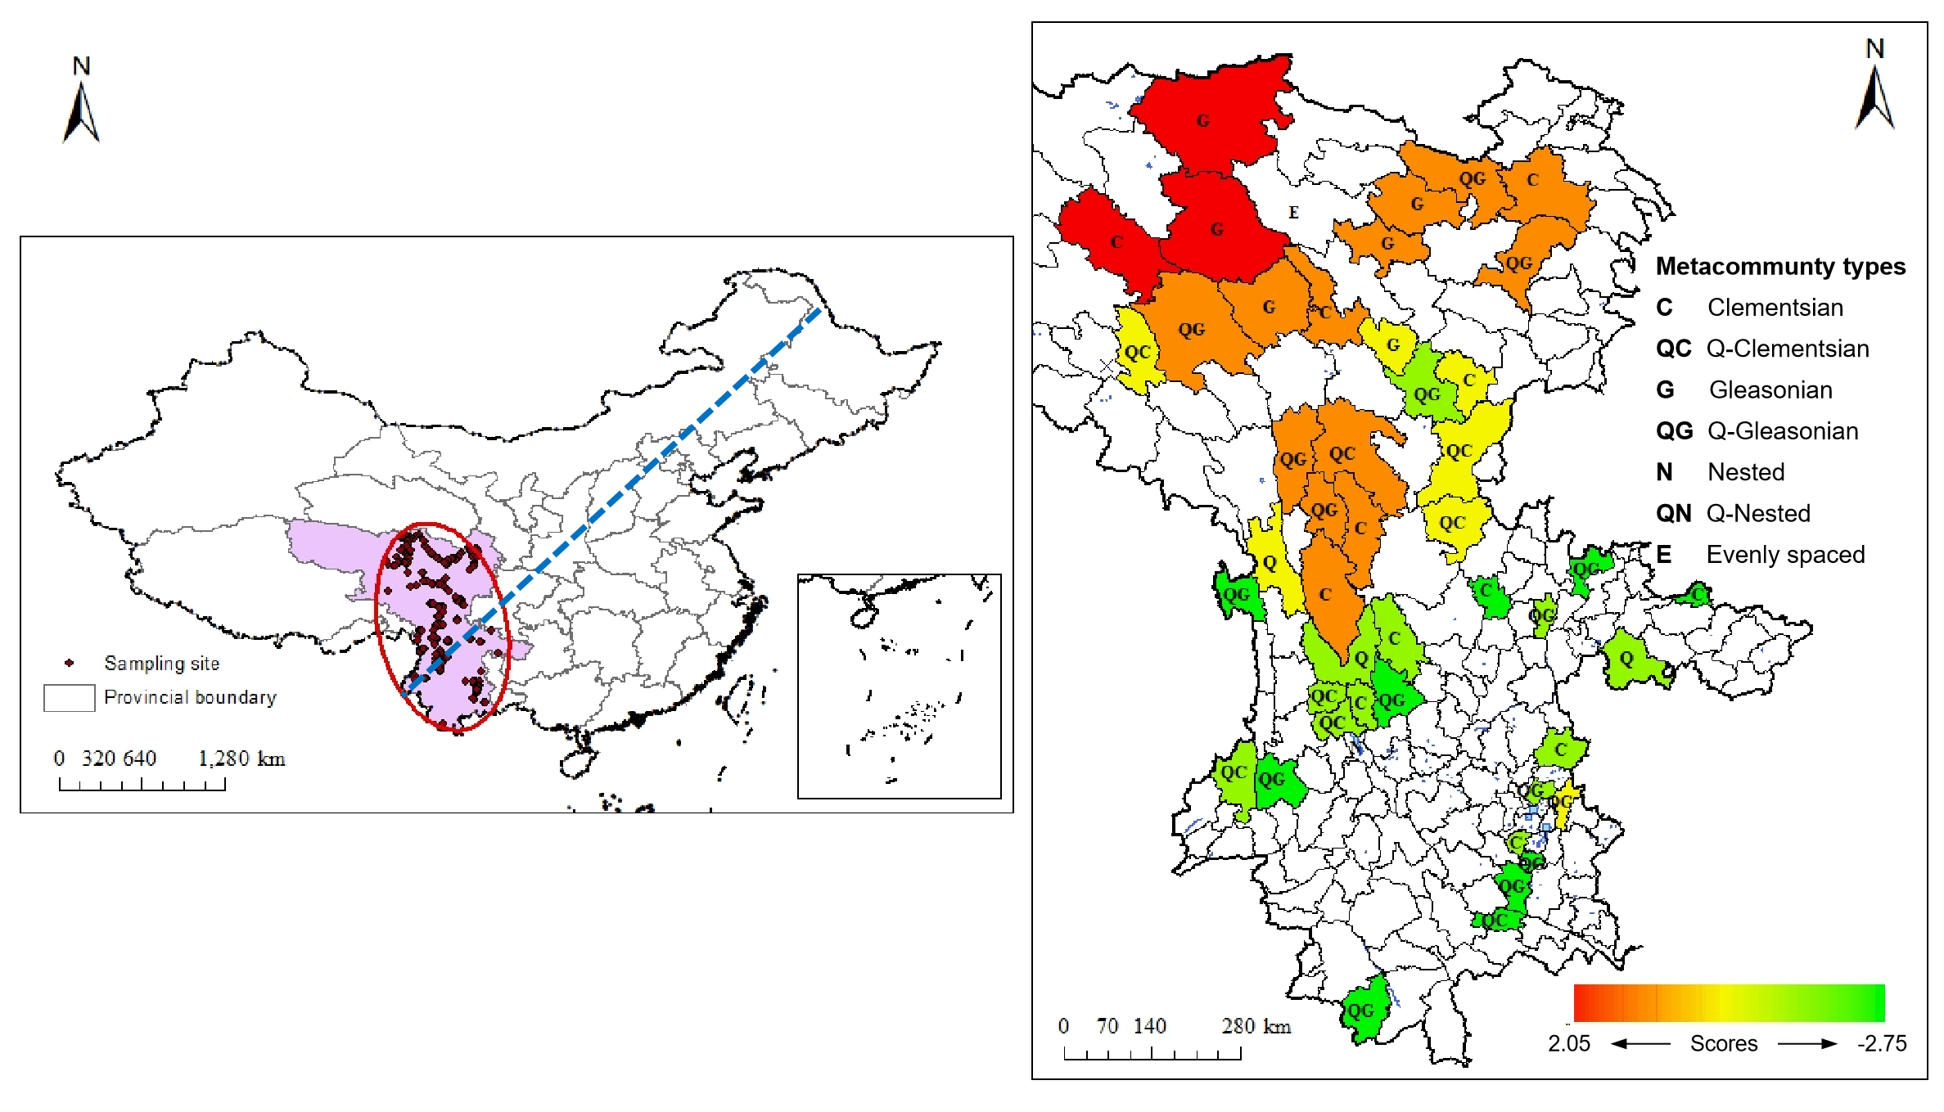
Fig. S1. Geographic location of the Hengduan Mountain region. The blue line indicates the “Hu line” as proposed by the Chinese geographer Hu Huanyong, which is regarded as the Chinese population density distribution line. Colors represent their canonical scores along a discriminant analysis separating macrophyte metacommunity patterns using local and regional variables together (see Methods), and letters represent the original results from the EMS analysis.

Fig. S2. Relationships among the environmental variables. HHYL indicates Huhuanyong Line, Depth indicates sampling depth, Geodist indicates geographic distance.

