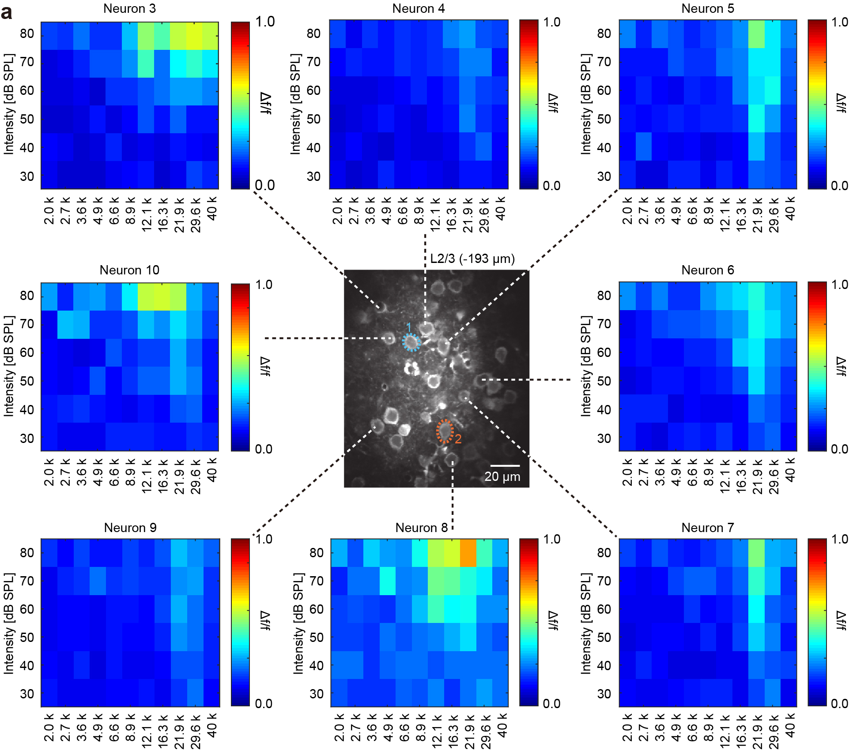
Supplementary Figure 1
Frequency response areas (FRAs) of individual neurons in layer 2/3 of the auditory cortex, recorded by two-photon Ca²⁺ imaging.
Centre panel: A representative two-photon image in layer 2/3 of the auditory cortex (depth is 193 μm from the pial surface). Surrounding panels: Colour-coded FRAs of individual neurons in the imaging plane. Dashed lines indicate the soma location of each neuron.

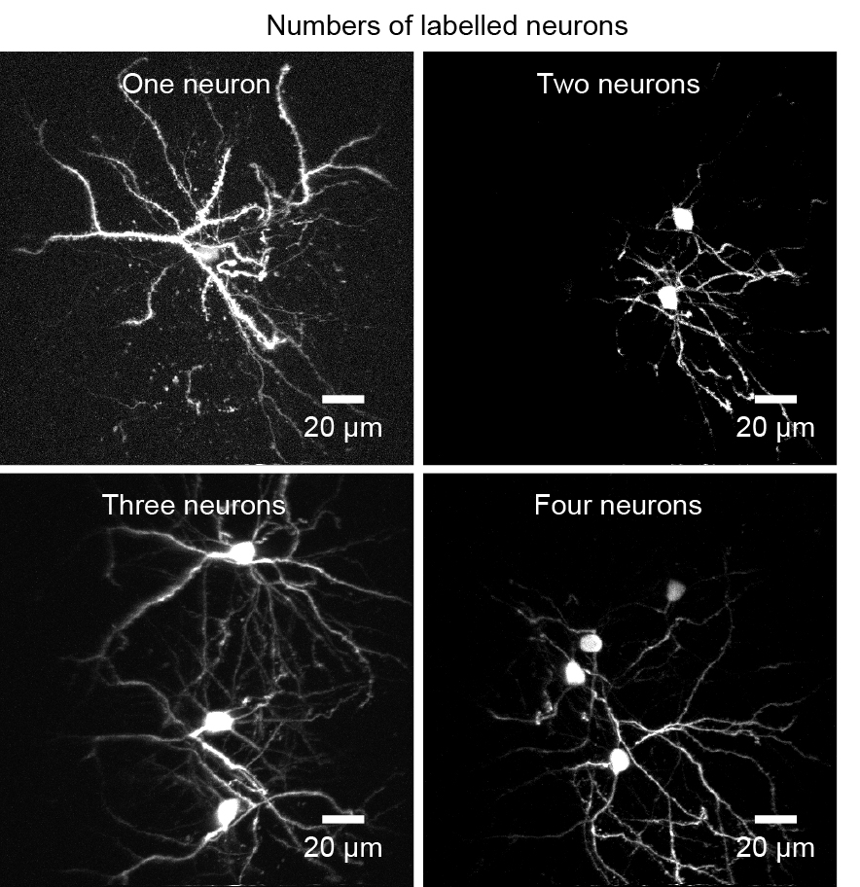

Supplementary Figure 2
The number of labelled neurons can be controlled by electroporated manipulation.
Different numbers of neurons (from 1 to 4) can be labelled in one brain area and controlled by electroporated manipulation.

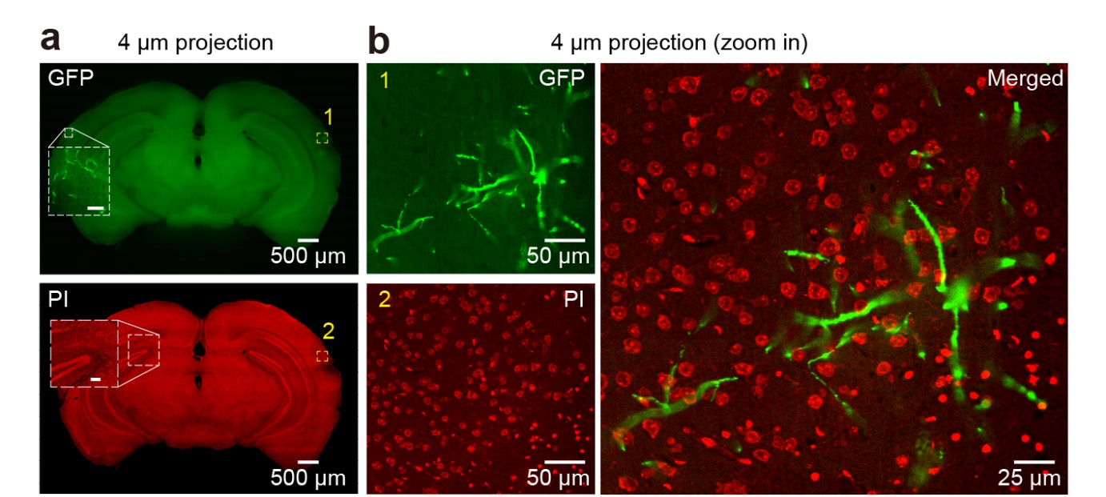
Supplementary Figure 3
Whole-brain dual-colour imaging.
a, Maximum intensity projections of two serial coronal sections in the GFP channel (upper) and propidium iodide (PI) channel (bottom).
b, Enlarged views of the areas outlined by the yellow dashed boxes in panel a. Left: two channels are shown separately; Right: the merged image.

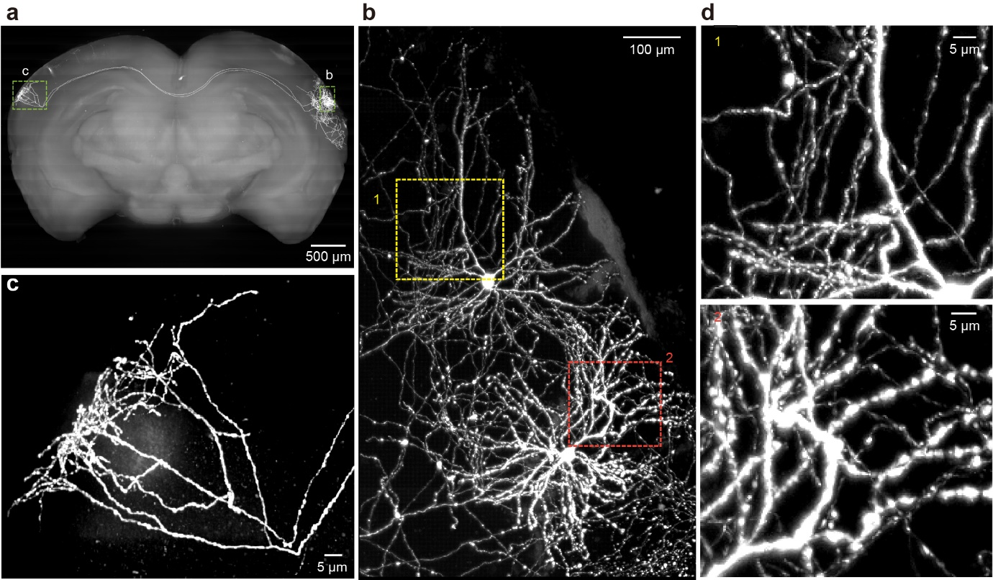
Supplementary Figure 4
Maximum-intensity projection of the labelled neurons with long-range projections.
a, Coronal view of whole-brain maximum intensity projections.
b-c, Enlarged views of the areas outlined by the green dashed boxes in a. Dendrites and axonal terminations are shown in b and c, respectively.
d, Enlarged views of the dendrite areas outlined by the yellow and red dashed boxes in b.
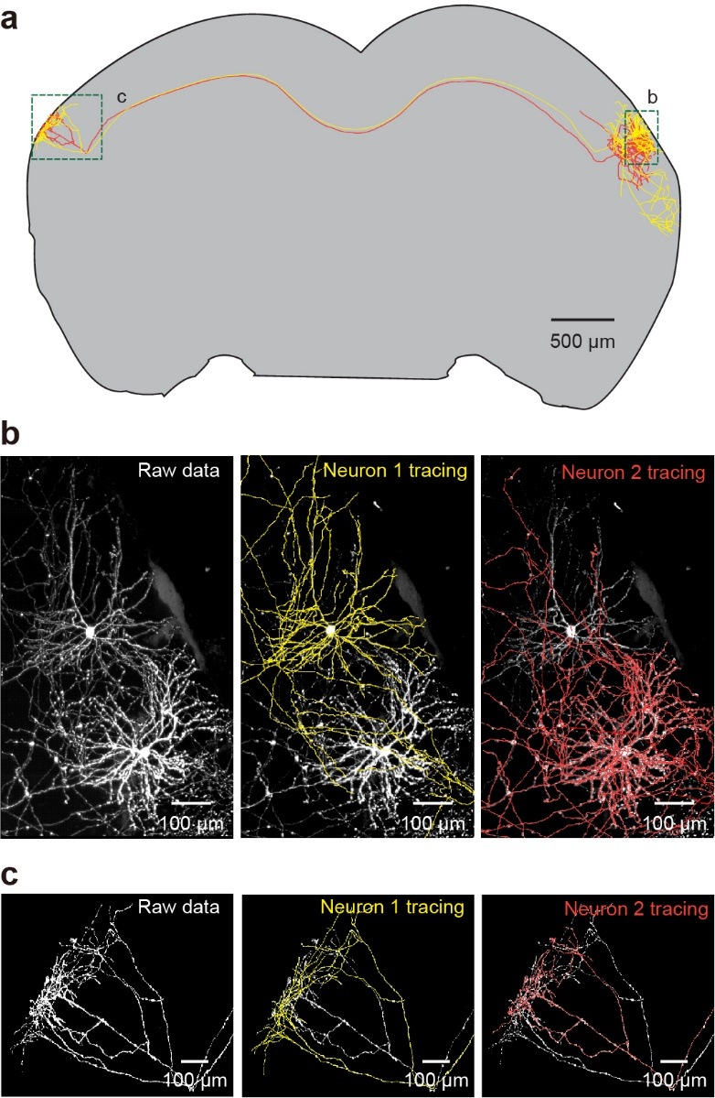
Supplementary Figure 5
Complete manual reconstruction of individual neurons.
a, Reconstruction of two representative neurons with long-range projections. Each colour indicates one neuron.
b, Left: raw maximum intensity projection of the neurites around soma. Middle right: serial reconstruction of the neurites of neurons 1 and 2, respectively.
c, Left: raw maximum intensity projection of axonal terminations in the contralateral areas. Middle right: serial reconstruction of the axonal terminations of neurons 1 and 2, respectively. Note that, interestingly, these two neurons show a similar projection pattern.
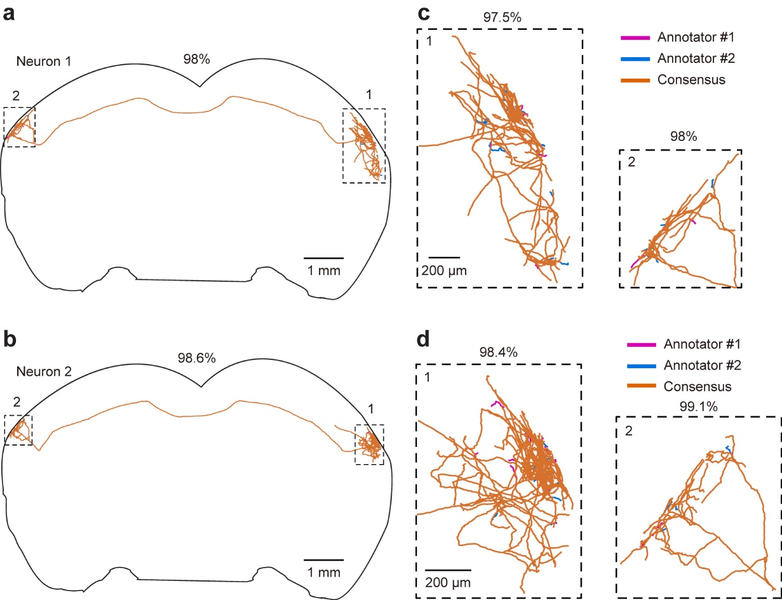
Supplementary Figure 6
Consensus validation of the neurons traced by two annotators.
a-b, Two representative reconstructed neurons with long-range projections.
c-d, Enlarged views of the areas outlined by the black dashed boxes in a and b. Orange, consensus result between two experienced annotators; magenta and blue indicate parts traced by only one of the two annotators.
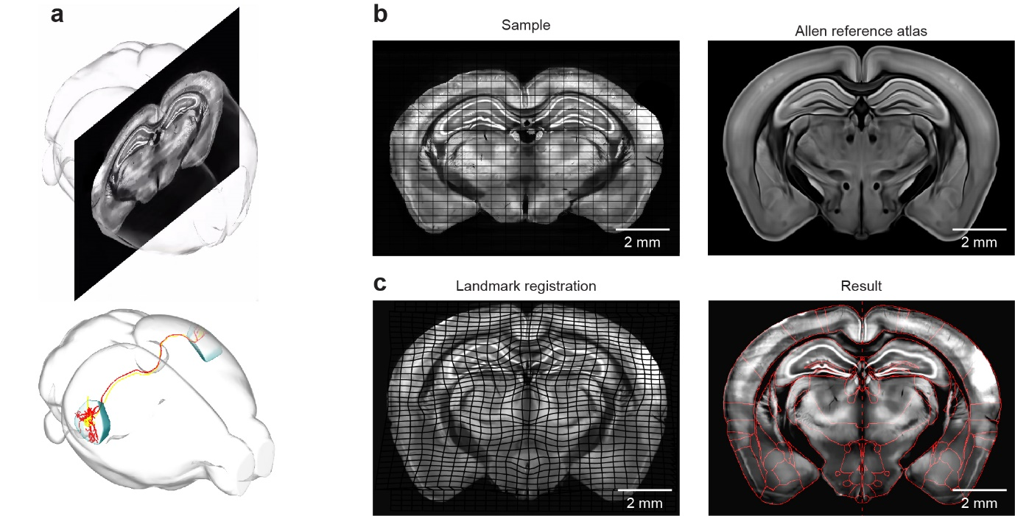
Supplementary Figure 7
Sample brains aligned to the template of the Allen Brain Atlas.
a, A raw imaged brain with overlaid neurites is aligned to the template of the Allen Brain Atlas.
b-c, A raw imaged brain is aligned to the template of the Allen Brain Atlas after dense landmark-based 2D registration with the local-regions approach.
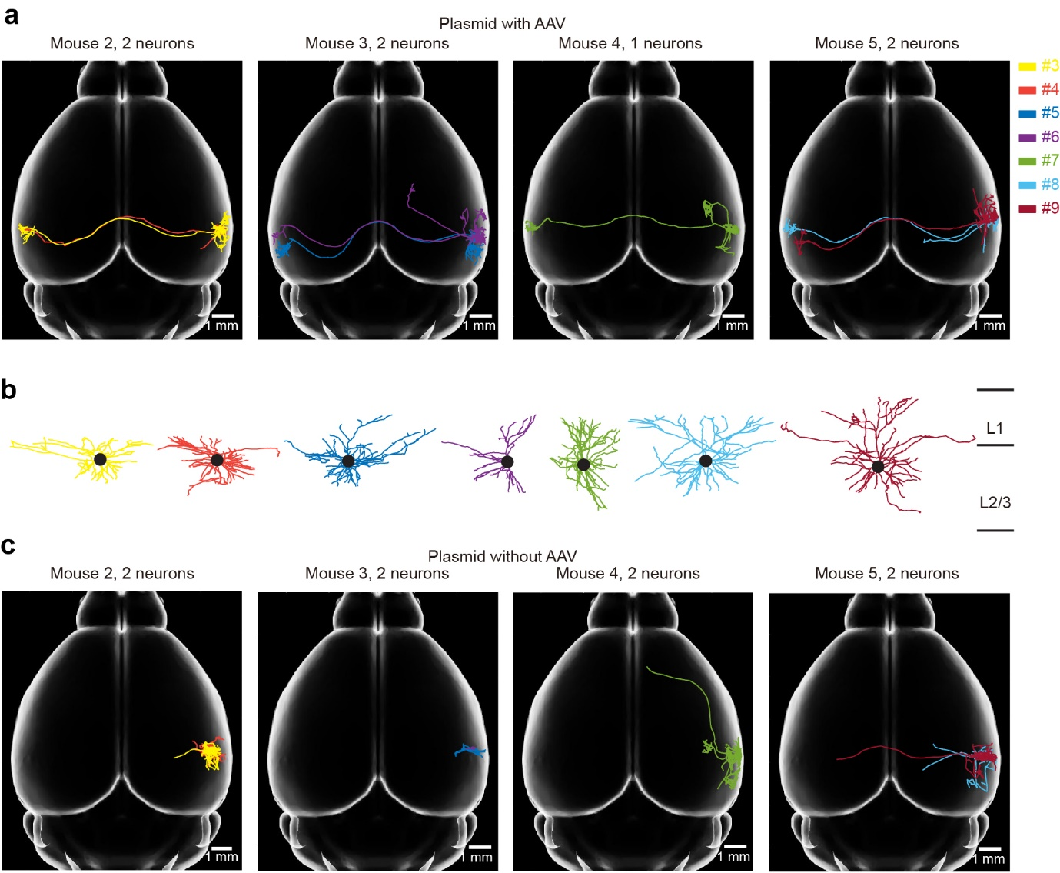
Supplementary Figure 8
Comparison of the reconstructed neurons with different labelling methods.
a, Horizontal view of the reconstructed individual neurons labelled by plasmid with local AAV injection. Four mice are shown individually.
b, Enlarged view of the dendrites of reconstructed neurons shown in a.
c, Horizontal view of the reconstructed individual neurons labelled by plasmid without AAV injection. Four mice are shown individually.

