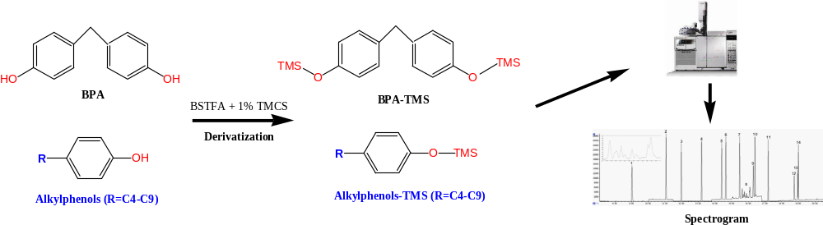
A diagram shows a liquid-liquid extraction combined with derivatization and gas chromatography-mass spectrometry (GC-MS) method for the rapid determination of C4-C9 alkylphenols (4-tert-butylphenol, 4-n-butylphenol, 4-n-pentylphenol, 4-n-hexylphenol, 4-n-heptylphenol, 4-n-octylphenol, 4-tert-octylphenol, 4-n-nonylphenol and 4-nonylphenol) and bisphenol A in the environmental water.

