Table1. Information of Samples
Sample no. | Statue | Photo of the sampling positions | Description
JYS-1-1 | Tutang Buddha | 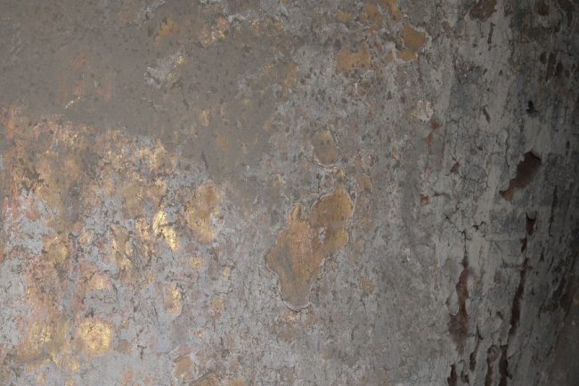 | Gold and paper in sublayer collected from lower part of the left side of Buddha
JYS-1-2 | Tutang Buddha | 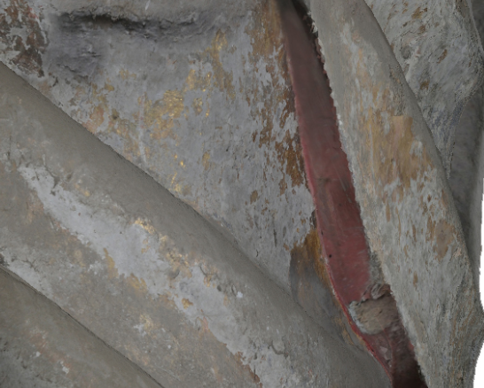 | Red pigment fragment collected from below the left sleeve of Buddha
JYS-1-3 | Tutang Buddha | 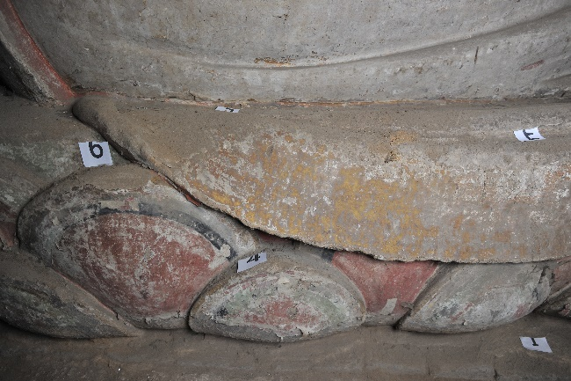 | Red pigment fragment collected from lower part of the right side of Buddha
JYS-1-4 | Tutang Buddha | 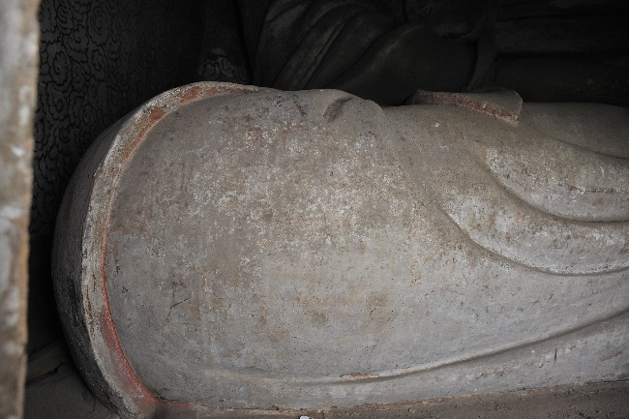 | Lime layer fragment  Collected from  lower part of the right side of Buddha
JYS-1-5 | Tutang Buddha | 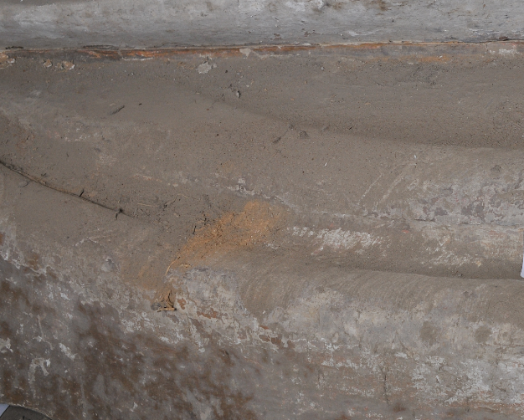 | Fine clay layer fragment collected from the leg
JYS-1-6 | Tutang Buddha | 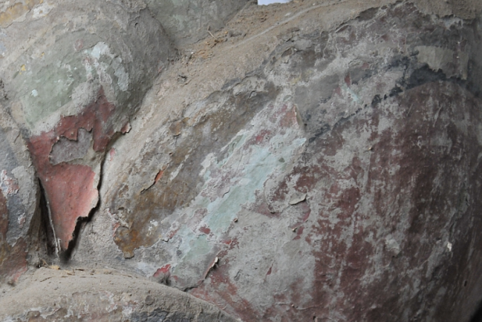 | Black pigment fragment collected fromlower part of the right side of Buddha
JYS-2-1 | Avalokitesvara  Bodhisattva | 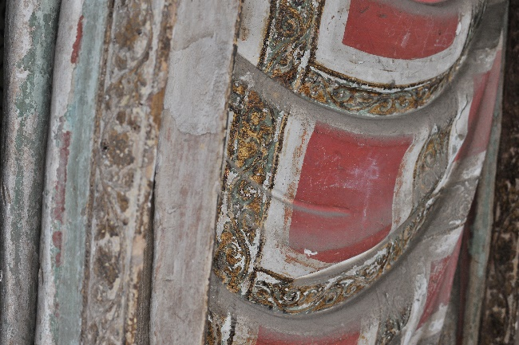 | White pigment fragment collected from right sleeve of statue
JYS-2-2 | Avalokitesvara  Bodhisattva | 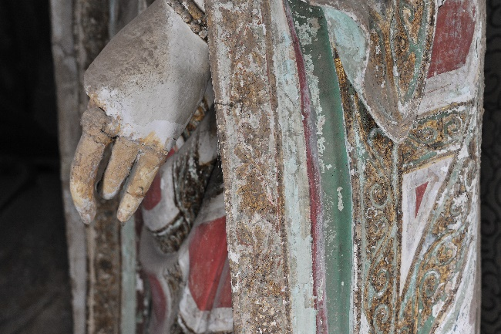 | Gold fragment collected fromleft sleeve of statue
JYS-2-3 | Avalokitesvara  Bodhisattva | 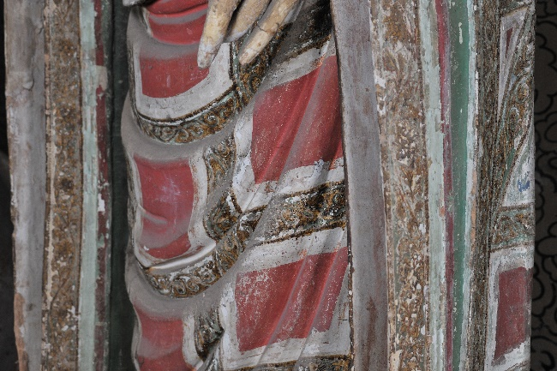 | Red pigment fragment collected from Kasaya of the statue
JYS-2-4 | Avalokitesvara  Bodhisattva | 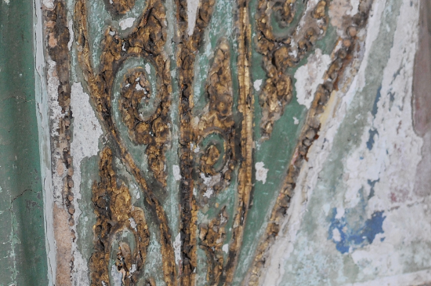 | Dark-blue pigment and paper in sublayer fragment collected from Kasaya of the statue
JYS-2-5 | Avalokitesvara  Bodhisattva | 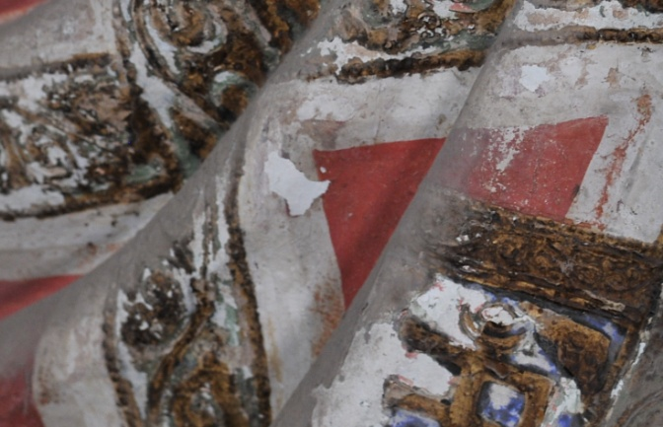 | White pigment fragment collected from Kasaya of the statue
JYS-2-6 | Avalokitesvara  Bodhisattva | 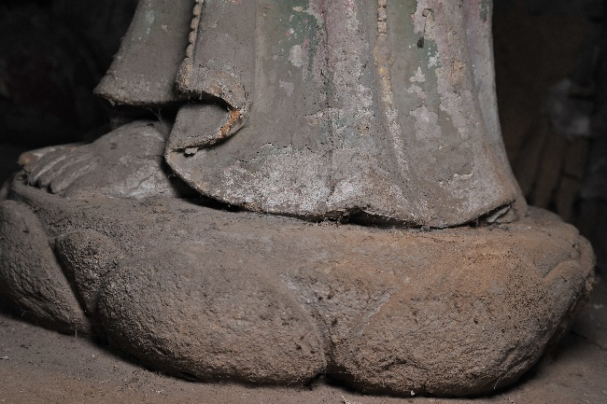 | Fine clay layer fragment collected from underneath the statue’s feet
JYS-3-1 | Mahasthamaprapta bodhisattva | 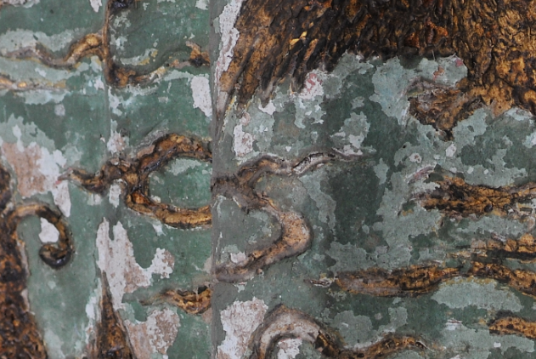 | Green pigment and paper in sublayer fragment collected from around the hemline of the left side of Buddha
JYS-3-2 | Mahasthamaprapta bodhisattva | 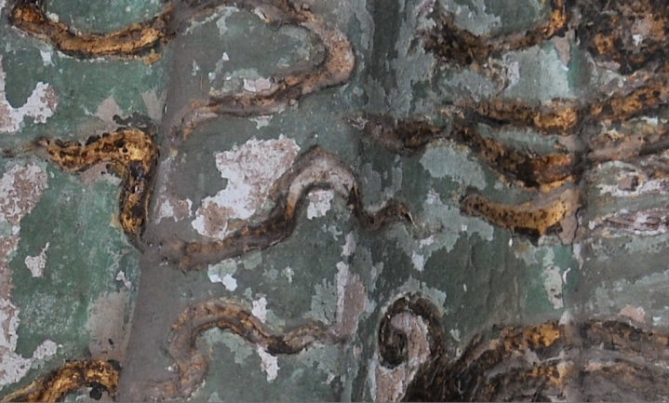 | Gold fragment collected from the hemline of the left side of Buddha
JYS-3-3 | Mahasthamaprapta bodhisattva | 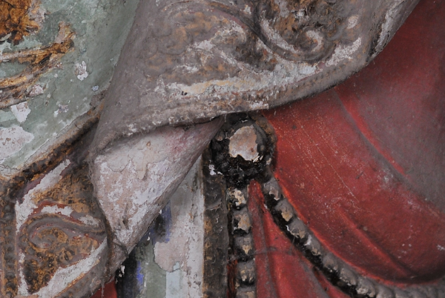 | Black pigment fragment collected from the hemline of the left side of Buddha
JYS-3-4 | Mahasthamaprapta bodhisattva | 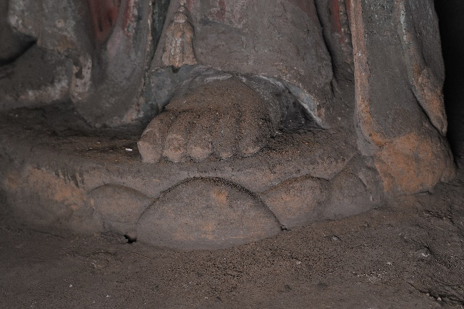 | Fine clay layer fragment collected from underneath the statue’s feet
JYS-4 | The mountainside | 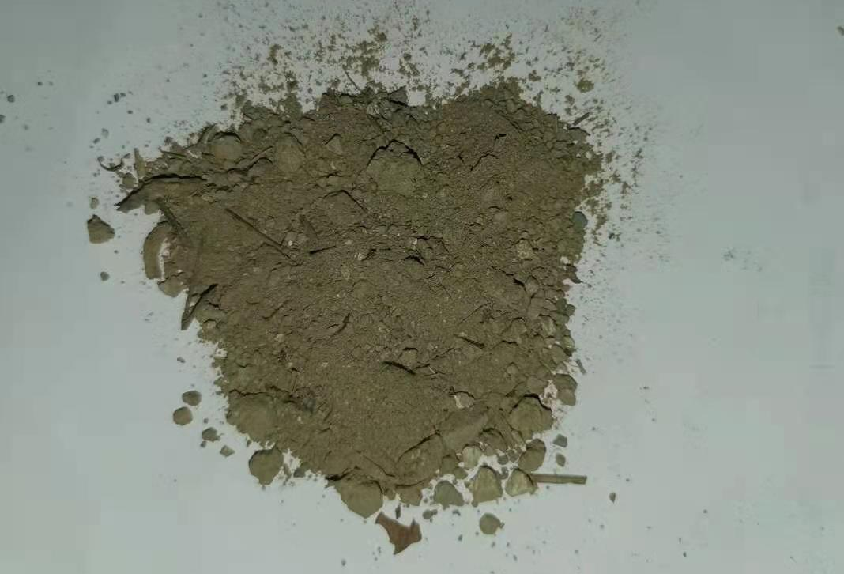 | Mountain soil sample

Table 2. The analysis results of major color pigments of the statues
Sample | Raman band s(cm⁻¹) | Main elements (SEM–EDS) | Pigment
JYS-1-1 | / | Au | Gold
JYS-1-2 | 252, 287, 346 | Pb, Hg | Cinnabar; minium may also be included
JYS-1-3 | – | Pb | Most likely to be minium
JYS-1-4 | 152, 278, 1087 | Ca | Calcium carbonate
JYS-1-6 | – | – | –
JYS-2-1 | 142,448,975 | Pb | Most likely to be lead white
JYS-2-2 | / | Au | Gold
JYS-2-3 | 252、286、342 | Pb, Hg | Mix of cinnabar and minium
JYS-2-3 | 160,225,313,475,546 | Pb, Hg | Mix of cinnabar and minium
JYS-2-4 | 137, 174, 247, 400, 543, 766, 836, 944, 1096, 1348, 1425, 1581 | Cu | Azurite
JYS-2-5 | 446, 612, 639, 973, 1051 | Pb | Lead white
JYS-3-1 | 360, 514, 825, 915, 981 | Cu | Atacamite
JYS-3-2 | / | Au | Gold
JYS-3-3 | – | – | –

Table 3. Particle size distribution of the fine clay layer.
Particle size(mm)  Sample Ratio(%)  Name | Coarse sand | Medium sand | Fine sand | Coarse powder particle | Fine powder particle | Clay particles
Particle size(mm)  Sample Ratio(%)  Name | 0.5< d ≤ 2 | 0.25< d ≤ 0.5 | 0.075< d ≤ 0.25 | 0.01< d ≤ 0.075 | 0.005< d ≤ 0.01 | d ≤ 0.005
JYS-4 | / | / | 6.17 | 58.03 | 16.56 | 19.24
JYS-1-5 | / | / | 8.45 | 60.24 | 15.29 | 16.02
JYS-2-6 | / | / | 8.67 | 62.21 | 14.82 | 14.30
JYS-3-4 | / | / | 7.89 | 61.45 | 15.63 | 15.03

