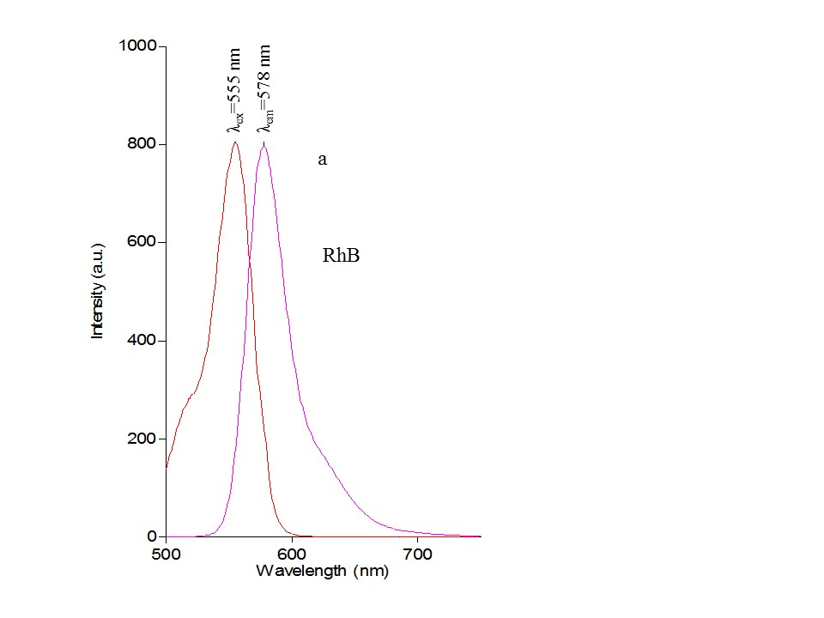
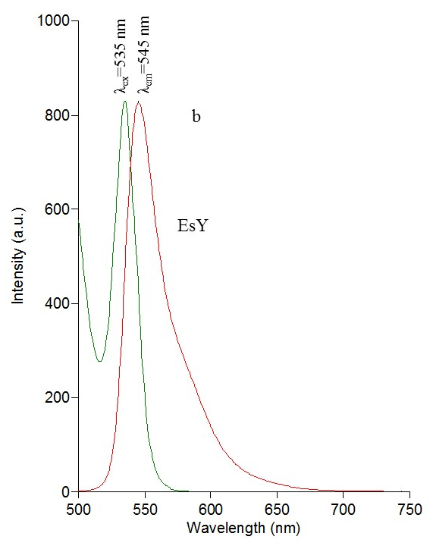

Supplementary Fig. 1. Excitation and emission spectra of RHB (a) and EsY (b)

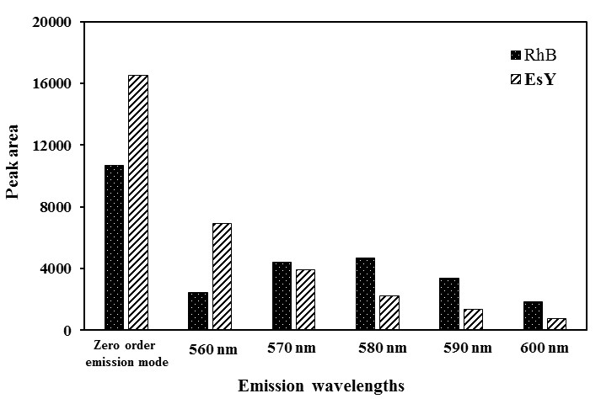

Supplementary Fig. 2. Peak area of RhB and EsY at different emission wavelengths after excitation at 535 nm.

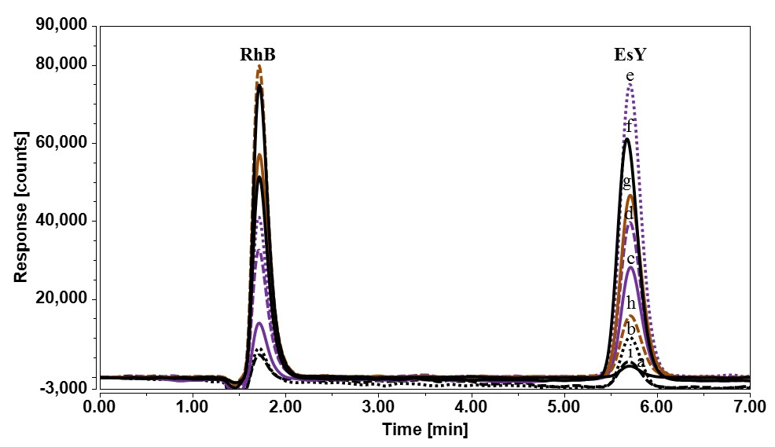

Supplementary Fig. 3. HPLC-FLD chromatogram of RhB and EsY at different excitation wavelengths
a) 450 nm b) 470 nm c) 490 nm d) 510 nm e) 530 nm f) 535 nm g) 540 nm
h) 550 nm and i) 560 nm at zero order emission mode.

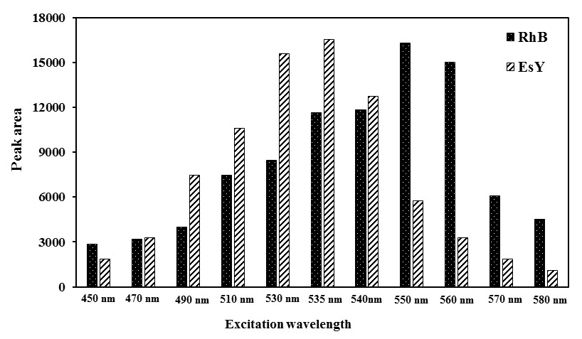

Supplementary Fig. 4. Peak area of RhB and EsY at different excitation wavelengths at zero order emission mode.

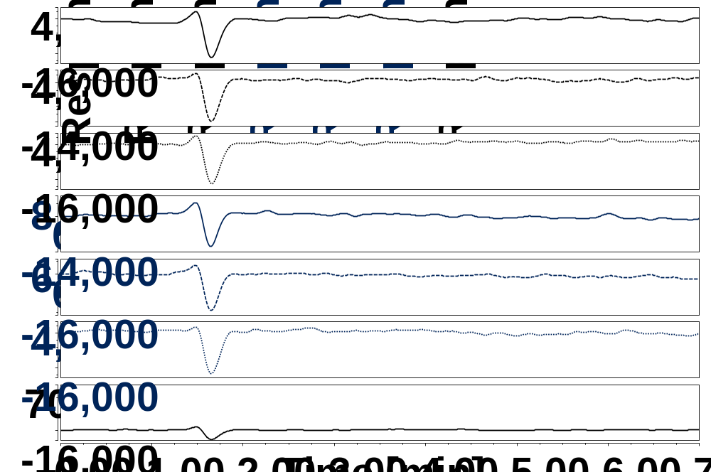

Supplementary Fig. 5. HPLC-FLD chromatogram of a negative chili sauce samples
.

