Supplementary information

On an effective and efficient method for exploiting the wisdom of the inner crowd

*Itsuki Fujisaki¹, Kunhao Yang², & *Kazuhiro Ueda¹

¹ Graduate School of Arts and Sciences, The University of Tokyo; Tokyo, Japan
² Faculty of Law, Chuo Gakuin University; Osaka, Japan
*e-mail: bpmx3ngj@gmail.com (I.F.), ueda@g.ecc.u-tokyo.ac.jp (K.U.)

This PDF file includes:

Supplementary text
Figures S1 to S10
Table S1

S1. Additional analysis of data from two people in the Other’s perspective condition
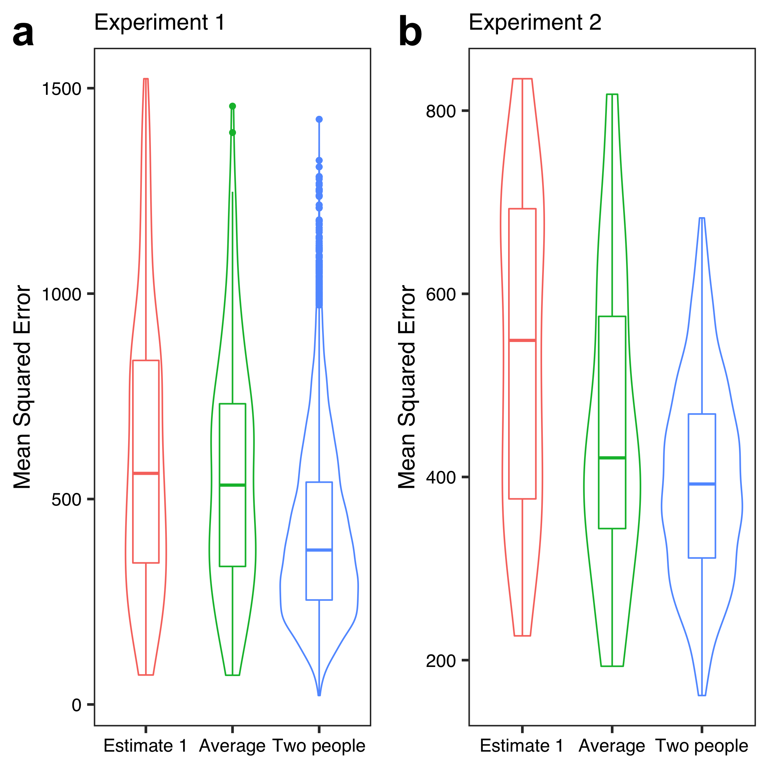
Fig. S1. Results of the analysis in Experiment 1(a) and Experiment 2(b). For the ‘Average’ category, Estimate 1 and Estimate 2 were averaged. For the ‘Two people’ category, all combinations of two people were selected, and their separate Estimate 1 responses were averaged. Subsequently, the MSE was calculated.

Table S1. Average MSE for each estimate in Experiments 1 and 2
 | Estimate 1 | Average | Two people
Experiment 1 | 615.82 | 564.02 | 414.39
Experiment 2 | 541.09 | 455.53 | 396.99

S2. Data on final estimates
The findings revealed that the third (i.e., final) estimates were not more accurate than the first estimates, except for in the Repeated condition. To investigate why, we conducted an additional analysis on the final estimates. We calculated how much the final estimates were weighted on Estimate 2, using the following equation.

$$Weighting on Estimate 2 = 1-((Estimate 3 - Estimate 1) / (Estimate 2 - Estimate 1))$$

Fig. S2 shows the results of the analysis. There were many cases where the values of weighting on Estimate 2 were zero and one. In these cases, participants could not harness the wisdom of the inner crowd effect. Especially, in the Other’s perspective condition, the value focused on zero. That is, participants tended to adopt Estimate 1 as their final answer.
In contrast, in the Repeated condition, there were certain cases where the third estimates were around 0.5 (i.e., conducting averaging). Thus, as mentioned in the main text, the final estimates in the Repeated condition were more accurate than the first estimates.

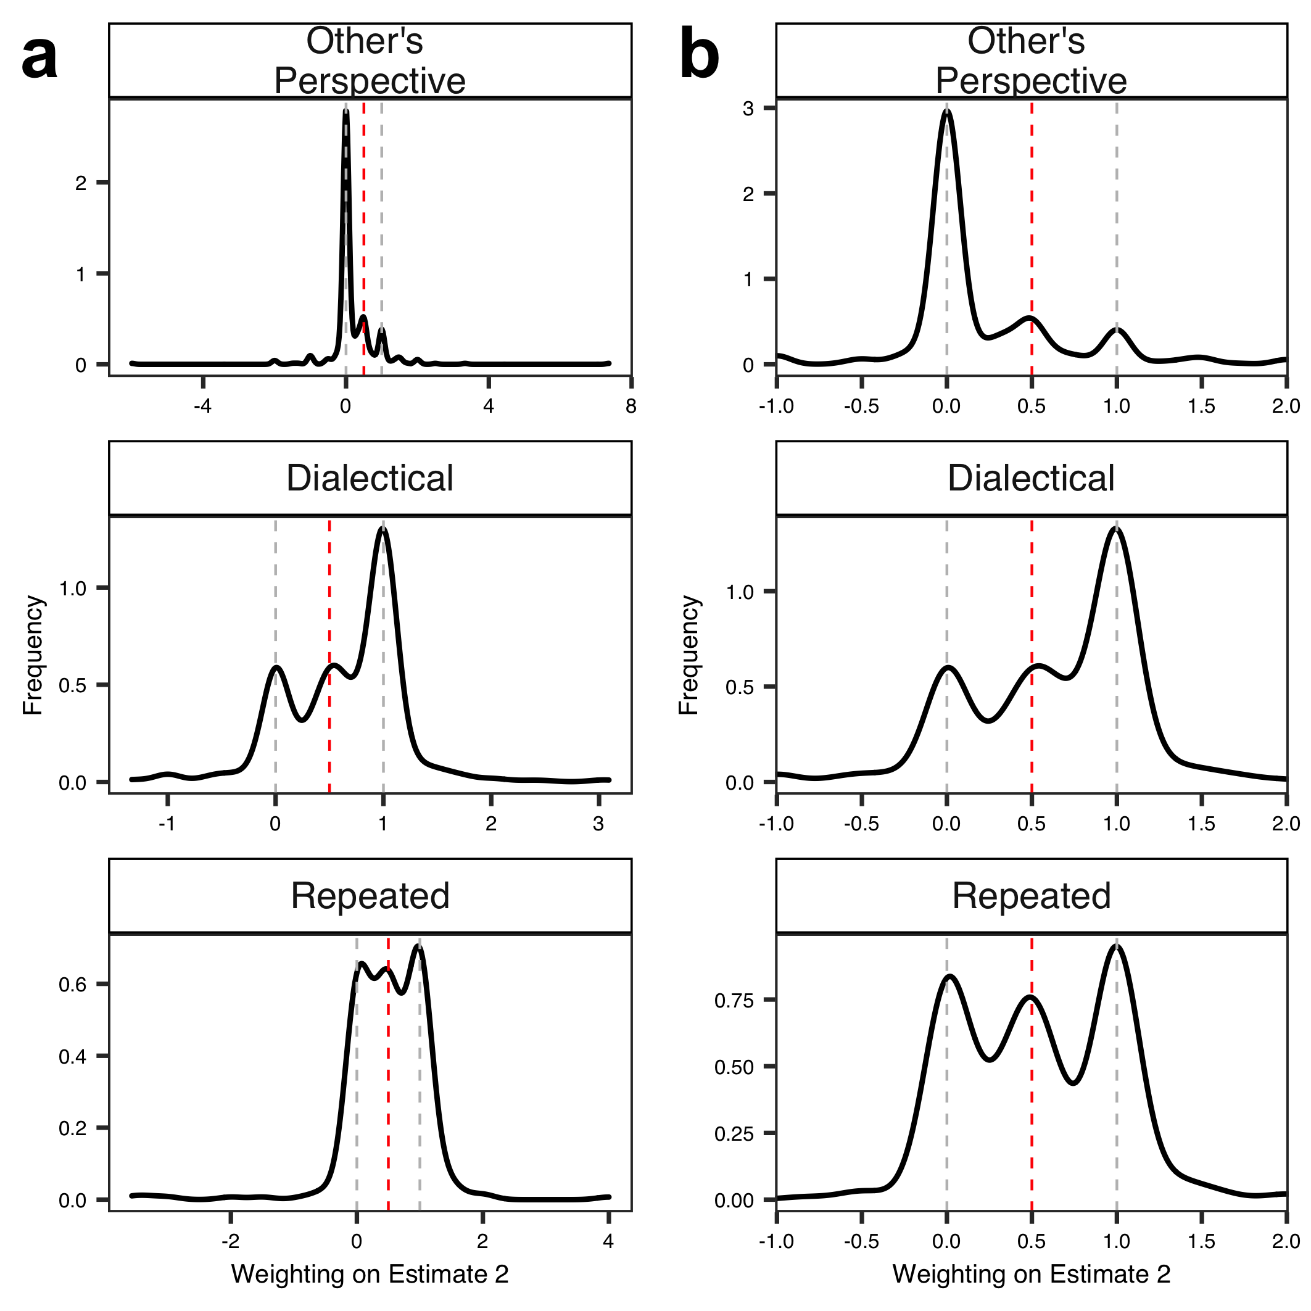
Fig. S2. Results of the analysis of final estimates(a). Each black line represents a probability density function. In (b), for simplicity, we show the case where the value of the weighting on Estimate 2 was from -1.0 to 2.0. The dotted red line indicates the case where the third estimate was the average of Estimate 1 and Estimate 2. The dotted grey lines represent the case where the final estimate was the same as Estimate 1 or Estimate 2. Note that when Estimate 1 and Estimate 2 had the same value, we could not calculate the weighting on Estimate 2. Therefore, we excluded these cases from the analysis.

S3. Analysis of the relationship between confidence in Estimate 1 and the final estimate
In Experiment 2, the participants rated their level of confidence in their own estimates and gave a final answer. What is the relationship between them? One might think that less-confident participants put more weight on their public opinions. However, we did not find such results.
Specifically, we examined the relationship between the level of confidence in Estimate 1 and the value of weighting on Estimate 2. For each participant, we computed the mean of these values for all questions and then calculated their correlation (Fig. S3). We found no significant correlations in all conditions (ps > .1).

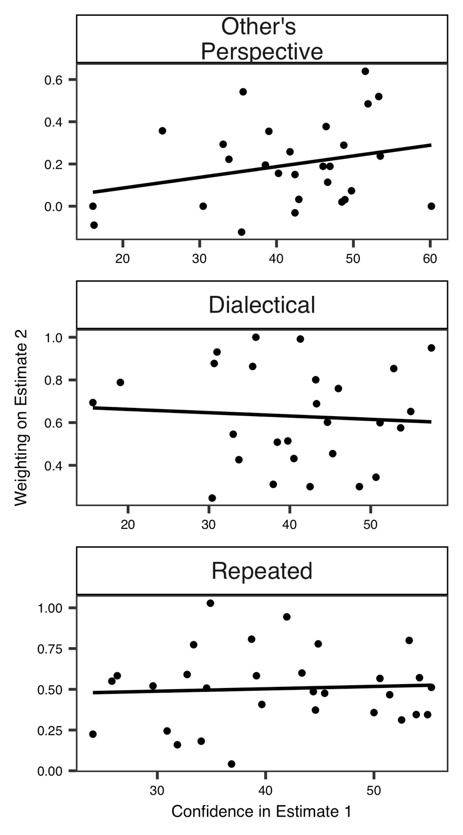
Fig. S3. Results of the analysis of the relationship between participants’ level of confidence in Estimate 1 and the value of weighting on Estimate 2. Each plot indicates each participant, and black lines represent the regression lines. We found no significant correlations in all conditions (Other’s perspective: p = .16; Dialectical: p = .73; Repeated: p = .75).

S4. Optimal weighting
Here, we calculated the optimal weighting of the participants’ own estimate (Estimate 1) and estimate of public opinion (Estimate 2; i.e., the Other’s perspective condition) using the following equation:
(w × Estimate 1 + (100 – w) × Estimate 2)/100
where w represents the weighted percentage of a participant’s own estimate. We manipulated w from 0 to 100 in steps of 1. Specifically, we set 101 levels (w = 0, 1.... .99, and 100) and calculated the MSE for each w.
Fig. S4 shows the results indicating the relationship between w and the MSE. The red dotted line represents the optimal weighting: In Experiment 1, w = 57 and in Experiment 2, w = 46. In other words, which estimate should be weighed more depended on the study (Experiment 1: Estimate 1; Experiment 2: Estimate 2).
The figure also shows the dotted grey line for the average estimate (w = 50). It can be observed that these MSEs are almost the same to the optimal weighting across the two studies (Experiment 1: red line = 562.44, grey dotted line = 564.02; Experiment 2: red line = 455.15, grey dotted line = 455.35). Subsequently, we can assume that our method (i.e., averaging) is a robust strategy.

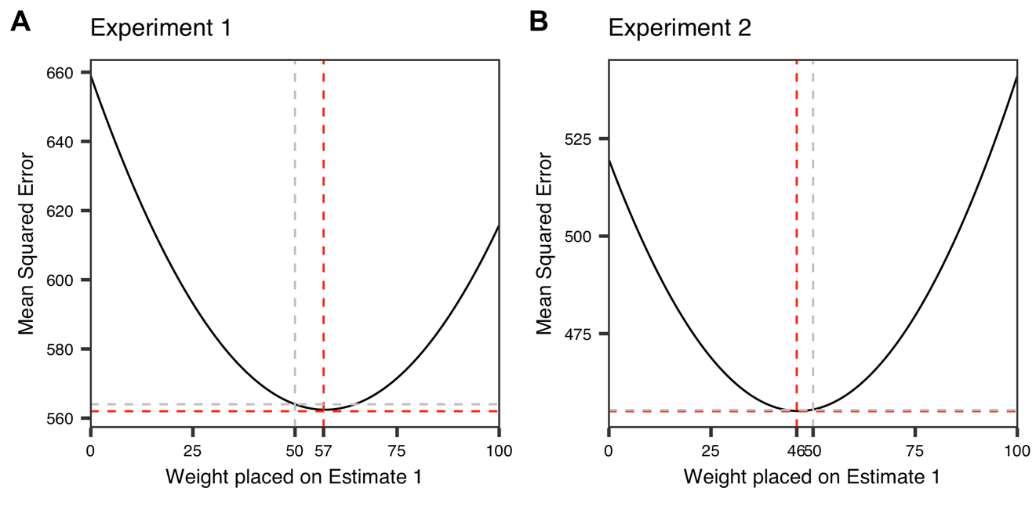
Fig. S4. Results of optimal weighting in Experiment 1(a) and Experiment 2(b).

S5. Results of estimated value
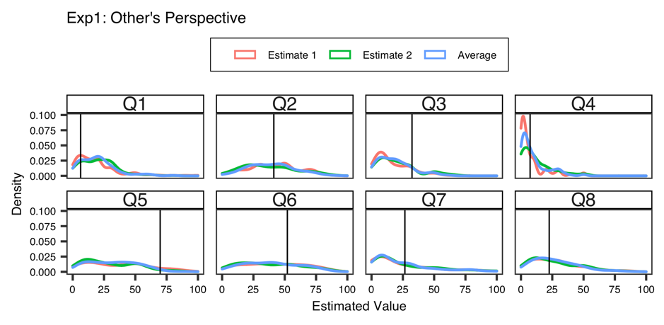
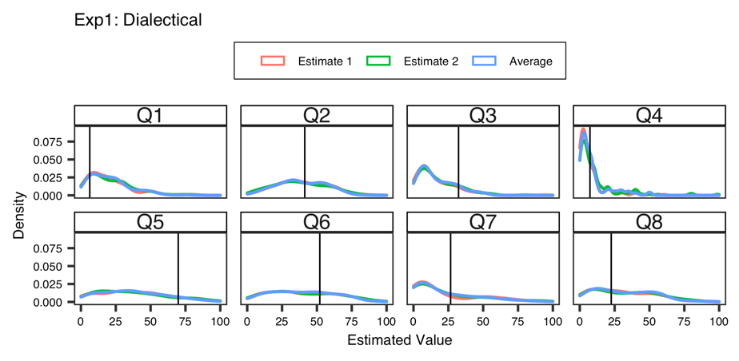
Fig. S5. Estimated values of the Other’s perspective condition in Experiment 1. Each line represents a probability density function. The black line indicates the correct answer.
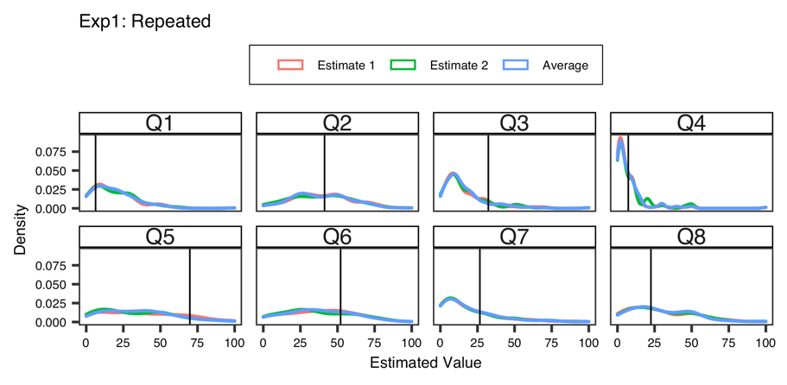
Fig. S6. Estimated values of the Dialectical condition in Experiment 1.
Fig. S7. Estimated values of the Repeated condition in Experiment 1.

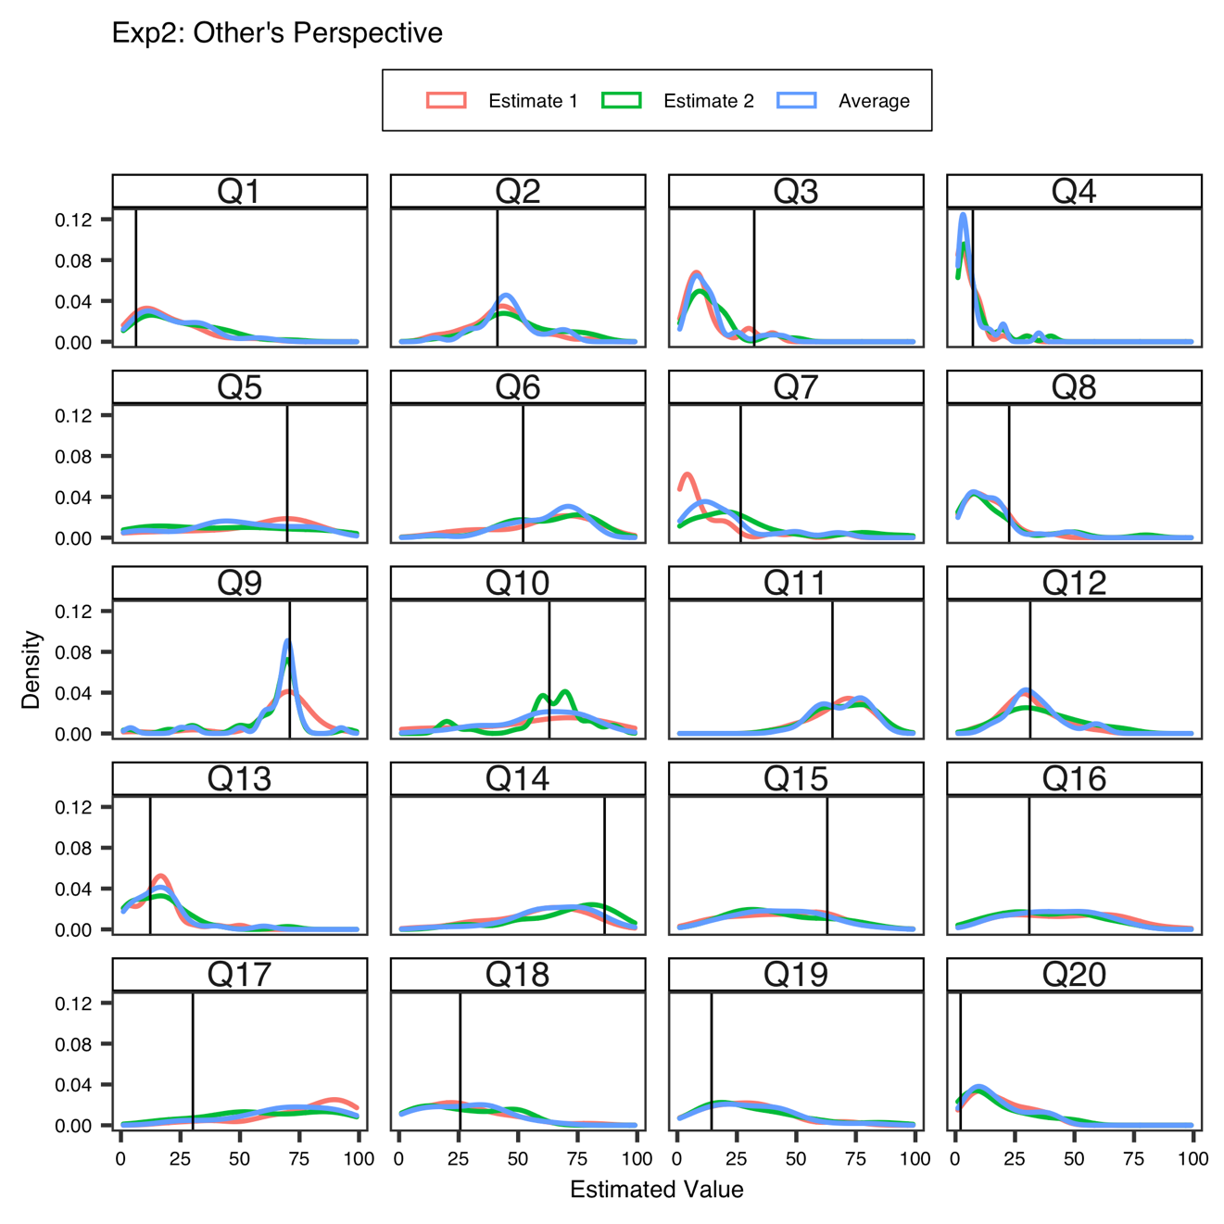
Fig. S8. Estimated values of the Other’s perspective condition in Experiment 2.

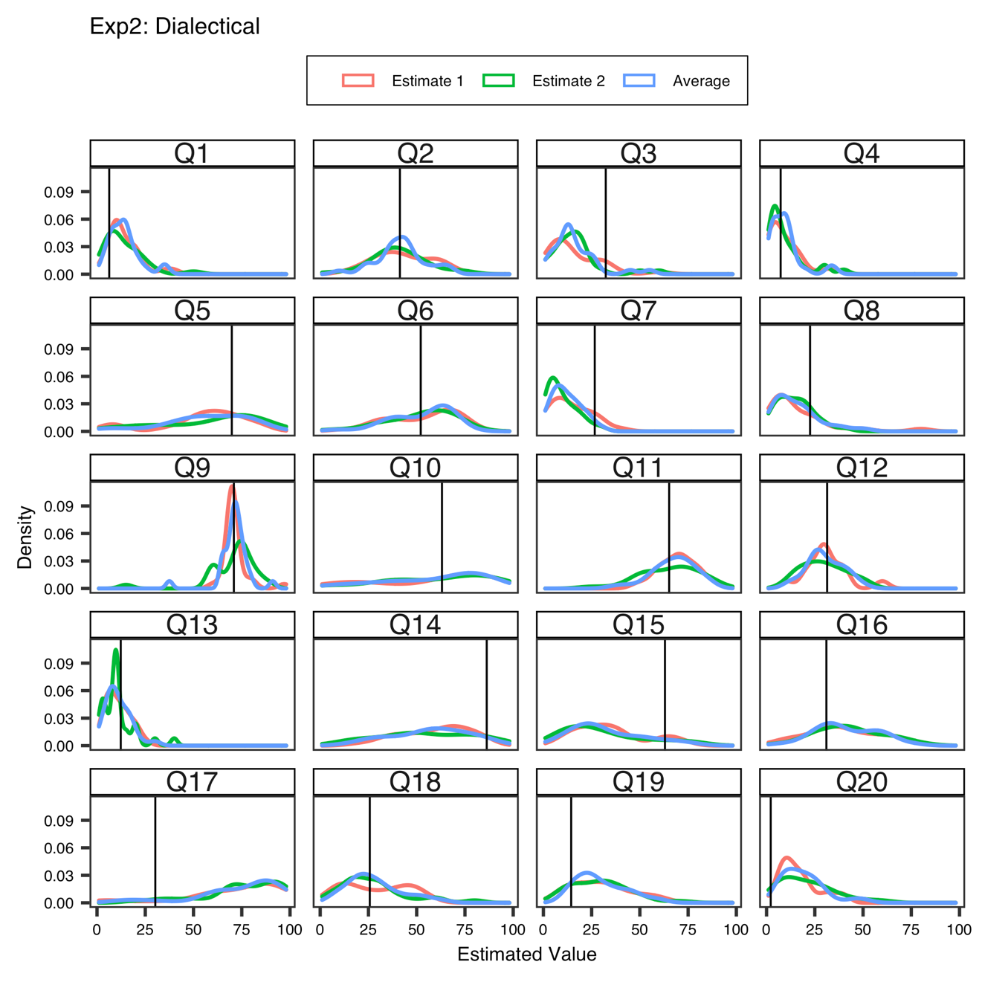
Fig. S9. Estimated values of the Dialectical condition in Experiment 2.

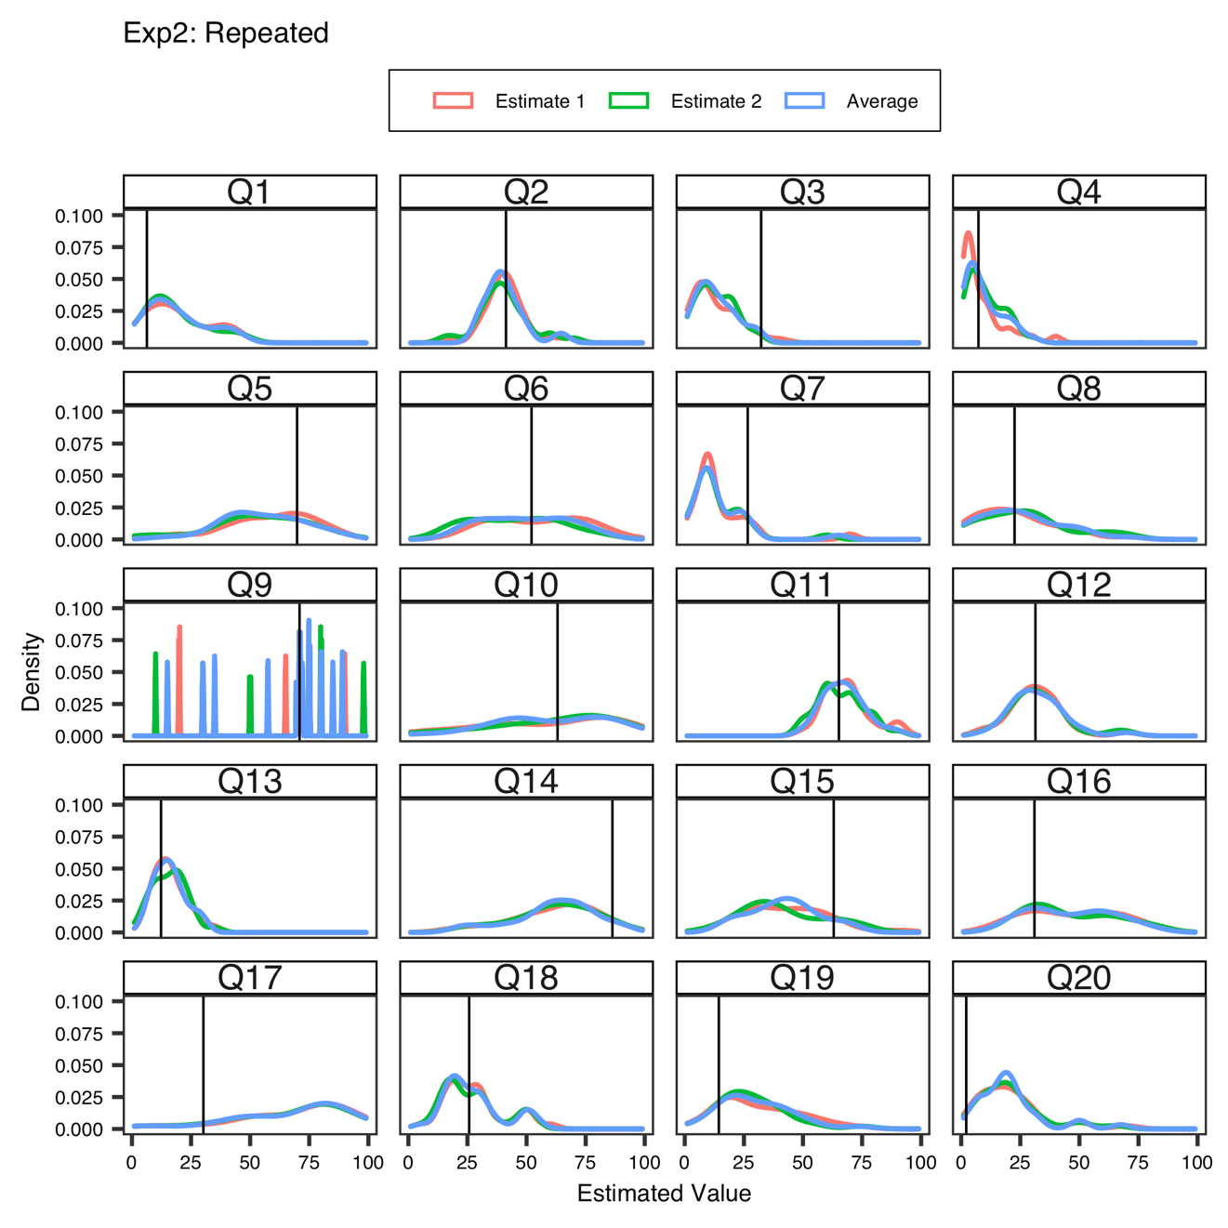
Fig. S10. Estimated values of the Repeated condition in Experiment 2. In Q9, the estimated values focused on around 75. For this reason, the lines of Estimate 1 and Estimate 2 are hardly visible.

