Supplementary Information for “Pricing carbon emissions reduces health inequities from air pollution exposure”

Xinyuan Huang, Vivek Srikrishnan, Jonathan Lamontagne, Klaus Keller, Wei Peng*

*Contact: weipeng@psu.edu

This supplementary information appendix includes the following information:

- Additional information on method
  - Additional data description
  - Details of ensemble design (Table S1)
  - Emissions sector mapping (Table S2, Table S3)
  - Baseline mortality rates (Table S4)
- Additional results for:
  - Health outcomes in 2100
    - Distribution of PM_{2.5}-attributable death rates across regions and age groups in 2100 (Figure S1)
    - Country-level distribution of PM_{2.5}-attributable death rates in 2100 (Figure S2)
    - Regional changes in the health drivers, exposures, and risks as a result of the considered global carbon price in 2100 (Figure S3)
  - Supplementary figures for figure 4, about regional variations in health outcomes in 2050
    - Changes in organic carbon emissions due to the considered global carbon price in some regions in 2050 (Figure S4)
    - Changes in unmanaged forest area and area for biomass due to the considered global carbon price in 2050 (Figure S5)
    - Changes in residential/commercial organic carbon emissions due to the considered global carbon price in 2050 (Figure S6)
    - Air pollution exposure without the considered global carbon price in 2050 (Figure S7)
    - Projected regional age structures in 2050 (Table S5)
  - Supplementary figures for figure 4, about global distributions in the health drivers and exposures in 2050
    - Global distribution of changes in primary energy mix in 2050 (Figure S8)
    - Global distribution of changes in precursor air pollutant emissions in 2050 (Figure S9)
    - Global distribution of changes in PM_{2.5} concentrations in 2050 (Figure S10)
- Sensitivity analysis for health impact assessment
  - Upper and lower limits of relative risk functions (Figure S11, Figure S12)

1. Additional information on method

1.1 Additional data description

1.1.1 Shared Socioeconomic Pathways

​The Shared Socioeconomic Pathways (SSPs) are reference pathways describing plausible alternative trends in the evolution of society and ecosystems over a century timescale¹. The Five different SSPs are defined based on a “challenge space” where socioeconomic and environmental challenges are represented on two dimensions: challenges related to adaptation, and challenges related to mitigation¹. The five SSPs are sustainability (SSP1), middle-of-the-road (SSP2), regional rivalry (SSP3), inequality (SSP4), and fossil-fueled development (SSP5). These SSPs are designed without considering the changing climate or the effects of climate policy². The five SSPs have been translated into quantitative scenarios by various integrated assessment models³, which are reflected by assumptions about energy demand and supply, technological change, and land-use changes. For the demographic assumptions, a single population and urbanization pathway is developed for each SSP by the International Institute for Applied Systems Analysis (IIASA)³. These SSP-varying quantitative assumptions have been used to sample future uncertainties and construct the scenario ensemble in this study.

1.1.2 Global Burden of Disease

The Global Burden of Disease (GBD) is a project quantifying the health burden from hundreds of diseases, injuries, and risk factors, with the aim of identifying priorities for health care improvement and strategies to address health disparities. Global Burden of Disease Study 2019⁴ (GBD 2019) is the latest version of GBD, whose results are being used in this study. It provided the estimation of the health impacts from 87 risk factors in 204 countries and territories around the world. In particular, exposure to ambient particulate matter is one risk factor being evaluated in GBD 2019.

1.1.3 International Futures

The International Futures (IFs) is a global integrated assessment model that quantifies the future developments of economic, demographic, education, health, environment, technology, domestic governance, infrastructure, agriculture, energy and environment⁵. Specifically, IFs v7.64 projects the baseline mortality rates of various diseases in 183 countries and territories throughout the century. The projections vary across SSPs. These SSP-varying, country-specific projections of the baseline mortality rates are being used in our health impact assessment.

1.2 Details of our ensemble design

We construct a large-scale scenario ensemble using a leading global-scale process-based integrated assessment model, GCAM v5.4⁶. We consider one policy lever, i.e., whether a globally uniform carbon price trajectory is implemented from 2020-2100. We then sample seven types of future uncertainties in socioeconomic, technological, and land-use aspects. We deploy a full factorial experimental design across the seven factors to encompass a wide range of futures⁷. Among the seven, four of them (i.e., socioeconomics, energy demand, agricultural and land use, fossil fuel extraction costs) are sampled by considering five sets of assumptions that reflect the storylines of Shared Socioeconomic Pathways (SSPs)³. For the other three factors, we sample the future water runoffs using varying levels of ground water level and reservoir capacity, and we sample the future competitiveness of low-emission energy technologies and carbon capture and sequestration (CCS) technology using varying levels of projected costs. The quantitative assumptions for different SSPs and technology costs are reported in Lamontagne et al 2018⁷ and Calvin et al. 2017⁸.

Table S1 Scenario ensemble design with numbers of feasible future scenarios. The numbers in the parentheses are the numbers of scenarios that GCAM is able to solve using that combination of input assumptions and find solutions that can clear all markets simultaneously.
Policy lever | Future uncertainties
Carbon Price | Water runoffª  (Groundwater level/Reservoir capacity level) | Socio-  economic | Energy demand | AGLU^{b} | Fossil fuel costs | Low-emissions energy costs | CCS^{c}
No  (14,526) | Low/low  (7,187) | SSP1  (5,926) | SSP1  (5,747) | SSP1  (5,973) | SSP1  (5,741) | Low  (9,553)
No  (14,526) | Low/low  (7,187) | SSP2  (5,773) | SSP2  (5,745) | SSP2  (5,943) | SSP2  (5,687) | Low  (9,553) | Low
No  (14,526) | Low/high  (7,171) |  |  |  |  | Mid  (9,571) | (14,315)
No  (14,526) | Low/high  (7,171) | SSP3  (5,793) | SSP3  (5,700) | SSP3  (4,908) | SSP3  (5,792) | Mid  (9,571)
Yes  (14,180) | High/low  (7,179)
Yes  (14,180) | High/low  (7,179) | SSP4  (5,949) | SSP4  (5,766) | SSP4  (5,900) | SSP4  (5,710) | Mid  (9,571)
Yes  (14,180) | High/high  (7,169) |  |  |  |  | High  (9,582) | High
Yes  (14,180) | High/high  (7,169) | SSP5  (5,265) | SSP5  (5,748) | SSP5  (5,982) | SSP5  (5,776) | High  (9,582) | (14,391)

The numbers of scenarios vary slightly across different assumptions, because some combinations of the assumptions lead to unsolvable markets and infeasible solutions.
For example, the number of combinations with SSP5 socioeconomic assumption and SSP3 AGLU assumption is less than others. The socioeconomic trajectory described in the SSP5 scenario, which features rapid population and economic growth, may not be compatible with the agricultural and land use assumptions in SSP3, with low agricultural productivity and technological development and restricted trade.

1.3 Sector mapping between GCAM and EDGAR

To map from GCAM to TM5-FASST⁹ regions for ambient PM_{2.5} concentrations assessment, we downscale the emissions for 32 GCAM regions to 178 countries by sector and for each type of precursor emissions, using the country-to-region ratios based on the Emission Database for Global Atmospheric Research (EDGAR) data^{10,11}. We then re-aggregate country-level emissions to the 56 TM5-FASST regions. Since the sectors in GCAM and EDGAR are completely different, we consider five aggregate sectors (i.e., power, agriculture, industry, residential/commercial, and transportation) to map GCAM emission sectors to the EDGAR sectors. Specifically, there are 65 sectors in GCAM and 30 sectors in EDGAR. We assign each sector in GCAM and EDGAR to one or the five aggregate sectors (Table S2 for GCAM and Table S3 for EDGAR). Note that negative emission technologies (NETs) are not introduced in our discussion because NETs are not major emitting sources for air pollutant emissions and therefore GCAM does not account for their air pollution emissions.

Table S2. Sector mapping between GCAM sectors and six aggregate sectors. The full descriptions of the GCAM sector names can be found on its online documentation (http://jgcri.github.io/gcam-doc/index.html).
Aggregate Sectors | GCAM Sectors
Power | backup_electricity; csp_backup; district heat; elec_biomass (conv); elec_biomass (IGCC); elec_coal (conv pul); elec_coal (IGCC); elec_gas (CC); elec_gas (steam/CT); elec_refined liquids (CC); elec_refined liquids (steam/CT); electricity; electricity_net_ownuse
Agriculture | Beef; biomass; Corn; Dairy; FiberCrop; FodderGrass; FodderHerb; MiscCrop; OilCrop; OtherGrain; PalmFruit; Pork; Poultry; Rice; RootTuber; SheepGoat; SugarCrop; UnmanagedLand; Wheat
Industry | cement; gas pipeline; H2 central production; H2 forecourt production; industrial energy use; industrial feedstocks; industrial processes; N fertilizer; process heat cement
Residential/commercial | comm cooling; comm heating; comm others; resid cooling; resid heating; resid others; urban processes
Transportation | trn_aviation_intl; trn_freight; trn_freight_road; trn_pass; trn_pass_road; trn_pass_road_bus; trn_pass_road_LDV; trn_pass_road_LDV_2W; trn_pass_road_LDV_4W; trn_shipping_intl

Table S3. Sector mapping between EDGAR air pollutant precursor emissions sectors and 6 aggregate sectors

Aggregate Sectors | EDGAR Sectors
Power | Public electricity and heat production
Agriculture | Agricultural waste burning; Direct soil emissions; Manure in pasture/range/paddock; Manure management; Other direct soil emissions; Rice cultivation
Industry | Cement production; Fossil fuel fires; Fugitive emissions from gaseous fuels; Fugitive emissions from liquid fuels; Fugitive emissions from oil and gas; Fugitive emissions from solid fuels; Lime production; Manufacturing Industries and Construction; Other Energy Industries; Production of chemicals; Production of metals; Production of other minerals; Production of pulp/paper/food/drink; Soda ash production and use; Solvent and other product use of chemicals/degrease/paint/other
Residential/commercial | Residential and other sectors; Solvent and other product use: degrease
Transportation | Domestic aviation; Inland navigation; International aviation; International navigation; Other transportation; Rail transportation; Road transportation

​​
1.4 Baseline mortality rates

For future time periods, we use the age-specific baseline mortality rates for each country projected by the International Futures (IFs) model v7.64⁵, which vary across the five SSPs. The baseline mortality rates from IFs are projected based on the GDP per capita and education attainment level and calibrated using the GBD 2004 data for cardiovascular diseases, diabetes, malignant neoplasms, respiratory diseases, and respiratory infections. We map IF-reported rates onto the six considered diseases according to subsets of diseases. For IHD and stroke, we use the rates for total cardiovascular disease from IF and multiply by the shares of IHD and stroke in total cardiovascular-disease-related deaths; for LC, we use the rates for malignant neoplasms; for COPD, we use the rates for respiratory disease; for LRI, we use the rates for respiratory infections; and for DB, we use the rates for diabetes.

Table S4. Baseline mortality rates of six diseases in 2015 (unit: deaths per million people). We compared the estimates from GBD 2019⁴ and the estimates using our mapping methods based on IF projections. More details can be found in the Method section in the main text. The lower bound (LB) and upper bound (UB) represent the 95% confidence interval based on the relative risk functions.

 | GBD 2019 |  |  | Our results
 | Central Value | Lower bound | Upper bound | Our results
Ischemic heart disease (IHD) | 2033 | 1895 | 2184 | 1945
Stroke | 1392 | 1266 | 1508 | 1319
Chronic obstructive pulmonary disease (COPD) | 718 | 630 | 819 | 640
Lower respiratory tract infection (LRI) | 377 | 319 | 443 | 265
Lung cancer | 424 | 393 | 459 | 407
Type-2 diabetes | 226 | 195 | 262 | 218
2. Additional results

2.1 Health outcomes in 2100

2.1.1 Distribution of PM_{2.5}-attributable death rates across regions and age groups in 2100

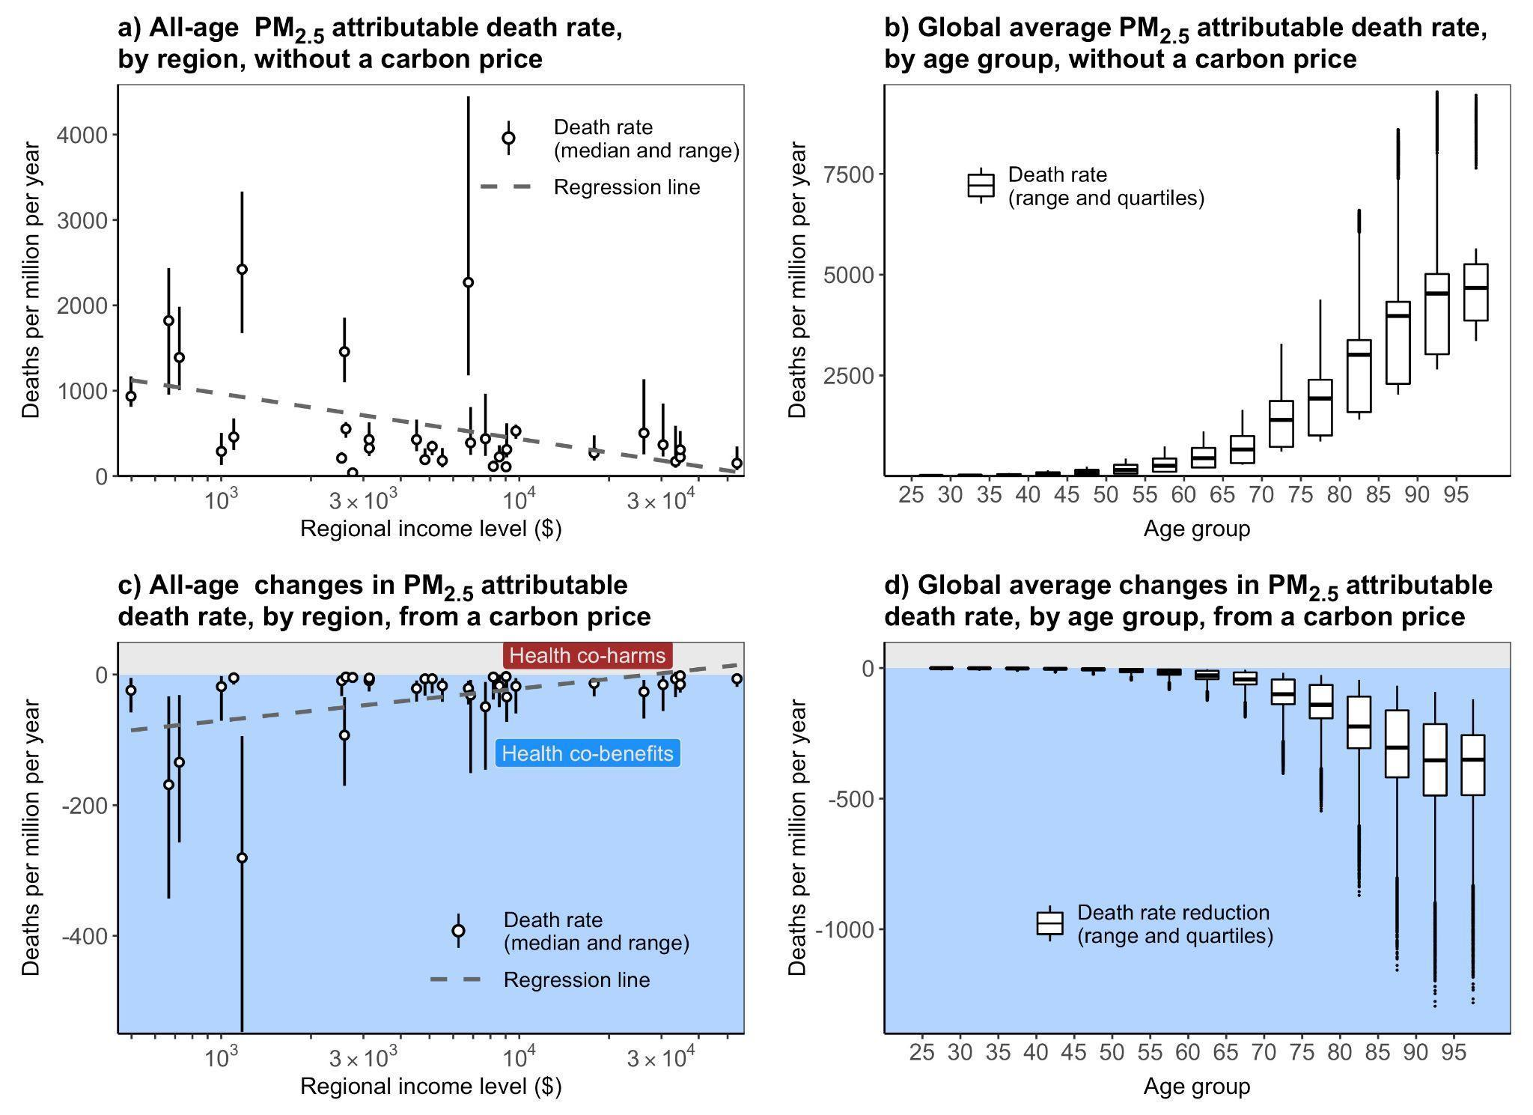

Figure S1. Distribution of PM_{2.5}-attributable death rates across regions and age groups in 2100. Panels a) and b) show the PM_{2.5}-attributable death rate without the carbon price, while the panels c) and d) depict the changes in death rate due to a global carbon price of $69/ton. Panel a) and c) illustrate the variation across world regions, ranked from low to high per capita income in 2015 (from left to right). The circles and error bars represent the scenario medians and ranges (N=13,936). Panel b) and d) show the variation across adult age groups, ranked by 5-year groups from 25–29 to 95+ years old (from left to right). The box plots show the scenario medians, quartiles, and ranges (N=13,936).

2.1.2 Country-level distribution of PM_{2.5}-attributable death rates in 2100
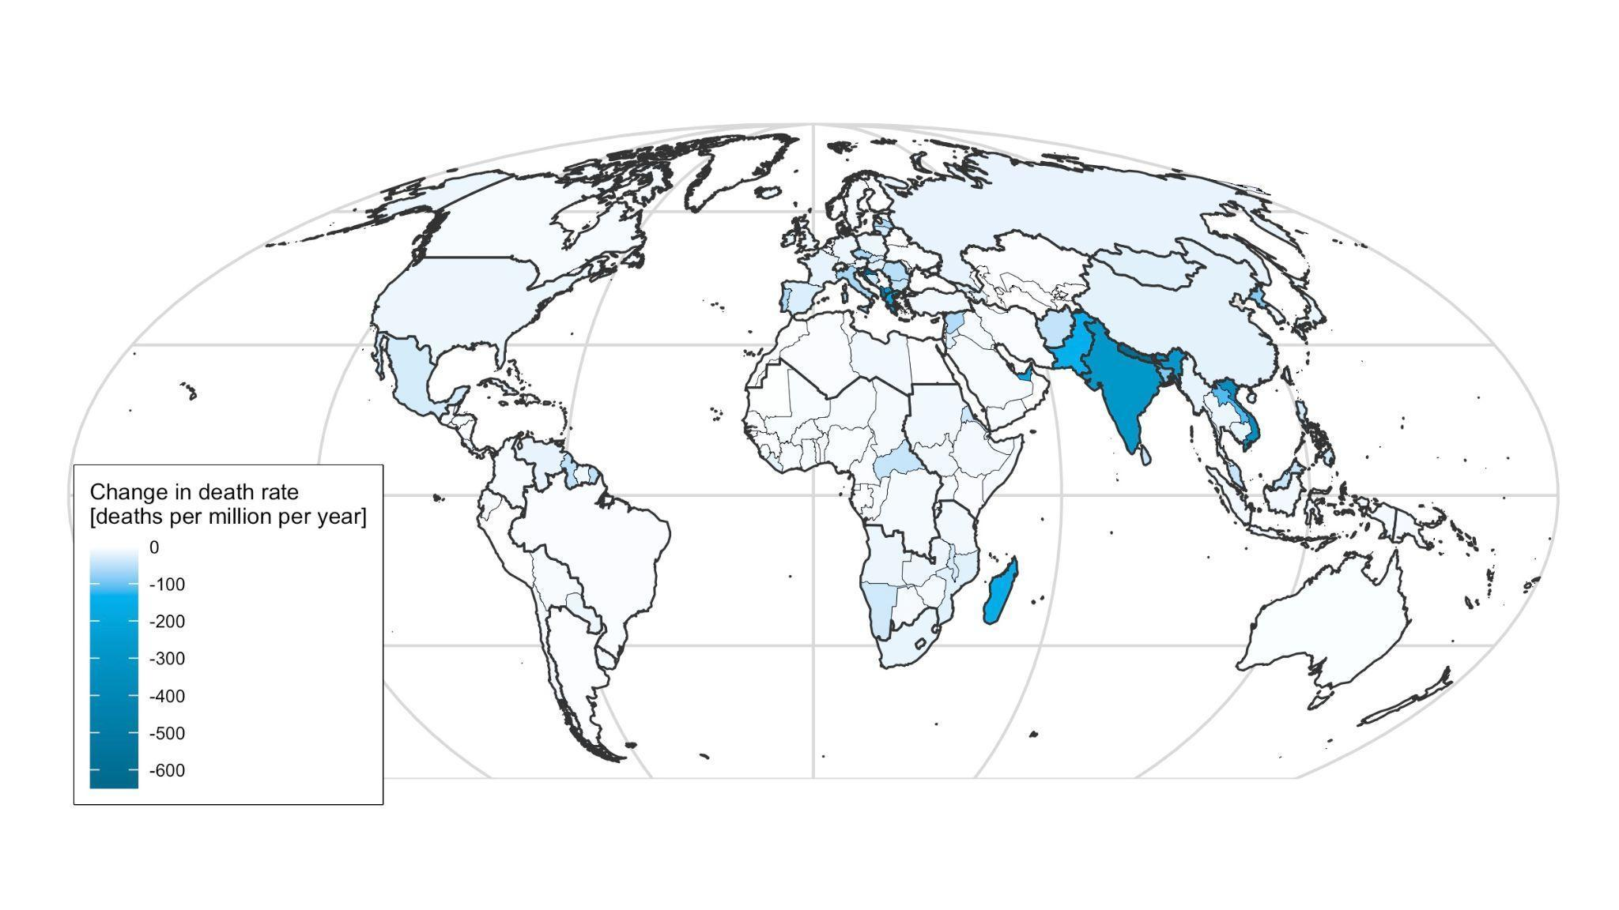

Figure S2. Impacts of a global carbon price on 2100 regional distribution of PM_{2.5}-attributable death rates. The map shows the changes in ensemble median PM_{2.5}-attributable death rate due to the carbon price (N=13,936). We simulate the precursor emissions of air pollutants for 32 GCAM regions (shown as thicker borderlines, except Antarctica). We analyze health impact assessment for 178 regions and countries (shown as lighter borderlines), using downscaled emissions, simulated pollution levels, and socio-demographic information. We estimate the death rates using the median relative risks values from the Global Burden of Disease study.

2.1.3 Regional changes in the health drivers, exposures, and risks as a result of the considered global carbon price in 2100.

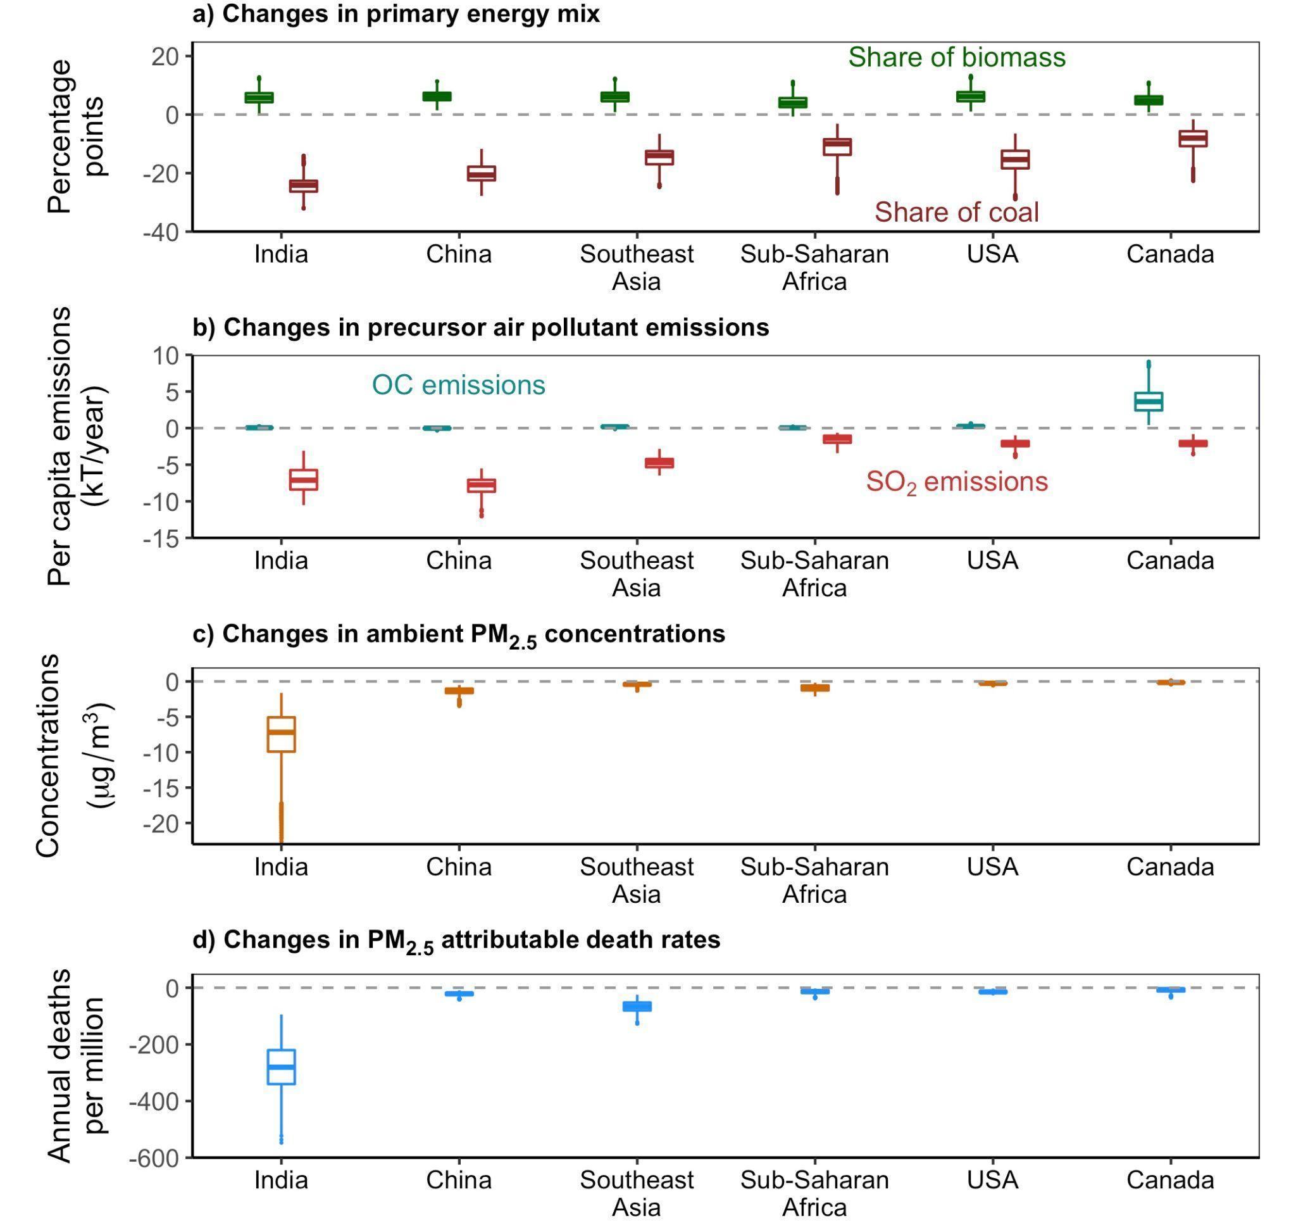
Figure S3. Regional changes in the health drivers, exposures, and risks as a result of the considered global carbon price in 2100. Panel a) shows the changes (by percentage points) in shares of coal and biomass in primary energy mix. Panel b) shows the changes in organic carbon (OC) and sulfur dioxide (SO₂) emissions per capita per year (See Supplemental Figure S7 for zoom-in results of regions except for Canada). Panels c) and d) show the changes in annual average PM_{2.5} concentrations and PM_{2.5}-attributable death rates. The box and whiskers show the ensemble median, quartiles, and range.

2.2 Supplementary figures for figure 4, about regional variations in health outcomes in 2050

2.2.1 Changes in organic carbon emissions in selected regions
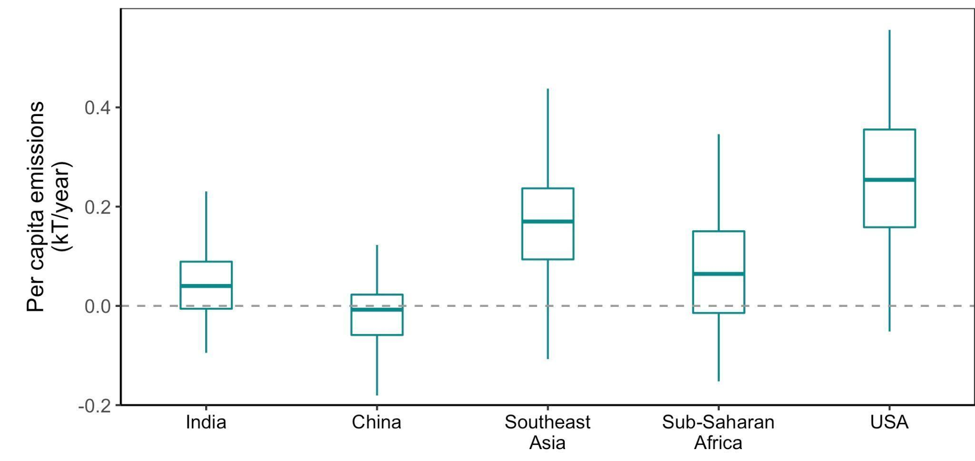
Figure S4. Changes in per capita organic carbon emissions as a result of the considered global carbon price in 2050 in selected regions. The box plots show the scenario medians, quartiles, and ranges for the whole ensemble (N=13,936).

2.2.2 Changes in unmanaged forest area and area for biomass due to the carbon price in 2050

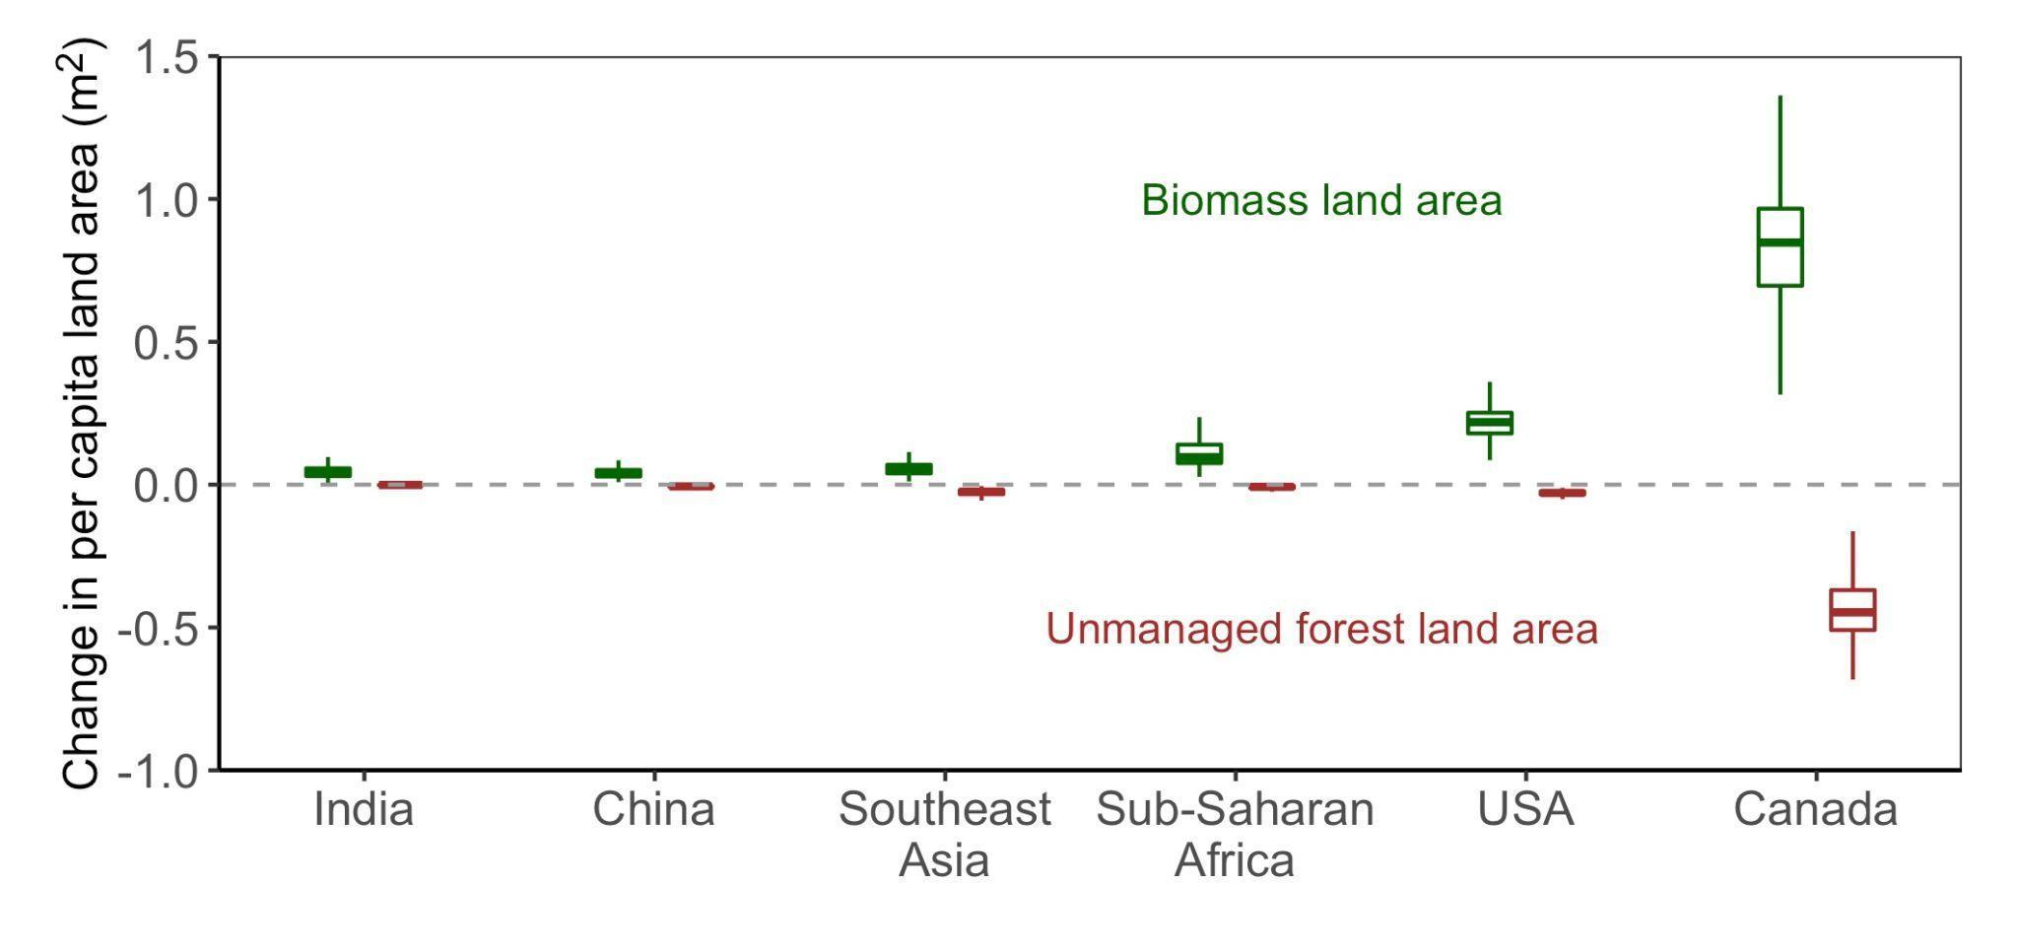

Figure S5. Changes in unmanaged forest area and area for biomass due to the global carbon price in 2050. The box plots show the scenario medians, quartiles, and ranges for the whole scenario ensemble (N=13,936).

2.2.3 Changes in residential/commercial organic carbon emissions due to the carbon price in 2050
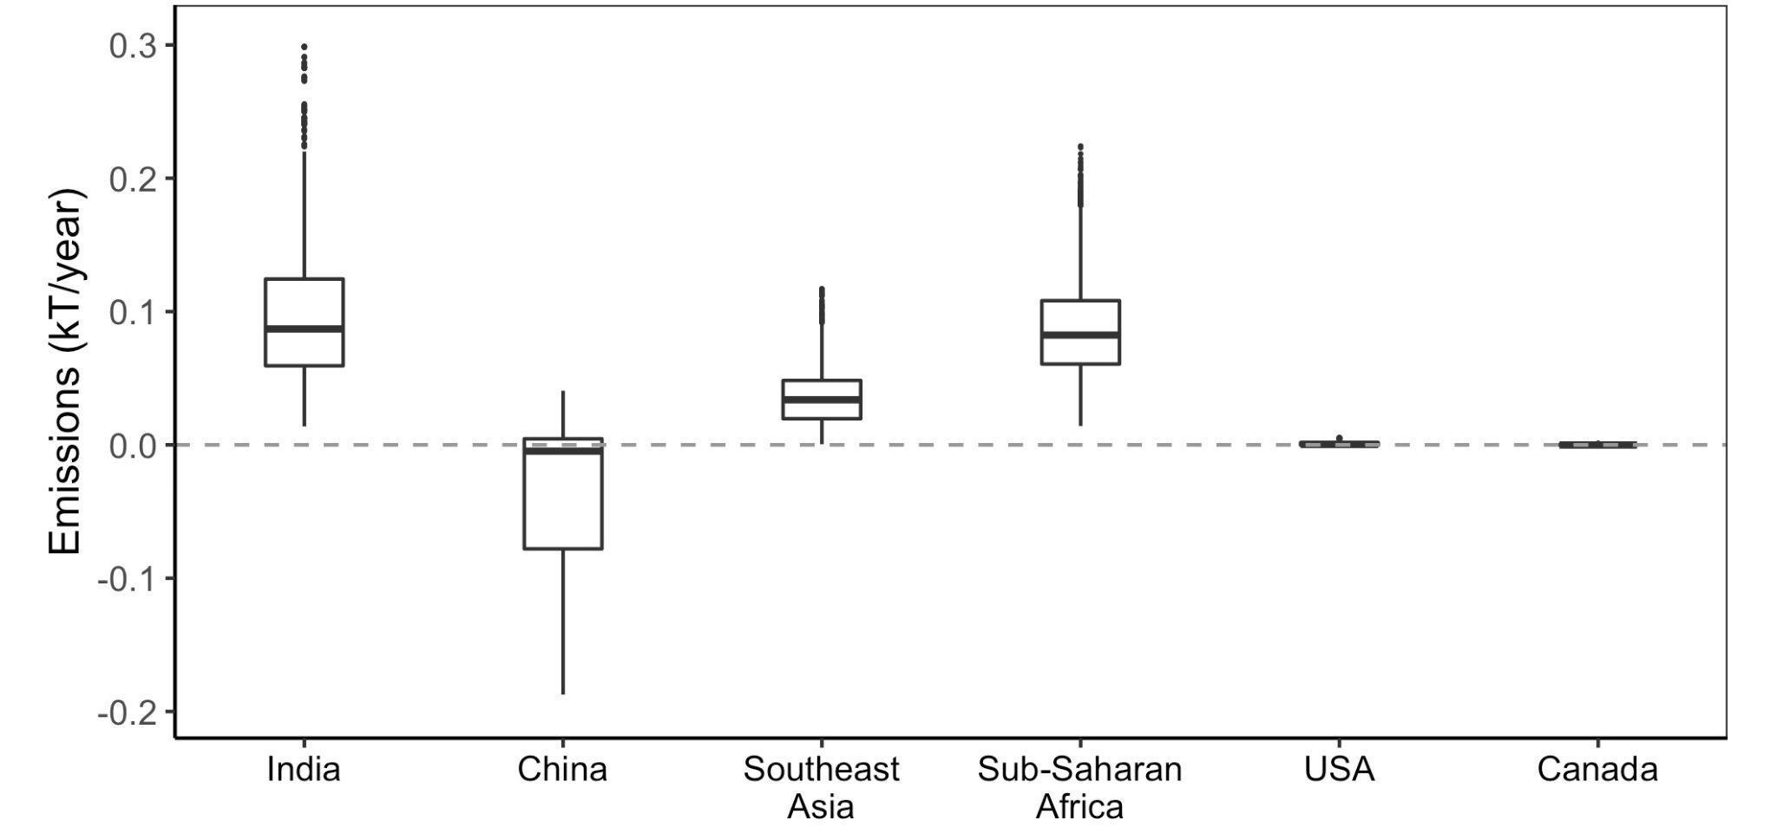
Figure S6. Changes in residential/commercial organic carbon emissions due to the carbon price in 2050. The box plots show the scenario medians, quartiles, and ranges (N=13,936). Specifically, China decreases organic carbon emissions across most scenarios. In commercial sectors, China is projected to have large decreases in OC emissions due to fast electrification¹²; in residential sectors, China is projected to have a transition from coal use to biomass use and will have small increases in OC emissions similar to other regions. As a net result, China is projected to have reduced OC emissions due to the electrification efforts in commercial sectors.

2.2.4 PM_{2.5} exposure level without the considered global carbon price in 2015
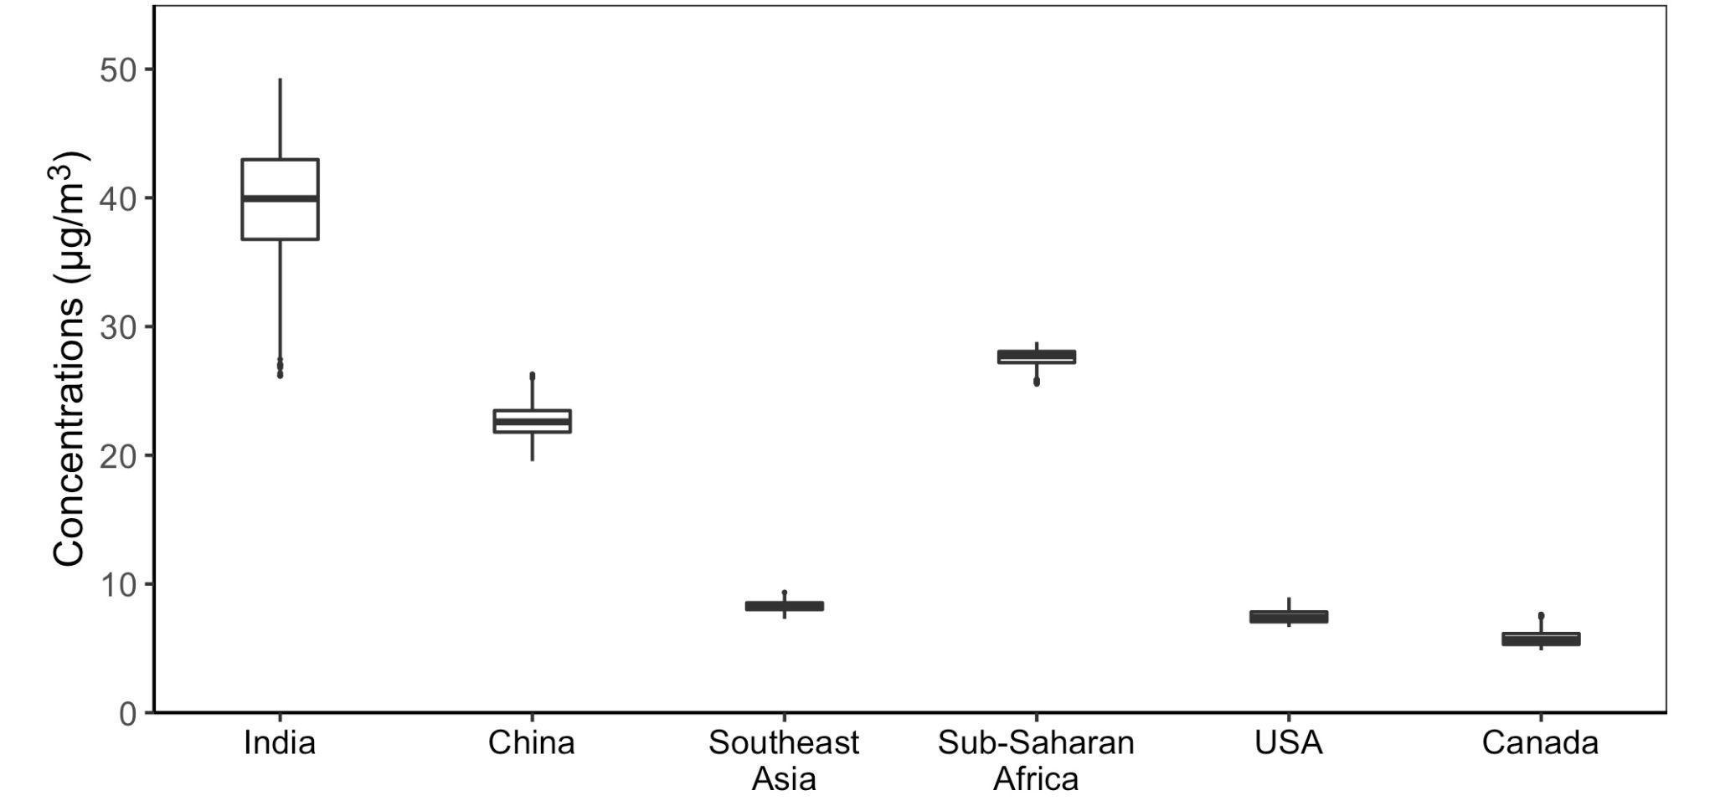

Figure S7. Air pollution exposure without the carbon price in selected countries. The box plots show the scenario medians, quartiles, and ranges for the whole ensemble (N=14,526). There are variations across scenarios because the model emissions were harmonized and calibrated for the year 2010; the emissions in 2015 hence were “projected” following the scenario-specific assumptions.

2.2.5 Age structure in developing and developed regions

Table S5 Age structure in selected regions in SSP2 in 2050

 | India | China | Southeast  Asia | Sub-  Saharan  Africa | USA | Canada
Population aged between 25 and 64 (million) | 251 | 356 | 143 | 97 | 92 | 13
Population older than 65 (million) | 929 | 663 | 413 | 817 | 197 | 24
Percent of elderly people (%) | 21 | 35 | 26 | 11 | 32 | 35

2.3 Supplementary figures for figure 4, about global distributions in the health drivers and exposures in 2050

2.3.1 Regional-level distribution of changes in primary energy mix in 2050

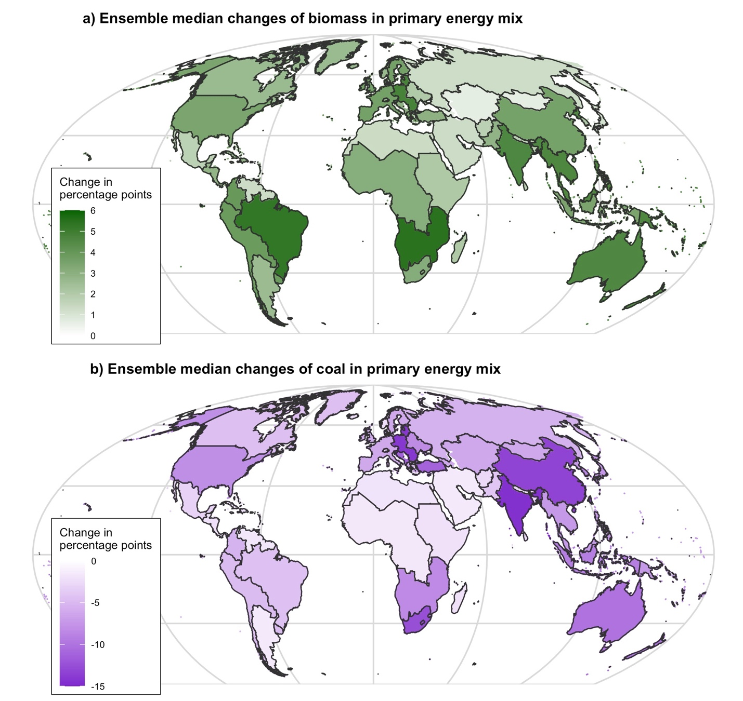

Figure S8. Impacts of a global carbon price on future regional distribution of changes in primary energy mix. The maps show the 2050 regional changes in ensemble median biomass and coal shares due to the carbon price (N=13,936). Panel a) shows the increase in shares of biomass consumption in primary energy mix, and panel b) show the decreases in shares of coal consumption in primary energy mix.
2.3.2 Regional-level distribution of changes in precursor air pollutant emissions in 2050

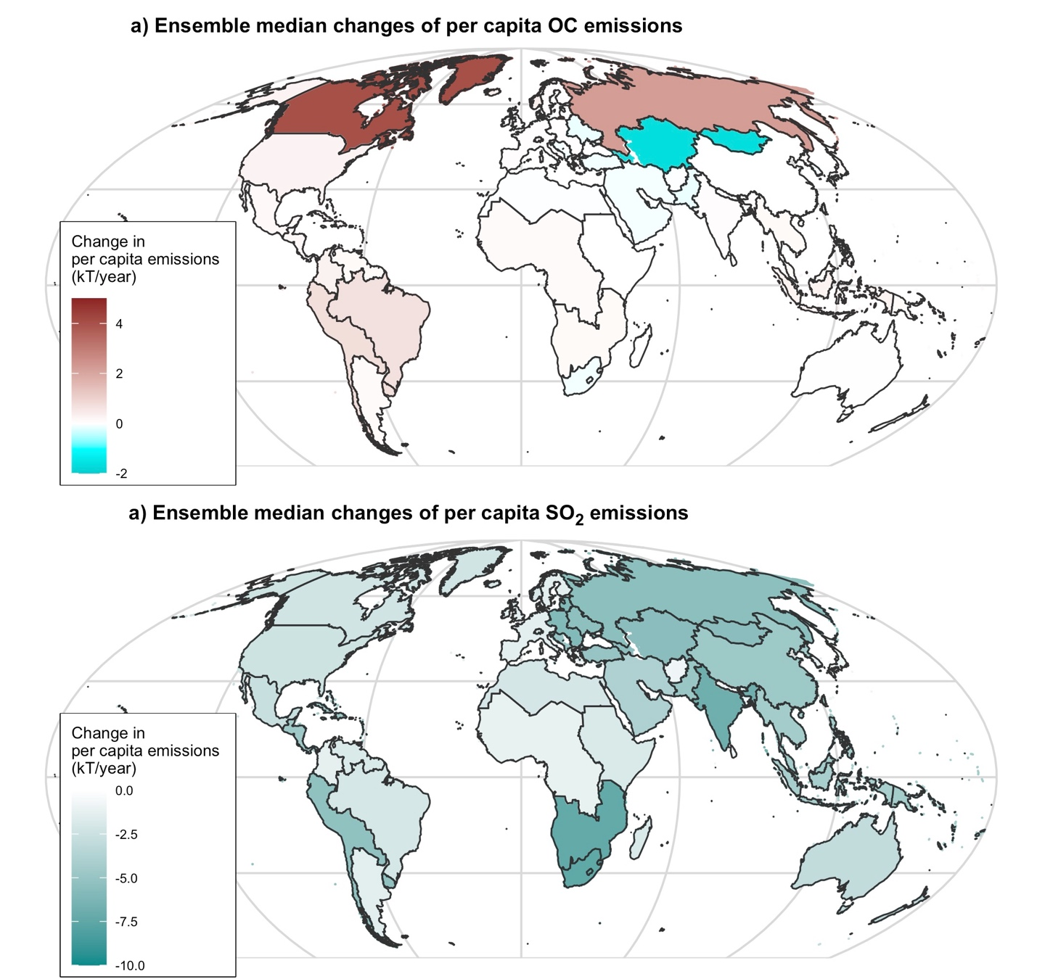

Figure S9. Impacts of a global carbon price on future regional distribution of changes in precursor air pollutant emissions. The maps show the 2050 regional changes in ensemble median organic carbon (OC) and sulfur dioxide (SO₂) emissions due to the carbon price (N=13,936). Panel a) shows the changes in OC emissions, and panel b) show the decreases in SO₂ emissions.

2.3.3 Regional-level distribution of changes in PM_{2.5} concentrations in 2050

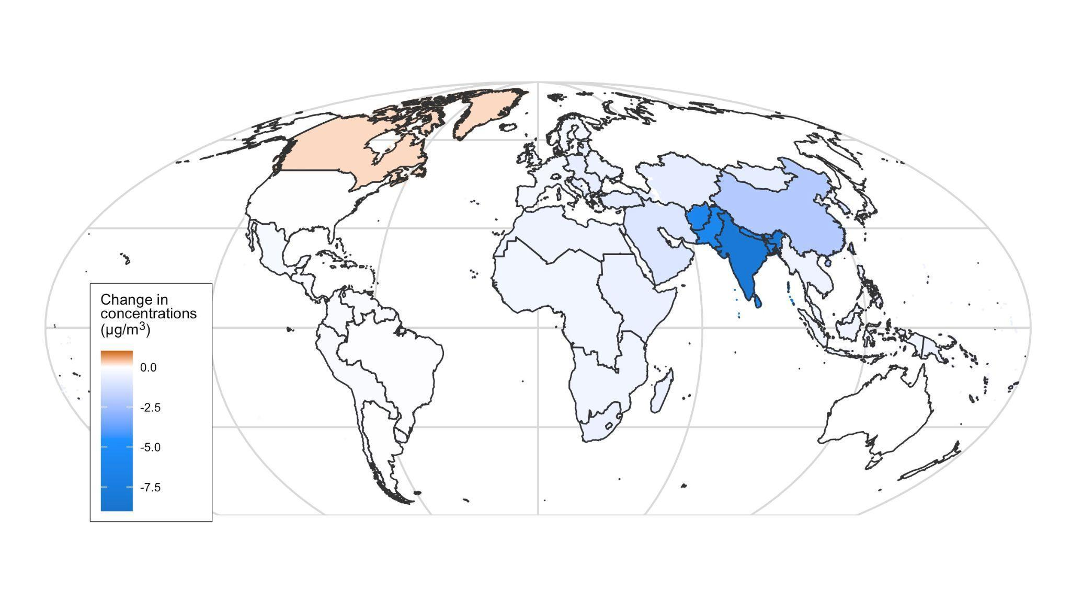
Figure S10. Impacts of a global carbon price on future regional distribution of changes in PM_{2.5} concentrations. The maps show the 2050 regional changes in ensemble median PM_{2.5} concentrations due to the carbon price (N=13,936).

3. Sensitivity analysis

3.1 Distribution of PM_{2.5}-attributable death rates across regions and age groups in 2050, with upper bounds of relative risks

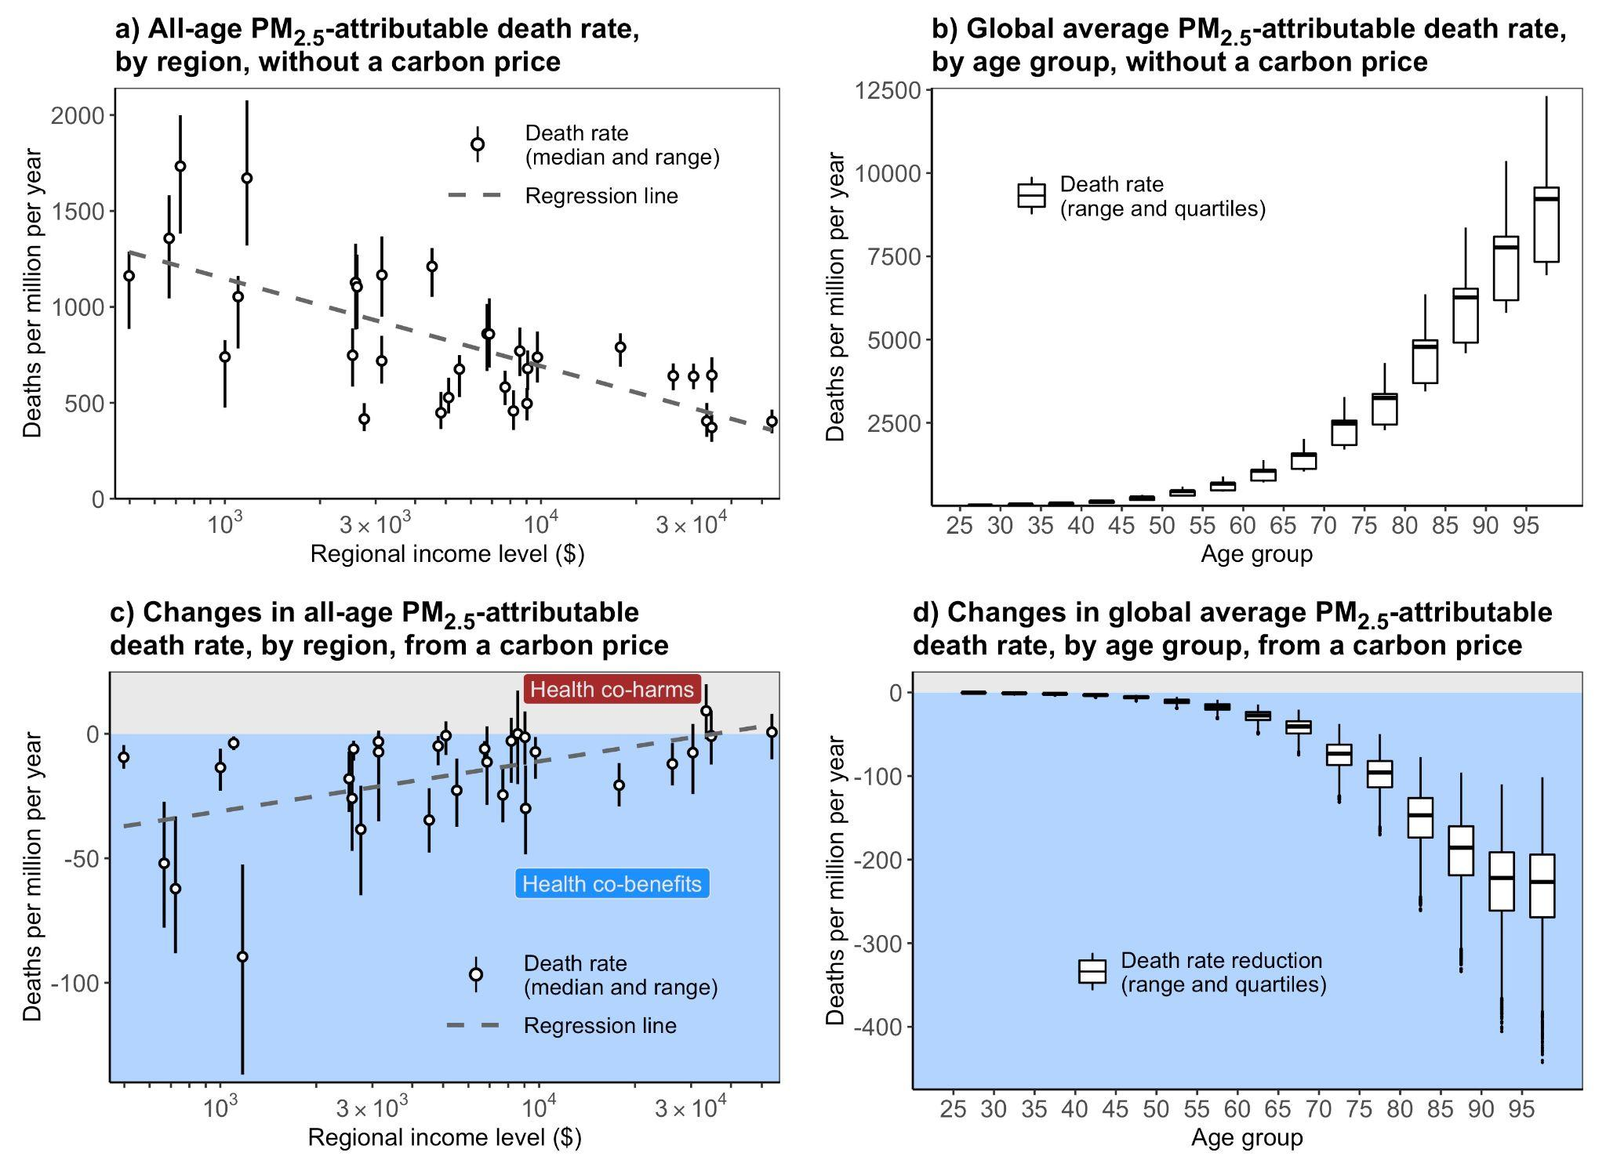

Figure S11. Distribution of PM_{2.5}-attributable death rates across regions and age groups in 2050, using the upper bounds of relative risks from GBD 2019⁴. Panels a) and b) show the PM_{2.5}-attributable death rate without the carbon price, while the panels c) and d) depict the changes in death rate due to a global carbon price of $69/ton. Panel a) and c) illustrate the variation across world regions, ranked from low to high per capita income in 2015 (from left to right). The circles and error bars represent the scenario medians and ranges (N=13,936). Panel b) and d) show the variation across adult age groups, ranked by 5-year groups from 25–29 to 95+ years old (from left to right). The box plots show the scenario medians, quartiles, and ranges (N=13,936).

3.2 Distribution of PM_{2.5}-attributable death rates across regions and age groups in 2050, with lower bounds of relative risks

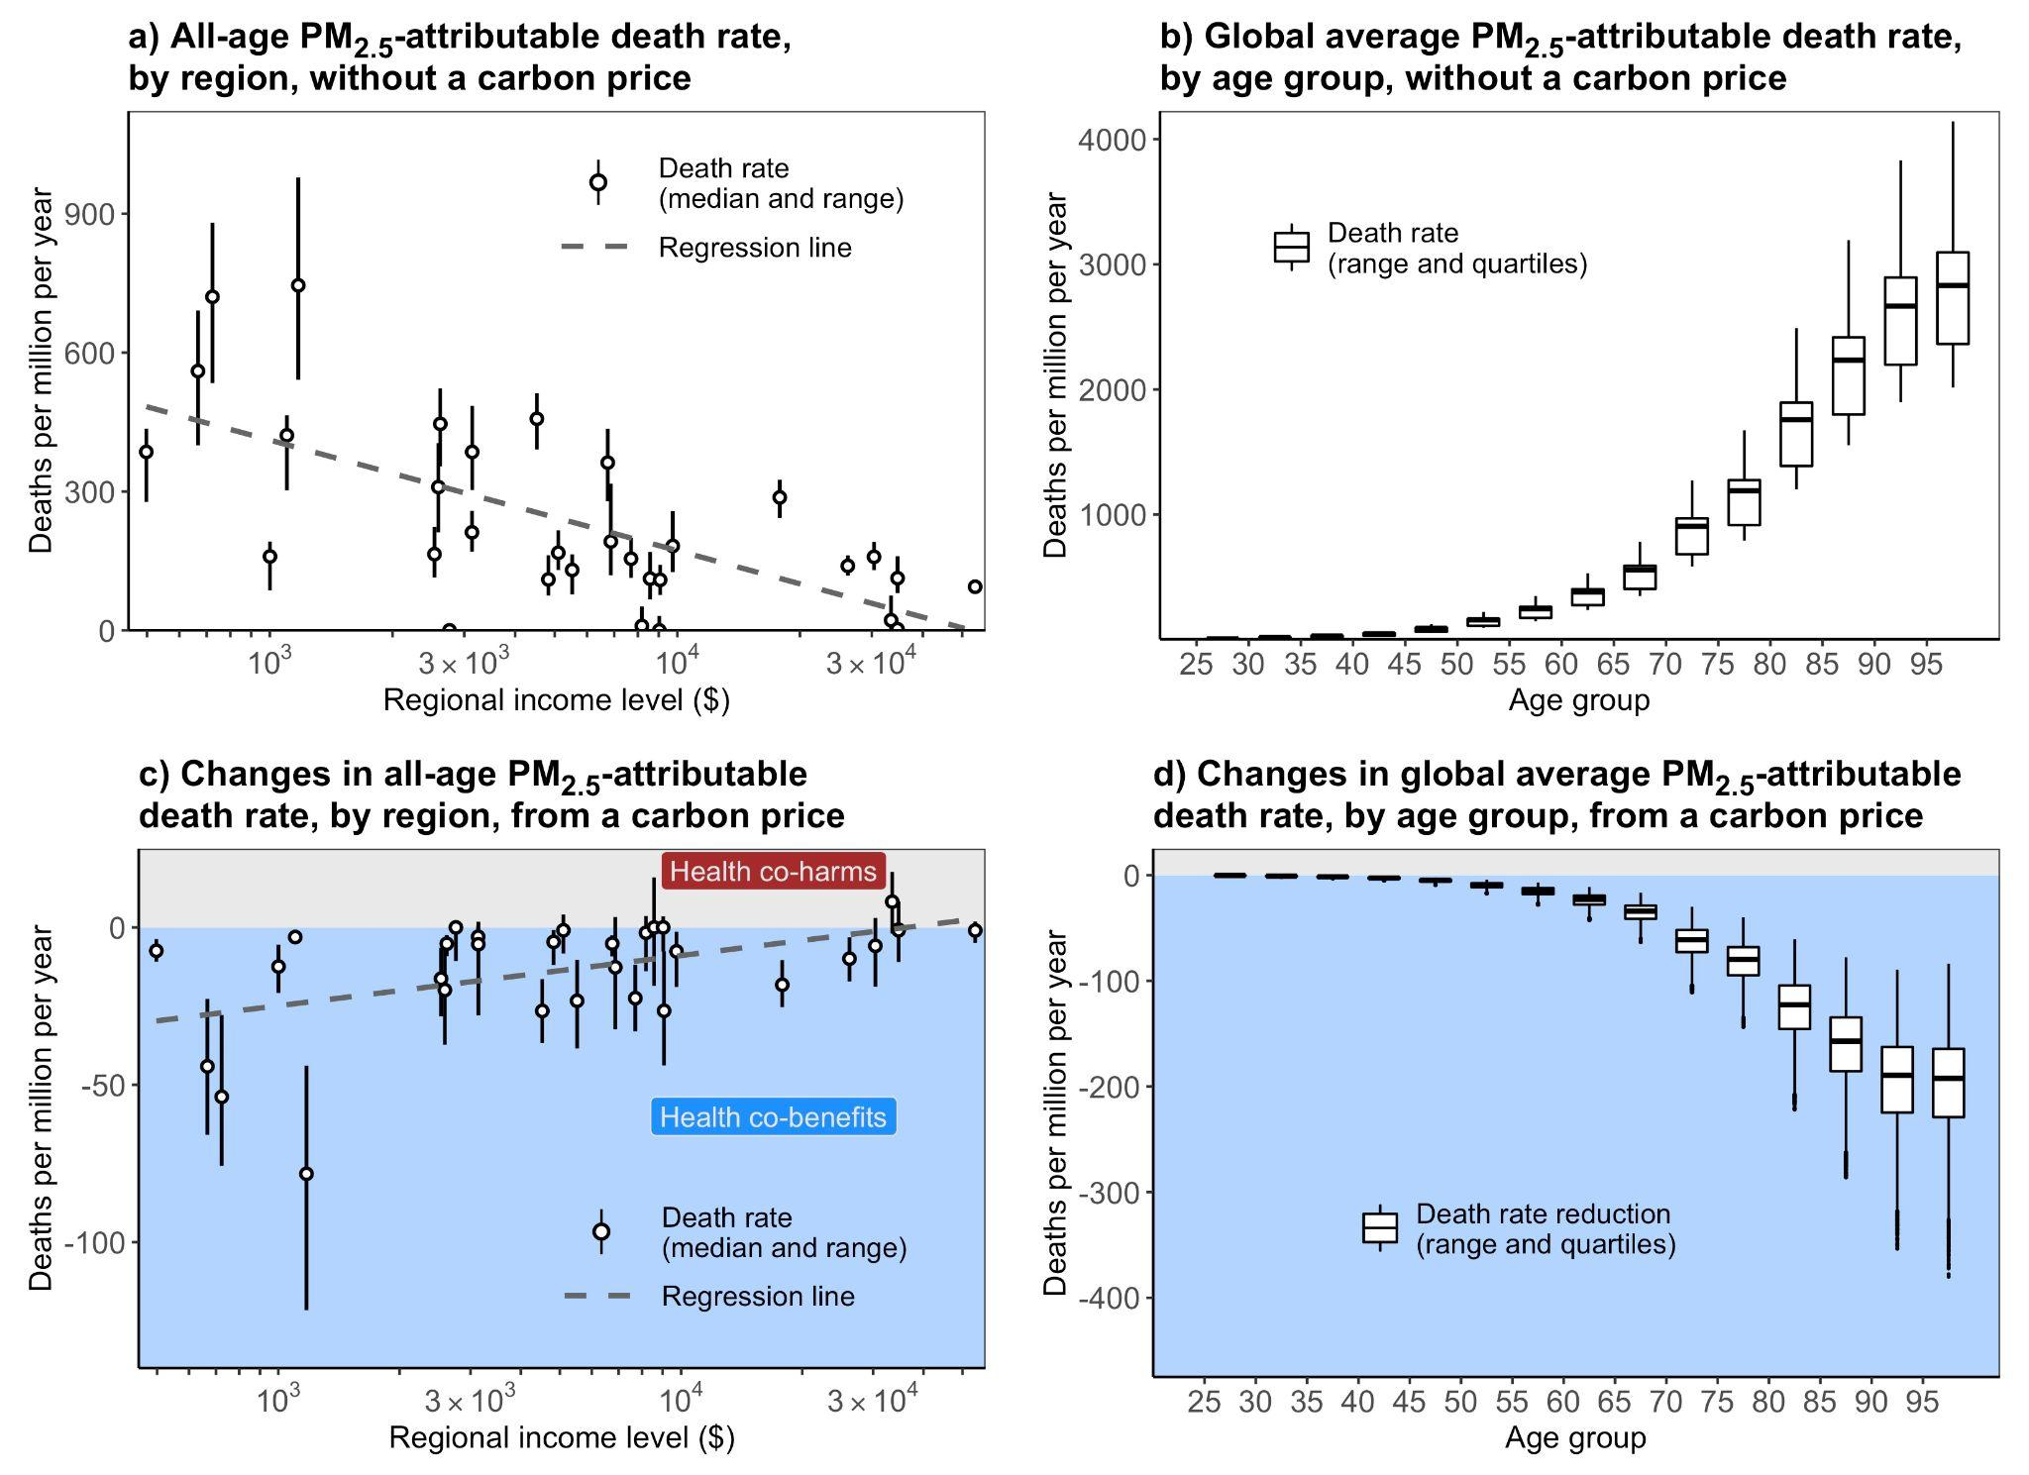

Figure S12. Distribution of PM_{2.5}-attributable death rates across regions and age groups in 2050, using the lower bounds of relative risks from GBD 2019⁴. Panels a) and b) show the PM_{2.5}-attributable death rate without the carbon price, while the panels c) and d) depict the changes in death rate due to a global carbon price of $69/ton. Panel a) and c) illustrate the variation across world regions, ranked from low to high per capita income in 2015 (from left to right). The circles and error bars represent the scenario medians and ranges (N=13,936). Panel b) and d) show the variation across adult age groups, ranked by 5-year groups from 25–29 to 95+ years old (from left to right). The box plots show the scenario medians, quartiles, and ranges (N=13,936).

Reference

1. O’Neill, B. C. et al. The roads ahead: Narratives for shared socioeconomic pathways describing world futures in the 21st century. Glob. Environ. Change 42, 169–180 (2017).
2. Kriegler, E. et al. The need for and use of socio-economic scenarios for climate change analysis: A new approach based on shared socio-economic pathways. Glob. Environ. Change 22, 807–822 (2012).
3. Riahi, K. et al. The Shared Socioeconomic Pathways and their energy, land use, and greenhouse gas emissions implications: An overview. Glob. Environ. Change 42, 153–168 (2017).
4. Murray, C. J. L. et al. Global burden of 87 risk factors in 204 countries and territories, 1990–2019: a systematic analysis for the Global Burden of Disease Study 2019. The Lancet 396, 1223–1249 (2020).
5. Hughes, B. B. et al. Projections of global health outcomes from 2005 to 2060 using the International Futures integrated forecasting model. Bull. World Health Organ. 89, 478–486 (2011).
6. Calvin, K. et al. GCAM v5.1: representing the linkages between energy, water, land, climate, and economic systems. Geosci. Model Dev. 12, 677–698 (2019).
7. Lamontagne, J. R. et al. Large Ensemble Analytic Framework for Consequence‐Driven Discovery of Climate Change Scenarios. Earths Future 6, 488–504 (2018).
8. Calvin, K. et al. The SSP4: A world of deepening inequality. Glob. Environ. Change 42, 284–296 (2017).
9. Van Dingenen, R. et al. TM5-FASST: a global atmospheric source–receptor model for rapid impact analysis of emission changes on air quality and short-lived climate pollutants. Atmospheric Chem. Phys. 18, 16173–16211 (2018).
10. Crippa, M. et al. Gridded emissions of air pollutants for the period 1970–2012 within EDGAR v4.3.2. Earth Syst. Sci. Data 10, 1987–2013 (2018).
11. Janssens-Maenhout, G. et al. EDGAR v4.3.2 Global Atlas of the three major greenhouse gas emissions for the period 1970–2012. Earth Syst. Sci. Data 11, 959–1002 (2019).
12. Peng, W., Yang, J., Lu, X. & Mauzerall, D. L. Potential co-benefits of electrification for air quality, health, and CO2 mitigation in 2030 China. Appl. Energy 218, 511–519 (2018).

