Supplementary Text

Assessment of reliability of isotopic dates in meteorite chronology

The required level of reliability of the dates of asteroidal and planetary materials for evaluating distribution of short-lived radionuclides in the Solar System is the same as in determination of physical constants, e.g., half-lives of radioisotopes, from analysis of natural geological materials ⁷⁸. We need to assure that both chronometers date the same event (or synchronous events), that precursor material was completely homogenised during this event, and that the event that is being dated was short compared to the time difference between formation of the two rocks. The isotopic systems must have remained closed ever since. Both chronometers must yield model-independent and sufficiently precise dates.
The reliability of the dates can be assessed using several criteria, some of which are general, and the others are applicable only to certain dating schemes. There are several lines of evidence for closed system behaviour that can be used for any isotope chronometer. The first is the absence of signs of significant metamorphic and/or aqueous processing in the petrologic record. The second is uniformity of the ages of several meteorites or their components that are compositionally similar and probably come from the same parent body (in the case of achondrites), or were produced by the same process in the accreting disk (in the case of CAIs and chondrules). Furthermore, the absence of age variations among similar meteorites with variable extent of secondary processing (metamorphism, alteration, shock) shows that these secondary processes did not cause detectable migration of parent and daughter isotopes, and hence did not disturb the ages. The absence of excess scattering in isochron regressions also supports closed system behaviour. If the isochron includes data for multiple minerals of igneous origin that plot on the same line, and these minerals have different rates of diffusion of parent and/or daughter elements, then the absence of excess scattering also confirms that the minerals cooled quickly enough to make their closure for diffusion effectively “point-like” ⁷⁸. Model independence of the ages is achieved by high abundance ratio of radiogenic isotopes to non-radiogenic isotopes of the daughter elements. Finally, precision and analytical accuracy rely on the quality of analytical procedures, and sufficient sample size and concentration of the parent and daughter elements to generate precisely measurable radiogenic excesses.
In Pb-isotopic dating, the closed system behaviour, and the accuracy of the dates, are additionally verified by consistency between ²⁰⁶Pb*/²³⁸U and ²⁰⁷Pb*/²³⁵U ages (asterisk denotes radiogenic isotopes), which is usually referred to as concordance of the U-Pb system. This criterion is widely used in dating of young rocks using highly resistant minerals such as zircon where the crystallisation age is calculated from the ²⁰⁶Pb*/²³⁸U ratio ⁷⁹. The ages of very old rocks, including meteorites, are calculated more precisely from the abundance of radiogenic ²⁰⁷Pb* and ²⁰⁶Pb* alone, and variations of the measured ²⁰⁶Pb*/²³⁸U and ²⁰⁷Pb*/²³⁵U ratios do not necessarily indicate compromised age determination. However, it is important to know when fractionation between U and radiogenic Pb occurred. Present-day fractionation, introduced by laboratory treatment (except for some cases of severe acid leaching ⁸⁰) or recent weathering, does not generally cause fractionation of ²⁰⁷Pb* and ²⁰⁶Pb* and age inaccuracy. In contrast, ancient U/Pb fractionation due to asteroidal metamorphism or metasomatism, produces, over time, variable ²⁰⁷Pb*/²⁰⁶Pb* ratios that complicate Pb-isotopic dating. The time of U/Pb fractionation can be determined from the lower intercept of a regression in a ²⁰⁷Pb*/²³⁵U vs. ²⁰⁶Pb*/²³⁸U diagram (called concordia diagram). The lower intercept that equals zero within uncertainty indicates that U/Pb fractionation took place at present, and ²⁰⁷Pb*/²⁰⁶Pb* ratios are invariable and accurately reflect the timing of rock crystallisation. A non-zero lower intercept points to ancient U/Pb fractionation, or multiple fractionation episodes. Pb-isotopic dates of meteorites that were derived from U-Pb data that yield non-zero lower concordia intercepts should be considered suspect.

Calculation of initial ²⁶Al/²⁷Al projected to a certain time
The initial (²⁶Al/²⁷Al)₀ ratio of precursor material for each parent body is a function of the Pb-Pb age difference between a reference point and achondrite, and the half-life of ²⁶Al (0.705 Ma, ¹). For better visualization of ²⁶Al heterogeneity in the early Solar System we projected initial (²⁶Al/²⁷Al)₀ ratios to the ages of the two commonly used in cosmochemistry references, CAIs (Fig. S15A) and volcanic angrite D’Orbigny (Fig. S15B). For comparison, we also plot initial (²⁶Al/²⁷Al)₀ of the precursor material for two ungrouped achondrites with carbonaceous affinity, NWA 2976 ²¹ and NWA 6704 ²³, and ungrouped achondrite Asuka 881394 ²⁷.
The uncertainty of projected initial ²⁶Al/²⁷Al includes uncertainties of the ²⁶Al/²⁷Al from the isochrons, and uncertainties of the Pb-Pb ages of unknowns. Since change in the age and/or ²⁶Al/²⁷Al ratio of the reference points equally shifts all data points, the uncertainties of the reference points are not included. Uncertainty components are combined as quadratic sums, i.e., assuming that they are uncorrelated.
Projections of the initial (²⁶Al/²⁷Al)₀ ratio to both reference ages, either CAIs or D’Orbigny, clearly display the heterogeneous distribution of ²⁶Al among achondrites. Thus, the parent body of EC 002 has a CAIs-like initial (²⁶Al/²⁷Al)₀ ratio, while precursor materials of other achondrites were formed with lower (²⁶Al/²⁷Al)₀ ratio.

Modelling pre-history of the EC 002 protolith using initial δ²⁶Mg*₀
The intercept of the ²⁶Al-²⁶Mg mineral and whole-rock isochron provides δ²⁶Mg*₀=-0.009±0.005 ⁴⁵. This initial value suggests that EC 002 was derived from a chondritic source (Fig. S16), in agreement with analyses from ⁴⁴. A significant increase of the ²⁷Al/²⁴Mg ratio up to 1.299 (calculated from data ⁴⁴) from 0.101 (CI value, ⁸¹) happened rapidly after accretion during partial melting and/or fractional crystallization of the magma. Isotopic evolution of ²⁶Mg* (Fig. S16) shows that time of accretion of the EC 002 parent body is not resolved from the EC 002 crystallization time.

Fig. S1.
Summary of ²⁰⁷Pb/²⁰⁶Pb ratios for the regular and large SRM 981 (a) and Early Time (b) standards. Shaded area is certified ²⁰⁷Pb/²⁰⁶Pb value of 0.91464 ± 0.00033.

Fig. S2.
U and Pb distribution (A and B) and ²⁰⁶Pb/²⁰⁴Pb ratios (C) between leaching steps. WR – whole rock, oPx – orthopyroxene, cPx – clinopyroxene, plag – plagioclase.

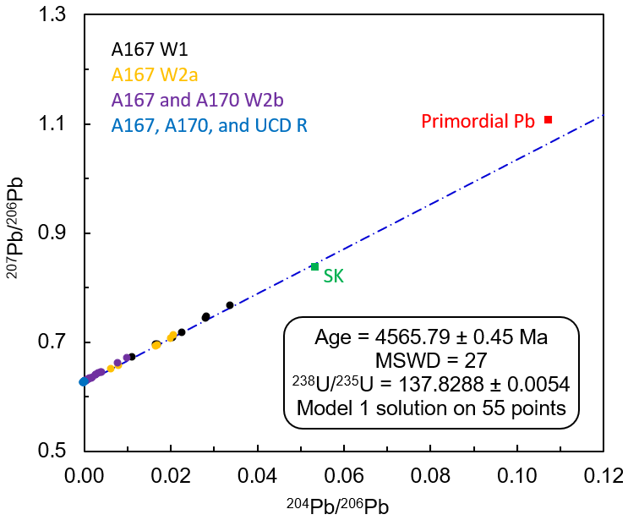
Fig. S3.
Pb-Pb isochron diagram for all analysed fractions. Primordial Pb – isotopic composition of Pb in Canyon Diablo troilite ⁵⁰, SK – isotopic composition of modern terrestrial Pb ⁸².

Fig. S4.
A – Pb-Pb isochron diagram for W2b and R fractions. B – isochron passes through the isotopic composition of the primordial Pb ^{49,50}.

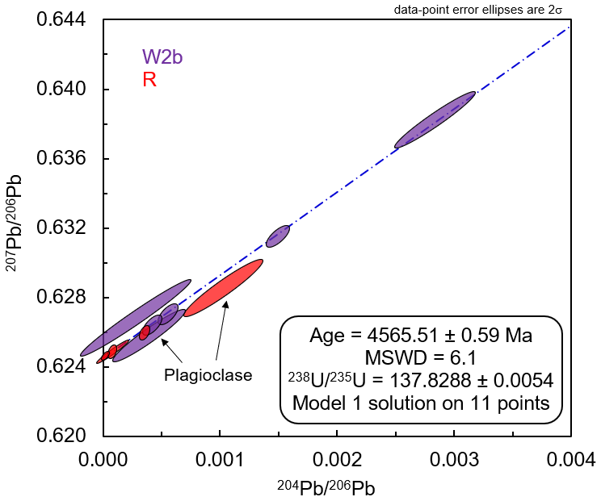
Fig. S5.
Pb-Pb isochron diagram for R (red) and W2b (purple) fractions from A167 analytical session. Data points from the A170 and UCD sessions are not shown for clarity. All plagioclase points lie below the isochron, suggesting that the U-Pb system was open. The data point above the isochron is W2b leachate of pyroxene, its exclusion is described further.

Fig. S6.
The distribution of radiogenic ²⁰⁶Pb in W2b and R fractions in A167, A170, and UCD analytical sessions.

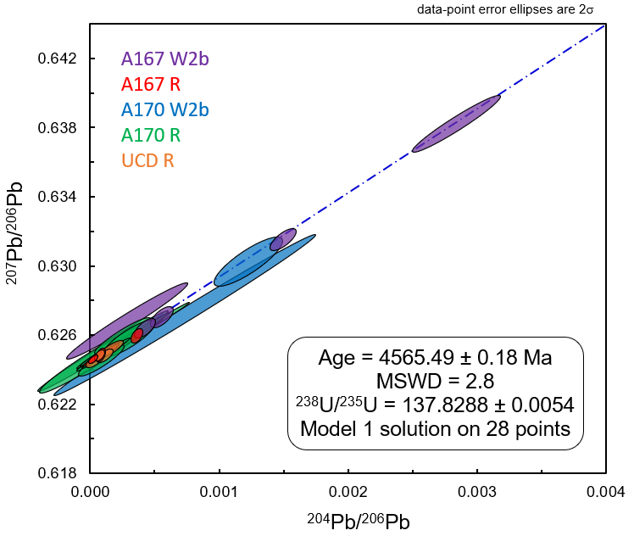
Fig. S7.
Pb-Pb isochron diagram for R and W2b fractions with ²⁰⁶Pb* > 0.5×10⁻¹³ mol.

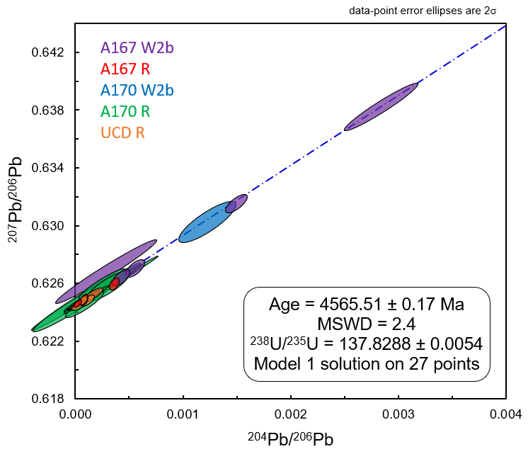
Fig. S8.
Pb-Pb isochron diagram for R and W2b fractions with ²⁰⁶Pb* > 1.0×10⁻¹³ mol.

Fig. S9.
A - Pb-Pb isochron diagram for R and W2b fractions with ²⁰⁶Pb* > 2.0×10⁻¹³ mol. B – the same isochron passes through the isotopic composition of the primordial Pb ^{49,50}.

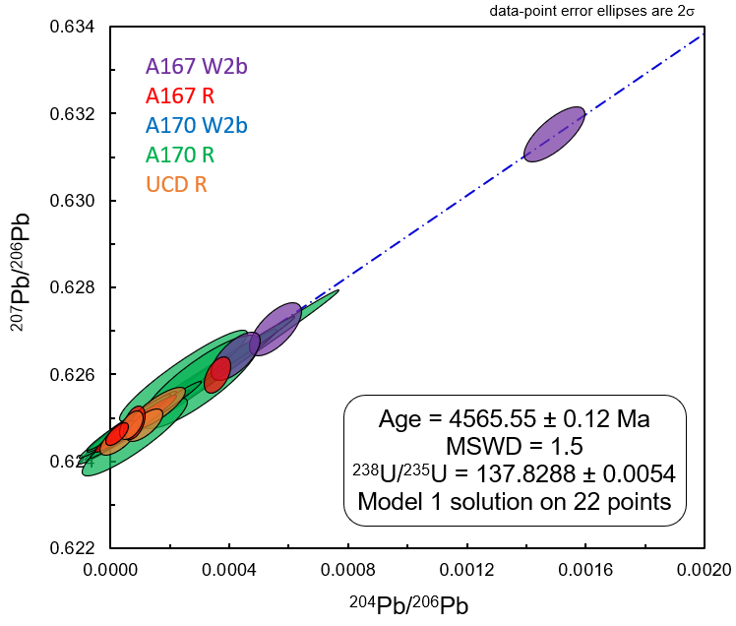
Fig. S10.
Pb-Pb isochron diagram for R and W2b fractions with ²⁰⁶Pb* > 5.0×10⁻¹³ mol.

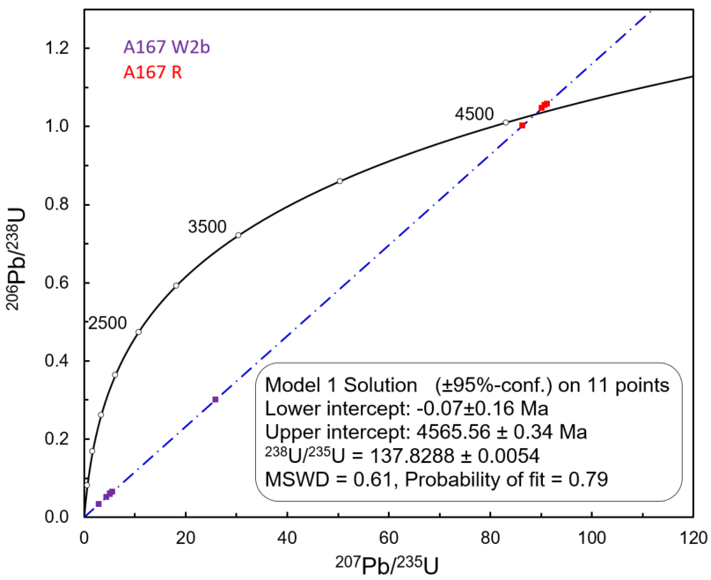
Fig. S11.
A167 W2b and R data plotted in Concordia diagram. The intercept at zero confirms that U-Pb disturbance was caused by our leaching procedure and before U-Pb isotopic system was closed. An upper interception with an age of 4565.56 ± 0.34 Ma is in agreement with Pb-Pb isochron and ²⁰⁷Pb*/²⁰⁶Pb* model ages, confirming their accuracy.

Fig. S12.
Correlation of the ²³⁸U/²³⁵U and ²³⁶U/²³⁸U ratios in the different sample/spike mixtures using certified (a) and measured (b) isotopic composition of the double spike IRMM-3636

Fig. S13.
Isotopic composition (²³⁵U/²³⁶U and ²³⁸U/²³⁶U ratios) of the IRMM-3636 double spike

Fig. S14.
Uranium isotopic composition of EC 002 relative to terrestrial basalts (this study), and average Solar system values of 137.786±0.013 ³⁴ (dark grey) and 137.794±0.027 ⁵¹ (light grey).

Fig. S15.
Initial ²⁶Al/²⁷Al ratios for CAIs ¹⁴ (red squares), volcanic angrites ²² (blue circles) and ungrouped achondrites ^{21,25,27} (green, yellow and purple), projected to either to the age of CAIs ³⁴ (a) or the age of D’Orbigny (b). Achondrites with carbonaceous affinity are shown with triangles, non-carbonaceous achondrites – with circles. The values for Erg Chech 002 are shown with dotted circle (SIMS data ⁴⁴) and solid circle (MC-ICPMS data ⁴⁵). The age of D’Orbigny is calculated from the Pb-Pb isochron age of 4564.42±0.12 Ma (@²³⁸U/²³⁵U=137.88) from ¹⁶, and ²³⁸U/²³⁵U=137.7906±0.0060, a weighted average of four measurements from ^{20,38}. The age of Sahara 99555 is calculated from the Pb-Pb ages of 4564.61±0.13 Ma (@²³⁸U/²³⁵U=137.88), a weighted average of Pb-Pb isochron ages from ^{17,37}, and ²³⁸U/²³⁵U=137.7945±0.0095, a weighted average of two measurements from ^{34,38}.

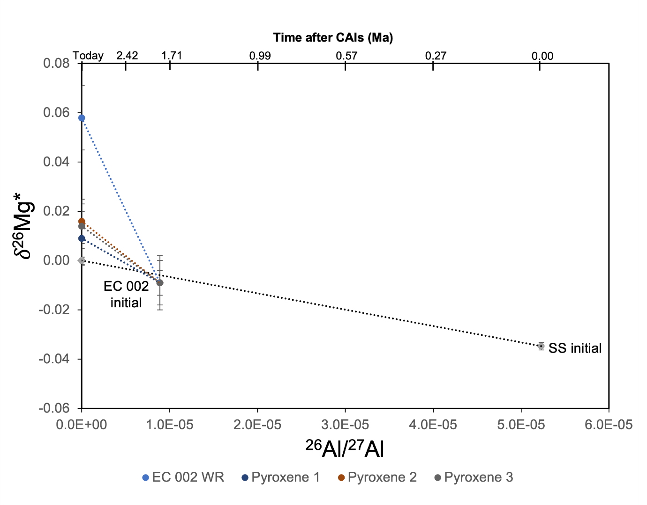
Fig. S16.
²⁶Mg* isotopic evolution diagram for EC 002 showing the radiogenic ingrowth of ²⁶Mg* from ²⁶Al decay in whole-rock and pyroxene fractions. The Solar system initial composition (SS initial) from ¹⁴, SS initial evolution (grey dotted line) corresponds to solar (=CI) ²⁷Al/²⁴Mg=0.101 from ⁸¹. EC 002 initial and δ²⁶Mg* data for whole-rock (WR) and pyroxene fractions are from ⁴⁵.

Table S1.
Uranium isotopic composition of the standards, terrestrial basalts, and EC 002
Sample | ²³⁸U/²³⁵U normalized | 95% MAD | n | MSWD | Published value |  | Reference
IRMM-184 | 137.6828 | 0.0027 | 32 | 5 | 137.6830 | 0.0200 | ⁶⁷
SRM 960 | 137.8505 | 0.0061 | 20 | 6.5 | 137.8370 | 0.0150 | ⁶⁷
BHVO-2 | 137.7990 | 0.0043 | 3 | 0.5 | 137.7940 | 0.0030 | ⁵²
BCR-2 | 137.7980 | 0.0170 | 3 | 4.9 | 137.8020 | 0.0030 | ⁵²
EC 002 Bulk | 137.8312 | 0.0030 | 4 | 0.8
EC 002 Wash | 137.8106 | 0.0060 | 1
EC 002 Residue | 137.8288 | 0.0054 | 5 | 2.1

Table S2.
Cr isotopic composition of Erg Chech 002
Sample | ε⁵³Cr | ±2SE | ε⁵⁴Cr | ±2SE
Erg Chech 002 (A) | 0.36 | 0.03 | -0.70 | 0.07
Erg Chech 002 (B) | 0.39 | 0.04 | -0.59 | 0.07
Average | 0.37 | 0.02 | -0.65 | 0.10

Table S3.
Sr isotope systematics of Erg Chech 002
Sample | ⁸⁷Sr/⁸⁶Sr | ± 2SE | ⁸⁴Sr/⁸⁶Sr | ± 2SE | ε⁸⁴Sr | ± 2SE | Comment
A167 01R | 0.7402478 | 0.0000035 | 0.0564895 | 0.0000036 | -0.303 | 0.635 | WR
A167 02R | 0.7407883 | 0.0000034 | 0.0564925 | 0.0000021 | 0.223 | 0.364 | WR
A167 03R | 0.7733258 | 0.0000055 | 0.0564892 | 0.0000026 | -0.368 | 0.460 | Px
A167 04R | 0.7824441 | 0.0000040 | 0.0564840 | 0.0000049 | -1.273* | 0.864* | Px
A167 05R | 0.7443510 | 0.0000040 | 0.0564919 | 0.0000022 | 0.124 | 0.394 | Px
A167 06R | 0.7523631 | 0.0000041 | 0.0564917 | 0.0000024 | 0.077 | 0.422 | Plag
A169 43** | 0.7381390 | 0.0000019 | 0.0564923 | 0.0000020 | 0.188 | 0.355 | WR
Weighted average |  |  |  |  | 0.060 | 0.240
* value excluded from weighted average calculation because of low precision
** fraction from U IC (²³⁸U/²³⁵U) session

Table S4.
Oxygen isotope data of Erg Chech 002 (University of Göttingen, UCLA, and UNM data)
Sample | Comment | N | δ΄¹⁷O | 2SD | 2SEM | δ΄¹⁸O | 2SD | 2SEM | Δ΄¹⁷O | 2SD | 2SEM
EC 002 | UG, this study | 7 | 1.875 | 0.406 | 0.154 | 3.769 | 0.743 | 0.281 | -0.114 | 0.023 | 0.009
EC 002 | UNM, ⁷⁷ | 7 | 1.720 | 0.202 | 0.076 | 3.497 | 0.389 | 0.147 | -0.126 | 0.030 | 0.011
EC 002 | UCLA*, this study | 1 | 2.251 | 0.009 |  | 4.629 | 0.004 |  | -0.193 | 0.009
EC 002 | UCLA, this study | 1 | 2.299 | 0.009 |  | 4.629 | 0.004 |  | -0.145 | 0.009
SC olivine | UG, this study | 10 | 2.700 | 0.203 | 0.064 | 5.212 | 0.391 | 0.124 | -0.052 | 0.013 | 0.004
*UCLA data before anchoring to the composition of SC olivine

