Single-pulse X-ray Acoustic Computed Tomography Image Guided Precision Radiation Therapy

Gilberto Gonzalez ¹, Kiana Prather², Prabodh Kumar Pandey³, Leshan Sun⁴, Joseph Caron¹, Siqi Wang⁴, Salahuddin Ahmad¹, Liangzhong Xiang^{3,4,5*} and Yong Chen^{1*}

¹Department of Radiation Oncology, University of Oklahoma College of Medicine, Oklahoma City, OK, 73104

² University of Oklahoma College of Medicine, Oklahoma city, OK

³ Department of Radiological Sciences, University of California, Irvine, CA 92697

⁴Department of Biomedical Engineering, University of California, Irvine, CA 92617

⁵Beckman Laser Institute & Medical Clinic, University of California, Irvine, CA 92612

Supplementary Information

- Experimental setup
A customized transducer detection system is used to capture the x-ray acoustic signals generated by clinical linear accelerator (Varian Truebeam). Beams were delivered at 10 MV-FFF energy with 2400 MU/min dose rate. Since the central frequency of the induced signal was measured to be around 20 – 50 kHz in water with a photon dose deposition, a low-frequency 0.5 MHz transducer (Olympus V389-SU) was used. This transducer was positioned in the tank perpendicular to the beam at a fixed position, with the surface of the transducer at a distance of approximately 10.5 cm from the lateral beam edge. The transducer was placed approximately 5 cm depth into the water tank, which was enough to reduce reflections from the water surface. The transducer was then connected to a two-stage amplification system. The first stage preamplifier (Olympus 5660B Preamp) had 60dB amplification and the second stage preamplifier (SRS SR560 Low-Noise Preamplifier) had a low noise amplification of 20dB, with a set -6dB bandpass of 10 kHz to 30 kHz. This bandwidth was selected based on the frequency of the signal collected in order to effectively eliminate noise that occurs outside this bandwidth. This resulted in the best signal quality for single-pulse mode acquisition. The signal was collected by the oscilloscope outside of the linac vault and its triggering was performed using the linac gun BNC connector from the control console. Figure 1 shows the XACT detection system. Figure 2A is a photograph of the linac room with the experimental setup. Figure 2B shows the 1D scanner (Sun Nuclear) used to hold the transducer and also to perform the XACT to dose-depth linearity test. Figure 2C shows the high density cerrobend rod used to test single-pulse XACT with a 2.25 MHz transducer,

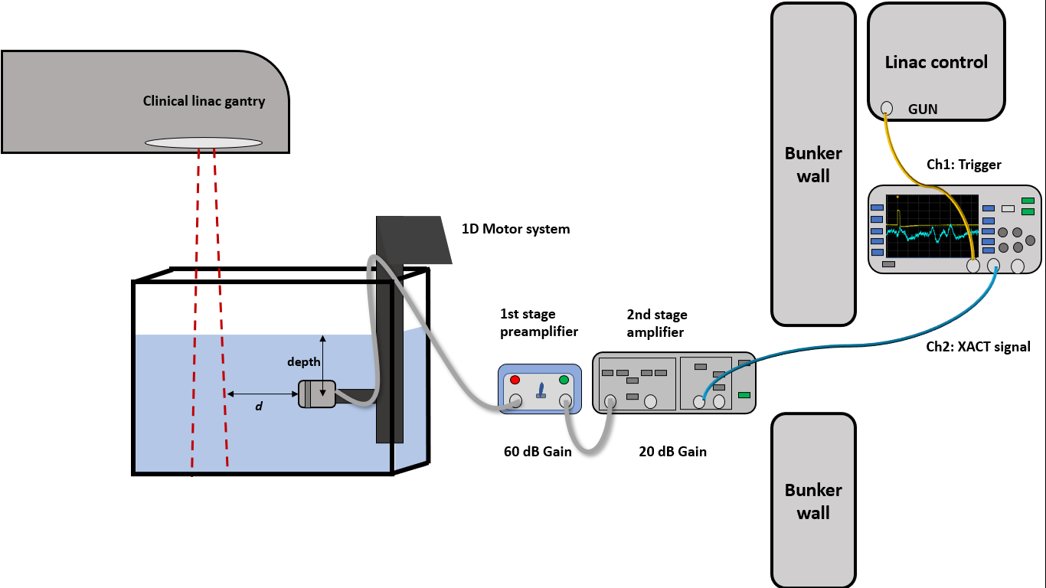

Figure 1. Experimental setup diagram. The water tank was set to SSD = 100cm. The depth of measurement was set from water surface to the mid-face of the transduce. The distance ´d´ was set by measuring the distance between the transducer’s surface and the edge of the beam’s light field. For our results, a depth of measurement of 5cm was used and the distance from transducer to light field was set to 10.5cm. The transducer was shielded with copper-tape and connected to the Olympus preamplifier, further passing to the SRS amplifier. The output signal would be taken out of the vault via a cable-tunnel in the wall and sent to the oscilloscope. To trigger acquisition, a signal from the GUN BNC outlet was taken from the machine control console. The oscilloscope allows signal acquisition with an averaging button or normal mode (single pulses).

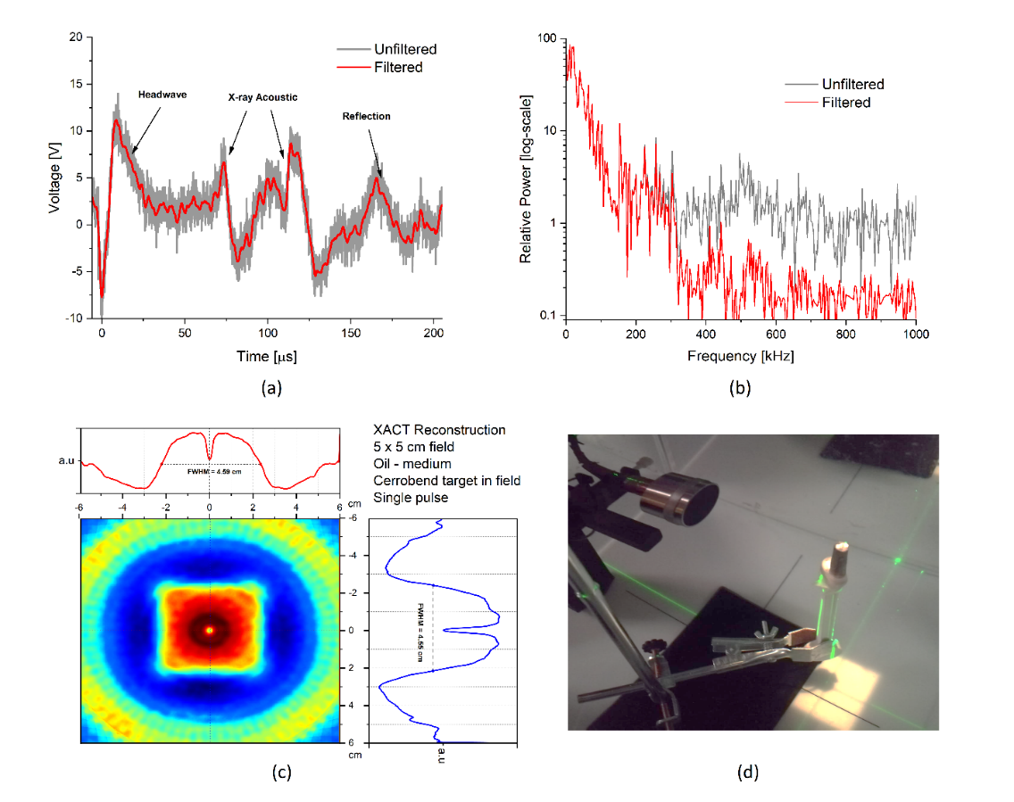
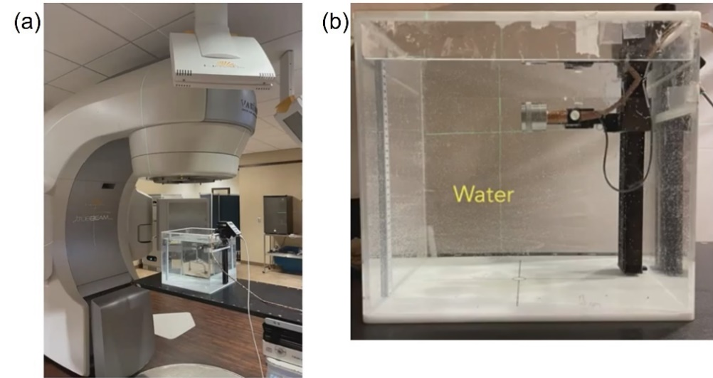
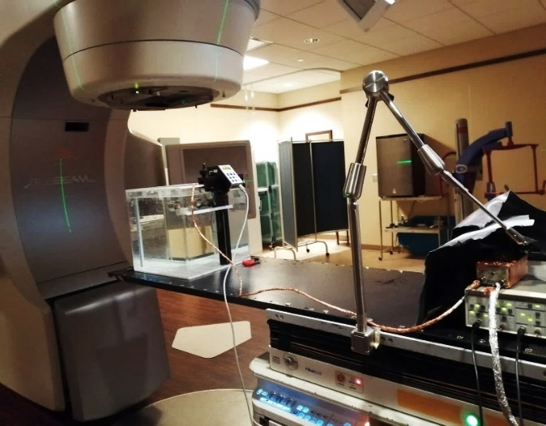

A.

B.

C.

Figure 2. A. Experimental setup in the linac vault. The transducer in the water tank is connected to the two-stage amplifiers. B. The transducer was positioned along depth via a step-motor system in the water tank (1D SCANNER, Sun Nuclear Corporation, Melbourne, FL). C. A 7-mm diameter cerrobend rod was placed at the isocenter of the field for XACT acquisition.

- Oscilloscope images from both medium
The impact of the Grüneisen parameter on the XACT signal is demonstrated in the oscilloscope acquisitions. Several averaging levels were selected. It is observed that for vegetable oil, the peaks of the acoustic signal are prominent with respect to the background noise. For XACT in water, the signal is of poorer quality and noisy. Figure 3 shows examples of two different field sizes and averaging levels.
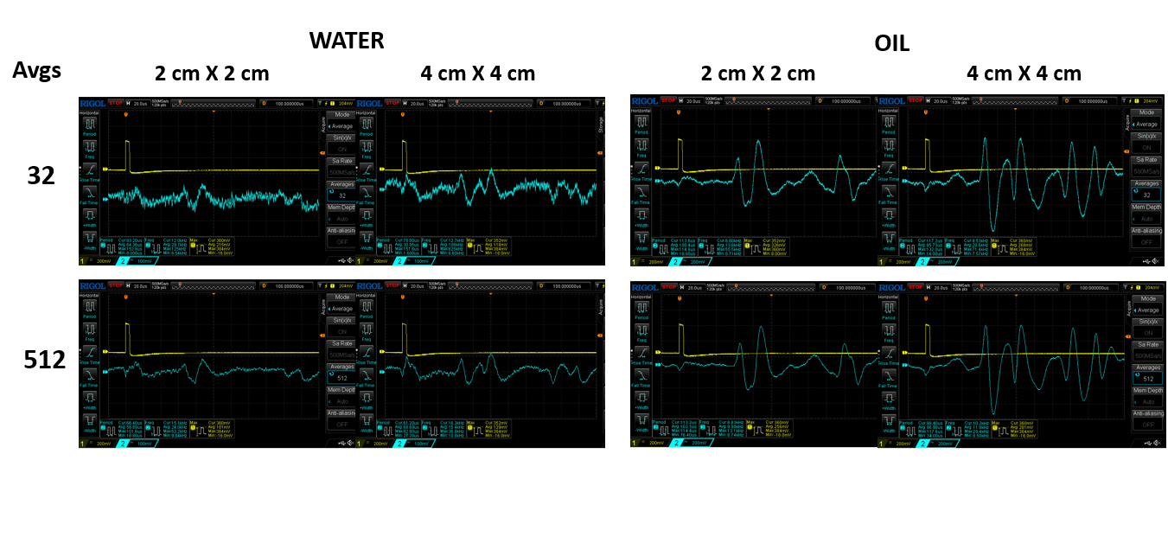
The results in Table 1 show that XACT in water required more averages to increase SNR to reach Rose Criterion (SNR ≥ 5); however, for oil the SNR is sufficient without any averaging. In Table 2, the second stage amplifier and bandpass filtering were adjusted to the single-pulse acquisition. For a 0.5 MHz transducer. Rotating the collimator decreased SNR at the more oblique angles (30° - 45°), this is because the pressure sources were no longer alligned in the distance from radiation beam edge to the transducer. For oil, a higher frequency 2.25 MHz transducer was tested and the results were similar, however because of the increased Grüneisen parameter, the SNR was sufficient in every collimator angle acquisition.

Figure 3. XACT signals obtained by the oscilloscope in water and oil using two levels of averaging: 32 and 512. The signal SNR and quality was much greater in oil compared to water. This is because the initial pressure wave generated in oil is stronger by several folds, the Grüneisen parameter of oil ranges between 0.9-0.95, whereas for water it is 0.12.
TABLE 1. Signal to noise ratio and peak-to-peak voltage as a function of signal averaging in medium with different Grüneisen parameters
 | Water ( $Γ$ = 0.10 – 0.12 ) |  | Vegetable oil ( $Γ$ = 0.90 – 0.95 )
Signal averages | Peak-to-peak (V) | SNR | Peak-to-peak (V) | SNR

2 | 0.560 | 1.7 | 1.32 | 17.0
8 | 0.272 | 3.2 | 1.10 | 19.1
16 | 0.280 | 5.5 | 1.30 | 19.4
32 | 0.216 | 6.1 | 1.22 | 20.6
64 | 0.232 | 9.3 | 1.24 | 20.1
128 | 0.232 | 10.2 | 1.24 | 20.2
256 | 0.200 | 10.7 | 1.22 | 19.2
512 | 0.208 | 10.9 | 1.22 | 20.6

TABLE 2. Single pulse mode SNR as a function of collimator angle facing the transducer in medium with different Grüneisen parameters. An additional 2.25 MHz transducer was used for oil medium.
 | Water ( $Γ$ = 0.10 – 0.12 ) |  | Vegetable oil ( $Γ$ = 0.90 – 0.95 )
Collimator angle | 4 cm depth | 8 cm depth | 4 cm depth (0.5 MHz) | 4 cm depth (2.25 MHz)

0 | 5.82 | 5.56 | 8.99 | 7.29
15 | 6.03 | 5.46 | 8.03 | 6.70
30 | 4.00 | 3.82 | 6.06 | 4.93
45 | 3.35 | 3.76 | 6.28 | 5.25

- XACT and field size
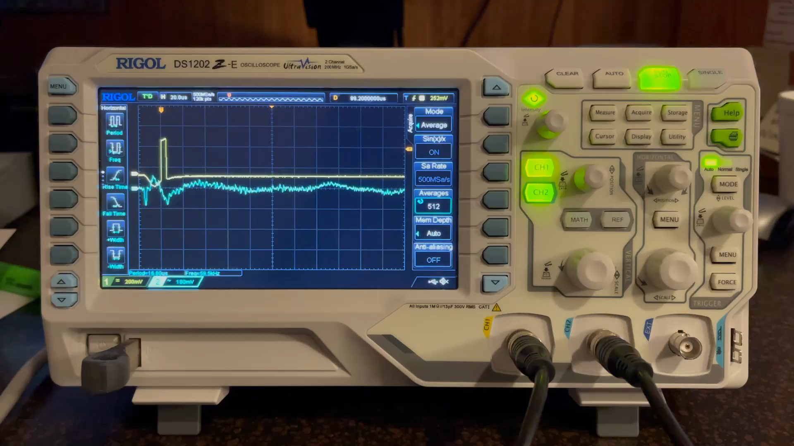

Additional to this supplementary document, there is the video showing the XACT signals in real-time while changing the field size. The XACT signal can give information about the radiation field size and position.
When the radiation field in front of the transducer is increased in X-dimension, the amount of pressure sources facing the transducer also increases, therefore the amplitude of the XACT peaks increases as well.
Afterwards, the Y-dimension was increased by extending the far-edge of the field (to keep the distance between transducer and first edge of the field). The net effect is that the peaks corresponding to each field edge become more noticeable and start to separate further. The second peak also becomes smaller in amplitude as distance increases, given that the pressure wave must travel more distance and is attenuated more.

