Figure S1: 2D PCA scores plot of (A) sum-normalized, (B) internal standard-normalized and (C) myo-inositol-normalized salivary metabolomic data. Green and red indicates saliva samples collected before and after mask use, respectively.
Figure S2: Heatmap analysis of (A) sum-normalized, (B) internal standard-normalized and (C) myo-inositol-normalized data showing highly conserved individual metabotypes irrespective of mask use. Alphabets (A, B, …I, J) represents individual volunteers. Samples collected before and after use of FFP2 masks are indicated by 1 and 2, respectively.
Figure S3: Changes in myo-inositol-normalized relative abundance of metabolites upon FFP2 mask use.

Figure S1:
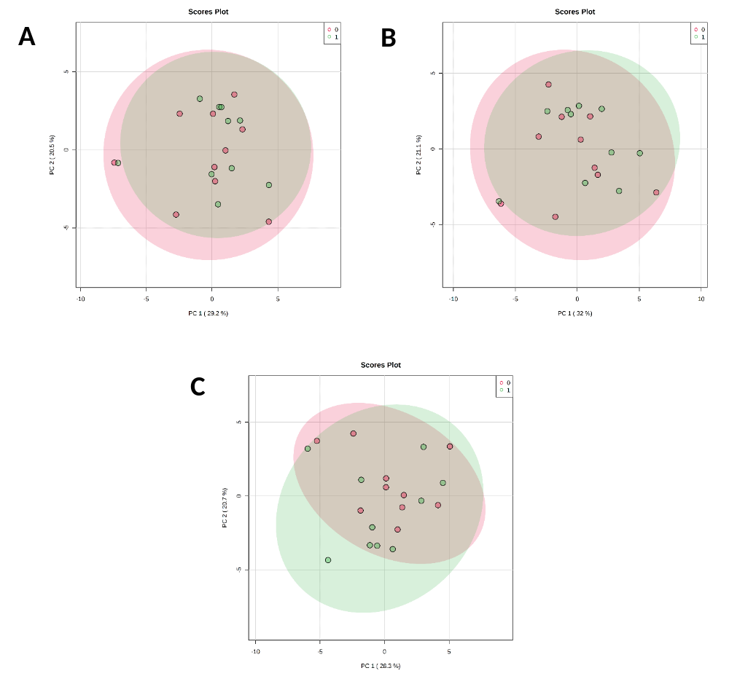

Figure S2A:
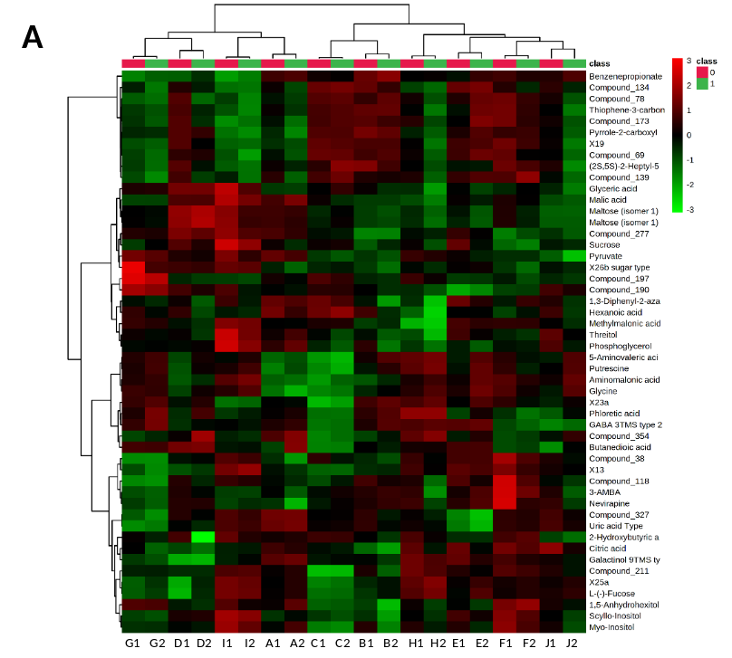
Figure S2B:
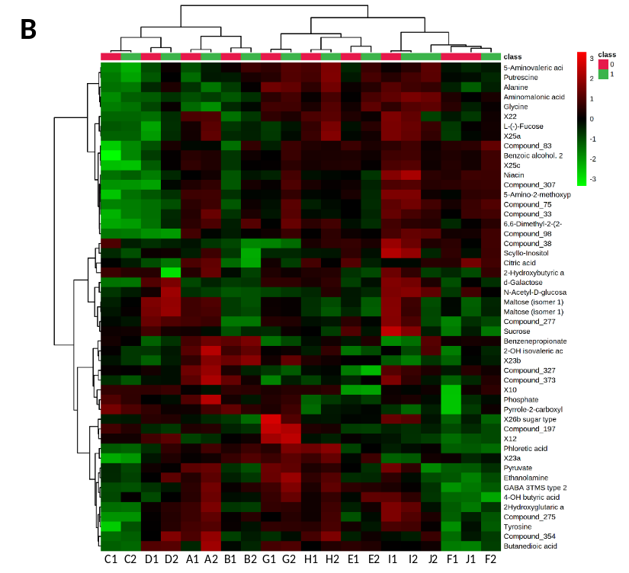
Figure S2C:
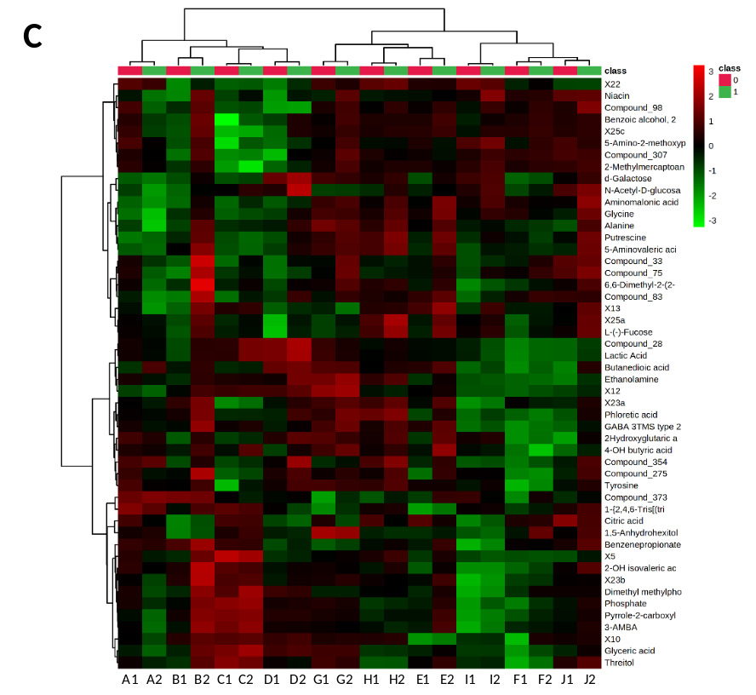
Figure S3:
