Supplementary Information:
For each combination of location and climate variable, we present three figures for the UNSEEN analysis. MAM refers to the March-May season.

Figure 1 depicts stability across lead times, showing the climate variable plotted by lead time, to verify that none of the lead times show drift.

Figure 2 depicts the independence across lead times, showing pairwise rank correlations between ensemble members. We indicate below the figure whether there were any lead times for which the median correlation is greater than 0.25, and therefore that lead time was excluded from the analysis.

Figure 3 interrogates the fidelity of the ensemble to observations in terms of the mean, standard deviation, skewness, and kurtosis. The pdf of UNSEEN results is plotted in grey, with the 95th percentile of the ensemble indicated by black dotted lines. The observed value is plotted as a blue vertical line. We note below the figure whether there was any bias-correction applied.

Maximum temperature MAM Kansas:
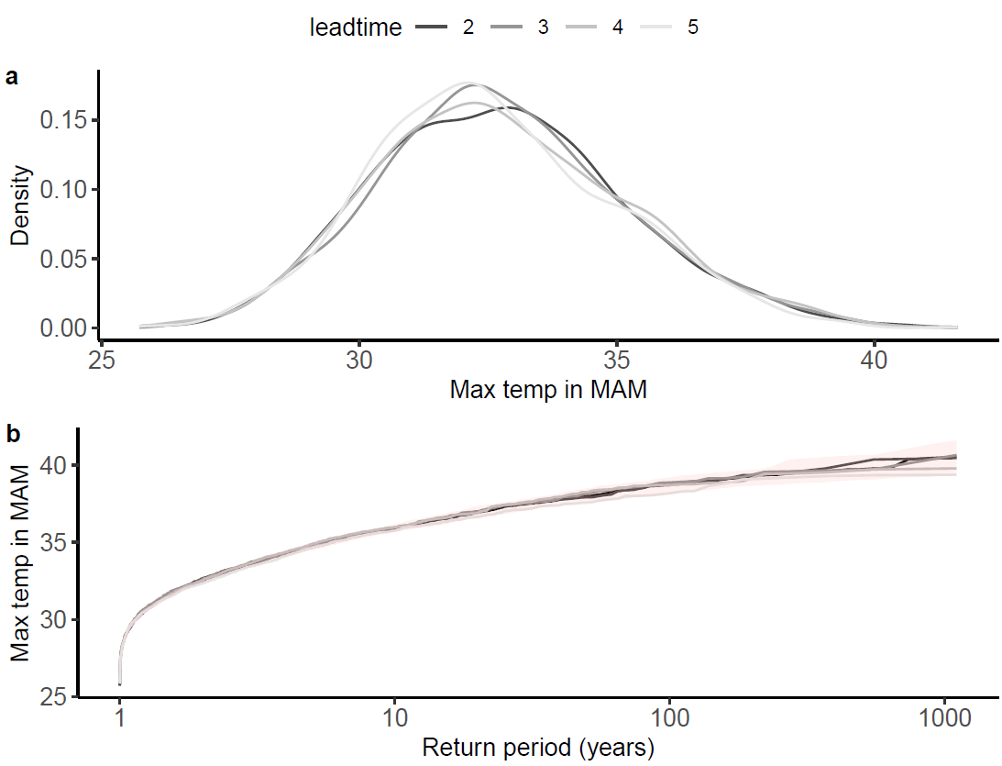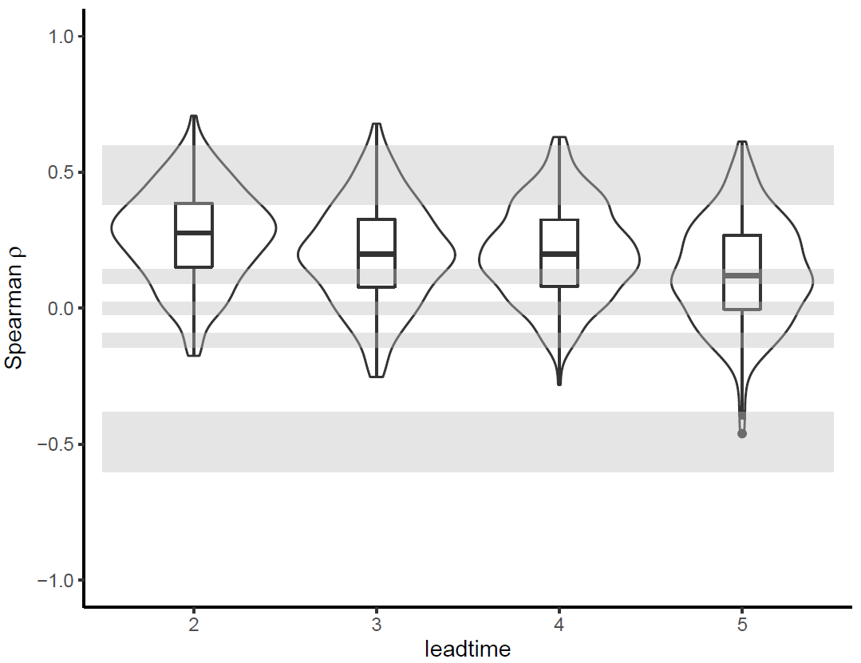
Figure 1 Figure 2. Lead 2 has a correlation of >0.25,
therefore was removed from the analysis

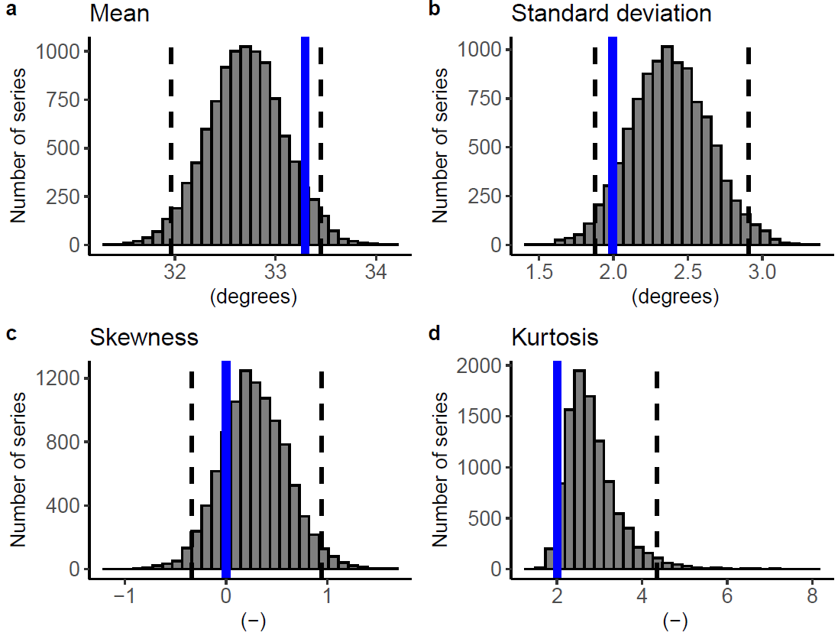
Figure 3

Number of days above the “stressed” threshold MAM Kansas:
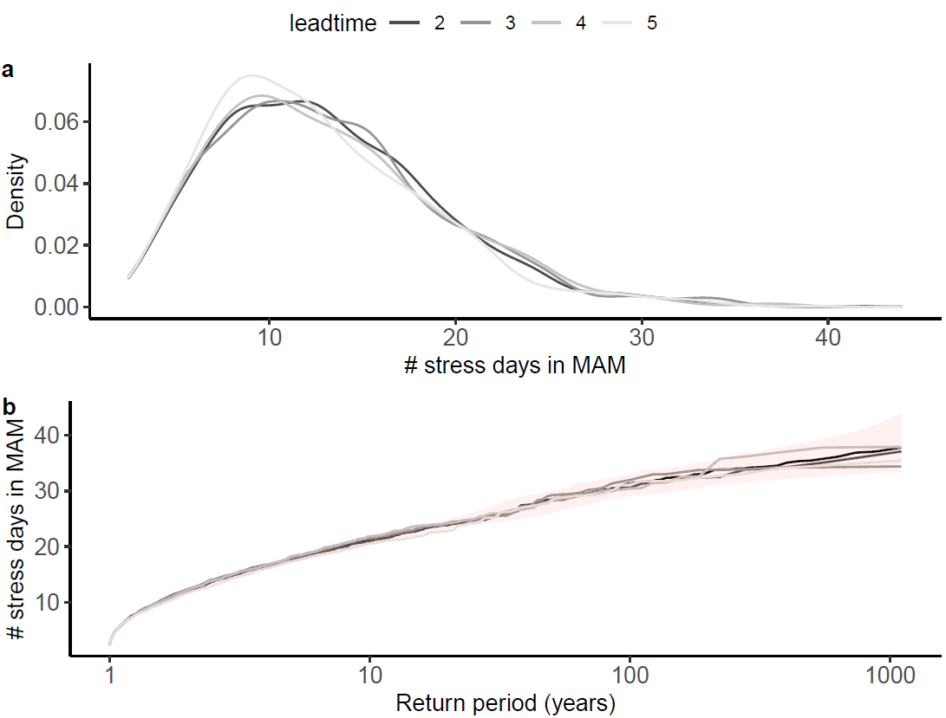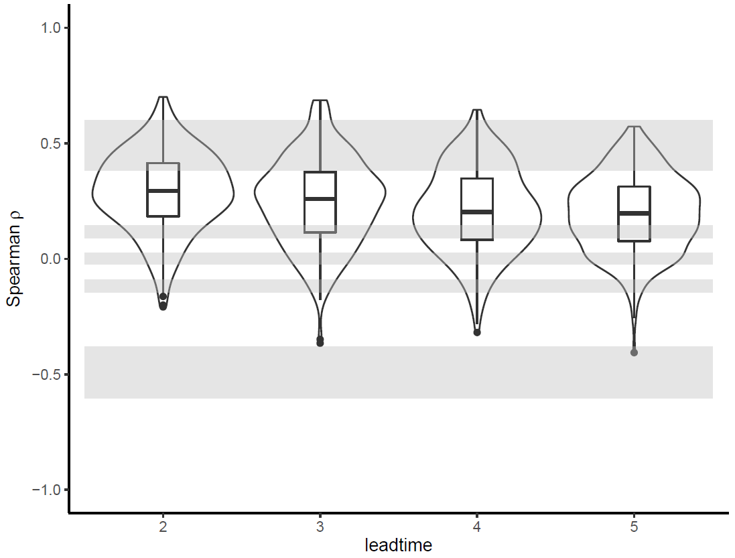
Figure 1 Figure 2. Leads 2&3 median correlation
>0.25, therefore removed from the analysis

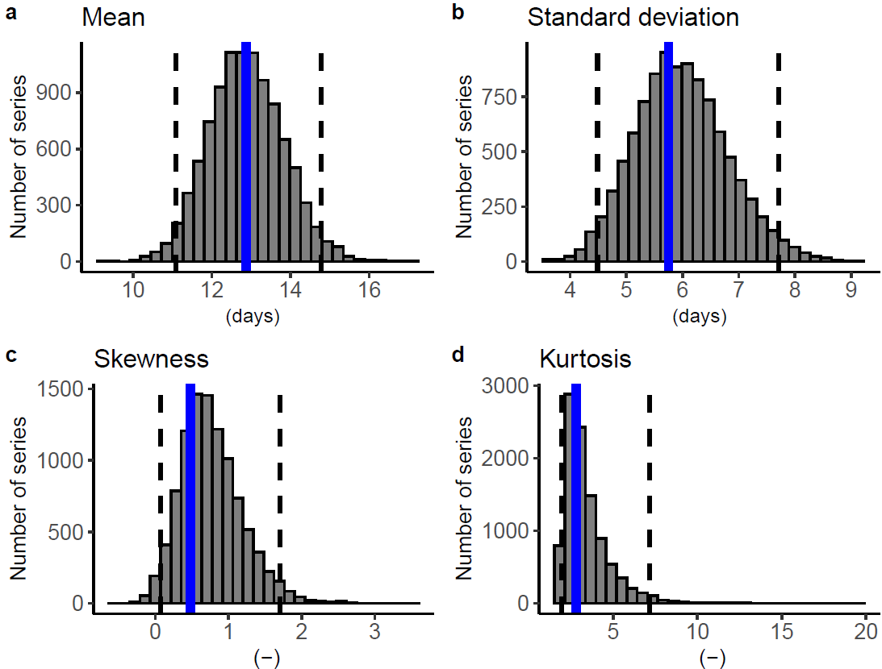
Figure 3, using an additive bias correction of ~2.5.

Number of days above enzyme breakdown threshold MAM Kansas:

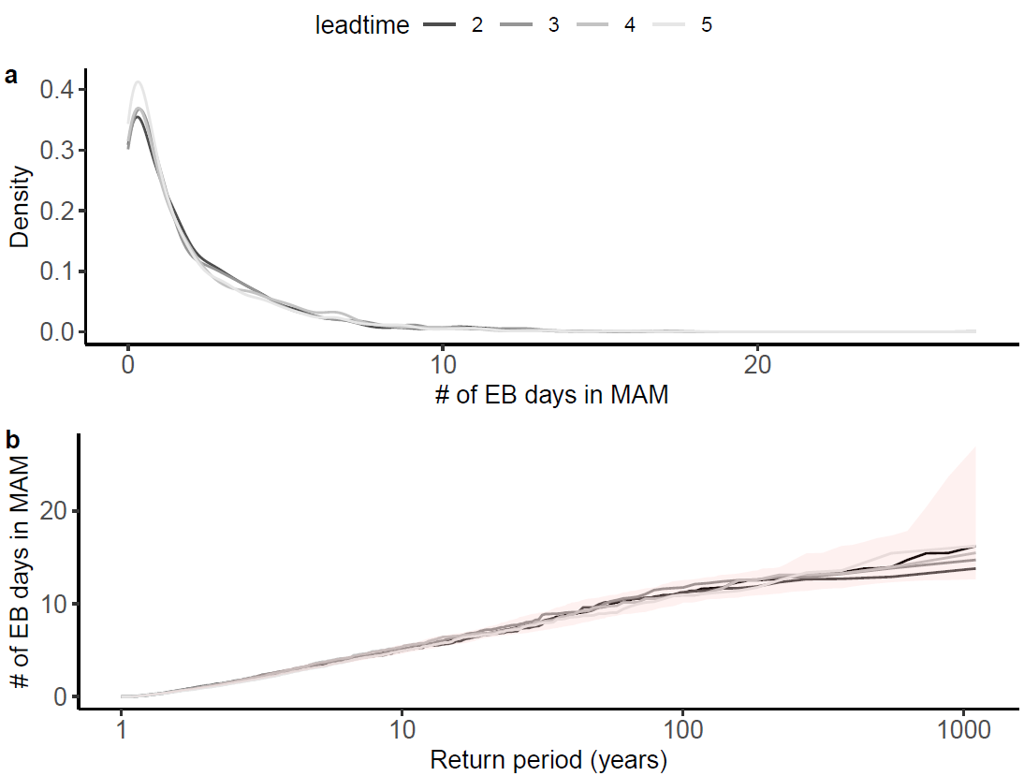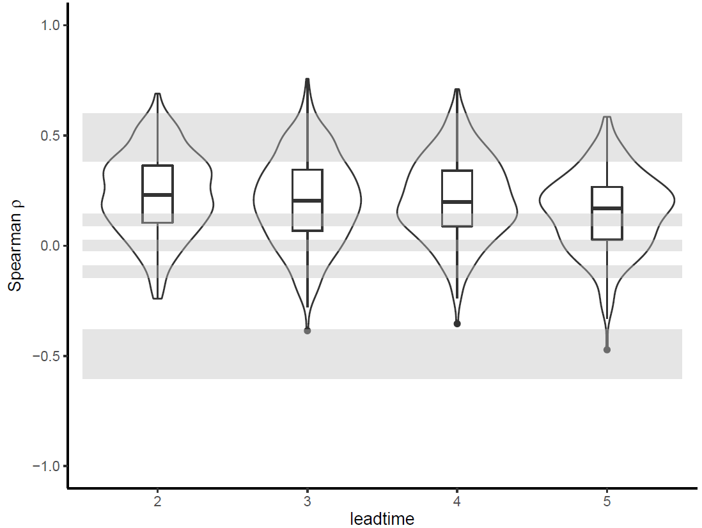
Figure 1 Figure 2

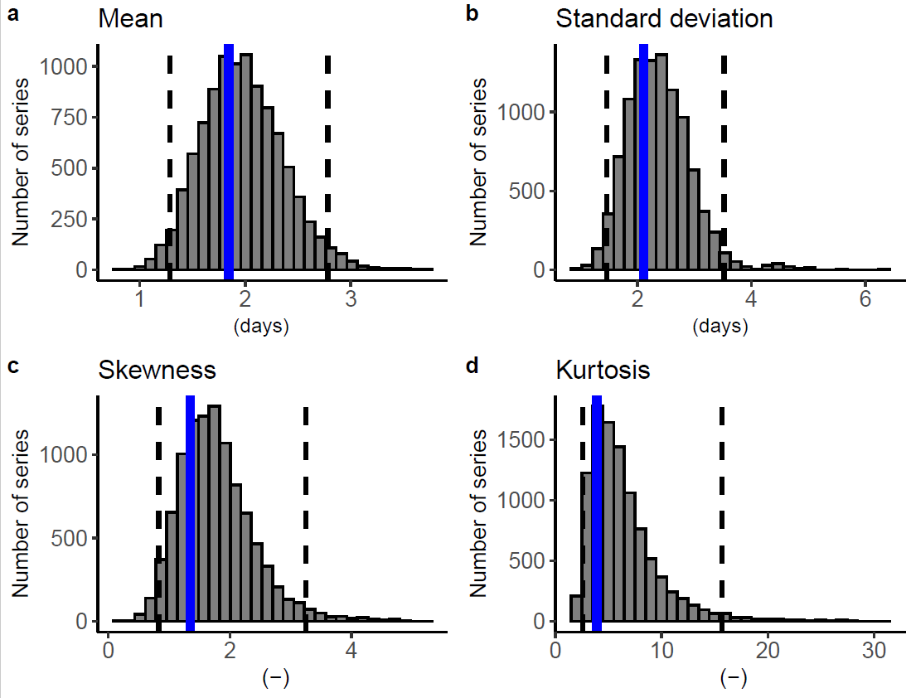
Figure 3

Cumulative precipitation MAM Kansas:
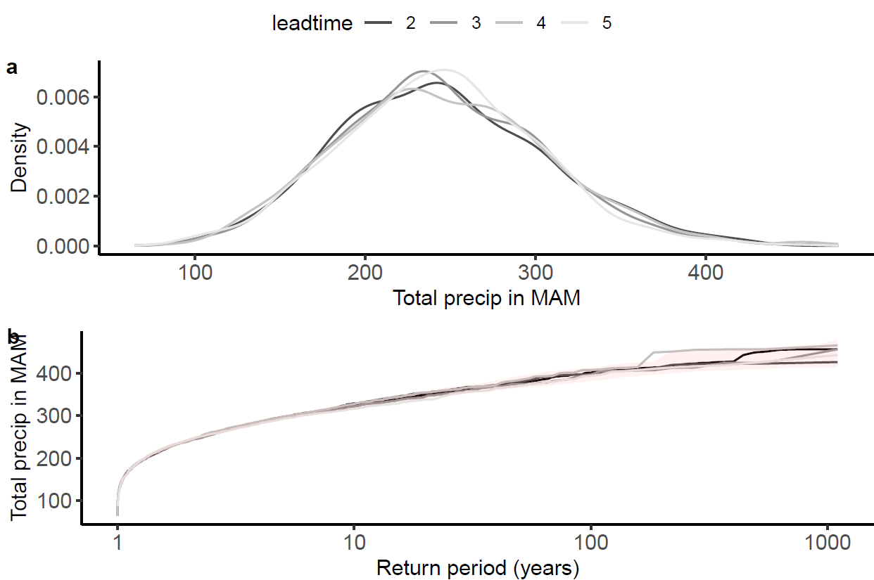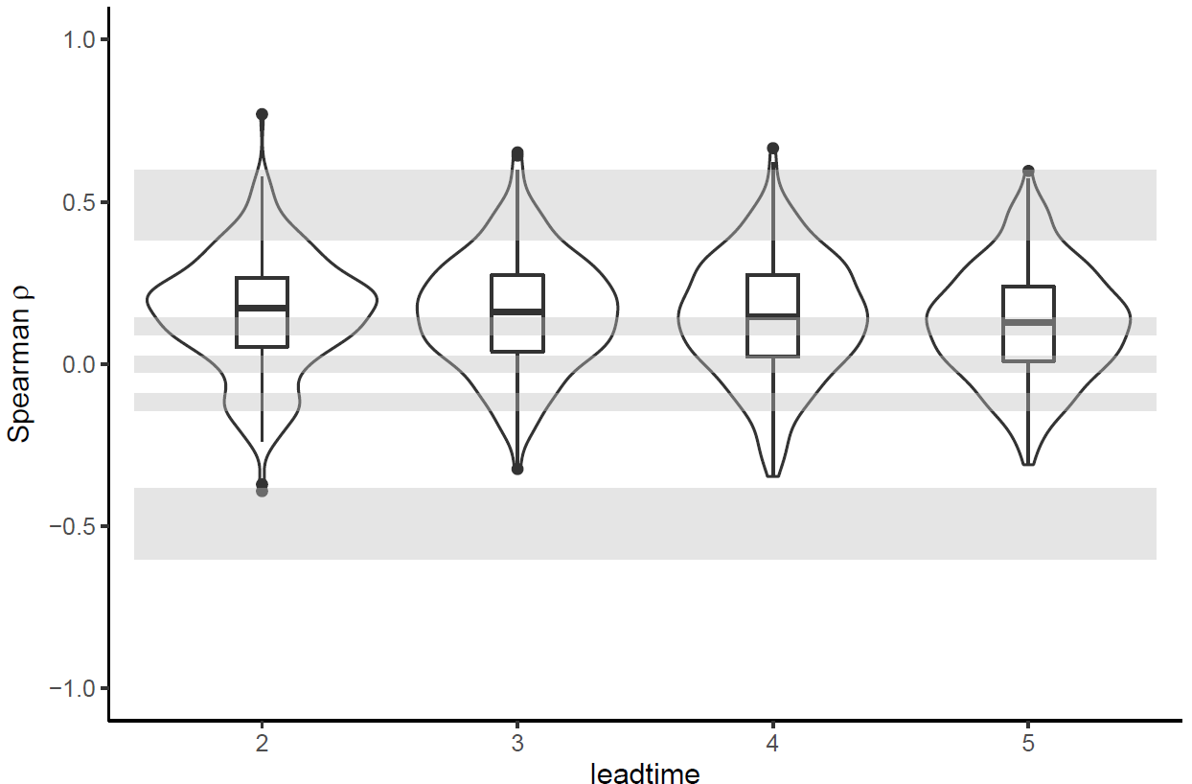
Figure 1 Figure 2

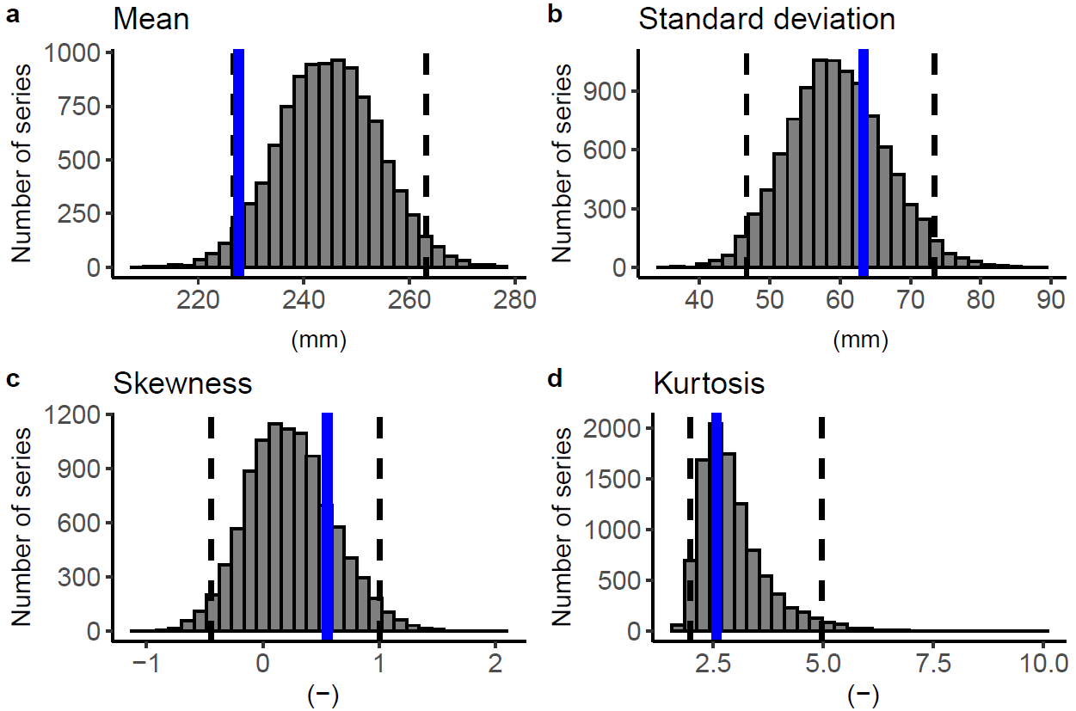
Figure 3
Maximum temperature MAM China:
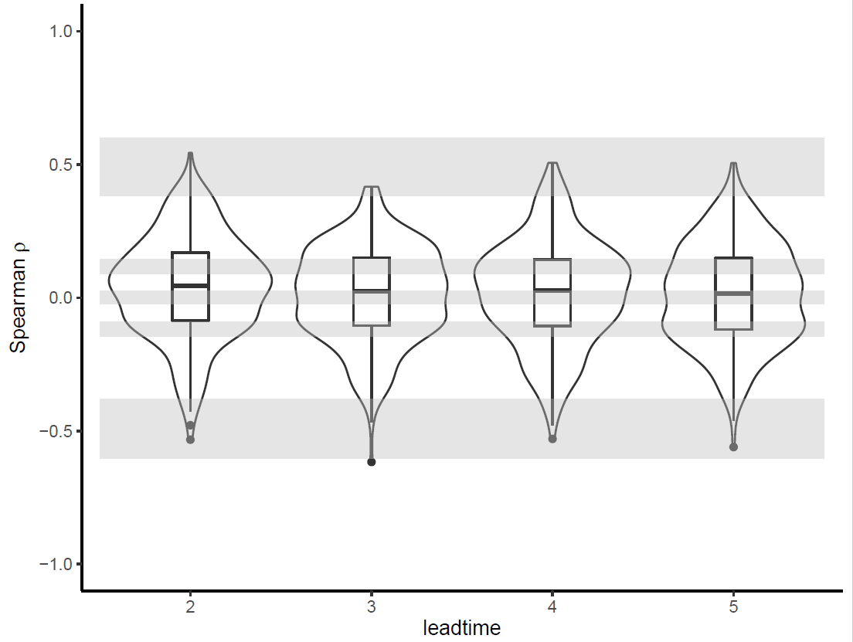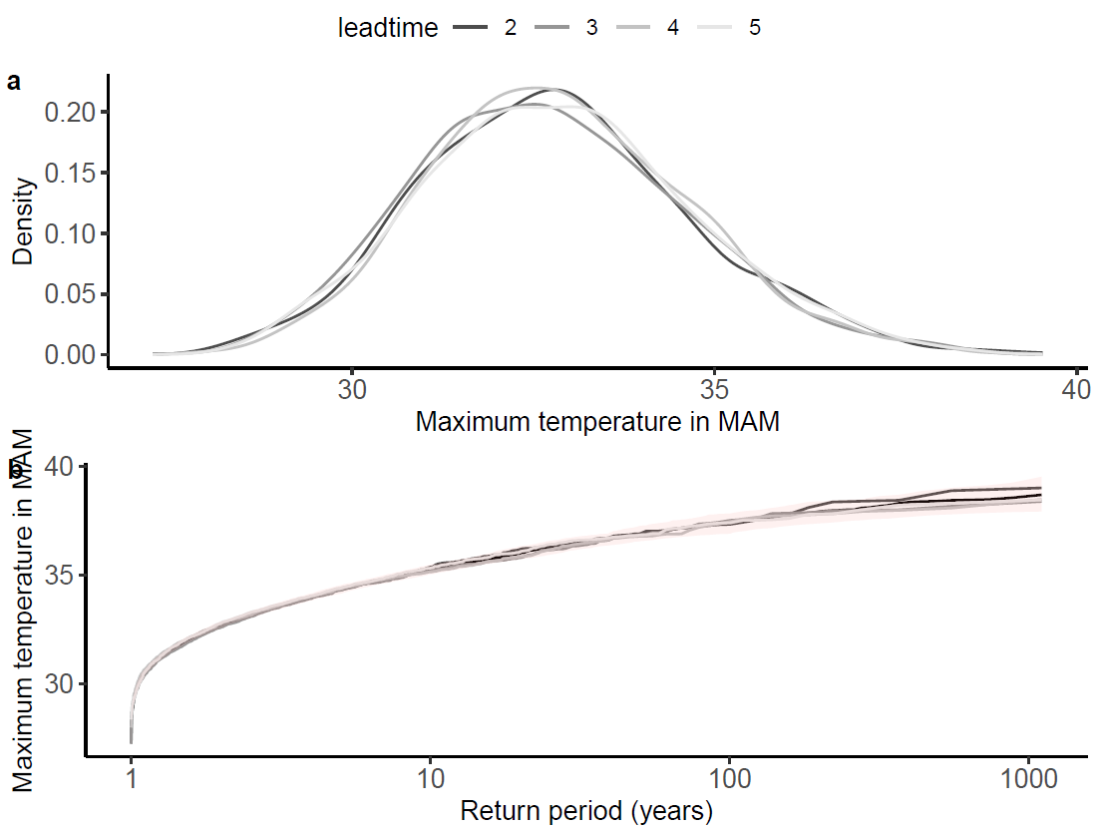
Figure 1 Figure 2

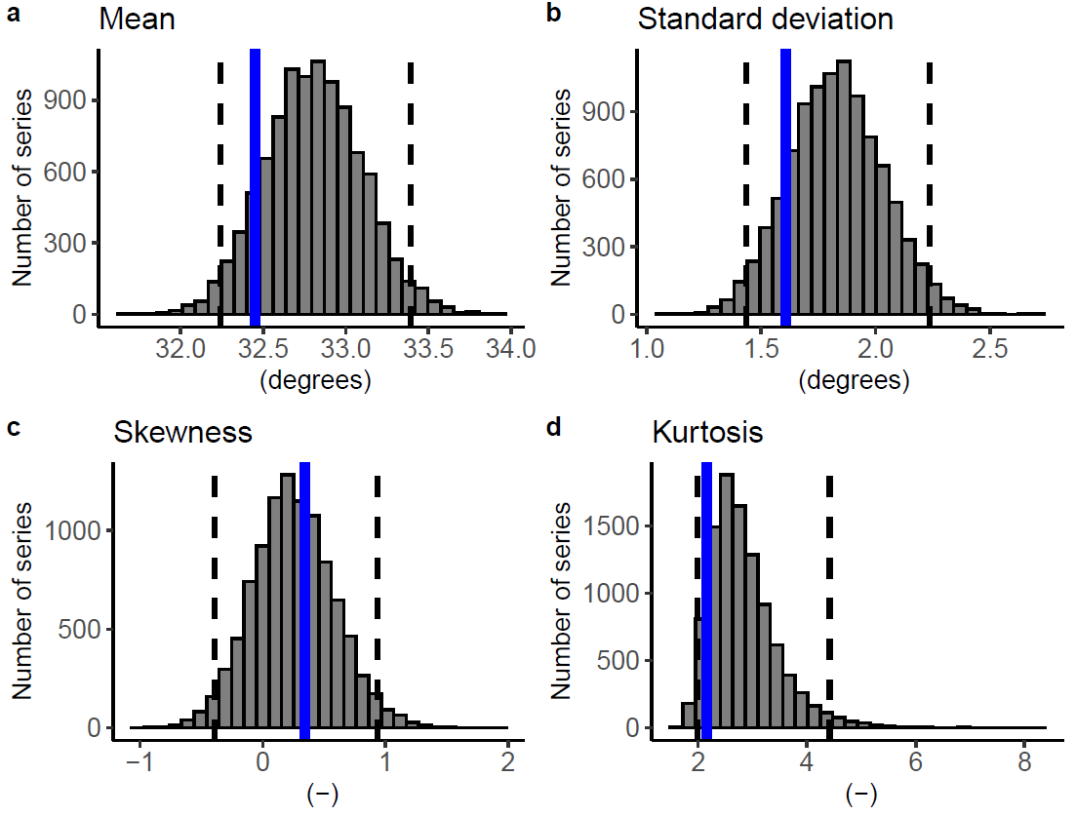
Figure 3

Number of days above the “stressed” threshold MAM China:
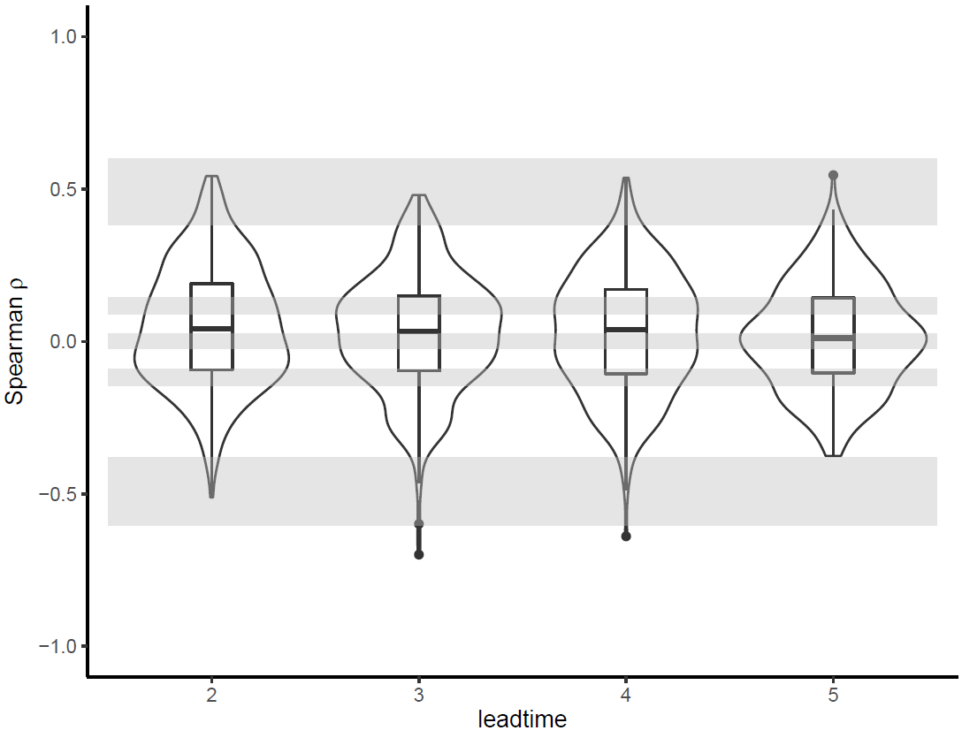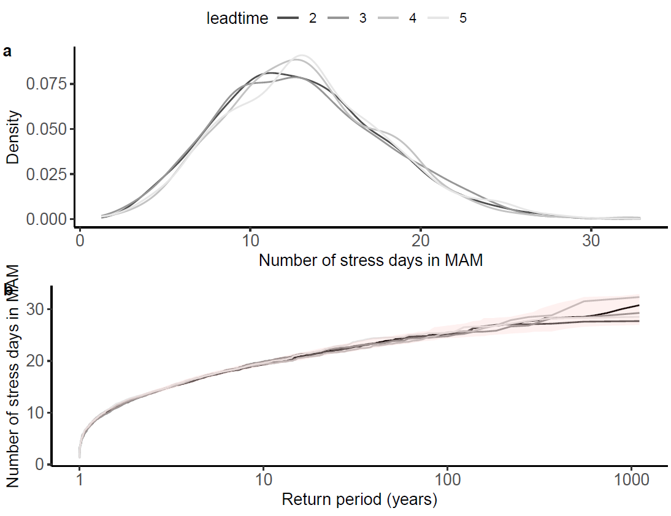
Figure 1 Figure 2

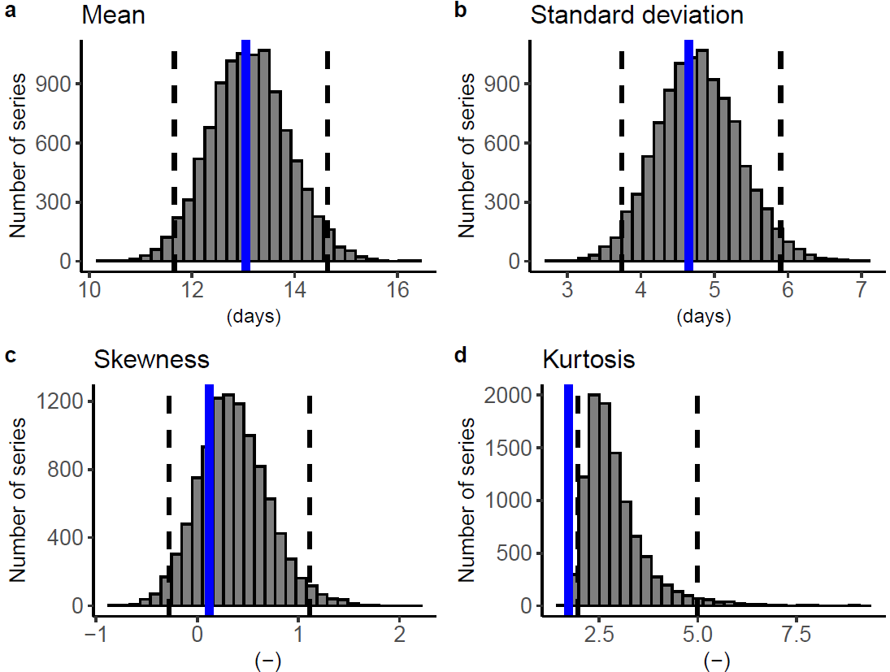
Figure 3. Note that the observed value for the kurtosis lies outside the 95th percentile of the UNSEEN results, therefore this variable should be interpreted with caution.

Number of days above the “enzyme breakdown” threshold MAM China:
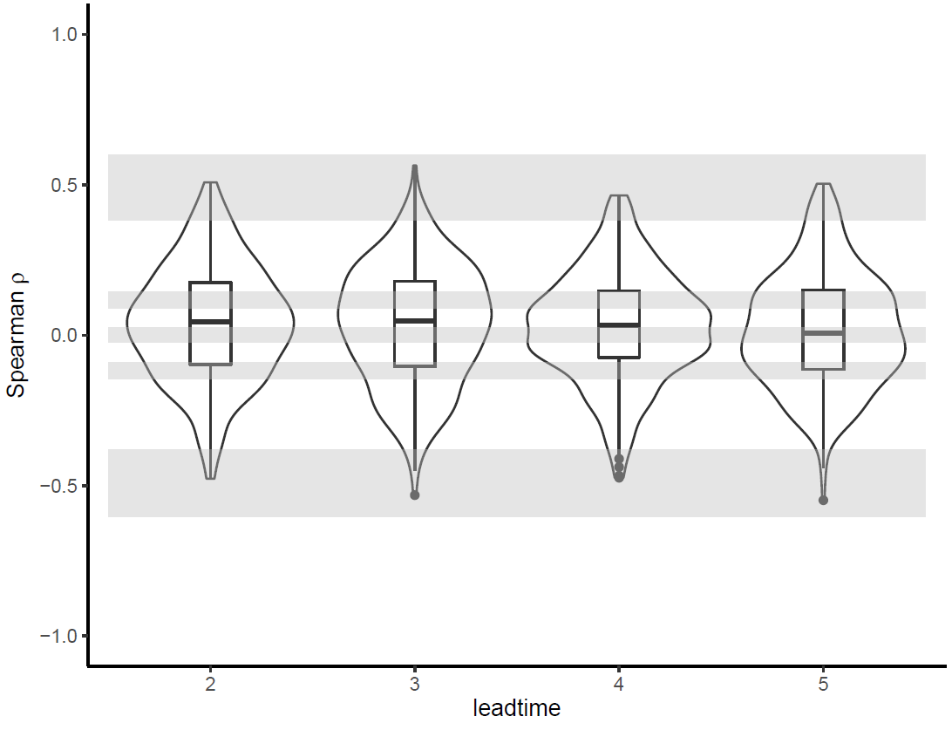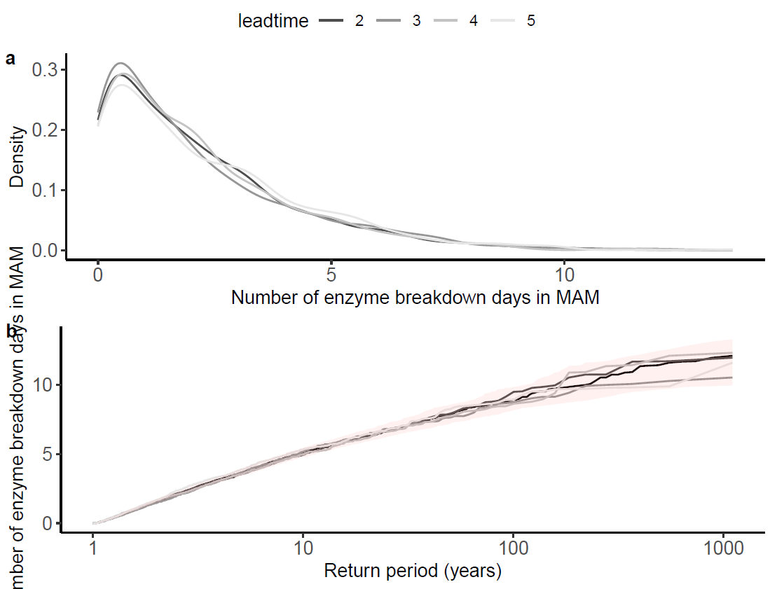
Figure 1 Figure 2

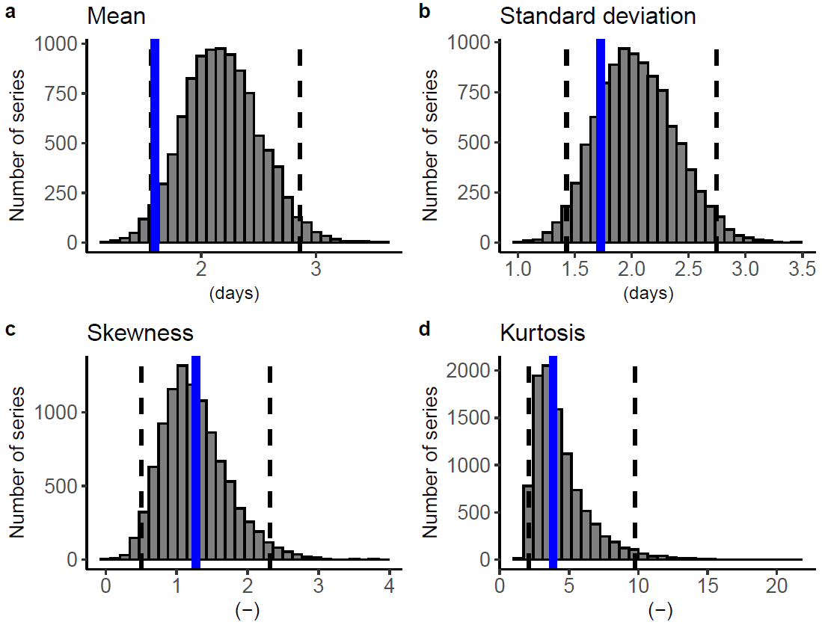
Figure 3

Cumulative precipitation March-May China (biascorr -25mm):
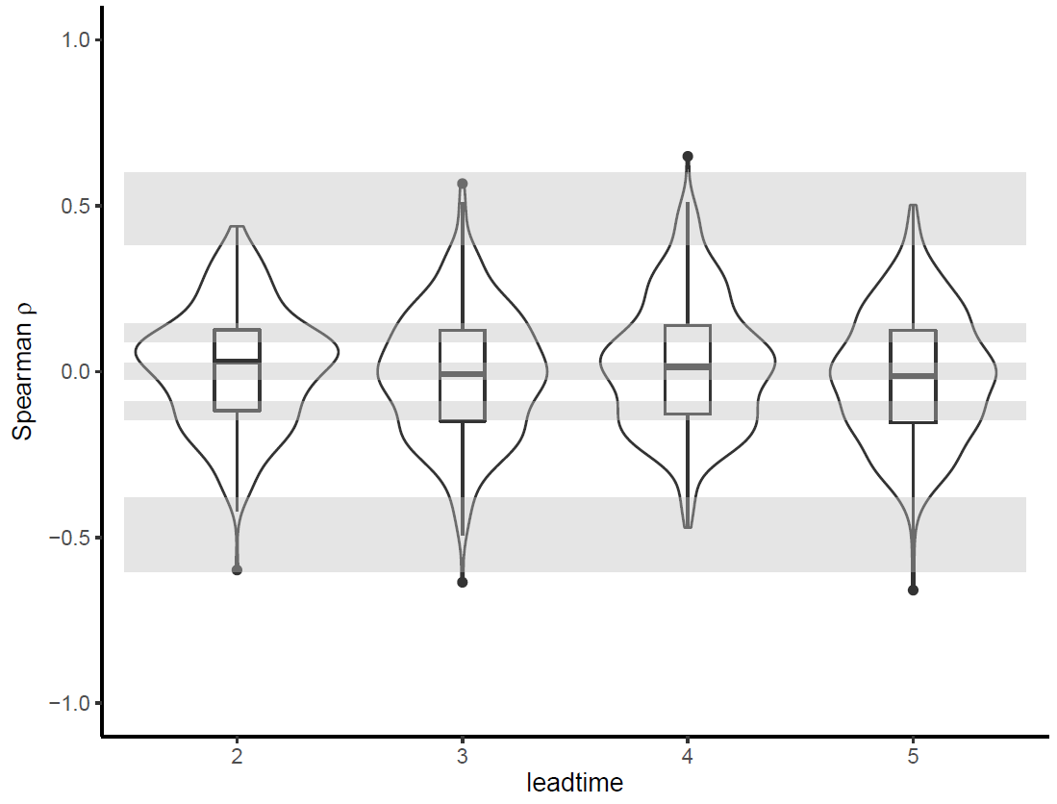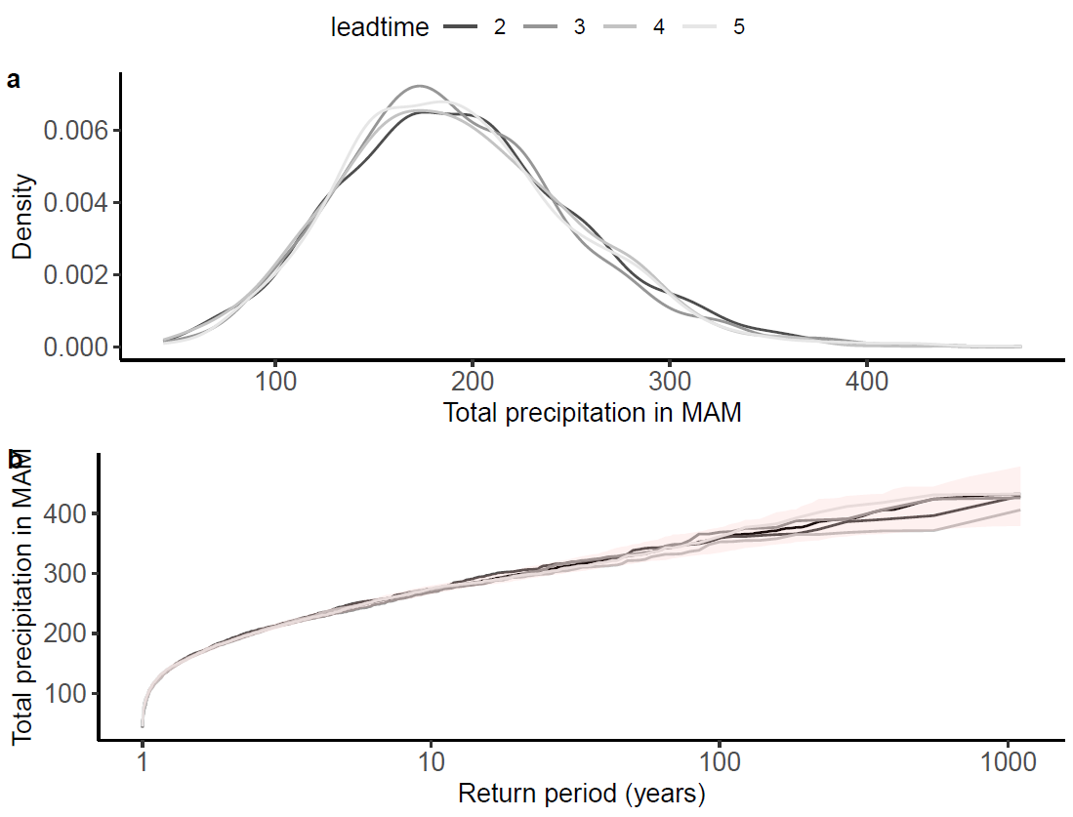
Figure 1 Figure 2

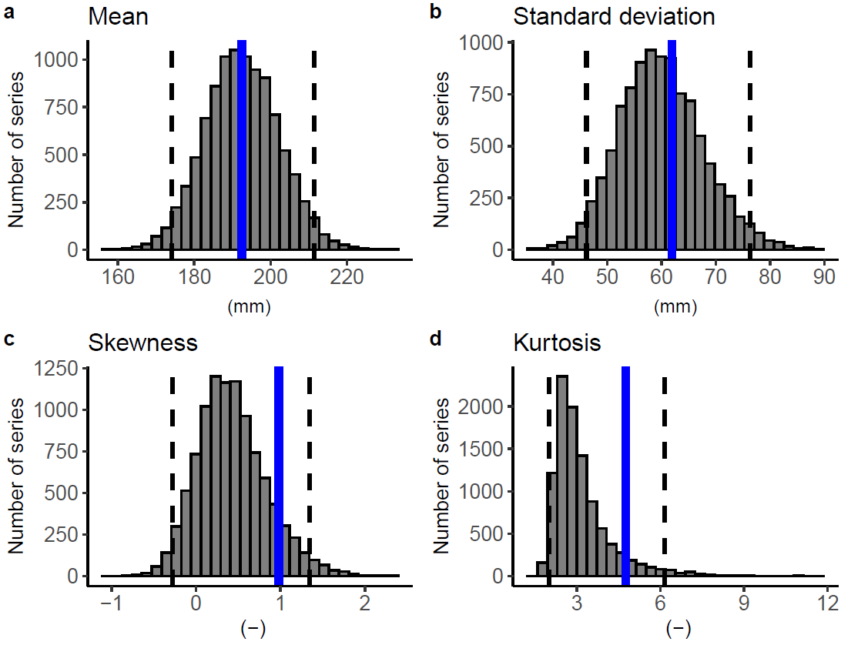
Figure 3, using an additive bias correction of negative ~25mm.

