Supporting Information

A. Representational Learning Method Description
Representational learning attempts to capture the feature of the input data (speech, text, or images) on a representational space i.e. feature extraction. It is sometimes also called a self-supervised learning model as it doesn’t require any prior labeling (supervised technique) and works in “self-labeling” or “self-supervised” manner where the model attempts to capture features out of the dataset, of which it uses as “labels”. This approach itself becomes a field in itself usually under the header of Deep Learning or Feature Learning [1]. Recently, there is a breakthrough from the team in Meta AI (Facebook) where they claim to have a universal algorithm to recognize all kinds of data (all modalities) i.e. speech, text, and images [2], but the model to analyse visual data is not available online yet during the writing of this manuscript. Usually, each type of data (speech, text, or images) is approached uniquely by a single-purpose representation algorithm. In this work, we solely focus on the representation algorithm for computer visual purposes i.e. to recognise images. We are aware of the other available more recent representation learning models for computer vision (BEiT [3], MAE [4], SimMIM [5], MasFeat [6]) but also perhaps there is even the latest one that we are not aware of yet as this field is evolving fast. However, we decide to keep the method chosen as described below as a proof of principle of representation learning application in ARPES.

The current existing self-supervised learning models focus on proposing different training objective functions to discriminate between images from different classes, and they train the models using pre-text tasks using data augmentations. The key of learning good and generalisable embedding features is by designing a proper data augmentation setup to learn the important part of the representation, for example, by colour distorting or random cropping the images. To train the models, a contrastive learning is mainly used to learn an embedding space in which similar sample pairs stay close to each other while dissimilar ones are far apart. This can be done by conducting negative sampling.

We compare existing self-supervised models for computer vision as follows (based on the method and pretext):
Models | Method |  |  |  | Pretext
Models | Contrastive | Clustering | Momentum Encoder | Moving Average Encoder | Pretext
SwAV [7] | ✓ | ✓ | ✗ | ✗ | Colorisation
BYOL [8] | ✗ | ✗ | ✗ | ✓ | Colorisation, Crop, Rotate, Gaussian Noise
DINO [9] | ✗ | ✗ | ✓ | ✗ | Multi-crop, color jittering,  Gaussian blur, and solarisation
MoCo[10] | ✓ | ✗ | ✓ | ✗ | Crop

DINO
DINO is a self-supervised model that takes the inspiration from NLP models by using a transformer-based model that was built upon the Vision Transformer (ViT) backbone [11]. The model utilises knowledge distillation technique to learn from a teacher network, formed from past iterations of the student network. It applies the momentum encoder to train the model with a self-supervised objective as the substitute of the contrastive learning. For more details, refer to [12].

MoCo
Momentum Contrast (MoCo) proposes to maintain consistency of representations by applying momentum encoder. The idea is to slowly update the parameters by looking at samples collected in the dictionary to avoid loss of consistency during the training of the momentum encoder. The previous samples are stored in a dictionary. For more details, refer to [32].

SWAV
An online clustering-based self-supervised method that applies contrastive methods without requiring to compute pairwise comparisons and it simultaneously clusters the data while enforcing consistency between cluster assignments produced for different augmentations (or “views”) of the same image, instead of comparing features directly as in contrastive learning. SWAV uses swapping predictions instead of contrastive learning. For more details, refer to [35].

BYOL
BYOL is a self-supervised model that learns image representation by using two neural networks: the online and target networks. The model learns to minimize a similarity loss between the output of both networks. The target network provides the regression target that can be used to give the signal to train the online network, where the target network is the exponential moving average of the online parameter. For more details, refer to [8].

B. Spatially resolved ARPES
The 4D ARPES data used is the ARPES result of Fe₃Sn₂ kagome material well described in these references [13-15]. The data is obtained from micro-focused laser ARPES experiments done in Felix’s Baumberger laboratory in University of Geneva. Reference [16] describes the experimental information in detail. Manual search (and subsequent manual labelling) reveals that the ARPES dataset (dispersion images on each realspace position) can be grouped into four distinct labels/clusters (main Figure 2(b) inset). Group 1 is any dispersion image that has only the electron pocket. Group 2 is similar to Group 1 but with extra “wing” outside the inner electron pocket. Group 3 is any picture that has bands lying close to Fermi energy. Group 4 is similar to Group 2 but the shape is wider with band smearing at the center of the pocket minimum. In total, there are 4893 ARPES images (angle ($ϕ$), energy axes vs I) distributed over realspace of size $80×62$ datapoints. The missing images $(80×62=4960>4893)$ are regarded as blank and ignored located at the edges of the picture (they do not disturb the realspace image presentation). The manual labeling is done by two independent experts to create the truth table where discrepancies in labeling are settled through subsequent discussion until the final label is agreed. These labeling processes results in total of 2670 labeled images (Group 1: 292, Group 2: 1868, Group 3: 183, Group 4: 327) where the remaining 2223 images are unlabeled due to its high ambiguity and no consensus reached between the two experts (Figure SI1(a)). We can see here that the labeled images are imbalance (11:70:7:12) in grouping which will affect the calculation of recall and precision later (see definition in appendix). Afterwards, these 2670 images are divided into 5 folds which has train and test folders each (Figure SI1(a)). The test folders contain a unique set of 461 images (Group 1: 32, Group 2: 356, Group 3: 26, Group 4: 47) with similar proportion of the overall labeled set (7:77:6:10) (Figure SI1(c)). Meanwhile, the train folders on each fold contain a set of 1851 images (Group 1: 131, Group 2: 1425, Group 3: 106, Group 4: 189) with the same proportion as the test folder (7:77:6:10) (figure SI1(c)). However, it should be noted that the train images are not a unique set for each fold; some images on train dataset are overlapping. Afterwards, any process of training and testing the neural network will be done onto these 5 folds that we have created. Subsequently, the evaluation metrics (ACC, F1, PRE, REC) are created for each of the fold where the averages are calculated.

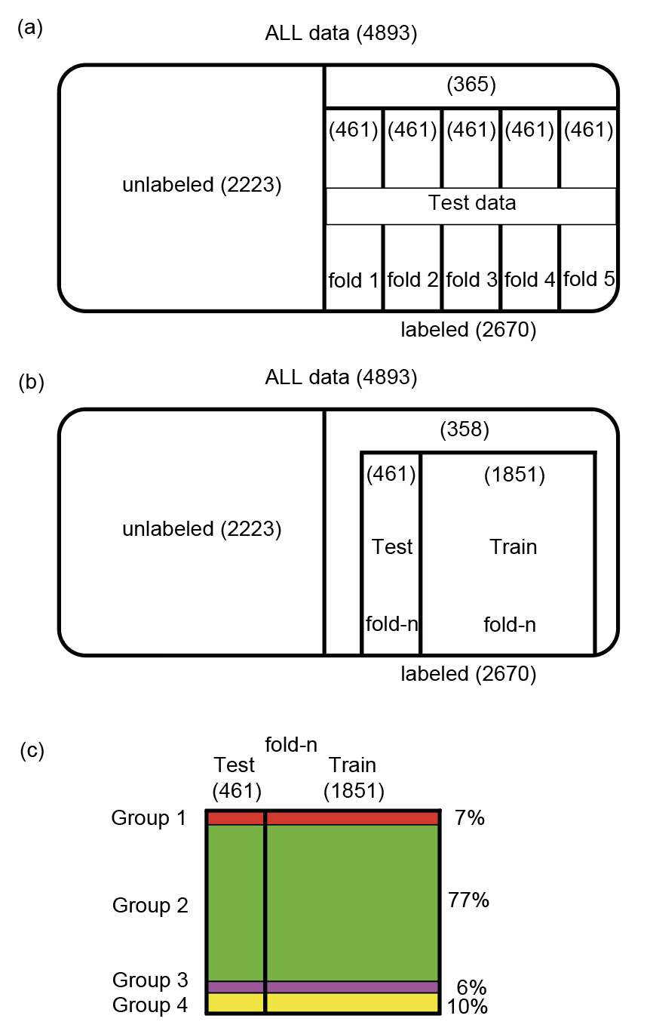
SI1 Venn diagram describing the proportion of labeled/unlabeled data of Fe3Sn2 – (a) Venn diagram describing the proportion of each unlabeled and labeled data, where the labeled data is further divided (uniquely) into 5 sub-group to create a test-data set for 5 folds i.e. no overlapping test data from each fold. (b) Venn diagram of test vs train dataset for each fold (called fold-n here) where in this case the train dataset from each fold may overlap on each other. (c) Venn diagram showing that for each train and test dataset, the total number from each group is kept the same (7%, 77%, 6%, 10% for each group respectively).

1. Bengio, Y., A. Courville, and P. Vincent, Representation Learning: A Review and New Perspectives. Ieee Transactions on Pattern Analysis and Machine Intelligence, 2013. 35(8): p. 1798-1828.
2. Baevski, A., et al., data2vec: A General Framework for Self-supervised Learning in Speech, Vision
and Language. Meta AI Research, 2022.
3. Bao, H., L. Dong, and F. Wei, BEiT: BERT Pre-Training of Image Transformers. 2021.
4. He, K., et al., Masked Autoencoders Are Scalable Vision Learners. 2021.
5. Xie, Z., et al., SimMIM: A Simple Framework for Masked Image Modeling. 2021.
6. Wei, C., et al., Masked Feature Prediction for Self-Supervised Visual Pre-Training. 2021.
7. Caron, M., et al. Unsupervised Learning of Visual Features by Contrasting Cluster Assignments. in Thirty-fourth Conference on Neural Information Processing Systems (NeurIPS). 2020.
8. Grill, J.-B., et al., Bootstrap your own latent: A new approach to self-supervised learning. arXiv 2006.07733, 2020.
9. Caron, M., et al., Emerging properties in self-supervised vision transformers. arXiv preprint arXiv:2104.14294, 2021.
10. He, K., et al. Momentum contrast for unsupervised visual representation learning. in Conference on Computer Vision and Pattern Recognition. 2020.
11. Dosovitskiy, A.a.B., Lucas and Kolesnikov, Alexander and Weissenborn, Dirk and Zhai, Xiaohua and Unterthiner, Thomas and Dehghani, Mostafa and Minderer, Matthias and Heigold, Georg and Gelly, Sylvain and Uszkoreit, Jakob and Houlsby, Neil, An Image is Worth 16x16 Words: Transformers for Image Recognition at Scale. arXiv, 2020.
12. Dosovitskiy, A., et al., An Image is Worth 16x16 Words: Transformers for Image Recognition at S cale. 2021.
13. Heritage, K., et al., Images of a First-Order Spin-Reorientation Phase Transition in a Metallic Kagome Ferromagnet. Advanced Functional Materials, 2020. 30(36): p. 1909163.
14. Yao, M., et al., Switchable Weyl nodes in topological Kagome ferromagnet Fe3Sn2. arXiv, 2018. 1810.01514.
15. Ye, L.D., et al., Massive Dirac fermions in a ferromagnetic kagome metal. Nature, 2018. 555(7698): p. 638-+.
16. Cucchi, I., et al., Microfocus Laser–Angle-Resolved Photoemission on Encapsulated Mono-, Bi-, and Few-Layer 1T′-WTe2. Nano Letters, 2019. 19(1): p. 554-560.

