Supplementary information for the manuscript
“Effects of crop rotation and soil tillage on suppressing the syndrome “basses richesses” vector Pentastiridius leporinus in sugar beet”

Author information

René Pfitzer¹, Michael Rostás², Patrick Häußermann³, Thilo Häuser³, André Rinklef³, Klaus Schrameyer⁴, Ralf T. Voegele³, Johann Maier⁵, Mark Varrelmann^{1, 2}
1 Institute of Sugar Beet Research, Holtenser Landstraße 77, 37079 Göttingen, Germany
2 University of Göttingen, Faculty of Agricultural Sciences, Department of Crop Sciences, Agricultural
Entomology, Grisebachstrasse 6, 37077 Göttingen, Germany
3 Institute of Phytomedicine, University of Hohenheim, Otto-Sander-Str. 5, 70599 Stuttgart, Germany
4 Victoriastraße 12/1, 74613 Öhringen, Germany
5 Kuratorium für Versuchswesen und Beratung im Zuckerrübenanbau, Maximilianstraße 10, 68165 Mannheim, Germany
Corresponding author: Mark Varrelmann: varrelmann@ifz-goettingen.de

Figures S1 and S2

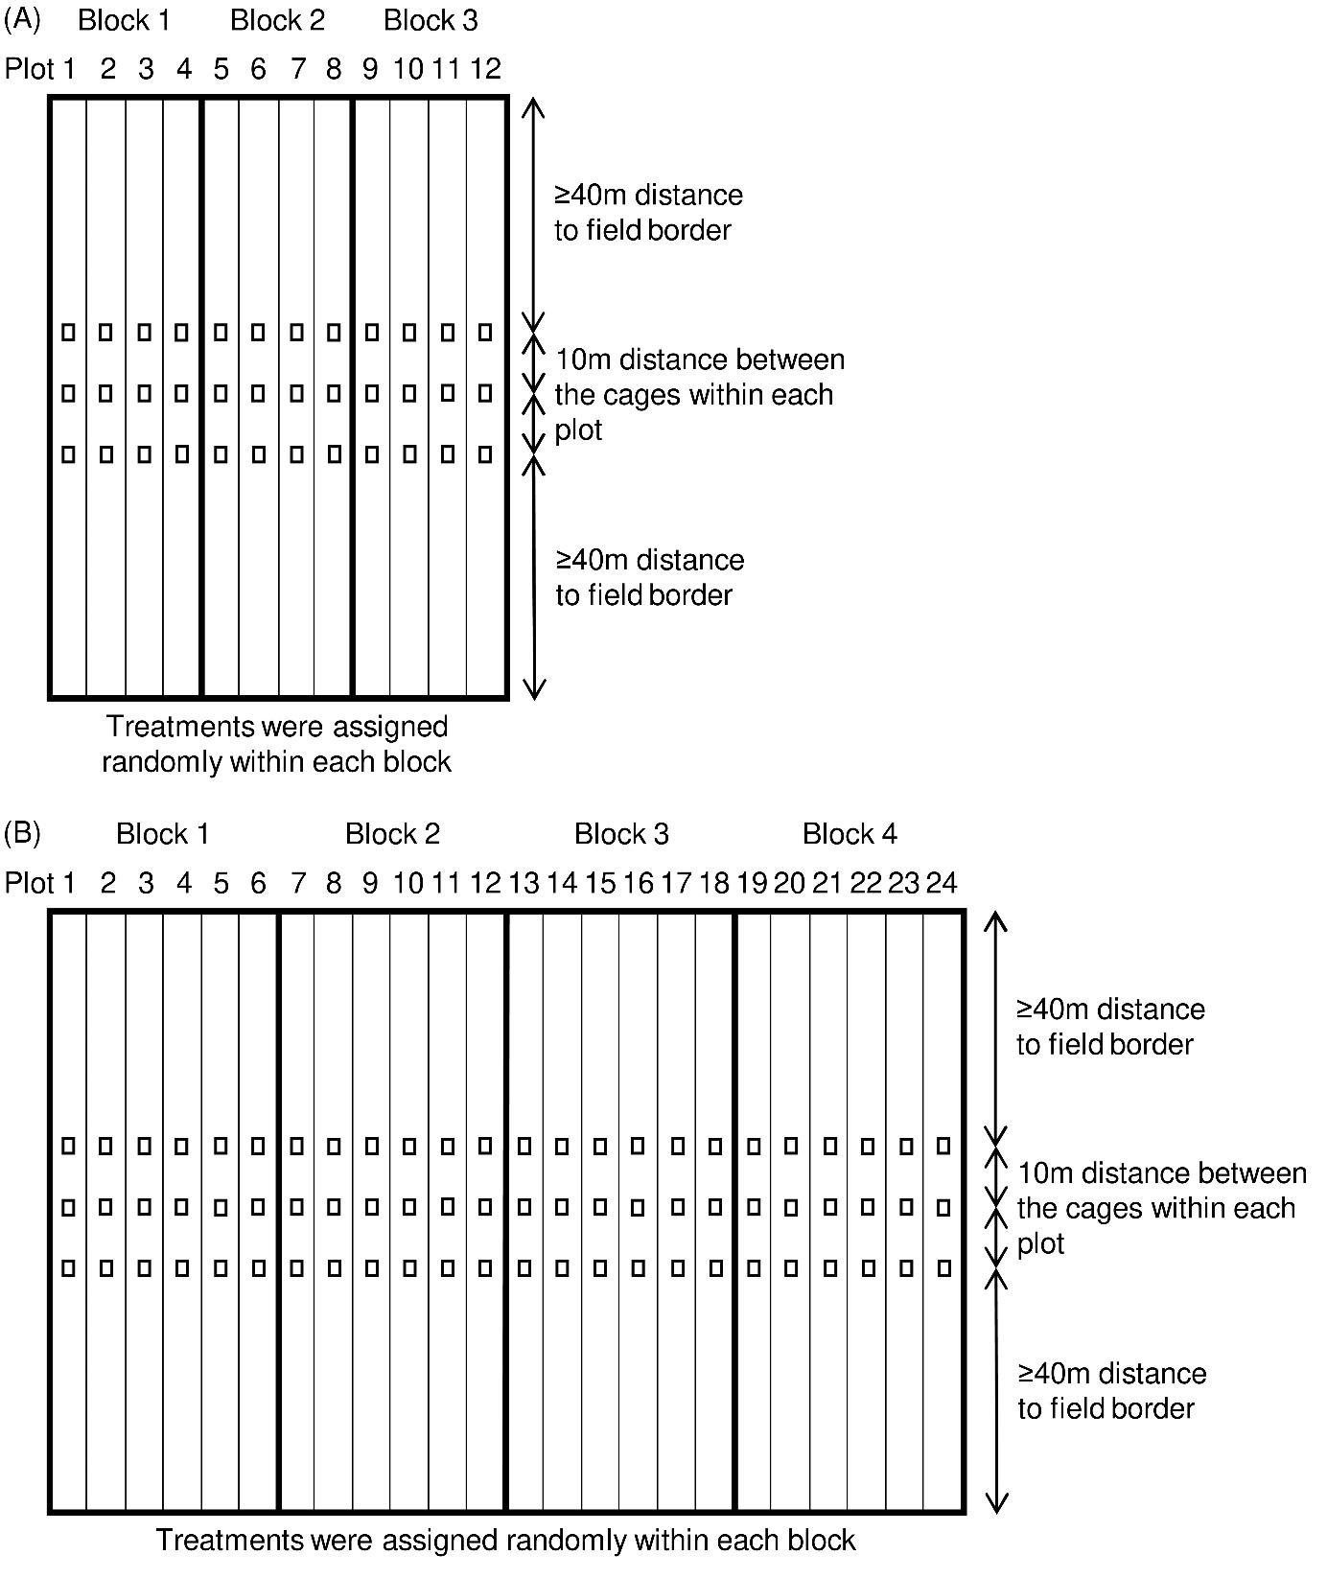
Fig. S1 Schematic representation of the experimental setup for the field trials; (a) in 2019; and (b) in 2020. Rectangles show the position of the cages

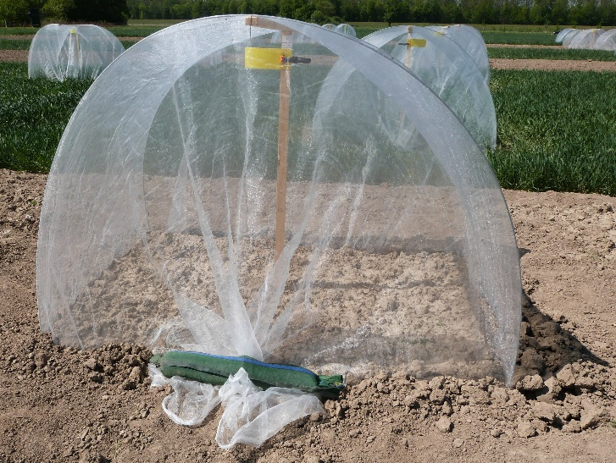
Fig. S2 Representation of the cages to catch P. leporinus adults emerging from the soil

