OWSum – Algorithmic Odor Prediction and Insight into Structure-Odor-Relationships
Doris Schicker^{a,b}, Satnam Singhª, Jessica Freiherr^{a,b}, and Andreas T. Grasskampª
ªSensory Analytics and Technologies, Fraunhofer Institute for Process Engineering and Packaging IVV, Giggenhauser Straße 35, 85354 Freising, Germany
^{b}Department of Psychiatry and Psychotherapy, Friedrich-Alexander-Universität Erlangen-Nürnberg, Schwabachanlage 6, 91054 Erlangen, Germany
- Supplementary Material -

Figure S1. Database characteristics. We show the number of extracted features for each descriptor in the upper graph. In total 103,643 features and 103,093 features with an idf-value higher than zero were extracted. In the bottom graph, we show the number of molecules smelling like a specific descriptor.
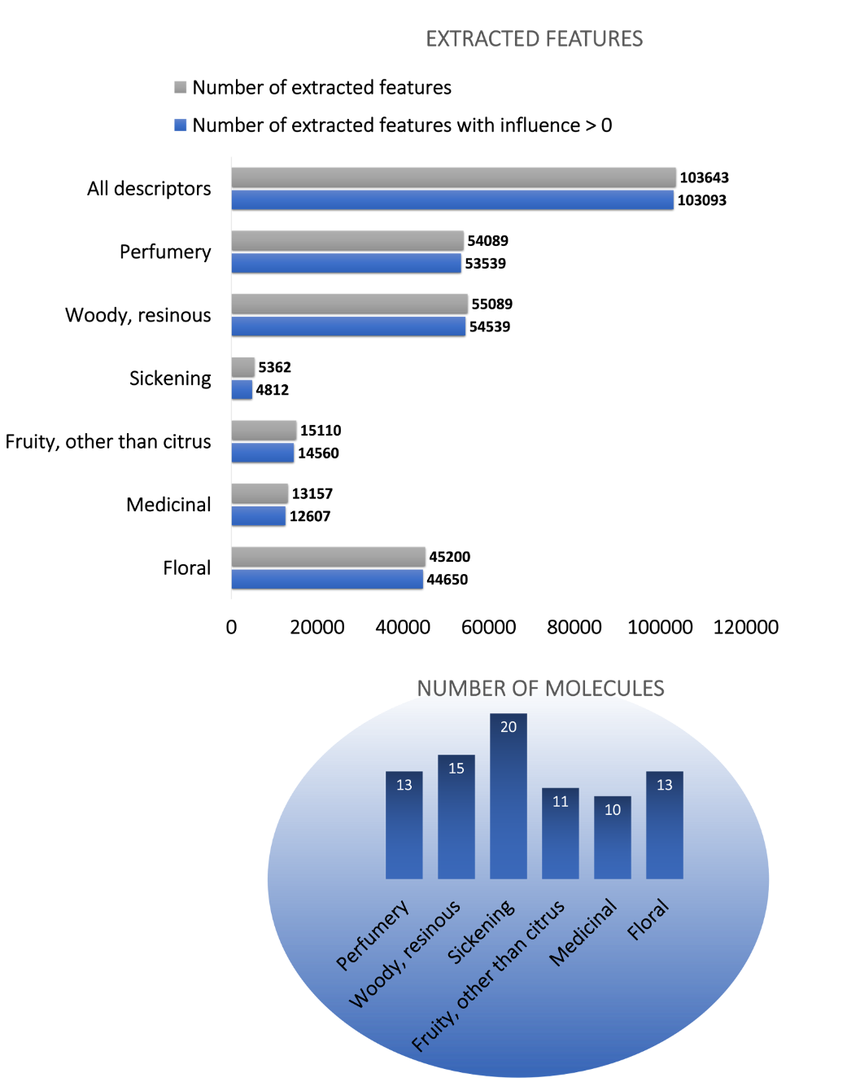
Figure S2: Example for the calculation of the descriptor overlap. 21 molecules smell like ‘woody, resinous’ and/or ‘medicinal’. 11 molecules of them only smell like ‘woody, resinous’, 6 only like ‘medicinal’. 4 smell like both descriptors. The resulting descriptor overlap between these two descriptors is 0.40.

