Supplementary figures:
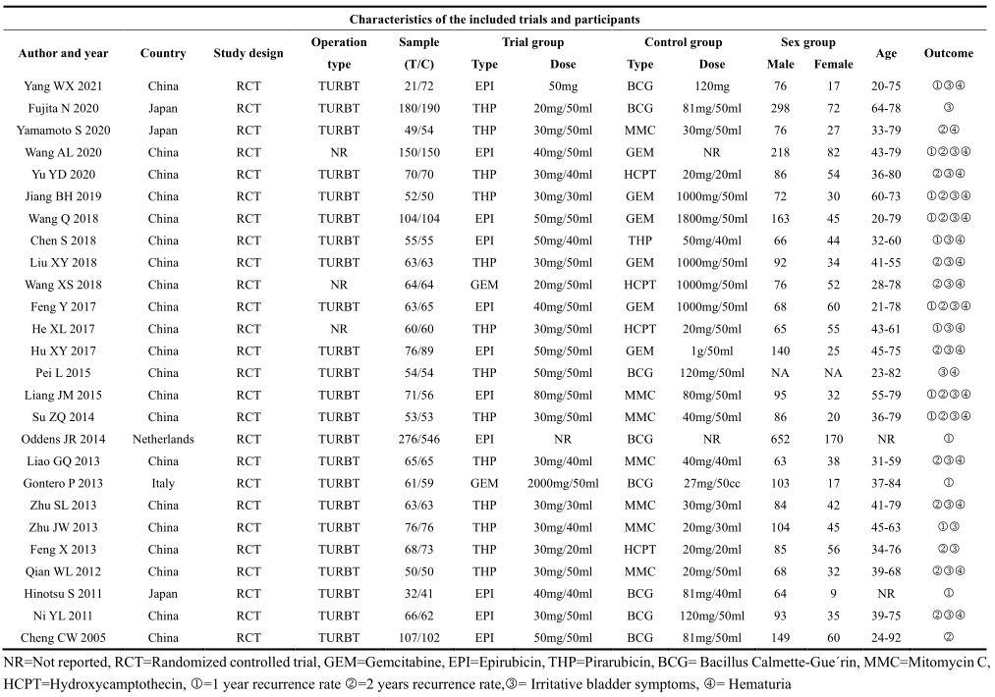 Table S1. Characteristics of the included trials and participants 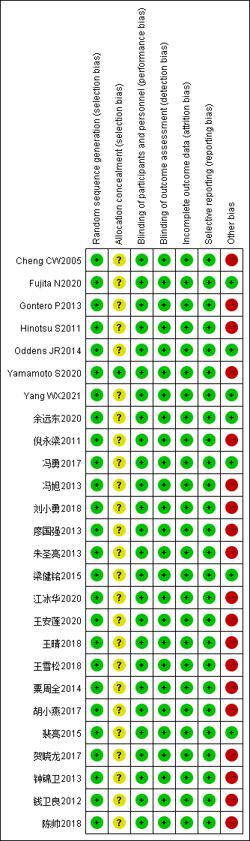
Fig S1 Risk of bias graph: review authors’ judgments about each risk of item presented as percentages across all included studies. 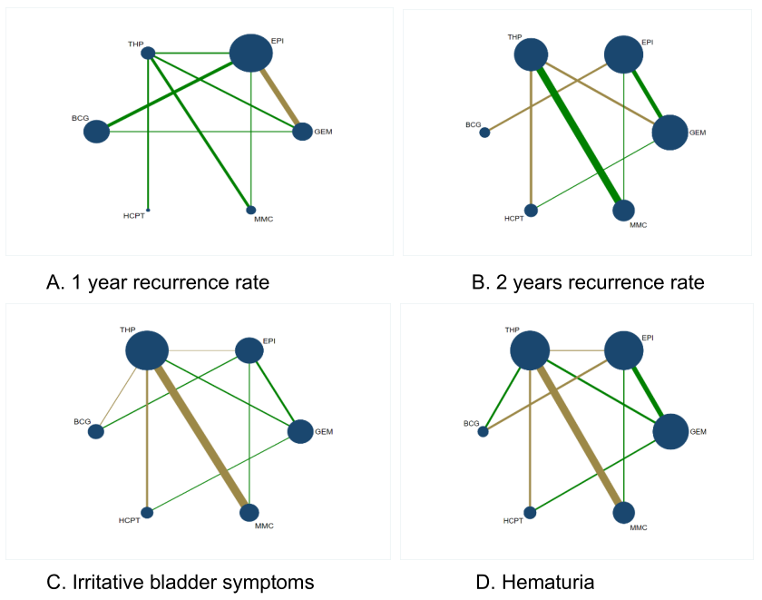 Fig.S2 Network geometry of connected network of studies. Circles represent the regimen as a nodein the network. Lines represent direct comparisons using studies. GEM=Gemcitabine, EPI=Epirubicin, THP=Pirarubicin, BCG= Bacillus Calmette-Gue´rin, MMC=Mitomycin C, HCPT=Hydroxycamptothecin.
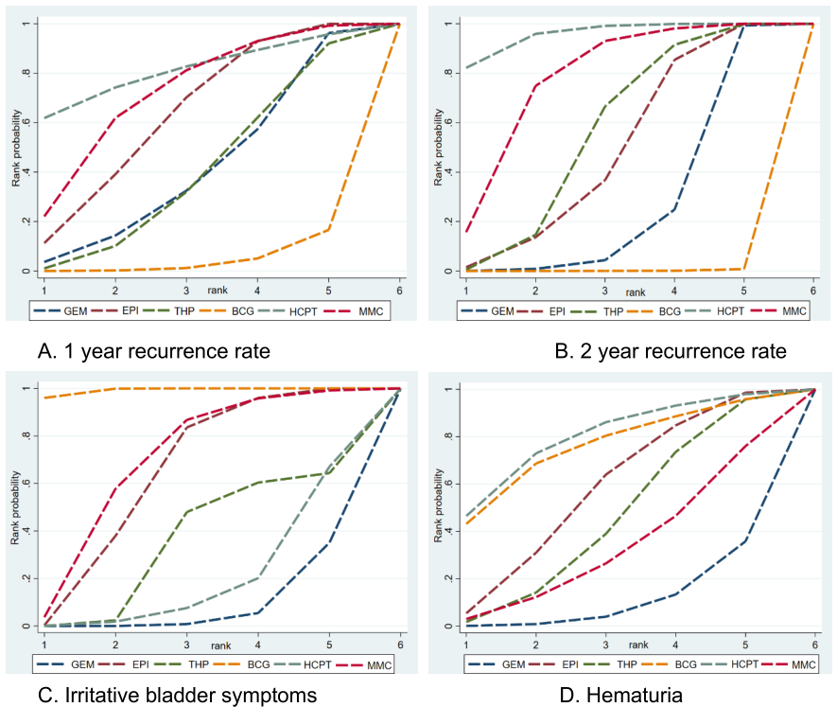
Fig.S3 Cumulative probability curve of different outcome indicators of each intervention scheme 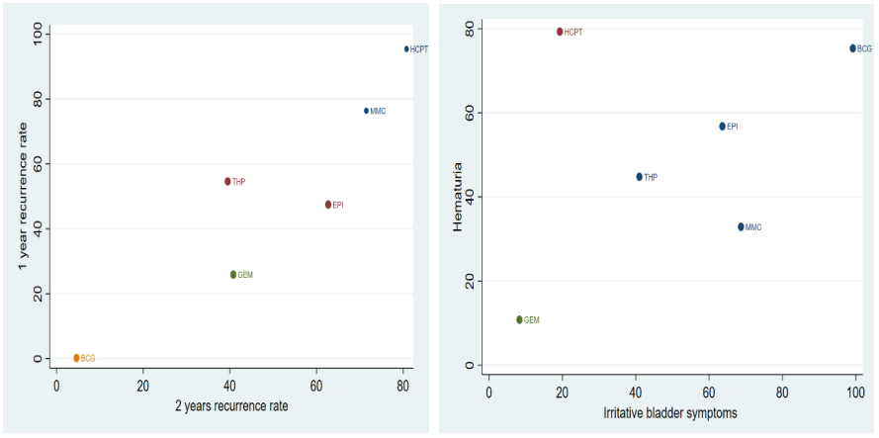 Fig.S4 cluster analysis of each intervention scheme
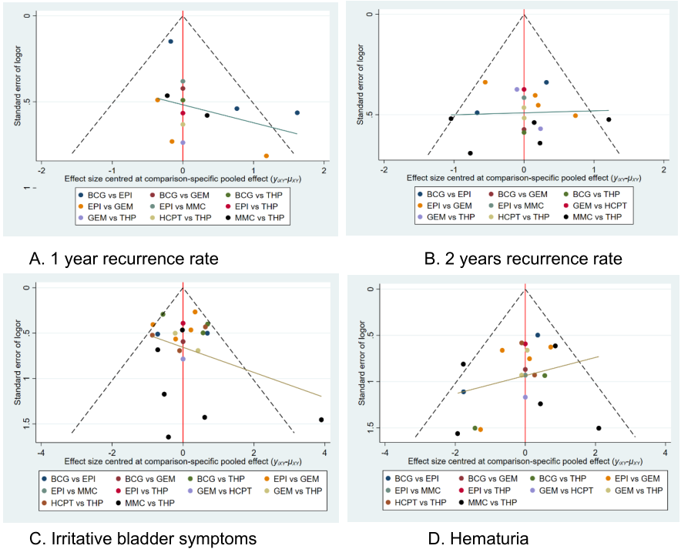 Fig.S5 Funnel diagram of each intervention scheme

