Supplement

Intact polar lipids source assignments
All three cores were dominated by phospholipids with variable relative amounts. While phosphatidylethanolamine (PE) and phosphatidylglycerol (PG) dominated the Brepollen long core HH14-897-GC-MF and the glacier-front core He560_26-2-K1, the marine influenced main basin core He519_2-3 contained higher amounts of phosphatidylcholine (PC), followed by PG and PE (Figure S 1). Phosphatidyl-(N)-monomethylethanolamine (PME), Phosphatidyl-(N,N)-dimethylethanolamine (PDME), diphosphatidylglycerol (DPG) and lyso-DPG were detected in minor amounts in all cores. The aminolipids, betaine lipids (BL), were also present in all three cores with varying amounts but always <10%. PG and PE are the most common lipids found in bacteria¹ and are typically assigned to sulfate-reducing bacteria^{2,3} (with DPG) in marine sediments, although other gram-negative bacteria are also potential sources. The fatty acid distribution in PG, PE, and DPG support a bacterial source as C_{16:1} fatty acids dominate these lipid classes as well as odd-numbered carbon fatty acids such as C_{17:1} and C_{br-15:0} (Figure S 2, note: the double bond and methyl-branch was not determined by HPLC-MS, but was identified by PLFA analyses via GC-MS). The assignment of PC to a bacterial source is not as straightforward as only 10% of all bacteria are estimated to possess the genes involved in its biosynthesis⁴ and PC - with BL- is more commonly assigned to phytoplankton⁵. The higher abundance of PC in the marine-influenced core could point to detrital remains of phytoplankton, however, the fatty acid distribution indicates that a large part of PC is likely of bacterial origin (Figure S 2). Similarly, BL contain fatty acids that point to bacterial sources, but a small contribution from detrital sources that bypassed degradation in these anoxic sediments cannot be excluded.

Compound specific radiocarbon dating of n-alkanes
n-Alkanes were separated from the neutral fraction of the intact polar lipid extract by a second silica column chromatography, eluting the alkane fraction with hexane. From three depth intervals of sediment core HH14-897-GC-MF, purified samples of n-C₁₉, n-C₂₀, n-C₂₁, and n-C₂₂ as well as combined n-C₂₆₊₂₈₊₃₀ and n-C₂₇₊₂₉₊₃₁ were collected using the GC-PFC used similarly as for intact polar lipid fatty acid purification. The purified splits were radiocarbon dated in the same manner as the intact polar lipid fatty acids using AMS at the MICADAS facility of the Alfred-Wegener-Institute in Bremerhaven, Germany.
The radiocarbon values obtained for all n-alkane samples indicate that a large part of the organic matter is derived from a radiocarbon free source (Table S 1). The F¹⁴C values are close to the detection-limit for gas measurements and can be considered to be F¹⁴C=0 within 2σ uncertainties in almost all cases except for the samples of combined n-C₂₇₊₂₉₊₃₁, whose F¹⁴C values suggest minor contributions from younger materials (less than 3 % assuming a modern source)⁶. In combination with low CPI values (Figure S 3), the age of the n-alkanes supports the assumption that freshly synthesized OM from terrestrial vegetation contributes a negligible amount to sedimentary OM. These results further support the application of a two-endmember model for radiocarbon based isotopic mass balances calculations.

Sediment core age models
Core He519_2-3 (27 cm long) collected from the Hornsund fjord main basin revealed near-constant ²¹⁰Pb_{ex} in the topmost part, considered a surface mixed layer, and steadily decreasing activities below. The modeled accumulation rate is approximately 4.1 mm/yr. The isotope ¹³⁷Cs was detected throughout the core and its maximum may be related to the 1986 Chernobyl event. Due to deep sediment mixing, the age model can only be treated as an approximation, but all models confirm that the sediments are considerably younger than the ²¹⁰Pb extinction age and were deposited -or last mixed- within the era of artificial radionuclides (Figure S 4).
The longest core (154 cm) HH14-897-GC-MF was collected from an area in Brepollen that was deglaciated between 1936 and 1960. The ²¹⁰Pb_{ex} decreased with depth and revealed a rapid accumulation rate of approximately 147 mm/yr until around 1968, when the coring site was still close to the tidewater glacier termini, decreasing to approximately 8.1 mm/yr during the younger period (Figure S 5). The modeled sediment accumulation rates agreed with 1963 (nuclear weapon tests) and 1986 (Chernobyl) peaks in ¹³⁷Cs and the thickness of preserved sediment lamination.
The inner fjord sediment core He560-26-2-K1 (22 cm long), collected from an area in Brepollen, that was deglaciated during the last 50 years (Figure 1), showed ²¹⁰Pb_{ex} throughout, indicating recent rapid deposition. There was no clear depth trend in ²¹⁰Pb_{ex}, and ¹³⁷Cs was present throughout. The calculated sediment accumulation rate was in the order of 25.5 mm/yr. ²¹⁰Pb_{sup} (²²⁶Ra) measured via its daughter ²¹⁴Pb yielded an apparent cyclicity, which could be related to annual layering and respective accumulation rate in the order of 30 mm/yr. Thus, the core is considered to comprise deposits accumulated within the last decade (Figure S 6).

Supplementary Table
Table S 1: Radiocarbon signature and respective ages of n-alkanes.
sample label | target comment | F¹⁴C | ±1σ | Age (¹⁴C) | ±1σ
HH14-897-GC-MF 0-3cm | n-C₁₉ | 0.003 | 0.005 | 47,332 | 512
HH14-897-GC-MF 0-3cm | n-C20 | 0.002 | 0.005 | 50,688 | 771
HH14-897-GC-MF 0-3cm | n-C21 | 0.006 | 0.006 | 41,041 | 617
HH14-897-GC-MF 0-3cm | n-C22 | 0.004 | 0.006 | 44,650 | 657
HH14-897-GC-MF 0-3cm | n-C26+28+30 | 0.002 | 0.004 | 52,331 | 553
HH14-897-GC-MF 0-3cm | n-C27+29+31 | 0.018 | 0.004 | 32,387 | 299
HH14-897-GC-MF 86-89cm | n-C19 | 0.016 | 0.006 | 33,322 | 618
HH14-897-GC-MF 86-89cm | n-C20 | 0.006 | 0.005 | 40,883 | 625
HH14-897-GC-MF 86-89cm | n-C21 | 0.010 | 0.006 | 36,860 | 488
HH14-897-GC-MF 86-89cm | n-C22 | 0.006 | 0.007 | 40,594 | 512
HH14-897-GC-MF 86-89cm | n-C26+C28+C30 | 0.017 | 0.005 | 32,797 | 786
HH14-897-GC-MF 86-89cm | n-C27+C29+C31 | 0.051 | 0.005 | 23,868 | 401
HH14-897-GC-MF 133-136cm | n-C19 | 0.003 | 0.004 | 46,486 | 1,248
HH14-897-GC-MF 133-136cm | n-C20 | 0.002 | 0.004 | 49,049 | 1,331
HH14-897-GC-MF 133-136cm | n-C21 | 0.013 | 0.004 | 34,871 | 707
HH14-897-GC-MF 133-136cm | n-C22 | 0.001 | 0.005 | 52,805 | 1,358
HH14-897-GC-MF 133-136cm | n-C26+28+30 | 0.003 | 0.003 | 46,920 | 1,392
HH14-897-GC-MF 133-136cm | n-C27+29+31 | 0.027 | 0.004 | 29,063 | 462

Supplementary Figures
Figure S 1: Intact polar lipid distribution of the radiocarbon dated polar fraction with depth in the three analyzed cores. BL- betaine lipids, PE- phosphatidylethanolamine, PME- phosphatidyl-(N)-monomethylethanolamine, PDME- phosphatidyl-(N,N)-dimethylethanolamine (PDME), PC- phosphatidylcholine, PG- phosphatidylglycerol, DPG- diphosphatidylglycerol.
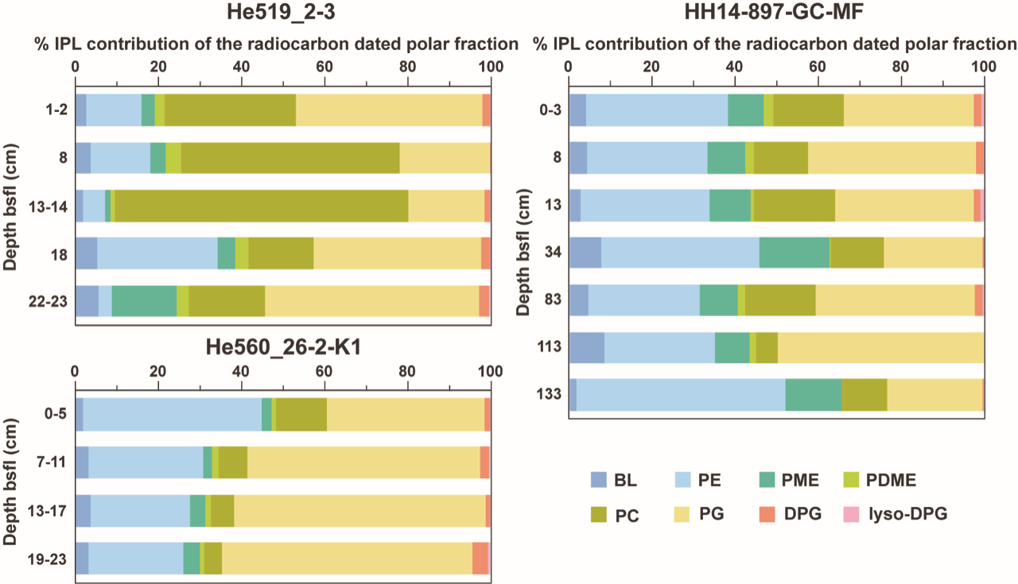

Figure S 2: a) Representative HPLC-MS chromatograms for the investigated sites depicted as heat maps showing the elution order of the detected phospholipids and amino lipids (zoom-in to retention time 6 to 12 min and m/z 550 to 1450) (for abbreviations see figure S 1). b) Distribution of molecular ions in the MS1 in positive mode with the corresponding combined fatty acid chain length for betaine lipids and the most abundant phospholipids. c) Representative negative mode MS2 fragmentation patterns of betaine lipids and phospholipids marked in bold in panel b) showing the presence of the radiocarbon dated C16:1 and C15:0 fatty acids in all of the polar lipids.

Figure S 3: Chromatograms for characteristic alkane distributions throughout the three cores displaying carbon preference index (CPI) values which indicate high (thermal) maturity (close to 1). The chromatograms shown here display the radiocarbon dated n-alkanes of the three depth intervals of sediment core HH14-897-GC-MF.
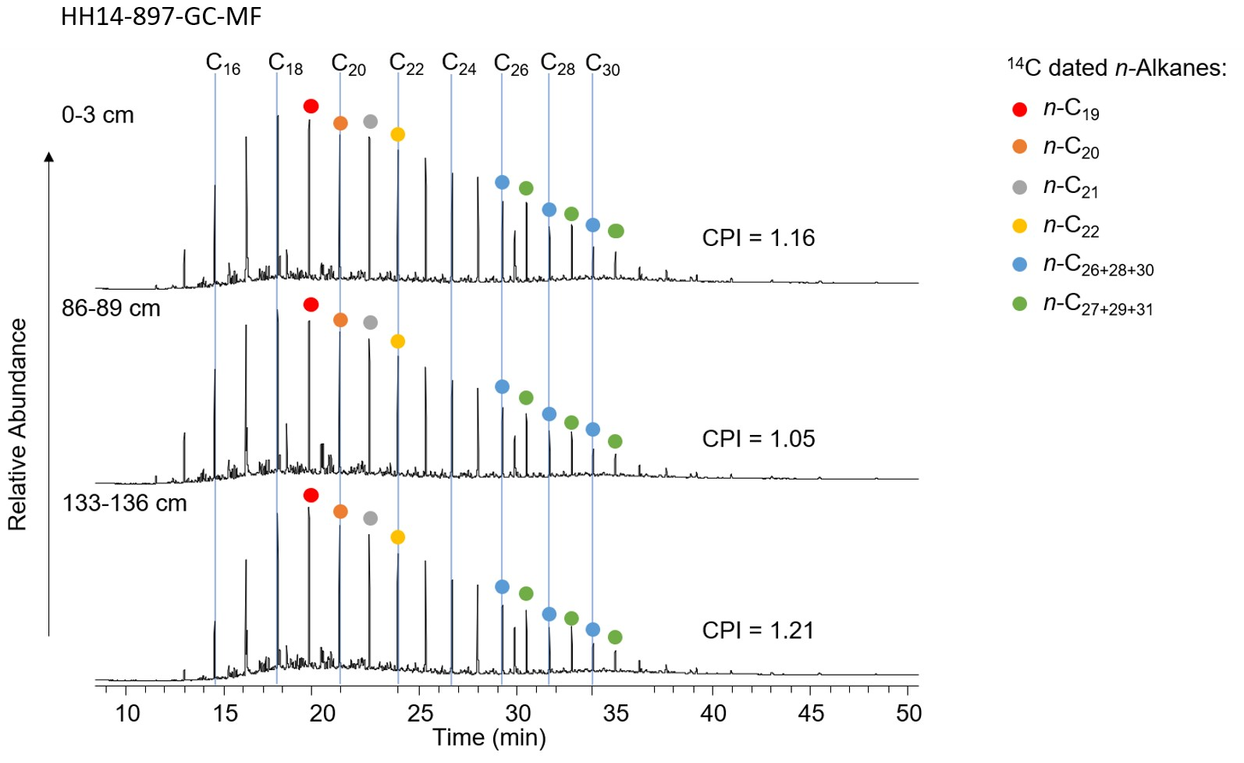

Figure S 4: Short-lived radionuclides measurements, and age depth model for He519_2-3 core. From left to right: ²¹⁰Pb_{ex} (semilogarithmic plot of excess ²¹⁰Pb), ¹³⁷Cs, the CFCS (constant flux constant sedimentation rate), and CRS (constant rate of supply) age models. SAR – sediment accumulation rate calculated with CFCS model, C 1986 – Chernobyl Nuclear Power Plant disaster in 1986. The surface mixed layer (SML) is in light gray (top 60 mm). The vertical error bars refer to analyzed sediment sample thickness, while the horizontal bars depict 2-sigma uncertainty. The figure was created in serac R package⁷.
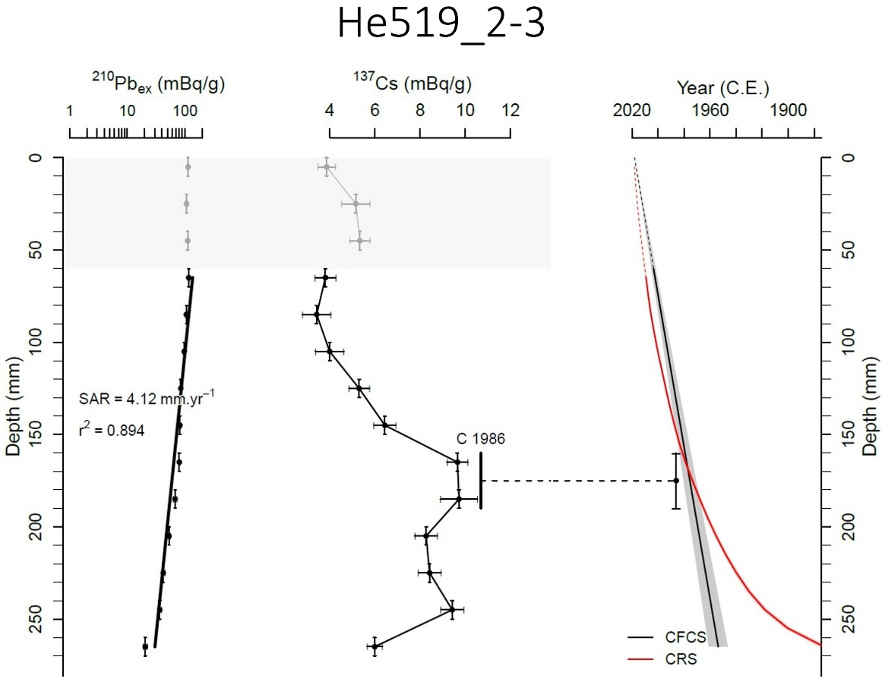

Figure S 5: Short-lived radionuclides measurements and age depth model for HH14-897-GC-MF core. From left to right: ²¹⁰Pb_{ex} (semilogarithmic plot of excess ²¹⁰Pb), ¹³⁷Cs, and the CFCS (constant flux constant sedimentation rate) with assumption of two periods of various accumulation rate, and CIC (constant initial concentration) age model. SAR – sediment accumulation rate calculated with CFCS model, C 1986 – Chernobyl Nuclear Power Plant disaster in 1986, NWT 1963 – Nuclear Weapon Tests fallout maximum in 1963. The coring site was deglaciated after 1920⁸. The vertical error bars refer to analyzed sediment sample thickness, while the horizontal bars depict 2-sigma uncertainty. The figure was created in serac R package⁷.
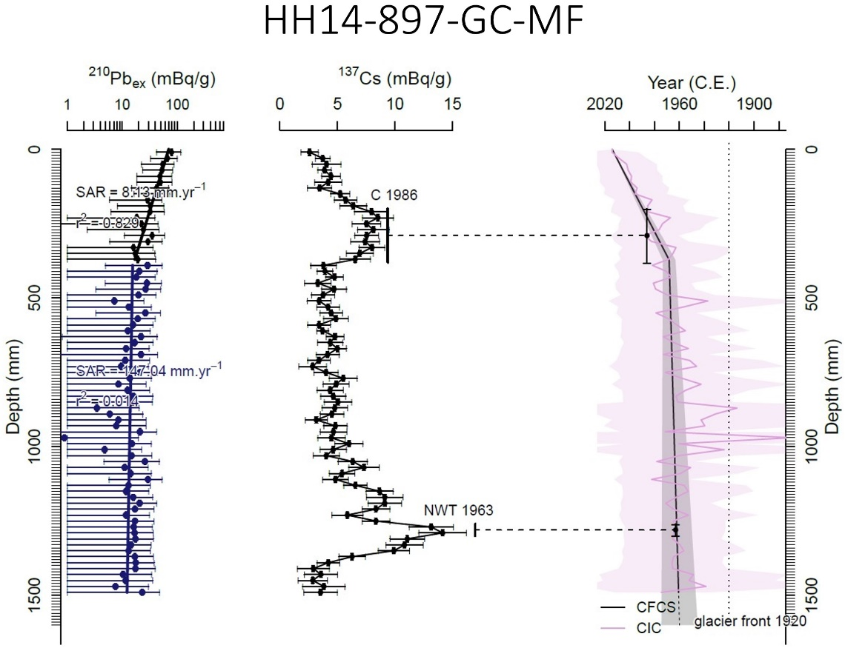

Figure S 6: Short-lived radionuclides measurements and age depth model for He560_26-2-K1 core. From left to right: ²¹⁰Pb_{ex} (semilogarithmic plot of excess ²¹⁰Pb), ¹³⁷Cs, and the CFCS (constant flux constant sedimentation rate) age model. SAR – sediment accumulation rate. The vertical error bars refer to analyzed sediment sample thickness, while the horizontal bars depict 2-sigma uncertainty. The figure was created in serac R package⁷.
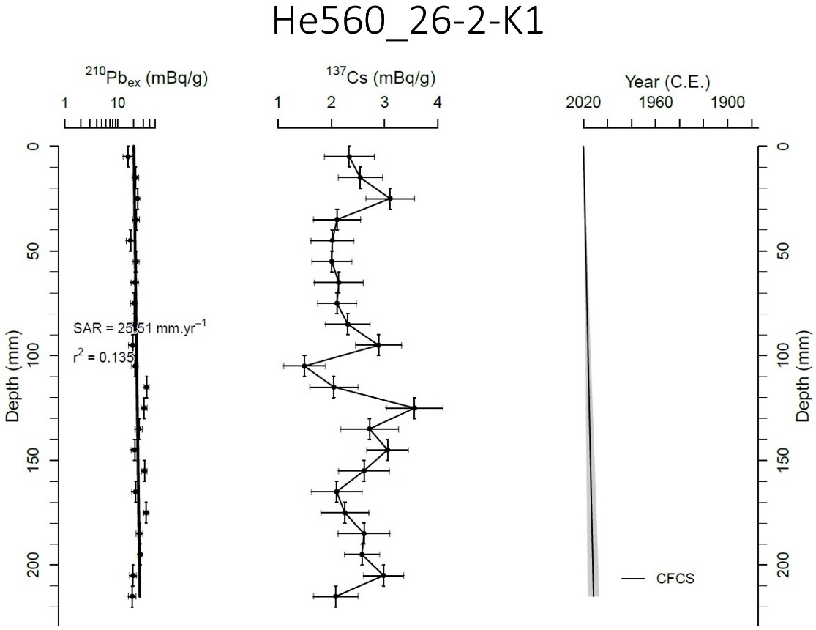
Figure S 7: Estimated surface DIC age displayed in fraction of modern carbon (F¹⁴C), based on a radiocarbon equipped Finite-volumE Sea ice-Ocean Model FESOM2 (see methods).
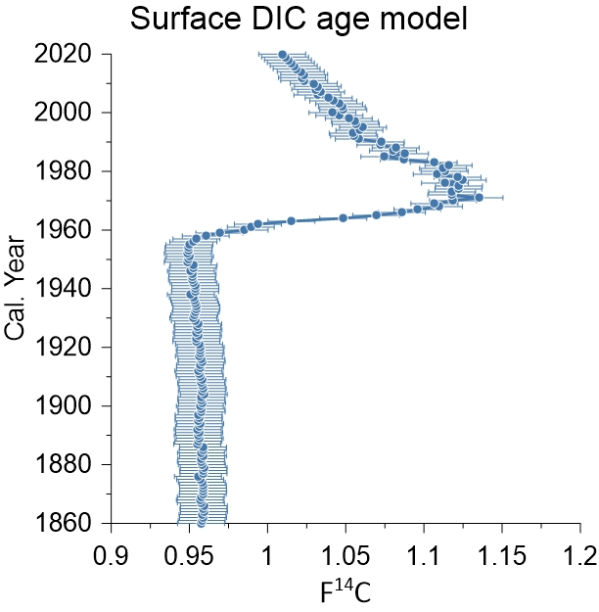

References
1. Sohlenkamp, C. & Geiger, O. Bacterial membrane lipids: diversity in structures and pathways. FEMS Microbiol Rev 40, 133–159 (2016).
2. Lipp, J. S. & Hinrichs, K. U. Structural diversity and fate of intact polar lipids in marine sediments. Geochim. Cosmochim. Acta 73, 6816–6833 (2009).
3. Schubotz, F. et al. Petroleum degradation and associated microbial signatures at the Chapopote asphalt volcano, Southern Gulf of Mexico. Geochim. Cosmochim. Acta 75, 4377–4398 (2011).
4. Sohlenkamp, C., López-Lara, I. M. & Geiger, O. Biosynthesis of phosphatidylcholine in bacteria. Prog. Lipid Res. 42, 115–162 (2003).
5. Dembitsky, V. M. Betaine ether-linked glycerolipids: Chemistry and biology. Prog. Lipid Res. 35, 1–51 (1996).
6. Mollenhauer, G., Grotheer, H., Gentz, T., Bonk, E. & Hefter, J. Standard operation procedures and performance of the MICADAS radiocarbon laboratory at Alfred Wegener Institute (AWI), Germany. Nucl. Instruments Methods Phys. Res. Sect. B Beam Interact. with Mater. Atoms 496, 45–51 (2021).
7. Bruel, R. & Sabatier, P. serac: an R package for ShortlivEd RAdionuclide chronology of recent sediment cores. J. Environ. Radioact. 225, 106449 (2020).
8. Błaszczyk, M., Jania, J. A. & Kolondra, L. Fluctuations of tidewater glaciers in Hornsund Fjord (Southern Svalbard) since the beginning of the 20th century. Polish Polar Res. 34, 327–352 (2013).

