Supplementary Information

Impact of microbial genome completeness on functional metagenomics
Raphael Eisenhofer*, Iñaki Odriozola*, Antton Alberdi
Globe Institute, University of Copenhagen, Denmark
*These two authors contributed equally

Online Methods

Data generation
Faecal and intestinal samples were collected from hundreds of specimens of five host species within different research projects with different research aims and study designs, yet employing similar procedures for data generation. Details of data generation are shown elsewhere and the overview of the main design and technical differences among studies is summarised in Table S1. In short, faecal and intestinal samples were preserved to minimise microbial community distortion and DNA quality decay before nucleic acid extraction. All DNA extractions were conducted at different time points in the same dedicated amplification-free laboratory at the Globe Institute (University of Copenhagen) and included negative controls. DNA was sheared to the desired fragment length (350-450 bp) using a Covaris LE220 instrument, and sequencing libraries prepared from 200 ng of starting template using the in-house developed BEST ¹ protocol. Sequencing was conducted using BGI and Illumina platforms to produce 150 nucleotide-long paired-end reads.

Bioinformatics
Fastp (0.23.1) ² was used to remove adapter sequences and filter low quality reads (<60 bp, <20 phred score, >5 Ns). Host reads were removed by mapped to their appropriate host genome using Bowtie2 (2.4.4, default settings) ³ and outputting the unmapped reads using samtools (1.12) ⁴. Assembly and binning was conducted using metaWRAP ⁵ (see Table S1 for details on (co)assembly strategy). MAGs were dereplicated using dRep (3.0.0) ⁶ at 98% average nucleotide identity, before being taxonomically annotated using GTDB-tk (1.7.0) ⁷. DRAM (1.2.4) ⁸ was used to annotate functions to MAGs and group functions into KEGG modules. The summarise_genomes.py script was modified to output all modules and module numbers (https://github.com/EisenRa/DRAM_more_modules/tree/1.2.4_more_modules).

Statistics and visualisation
Statistical analyses were conducted on KEGG module fullness data. Aimed at building robust models, only bacterial Phyla with more than five MAGs in each dataset were considered; namely, Actinobacteriota, Bacteroidota, Firmicutes and Proteobacteria. Similarly, only widespread KEGG modules present in at least five MAGs in each Phylum and dataset were used for statistical modelling. This filtering resulted in 138 KEGG modules observed across 1554 MAGs. Statistical analyses were conducted in two consecutive steps.

In the first step, generalised linear mixed effect models, as implemented in the R package glmmTMB ⁹, were used to estimate the relationship between fullness of KEGG modules and completeness of MAGs. A binomial distribution was used with the logit link function, since function fullness represents the proportion of enzymatic reactions (or steps) of a module present in a MAG. The total number of steps of each module were used as weights in the models. Genome completeness (numeric variable), the bacterial Phylum (categorical variable with four levels) and their interaction were used as fixed explanatory variables, thus a Phylum-specific slope was estimated for each module. Two models with two alternative host-level random effects were fitted to each module: one with a random slope (random = Completeness|Host) and the other with a random intercept (random = 1|Host). The two models were compared using the akaike information criteria (AIC) to explore whether and for which modules the Fullness-Completeness relationship varied between animal hosts.

In the second step, linear mixed effect modelling, as implemented in the R package lme4 ¹⁰, was used to explore predictors of the strength of the fullness-completeness relationship across modules. The Phylum-specific slopes estimated in above binomial models were used as response variables and bacterial Phylum (categorical variable with four levels), the KEGG domain of each module (categorical variable with seven levels), and the number of steps involved in a module (numerical variable) were used as fixed explanatory variables. Since four slopes were estimated for each module (one for each bacterial Phylum) and they were included in the response variable for this model, a module-level random effect was included in the model as random intercept (random = 1|module). We built bootstrap confidence intervals around the levels of the categorical variables through the bootMER() function with 999 simulations, and around the slope of the numeric variable using the function confint.merMod(), both included in the lme4 package. To make the marginal predictions for each categorical variable, the non-focal categorical variables (Phylum or domain) were kept in their reference level and the numeric variable (steps) in its mean value. Non-overlapping 95% confidence intervals between the levels of the categorical factors Phylum and domain were considered as evidence against the null hypothesis of no differences between groups. Similarly, for the numeric variable number of steps, a confidence interval of the slope not overlapping zero was considered as evidence against the null hypothesis of no association.

Methods references
1. Carøe, C. et al. Single-tube library preparation for degraded DNA. Methods Ecol. Evol. 9, 410–419 (2018).
2. Chen, S., Zhou, Y., Chen, Y. & Gu, J. fastp: an ultra-fast all-in-one FASTQ preprocessor. Bioinformatics 34, i884–i890 (2018).
3. Langmead, B. & Salzberg, S. L. Fast gapped-read alignment with Bowtie 2. Nat. Methods 9, 357–359 (2012).
4. Li, H. et al. The Sequence Alignment/Map format and SAMtools. Bioinformatics 25, 2078–2079 (2009).
5. Uritskiy, G. V., DiRuggiero, J. & Taylor, J. MetaWRAP—a flexible pipeline for genome-resolved metagenomic data analysis. Microbiome 6, 1–13 (2018).
6. Olm, M. R., Brown, C. T., Brooks, B. & Banfield, J. F. dRep: a tool for fast and accurate genomic comparisons that enables improved genome recovery from metagenomes through de-replication. ISME J. 11, 2864–2868 (2017).
7. Chaumeil, P.-A., Mussig, A. J., Hugenholtz, P. & Parks, D. H. GTDB-Tk: a toolkit to classify genomes with the Genome Taxonomy Database. Bioinformatics (2019) doi:10.1093/bioinformatics/btz848.
8. Shaffer, M. et al. DRAM for distilling microbial metabolism to automate the curation of microbiome function. Nucleic Acids Res. 48, 8883–8900 (2020).
9. Brooks, M. E. et al. glmmTMB balances speed and flexibility among packages for zero-inflated generalized linear mixed modeling. R J. 9, 378–400 (2017).
10. Bates, D., Sarkar, D., Bates, M. D. & Matrix, L. The lme4 package. R package version 2, 74 (2007).
Supplementary tables

Table S1. Main design and technical differences among studies incorporated in this publication.
Host | Common name | Origin | Sample type | Preservative | Study design | # individuals | # samples | Seq. techn. | Assembly | # MAGs
Apodemus sylvaticus | Wood mouse | Wild | Faeces | DNA/RNA Shield | Longitudinal | 25 | 125 | BGISeq | Individual coassembly | 448
Crocidura russula | Greater white-toothed shrew | Wild | Faeces | DNA/RNA Shield | Longitudinal | 20 | 80 | BGISeq | Individual coassembly | 87
Felis catus | Common cat | Domestic | Faeces | FTA cards | Cross-cut | 160 | 160 | BGISeq | Population  coassembly | 230
Gallus gallus | Broiler chicken | Farm | Caecal content | DNA/RNA Shield | Cross-cut | 620 | 620 | BGISeq | Individual assembly | 724
Mus musculus | Laboratory mouse | Laboratory | Faeces | DNA/RNA Shield | Longitudinal | 24 | 264 | Illumina | Individual coassembly | 191

Supplementary figures

Fig. S1: CheckM completeness and contamination values for each MAG in the study
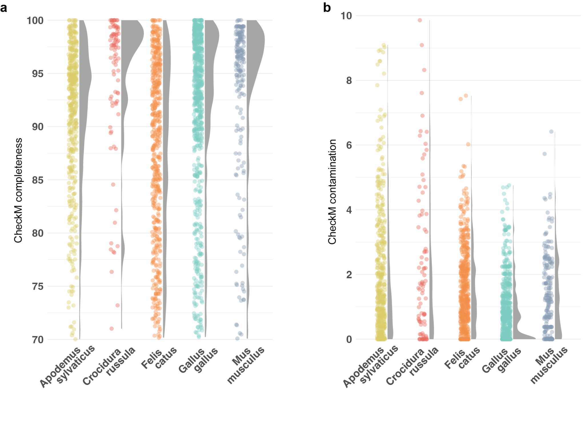
(a) Jitter plot and density curves of the MAG completeness scores computed by CheckM for each host. (b) Jitter plot and density curves of the MAG contamination scores computed by CheckM for each host.
Fig. S2: Relationship between function fullness and genome completeness.
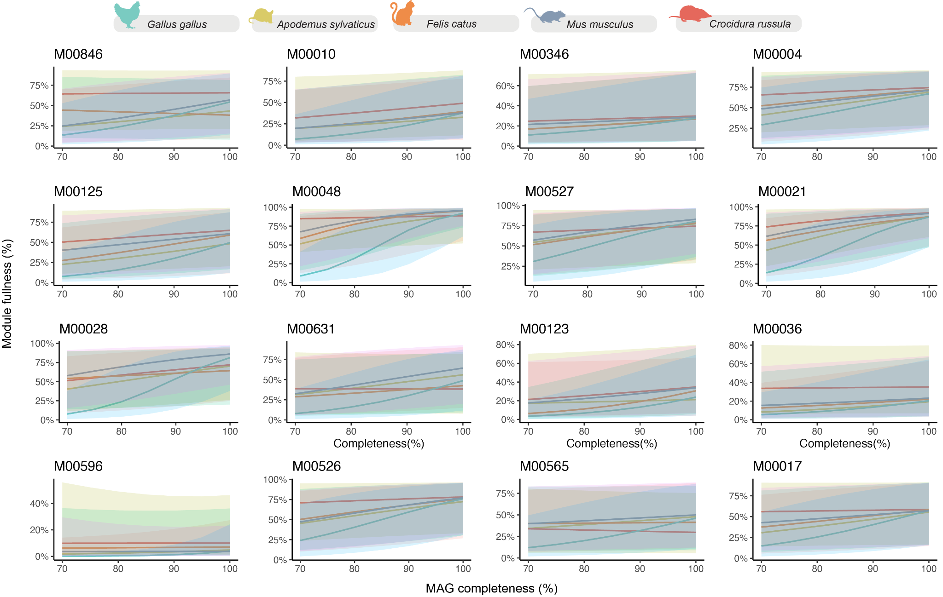
For illustrative purposes, the relationship between function fullness and genome completeness is shown in 16 randomly selected modules in which the random slope model performed better than the random intercept model.

