Supplementary Materials

Appendix 1: Timeline of the COVID-19 vaccination programme in Scotland as relevant to pregnant women
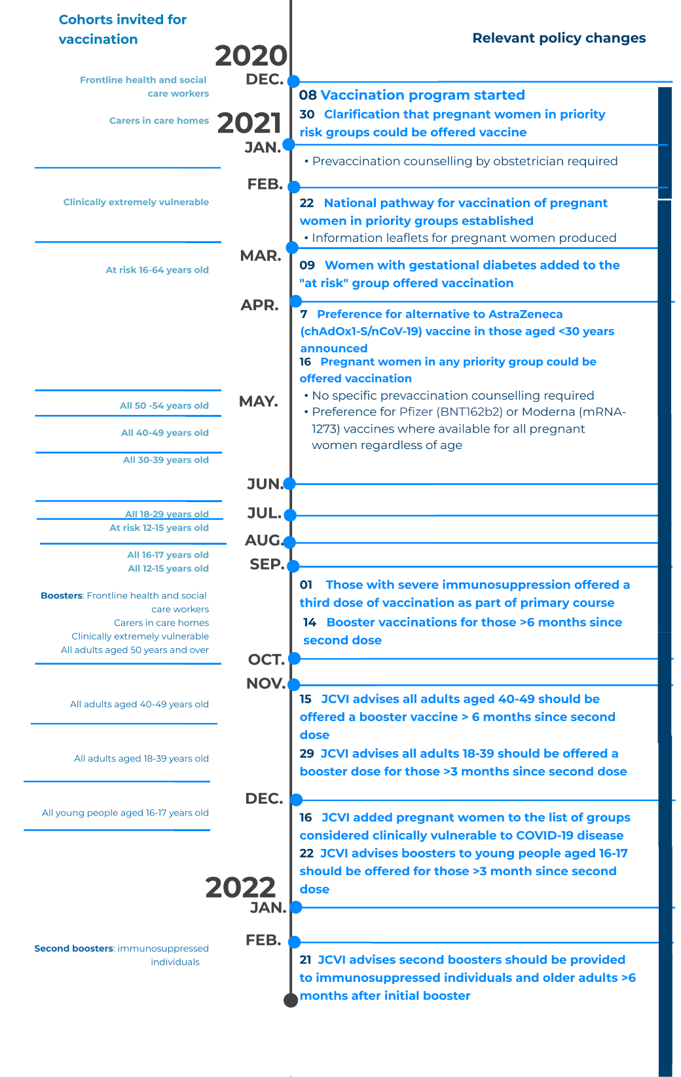

Appendix 2: Additional information on potential confounders included in analyses
Variable | Categorisation | Notes
Deprivation: Scottish Index of Multiple Deprivation (SIMD) | Quintile from 1 (most deprived) to 5 (least deprived)  Unknown | SIMD is a relative measure of deprivation calculated for each of 6,976 areas across Scotland. It draws on data on income, employment, education, health, access to services, crime and housing.^{1,2}
Ethnicity | White  South Asian  Black/Caribbean/African  Other/mixed ethnicity  Unknown | This classification is based on standard categories used in the Scottish decennial population census.³
Rural urban status | Large urban areas  Other urban areas  Accessible small towns  Remote small towns  Accessible rural areas  Remote rural areas  Unknown | We have grouped this according to the standard Scottish Government urban-rural categorisation.⁴ Where possible rural urban information was derived from postcode as identified from: general acute hospital discharge records (Scottish Morbidity Record (SMR) 01); maternity hospital discharge records (SMR 02); statutory termination of pregnancy notifications; the National Records of Scotland (NRS) statutory live birth registrations and the NRS statutory stillbirth registrations; where postcode was not available from these data sources it was taken from GP records (if available). As we rely on data from women’s maternity records and other sources capturing the end of pregnancy, we have higher levels of missing for this covariate among ongoing pregnancies in the COPS dataset.
Clinical vulnerability | Clinically extremely vulnerable (on highest risk list)  Clinically vulnerable (but excluding diabetes)  Not clinically vulnerable | Individuals considered clinically extremely vulnerable to SARS-CoV-2 infection were identified from the national highest risk/shielding list maintained by Public Health Scotland,⁵ with data kept up-to-date at the time the COPS cohort dataset was created for this study (26 April, 2022).  Individuals considered clinically vulnerable were those not on the highest risk list whose primary care/GP record included a diagnostic code indicating they were in any Q-COVID risk group (excluding diabetes) or had hypertension.⁶ These data are based on what was reported to GPs, with cross-sectional data available in June 2020 and January 2021. The data available in June 2020 was used to assign pregnancies between January 2015 and December 2020 to clinical vulnerability categories, with all later pregnancies assigned to categories based on the more recent cross section of data.  We intended to include diabetes as a separate confounder variable, based on information recorded in women’s maternity records, however this was not feasible as information was missing for a high proportion of women with early pregnancy loss.
¹Scottish Government. Scottish Index of Multiple Deprivation 2020 (Accessed 16 June 2022 at: https://www.gov.scot/collections/scottish-index-of-multiple-deprivation-2020/)
²Public Health Scotland. GPD Support: Deprivation (Accessed 16 June 2022 at: https://www.isdscotland.org/Products-and-Services/GPD-Support/Deprivation/SIMD/)
³IDS Scotland. Data Dictionary A-Z: Ethnic Group (Accessed 16 June 2022 at: https://www.ndc.scot.nhs.uk/Dictionary-A-Z/Definitions/index.asp?Search=E&ID=243&Title=Ethnic%20Group)
⁴Scottish Government. Scottish Government Urban Rural Classification 2016. (Accessed 16 June 2022 at: https://www.gov.scot/publications/scottish-government-urban-rural-classification-2016/)
⁵Public Health Scotland. COVID-19 – Search criteria for highest risk patients for inclusion to the shielding list (Accessed 16 June 2022 at: https://publichealthscotland.scot/publications/covid-19-search-criteria-for-highest-risk-patients-for-inclusion-to-the-shielding-list/covid-19-search-criteria-for-highest-risk-patients-for-inclusion-to-the-shielding-list-version-60/)
⁶Oxford University. QCovid® risk calculation (Accessed 16 June 2022 at: https://www.qcovid.org/)

