Extended data

Extended Data Table 1: Key characteristics of vaccinated and control groups included in the vaccination and miscarriage subgroup analyses
 | BNT162b2 sub-group analysis |  |  | mRNA-1273 sub-group analysis |  |  | ChAdOx1-S/nCoV-19 subgroup analysis
 | Vaccinated  cohort | Unvaccinated  historical controls | Unvaccinated  contemporary controls | Vaccinated  cohort | Unvaccinated  historical controls | Unvaccinated  contemporary controls | Vaccinated  cohort | Unvaccinated  historical controls | Unvaccinated  contemporary controls
Key characteristics
Number of pregnancies | 13675 | 41025 | 13675 | 2260 | 6780 | 2260 | 2612 | 7836 | 2612
Median age (min-max) | 31 (14-49) | 31 (14-50) | 31 (14-52) | 31 (17-51) | 31 (16-51) | 31 (14-46) | 32 (17-50) | 32 (16-51) | 32 (14-54)
Deprivation (SIMD quintile)
1 (most deprived) | 2361 (17.3%) | 8986 (21.9%) | 3216 (23.5%) | 461 (20.4%) | 1459 (21.5%) | 523 (23.1%) | 649 (24.8%) | 1673 (21.4%) | 611 (23.4%)
2 | 2523 (18.4%) | 8039 (19.6%) | 2821 (20.6%) | 412 (18.2%) | 1325 (19.5%) | 444 (19.6%) | 539 (20.6%) | 1544 (19.7%) | 498 (19.1%)
3 | 2667 (19.5%) | 7325 (17.9%) | 2515 (18.4%) | 315 (13.9%) | 1181 (17.4%) | 405 (17.9%) | 480 (18.4%) | 1384 (17.7%) | 498 (19.1%)
4 | 3168 (23.2%) | 8499 (20.7%) | 2717 (19.9%) | 459 (20.3%) | 1436 (21.2%) | 471 (20.8%) | 487 (18.6%) | 1585 (20.2%) | 499 (19.1%)
5 (least deprived) | 2850 (20.8%) | 7782 (19.0%) | 2319 (17.0%) | 599 (26.5%) | 1329 (19.6%) | 406 (18.0%) | 434 (16.6%) | 1531 (19.5%) | 478 (18.3%)
Unknown | 106 (0.8%) | 394 (1.0%) | 87 (0.6%) | 14 (0.6%) | 50 (0.7%) | 11 (0.5%) | 23 (0.9%) | 119 (1.5%) | 28 (1.1%)
Ethnicity
White | 11639 (85.1%) | 27297 (66.5%) | 11455 (83.8%) | 1746 (77.3%) | 4608 (68.0%) | 1891 (83.7%) | 2314 (88.6%) | 4829 (61.6%) | 2131 (81.6%)
South Asian | 496 (3.6%) | 964 (2.3%) | 458 (3.3%) | 123 (5.4%) | 140 (2.1%) | 82 (3.6%) | 76 (2.9%) | 149 (1.9%) | 88 (3.4%)
Black/Caribbean /African | 133 (1.0%) | 473 (1.2%) | 266 (1.9%) | 61 (2.7%) | 81 (1.2%) | 46 (2.0%) | 40 (1.5%) | 113 (1.4%) | 58 (2.2%)
Other/mixed ethnicity | 413 (3.0%) | 1022 (2.5%) | 491 (3.6%) | 115 (5.1%) | 168 (2.5%) | 88 (3.9%) | 59 (2.3%) | 199 (2.5%) | 99 (3.8%)
Unknown | 994 (7.3%) | 11269 (27.5%) | 1005 (7.3%) | 215 (9.5%) | 1783 (26.3%) | 153 (6.8%) | 123 (4.7%) | 2546 (32.5%) | 236 (9.0%)
Urban/rural status
Large urban areas | 4255 (31.1%) | 15503 (37.8%) | 5113 (37.4%) | 1504 (66.5%) | 2493 (36.8%) | 843 (37.3%) | 904 (34.6%) | 2985 (38.1%) | 962 (36.8%)
Other urban areas | 4686 (34.3%) | 14658 (35.7%) | 4783 (35.0%) | 316 (14.0%) | 2529 (37.3%) | 776 (34.3%) | 938 (35.9%) | 2744 (35.0%) | 926 (35.5%)
Accessible small towns | 1103 (8.1%) | 3310 (8.1%) | 1026 (7.5%) | 97 (4.3%) | 528 (7.8%) | 157 (6.9%) | 229 (8.8%) | 624 (8.0%) | 193 (7.4%)
Remote small towns | 442 (3.2%) | 1155 (2.8%) | 414 (3.0%) | 16 (0.7%) | 184 (2.7%) | 72 (3.2%) | 89 (3.4%) | 245 (3.1%) | 71 (2.7%)
Accessible rural areas | 1568 (11.5%) | 4084 (10.0%) | 1479 (10.8%) | 131 (5.8%) | 675 (10.0%) | 290 (12.8%) | 270 (10.3%) | 772 (9.9%) | 286 (10.9%)
Remote rural areas | 696 (5.1%) | 1858 (4.5%) | 572 (4.2%) | 17 (0.8%) | 310 (4.6%) | 84 (3.7%) | 116 (4.4%) | 336 (4.3%) | 102 (3.9%)
Unknown | 925 (6.8%) | 457 (1.1%) | 288 (2.1%) | 179 (7.9%) | 61 (0.9%) | 38 (1.7%) | 66 (2.5%) | 130 (1.7%) | 72 (2.8%)
Clinical vulnerability
Extremely vulnerable | 109 (0.8%) | 570 (1.4%) | 110 (0.8%) | 14 (0.6%) | 82 (1.2%) | 16 (0.7%) | 104 (4.0%) | 111 (1.4%) | 26 (1.0%)
Vulnerable | 3261 (23.8%) | 11709 (28.5%) | 3542 (25.9%) | 500 (22.1%) | 1878 (27.7%) | 571 (25.3%) | 1013 (38.8%) | 2169 (27.7%) | 685 (26.2%)
Not vulnerable | 10305 (75.4%) | 28746 (70.1%) | 10023 (73.3%) | 1746 (77.3%) | 4820 (71.1%) | 1673 (74.0%) | 1495 (57.2%) | 5556 (70.9%) | 1901 (72.8%)
Exposure (vaccination)
Gestation at first vaccination within exposure period
Preconception | 6126 (44.8%) | - | - | 828 (36.6%) | - | - | 1653 (63.3%) | - | -
2+0-5+6 weeks | 2975 (21.8%) | - | - | 486 (21.5%) | - | - | 691 (26.5%) | - | -
6+0-10+6 weeks | 1001 (7.3%) | - | - | 166 (7.3%) | - | - | 141 (5.4%) | - | -
11+0-15+6 weeks | 1978 (14.5%) | - | - | 420 (18.6%) | - | - | 70 (2.7%) | - | -
16+0-19+6 weeks | 1595 (11.7%) | - | - | 360 (15.9%) | - | - | 57 (2.2%) | - | -
Number of vaccinations*
1 | 10025 (73.3%) | - | - | 1615 (71.5%) | - | - | 2152 (82.4%) | - | -
2+ | 3650 (26.7%) | - | - | 645 (28.5%) | - | - | 460 (17.6%) | - | -
Dose number at first vaccination within exposure period
Dose 1 | 8181 (59.8%) | - | - | 1367 (60.5%) | - | - | 1394 (53.4%) | - | -
Dose 2 | 4123 (30.1%) | - | - | 514 (22.7%) | - | - | 1215 (46.5%) | - | -
Dose 3 | 1371 (10%) | - | - | 379 (16.8%) | - | - | 3 (0.1%) | - | -
Outcome (miscarriage)
Pregnancies ending in miscarriage up to 19+6 weeks | 1147 | 3804 | 1258 | 162 | 511 | 198 | 406 | 1152 | 389
Gestation at miscarriage
<=10+6 | 852 (74.3%) | 3467 (91.1%) | 867 (68.9%) | 127 (78.4%) | 468 (91.6%) | 133 (67.2%) | 322 (79.3%) | 1082 (93.9%) | 290 (74.6%)
11+0-13+6 | 212 (18.5%) | 223 (5.9%) | 285 (22.7%) | 26 (16.0%) | 25 (4.9%) | 46 (23.2%) | 62 (15.3%) | 44 (3.8%) | 74 (19.0%)
>=14+0 | 83 (7.2%) | 114 (3.0%) | 106 (8.4%) | 9 (5.6%) | 18 (3.5%) | 19 (9.6%) | 22 (5.4%) | 26 (2.3%) | 25 (6.4%)
Imputed gestation for miscarriage
Yes | 638 (55.6%) | 3108 (81.7%) | 619 (49.2%) | 103 (63.6%) | 426 (83.4%) | 87 (43.9%) | 233 (57.4%) | 967 (83.9%) | 207 (53.2%)
No – available from ANC booking | 394 (34.4%) | 224 (5.9%) | 484 (38.5%) | 50 (30.9%) | 29 (5.7%) | 87 (43.9%) | 132 (32.5%) | 52 (4.5%) | 138 (35.5%)
No – available from end of pregnancy record | 115 (10.0%) | 472 (12.4%) | 155 (12.3%) | 9 (5.6%) | 56 (11.0%) | 24 (12.1%) | 41 (10.1%) | 133 (11.5%) | 44 (11.3%)
Lag between first vaccination (or date of matching in unvaccinated) and miscarriage
<2 weeks | 56 (4.9%) | 158 (4.2%) | 76 (6.0%) | 11 (6.8%) | 38 (7.4%) | 18 (9.1%) | 17 (4.2%) | 27 (2.3%) | 7 (1.8%)
2-5 weeks | 166 (14.5%) | 483 (12.7%) | 180 (14.3%) | 33 (20.4%) | 72 (14.1%) | 33 (16.7%) | 59 (14.5%) | 101 (8.8%) | 48 (12.3%)
6-9 weeks | 357 (31.1%) | 1299 (34.1%) | 391 (31.1%) | 48 (29.6%) | 180 (35.2%) | 58 (29.3%) | 130 (32.0%) | 408 (35.4%) | 132 (33.9%)
>=10 weeks | 568 (49.5%) | 1864 (49.0%) | 611 (48.6%) | 70 (43.2%) | 221 (43.2%) | 89 (44.9%) | 200 (49.3%) | 616 (53.5%) | 202 (51.9%)
SIMD=Scottish Index of Multiple Deprivation
*Between 6 weeks pre-conception and the earliest of either: end of pregnancy or 19+6 weeks gestation
All groups exclude women with confirmed SARS-CoV-2 infection between 6 weeks preconception and the earliest of either: end of pregnancy or the end of the exposure period at 2+6 weeks gestation

Extended Data Fig 1: Selection of pregnancies for the analysis of association between COVID-19 vaccination and risk of ectopic pregnancy
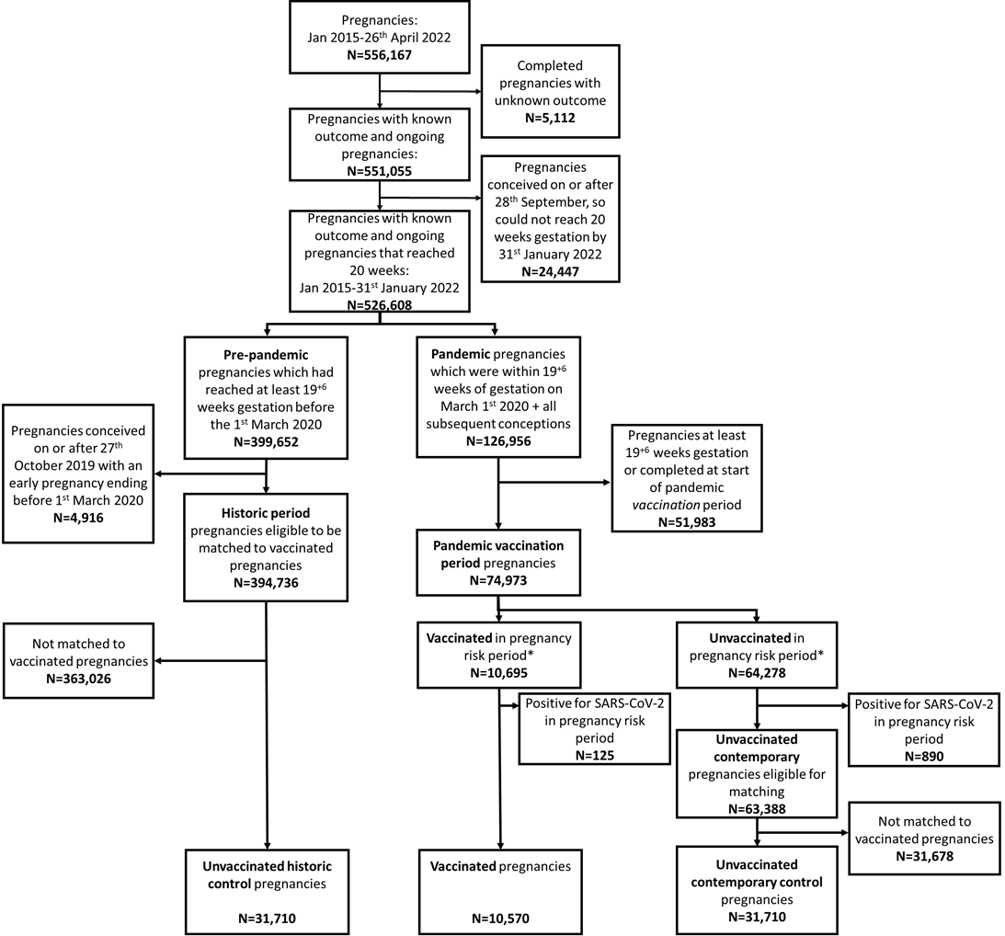
*For ectopic analysis, vaccination needs to be given between 6 weeks preconception and up to the earliest of: (1) end of pregnancy or (2) 2 weeks 6 days gestation.

Extended Data Table 2: Key characteristics of vaccinated and control groups included in the vaccination and ectopic pregnancy analyses
 | All vaccinations
 | Vaccinated  cohort | Unvaccinated  historical controls | Unvaccinated  contemporary controls
Key characteristics
Number of pregnancies | 10,570 | 31,710 | 31,710
Median age (min-max) | 31 (15-51) | 31 (14-52) | 31 (12-54)
Deprivation (SIMD quintile)
1 (most deprived) | 2,147 (20.3%) | 7,034 (22.2%) | 7,351 (23.2%)
2 | 2,101 (19.9%) | 6,378 (20.1%) | 6,520 (20.6%)
3 | 1,941 (18.4%) | 5,606 (17.7%) | 5,763 (18.2%)
4 | 2,286 (21.6%) | 6,448 (20.3%) | 6,359 (20.1%)
5 (least deprived) | 2,000 (18.9%) | 5,860 (18.5%) | 5,477 (17.3%)
Unknown | 95 (0.9%) | 384 (1.2%) | 240 (0.8%)
Ethnicity
White | 8,873 (83.9%) | 20,243 (63.8%) | 26,465 (83.5%)
South Asian | 367 (3.5%) | 735 (2.3%) | 1,071 (3.4%)
Black/Caribbean /African | 121 (1.1%) | 345 (1.1%) | 572 (1.8%)
Other/mixed ethnicity | 298 (2.8%) | 776 (2.4%) | 1,125 (3.5%)
Unknown | 911 (8.6%) | 9,611 (30.3%) | 2,477 (7.8%)
Urban/rural status
Large urban areas | 3,769 (35.7%) | 12,124 (38.2%) | 11,894 (37.5%)
Other urban areas | 3,452 (32.7%) | 11,151 (35.2%) | 11,144 (35.1%)
Accessible small towns | 773 (7.3%) | 2,508 (7.9%) | 2,345 (7.4%)
Remote small towns | 323 (3.1%) | 936 (3.0%) | 925 (2.9%)
Accessible rural areas | 1,046 (9.9%) | 3,159 (10.0%) | 3,371 (10.6%)
Remote rural areas | 444 (4.2%) | 1,396 (4.4%) | 1,331 (4.2%)
Unknown | 763 (7.2%) | 436 (1.4%) | 700 (2.2%)
Clinical vulnerability
Extremely vulnerable | 120 (1.1%) | 465 (1.5%) | 275 (0.9%)
Vulnerable | 2,760 (26.1%) | 8,959 (28.3%) | 8,231 (26.0%)
Not vulnerable | 7,690 (72.8%) | 22,286 (70.3%) | 23,204 (73.2%)
Exposure (vaccination)
Gestation at first vaccination within exposure period
Preconception | 9,291 (87.9%) | - | -
2 weeks (2+0 to 2+6) | 1,279 (12.1%) | - | -
Number of vaccinations*
1 | 10,539 (99.7%) | - | -
2+ | 31 (0.3%) | - | -
Dose number at first vaccination within exposure period
Dose 1 | 5,719 (54.1%) | - | -
Dose 2 | 4,832 (45.7%) | - | -
Dose 3 | 19 (0.2%) | - | -
Type of vaccination**
BNT162b2 | 7,340 (69.4%) | - | -
mRNA-1273 | 1,040 (9.4%) | - | -
ChAdOx1-S/nCoV-19 | 1,954 (18.5%) | - | -
1+ different type | 236 (2.2%) | - | -
Outcome (ectopic pregnancy)
Pregnancies ending in ectopic pregnancy up to 19+6 weeks | 126 | 379 | 336
Gestation at ectopic pregnancy
<=10+6 | 125 (99.2%) | 376 (99.2%) | 324 (96.4%)
11+0-13+6 | 1 (0.8%) | 2 (0.5%) | 8 (2.4%)
>=14+0 | 0 | 1 (0.3%) | 4 (1.2%)
Imputed gestation for ectopic pregnancy
Yes | 106 (84.1%) | 334 (88.1%) | 270 (80.4%)
No – available from ANC booking | 7 (5.6%) | 3 (0.8%) | 32 (9.5%)
No – available from end of pregnancy record | 13 (10.3%) | 42 (11.1%) | 34 (10.1%)
Lag between first vaccination (or gestational week of matching in unvaccinated) and ectopic pregnancy
<=5 weeks | 2 (1.6%) | 9 (2.4%) | 14 (4.2%)
6-9 weeks | 65 (51.6%) | 219 (57.8%) | 182 (54.2%)
>=10 weeks | 59 (46.8%) | 151 (39.8%) | 140 (41.7%)
SIMD=Scottish Index of Multiple Deprivation
*Between 6 weeks preconception and the earliest of either: end of pregnancy or 2+6 weeks gestation
All groups exclude women with confirmed SARS-CoV-2 infection between 6 weeks preconception and the earliest of either: end of pregnancy or the end of the exposure period at 2+6 weeks gestation

Extended Data Table 3: Key characteristics of vaccinated and control groups included in the vaccination and ectopic pregnancy subgroup analyses
 | BNT162b2 sub-group analysis |  |  | mRNA-1273 sub-group analysis |  |  | ChAdOx1-S/nCoV-19 subgroup analysis
 | Vaccinated  cohort | Unvaccinated  historical controls | Unvaccinated  contemporary controls | Vaccinated  cohort | Unvaccinated  historical controls | Unvaccinated  contemporary controls | Vaccinated  cohort | Unvaccinated  historical controls | Unvaccinated  contemporary controls
Key characteristics
Number of pregnancies | 7340 | 22020 | 22020 | 1040 | 3120 | 3120 | 1954 | 5862 | 5862
Median age (min-max) | 30 (15-49) | 30 (14-50) | 30 (12-53) | 30 (18-51) | 30 (17-52) | 30 (14-48) | 32 (18-50) | 32 (17-51) | 32 (14-54)
Deprivation (SIMD quintile)
1 (most deprived) | 1379 (18.8%) | 4950 (22.5%) | 5140 (23.3%) | 250 (24.0%) | 729 (23.4%) | 769 (24.6%) | 492 (25.2%) | 1244 (21.2%) | 1293 (22.1%)
2 | 1458 (19.9%) | 4461 (20.3%) | 4597 (20.9%) | 208 (20.0%) | 631 (20.2%) | 621 (19.9%) | 404 (20.7%) | 1156 (19.7%) | 1167 (19.9%)
3 | 1402 (19.1%) | 3889 (17.7%) | 4000 (18.2%) | 138 (13.3%) | 521 (16.7%) | 576 (18.5%) | 350 (17.9%) | 1068 (18.2%) | 1040 (17.7%)
4 | 1664 (22.7%) | 4442 (20.2%) | 4395 (20.0%) | 201 (19.3%) | 641 (20.5%) | 625 (20.0%) | 363 (18.6%) | 1196 (20.4%) | 1210 (20.6%)
5 (least deprived) | 1374 (18.7%) | 4016 (18.2%) | 3728 (16.9%) | 234 (22.5%) | 568 (18.2%) | 507 (16.2%) | 323 (16.5%) | 1117 (19.1%) | 1103 (18.8%)
Unknown | 63 (0.9%) | 262 (1.2%) | 160 (0.7%) | 9 (0.9%) | 30 (1.0%) | 22 (0.7%) | 22 (1.1%) | 81 (1.4%) | 49 (0.8%)
Ethnicity
White | 6189 (84.3%) | 14097 (64.0%) | 18468 (83.9%) | 750 (72.1%) | 2078 (66.6%) | 2627 (84.2%) | 1730 (88.5%) | 3618 (61.7%) | 4812 (82.1%)
South Asian | 239 (3.3%) | 509 (2.3%) | 728 (3.3%) | 63 (6.1%) | 66 (2.1%) | 94 (3.0%) | 53 (2.7%) | 139 (2.4%) | 216 (3.7%)
Black/Caribbean /African | 64 (0.9%) | 217 (1.0%) | 375 (1.7%) | 29 (2.8%) | 34 (1.1%) | 58 (1.9%) | 28 (1.4%) | 73 (1.2%) | 116 (2.0%)
Other/mixed ethnicity | 187 (2.5%) | 521 (2.4%) | 748 (3.4%) | 56 (5.4%) | 83 (2.7%) | 104 (3.3%) | 47 (2.4%) | 152 (2.6%) | 239 (4.1%)
Unknown | 661 (9.0%) | 6676 (30.3%) | 1701 (7.7%) | 142 (13.7%) | 859 (27.5%) | 237 (7.6%) | 96 (4.9%) | 1880 (32.1%) | 479 (8.2%)
Urban/rural status
Large urban areas | 2238 (30.5%) | 8346 (37.9%) | 8198 (37.2%) | 713 (68.6%) | 1194 (38.3%) | 1151 (36.9%) | 679 (34.7%) | 2310 (39.4%) | 2245 (38.3%)
Other urban areas | 2574 (35.1%) | 7788 (35.4%) | 7816 (35.5%) | 135 (13.0%) | 1149 (36.8%) | 1079 (34.6%) | 710 (36.3%) | 1997 (34.1%) | 2009 (34.3%)
Accessible small towns | 555 (7.6%) | 1739 (7.9%) | 1623 (7.4%) | 40 (3.8%) | 255 (8.2%) | 254 (8.1%) | 167 (8.5%) | 464 (7.9%) | 429 (7.3%)
Remote small towns | 249 (3.4%) | 683 (3.1%) | 657 (3.0%) | 6 (0.6%) | 78 (2.5%) | 98 (3.1%) | 65 (3.3%) | 157 (2.7%) | 152 (2.6%)
Accessible rural areas | 788 (10.7%) | 2179 (9.9%) | 2332 (10.6%) | 49 (4.7%) | 285 (9.1%) | 337 (10.8%) | 191 (9.8%) | 599 (10.2%) | 640 (10.9%)
Remote rural areas | 357 (4.9%) | 983 (4.5%) | 922 (4.2%) | 3 (0.3%) | 125 (4.0%) | 131 (4.2%) | 82 (4.2%) | 248 (4.2%) | 244 (4.2%)
Unknown | 579 (7.9%) | 302 (1.4%) | 472 (2.1%) | 94 (9.0%) | 34 (1.1%) | 70 (2.2%) | 60 (3.1%) | 87 (1.5%) | 143 (2.4%)
Clinical vulnerability
Extremely vulnerable | 48 (0.7%) | 317 (1.4%) | 193 (0.9%) | 0 (0.0%) | 42 (1.3%) | 25 (0.8%) | 72 (3.7%) | 94 (1.6%) | 51 (0.9%)
Vulnerable | 1754 (23.9%) | 6165 (28.0%) | 5675 (25.8%) | 207 (19.9%) | 914 (29.3%) | 832 (26.7%) | 751 (38.4%) | 1676 (28.6%) | 1539 (26.3%)
Not vulnerable | 5538 (75.4%) | 15538 (70.6%) | 16152 (73.4%) | 833 (80.1%) | 2164 (69.4%) | 2263 (72.5%) | 1131 (57.9%) | 4092 (69.8%) | 4272 (72.9%)
Exposure (vaccination)
Gestation at first vaccination within exposure period
Preconception | 6434 (87.7%) | - | - | 891 (85.7%) | - | - | 1741 (89.1%) | - | -
2 weeks (2+0 to 2+6) | 906 (12.3%) | - | - | 149 (14.3%) | - | - | 213 (10.9%) | - | -
Number of vaccinations* |  | - | - |  | - | - |  | - | -
1 | 7314 (99.6%) | - | - | 1039 (99.9%) | - | - | 1950 (99.8%) | - | -
2+ | 26 (0.4%) | - | - | 1 (0.1%) | - | - | 4 (0.2%) | - | -
Dose number at first vaccination within exposure period
Dose 1 | 4064 (55.4%) | - | - | 626 (60.2%) | - | - | 1002 (51.3%) | - | -
Dose 2 | 3258 (44.4%) | - | - | 414 (39.8%) | - | - | 951 (48.7%) | - | -
Dose 3 | 18 (0.2%) |  |  | 0 |  |  | 1 (0.1%)
Outcome (ectopic pregnancy)
Pregnancies ending in ectopic pregnancy up to 19+6 weeks | 87 | 271 | 238 | 13 | 22 | 26 | 26 | 76 | 63
Gestation at ectopic pregnancy
<=10+6 | 86 (98.9%) | 268 (98.9%) | 228 (95.8%) | 13 (100%) | 22 (100%) | 25 (96.2%) | 26 (100%) | 76 (100%) | 62 (98.4%)
11+0-13+6 | 1 (1.1%) | 2 (0.7%) | 7 (2.9%) | 0 | 0 | 0 | 0 | 0 | 1 (1.6%)
>=14+0 | 0 | 1 (0.4%) | 3 (1.3%) | 0 | 0 | 1 (3.8%) | 0 | 0 | 0
Imputed gestation for ectopic pregnancy
Yes | 71 (81.6%) | 237 (87.5%) | 188 (79.0%) | 13 (100%) | 19 (86.4%) | 21 (80.8%) | 22 (84.6%) | 70 (92.1%) | 52 (82.5%)
No – available from ANC booking | 5 (5.7%) | 3 (1.1%) | 24 (10.1%) | 0 | 0 | 4 (15.4%) | 2 (7.7%) | 0 | 4 (6.3%)
No – available from end of pregnancy record | 11 (12.6%) | 31 (11.4%) | 26 (10.9%) | 0 | 3 (13.6%) | 1 (3.8%) | 2 (7.7%) | 6 (7.9%) | 7 (11.1%)
Lag between first vaccination (or gestational week of matching in unvaccinated) and ectopic pregnancy
<=5 weeks | 2 (2.3%) | 6 (2.2%) | 11 (4.6%) | 0 | 1 (4.5%) | 1 (3.8%) | 0 | 2 (2.6%) | 2 (3.2%)
6-9 weeks | 45 (51.7%) | 166 (61.3%) | 132 (55.5%) | 10 (76.9%) | 10 (45.5%) | 15 (57.7%) | 10 (38.5%) | 38 (50.0%) | 33 (52.4%)
>=10 weeks | 40 (46.0%) | 99 (36.5%) | 95 (39.9%) | 3 (23.1%) | 11 (50.0%) | 10 (38.5%) | 16 (61.5%) | 36 (47.4%) | 28 (44.4%)
SIMD=Scottish Index of Multiple Deprivation
**Between 6 weeks preconception and the earliest of either: end of pregnancy or 2+6 weeks gestation
All groups exclude women with confirmed SARS-CoV-2 infection between 6 weeks preconception and the earliest of either: end of pregnancy or the end of the exposure period at 2+6 weeks gestation

Extended Data Fig 2: Selection of pregnancies for the analysis of association between SARS-CoV-2 infection and risk of miscarriage
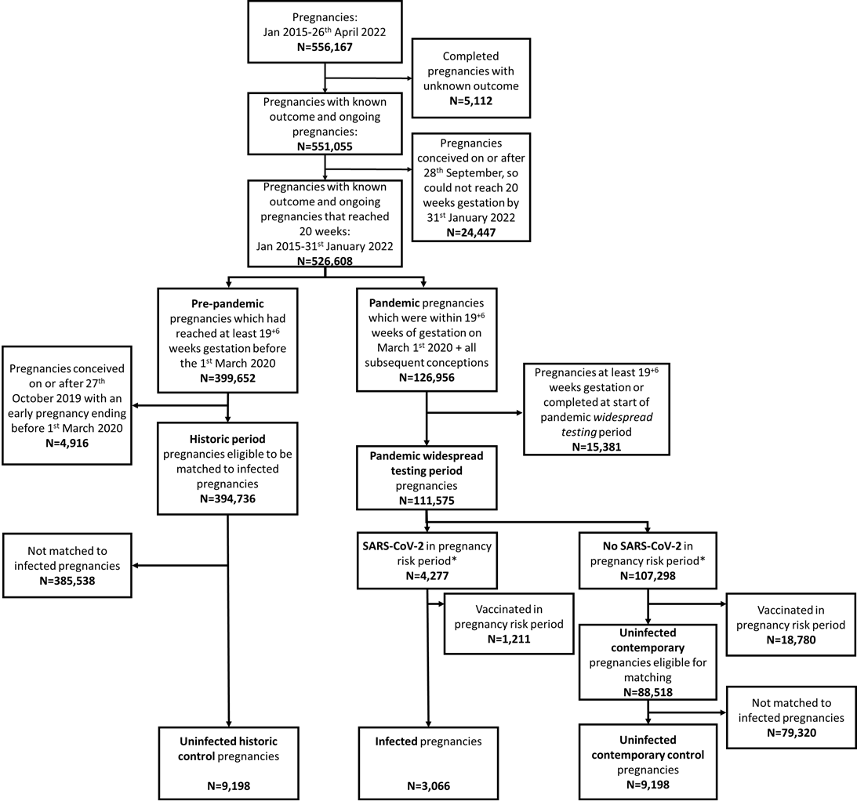
*For miscarriage analysis, SARS-CoV-2 infection needs to be recorded between six weeks pre-conception and up to the earliest of: (1) end of pregnancy or (2) 19+6 weeks gestation.

Extended Data Table 4: Key characteristics of infected and control groups included in the infection and miscarriage analyses
 | Infected  cohort | Uninfected  historical controls | Uninfected  contemporary controls
Key characteristics
Number of pregnancies | 3,066 | 9,198 | 9,198
Median age (min-max) | 28 (14-48) | 28 (14-48) | 28 (13-51)
Deprivation (SIMD quintile)
1 (most deprived) | 947 (30.9%) | 2,219 (24.1%) | 2,456 (26.7%)
2 | 752 (24.5%) | 1,936 (21.0%) | 1,963 (21.3%)
3 | 491 (16.0%) | 1,709 (18.6%) | 1,649 (17.9%)
4 | 488 (15.9%) | 1,720 (18.7%) | 1,714 (18.6%)
5 (least deprived) | 374 (12.2%) | 1,547 (16.8%) | 1,368 (14.9%)
Unknown | 14 (0.5%) | 67 (0.7%) | 48 (0.5%)
Ethnicity
White | 2,713 (88.5%) | 6,395 (69.5%) | 7,750 (84.3%)
South Asian | 103 (3.4%) | 223 (2.4%) | 273 (3.0%)
Black/Caribbean /African | 40 (1.3%) | 98 (1.1%) | 145 (1.6%)
Other/mixed ethnicity | 79 (2.6%) | 217 (2.4%) | 334 (3.6%)
Unknown | 131 (4.3%) | 2,265 (24.6%) | 696 (7.6%)
Urban/rural status
Large urban areas | 1,266 (41.3%) | 3,312 (36.0%) | 3,302 (35.9%)
Other urban areas | 1,092 (35.6%) | 3,521 (38.3%) | 3,474 (37.8%)
Accessible small towns | 198 (6.5%) | 732 (8.0%) | 665 (7.2%)
Remote small towns | 54 (1.8%) | 291 (3.2%) | 283 (3.1%)
Accessible rural areas | 217 (7.1%) | 873 (9.5%) | 950 (10.3%)
Remote rural areas | 76 (2.5%) | 393 (4.3%) | 367 (4.0%)
Unknown | 163 (5.3%) | 76 (0.8%) | 157 (1.7%)
Clinical vulnerability
Extremely vulnerable | 18 (0.6%) | 115 (1.3%) | 70 (0.8%)
Vulnerable | 823 (26.8%) | 2,577 (28.0%) | 2,424 (26.4%)
Not vulnerable | 2,225 (72.6%) | 6,506 (70.7%) | 6,704 (72.9%)
Exposure (SARS-CoV-2 infection)
Gestation at first infection within exposure period
Pre-conception | 662 (21.6%) | - | -
2+0-5+6 weeks | 563 (18.4%) | - | -
6+0-10+6 weeks | 598 (19.5%) | - | -
11+0-15+6 weeks | 568 (18.5%) | - | -
16+0-19+6 weeks | 675 (22.0%) | - | -
Number of infections*
1 | 3,055 (99.6%) | - | -
2+ | 11 (0.4%) | - | -
Evidence of symptomatic infection*
No | 837 (29.3%) | - | -
Yes | 2,229 (72.7%) | - | -
Outcome (miscarriage)
Pregnancies ending in miscarriage up to 19+6 weeks | 209 | 613 | 601
Gestation at miscarriage
<=10+6 | 140 (67.0%) | 549 (89.6%) | 390 (64.9%)
11+0-13+6 | 44 (21.1%) | 39 (6.4%) | 143 (23.8%)
>=14+0 | 25 (12%) | 25 (4.1%) | 68 (11.3%)
Imputed gestation for miscarriage
Yes | 107 (51.2%) | 501 (81.7%) | 272 (45.3%)
No – available from ANC booking | 75 (35.9%) | 29 (4.7%) | 257 (42.8%)
No – available from end of pregnancy record | 27 (12.9%) | 83 (13.5%) | 72 (12%)
Lag between first infection (or gestational week of matching in uninfected) and miscarriage
<2 weeks | 21 (10%) | 82 (13.4%) | 90 (15%)
2-5 weeks | 68 (32.5%) | 161 (26.3%) | 173 (28.8%)
6-9 weeks | 54 (25.8%) | 183 (29.9%) | 164 (27.3%)
>=10 weeks | 66 (31.6%) | 187 (30.5%) | 174 (29%)
SIMD=Scottish Index of Multiple Deprivation
*Between 6 weeks pre-conception and the earliest of either: end of pregnancy or 19+6 weeks gestation
All groups exclude women who received COVID-19 vaccination between 6 weeks pre-conception and the earliest of either: end of pregnancy or the end of the exposure period at 19+6 weeks gestation

Extended Data Fig 3: Selection of pregnancies for the analysis of association between SARS-CoV-2 infection and risk of ectopic pregnancy
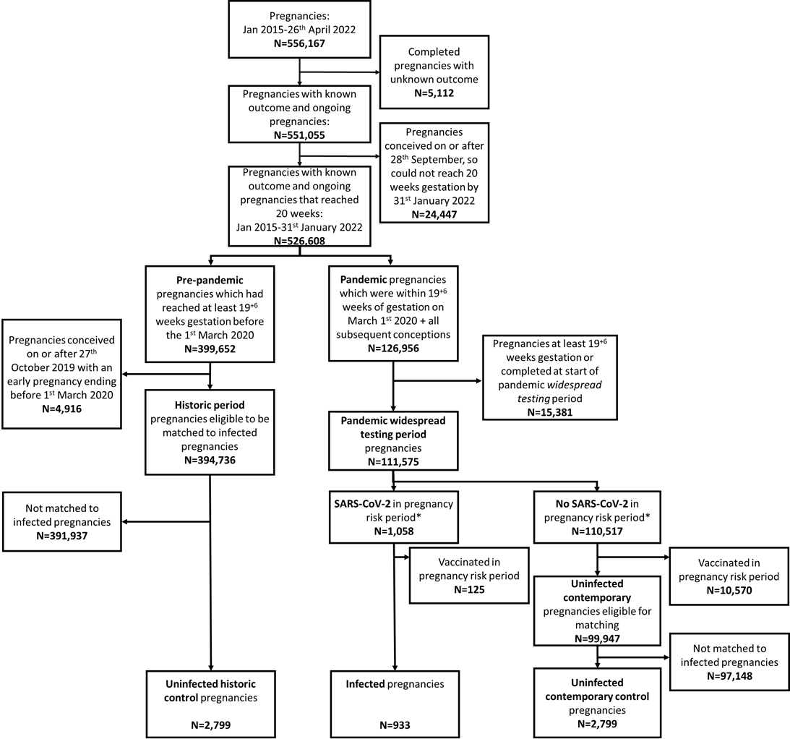
*For ectopic pregnancy analysis, SARS-CoV-2 infection needs to be recorded between six weeks pre-conception and up to the earliest of: (1) end of pregnancy or (2) 2+6 weeks gestation.

Extended Data Table 5: Key characteristics of infected and control groups included in the infection and ectopic pregnancy analyses
 | Infected  cohort | Uninfected  historical controls | Uninfected  contemporary controls
Key characteristics
Number of pregnancies | 933 | 2,799 | 2,799
Median age (min-max) | 28 (13-45) | 28 (14-45) | 28 (13-46)
Deprivation (SIMD quintile)
1 (most deprived) | 300 (32.2%) | 724 (25.9%) | 784 (28.0%)
2 | 227 (24.3%) | 586 (20.9%) | 619 (22.1%)
3 | 148 (15.9%) | 497 (17.8%) | 466 (16.6%)
4 | 151 (16.2%) | 536 (19.1%) | 537 (19.2%)
5 (least deprived) | 95 (10.2%) | 421 (15.0%) | 371 (13.3%)
Unknown | 12 (1.3%) | 35 (1.3%) | 22 (0.8%)
Ethnicity
White | 790 (84.7%) | 1,802 (64.4%) | 2,374 (84.8%)
South Asian | 26 (2.8%) | 49 (1.8%) | 74 (2.6%)
Black/Caribbean /African | 9 (1.0%) | 28 (1.0%) | 39 (1.4%)
Other/mixed ethnicity | 24 (2.6%) | 50 (1.8%) | 70 (2.5%)
Unknown | 84 (9.0%) | 870 (31.1%) | 242 (8.6%)
Urban/rural status
Large urban areas | 382 (40.9%) | 987 (35.3%) | 1,007 (36.0%)
Other urban areas | 349 (37.4%) | 1,056 (37.7%) | 1,016 (36.3%)
Accessible small towns | 59 (6.3%) | 233 (8.3%) | 238 (8.5%)
Remote small towns | 15 (1.6%) | 93 (3.3%) | 87 (3.1%)
Accessible rural areas | 51 (5.5%) | 280 (10.0%) | 288 (10.3%)
Remote rural areas | 17 (1.8%) | 110 (3.9%) | 113 (4.0%)
Unknown | 60 (6.4%) | 40 (1.4%) | 50 (1.8%)
Clinical vulnerability
Extremely vulnerable | 5 (0.5%) | 30 (1.1%) | 26 (0.9%)
Vulnerable | 249 (26.7%) | 775 (27.7%) | 739 (26.4%)
Not vulnerable | 679 (72.8%) | 1,994 (71.2%) | 2,034 (72.7%)
Exposure (SARS-CoV-2 infection)*
Gestation at infection within exposure period*
Preconception | 786 (84.2%) | - | -
2 weeks (2+0 to 2+6) | 147 (15.8%) | - | -
Evidence of symptomatic infection**
No | 249 (26.7%) | - | -
Yes | 684 (73.3%) | - | -
Outcome (ectopic pregnancy)
Pregnancies ending in ectopic pregnancy up to 19+6 weeks | 8 | 33 | 33
Gestation at ectopic pregnancy
<=10+6 | 8 (100%) | 33 (100%) | 33 (100%)
Imputed gestation for ectopic pregnancy
Yes | 8 (100%) | 30 (90.9%) | 30 (90.9%)
No – available from ANC booking | 0 | 0 | 3 (9.1%)
No – available from end of pregnancy record | 0 | 3 (9.1%) | 0
Lag between infection (or gestational week of matching in uninfected) and ectopic pregnancy
<=5 weeks | 0 | 1 (3.0%) | 0
6-9 weeks | 5 (62.5%) | 18 (54.5%) | 20 (60.6%)
>=10 weeks | 3 (37.5%) | 14 (42.4%) | 13 (39.4%)
SIMD=Scottish Index of Multiple Deprivation
*It was only possible to have one infection in the exposure period (i.e. between 6 weeks pre-conception and 2+6 weeks gestation)
**Between 6 weeks pre-conception and the earliest of either: end of pregnancy or 2+6 weeks gestation
All groups exclude women who received COVID-19 vaccination between 6 weeks pre-conception and the earliest of either: end of pregnancy or the end of the exposure period at 2+6 weeks gestation

