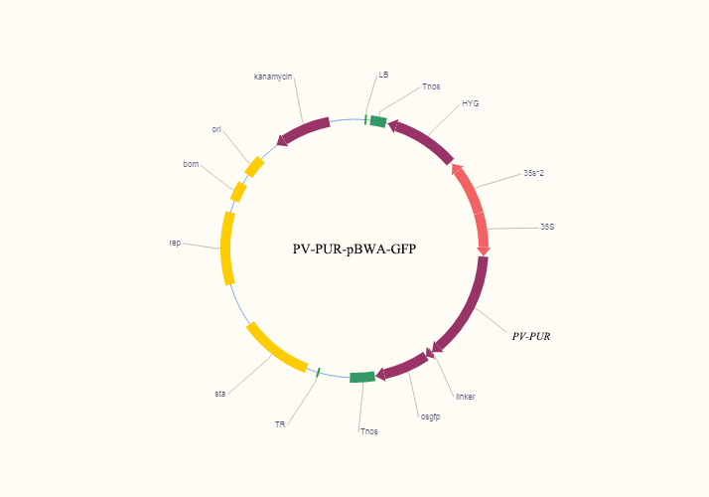
Supplementary Fig. 1 PV-PUR-pBWA-GFP vector map
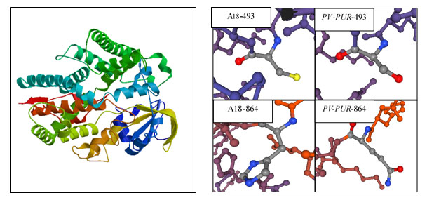
Supplementary Fig. 2 Prediction of tertiary structure and mutation site structure for the PV-PUR protein
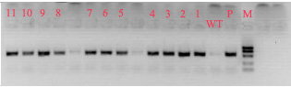
Supplementary Fig. 3 Agarose gel electrophoresis analysis of transgenic plants

