Supporting Information

Superatomic Icosahedral-C_{n}B_{12-n} (n = 0, 1, 2) Stuffed Mononuclear and Binuclear Borafullerene and Borospherene Nanoclusters with Spherical Aromaticity
Min Zhang, Wei-Ping Jia, Ting Zhang, Bin-Bin Pei, Jia Xu, Xinxin Tian, Hai-Gang Lu*, and Si-Dian Li*
Institute of Molecular Science, Shanxi University, Taiyuan 030006, China

Contents
Figure S1 Structural constructions of mononuclear I_{h} B₁₀₄, C_{i} C₅₀B₅₄ (1)，C₁ C₅₀B₅₄
(2), and S₁₀ C₅₀B₅₄ (3) based on the structural motif of I_{h} C₈₀.
Figure S2 Structural constructions of binuclear C_{s} C₈₈B₇₈ (4), C_{s} C₈₈B₇₈ (5), and C_{s}
C₈₈B₇₈ (6) based on the structural motifs of I_{h} C₈₀ and D_{5d} C₁₂₀.
Figure S3 Structural constructions of binuclear C_{s} B₁₈₀ (7)，C_{s} B₁₈₂ (8)，and C_{s} B₁₈₄ (9) based on the structural motifs of I_{h} C₇₀ and C_{2v} C₁₁₀.
Figure S4 Relative energies of low-lying isomers of C₅₀B₅₄.
Figure S5 Relative energies of low-lying isomers of C₈₈B₇₈.
Figure S6 Relative energies of low-lying isomers of B₁₈₄.
Figure S7 Optimized structures of C₁ C₅₀B₃₄ and C_{2h} C₅₀B₃₄ based on the structural motif of I_{h} C₆₀ and optimized structure of C₅ C₅₀B₄₄ based on the structural motif of D_{5h} C₇₀ .
Figure S8 Calculated cohesive energy per atom (E_{c}, eV/atom) of the optimized core-shell boron clusters B_{n} (n = 110-192) as a function of the cluster size (n) at TPSSh/6-311G(d) level.
Figure S9 BOMD simulations of (a) C_{i} C₅₀B₅₄ (1) at 1500K, (b) S₁₀ C₅₀B₅₄ (3) at 1500K, and (c) C_{s} B₁₈₄ (9) at 500K.
Figure S10 The superatomic electronic configuration 1S²1P⁶1D¹⁰1F⁸ of carborane D_{5d} C₂B₁₀H₁₂.
Figure S11 AdNDP bonding analysis of S₁₀ C₅₀B₅₄ (3).
Figure S12 Superatomic bonding orbitals of the two icosahedral B₁₂ cores in C_{s} B₁₈₂
(8) and C_{s} B₁₈₄ (9).
Table S1 Calculated formation energies per atom and HOMO-LUMO gaps of the optimized borafullerenes C₅₀B₅₄ (1, 2, 3) and C₈₈B₇₈ (4, 5, 6) and the calculated NICS values (in ppm) at the geometric centers of the icosahedral-C_{n}B_{12-n} cores in them.
Table S2 Calculated cohesive energies per atom and HOMO-LUMO gaps of the optimized core-shell borospherenes B_{n} (n = 176-188) and the calculated NICS values (in ppm) at the geometric centers of icosahedral-B₁₂ cores in them.
Table S3 Optimized coordinates (x, y, z) of C_{i} C₅₀B₅₄ (1), C₁ C₅₀B₅₄ (2), S₁₀ C₅₀B₅₄ (3), C_{s} C₈₈B₇₈ (4), C_{s} C₈₈B₇₈ (5), C_{s} C₈₈B₇₈ (6), C_{s} B₁₈₀ (7), C_{s} B₁₈₂ (8) and C_{s} B₁₈₄ (9) at PBE0/6-311G(d) level.

Fig. S1 Structural constructions of mononuclear I_{h} B₁₀₄, C_{i} C₅₀B₅₄ (1)，C₁ C₅₀B₅₄ (2)，and S₁₀ C₅₀B₅₄ (3) based on the structural motif of I_{h} C₈₀, with the icosahedral-C_{n}B_{12-n} (n = 0, 1, 2) cores at the center highlighted in pink.

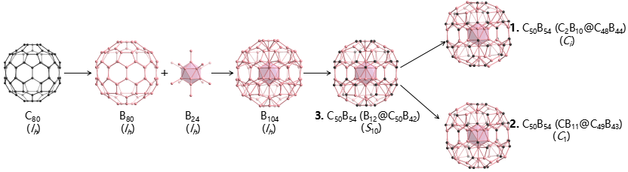

Fig. S2 Structural constructions of binuclear C_{s} C₈₈B₇₈ (4)，C_{s} C₈₈B₇₈ (5)，and C_{s} C₈₈B₇₈ (6) based on the structural motifs of I_{h} C₈₀ and D_{5d} C₁₂₀, with the interconnected icosahedral-C_{n}B_{12-n} (n = 0, 1, 2) cores at the center highlighted in pink.

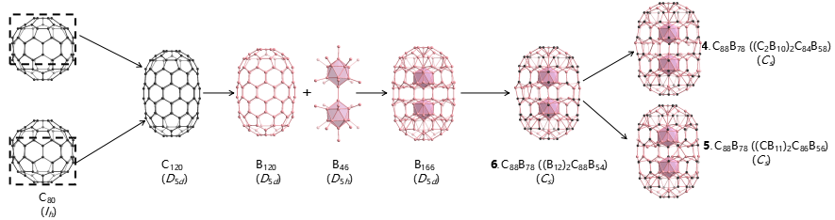

Fig. S3 Structural constructions of binuclear C_{s} B₁₈₀ (7), C_{s} B₁₈₂ (8), and C_{s} B₁₈₄ (9) based on the structural motifs of I_{h} C₇₀ and C_{2v} C₁₁₀, with the interconnected icosahedral-B₁₂ (n = 0, 1, 2) cores at the center highlighted in pink.

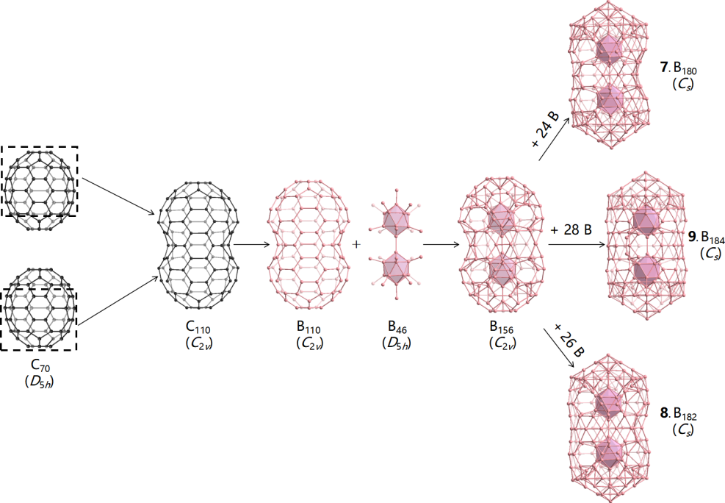
Fig. S4 Relative energies of the low-lying isomers of C₅₀B₅₄ at PBE0/6-31G(d) and PBE0/6-311G(d) (in parentheses) levels in eV.

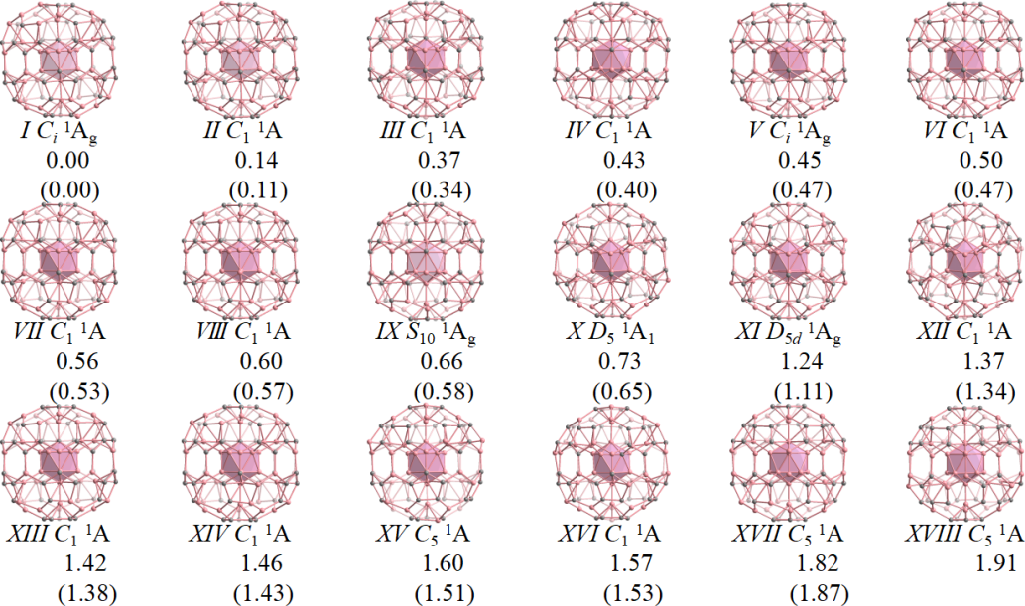

Fig. S5 Relative energies of the low-lying isomers of C₈₈B₇₈ at PBE0/6-31G(d) and PBE0/6-311G(d) (in parentheses) levels in eV.
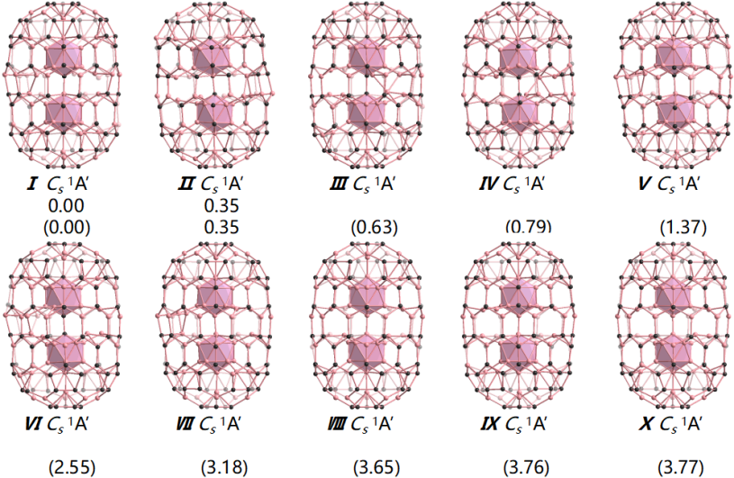
Fig. S6 Relative energies of the low-lying isomers of B₁₈₄ at PBE0/6-31G(d) and PBE0/6-311G(d) (in parentheses) levels in eV.
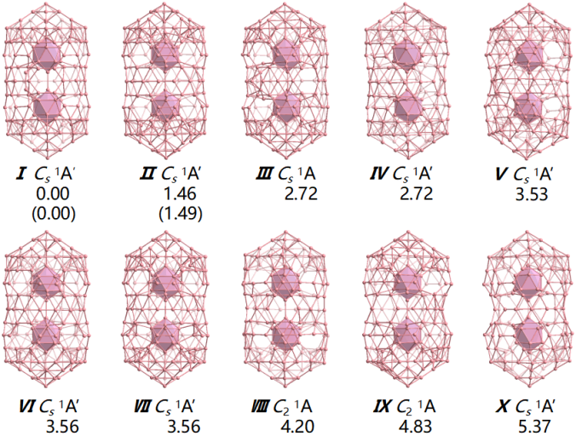
Fig. S7 (a) Optimized structures of C₁ C₅₀B₃₄ obtained in this work and C_{2h} C₅₀B₃₄ from Ref. 41 based on the structural motif of I_{h} C₆₀, with relative energies indicated in eV. (b) Optimized structure of C₅ C₅₀B₄₄ constructed in the work based on the structural motif of D_{5h} C₇₀ at PBE0/6-311G(d) level.

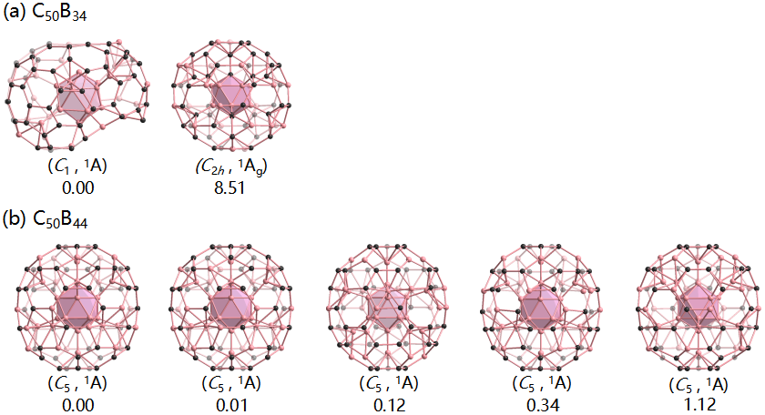

Fig. S8 Calculated cohesive energy per atom (E_{c}, eV/atom) of the optimized core-shell boron clusters B_{n} (n = 110-192) as a function of the cluster size (n) at TPSSh/6-311G(d) level.
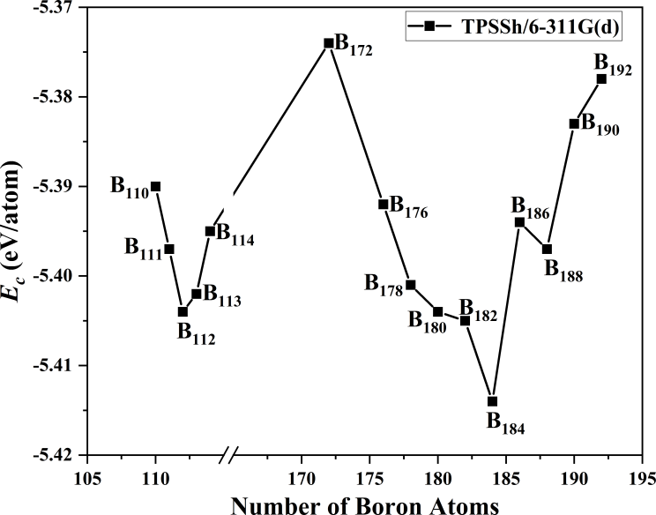

Fig. S9 BOMD simulations of (a) C_{i} C₅₀B₅₄ (1) at 1500K, (b) S₁₀ C₅₀B₅₄ (3) at 1500K, and (c) C_{s} B₁₈₄ (9) at 500 K, with the calculated average root−mean−square−deviations (RMSD) and maximum bond length deviations (MAXD) indicated.
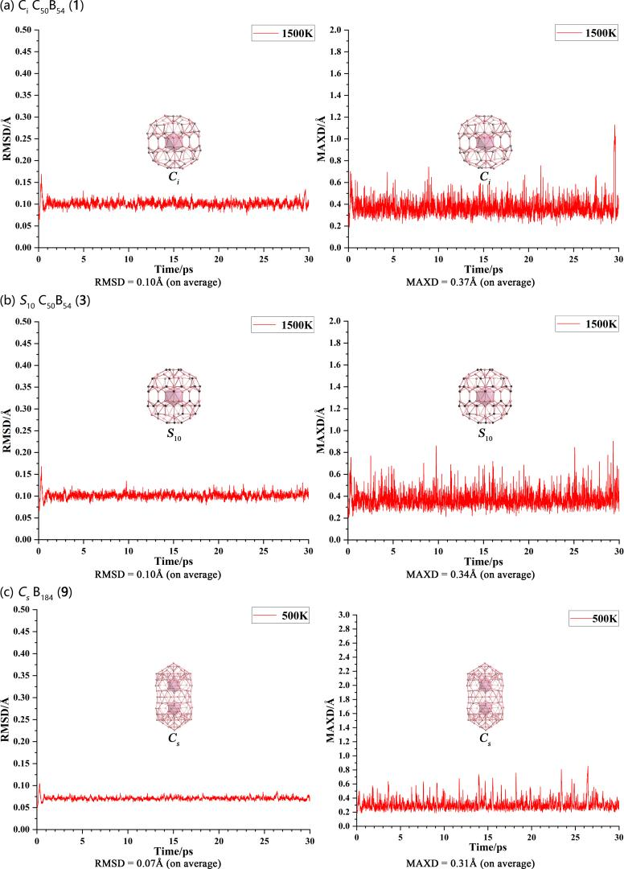
Fig. S10 The superatomic electronic configuration 1S²1P⁶1D¹⁰1F⁸ of carborane D_{5d} C₂B₁₀H₁₂ in canonical molecular orbitals.
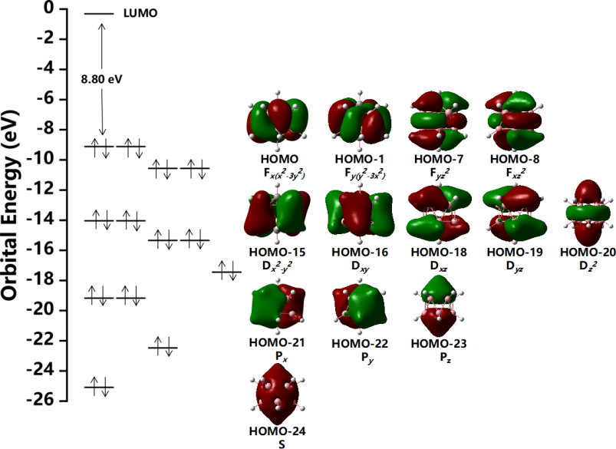
Fig. S11 AdNDP bonding pattern of S₁₀ C₅₀B₅₄ (3) with the occuoation numbers indicated.
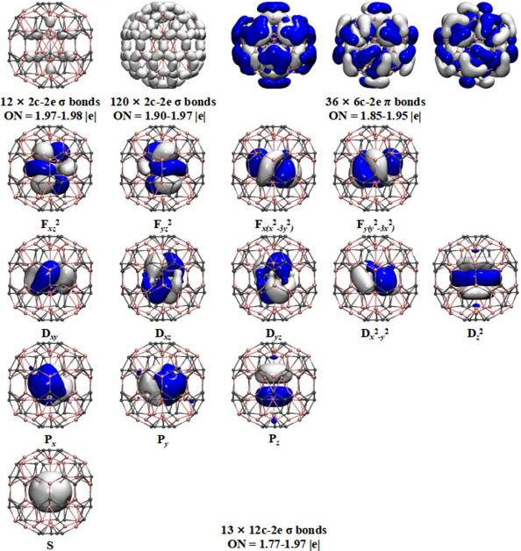

Fig. S12 The superatomic bonding orbitals of the two icosahedral B₁₂ cores in C_{s} B₁₈₂ (8) and C_{s} B₁₈₄ (9) revealed by AdNDP analyses.

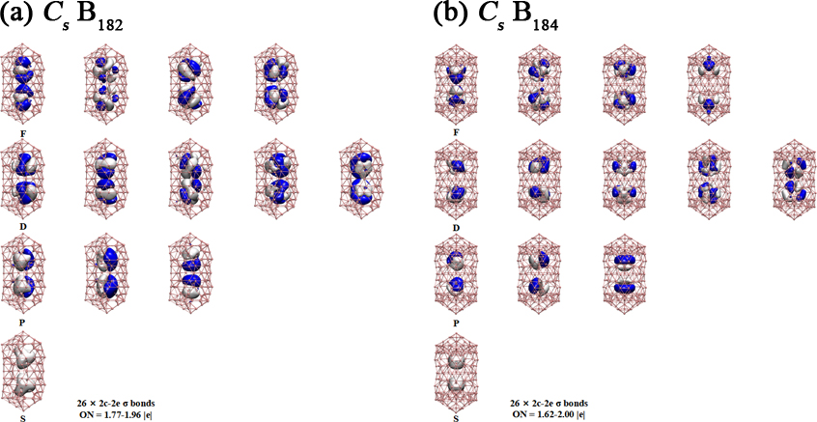

Table S1 Calculated formation energies (E_{f}) (in eV/atom) and HOMO-LUMO gaps (△E_{gap}) (in eV) of the optimized borafullerenes C₅₀B₅₄ (1, 2, 3) and C₈₈B₇₈ (4, 5, 6) and the calculated NICS values (in ppm) at the geometric centers of the icosahedral-C_{n}B_{12-n} cores in them at PBE0/6-311G(d).

Cluster(Symmetry) | PBE0
Cluster(Symmetry) | E_{f} | NICS | △E_{gap}
C₅₀B₅₄(C_{i}) (1) | -0.213 | -23.23 | 2.28
C₅₀B₅₄(C₁) (2) | -0.211 | -20.54 | 2.24
C₅₀B₅₄(S₁₀) (3) | -0.207 | -17.70 | 2.75
C₈₈B₇₈(C_{s}) (4) | -0.209 | -32.47/-28.04 | 0.83
C₈₈B₇₈(C_{s}) (5) | -0.204 | -29.06/-28.25 | 1.75
C₈₈B₇₈(C_{s}) (6) | -0.189 | -28.39/-28.66 | 1.61

Table S2 Calculated cohesive energies per atom (E_{c}) (in eV/atom) and HOMO-LUMO gaps (△E_{gap}) (in eV) of the optimized core-shell borospherenes B_{n} (n = 176-188) and the calculated NICS values (in ppm) at the geometric centers of icosahedral-B₁₂ cores in them at PBE0/6-311G(d) level.

Cluster(Symmetry) | PBE0
Cluster(Symmetry) | -E_{c} | NICS | △E_{gap}
B₁₇₆(C₁) | 5.668 | -29.52/-29.52 | 1.51
B₁₇₈(C₁) | 5.678 | -27.80/-27.80 | 1.35
B₁₈₀(C_{s}) (7) | 5.681 | -30.95/-30.95 | 1.46
B₁₈₂(C_{s}) (8) | 5.679 | -28.32/-28.32 | 1.32
B₁₈₄(C_{s}) (9) | 5.691 | -32.68/-32.65 | 0.87
B₁₈₆(C_{5v}) | 5.670 | -20.63/-20.63 | 1.21
B₁₈₈(C_{s}) | 5.673 | -25.27/-25.27 | 1.02

Table S3 Optimized coordinates (x, y, z) of C_{i} C₅₀B₅₄ (1), C₁ C₅₀B₅₄ (2), S₁₀ C₅₀B₅₄ (3), C_{s} C₈₈B₇₈ (4), C_{s} C₈₈B₇₈ (5), C_{s} C₈₈B₇₈ (6), C_{s} B₁₈₀ (7), C_{s} B₁₈₂ (8) and C_{s} B₁₈₄ (9) at PBE0/6-311G(d) level.

C_{i} C₅₀B₅₄ (1)

B -0.04757300 2.86537500 -1.50473900
B 0.04757300 -2.86537500 1.50473900
B 1.70314700 -2.30417700 -1.50872400
B 0.00741500 -0.04178400 -3.10049800
B -2.73228100 0.83475500 -1.50881300
B -1.70314700 2.30417700 1.50872400
B 1.62589300 2.35749700 1.50822200
B 2.70281200 0.92886000 -1.50668200
B 2.73228100 -0.83475500 1.50881300
B -0.00741500 0.04178400 3.10049800
B -2.70281200 -0.92886000 1.50668200
B -1.62589300 -2.35749700 -1.50822200
B 1.37316300 0.47381000 -0.73625500
B 0.82905000 1.19949500 0.73446400
B -1.38979600 0.41840700 -0.73908100
B -0.87746700 1.16594200 0.73361600
B 0.87746700 -1.16594200 -0.73361600
B 1.38979600 -0.41840700 0.73908100
B -0.82905000 -1.19949500 -0.73446400
B -1.37316300 -0.47381000 0.73625500
B -0.02855300 1.45361700 -0.74123500
B 0.02855300 -1.45361700 0.74123500
B 1.64979800 -2.19260100 3.53030700
B 2.58364300 0.88590900 3.55307300
B -0.06259700 2.87195700 3.61467800
B -1.55676000 -2.26107500 3.53182200
B -2.61505900 0.77509100 3.55800800
C 0.02360800 4.37113600 -0.77048100
B 2.54513900 3.42856400 -0.80818200
B -2.47227800 3.48189600 -0.80855500
C 4.15261300 1.32772800 -0.76970800
B 4.03602800 -1.36077000 -0.81508100
C 2.54602700 -3.54722200 -0.76836200
B -0.04576100 -4.28932300 -0.81206800
C -2.58262200 -3.51601300 -0.76924800
B -4.06428200 -1.27487500 -0.81468900
C -4.13727500 1.37197500 -0.76951600
B -4.03602800 1.36077000 0.81508100
C -2.54602700 3.54722200 0.76836200
B 0.04576100 4.28932300 0.81206800
C 2.58262200 3.51601300 0.76924800
B 4.06428200 1.27487500 0.81468900
C 4.13727500 -1.37197500 0.76951600
B 2.47227800 -3.48189600 0.80855500
C -0.02360800 -4.37113600 0.77048100
B -2.54513900 -3.42856400 0.80818200
C -4.15261300 -1.32772800 0.76970800
B 0.06259700 -2.87195700 -3.61467800
B 2.61505900 -0.77509100 -3.55800800
B -2.58364300 -0.88590900 -3.55307300
B 1.55676000 2.26107500 -3.53182200
B -1.64979800 2.19260100 -3.53030700
C 1.23704900 -0.31060800 -4.21874400
C -1.20392000 -0.42042400 -4.19539900
C 0.69171600 1.06696100 -4.16815600
C -0.78197300 1.00081500 -4.16135700
C 1.40075300 -3.26885700 -2.85595200
B 2.70160800 -2.39088200 -2.96579200
B -1.43194600 -3.37053800 -2.96201100
C -2.61085000 -2.32567900 -2.85960400
C 3.49869600 0.33979300 -2.85576100
C 1.36198600 -3.95539100 -1.55037300
C -1.41800500 -4.01445800 -1.54547100
C 3.35020600 -2.57304300 -1.55640500
C -3.30478400 -2.49796200 -1.56173200
C 4.15540600 0.07687800 -1.55670700
B 3.10986900 1.85152100 -2.95855300
B -3.61250700 0.33644800 -2.96309700
C -3.01964600 1.78483200 -2.85252100
C 0.76056400 3.44260300 -2.85138700
B -0.79596900 3.54745800 -2.95754000
C 3.48845600 2.40368000 -1.55135400
C -4.23592500 0.11116200 -1.55215200
C -3.40213000 2.38366500 -1.55352900
C -1.20613600 4.07022300 -1.54988300
C 1.21413500 3.98507500 -1.55284800
C -1.21413500 -3.98507500 1.55284800
C -0.76056400 -3.44260300 2.85138700
C -3.48845600 -2.40368000 1.55135400
B -3.10986900 -1.85152100 2.95855300
C 1.20613600 -4.07022300 1.54988300
B 0.79596900 -3.54745800 2.95754000
C 3.40213000 -2.38366500 1.55352900
C 3.01964600 -1.78483200 2.85252100
C 4.23592500 -0.11116200 1.55215200
B 3.61250700 -0.33644800 2.96309700
C -4.15540600 -0.07687800 1.55670700
C -3.49869600 -0.33979300 2.85576100
C 2.61085000 2.32567900 2.85960400
C 3.30478400 2.49796200 1.56173200
C -3.35020600 2.57304300 1.55640500
B -2.70160800 2.39088200 2.96579200
C -1.36198600 3.95539100 1.55037300
C -1.40075300 3.26885700 2.85595200
B 1.43194600 3.37053800 2.96201100
C 1.41800500 4.01445800 1.54547100
C -1.23704900 0.31060800 4.21874400
C 1.20392000 0.42042400 4.19539900
C 0.78197300 -1.00081500 4.16135700
C -0.69171600 -1.06696100 4.16815600
C -0.00285900 0.00662900 1.55030000
C 0.00285900 -0.00662900 -1.55030000
B -0.06195200 1.32720300 4.34461400
B 0.06195200 -1.32720300 -4.34461400

C₁ C₅₀B₅₄ (2)

B -0.84588100 2.82247900 -1.27265700
B 0.84483900 -2.83127300 1.32939700
B 2.33700000 -1.55950000 -1.54872500
B 0.06878900 0.24936900 -3.13193600
B -2.82038300 0.12534400 -1.53359100
B -2.35810100 1.54599500 1.61022500
B 0.85197300 2.58195400 1.76058600
B 2.33938200 1.78167900 -1.28187800
B 2.82744400 -0.13114400 1.58100600
B -0.10961400 -0.25360300 3.10881900
B -2.36780500 -1.76967800 1.34731400
B -0.85114200 -2.58508400 -1.70081700
B 0.03285600 0.12393800 -1.56035800
B 1.18498100 0.91081200 -0.59598000
B 0.42039800 1.31737500 0.88794400
B -1.44167400 0.05083100 -0.72774800
B -1.20576200 0.78770300 0.80618400
B 1.19316800 -0.79422500 -0.73199800
B 1.43464400 -0.05877200 0.80000300
B -0.43117300 -1.32550900 -0.81082600
B -1.20035800 -0.91379200 0.67182000
B -0.44402700 1.43250400 -0.59234200
B 0.43114000 -1.43923000 0.66811500
B 2.15646400 -1.88123300 3.45210900
B 2.15085000 1.31739600 3.70464200
B -0.91415600 2.31389300 3.74119000
B -0.90492100 -2.87682600 3.33290200
B -2.95730400 -0.28978400 3.54795400
C -1.22833300 4.24420700 -0.47076300
B 1.45837500 4.05778600 -0.45408200
B -3.34839400 2.67102200 -0.67054700
C 3.62303000 2.53078300 -0.50704900
B 4.27720800 -0.07258400 -0.72771800
C 3.49271200 -2.59666600 -0.91816000
B 1.20970900 -4.01483700 -1.10148900
C -1.43973700 -4.04831100 -1.13567900
B -3.50371700 -2.32005900 -1.07333400
C -4.36061800 0.18146900 -0.87158300
B -4.30525700 0.07415500 0.72082300
C -3.47281700 2.58477000 0.90272500
B -1.21108000 4.01631700 1.11205100
C 1.43594800 4.02756400 1.13039400
B 3.51514900 2.32633000 1.07104400
C 4.34195200 -0.17771200 0.85083500
B 3.36283000 -2.67528100 0.66971000
C 1.22679700 -4.22354400 0.46897100
B -1.45839500 -4.06137600 0.46276200
C -3.60582100 -2.51753400 0.49160300
B 0.92432500 -2.29770200 -3.73155000
B 2.79709200 0.28522800 -3.48615400
B -2.12052900 -1.31590900 -3.72062300
B 0.91054400 2.86501200 -3.32092500
B -2.12930000 1.87704500 -3.46707800
C 0.51489100 -0.83676500 -4.34383800
C 1.34396200 0.37473000 -4.22966200
C -0.89779000 -0.42256800 -4.34146800
C 0.44348400 1.53749800 -4.15617600
C -0.94194500 1.04474200 -4.22575800
C 2.31475600 -2.42117100 -3.00033900
B 3.33677500 -1.25018600 -2.99244100
B -0.33456700 -3.32797900 -3.23539400
C -1.76266600 -2.72659000 -3.11370000
C 3.27817500 1.54082300 -2.66481100
C 2.46459500 -3.23013800 -1.76622600
C -0.15747800 -4.09552900 -1.88916600
C 3.99965000 -1.36860000 -1.58710900
C -2.40990700 -3.21294900 -1.87054400
C 3.98029000 1.38654600 -1.36772800
B 2.48624300 2.87806300 -2.68112300
B -3.45707000 -0.48043400 -3.08180100
C -3.31999800 1.05157500 -2.85043900
C -0.20169600 3.68739200 -2.56817600
B -1.71155900 3.35574800 -2.73486800
C 2.67718500 3.42012800 -1.23234100
C -4.05081000 -0.99037700 -1.73367100
C -3.90731200 1.41772700 -1.53736800
C -2.29657800 3.65524500 -1.32137900
C 0.04373400 4.25713200 -1.21931000
C -0.03837500 -4.26665700 1.22777100
C 0.21084200 -3.73009200 2.58620300
C -2.67098700 -3.40782400 1.23325700
B -2.51507400 -2.88392500 2.70144700
C 2.30267500 -3.64900300 1.31925600
B 1.73033600 -3.38015400 2.74880000
C 3.92385800 -1.41770500 1.53069800
C 3.37237200 -1.05937500 2.85783300
C 4.05805600 0.99307600 1.72163800
B 3.50589800 0.48338100 3.08980700
C -4.01413600 -1.39490600 1.35695900
C -3.36803200 -1.55776900 2.67781200
C 1.78689200 2.74874300 3.13097700
C 2.41714500 3.21387300 1.87088700
C -4.01856300 1.37573400 1.57227800
B -3.41481000 1.26755800 3.00750200
C -2.46412000 3.22308800 1.77302100
C -2.34195500 2.43048300 3.02357900
B 0.34554400 3.36333500 3.26026400
C 0.16131800 4.09591300 1.89270200
C -0.48832800 0.87673300 4.28455300
C 0.92705000 0.42777500 4.24624000
C 0.96413800 -1.04493600 4.13622700
C -0.42700100 -1.56423500 4.11429500
C -0.04317000 -0.12748200 1.57467400
B -1.42470300 -0.37934700 4.31002900

S₁₀ C₅₀B₅₄ (3)

B -0.05475100 2.84779700 -1.49818200
B 0.05475100 -2.84779700 1.49818200
B 1.71862100 -2.27274500 -1.49580200
B 0.00044200 -0.00123200 -3.16113300
B -2.72565800 0.82773800 -1.49771100
B -1.71862100 2.27274500 1.49580200
B 1.62963700 2.33703200 1.49643200
B 2.69192100 0.93143700 -1.49740300
B 2.72565800 -0.82773800 1.49771100
B -0.00044200 0.00123200 3.16113300
B -2.69192100 -0.93143700 1.49740300
B -1.62963700 -2.33703200 -1.49643200
B 0.00025900 -0.00089300 -1.59316000
B 1.37228500 0.48637400 -0.72679500
B 0.82416000 1.20087600 0.72664900
B -1.39623500 0.41261600 -0.72739800
B -0.88725600 1.15519000 0.72627000
B 0.88725600 -1.15519000 -0.72627000
B 1.39623500 -0.41261600 0.72739800
B -0.00025900 0.00089300 1.59316000
B -0.82416000 -1.20087600 -0.72664900
B -1.37228500 -0.48637400 0.72679500
B -0.03871100 1.45540000 -0.72754200
B 0.03871100 -1.45540000 0.72754200
B 1.65180300 -2.16964300 3.56776200
B 2.57370400 0.89992900 3.56805300
B -0.06073900 2.72548300 3.56818300
B -1.55323100 -2.24111500 3.56776500
B -2.61109900 0.78422500 3.56795800
C 0.02702500 4.36970000 -0.78530700
B 2.54548600 3.42061000 -0.80673900
B -2.46643700 3.47799700 -0.80652600
C 4.16447900 1.32457600 -0.78536300
B 4.03971700 -1.36408900 -0.80687400
C 2.54712500 -3.55207700 -0.78567900
B -0.04912900 -4.26352700 -0.80703100
C -2.59078100 -3.52003000 -0.78561100
B -4.06993100 -1.27087000 -0.80697500
C -4.14777600 1.37602400 -0.78537900
B -4.03971700 1.36408900 0.80687400
C -2.54712500 3.55207700 0.78567900
B 0.04912900 4.26352700 0.80703100
C 2.59078100 3.52003000 0.78561100
B 4.06993100 1.27087000 0.80697500
C 4.14777600 -1.37602400 0.78537900
B 2.46643700 -3.47799700 0.80652600
C -0.02702500 -4.36970000 0.78530700
B -2.54548600 -3.42061000 0.80673900
C -4.16447900 -1.32457600 0.78536300
B 0.06073900 -2.72548300 -3.56818300
B 2.61109900 -0.78422500 -3.56795800
B -2.57370400 -0.89992900 -3.56805300
B 1.55323100 2.24111500 -3.56776500
B -1.65180300 2.16964300 -3.56776200
C 0.06190100 -1.25241200 -4.28956400
C 1.21040900 -0.32794000 -4.28925600
C -1.17216600 -0.44575400 -4.28885300
C 0.68608200 1.04993900 -4.28847400
C -0.78629500 0.97713800 -4.28836400
C 1.39012000 -3.20082100 -2.86060100
B 2.70796400 -2.37753300 -2.96546400
B -1.42458000 -3.31037700 -2.96577900
C -2.61477500 -2.31131800 -2.86056700
C 3.47438200 0.33319800 -2.86091700
C 1.34854600 -3.92214300 -1.56083500
C -1.41369900 -3.99518800 -1.56045500
C 3.36268500 -2.57909900 -1.56022800
C -3.31315600 -2.49456600 -1.56060300
C 4.14698100 0.07058700 -1.56078800
B 3.09863000 1.84102900 -2.96548300
B -3.58923600 0.33197900 -2.96596700
C -3.00690500 1.77267300 -2.86069700
C 0.75678900 3.40751900 -2.86106000
B -0.79358900 3.51606900 -2.96585200
C 3.49154100 2.40083800 -1.55983800
C -4.23626500 0.10981100 -1.56031300
C -3.39631000 2.38005300 -1.56033200
C -1.20459900 4.06248300 -1.55993200
C 1.21410100 3.96554400 -1.56067200
C -1.21410100 -3.96554400 1.56067200
C -0.75678900 -3.40751900 2.86106000
C -3.49154100 -2.40083800 1.55983800
B -3.09863000 -1.84102900 2.96548300
C 1.20459900 -4.06248300 1.55993200
B 0.79358900 -3.51606900 2.96585200
C 3.39631000 -2.38005300 1.56033200
C 3.00690500 -1.77267300 2.86069700
C 4.23626500 -0.10981100 1.56031300
B 3.58923600 -0.33197900 2.96596700
C -4.14698100 -0.07058700 1.56078800
C -3.47438200 -0.33319800 2.86091700
C 2.61477500 2.31131800 2.86056700
C 3.31315600 2.49456600 1.56060300
C -3.36268500 2.57909900 1.56022800
B -2.70796400 2.37753300 2.96546400
C -1.34854600 3.92214300 1.56083500
C -1.39012000 3.20082100 2.86060100
B 1.42458000 3.31037700 2.96577900
C 1.41369900 3.99518800 1.56045500
C -1.21040900 0.32794000 4.28925600
C -0.06190100 1.25241200 4.28956400
C 1.17216600 0.44575400 4.28885300
C 0.78629500 -0.97713800 4.28836400
C -0.68608200 -1.04993900 4.28847400

C_{s} C₈₈B₇₈ (4)
B 2.37681800 -0.69364500 1.63956300
B -2.25899600 -3.70315500 -1.59616400
B -0.90205100 -0.71698000 -2.84336400
B -0.90205100 -0.71698000 2.84336400
B 0.86666900 -3.72741000 2.71229500
B 2.92498600 -3.66312400 0.00000000
B 2.37681800 -0.69364500 -1.63956300
B 0.86666900 -3.72741000 -2.71229500
B -0.00599500 -5.27294100 0.00000000
B -2.25899600 -3.70315500 1.59616400
B -2.82674900 -0.66302100 0.00000000
B 1.22462000 -1.50564400 -0.86156000
B 1.49195700 -2.95717900 0.00000000
B -0.42271600 -1.44682000 1.42104000
B 0.47965500 -2.94113000 1.38983100
B -0.42271600 -1.44682000 -1.42104000
B 0.47965500 -2.94113000 -1.38983100
B -1.43491400 -1.48245500 0.00000000
B -1.12827600 -2.91594600 0.84818300
B 1.22462000 -1.50564400 0.86156000
B -1.12827600 -2.91594600 -0.84818300
B 1.75769100 0.91282900 -2.55307800
B -0.87679400 3.68744100 2.64668200
B 1.75769100 0.91282900 2.55307800
B -2.64111600 0.77906500 -1.17105100
B -0.87679400 3.68744100 -2.64668200
B 2.21750500 3.77748600 -1.63617400
B 2.92169000 0.59713400 0.00000000
B 2.21750500 3.77748600 1.63617400
B -0.02609300 5.25765600 0.00000000
B -2.78520300 3.68846700 0.00000000
B -2.64111600 0.77906500 1.17105100
B 1.51095500 1.45392100 0.00000000
B 1.17090800 2.92856600 -0.84211400
B -1.12319800 1.40940200 -0.88809400
B -0.41874700 2.87012900 -1.38737600
B 0.57884900 1.44434500 1.45116400
B 1.17090800 2.92856600 0.84211400
B -1.12319800 1.40940200 0.88809400
B -1.41058300 2.88076400 0.00000000
B 0.57884900 1.44434500 -1.45116400
B -0.41874700 2.87012900 1.38737600
C -1.25222300 -6.43072300 0.00000000
C -4.37885200 3.03586800 0.00000000
B 1.27930500 3.05604000 4.02666400
B 4.11874800 3.08346800 0.00000000
B 1.27930500 3.05604000 -4.02666400
B -3.40068000 3.01454000 -2.43441700
B -3.40068000 3.01454000 2.43441700
B -4.41728200 0.81131400 -1.34447000
B -4.41728200 0.81131400 1.34447000
C -4.25784300 -1.53916200 0.00000000
B -3.46286400 -1.53737800 2.51113800
C -3.87677000 -3.86689600 1.34629300
C -3.87677000 -3.86689600 -1.34629300
C -2.43166000 -3.79948600 -3.30103300
B -3.46286400 -1.53737800 -2.51113800
B -2.46570700 0.73803600 -3.47935300
B -0.06593200 0.74852600 -4.34356600
B 2.77767800 0.85565500 -3.85267700
B 1.30611600 -1.50423800 -4.04587600
C 2.37381100 -3.82825300 -3.42160200
C 4.03740600 -3.86268700 -1.22983400
C -2.43166000 -3.79948600 3.30103300
B -2.46570700 0.73803600 3.47935300
B -0.06593200 0.74852600 4.34356600
B 2.77767800 0.85565500 3.85267700
B 4.16594800 0.84886800 1.45419800
B 4.16594800 0.84886800 -1.45419800
B 4.46198700 -1.42703700 0.00000000
B 1.30611600 -1.50423800 4.04587600
C 2.37381100 -3.82825300 3.42160200
C 4.03740600 -3.86268700 1.22983400
C 1.21912800 6.40566100 0.00000000
B -2.17873500 5.70124000 1.56385700
B 0.77088700 5.73921800 2.53394500
B -2.17873500 5.70124000 -1.56385700
B 2.62072100 5.75661900 0.00000000
B 0.77088700 5.73921800 -2.53394500
B -0.77882200 -5.73044300 -2.52476100
B 2.15755800 -5.68375100 -1.55889700
B 2.15755800 -5.68375100 1.55889700
B -2.64423200 -5.76703300 0.00000000
B -0.77882200 -5.73044300 2.52476100
B 0.00502200 -3.85169500 -4.24359500
B 0.00502200 -3.85169500 4.24359500
C -0.00218600 3.71302500 0.00000000
C 0.07071600 0.69741300 0.00000000
C 0.04377800 -0.74459800 0.00000000
C 0.03012800 -3.73988600 0.00000000
C -2.19084600 -5.07826900 -2.56219200
C -2.19084600 -5.07826900 2.56219200
C 0.33510800 -5.13778500 -3.42134900
C 0.33510800 -5.13778500 3.42134900
C 1.76044600 -5.09676200 -2.96313500
C 1.76044600 -5.09676200 2.96313500
C -3.09390300 -5.12067300 -1.35304600
C -3.09390300 -5.12067300 1.35304600
C 3.37058700 -5.08848100 -0.74476200
C 3.37058700 -5.08848100 0.74476200
C -0.37323400 -6.42288400 -1.18921700
C 1.02083300 -6.40207500 -0.73031300
C 1.02083300 -6.40207500 0.73031300
C -0.37323400 -6.42288400 1.18921700
C 0.34460500 6.39635900 -1.20214800
C -1.06343700 6.37820800 -0.74187300
C -1.06343700 6.37820800 0.74187300
C 0.34460500 6.39635900 1.20214800
C -3.34011100 5.06710400 -0.74185500
C -3.34011100 5.06710400 0.74185500
C -1.77114400 5.05536100 -2.93087900
C -1.77114400 5.05536100 2.93087900
C -0.35752300 5.07038200 -3.40067400
C -0.35752300 5.07038200 3.40067400
C 2.20838800 5.13558900 -2.56826800
C 2.20838800 5.13558900 2.56826800
C 3.09587200 5.13609100 1.36281500
C 3.09587200 5.13609100 -1.36281500
C -3.96008600 3.79177400 -1.18809600
C -3.96008600 3.79177400 1.18809600
C -2.37564500 3.76667400 -3.36928400
C -2.37564500 3.76667400 3.36928400
C -0.11630900 3.79232400 -4.12995800
C -0.11630900 3.79232400 4.12995800
C 3.84805800 3.84505600 -1.36928800
C 3.84805800 3.84505600 1.36928800
C 2.44326900 3.85766100 -3.29889800
C 2.44326900 3.85766100 3.29889800
C -1.36174500 2.99954200 -4.11667100
C -1.36174500 2.99954200 4.11667100
C 3.44487000 3.08865700 -2.57228000
C 3.44487000 3.08865700 2.57228000
C -3.47751100 1.45424900 -2.42446400
C -3.47751100 1.45424900 2.42446400
C -1.37557900 1.53607400 -4.19063300
C -1.37557900 1.53607400 4.19063300
C 1.36243300 1.49152500 -4.15211400
C 1.36243300 1.49152500 4.15211400
C -4.60757500 1.60161500 0.00000000
C 3.49827200 1.61977100 -2.67610600
C 3.49827200 1.61977100 2.67610600
C 4.23247700 1.53491500 0.00000000
C -4.12311200 -0.75235000 -1.25925600
C -4.12311200 -0.75235000 1.25925600
C -2.42621000 -0.87365900 -3.46667100
C -2.42621000 -0.87365900 3.46667100
C -0.11807600 -0.86818000 -4.24201400
C -0.11807600 -0.86818000 4.24201400
C 2.53026000 -0.66941000 -3.39089200
C 2.53026000 -0.66941000 3.39089200
C 4.11145700 -0.70372900 -1.39086800
C 4.11145700 -0.70372900 1.39086800
C -1.40112200 -1.68203200 -4.18258000
C -1.40112200 -1.68203200 4.18258000
C 3.48343300 -1.50386200 -2.49532800
C 3.48343300 -1.50386200 2.49532800
B -4.16758900 -3.11744700 0.00000000
B 4.60194100 -3.09079700 0.00000000
C -3.47887700 -3.07957000 -2.54852200
C -3.47887700 -3.07957000 2.54852200
C -1.37969900 -3.12571700 -4.07838900
C -1.37969900 -3.12571700 4.07838900
C 1.36561700 -3.05842000 4.16611100
C 1.36561700 -3.05842000 -4.16611100
B 3.42179100 -3.07690300 -2.47191800
B 3.42179100 -3.07690300 2.47191800

C_{s} C₈₈B₇₈ (5)

B -2.53453500 0.73142100 1.81262100
B 2.22397100 3.60041700 -1.62355200
B 0.88534900 0.67110600 -2.85870900
B 0.88534900 0.67110600 2.85870900
B -0.80939600 3.70106700 2.68816900
B -2.74965800 3.72097800 0.00000000
B -2.53453500 0.73142100 -1.81262100
B -0.80939600 3.70106700 -2.68816900
B 0.05058300 5.33951600 0.00000000
B 2.22397100 3.60041700 1.62355200
B 2.82190300 0.51618300 0.00000000
B -1.27545100 1.35220700 -0.88777600
B -1.47520500 2.82151900 0.00000000
B 0.40498500 1.35461800 1.42106100
B -0.49393600 2.83173800 1.39494700
B 0.40498500 1.35461800 -1.42106100
B -0.49393600 2.83173800 -1.39494700
B -0.03496800 3.72463800 0.00000000
B 1.44681700 1.39179800 0.00000000
B 1.11411800 2.81371400 0.85068600
B -1.27545100 1.35220700 0.88777600
B 1.11411800 2.81371400 -0.85068600
B -0.93810700 -1.22104100 -2.87524200
B 0.82983800 -3.72499200 2.65077400
B -0.93810700 -1.22104100 2.87524200
B 2.64232300 -0.88367700 -1.19372500
B 0.82983800 -3.72499200 -2.65077400
B -2.29383700 -3.67422900 -1.63769000
B -3.02453400 -1.18103800 0.00000000
B -2.29383700 -3.67422900 1.63769000
B -0.06843800 -5.41257500 0.00000000
B 2.76384100 -3.78274600 0.00000000
B 2.64232300 -0.88367700 1.19372500
B -1.46517700 -1.52526200 0.00000000
B -1.15991300 -2.96107600 -0.84049400
B 1.17987300 -1.52299200 -0.86243400
B 0.43906400 -2.96023900 -1.35801900
B -0.44769800 -1.52462400 1.39609900
B -1.15991300 -2.96107600 0.84049400
B -0.01027100 -3.85365300 0.00000000
B 1.17987300 -1.52299200 0.86243400
B 1.42450900 -2.97566200 0.00000000
B -0.44769800 -1.52462400 -1.39609900
B 0.43906400 -2.96023900 1.35801900
C -0.88095300 6.54857700 -0.73333600
C -0.88095300 6.54857700 0.73333600
C 0.51674600 6.48149300 1.18178200
C -1.64380400 5.16109200 2.87919400
C -3.17991000 5.18627900 0.74337200
C -3.17991000 5.18627900 -0.74337200
C -1.64380400 5.16109200 -2.87919400
C -0.22320900 5.13493600 -3.35729200
C 2.30279800 4.98792100 -2.53732800
C 3.16347300 4.95841100 -1.30626100
C 3.16347300 4.95841100 1.30626100
C 2.30279800 4.98792100 2.53732800
C -0.22320900 5.13493600 3.35729200
B -1.34862700 -3.02284000 4.03816800
B -4.28410700 -2.97205000 0.00000000
B -1.34862700 -3.02284000 -4.03816800
B 3.36028300 -3.11733100 -2.43592500
B 3.36028300 -3.11733100 2.43592500
B 4.43006300 -0.91256600 -1.32618900
B 4.43006300 -0.91256600 1.32618900
B 3.46019600 1.42608400 2.48600700
C 3.50654300 2.94720100 2.49163000
C 3.87625400 3.67095300 1.25142500
C 3.87625400 3.67095300 -1.25142500
C 3.50654300 2.94720100 -2.49163000
C 2.50256200 3.72465900 -3.27696500
B 3.46019600 1.42608400 -2.48600700
B 2.49047800 -0.80286000 -3.49665100
B 0.11290400 -0.70690600 -4.40793100
B -2.68975900 -0.65666300 -3.53152600
B -1.33127200 1.60636900 -4.07824400
C 1.42179400 3.09225900 -4.06415300
C -1.36198400 3.14234600 -4.14232000
C -3.43146200 3.33864600 -2.50518500
C -2.35745300 3.94386400 -3.32049500
C -3.85054800 3.97699200 -1.24046500
C -3.43146200 3.33864600 2.50518500
C -1.36198400 3.14234600 4.14232000
C 1.42179400 3.09225900 4.06415300
C 2.50256200 3.72465900 3.27696500
B 2.49047800 -0.80286000 3.49665100
B 0.11290400 -0.70690600 4.40793100
B -2.68975900 -0.65666300 3.53152600
B -4.20577600 -0.62797800 1.45136100
B -4.20577600 -0.62797800 -1.45136100
B -4.31367700 1.65403300 0.00000000
B -1.33127200 1.60636900 4.07824400
C -2.35745300 3.94386400 3.32049500
C -3.85054800 3.97699200 1.24046500
B 2.04286400 -5.80019600 1.55750100
B -0.91448200 -5.72302700 2.51823200
B 2.04286400 -5.80019600 -1.55750100
B -2.74079600 -5.68185400 0.00000000
B -0.91448200 -5.72302700 -2.51823200
B 0.90281600 5.70456100 -2.49125200
B -2.01393100 5.81349600 -1.53758300
B -2.01393100 5.81349600 1.53758300
B 2.70962100 5.63756500 0.00000000
B 0.90281600 5.70456100 2.49125200
B 0.03417400 3.87144000 -4.21636000
B 0.03417400 3.87144000 4.21636000
C -0.01366000 -0.76680600 0.00000000
C -0.05045500 0.65852900 0.00000000
C 0.91540400 -6.53017700 -0.75010300
C 0.91540400 -6.53017700 0.75010300
C -0.50842300 -6.48784500 1.20965200
C -0.50842300 -6.48784500 -1.20965200
C 0.51674600 6.48149300 -1.18178200
C -4.30656100 3.21989700 0.00000000
C -1.38268100 -6.46370800 0.00000000
C 3.24031100 -5.18589600 -0.74217700
C 3.24031100 -5.18589600 0.74217700
C 1.65975800 -5.12694300 -2.93309400
C 1.65975800 -5.12694300 2.93309400
C 0.23695800 -5.08809200 -3.39061800
C 0.23695800 -5.08809200 3.39061800
C -2.33160400 -5.03909300 -2.56403400
C -2.33160400 -5.03909300 2.56403400
C -3.20898900 -5.02016300 -1.35063400
C -3.20898900 -5.02016300 1.35063400
C 3.90914700 -3.92157000 -1.19252800
C 3.90914700 -3.92157000 1.19252800
C 2.30682700 -3.85020500 -3.37786600
C 2.30682700 -3.85020500 3.37786600
C 0.03000100 -3.80293500 -4.12289800
C 0.03000100 -3.80293500 4.12289800
C -2.54224600 -3.74631000 -3.28774700
C -2.54224600 -3.74631000 3.28774700
C -3.94503300 -3.72268000 -1.34938600
C -3.94503300 -3.72268000 1.34938600
C 1.30276900 -3.05446000 -4.12279200
C 1.30276900 -3.05446000 4.12279200
C -3.54383400 -2.95153400 -2.54310100
C -3.54383400 -2.95153400 2.54310100
C -4.45949700 -1.40447300 0.00000000
C 3.48338400 -1.54507200 -2.43110100
C 3.48338400 -1.54507200 2.43110100
C 1.35955000 -1.58507300 -4.20613800
C 1.35955000 -1.58507300 4.20613800
C -1.38872600 -1.44932000 -4.22961600
C -1.38872600 -1.44932000 4.22961600
C -3.63030800 -1.48331600 -2.61602500
C -3.63030800 -1.48331600 2.61602500
C 4.36694600 -3.17233000 0.00000000
C 4.62922500 -1.73816800 0.00000000
C 4.14737700 0.67141100 -1.24250400
C 4.14737700 0.67141100 1.24250400
C 2.42371300 0.79183500 -3.46817100
C 2.42371300 0.79183500 3.46817100
C 0.11403300 0.89531500 -4.28822300
C 0.11403300 0.89531500 4.28822300
C -2.60821400 0.91184300 -3.45735300
C -2.60821400 0.91184300 3.45735300
C -4.12824200 0.95643400 -1.41322100
C -4.12824200 0.95643400 1.41322100
C 4.17033600 2.97286000 0.00000000
C 1.36817300 6.44527100 0.00000000
C 4.28504200 1.48330100 0.00000000
C 1.41585400 1.65647300 -4.18357300
C 1.41585400 1.65647300 4.18357300
B -3.67029400 1.80777600 -2.66860400
B -3.67029400 1.80777600 2.66860400

C_{s} C₈₈B₇₈ (6)

B 2.44124900 -0.74059300 1.76571200
B -2.21271100 -3.66686300 -1.61758500
B -0.90575800 -0.74731600 -2.85422100
B -0.90575800 -0.74731600 2.85422100
B 0.79418100 -3.72310800 2.68074100
B 2.72132500 -3.72554800 0.00000000
B 2.44124900 -0.74059300 -1.76571200
B 0.79418100 -3.72310800 -2.68074100
B -0.02485200 -5.35174500 0.00000000
B -2.21271100 -3.66686300 1.61758500
B -2.86373600 -0.58211300 0.00000000
B -0.00752600 -0.69065700 0.00000000
B 1.21537700 -1.38326100 -0.87822000
B 1.45216300 -2.84026000 0.00000000
B -0.44770800 -1.40438900 1.42361700
B 0.47028400 -2.86349700 1.39732800
B -0.44770800 -1.40438900 -1.42361700
B 0.47028400 -2.86349700 -1.39732800
B 0.02735700 -3.74980000 0.00000000
B -1.49053900 -1.44494900 0.00000000
B -1.13432900 -2.86307000 0.84807100
B 1.21537700 -1.38326100 0.87822000
B -1.13432900 -2.86307000 -0.84807100
B 0.78302800 1.31442600 -2.89974200
B -0.82579700 3.78539700 2.64825000
B 0.78302800 1.31442600 2.89974200
B -2.79901000 1.02026300 -0.96765600
B -0.82579700 3.78539700 -2.64825000
B 2.28732300 3.68807000 -1.63759300
B 2.95731700 1.25670800 0.00000000
B 2.28732300 3.68807000 1.63759300
B 0.09162500 5.44107900 0.00000000
B -2.72643900 3.88406700 0.00000000
B -2.79901000 1.02026300 0.96765600
B -0.08942800 0.81067000 0.00000000
B 1.40302900 1.52948400 0.00000000
B 1.15429100 2.97482700 -0.84623700
B -1.26136300 1.62397200 -0.85247300
B -0.45054200 3.02671300 -1.36059300
B 0.37664700 1.56204400 1.40192200
B 1.15429100 2.97482700 0.84623700
B 0.03915900 3.89313300 0.00000000
B -1.26136300 1.62397200 0.85247300
B -1.40704300 3.08435200 0.00000000
B 0.37664700 1.56204400 -1.40192200
B -0.45054200 3.02671300 1.36059300
C -0.46679600 -6.50083700 -1.18286600
C 0.93203300 -6.54314100 -0.73231400
C -1.32236400 -6.47813600 0.00000000
C 0.93203300 -6.54314100 0.73231400
C -0.46679600 -6.50083700 1.18286600
C 3.94411400 3.72504000 1.34989700
C 2.54269300 3.75182400 -3.29083300
C -2.30568600 3.85977200 -3.38652000
C -3.89249300 3.94215100 1.18985700
C -0.02806700 3.81585900 4.13017600
C -1.29725700 3.06225200 -4.11806200
C -4.27885100 3.18261700 0.00000000
C -1.29725700 3.06225200 4.11806200
C 3.54357800 2.95920000 2.54699500
C 3.54357800 2.95920000 -2.54699500
C 1.68829200 -5.13737600 2.88678700
C 3.22970200 -5.14113600 0.74796700
C 3.22970200 -5.14113600 -0.74796700
C 1.68829200 -5.13737600 -2.88678700
C 0.26354900 -5.14956600 -3.37337900
C -2.27890600 -5.03577000 -2.54738400
C -3.14538700 -5.01762200 -1.31092200
C -3.14538700 -5.01762200 1.31092200
C -2.27890600 -5.03577000 2.54738400
C 0.26354900 -5.14956600 3.37337900
C 1.39171600 1.43204700 -4.22056300
C -3.51935200 1.53335100 -2.47343900
C -3.51935200 1.53335100 2.47343900
C 1.39171600 1.43204700 4.22056300
C 4.41254700 1.37845700 0.00000000
C -1.66764100 5.15690000 2.95577800
C -0.23845500 5.11785800 3.41334700
C -3.26276300 5.23312400 0.74948400
C -3.26276300 5.23312400 -0.74948400
C 2.33609200 5.04966800 2.56977200
C 3.21285400 5.02802200 1.35340500
C -1.66764100 5.15690000 -2.95577800
C -0.23845500 5.11785800 -3.41334700
C 3.21285400 5.02802200 -1.35340500
C 2.33609200 5.04966800 -2.56977200
B 1.34980900 3.02522000 4.04248700
B 4.27295600 2.96791300 0.00000000
B 1.34980900 3.02522000 -4.04248700
B -3.36525700 3.11555700 -2.44573900
B -3.36525700 3.11555700 2.44573900
B -4.43500100 0.85563600 -1.39898300
B -4.43500100 0.85563600 1.39898300
C -4.17620400 -0.72053200 -1.25562900
C -4.17620400 -0.72053200 1.25562900
C -4.32384900 -1.52247700 0.00000000
B -3.46038700 -1.46275400 2.48343600
C -4.16036200 -3.02193500 0.00000000
C -3.49045900 -2.99400900 2.49173200
C -3.86437000 -3.72415000 1.25343000
C -3.86437000 -3.72415000 -1.25343000
C -3.49045900 -2.99400900 -2.49173200
C -2.49005500 -3.76133300 -3.28043400
B -3.46038700 -1.46275400 -2.48343600
C -2.43172100 -0.81045000 -3.47565100
B -2.50175700 0.79745000 -3.49810800
B -0.11371800 0.70378500 -4.43321200
B 2.66456100 0.66717200 -3.50542800
C 2.59645300 -0.93181600 -3.39354500
C 3.56378800 -1.77277600 -2.59180800
B 1.31495100 -1.60581100 -4.06233000
C -0.11770800 -0.89967900 -4.29026600
C -1.42329100 -1.67261000 -4.20603500
C -1.41783100 -3.11322500 -4.07410500
C 1.35970100 -3.13168500 -4.13864300
C 3.39035500 -3.21824400 -2.47406300
C 4.29338200 -3.16853700 0.00000000
C 2.35420500 -3.88582400 -3.31952600
C 3.85259900 -3.89878000 -1.22908100
C 3.39035500 -3.21824400 2.47406300
C 1.35970100 -3.13168500 4.13864300
C -1.41783100 -3.11322500 4.07410500
C -2.49005500 -3.76133300 3.28043400
B -2.50175700 0.79745000 3.49810800
C -2.43172100 -0.81045000 3.47565100
C -1.42329100 -1.67261000 4.20603500
B -0.11371800 0.70378500 4.43321200
C -0.11770800 -0.89967900 4.29026600
B 2.66456100 0.66717200 3.50542800
C 2.59645300 -0.93181600 3.39354500
B 4.15653600 0.63695800 1.45671400
C 4.05097500 -0.96558700 1.42279000
B 4.15653600 0.63695800 -1.45671400
C 4.05097500 -0.96558700 -1.42279000
B 4.26678600 -1.63633300 0.00000000
C 3.56378800 -1.77277600 2.59180800
B 1.31495100 -1.60581100 4.06233000
C 2.35420500 -3.88582400 3.31952600
C 3.85259900 -3.89878000 1.22908100
C -0.90961700 6.55274800 0.75116100
C 0.51403500 6.51460800 1.21167700
C -0.90961700 6.55274800 -0.75116100
C 1.39130100 6.49420900 0.00000000
C 0.51403500 6.51460800 -1.21167700
B -2.04623600 5.82934500 1.56907000
B 0.91658400 5.73957000 2.52605000
B -2.04623600 5.82934500 -1.56907000
B 2.74441700 5.69257300 0.00000000
B 0.91658400 5.73957000 -2.52605000
C 3.94411400 3.72504000 -1.34989700
C 2.54269300 3.75182400 3.29083300
C -2.30568600 3.85977200 3.38652000
C -0.02806700 3.81585900 -4.13017600
C -3.89249300 3.94215100 -1.18985700
C 3.62413200 1.48870200 2.61933800
C 3.62413200 1.48870200 -2.61933800
C -1.34935900 1.58263200 -4.19811000
C -4.36592900 1.68538700 0.00000000
C -1.34935900 1.58263200 4.19811000
B -0.86563000 -5.72989400 -2.49855500
B 2.05645100 -5.78339200 -1.53819300
B 2.05645100 -5.78339200 1.53819300
B -2.68234000 -5.68754100 0.00000000
B -0.86563000 -5.72989400 2.49855500
B -0.02664500 -3.88325900 -4.22268800
B -0.02664500 -3.88325900 4.22268800

C_{s} B₁₈₀ (7)

B -0.89190900 1.10069300 3.52493500
B 0.82802000 1.12036800 3.56590000
B 1.37029700 -0.50752000 3.58774400
B -1.41410400 -0.54281100 3.55579700
B -0.00503400 -1.52676000 3.58510300
B 1.45401000 0.41340100 2.05248400
B 0.94482100 -1.29105800 2.05448500
B -1.44575200 0.35418500 2.01980100
B -0.82229500 -1.31837900 2.05827900
B -0.03240500 -0.05907400 4.50429700
B 0.03308300 -0.08319500 0.95212400
B -1.73987100 3.83176100 4.04018100
B -3.19993100 2.77899300 3.97368600
B -3.20138700 1.93906100 5.49949000
B -1.75801400 2.35909200 6.39260700
B -0.90297100 3.48451800 5.50055600
B 0.75027200 1.13070700 7.30807200
B -1.50961400 -0.50458000 7.30343200
B -3.74809200 0.31997300 5.50690200
B -2.88207700 -0.91384100 6.40026400
B -0.12481800 -1.51245700 7.24900300
B -1.52191700 -3.40438700 5.49462900
B -4.32704300 -0.37684100 4.08960600
B -1.91365100 -3.71653100 2.75627100
B -3.49588600 -2.88371700 2.66820800
B -1.40503500 -2.82861300 0.00000000
B -3.87333400 -2.11223500 1.28706400
B -2.83122500 -1.81038900 0.00000000
B -4.40197600 -0.38353000 1.18592600
B -4.53200300 0.52871800 2.57043400
B -3.93328500 2.14160300 2.57194600
B -3.11966200 2.74013600 1.21815400
B -3.19837800 -0.08722000 0.00000000
B -2.96503200 1.64075900 0.00000000
B -0.74075200 -3.43157000 1.42879600
B -0.98072300 -4.23461900 4.05121900
B 0.86935900 -3.92529000 1.31687900
B 1.85577600 -4.07112500 2.69529200
B 1.81089900 -3.59032500 0.00000000
B -0.63778200 3.82328500 0.00000000
B -1.69606000 3.71624700 1.25318600
B -0.83524300 4.31647600 2.65063300
B 0.95226300 3.84848800 0.00000000
B 3.21217000 -2.80285200 0.00000000
B 3.68829800 -2.10997400 1.49476100
B 4.15995500 -0.49514800 1.48148200
B 4.09800400 0.37810300 0.00000000
B 3.62728200 1.93920400 0.00000000
B 3.15489900 2.68905300 1.46808900
B 1.77876200 3.65485700 1.47629800
B 3.94417000 2.09780500 2.80164600
B 4.44831800 0.46744800 2.80973200
B 4.17322600 -0.53090900 4.21466000
B 3.61680100 -2.18023600 4.20238100
B 3.27655900 -3.10469100 2.78466700
B 1.27741100 -3.46718300 5.56085300
B 2.67537400 -2.42398300 5.62284200
B 2.60745500 -0.94922600 6.48316000
B 1.27465500 -0.50826900 7.34662900
B -0.14855800 -2.92330500 6.37929300
B 3.56894600 0.19710000 5.65291000
B 1.59009500 2.25379300 6.45141400
B 3.03382200 1.84745500 5.63676700
B 3.12417500 2.76857600 4.18387300
B 0.82102100 3.49269900 5.56904700
B 0.88861000 4.29771400 2.71340600
B 1.72170000 3.79172300 4.14187600
B 0.79054600 -4.20777700 4.08609800
B -0.10408400 -0.03048300 6.21420000
B -3.91841100 -2.08634300 4.12300500
B -2.85612700 -2.37118500 5.47754000
B -0.11357700 -2.80024400 4.60524700
B -2.11985200 -2.54951800 1.48692400
B -2.68484800 -0.85806000 4.58992500
B -2.95602600 0.88073800 1.51775800
B -1.67053000 2.13354900 4.57402500
B -0.00763000 3.04977100 1.43923300
B 1.54985200 2.12727400 4.68056500
B 3.00062500 0.89660500 1.50862800
B 2.51478300 -0.89503600 4.72397100
B 1.94062200 -2.55143100 1.48764700
B -0.09987700 -0.07199100 8.14506400
B 4.08449200 -1.44519300 5.67185100
B 2.52932000 3.48470200 5.62520400
B -2.64731300 3.53394400 5.42590300
B -4.27917500 -1.32753800 5.56051900
B -0.16421200 -4.42918700 5.51741800
B -0.00687200 1.44288600 2.02239000
B -0.89190900 1.10069300 -3.52493500
B -1.41410400 -0.54281100 -3.55579700
B -0.00503400 -1.52676000 -3.58510300
B 0.82802000 1.12036800 -3.56590000
B 1.37029700 -0.50752000 -3.58774400
B -0.82229500 -1.31837900 -2.05827900
B 0.94482100 -1.29105800 -2.05448500
B -0.00687200 1.44288600 -2.02239000
B 1.45401000 0.41340100 -2.05248400
B -0.03240500 -0.05907400 -4.50429700
B 0.03308300 -0.08319500 -0.95212400
B -3.19993100 2.77899300 -3.97368600
B -1.73987100 3.83176100 -4.04018100
B -0.90297100 3.48451800 -5.50055600
B -1.75801400 2.35909200 -6.39260700
B -3.20138700 1.93906100 -5.49949000
B -0.94284600 1.17906000 -7.32652800
B -1.50961400 -0.50458000 -7.30343200
B 0.75027200 1.13070700 -7.30807200
B 0.82102100 3.49269900 -5.56904700
B 1.59009500 2.25379300 -6.45141400
B 1.27465500 -0.50826900 -7.34662900
B 3.56894600 0.19710000 -5.65291000
B 1.72170000 3.79172300 -4.14187600
B 4.44831800 0.46744800 -2.80973200
B 3.94417000 2.09780500 -2.80164600
B 3.15489900 2.68905300 -1.46808900
B 1.77876200 3.65485700 -1.47629800
B 0.88861000 4.29771400 -2.71340600
B -0.83524300 4.31647600 -2.65063300
B -1.69606000 3.71624700 -1.25318600
B 4.15995500 -0.49514800 -1.48148200
B 4.17322600 -0.53090900 -4.21466000
B 3.68829800 -2.10997400 -1.49476100
B 3.27655900 -3.10469100 -2.78466700
B -3.11966200 2.74013600 -1.21815400
B -3.93328500 2.14160300 -2.57194600
B 0.86935900 -3.92529000 -1.31687900
B -0.74075200 -3.43157000 -1.42879600
B -3.87333400 -2.11223500 -1.28706400
B -4.40197600 -0.38353000 -1.18592600
B -3.49588600 -2.88371700 -2.66820800
B -1.91365100 -3.71653100 -2.75627100
B -0.98072300 -4.23461900 -4.05121900
B 0.79054600 -4.20777700 -4.08609800
B 1.85577600 -4.07112500 -2.69529200
B 2.67537400 -2.42398300 -5.62284200
B 1.27741100 -3.46718300 -5.56085300
B -0.14855800 -2.92330500 -6.37929300
B -0.12481800 -1.51245700 -7.24900300
B 2.60745500 -0.94922600 -6.48316000
B -1.52191700 -3.40438700 -5.49462900
B -2.88207700 -0.91384100 -6.40026400
B -2.85612700 -2.37118500 -5.47754000
B -3.91841100 -2.08634300 -4.12300500
B -3.74809200 0.31997300 -5.50690200
B -4.53200300 0.52871800 -2.57043400
B -4.32704300 -0.37684100 -4.08960600
B 3.61680100 -2.18023600 -4.20238100
B -0.10408400 -0.03048300 -6.21420000
B 3.12417500 2.76857600 -4.18387300
B 3.03382200 1.84745500 -5.63676700
B 2.51478300 -0.89503600 -4.72397100
B 3.00062500 0.89660500 -1.50862800
B 1.54985200 2.12727400 -4.68056500
B -0.00763000 3.04977100 -1.43923300
B -1.67053000 2.13354900 -4.57402500
B -2.95602600 0.88073800 -1.51775800
B -2.68484800 -0.85806000 -4.58992500
B -2.11985200 -2.54951800 -1.48692400
B -0.11357700 -2.80024400 -4.60524700
B 1.94062200 -2.55143100 -1.48764700
B -0.09987700 -0.07199100 -8.14506400
B -0.16421200 -4.42918700 -5.51741800
B -4.27917500 -1.32753800 -5.56051900
B -2.64731300 3.53394400 -5.42590300
B 2.52932000 3.48470200 -5.62520400
B 4.08449200 -1.44519300 -5.67185100
B -1.44575200 0.35418500 -2.01980100
B -0.94284600 1.17906000 7.32652800
B -2.24830400 0.70837600 6.32787400
B -0.01142100 4.17411200 4.05952100
B 2.39264200 -3.49827600 4.12687500
B 3.96382200 1.21106300 4.18911600
B -4.31596700 -1.26625200 2.60998000
B 4.09127400 -1.39168400 0.00000000
B 2.54325100 3.33069600 0.00000000
B -4.31596700 -1.26625200 -2.60998000
B 2.39264200 -3.49827600 -4.12687500
B 3.96382200 1.21106300 -4.18911600
B -0.01142100 4.17411200 -4.05952100
B -2.24830400 0.70837600 -6.32787400

C_{s} B₁₈₂ (8)

B -1.42342200 -0.08552400 3.61659300
B -0.43677900 1.32829300 3.62442100
B 1.21473900 0.85757800 3.55961700
B -0.40491400 -1.46885400 3.52296800
B 1.25020200 -0.88272200 3.44741900
B 0.41681200 1.45144600 2.04525700
B 1.48033500 0.05825100 1.97119200
B -1.22998400 -0.91337100 2.02994900
B 0.44698600 -1.41678400 1.96067700
B 0.07393300 -0.08159800 4.52186700
B -0.04197800 0.01913700 0.94595200
B -4.18219100 0.79036100 4.29896600
B -4.16667500 -1.00624800 4.29245900
B -3.27640100 -1.51645200 5.64673300
B -2.81125900 -0.12775700 6.52265800
B -3.31683600 1.27778200 5.68455400
B -0.39995200 1.30432300 7.36115200
B -0.39199000 -1.48142300 7.34958900
B -2.30154400 -2.87135900 5.54951900
B -0.81564300 -2.84441900 6.40729700
B 1.28349700 -0.92032200 7.36447900
B 2.01910700 -3.09036200 5.50500200
B -2.11928900 -3.84489400 4.14574600
B 2.28948400 -3.80910600 2.70556200
B 0.56853600 -4.26337600 2.76750000
B 1.78554800 -2.66052000 0.00000000
B -0.47244200 -4.03653500 1.41006600
B 0.33918200 -3.69472500 0.00000000
B -2.17836000 -3.63584600 1.45199400
B -3.03955000 -3.30483000 2.80940400
B -4.06080900 -1.90307100 2.80824600
B -4.19082200 -0.97281500 1.44262400
B -2.86059100 -3.04981800 0.00000000
B -3.80797700 -1.72964400 0.00000000
B 2.89263700 -3.05277100 1.43504600
B 3.01057400 -3.19760700 4.13010300
B 3.89634400 -1.54487700 1.45371300
B 4.48508400 -0.74560400 2.72262400
B 3.17206500 -0.68642000 0.00000000
B -3.76489300 1.62286400 0.00000000
B -4.16172600 0.85977200 1.45701400
B -4.06685200 1.75357000 2.83915000
B -2.83024700 2.94917100 0.00000000
B 3.52960900 1.01942800 0.00000000
B 3.79913300 1.83459600 1.37575200
B 2.69217200 3.25859400 1.37527600
B 1.83837500 3.58967300 0.00000000
B 0.29835400 4.06789100 0.00000000
B -0.52866000 4.22560000 1.45288100
B -2.25869700 3.58789300 1.45934800
B 0.39424200 4.41334000 2.80583600
B 2.08571100 3.91843100 2.77322100
B 2.80571200 3.26170200 4.23319700
B 3.93745600 1.86773700 4.18096600
B 4.33965200 1.03698900 2.70905600
B 3.59021400 -0.76769400 5.52248800
B 3.58047600 0.89899200 5.55800300
B 2.35958800 1.67057000 6.45810300
B 1.24892700 0.79839500 7.30493800
B 2.44869200 -1.68187200 6.42063600
B 1.85761800 3.08689200 5.63676700
B -0.88384400 2.63979800 6.52905900
B 0.26515700 3.56815500 5.66001200
B -0.49385100 4.21307800 4.29307800
B -2.37394300 2.64435900 5.68110900
B -3.06763900 3.19011100 2.83338500
B -2.20232400 3.61741400 4.29756900
B 4.08190500 -1.66886100 4.13543900
B 0.08837000 -0.11000100 6.23500900
B -0.38445600 -4.39459500 4.12683400
B 0.39227400 -3.70726600 5.52027000
B 2.32215600 -1.56513500 4.58696700
B 0.95788300 -3.01338900 1.49992600
B -0.77082800 -2.73722300 4.51903400
B -2.52381700 -1.90737900 1.63244200
B -2.68168200 -0.10565400 4.72226600
B -2.55080200 1.76079400 1.67854100
B -0.85175900 2.51426800 4.73038800
B 0.92865800 2.96770600 1.56874600
B 2.23157100 1.62125100 4.64508300
B 3.11380800 0.19808100 1.51484100
B 0.07023000 -0.03913200 8.16556000
B 3.49491800 2.60022200 5.65863000
B -1.37680000 4.02537000 5.75057300
B -4.28289800 -0.13027400 5.74577800
B -1.28684700 -4.24658300 5.52255400
B 3.66521900 -2.50426300 5.52794200
B -1.23206600 0.84366300 2.07815800
B -1.42342200 -0.08552400 -3.61659300
B -0.40491400 -1.46885400 -3.52296800
B 1.25020200 -0.88272200 -3.44741900
B -0.43677900 1.32829300 -3.62442100
B 1.21473900 0.85757800 -3.55961700
B 0.44698600 -1.41678400 -1.96067700
B 1.48033500 0.05825100 -1.97119200
B -1.23206600 0.84366300 -2.07815800
B 0.41681200 1.45144600 -2.04525700
B 0.07393300 -0.08159800 -4.52186700
B -0.04197800 0.01913700 -0.94595200
B -4.16667500 -1.00624800 -4.29245900
B -4.18219100 0.79036100 -4.29896600
B -3.31683600 1.27778200 -5.68455400
B -2.81125900 -0.12775700 -6.52265800
B -3.27640100 -1.51645200 -5.64673300
B -1.38546100 -0.11215900 -7.33236700
B -0.39199000 -1.48142300 -7.34958900
B -0.39995200 1.30432300 -7.36115200
B -2.37394300 2.64435900 -5.68110900
B -0.88384400 2.63979800 -6.52905900
B 1.24892700 0.79839500 -7.30493800
B 1.85761800 3.08689200 -5.63676700
B -2.20232400 3.61741400 -4.29756900
B 2.08571100 3.91843100 -2.77322100
B 0.39424200 4.41334000 -2.80583600
B -0.52866000 4.22560000 -1.45288100
B -2.25869700 3.58789300 -1.45934800
B -3.06763900 3.19011100 -2.83338500
B -4.06685200 1.75357000 -2.83915000
B -4.16172600 0.85977200 -1.45701400
B 2.69217200 3.25859400 -1.37527600
B 2.80571200 3.26170200 -4.23319700
B 3.79913300 1.83459600 -1.37575200
B 4.33965200 1.03698900 -2.70905600
B -4.19082200 -0.97281500 -1.44262400
B -4.06080900 -1.90307100 -2.80824600
B 3.89634400 -1.54487700 -1.45371300
B 2.89263700 -3.05277100 -1.43504600
B -0.47244200 -4.03653500 -1.41006600
B -2.17836000 -3.63584600 -1.45199400
B 0.56853600 -4.26337600 -2.76750000
B 2.28948400 -3.80910600 -2.70556200
B 3.01057400 -3.19760700 -4.13010300
B 4.08190500 -1.66886100 -4.13543900
B 4.48508400 -0.74560400 -2.72262400
B 3.58047600 0.89899200 -5.55800300
B 3.59021400 -0.76769400 -5.52248800
B 2.44869200 -1.68187200 -6.42063600
B 1.28349700 -0.92032200 -7.36447900
B 2.35958800 1.67057000 -6.45810300
B 2.01910700 -3.09036200 -5.50500200
B -0.81564300 -2.84441900 -6.40729700
B 0.39227400 -3.70726600 -5.52027000
B -0.38445600 -4.39459500 -4.12683400
B -2.30154400 -2.87135900 -5.54951900
B -3.03955000 -3.30483000 -2.80940400
B -2.11928900 -3.84489400 -4.14574600
B 3.93745600 1.86773700 -4.18096600
B 0.08837000 -0.11000100 -6.23500900
B -0.49385100 4.21307800 -4.29307800
B 0.26515700 3.56815500 -5.66001200
B 2.23157100 1.62125100 -4.64508300
B 0.92865800 2.96770600 -1.56874600
B -0.85175900 2.51426800 -4.73038800
B -2.55080200 1.76079400 -1.67854100
B -2.68168200 -0.10565400 -4.72226600
B -2.52381700 -1.90737900 -1.63244200
B -0.77082800 -2.73722300 -4.51903400
B 0.95788300 -3.01338900 -1.49992600
B 2.32215600 -1.56513500 -4.58696700
B 3.11380800 0.19808100 -1.51484100
B 0.07023000 -0.03913200 -8.16556000
B 3.66521900 -2.50426300 -5.52794200
B -1.28684700 -4.24658300 -5.52255400
B -4.28289800 -0.13027400 -5.74577800
B -1.37680000 4.02537000 -5.75057300
B 3.49491800 2.60022200 -5.65863000
B -1.22998400 -0.91337100 -2.02994900
B -1.38546100 -0.11215900 7.33236700
B 0.79877000 -2.33848900 6.52065300
B -1.36578700 3.99341900 2.88594100
B -4.26464000 -0.12310200 2.88350100
B 2.81209400 -1.95083200 2.88602900
B 3.40424100 2.69513300 2.76025800
B -1.35018400 3.81127000 0.00000000
B -4.04680500 -0.07268800 0.00000000
B -1.39873000 -3.89907800 0.00000000
B 3.41849100 -2.32867300 0.00000000
B 2.81209400 -1.95083200 -2.88602900
B 3.40424100 2.69513300 -2.76025800
B -1.36578700 3.99341900 -2.88594100
B -4.26464000 -0.12310200 -2.88350100
B 0.79877000 -2.33848900 -6.52065300

C_{s} B₁₈₄ (9)

B -1.07928000 0.98496400 3.58414200
B 0.60438400 1.29395000 3.59779600
B 1.40955400 -0.21459800 3.60996900
B -1.30728400 -0.72162000 3.57589000
B 0.23728600 -1.45882900 3.58361700
B 1.26532200 0.69690900 2.05045700
B 1.04193600 -1.06250100 2.03969300
B -1.56688200 0.18506600 2.07149800
B -0.71644600 -1.39349400 2.03179500
B -0.02918100 -0.02451100 4.55513600
B -0.14106700 -0.00838400 0.94834900
B -2.43213800 3.46270200 4.16422400
B -3.62253000 2.21160400 4.16540000
B -3.41526500 1.29672100 5.61303000
B -2.06656800 1.91400400 6.47137600
B -1.51649500 3.29973600 5.61700500
B 0.60648500 1.26694200 7.36401000
B -1.29614800 -0.74062100 7.34780600
B -3.63992000 -0.42569500 5.60736300
B -2.50772500 -1.39326800 6.45684300
B 0.24874300 -1.47878400 7.34063400
B -0.76033600 -3.60240100 5.55498100
B -4.09137600 -1.23166400 4.15402100
B -1.13816300 -4.30572400 2.68242300
B -2.70772300 -3.58274600 2.71904800
B -1.10135800 -3.80344400 0.00000000
B -3.24191000 -2.66410800 1.46760600
B -2.61363000 -3.23477300 0.00000000
B -4.02467300 -1.15370000 1.45594300
B -4.51896600 -0.26890900 2.76646000
B -4.27533400 1.42632200 2.76685200
B -3.57923900 2.15961300 1.46284100
B -4.10208400 -0.26767300 0.00000000
B -3.94641200 1.37638000 0.00000000
B -0.11892400 -4.09313800 1.29306900
B -0.12289900 -4.22918600 4.07776100
B 1.56858000 -3.75935900 1.28846400
B 2.56156200 -3.60182400 2.69110200
B 2.45397300 -3.16798300 0.00000000
B -1.55634900 3.73665200 0.00000000
B -2.35628100 3.37447500 1.45501000
B -1.65755900 4.13305100 2.75815600
B 0.07743800 4.07693100 0.00000000
B 3.78740500 -2.18945000 0.00000000
B 3.99922200 -1.37558600 1.46538800
B 4.20578500 0.34879700 1.45704300
B 4.14499200 1.21019200 0.00000000
B 3.13933700 2.56036700 0.00000000
B 2.46435500 3.15623000 1.44880900
B 0.93473600 3.95883300 1.45816300
B 3.40545500 2.80207900 2.76958300
B 4.25654800 1.33729800 2.78078900
B 4.22441800 0.30081700 4.17442800
B 3.97893300 -1.40703800 4.15539800
B 3.75775700 -2.38680200 2.75407400
B 1.95594000 -3.10606500 5.56593700
B 3.14276500 -1.83896900 5.59914000
B 2.78422100 -0.40568200 6.47425100
B 1.42011900 -0.23365100 7.35947800
B 0.50067600 -2.82836000 6.43274100
B 3.50831400 0.90217700 5.62843400
B 1.19598700 2.51338500 6.47595300
B 2.68009300 2.42848900 5.62825600
B 2.55163400 3.35451100 4.17209200
B 0.18604000 3.61421900 5.61653800
B 0.02864000 4.43063200 2.75583500
B 0.98342900 4.08306800 4.16049000
B 1.58633000 -3.93727600 4.08872900
B -0.01357700 -0.03748300 6.27577100
B -3.25612800 -2.74996600 4.13372300
B -2.32967200 -2.85768800 5.57644800
B 0.49169300 -2.68134100 4.65767600
B -1.39980900 -2.84163500 1.47741500
B -2.40200700 -1.31697100 4.67699100
B -3.16063300 0.41865300 1.54705700
B -1.97951400 1.84162300 4.69007000
B -0.59744700 3.06362100 1.55864700
B 1.15499200 2.41322300 4.68822100
B 2.79257600 1.41709800 1.52491700
B 2.67033900 -0.36324400 4.67539100
B 2.32989600 -2.16331800 1.48562000
B -0.02458500 -0.05398800 8.19641500
B 4.31353800 -0.60476700 5.63011400
B 1.85565000 3.92389200 5.63418400
B -3.19277300 2.98720100 5.63533000
B -3.86953200 -2.12057700 5.60978300
B 0.77076200 -4.34410600 5.54363400
B -0.32677100 1.47033800 2.04090500
B -1.07928000 0.98496400 -3.58414200
B -1.30728400 -0.72162000 -3.57589000
B 0.23728600 -1.45882900 -3.58361700
B 0.60438400 1.29395000 -3.59779600
B 1.40955400 -0.21459800 -3.60996900
B -0.71644600 -1.39349400 -2.03179500
B 1.04193600 -1.06250100 -2.03969300
B -0.32677100 1.47033800 -2.04090500
B 1.26532200 0.69690900 -2.05045700
B -0.02918100 -0.02451100 -4.55513600
B -0.14106700 -0.00838400 -0.94834900
B -3.62253000 2.21160400 -4.16540000
B -2.43213800 3.46270200 -4.16422400
B -1.51649500 3.29973600 -5.61700500
B -2.06656800 1.91400400 -6.47137600
B -3.41526500 1.29672100 -5.61303000
B -1.07220700 0.95711100 -7.35887900
B -1.29614800 -0.74062100 -7.34780600
B 0.60648500 1.26694200 -7.36401000
B 0.18604000 3.61421900 -5.61653800
B 1.19598700 2.51338500 -6.47595300
B 1.42011900 -0.23365100 -7.35947800
B 3.50831400 0.90217700 -5.62843400
B 0.98342900 4.08306800 -4.16049000
B 4.25654800 1.33729800 -2.78078900
B 3.40545500 2.80207900 -2.76958300
B 2.46435500 3.15623000 -1.44880900
B 0.93473600 3.95883300 -1.45816300
B 0.02864000 4.43063200 -2.75583500
B -1.65755900 4.13305100 -2.75815600
B -2.35628100 3.37447500 -1.45501000
B 4.20578500 0.34879700 -1.45704300
B 4.22441800 0.30081700 -4.17442800
B 3.99922200 -1.37558600 -1.46538800
B 3.75775700 -2.38680200 -2.75407400
B -3.57923900 2.15961300 -1.46284100
B -4.27533400 1.42632200 -2.76685200
B 1.56858000 -3.75935900 -1.28846400
B -0.11892400 -4.09313800 -1.29306900
B -3.24191000 -2.66410800 -1.46760600
B -4.02467300 -1.15370000 -1.45594300
B -2.70772300 -3.58274600 -2.71904800
B -1.13816300 -4.30572400 -2.68242300
B -0.12289900 -4.22918600 -4.07776100
B 1.58633000 -3.93727600 -4.08872900
B 2.56156200 -3.60182400 -2.69110200
B 3.14276500 -1.83896900 -5.59914000
B 1.95594000 -3.10606500 -5.56593700
B 0.50067600 -2.82836000 -6.43274100
B 0.24874300 -1.47878400 -7.34063400
B 2.78422100 -0.40568200 -6.47425100
B -0.76033600 -3.60240100 -5.55498100
B -2.50772500 -1.39326800 -6.45684300
B -2.32967200 -2.85768800 -5.57644800
B -3.25612800 -2.74996600 -4.13372300
B -3.63992000 -0.42569500 -5.60736300
B -4.51896600 -0.26890900 -2.76646000
B -4.09137600 -1.23166400 -4.15402100
B 3.97893300 -1.40703800 -4.15539800
B -0.01357700 -0.03748300 -6.27577100
B 2.55163400 3.35451100 -4.17209200
B 2.68009300 2.42848900 -5.62825600
B 2.67033900 -0.36324400 -4.67539100
B 2.79257600 1.41709800 -1.52491700
B 1.15499200 2.41322300 -4.68822100
B -0.59744700 3.06362100 -1.55864700
B -1.97951400 1.84162300 -4.69007000
B -3.16063300 0.41865300 -1.54705700
B -2.40200700 -1.31697100 -4.67699100
B -1.39980900 -2.84163500 -1.47741500
B 0.49169300 -2.68134100 -4.65767600
B 2.32989600 -2.16331800 -1.48562000
B -0.02458500 -0.05398800 -8.19641500
B 0.77076200 -4.34410600 -5.54363400
B -3.86953200 -2.12057700 -5.60978300
B -3.19277300 2.98720100 -5.63533000
B 1.85565000 3.92389200 -5.63418400
B 4.31353800 -0.60476700 -5.63011400
B -1.56688200 0.18506600 -2.07149800
B -1.07220700 0.95711100 7.35887900
B -0.78893800 4.08371400 4.15437300
B -4.18002900 0.52916600 4.15825900
B -1.84736000 -3.83074300 4.08599900
B 3.00497700 -2.90016200 4.12523700
B 3.62559700 1.95522000 4.18608100
B 4.41339900 -0.61556900 0.00000000
B 1.73855900 3.74501300 0.00000000
B -3.09869700 2.85651700 0.00000000
B -3.76122600 -2.03233800 0.00000000
B -4.18002900 0.52916600 -4.15825900
B -1.84736000 -3.83074300 -4.08599900
B 3.00497700 -2.90016200 -4.12523700
B 3.62559700 1.95522000 -4.18608100
B -0.78893800 4.08371400 -4.15437300
B 2.27835300 -0.32239000 -0.90866000
B 2.27835300 -0.32239000 0.90866000

