
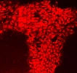



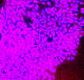


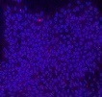






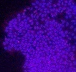
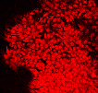


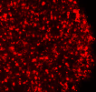

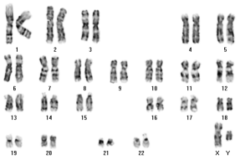
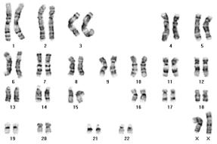
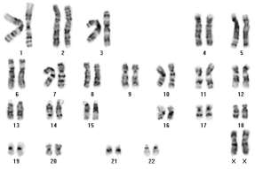
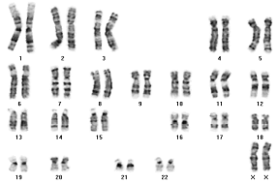
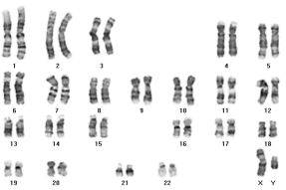
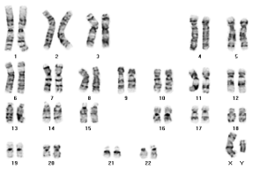
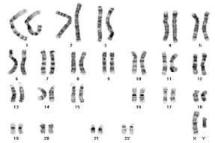
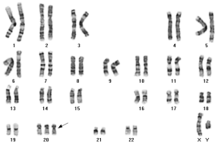
Merge
Merge
Merge
DAPI
DAPI
DAPI
KLF4
TRA-1-61
TRA-1-81
KLF4
TRA-1-61
TRA-1-81
DAPI
DAPI
DAPI
Merge
Merge
Merge
KLF4
TRA-1-61
TRA-1-81
DAPI
DAPI
DAPI
Merge
Merge
Merge
KLF4
TRA-1-61
TRA-1-81
DAPI
DAPI
DAPI
Merge
Merge
Merge
KLF4
TRA-1-61
TRA-1-81
DAPI
DAPI
DAPI
Merge
Merge
Merge
KLF4
TRA-1-61
TRA-1-81
DAPI
DAPI
DAPI
Merge
Merge
Merge
KLF4
TRA-1-61
TRA-1-81
DAPI
DAPI
DAPI
Merge
Merge
Merge
KLF4
TRA-1-61
TRA-1-81
DAPI
DAPI
DAPI
Merge
Merge
Merge
Non-DM 1
Non-DM 2
Non-DM 3
Non-DM 4
DM 1
DM 2
DM 3
DM 4
A
Fig. S1
Non-DM 4
Non-DM 3
Non-DM 1
Non-DM 2
DM 4
DM 3
DM 1
DM 2
B

