Supplementary material

Supplementary: Potential Field Source Surface modeling
To generate the footpoints shown in Fig 1(e) and Fig 2, a potential field source surface model (PFSS)^{16,17} was run using an ADAPT-GONG magnetogram³⁷⁻³⁹ from November 21st, 2022, with a source surface height set to the canonical value of 2.5 R_{S}¹⁸ via the the open source pfsspy⁴⁰ software. The footpoint mapping from PSP down to the solar surface followed the methodology⁴¹ comprising a ballistic heliosphere^{42,43} and the PFSS domain from 2.5R_{S} down to the photosphere.

The results for PSP E10 were distinct and compelling. As shown in Fig 1 and 2, for November 20 - November 21, PSP was rotating faster than the Sun and moving from left to right in the Carrington frame of reference shown in those plots. The footpoint mapping connected deep inside two mid-latitude negative polarity coronal holes of substantial area. This source mapping is uniquely well-supported as compared to prior PSP encounters owing to the comparison of the in situ data: Firstly, the magnetic polarity measured by PSP throughout the encounter well explained by the PFSS current sheet geometry and coronal hole polarity. Secondly, the times when PSP maps to the center of these large coronal holes correspond to maxima in solar wind speed, and at the time the connection switches from one source to another in the model there is a distinct dip in solar wind speed, clearly consistent with the traversal of overexpanded field lines at the coronal hole boundaries⁴⁴. This correspondence is clearly shown in figure 1 where the transition between "Stream 1" and "Stream 2" marked in the bottom panel corresponds to the dip in solar wind speed (black trace, panel 3).

Supplementary: PSP/SWEAP data analysis
We use proton and alpha particle measurements from the Solar Wind Electrons Alphas and Protons (SWEAP) instrument suite¹⁰ on Parker Solar Probe. The proton spectrum in Fig 4 is taken from the SPAN-Ion SF00 data product, averaged over the time range 2021-11-20/04:00:00 - 2021-11-20/19:00:00 and summed over all look directions. We work in units of energy flux as opposed to number flux or distribution function as it results in a spectrum spanning fewer orders of magnitude at high energy, facilitating the comparison between SPAN-Ion and ISOIS/Epi-Lo data, as well as being the quantity most directly related to the SPAN-Ion measurements. The power law for the protons is fit to the four highest energy SPAN data points and the ISOIS data points. The alpha spectrum is obtained in the same way from SPAN-Ion’s sf01 data product, except that a small amount (~1%) of contaminant protons leaking in from the sf00 channel are accounted for and subtracted. The large shift to higher energy of the alphas relative to the protons during this interval means that the contaminant protons have no impact on the power law part of the spectrum or its exponent, and only affect the lowest energy data points.

Supplementary: Reconnection magnetic field
The strength of the magnetic field that drives interchange reconnection will control the rate of magnetic energy release as well as the spectra of energetic particles produced. While the SDO/HMI observations reveal the structure of the magnetic field in the low corona, these measurements do not reveal the strength of the magnetic field that is actually undergoing reconnection since there is substantial variation of the field strength along the surface. To estimate the strength of the magnetic field driving the flow bursts measured by PSP, we project the measured magnetic field at PSP and project this magnetic field down to the solar surface. The radial magnetic field B_{R} at perihelion of E10 as shown in Figure 1 is around 600nT. Direct measurements of the radial profile of B_{R} over the PSP orbits have established an R⁻² scaling for the field, consistent with the conservation of the radial magnetic flux. However, deviations from this scaling are expected close to the sun. Specifically, because closed flux occupies a substantial fraction of the solar surface, the open flux will be compressed into a reduced fraction of the solar surface which will lead to greater compression of the magnetic field near the solar surface. A rough estimate of the increased magnetic field compression can be obtained by averaging the radial magnetic field obtained from the PFSS model during the E10 perihelion. The radial dependence of this averaged field is shown in Figure S1. The magnetic field compression from 2.5R_{s}, the outer boundary of the PFSS grid, down to just above the solar surface is around 26, which is well above the compression of around 6.25 from the R⁻² dependence. Thus, we assume that the R⁻² describes the radial dependence from R = 13.4R_{s} to 2.5R_{s} and take the compression of 26 from 2.5R_{s} to just above the solar surface. The projection of the 600nT field down to the solar surface is around 4.5G, which is in reasonable agreement with the strength of the solar surface magnetic field shown in Figure 2.

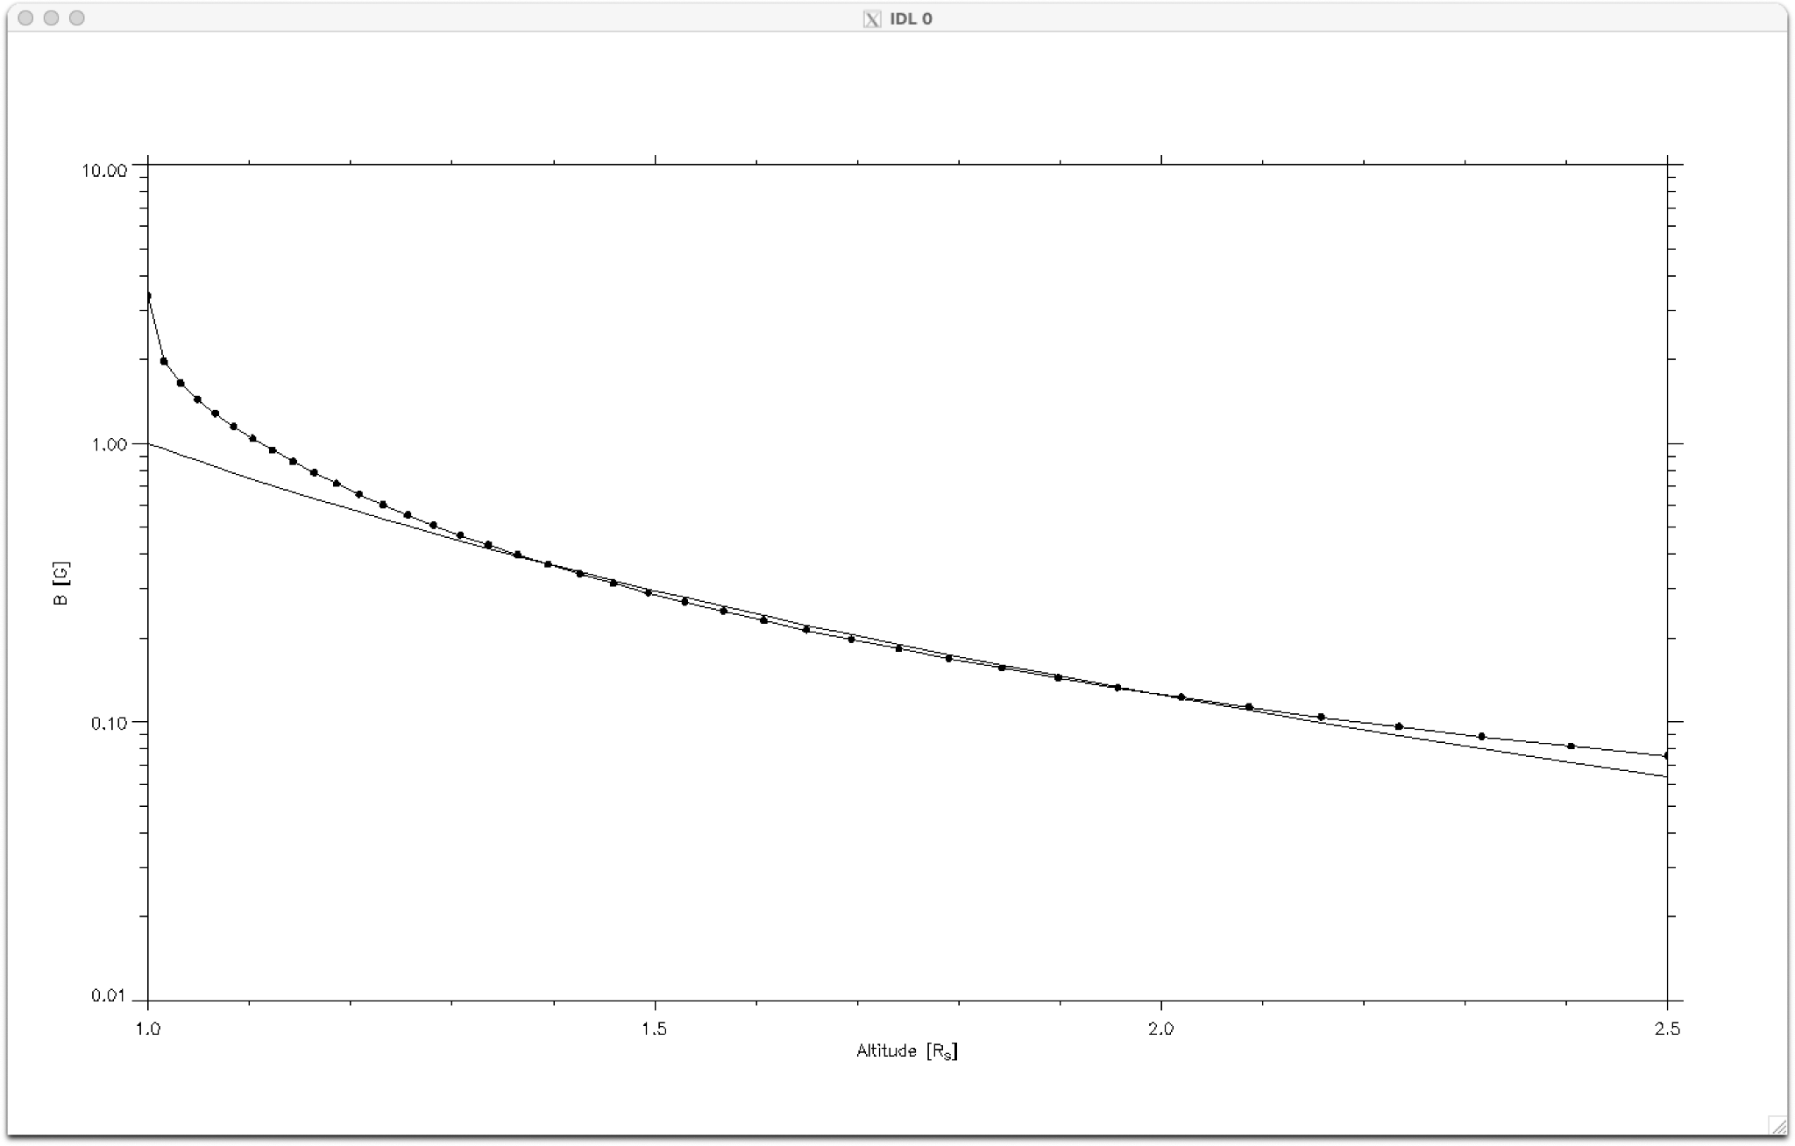

Supplementary: PIC simulations
Our estimate of the rate of interchange reconnection based on projections of the PSP observations back to the low corona suggest that reconnection there is deeply in the collisionless regime. To explore the structure of the interchange reconnection exhaust and the resulting energetic proton and alpha spectra measured at by PSP, we use the particle-in-cell (PIC) model p3d⁴⁵. The MHD model is not adequate to explore the particle energization documented in the PSP data. We limit the calculations to a 2D system with an initial magnetic geometry that leads to reconnection between open and closed flux low in the corona⁴⁶. Because of constraints on the domain size possible with the PIC model, there is no gravity in the simulations so the model does not describe the complete dynamics of the solar wind drive mechanism. In addition, line-tied boundary conditions are not imposed at the nominal coronal surface. Thus, the model is not a complete description of interchange reconnection in the low corona but will provide information on the dynamics of collisionless reconnection, the structure of the outflow exhaust and the spectra of accelerated particles. We include alpha particles (5% by number) so that the spectra of protons and alphas can be compared.

The initial state for the simulation consists of a band of vertical flux (field strength B₀ in the negative radial direction) with a low plasma density (0.1n₀) and an adjacent region with higher
density that is a cylindrical equilibrium. The detailed initial state has been described previously³⁴ so the governing equations are not repeated here. The peak magnetic field of the cylindrical equilibrium is 0.76B₀ with a peak density of n₀. The temperatures are uniform with T_{e} = T_{p} =T_{a} = 0.06m_{p}V_{A0}² with V_{A0} the Alfven speed based on B₀, n₀ and the proton mass m_{p}. Thus, in the initial state the plasma pressure is small compared with the magnetic pressure as expected in the corona. The guide field B_{z} is nonzero everywhere except in the region with vertical flux and is chosen to balance the pressure and tension forces. The peak value of B_{z} is 1.09B_{z} at the center of the region of cylindrical flux. The vertical and cylindrical field slightly overlap in the initial state and have opposite directions so that reconnection quickly onsets.

The results of the simulation are presented in normalized units: times to the Alfven transit time across the domain of scale length L, L/V_{A0}, plasma fluxes to n₀V_{A0} and energies to m_{p}V_{A0}² The domain dimensions in the x and y directions are equal. The mass ratio m_{p}/m_{e} = 25 is artificial as is the velocity of light (20V_{A0}) and the proton inertial scale d_{p} =L/163.84. As has been established in earlier papers, the results are not sensitive to these values²⁹. The radius of the cylindrical magnetic field is 60d_{p} and the grid scales are 0.02d_{p} in both space directions, with around 400 particles per cell.

Because the velocities and energies in the simulation are normalized to the Alfven speed V_{A0} and m_{p}V_{A0}², respectively, direct comparison with the observations require that these parameters, and specifically the Alfven speed V_{A0} where reconnection is taking place, be established. As described in the text of the paper, we use two distinct approaches for estimating V_{A0}. The first comes from the amplitude of the flow bursts measured by PSP at 13.4R_{s}, which have values around 300km/s. The second comes from comparing the proton spectra from the simulation and that measured with SPANi. Specifically, we equate the low energy limit of the proton powerlaw spectrum from the simulation and the observations. This yields m_{p}V_{A0}² = 1.4keV, which corresponds to V_{A0} = 370km/s. Thus, the two approaches yield comparable values, which enables us to directly compare the simulation results with the observations. Of course, the spectral indices of around -7 for the spectral indices of the proton and alpha energy fluxes from the simulation are independent of this normalization. That they are in approximate agreement with the observational data is strong support for the interchange reconnection model for these energetic particles. We further note that a simulation with half of the domain size (L=81.92d_{p}) produced powerlaw spectra with similar spectral indices.

References for Supplementary Material only

- Arge, C. N. et al, Air Force Assimilative Photospheric Flux Transport (ADAPT) Model, AIP confererence proceedings, 1216, 1, 343 (2010).
- Arge, C. N. et al., Improving data drivers for coronal and solar wind models, J. Phys., CS-444 (2011).
- Arge, C. N. et al., Modelinig the corona and solar wind using ADAPT maps that include far-side observations, Solar Wind 13 conference proceedings, CS-1539 (2013).
- Stansby, D, A. Yeates, and S. Badman, pfsspy: A Python package for potential source surface modeling, J. Open Source Software, 5, 2732 (2020).
- Badman, S. T. et al., Magnetic connectivity of the Ecliptic plane within 0.5 au: potential field source surface modeling of the first Parker Solar Probe encounter, Astrophys. J. Supp., 246, 23 (2020).
- Nolte, J. T. and E. C. Roelof, Large-scale structure of the interplanetary medium, I: High coronal source longitude of the quiet-time solar wind, Solar Phys., 33, 241 (1973).
- MacNeil, A. R. et al., A statistical evaluation of ballistic backmapping for the slow solar wind: The interplay of solar wind acceleration and corotation, MNRAS, 10.1093 (2021).
- Wang, Y.-M. and N. R. Sheeley Jr., Solar wind speed and coronal flux-tube expansion, Astrophys. J., 355, 726 (1990).
- Zeiler, A, et al., Three-dimensional particle simulations of collisionless magnetic reconnection, J. Geophys. Res., 107, 1230 (2002).
- Fisk, L. A., The open magnetic flux of the Sun. I. Transport by reconnections with coronal loops, Astrophys. J., 636, 563 (2005).

