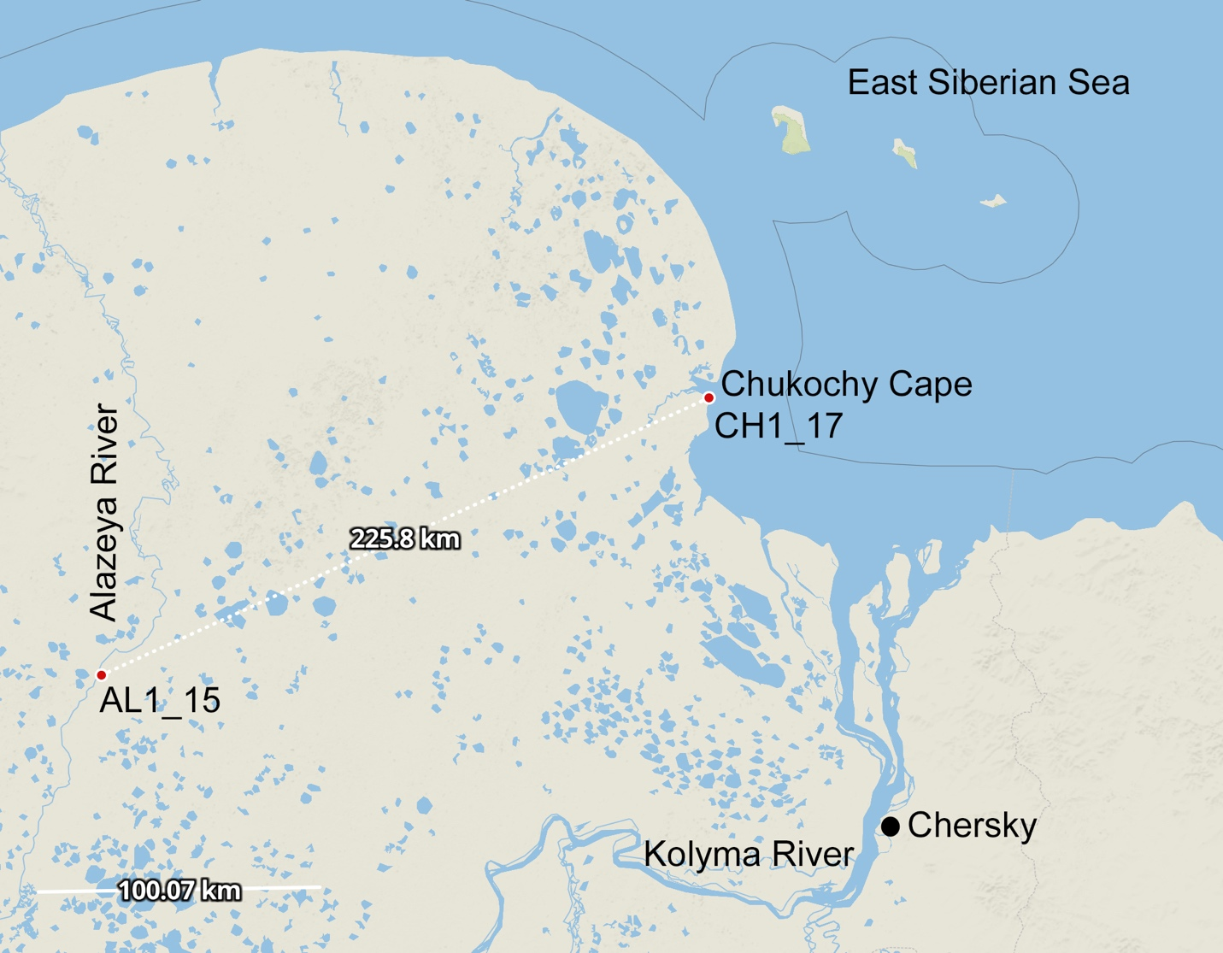

Fig. S1. The sampling sites located within the Kolyma Lowland in northeastern Siberia.
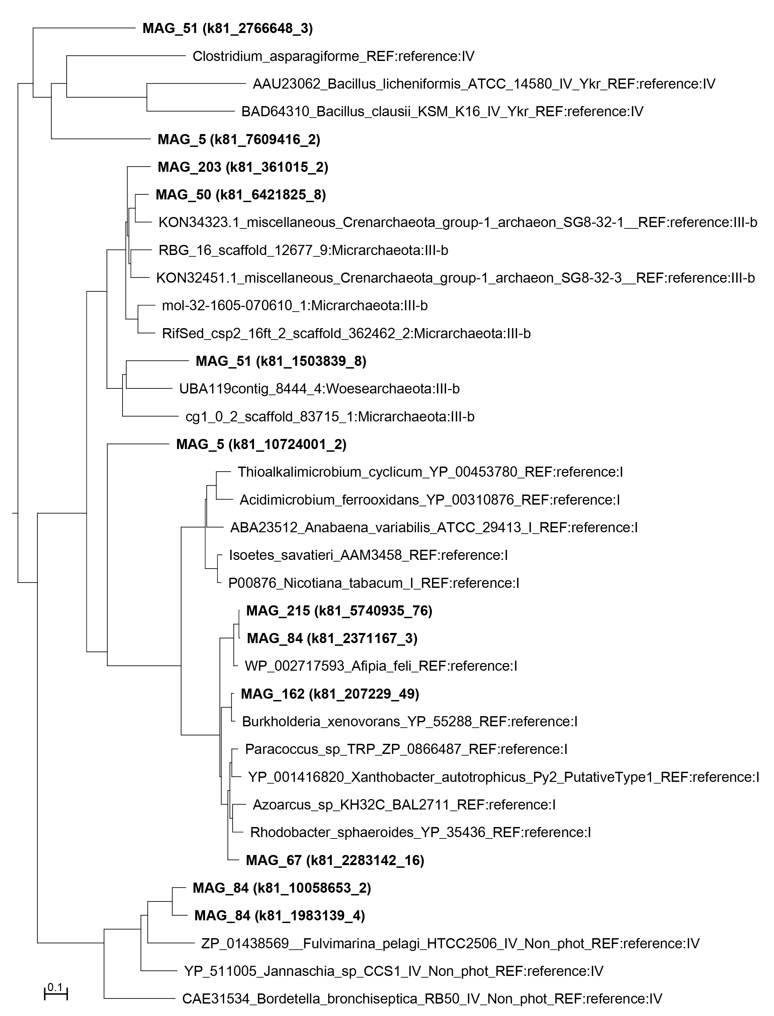

Fig. S2. Unrooted neighbor-joining phylogenetic tree of cbbL genes. Amino acid sequences of cbbL gene extracted from the corresponding MAG from this study are shown in bold. Gene IDs are given in brackets.

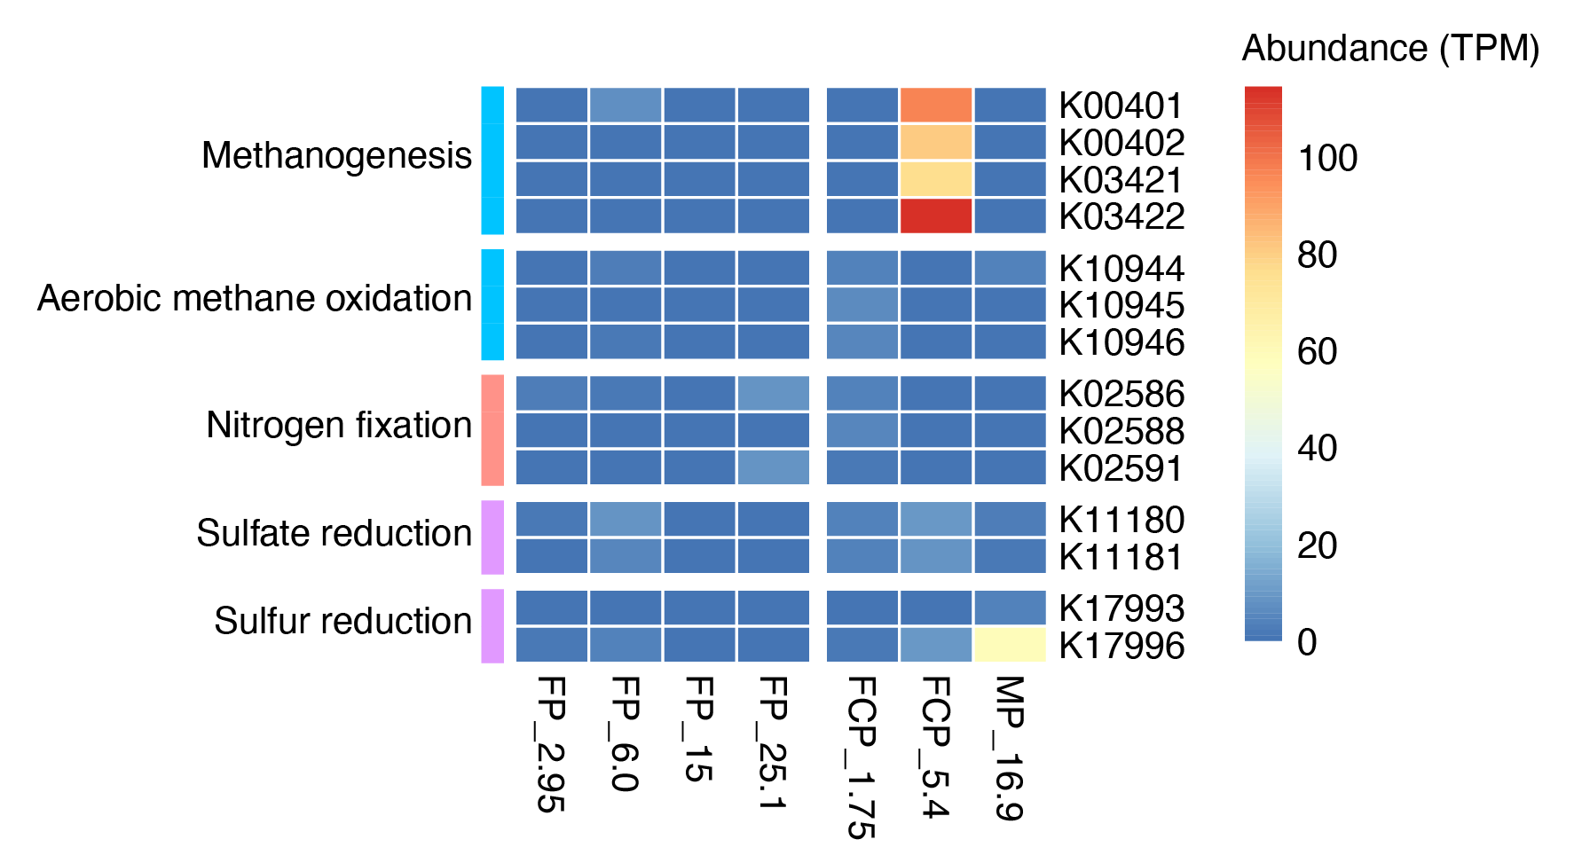
Fig. S3. Heatmap showing the normalized abundances of KEGG Orthologies (KOs) involved in methane, nitrogen and sulfur metabolisms. Mean normalized abundances for samples FP_2.95, FP_6.0, FP_25.1, FCP_1.75 and FCP_5.4 with technical replicates are shown.
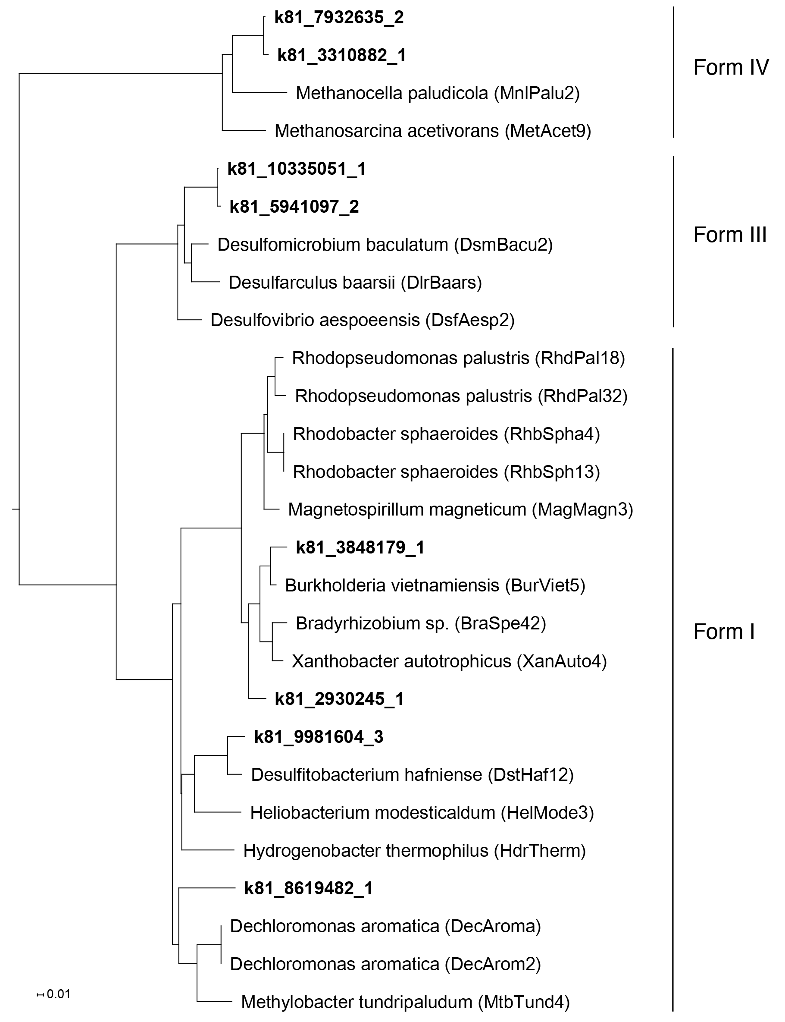

Fig. S4. Unrooted neighbor-joining phylogenetic tree of nifH genes. nifH gene obtained from co-assembled contigs are marked in bold.
Fig. S5. Heatmap showing the normalized abundances of KEGG Orthologies (KOs) involved in motility, bacterial secretion systems and sporulation. Mean normalized abundances for samples FP_2.95, FP_6.0, FP_25.1, FCP_1.75 and FCP_5.4 with technical replicates are shown.

