Electronic Supplementary Information for:

Effect of Zn(II) on pramlintide: structural kink, fibril formation, antifungal activity

Dorota Dudek¹, Emilia Dzień¹, Joanna Wątły¹, Aleksandra Mikołajczyk², Agnieszka Matera-Witkiewicz², Agata Hajda³, Joanna Olesiak-Bańska³ and Magdalena Rowińska-Żyrek^{1*}
¹ Faculty of Chemistry, University of Wrocław, F. Joliot-Curie 14, 50-383 Wrocław, Poland
² Screening of Biological Activity Assays and Collection of Biological Material Laboratory, Wroclaw Medical University Biobank, Faculty of Pharmacy, Wrocław Medical University, Poland
³ Faculty of Chemistry, Wrocław University of Science and Technology, Wyb. Wyspiańskiego 27, 50-370 Wrocław, Poland

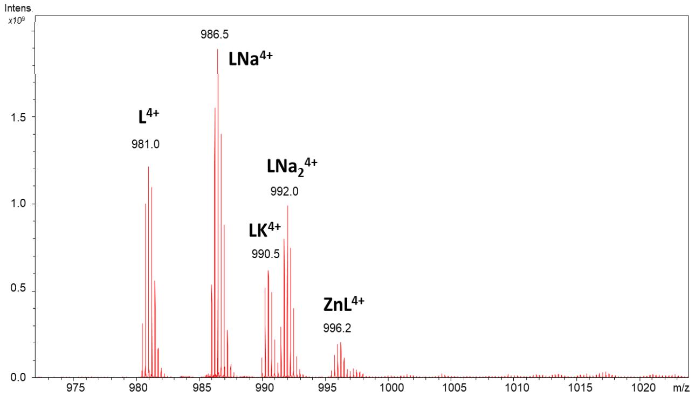
Figure S1. ESI-MS spectra of Zn(II)-rat amylin complex.
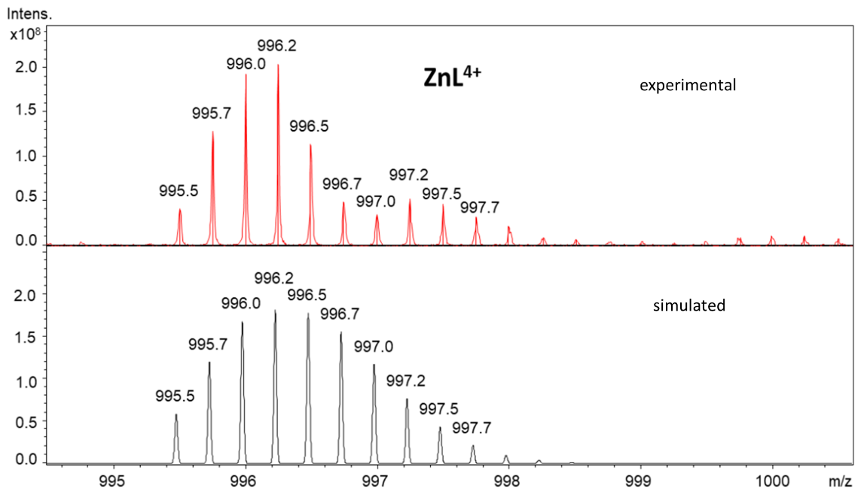
Figure S2. Isotopic distribution of Zn(II)-rat amylin complex.

Table S1. Potentiometric data for proton and Zn(II) complex with rat amylin.
 | Rat amylin
 | KCNTATCATQRLANFLVRSSNNLGPVLPPTNVGSNTY-NH₂
species | logβ | pK_{a}
HL | 10.20 (4) | 10.20 (Lys)
H₂L | 19.69 (3) | 9.49 (Tyr)
H₃L | 26.82 (6) | 7.13 (N-t)
Zn(II) complex
ZnL | 7.56 | -
ZnH₋₁L | -1.20 | 8.76
ZnH₋₂L | - | -
ZnH₋₃L | -23.27 | -

Figure S3. Distribution diagrams for the formation of Zn(II) complex with rat amylin. Conditions: T = 298 K, [Cu(II)] = 0,45x10-3 M; M/L molar ratio = 0.9:1.

In vitro toxicity studies
The cytotoxic effect of compounds selected after the antimicrobial testing (which was 256 μg/mL of amylin₁₋₁₉ and zinc complexes of amylin₁₋₁₉ and pramlintide) was determined. The NR cytotoxicity assay was performed using RPTEC cell line from ECACC collection. This method allows to determine the cells viability using their ability to incorporate and bind neutral red dye in lysosomes.¹ No significant decrease in cell viability was detected after 48 and 72 h incubation with the Zn(II)-pramlintide complex (viability equaled 96% and 99%, respectively).

References
- Repetto, G., del Peso, A. & Zurita, J. L. Neutral red uptake assay for the estimation of cell viability/cytotoxity. Nat Protoc. 3(7), 1125-1131 (2008).

