Factors influencing accumulation of the selected metals in the tissues of spiny-cheek crayfish (Orconectes limosus Raf.)
Magdalena Stanek · Bogusław Chachaj² · Szymon Różański³

¹ Department of Animal Physiology, Physiotherapy and Nutrition, Faculty of Animal Breeding and Biology, Bydgoszcz University of Science and Technology, Mazowiecka 28, 85-084 Bydgoszcz, Poland

² Department of Animal Biology and Environment, Faculty of Animal Breeding and Biology, Bydgoszcz University of Science and Technology, Mazowiecka 28, 85-084 Bydgoszcz, Poland

³ Laboratory of Chemical Research and Instrumental Analysis, Faculty of Animal Breeding and Biology, Bydgoszcz University of Science and Technology, Mazowiecka 28, 85-004 Bydgoszcz, Poland

Correspondence: Stanek Magdalena, mail: magdalena.stanek@pbs.edu.pl

Abstract The aim of the study was to analyse the effect of age and sex of crayfish on the degree of accumulation of selected metals in the meat and exoskeleton. A total of 50 males and 50 females of the spiny-cheek crayfish were caught in autumn (October 2019) after a period of intense feeding using fyke nets. Metal concentrations were determined in freeze dried samples of the abdominal meat, exoskeleton and bottom sediments and water using atomic absorption spectroscopy (AAS) with a SOLAR S4 spectrophotometer. The highest amounts of Zn were found in the meat of 4-year-old males, Cu of 3-year-old males, and Ca of 4-year-old males. As statistical calculations showed, both the age and sex of the crayfish were significant factors. BCF of Zn and Cu in the meat and exoskeleton of spiny-cheek crayfish was much higher from water than from sediments, unlike Ca. Only in a few cases the concentration of metals in the meat and exoskeleton significantly correlated with the total length (TL) of the crayfish. Consumption of 100 g of spiny-cheek crayfish meat could meet daily requirement for Zn up to 27.5% and for Ca in 12.4% and over 100% for Cu.

Key words: calcium, copper, zinc, crayfish tissues, bioaccumulation, sediment, water

Funding: The study was supported by a departmental sources only.
Introduction
The spiny-cheek crayfish (Orconectes limosus Raf.) is not native to Europe and its introduction in Poland has resulted in high abundance throughout most of the country (Holdich and Black 2007) and is commonly dominant as it has invaded almost the entire area of Polish waters, with the exception of the south-eastern part (Krzywosz 2004). This species of crayfish has small chelipeds with little meat, but it may be a consumer object for local people, like noble crayfish (Astacus astacus Linnaeus, 1758), although it is not exploited on such a scale as fish caught from this reservoir. This crayfish is immune to the crayfish plague because it carries a novel genotype of crayfish plague pathogen Aphanomyces astaci, so it is a threat to native noble and mud crayfish (Astacus leptodactylus Esch.) species. Spiny-cheek crayfish is tolerant of a wide range of environmental conditions including locations that have been affected by chemical pollution and eutrophication.
Edible crustaceans such as crab, shrimp, crayfish and lobsters are a valuable source of macronutrients and micronutrients essential for humans, such as Ca, K, Mg, Na, Fe, Cu, Zn (Nędzarek et al. 2020). Crayfish are frequently suggested as bioindicators for monitoring water conditions in polluted areas (Volpe et al. 2020). Research by Bergey and Weis (2007), Protasowicki et al. (2013) and Mackevičiené (2002) showed that in the case of numerous aquatic crustaceans, i.e. shrimps, crabs or crayfish, toxic metals tend to accumulate in the exoskeleton due to binding with chitin. Thus, this tissue has a very important detoxification function, because during the cyclical shedding of the armor, called molting, toxic metals are removed from the animal's body. Chitosan is a compound obtained from chitin, it is already widely used, among others in agriculture as a pesticide, growth stimulator and for fruit preservation. It can also be a carrier of drugs, a component of dressings, for the production of clothing and sewage treatment. The latest research by Polish scientists has confirmed that crayfish meat can be considered by the food industry as an alternative source of raw material (Śmietana et al. 2021). Can sewage be treated with waste? Such a question sounds like a question about the possibility of creating a perpetual motion machine.
The degree of accumulation of metals in tissues is influenced by physical and chemical factors, i.e. pH and temperature of the environment, contact time, metal concentration (Anastopoulos et al. 2017) and biological ones (i.e. species, size, body condition) (Balzani et al. 2021). Metals can accumulate metals directly from the sediments or by food (Mistri et al. 2020). The research of Keteles and Fleeger (2001) confirms that the tendency of metal accumulation in the exoskeleton of crustaceans is a specific feature and largely dependent on the type of metal. Therefore, it was interesting to know the influence of age and sex of the striped crayfish. Bioaccumulation of metals in crayfish bodies may impair the immune system, reproduction, heart rhythm, breathing processes, regeneration and moulting processes; it may also cause changes in pigmentation, increase glucose concentration, change pH of digestive juices and induce histopathological changes in the hepatopancreas (Protasowicki et al. 2013).
The aim of the study was to analyze the effect of age and sex of crayfish on the degree of accumulation of selected metals in the meat and exoskeleton, analyze correlation coefficient between the concentrated metals and body length and analyze bioaccumulation coefficient, and the percentage of the analysed metals in the water, sediment, meat and exoskeleton. Such complex analyses and interactions can improve our understanding of metal absorption, as well as enable more accurate estimates of the amount of bioavailable metals present at a given site. Additionally, we compared the determined concentrations of elements with recommendations for their daily intake.
The research hypothesis states that the age of crayfish, to a greater extent than sex, influences the degree of metal accumulation in crayfish tissues.

Introduction
The object of the study was the invasive North American spiny-cheek crayfish (Orconectes limosus Raf.), the introduction of which in Poland, unfortunately, resulted in excessive numbers throughout the country, disrupting biodiversity (Krzywosz 2004, Holdich and Black 2007). Due to its tolerant of a wide range of environmental conditions including chemically contaminated and eutrophicated reservoirs (Buřič et al. 2013) and its immune to crayfish plague due to the new genotype of pathogen Aphanomyces astaci, it poses a threat to native species of noble crayfish (Astacus astacus Linnaeus, 1758) and mud crayfish (Astacus leptodactylus Esch.) (Śmietana 2000). In accordance with the Regulation of the Minister of Agriculture and Rural Development of November 12, 2001 (Journal of Laws No. 138, item 1559) with the amendment introduced in paragraph 8 (Journal of Laws of 2003, No. 17, item 160), this crayfish species should be eliminated from the environment and the law requires not to release captured individuals back into the reservoir.
The latest research by Polish scientists has confirmed that crayfish meat can be considered by the food industry as an alternative source of raw material (Śmietana et al. 2021). According to the authors of these studies, the abdomen and chelae meat can be a source of minerals, too. As confirmed by numerous studies, crab, shrimp, crayfish and lobsters are a valuable source of macroelements and microelements essential for humans, but also of toxic metals in the event of water pollution (Balzani et al. 2021, Barrento et al. 2009, Heidarieh et al. 2013, Nędzarek et al. 2020, Raissy et al. 2011,). But what about the exoskeleton? Crayfish are frequently suggested as bioindicators for monitoring water conditions in polluted areas (Volpe et al. 2020). Research by Bergey and Weis (2007), Protasowicki et al. (2013) and Mackevičiené (2002) showed that in the case of numerous aquatic crustaceans, i.e. shrimps, crabs or crayfish, toxic metals tend to accumulate in the exoskeleton. This tissue therefore has a very important detoxification function, because toxic substances are removed from the animal's body during the cyclical shedding of armor, called moult. The main component of the shells of crustaceans is chitin (poly-β-(1,4)-N-acetyl-D-glucosamine), a natural biopolymer characterized by high bioactivity, biodegradability, non-toxicity, as well as good chelating property of heavy metal ions (Bhatnagar and Sillanpää 2009, Jaafarzadeh et al. 2015, de Sousa et al. 2020, Złotko et al. 2021). Therefore chitosan obtained from chitin is already widely used in medicine in nerve or wound repairand, in agriculture as a pesticide, growth stimulator and fruit preservative, but also in environmental protection in the treatment of wastewater (Zhang et al. 2022). Could the spiny-cheek exoskeleton be a reach source of divalent metals such as Zn, Cu and Ca?
The degree of accumulation of metals in tissues is influenced by physical and chemical factors, i.e. pH, salinity and temperature of the environment, contact time, metal concentration (Anastopoulos et al. 2017, Jaafarzadeh et al. 2015) and biological ones (i.e. tissue type, species, size, body condition, eating habits) (Balzani et al. 2021, Evans 1997, Zhang et al. 2019). The level of heavy metal accumulation in crayfish tissues is a good indicator of aquatic environmental contamination (Goretti et al. 2016, Kuklina et al. 2014, Varol and Sünbül 2018). Crayfish can accumulate metals from sediment (Varol and Sünbül 2018), water or with food (Mistri et al. 2020). The research of Keteles and Fleeger (2001) confirms that the tendency to accumulate metals in the exoskeleton of crustaceans is an individual feature of the organism and is highly dependent on the type of metal. Therefore, an analysis of age and sex of spiny-cheek crayfish was undertaken.
The aim of the study was to analyze the effect of age and sex of crayfish on the degree of accumulation of selected metals in the meat and exoskeleton, analyze correlation coefficient between the concentrated metals and body length and analyze bioaccumulation coefficient, and the percentage of the analysed metals in the water, sediment, meat and exoskeleton. Such complex analyses and interactions can improve our understanding of metal absorption, as well as enable more accurate estimates of the amount of bioavailable metals present at a given site. Additionally, we compared the determined concentrations of elements with recommendations for their daily intake.
The research hypothesis states that the age of crayfish, to a greater extent than sex, influences the degree of metal accumulation in crayfish tissues. As spiny-cheek crayfish are benthic crustaceans, the bioconcentration factor (BCF) of metals may be higher from sediment than from water.

Material and Methods
Crayfish collection
A total of 50 males and 50 females of the spiny-cheek crayfish were caught in autumn (October 2019) after a period of intense feeding using fyke nets. Traps were placed in the litoral zone of the reservoir at a depth of 1–2 m. Crayfish with damaged claws were not taken into account for further analyses. The traps were placed in the coastal zone of the Głowińsk reservoir near Rypin (north-central Poland) (Ryc.1.). Only healthy individuals were included in the study, and crayfish with damaged claws were not included for further analysis. After washing, the crayfish were placed in water and transported to the laboratory.

There were sexually mature individuals of total length from 80.7 to 104.2 mm (measured from the tip of the rostrum to the end of the telson) (Table 1). Spiny-cheek crayfish become sexually mature in Polish climatic conditions at the end of the second growing season (Holdich and Black 2007), when they reach a body length of 6 cm (Pielplow 1938; Juchno and Chybowski 2003). Spiny-cheek crayfish in Poland mate in autumn but females do not lay their eggs until spring (the end of April and beginning of May). The study included males with a well-developed first pair of pleopods form I of males, according to the description of Chybowski (2007). Females were in the same stage of reproductive cycle.

Water and bottom sediments collection
Water samples were taken from the subsurface layer and fixed with a few drops of concentrated nitric acid and was stored in the refrigerator for analysis. The sediment was collected from the bottom using an Ekman-Grab sampler and was stored in polyethylene bags.

Muscle and exoskeleton samples preparation
For analysis, the abdominal muscle and exoskeleton were dissected. Meat samples were preserved in the freezer at −20℃ until further processing. Exoskeleton was collected before it’s moulting by crayfish, when was hard and the levels of heavy metals could be maximal. Exoskeleton was air-dried and the muscle samples were freeze dried in Lyovac GT2 freeze-drier by Finn-Aqua (Finland) (parameters: temperature -40°C, pressure 6·10⁻² mbar, duration at least 48 h). The exoskeleton was first air-dried and then, like the meat samples, the material was freeze-dried in Lyovac GT2 freeze-drier by Finn-Aqua (Finland) (parameters: temperature -40°C, pressure 6·10-2 mbar, duration at least 48 h).

Minerals analyses
Cu, Zn and Ca concentrations were determined in freeze dried samples after aqua regia digestion (ISO 11466:1995) on Thermo SCIENTIFIC iCE 3000 SERIES spectrophotometer, calibrated using Merck standard solutions (Merck KGaA). The validation of the analysis was conducted on certified standards - Certified Reference Material ERM®-BB422 Fish Muscle, Certified Reference Material BCR®-670 Aquatic Plant and Certified Reference Material CRM027-050 Sandy Loam 10 (Tab. 2.). The concentrations of the metals were calculated from linear calibration plots obtained by measurement of the standard solutions. All determinations were made in triplicate and the data for samples of the meat, exoskeleton and bottom sediments were corrected to oven-dry (105°C) moisture content (given in mg kg⁻¹ dry weight - mg kg⁻¹ d.w.).

Bioconcentration Factor
The accumulation of elements in crayfish tissue was measured using bioconcentration factor (BCF). According to Jitar et al. (2015) and Vrhovnik et al. (2013), BCF is defined as follows:
BCF = Cb/C
where Cb—concentration of metals in the meat or exoskeleton; C—concentration of elements in sediments/water

Statistical analyses
Statistical calculations were made using Statistica 13.0 software (StatSoft 13.0). The arithmetic mean (x) and standard deviation (SD) were calculated. Significant differences between the groups were tested with one-way analysis of variance (ANOVA), and Tukey's test was used for multiple comparisons. The normality of the data was tested using the Shapiro-Wilk’s test and the homogeneity of variance was verified by means of the Levene’s test. The level of significance was determined at P ≤ 0.05. Relationships between metal concentrations and total length (TL) in the individual tissues in each group were determined based on the Pearson’s correlation coefficients (r).

Results
Our analyses indicated that metals accumulated in the following sequence: Zn>Cu>Ca in the abdominal meat samples and Ca>Zn>Cu in the exoskeleton, water and bottom sediment samples (Table 3).

The highest amounts of Zn were found in the meat of 4-year-old males, Cu of 3-year-old males, and Ca of 4-year-old males. As statistical calculations showed, both the age and sex of the crayfish were significant factors (Table 4.).

Significantly higher values of Zn and Cu were found in the exoskeleton of 3-year-old males. Ca concentrations ranged from 157.18 g/kg (3-year old males) to 171.50 g/kg (4-year old females), but the values were not significantly different between groups (Table 5).

Figures 1-3 show the percentage of the analysed metals in water, sediment, meat and exoskeleton. Zn and Cu accumulated in the greatest amounts in the meat (from 62.60 to 77.17%), and in the smallest amounts in the exoskeleton (from 4.87 to 12.30%). Ca was most abundant in the exoskeleton (77.30% in 4-year old females to 75.13% in 4-year old males). In the meat, the percentage of Ca ranged from 1.04% in 4-year old females to 3.58% in 4-year old males).

The ability of an aquatic organism to absorb chemicals from the environment can be assessed by the bioconcentration factor (BCF). Table 6. shows the values of BFC for each groups of individuals. The accumulation coefficient for Zn and Cu was higher in the meat, than for Ca in the exoskeleton. BCF of Zn and Cu in the meat and exoskeleton of spiny-cheek crayfish was much higher from water than from sediments, unlike Ca.

Correlations Between Minerals and TL
It was found that only in a few cases the concentration of metals in the meat and exoskeleton significantly correlated with the total length (TL) of the crayfish. Statistically significant correlation coefficients (P<0.05) between Zn and TL in 3-year old females and 4-year old males and between Cu and TL (P<0.05) in 3-year old males were observed. In the case of the exoskeleton, no significant correlations (P>0.05) were found between the concentration of metals and TL (Fig. 4.).

Table 7 present the content of Ca, Cu and Zn determined in the meat of crayfish calculated for 100 g of wet weight and % of the recommended daily intake (ZDS) for the analyzed minerals. The research indicated that crayfish meat was a rich source of Cu (over 100% ZDS), and consumption of 100 g of spiny-cheek crayfish meat could meet daily requirement for Zn up to 27.5% and for Ca in 12.4%.

Results
Our analyses indicated that metals accumulated in the following sequence: Zn>Cu>Ca in the abdominal meat samples and Ca>Zn>Cu in the exoskeleton, water and bottom sediment samples (Table 3). Figure 1. shows differences in the concentration of metals in the meat and exoskeleton between 3- and 4-year old individuals (3+ and 4+) without sex division and between males (M) and females (F) without age division. Sex was a significant factor affecting level of Ca in the meat (5.17 g/kg in males and 2.82 g/kg in females) and Zn in the exoskeleton (15.09 mg/kg in males and 10.32 mg/kg in females). As statistical calculations showed, age of the crayfish were significant factors affecting level of Zn, Cu and Ca in the meat and Zn and Cu in the exoskeleton. Significantly higher levels of Zn (16.06 mg/kg) and Cu (3.96 mg/kg) were determined in the exoskeleton of 3-year old individuals. In the case of meat, significantly higher values were found for Zn (117.42 mg/kg) and Ca (5.91g/kg) in 4-year old individuals, while the concentration of Cu (31.87 mg/kg) was higher in the tissue of 3-year old crayfish.

The highest amounts of Zn were found in the meat of 4-year-old males, Cu was determined in the highest amounts in 3-year-old males, and the level of Ca was significantly highest in the meat of 4-year-old males (Table 4.). Significant differences were found in the concentration of Zn between 3- and 4-year old females, and in the concentration of Cu between 3- and 4-year old males. Significantly highest values of Ca were determined in the meat in 4-year old males.

Significantly highest values of Zn and Cu were found in the exoskeleton of 3-year-old males. Significantly lowest level of Zn was determined in tissue of 4-year-old males. Ca concentrations ranged from 157.18 g/kg (3-year old males) to 171.50 g/kg (4-year old females), but these values were not significantly different between groups (Table 5).

Figures 2-4 show the percentage of the analysed metals in water, sediment, meat and exoskeleton. Zn and Cu accumulated in the greatest amounts in the meat (from 62.60 to 77.17%), and in the smallest amounts in the exoskeleton (from 4.87 to 12.30%). Ca was most abundant in the exoskeleton (77.30% in 4-year old females to 75.13% in 4-year old males). In the meat, the percentage of Ca ranged from 1.04% in 4-year old females to 3.58% in 4-year old males).

The ability of an aquatic organism to absorb chemicals from the environment can be assessed by the bioconcentration factor (BCF). Table 6. shows the values of BFC for each groups of individuals. The accumulation coefficient for Zn and Cu was higher in the meat, than for Ca in the exoskeleton. BCF of Zn and Cu in the meat and exoskeleton of spiny-cheek crayfish was much higher from water than from sediments, unlike Ca.

It was found that only in a few cases the concentration of metals in the meat and exoskeleton significantly correlated with the total length (TL) of the crayfish. Statistically significant correlation coefficients (P<0.05) between Zn and TL in 3-year old females and 4-year old males and between Cu and TL (P<0.05) in 3-year old males were observed. In the case of the exoskeleton, no significant correlations (P>0.05) were found between the concentration of metals and TL (Fig. 5.).

Table 7 present the content of Ca, Cu and Zn determined in the meat of crayfish calculated for 100 g of wet weight and % of the recommended daily intake (ZDS) for the analyzed minerals. The research indicated that crayfish meat was a rich source of Cu (over 100% ZDS), and consumption of 100 g of spiny-cheek crayfish meat could meet daily requirement for Zn up to 27.5% and for Ca in 12.4%.

Discussion
As confirmed by spiny-cheek crayfish research, Ca accumulated in the highest amounts in the exoskeleton, while Zn and Cu in meat. Nędzarek et al. (2020) obtained similar results for signal crayfish (Pacifastacus leniusculus). This is due to chitin, which builds the crustacean exoskeleton and has a high sorption capacity for metals. So this tissue is a rich source of this element and can be used as a natural fertilizer for plants. Chitin (poly-β-(1,4)-N-acetyl-D-glucosamine) is the most abundant natural biopolymer and it has attracted scientific attention as an inexpensive adsorbent for metals. Chitin can be an easily available and cheap material used for cleaning the environment of harmful metals (Złotko et al. 2021). The most valuable properties of chitin include: bioactivity, biodegradability, biocompatibility, non-toxicity, film formation and fiber formation, good chelating properties of heavy metal ions. The sorption capacity of chitin is influenced by physico-chemical factors such as pH, adsorbent dosage, contact time and initial metal concentration (Jaafarzadeh et al. 2015).
Calcium (Ca) is one of the most abundant cations in the body and affects the structure of the skeletal system and maintaining a proper acid-base balance. Absorption of Ca from the gastrointestinal tract is controlled by hormones such as: parathyroid hormones (PTH), calcitonin, and 1,25-dihydroxycholecalciferol and as confirmed by research muscle tissue is not the main site of Ca accumulation as opposed to scales, bones and skin (Lall, 2002). Our results on Ca accumulation in various tissues of spiny-cheek crayfish were in agreement with Nędzarek et al. (2020) and showed no significant sex and age differences in the content of this metal in the exoskeleton. As Wærvågen et al. (2016) confirmed, one of the main factors affecting the degree of skeletal calcification is the pH of the environment.
Zinc (Zn) plays an important role in the proper functioning of an organism, especially of the immune system, it is a component of many metalloenzymes, regulates metabolism of carbohydrates, proteins, nucleic acids, participates in insulin synthesis and in bone mineralization (Chavez-Sanchez et al. 2000). Zn uptake by the crayfish from solution is probably due largely to surface adsorption on the shell and gills. This can vary between different batches of animals and is influenced by the calcium concentration of the water (Bryan 1967).
Copper (Cu) Cu is a constituent of the crayfish respiratory pigment and 50–60% of the Cu in decapods is stored in the haemolymph. The large accumulation of Cu in the abdominal muscle could also be due to a physiological response to external stress (Mistri et al. 2020). Crayfish are useful for assessing the bioavailability of copper in aquatic ecosystems in a short-term monitoring program due to their rapid clean-up (Kouba et al. 2010; Xiong et al. 2020).
Statistically significant differences in the content of the determined metals in the meat between 3- and 4-year old crayfish were determined only for Zn, Cu and Ca (Cu and Zn in the exoskeleton). The period of exposure to the environmental factor plays a significant role in the level of accumulation of metals (Jaafarzadeh et al. 2015). Our previous research confirmed significant influence of spiny-cheek crayfish age on the level of Zn and Cu in meat (Stanek et al. 2017).
Statistically significant differences in the content of the determined metals in the meat between males and females (within one age group) were determined only for Ca. Significantly higher values of Zn and Cu were rather found in the exoskeleton of 3-year-old males than in females of spiny-cheek crayfish. Hagen and Sneddon (2009) showed no significant difference between male and female crayfish in Zn and Cu content. Naghshbandi et al. (2007) confirmed differences in Zn and Cu content in the muscle between sexes for mud crayfish. As Chen et al. (2005) confirmed, Cu is an essential metal for the blood pigment in crustaceans and therefore there should not be any differences between sexes. Kaya et al. (2015) observed that the quantity of chitin was greater in males than in females and the dry weight of chitin between species ranged from 4.71% to 11.84%. Second, using scanning electron microscopy (SEM), we observed that the male chitin surface structure contained 25 – 90 nm wide nanofibers and 90 – 250 nm nanopores, while no pores or nanofibers were observed in the chitin surface structure of the majority of females (nanofibers were observed only in M. desertus females). Differences in the metal content of the exoskeleton between males and females may be due to the difference in the frequency of moulting during the year (Jussila et al. 1995). Differences in the metal content of the meat between males and females may be due to differing growth rates between sexes. Female P. esculentus grow faster than males, so growth dilution of accumulated metals is probably more marked in females. On the other hand, unpublished data concerning Nephrops norvegicus show that males have higher feeding rates than females and concentration of metals may be higher (Canli and Furness 1993).
According to Tao et al. (2012), a BCF value > 1 – means that the organism has the potential to accumulate a chemical substance, but it is not considered significant unless it exceeds 100 or more. Another theory assumes that a BCF value of <1000 means that the chemical is not significantly bioaccumulative; with BCF in the range of 1000–5000, the chemical substance has a potential to bioaccumulate, and with BCF> 5000, the chemical substance shows high bioaccumulation (Costanza et al. 2012). Different BCF values in different tissues are related to the biochemical function of elements in life processes of the body, as well as physiological functions of individual organs (Nędzarek et al. 2020). The obtained BCF values for Zn were consistent with the data obtained, by Nędzarek et al. (2020) for signal crayfish (Pacifastacus leniusculus) but they were much lower for Cu. Our analyses confirmed that Zn and Cu accumulate mainly in the muscle, and Ca in the exoskeleton. This is because Ca is the main constituent of the exoskeleton as calcium carbonate (30%–40%), in addition to chitin (20-30%) and protein (20-30%) (Chen et al., 2020). The differences in the bioaccumulation of metals in a tissue by detoxification compared to other tissues can be expressed as the ratio of the levels found in these tissues (for example ratio Exoskeleton/Meat). The analyses of spiny-cheek crayfish showed the highest values of this ratio for Ca (several hundred times higher in comparison to Zn and Cu). The exoskeleton is in direct contact with the environment: metals in exoskeleton are associated with passive adsorption from water rather than through bioaccumulation (Mistri et al. 2020).
Correlations Between Minerals and TL
A significant negative correlation between body length and metal concentration in the meat may result from dilution of the concentration as the animal's body grows and could be indicative of faster metabolism in younger individuals compared to older ones (Balzani et al. 2021). Studies of Balzani et al. (2021) on P. clarkii showed that muscle had a slow rate of Cu uptake compared to other tissues and that Cu elimination was quite effective for this species, resulting in low accumulation after exposure. The lack of statistically significant correlations between the concentration of metals and TL in the exoskeleton may result from cyclic moulting, which results in the removal of metals.
The degree of absorption of Zn depends on the amount of Ca in the environment. Our analyses confirmed a positive and significant relationship between Zn and Ca concentration in the meat of 3-year-old males (high degree of correlation r=0,822835).

Discussion
As confirmed by spiny-cheek crayfish research, Ca accumulated in the highest amounts in the exoskeleton, while Zn and Cu in the meat. The analyses of spiny cheek crayfish showed that the concentration of metals in abdominal meat and in exoskeleton was in this decreasing order Ca> Zn> Cu. The same results were observed by Protasowicki et al. (2013) in signal crayfish (Pacifastacus leniusculus), by Goretti et al. (2016) in red swamp crayfish (Procambarus clarkii) from Lake Trasimeno, and by Varol and Sünbül (2018) in mud crayfish. Higher level of Cu than Zn in exoskeleton was analyzed by Nędzarek et al. (2020) in signal crayfish exoskeleton and by Mistri et al. (2020) in red swamp crayfish.
Calcium (Ca) is one of the macroelements responsible for building the skeletal system and maintaining a proper acid-base balance and as confirmed by the research of Lall (2002), muscle tissue is not the primary site of Ca accumulation, unlike the scales, bones and skin. It was confirmed by studies of a spiny-cheek crayfish, which showed calcium concentrations about 40 times higher in the exoskeleton compared to the muscle tissue. This is due to chitin, which builds the crustacean exoskeleton and has a high sorption capacity for metals, which is due to passive adsorption of metals from water (Mistri et al. 2020). So this tissue may be a rich source of Ca and can be used as a natural fertilizer for plants. Nędzarek et al. (2020) obtained from 2.4 to 3.8 times higher Ca level in the meat compared to the exoskeleton for signal crayfish. Our research did not confirm significant differences in the level of Ca in the exoskeleton between groups. Neither sex nor age were a significant factors affecting level of Ca in this tissue. As Wærvågen et al. (2016) confirmed, moult timing and frequency, as well as length increment per moult, have a major impact on exoskeleton calcification in Norwegian populations of the crayfish Astacus astacus (Linnaeus, 1758).
Zinc (Zn) is a microelement that plays an important role in the proper functioning of an organism. This metal is responsible for carbohydrates, proteins, nucleic acids metabolism, proper bone mineralization and the functioning of the immune system (Chavez-Sanchez et al. 2000). The degree of zinc accumulation in crayfish tissues depends on the concentration of calcium in the water and the correlation between these metals, moreover it is largely due to surface adsorption on the shell and gills (Bryan 1967). Our analyses of spiny-cheek crayfish demonstrated about 8.5 times higher concentration of Zn in meat compared to the exoskeleton. Nędzarek et al. (2020) found about 3 times higher Zn levels in signal crayfish meat compared to the exoskeleton. The same results were denoted by Mistri et al. (2020) in red swamp crayfish (the ratio was from 3.5 to 4.8 times). The studies of Jaafarzadeh et al. (2015) confirmed that the chitin extracted from the shrimp was an effective Zn adsorbent, but the contact time or individual predispositions strongly influenced the efficiency of biosorption.
Microelement which plays a significant role in the production of red blood cells, synthesis nucleic acids, hardening of collagen and keratinization of hair, haemocyanin biosynthesis and catabolism in aquatic arthropods and molluscs is copper (Cu) (Mistri et al. 2020). Our research showed almost 9 times higher concentration of this metal in meat compared to the exoskeleton. Significantly highest concentration of this metal in the exoskeleton was found in 3-year-old males of spiny-cheek crayfish. Nędzarek et al. (2020) found about 1.3 times higher Cu levels in signal crayfish meat compared to the exoskeleton. The same results were denoted by Mistri et al. (2020) in red swamp crayfish (the ratio was from 1.3 to 3.4 times). The studies of Balzani et al. (2021) on P. clarkii showed that the muscle tissue was characterized by the lowest degree of Cu absorption compared to other tissues, which confirms a greater degree of elimination than accumulation. No significant differences in Cu concentration in the abdominal meat between females and males of spiny-cheek crayfish within one age group were observed. The only significant differences were found in the Cu concentration in meat between 3- and 4-year old males. These differences are likely due to the ability of crayfish to clear metals rapidly and this is why these animals are useful for assessing Cu bioavailability in aquatic ecosystems in a short-term monitoring program (Kouba et al. 2010; Xiong et al. 2020). As demonstrated by Mistri et al. (2020), the large accumulation of Cu in the abdominal muscle may also be caused by a physiological response to external stress.
Statistically significant differences in the content of the determined metals between 3- and 4-year old crayfish were determined for Zn, Cu and Ca in the meat and for Cu and Zn in the exoskeleton. The analyses showed significant differences in the concentration of Zn in meat between 3- and 4-year old females and in the concentration of Cu between 3- and 4-year old males. As confirmed by Jafarzadeh et al. (2015) in studies performed on shrimp shells, the period of exposure to the environmental factor is responsible for the level of accumulation of metals such as Zn. This is consistent with our previous research, which confirmed the significant influence of the age of spiny-cheek crayfish on the Zn and Cu levels in meat (Stanek et al. 2017). Lower metal values in the meat of older individuals (for example Cu in 4-year old spiny-cheek crayfish) may be due to a dilution effect. When the growth rate is faster, as is often the case in younger organisms, then the growth dilution effect will be greater (Evans-Illidge 1997).
Statistically significant differences in the content of the determined metals between males and females were determined for Ca in the meat and for Zn in the exoskeleton. Hagen and Sneddon (2009) and Nędzarek et al. (2020) showed no significant difference between males and females crayfish in Zn and Cu content in the meat. Naghshbandi et al. (2007) confirmed differences in Zn and Cu content in the muscle between sexes for mud crayfish. Chen et al. (2005) confirmed the lack of significant differences in Cu concentration between individuals of different sexes in any tissue. One of hypothesis is that Cu is an essential element for the blood pigments of crustaceans, and its requirement should not differ between the sexes. Differences in the concentration of this metal may appear in small crustaceans or juveniles with little or no haemocyanin, which may result in an increase in the concentration of Cu in the body as the size of the animal increases. Kaya et al. (2015) confirmed by scanning electron microscopy (SEM) that the male chitin surface structure contained 25 – 90 nm wide nanofibers and 90 – 250 nm nanopores, while no pores or nanofibers were observed in the chitin surface structure of the majority of females (nanofibers were observed only in M. desertus females). Moreover, they confirmed the differences in dry matter of chitin between species (these values ranged from 4.71% to 11.84%) and they observed that the quantity of chitin was greater in males than in females. The research of Jussila et al. (1995) on noble crayfish confirmed differences in the metal content of the exoskeleton between males and females may be due to the difference in the frequency of moulting during the year. This was confirmed by the research of Nędzarek et al. (2020) on the level of heavy metals in the exoskeleton of signal crayfish from the Wieprza River. Differences in the metal content of the meat between males and females may be due to differing growth rates between sexes (Evans-Illidge 1997). Moreover, research concerning Nephrops norvegicus show that males have higher feeding rates than females and concentration of metals may be higher (Canli and Furness 1993).
According to Tao et al. (2012), a BCF value > 1 – means that the organism has the potential to accumulate a chemical substance and BCF value > 100 means high accumulation capacity. Other literature sources indicate that a BCF value of <1000 means that the chemical is not significantly bioaccumulative; with BCF in the range of 1000–5000, the chemical substance has a potential to bioaccumulate, and with BCF > 5000, the chemical substance shows high bioaccumulation (Costanza et al. 2012; Varol and Sünbül (2018). The calculated BCF values for Zn were consistent with the data obtained, by Nędzarek et al. (2020) for signal crayfish, and BCF values for Cu were the same as obtained by Varol and Sünbül (2018) for mud crayfish. Our analyses confirmed that Zn and Cu accumulate mainly in the muscle, and Ca in the exoskeleton. This is because Ca is the main constituent of the exoskeleton as calcium carbonate (30%–40%), in addition to chitin (20-30%) and protein (20-30%) (Chen et al. 2020). The analyses of spiny-cheek crayfish showed a much higher bioaccumulation capacity of Zn and Cu in the meat from water (BCF > 1000), and a greater bioaccumulation capacity of Ca in the exoskeleton from sediments (BCF > 3). Since the shellfish exoskeleton is in direct contact with the environment, metals accumulate in this tissue through passive adsorption from water or sediment rather than bioaccumulation (Mistri et al. 2020). The differences in the bioaccumulation of metals in a tissue by detoxification compared to other tissues can be expressed as the ratio of the levels found in these tissues (for example ratio Exoskeleton/Meat). BCF values for Zn and Cu were similar and were below 1, while in the case of Ca, BCF value was in the range from 20.98 to 74.24. Two factors influence the BCF values in different tissues: different biochemical functions of elements and different physiological functions of individual organs (Nędzarek et al. 2020). In order to confirm this tendency of metal accumulation in the analyzed crayfish specie, studies on individuals obtained from reservoirs with various degrees of eutrophication should be carried out.
The lack of significant relationships between the length of the body and the concentration of metals (negative correlations) in the meat may result from the dilution of the concentration of metals as the animal's body grows, moreover, it may indicate faster metabolism in younger animals compared to older ones (Balzani et al. 2021), and it may also results from the growth-hindering effect of metals. Conversely, positive correlations indicate a trend of metal accumulation as the animal grows (Ergen et al. 2015). A significant negative correlations between the concentration of metals and TL in the exoskeleton may result from cyclic moulting, which results in the removal of metals. Our analyses on spiny-cheek crayfish confirmed this. The degree of absorption of Zn depends on the amount of Ca in the environment. Our analyses confirmed a positive and significant relationship between Zn and Ca concentration in the meat of 3-year-old males (high degree of correlation r=0,822835).

Conclusions
Factors influencing the differences in the accumulation of heavy metals in crayfish tissues are age, which is equivalent to the time of exposure of the animal to metals, and gender, which determines the moulting cycle and detoxification processes. This hypothesis was confirmed by spiny-cheek crayfish analyses. For most metals, significant differences were found between 3- and 4-year old individuals both in the meat and exoskeleton. The analyses of spiny-cheek crayfish partially supported the hypothesis of the bioconcentration factor (BCF) as this mechanism depends on the type of metal. As evidenced by the studies of other authors, environmental conditions are very important, especially pH (which affects the degree of bone mineralization), therefore this mechanism requires further research. Knowledge of the mechanisms of metal bioaccumulation and the factors influencing it is an important contribution to the environmental monitoring of freshwater ecosystems. According to U.S. Food and Drugs Administration the maximum allowable level is 6.1 mg kg⁻¹ d.w. for Cu and 21.2 mg kg⁻¹ d.w. for Zn (Alcorlo et al. 2006) analysed Orconectes limosus Raf. are suitable for human consumption.

Statements and Declarations
Ethical Approval: All procedures performed in studies involving animals were in accordance with the ethical standards of the institution or practice at which the studies were conducted. All efforts were made to minimize suffering according to Polish law and the EU Directive (no. 2010/63/EU). All members of the research team were trained in animal care, handling and euthanasia by PolLASA (Polish Laboratory Animal Science Association).
Consent to Participate: All authors confirmed their participation in the publication.
Consent to Publish: All authors read and approved the final manuscript and approved the version to be published.
Author Contributions: All authors contributed to the study conception and design. Material preparation, data collection were performed by [Bogusław Chachaj] and [Magdalena Stanek] analysis were performed by [Szymon Różański]. The first draft of the manuscript was written by [Magdalena Stanek]
Funding: The study was supported by a departmental sources only and grants were received during the preparation of this manuscript.
Competing Interests: The authors have no relevant financial or non-financial interests to disclose.
Availability of data and materials: The datasets generated during and/or analysed during the current study are available from the corresponding author on reasonable request.

References
Alcorlo P, Otero M, Crehuet M, Baltanás A, Montes C (2006) The use of the red swamp crayfish (Procambarus clarkii, Girard) as indicator of the bioavailability of heavy metals in environmental monitoring in the River Guadiamar (SW, Spain). Sci Total Environ 366(1):380–390. DOI:10.1016/j.scitotenv.2006.02.023
Anastopoulos I, Bhatnagar A, Bikiaris D, Kyzas G (2017). Chitin Adsorbents for Toxic Metals: A Review. Int J Mol Sci 18(1):114. DOI:10.3390/ijms18010114
Balzani P, Kouba A, Tricarico E et al (2021) Metal accumulation in relation to size and body condition in an all-alien species community. Environ Sci Pollut Res 29:25848–25857. https://doi.org/10.1007/s11356-021-17621-0
Barrento S, Marques A, Teixeira B, Analceto P, Carvalho ML, Vaz-Pires P, Nunes ML (2009) Macro and trace elements in two populations of brown crab Cancer pagurus: ecological and human health implications. J Food Compos Anal 22:65–71. https://doi.org/10.1016/j.jfca.2008.07.010
Bergey LL, Weis JS (2007) Molting as a mechanism of depuration of metals in the fiddler crab, Uca pugnax. Mar Environ Res 64(5):556–562. DOI:10.1016/j.marenvres2007.04.009
Bhatnagar A, Sillanpää M (2009) Applications of chitin- and chitosan-derivatives for the detoxification of water and wastewater — A short review. Adv Colloid Interface Sci 152(1-2):26–38. DOI:10.1016/j.cis.2009.09.003
Bryan GW (1967) Zinc regulation in the freshwater crayfish (including some comparative copper analyses). J Exp Biol 46:281–296
Buřič M, Kouba A, Kozák P (2013) Reproductive plasticity in freshwater invader: from long-term sperm storage to parthenogenesis. PLoS ONE 8(10):e77597. https://doi.org/10.1371/journal.pone.0077597
Canli M, Furness RW (1993) Heavy Metals in tissues of the Norway lobster Nephrops norvegicus: Effects of Sex, Size and Season. Chem Ecol 8(1):19–32. DOI:10.1080/02757549308035297
Chavez-Sanchez C, Martinez-Palacios CA, Martinez-Perez G, Ross LG (2000) Phosphorus and calcium requirements in the diet of the American cichlid Cichlasoma urophthalmus (Günther). Aquac Nutr 6:1–9. https://doi.org/10.1046/j.1365-2095.2000.00118.x
Chen M-H, Chen Ch-Y, Chou H-Y, Wen T-Ch (2005) Gender and size effects of metal bioaccumulation on the rock crab, Thalamita crenata, in Dapeng Bay, Southwestern Taiwan. Mar Pollut Bull 50:463–484. DOI:10.1016/j.marpolbul.2005.01.012
Chen J, Jiang S, Jiang H (2020) A review on conversion of crayfish-shell derivatives to functional materials and their environmental applications. J Bioresour Bioprod 5(4):238–247. DOI:10.1016/j.jobab.2020.10.002
Chybowski Ł (2007) Morphometric, fecundity, density, and feeding intensity of the spiny-cheek crayfish, Orconectes limosus (Raf.) in natural condition. Arch Pol Fisch 15(3):175–241
Costanza J, Lynch DG, Boethling RS, Arnot JA (2012) Use of the bioaccumulation factor to screen chemicals for bioaccumulation potential. Environ Toxicol Chem 31(10):2261–2268. https://doi.org/10.1002/etc.1944
Ergen FŞ, Tunca EÜ., Ozkan AD, Ölmez TT, Acaröz E, Altındağ A, Tekinay T, Tunca E (2015) Interactions between metals accumulated in the narrow-clawed crayfish Astacus leptodactylus (Eschscholtz, 1823) in Dikilitaş Lake, Turkey. Chem Ecol 31(5):455–465. DOI:10.1080/02757540.2015.1050002
Evans-Illidge E (1997) Heavy Metals in commercial prawn and crayfish species in Torres Strait Great Barrier Reef Marine Park Authority ISBN 0 642 26442 2. https://elibrary.gbrmpa.gov.au
Goretti E, Pallottini M, Ricciarini MI, Selvaggi R, Cappelletti D (2016) Heavy metals bioaccumulation in selected tissues of red swamp crayfish: An easy tool for monitoring environmental contamination levels. Sci Total Environ 559:339–346. DOI:10.1016/j.scitotenv.2016.03.169
Hagen JP, Sneddon J (2009) Determination of copper, iron, and zinc in crayfish (Procambrus clarkii) by inductively coupled plasma–optical emission spectrometry. Spectrosc Lett 42(1):58–61. DOI:10.1080/00387010802375065
Heidarieh M, Maragheh MG, Shamami MA et al. (2013) Evaluate of heavy metal concentration in shrimp (Penaeus semisulcatus) and crab (Portunus pelagicus) with INAA method. SpringerPlus 2-72. https://doi.org/10.1186/2193-1801-2-72
Holdich D, Black J (2007) The spiny-cheek crayfish, Orconectes limosus (Rafinesque, 1817) [Crustacea: Decapoda: Cambaridae], digs into the UK. Aquat Invasions 2(1):1–15. doi:10.3391/ai.2007.2.1.1
Jaafarzadeh N, Mengelizadeh N, Takdastan A, Farsani MH, Niknam N, Aalipour M et al. (2015) Biosorption of heavy metals from aqueous solutions onto chitin. Int J Env Health Eng 4:1–7. DOI:10.4103/2277-9183.153992
Jarosz M, Rychlik E, Stoś K, Charzewska J (2020) Standards of nutrition for the Polish population - amendment. Publisher: Institute of Food and Nutrition in Warsaw.
Jitar O, Teodosiu C, Oros A, Plavan G, Nicoara M. (2015) Bioaccumulation of heavy metals in marine organisms from the Romanian sector of the Black Sea. N Biotechnol 32:369–378. DOI: https://doi.org/10.1016/j.nbt.2014.11.004
Juchno D, Chybowski Ł (2003) Histological analyses of gonad development in female spiny-cheek crayfish (Orconectes limosus RAF). Arch Pol Fish 11(1):69–78
Jussila J, Henttonen P, Huner JV (1995) Calcium, magnesium, and manganese content of noble crayfish (Astacus astacus (L.)) branchial carapace and its relationship to water and sediment mineral contents of two ponds and one lake in central Finland, pp. 230–238. In, Geddes M. C., Fielder D. R., and Richardson A. M. M. (eds.), Freshwater Crayfish X. Tenth International Symposium of Astacology, Adelaide, Australia.
Kaya M, Lelešius E, Nagrockaitė R, Sargin I, Arslan G, Mol A et al. (2015) Differentiations of chitin content and surface morphologies of chitins extracted from male and female grasshopper species. PLoS ONE 10(1): e0115531. DOI:10.1371/journal.pone.0115531
Keteles KA, Fleeger JW (2001) The contribution of ecdysis to the fate of copper, zinc and cadmium in grass shrimp, Palaemonetes pugio Holthius. Mar Pollut Bull 42(12):1397–1402. DOI:10.1016/S0025-326X(01)00172-2
Kouba A, Buřič M, Kozák P (2010) Bioaccumulation and effects of heavy metals in crayfish: A Review. Water Air Soil Pollut 211(1-4):5–16. DOI:10.1007/s11270-009-0273-8
Krzywosz T (2004) Is it reverse of spiny cheek crayfish? Komun Ryb. 5:21–23
Kuklina I, Koub, A, Buřič M, Horká I, Ďuri Z, Kozák P (2014) Accumulation of heavy metals in crayfish and fish from selected Czech reservoirs. BioMed Res Int 306103:1–9. DOI:10.1155/2014/306103
Lall SP (2002) The minerals. In: Halver J.E. and Hardy R.W, Fish Nutrition 259–308
Mackevičiené G (2002) Bioaccumulation of heavy metals in noble crayfish (Astacus astacus L.) tissues under aquaculture conditions. Ekol (Vilnius) 2:79–82
Mistri M, Munari C, Pagnoni A, Chenet T, Pasti L, Cavazzini A (2020) Accumulation of trace metals in crayfish tissues: is Procambarus clarkii a vector of pollutants in Po Delta inland waters? Eur Zool J 87(1):46–57. DOI: 10.1080/24750263.2020.1717653
Naghshbandi N, Zare S, Heidari R, Razzaghzadeh S (2007) Concentration of heavy metals in different tissues of Astacus leptodactylus from Aras Dam of Iran. Pak J Biol Sci 10(21):3956–3959. DOI:10.3923/pjbs.2007.3956.3959
Nędzarek A, Czerniejewski P, Tórz A (2020) Macroelements and Trace Elements in Invasive Signal Crayfish (Pacifastacus leniusculus) from the Wieprza River (Southern Baltic): Human Health Implications. Biol Trace Elem Res 197:304–315. DOI:10.1007/s12011-019-01978-y
Pielplow U (1938) Fischerieiwissenschaftliche Monographie von Cambarus affinis Say. Z Fischerei Hilfswiss 36(16):350–437
Protasowicki M, Własow T, Rajkowska M, Polna M, Bernad A (2013) Metal concentrations in selected organs of crayfish—Orconectes limosus and Pacifastacus leniusculus from Mazurian Lakes. J Elementol 1:683–694. DOI:10.5601/jelem.2013.18.4.537
Raissy M, Ansari M, Rahimi E (2011) Mercury, arsenic, cadmium and lead in lobster (Panulirus homarus) from the Persian Gulf. Toxicol Ind Health 27(7):655–659. DOI:10.1177/0748233710395346
Regulation of the Minister of Agriculture and Rural Development of November 12, 2001 (Journal of Laws No. 138, item 1559) (In Polish).
de Sousa VR, da Cunha Santos MA, de Sousa VB, de Araújo NG, Navarro de Lima SL, Menezes RR (2020) A Review on Chitosan's Uses as Biomaterial: Tissue Engineering, Drug Delivery Systems and Cancer Treatment. Materials (Basel) 3(21):4995. DOI: 10.3390/ma13214995
Stanek M, Dąbrowski J, Różański Sz, Janicki B, Długosz J (2017) Heavy Metals bioaccumulation in tissues of spiny-cheek crayfish (Orconectes limosus) from Lake Gopło: Effect of Age and Sex. Bull Environ Contam Toxicol 98(6):740–746. DOI:10.1007/s00128-017-2098-2
Śmietana P (2000) The problem of active protection of native crayfish in Poland. Mag Przem Ryb 1(13):22–23
Śmietana N, Panicz R, Sobczak M, Śmietana P, Nędzarek A (2021) Spiny-cheek crayfish, Faxonius limosus (Rafinesque, 1817), as an Alternative Food Source. Animals 11(1), 59. https://doi.org/10.3390/ani11010059
Tao Y, Yuan Z, Xiaona H, Wein M (2012) Distribution and bioaccumulation of heavy metals in aquatic organisms of different trophic levels and potential health risk assessment from Taihu lake, China. Ecotox Environ Safe 81:55–64. https://doi.org/10.1016/j.ecoenv.2012.04.014
Varol M, Sünbül MR (2018) Biomonitoring of trace metals in the Keban Dam Reservoir (Turkey) using mussels (Unio elongatulus eucirrus) and crayfish (Astacus leptodactylus). Biol Trace Elem Res 185(1):216–224. DOI:10.1007/s12011-017-1238-1
Volpe MG, Ghia D, Safari O. et al (2020) Fast non-destructive assessment of heavy metal presence by ATR–FTIR analysis of crayfish exoskeleton. Environ Sci Pollut Res 27:21021–21031. https://doi.org/10.1007/s11356-020-08405-z
Vrhovnik P, Arrebola JP, Serafimovski T, Dolenec T, Smuc NR, Dolenec M, Mutch E (2013) Potentially toxic contamination of sediments, water and two animal species in Lake Kalimanci, FYR Macedonia: Relevance to human health. Environ Pollut 180:92–100. https://doi.org/10.1016/j.envpol.2013.05.004
Wærvågen Svein Birger, Tom Andersen, Taugbøl, Trond (2016) Exoskeleton calcification in Norwegian populations of the crayfish Astacus astacus (Linnaeus, 1758) (Decapoda: Astacidae) varies with size, gender, and ambient calcium concentration. J Crustac Biol 36(2):189–197. DOI:10.1163/1937240x-00002406
Xiong B, Xu T, Li R-p et al (2020) Heavy metal accumulation and health risk assessment of crayfish collected from cultivated and uncultivated ponds in the Middle Reach of Yangtze River. Sci Total Environ 736: https://doi.org/10.1016/j.scitotenv.2020.139963
Złotko K, Waśko A, Kamiński DM, Budziak-Wieczorek I, Bulak P, Bieganowski A (2021) Isolation of chitin from Black Soldier Fly (Hermetia illucens) and its usage to metal sorption. Polymers 13(5):818. https://doi.org/10.3390/polym13050818
Zhang Z, Fang Z, Li J, Sui T, Lin L, Xu X (2019) Copper, zinc, manganese, cadmium and chromium in crabs from the mangrove wetlands in Qi’ao Island, South China: Levels, bioaccumulation and dietary exposure. Watershed Ecol Environ 1:26–32. DOI:10.1016/j.wsee.2019.09.001
Zhang M, Zhang F, Li C, An H, Wan T, Zhang P (2022) Application of chitosan and its derivative polymers in clinical medicine and agriculture. Polymers (Basel) 28;14(5):958. DOI: 10.3390/polym14050958.

Additional figure (Figure 1.)

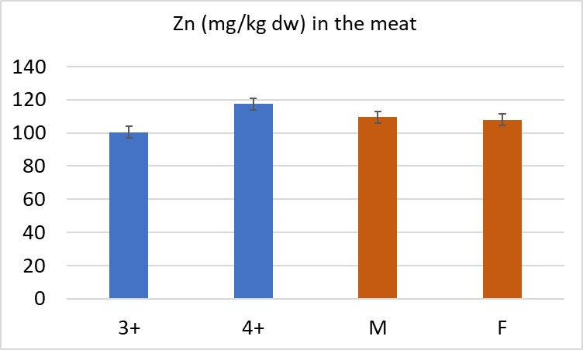  a  b | 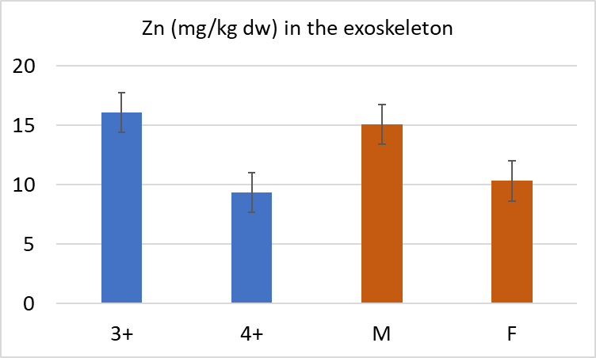  b  a  b  a
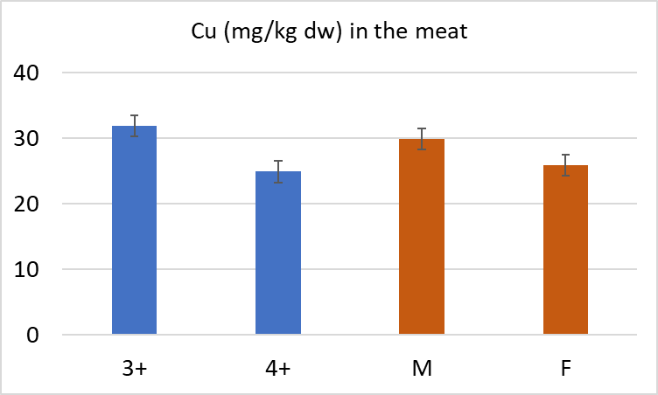  b  a | 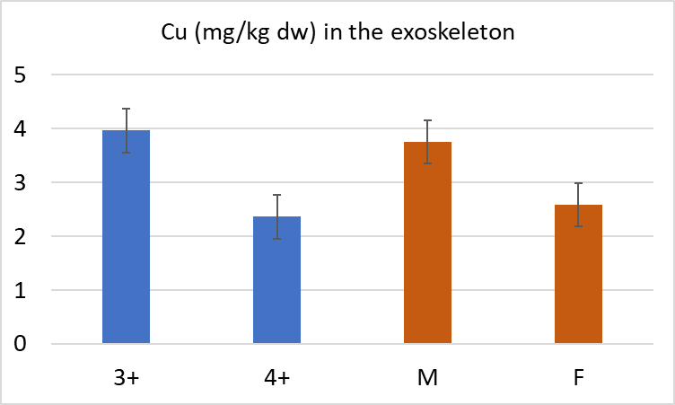  b  a
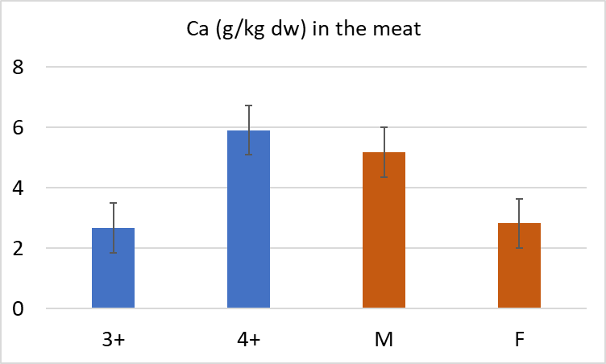  a  b  a  b | 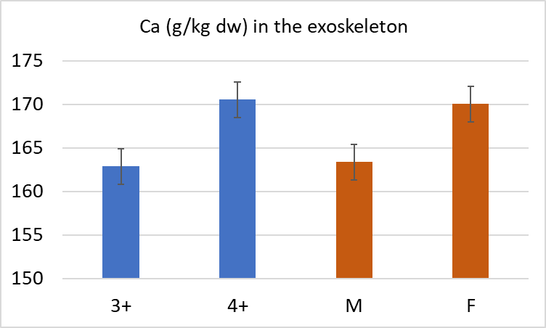
Fig.1. Concentration of Zn and Cu (mg/kg dw) and Ca (g/kg dw) in the meat and exoskeleton of spiny-cheek crayfish (Orconectes limosus) caught from Głowińsk
different letters (a, b) mean significant differences between 3- and 4-year old individuals
different letters (a, b) mean significant differences between males and females

