Supplementary Figures

Figure S1.
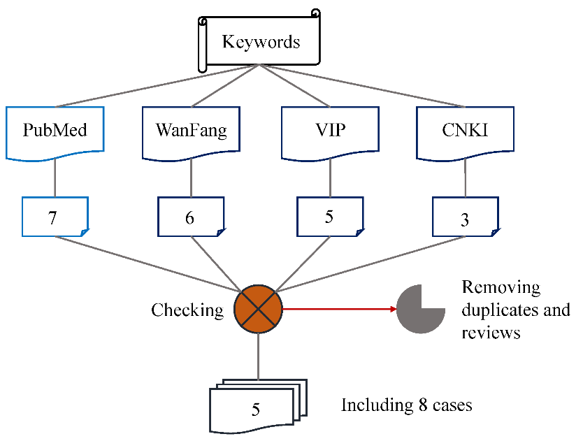
Figure S1. Workflow chart of data mining.

Figure S2.
Figure S2. Identified mutations of FOXG1 in DECIPHER and ClinVar databases.

Figure S3.
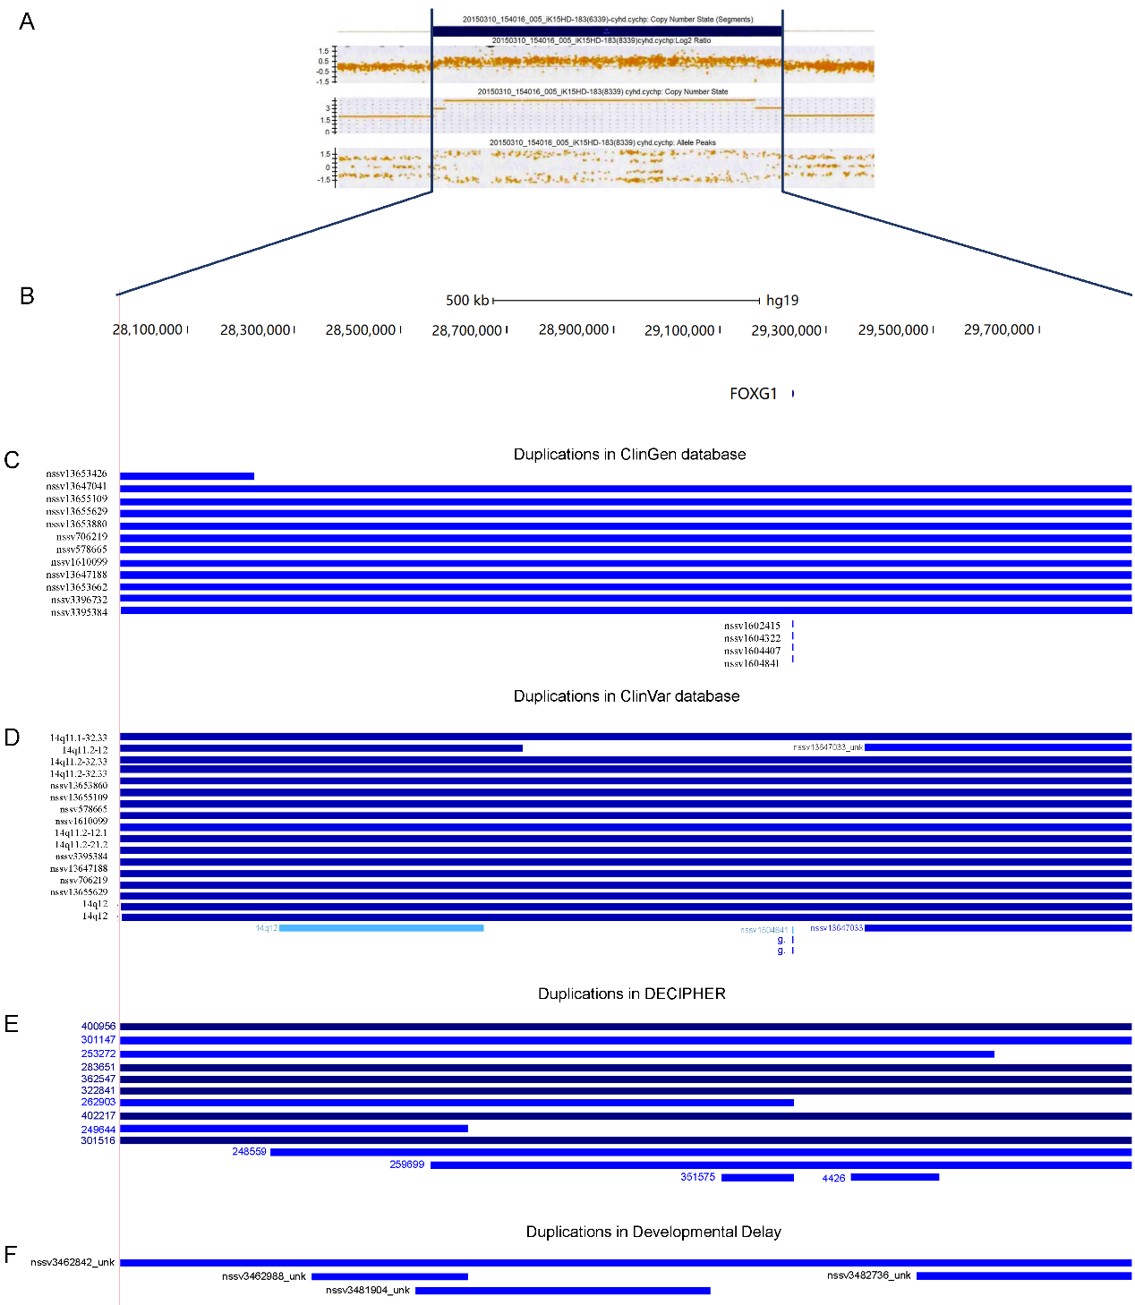
Figure S3. Microduplication covering 14q12(27974743-29875213). A) Chromosomal microarray analysis for patient 7; B) Genomic region; C) Microduplications in ClinGen database; D) Microduplications in ClinVar database; E) Microduplications in DECIPHER database; F) Microduplications in Developmental Delay data.

